Supporting Information

Characterization of particle-surface interactions via anharmonic acoustic transduction

Carlos da Silva Granja¹, Niklas Sandström², Igor Efimov¹, Victor P Ostanin³, Wouter van der Wijngaart², David Klenerman³, Sourav K Ghosh¹*

1 Centre for Biological Engineering, Loughborough University, UK
2 Micro and Nanosystems, KTH Royal Institute of Technology, Sweden
3 Department of Chemistry, University of Cambridge, UK

* Corresponding author

§1. Loop feature of $I_{3f}$-$I_{1f}$ graph

The peak value of $I_{1f}$ is achieved when $ω$ is close to the fundamental resonance. $I_{3f}$ increases as a cubic function of $I_{1f}$ as suggested by Eq.5 in the article (note the current is proportional to the oscillation amplitude), but it is also modified by its proximity to the third overtone resonance. Since the third overtone resonance does not coincide exactly at ${3ω}_{0}$ but is slightly shifted upwards by $ϵ$, the peak value of $I_{3f}$ is thus achieved for a slightly higher value of $ω$. As a result, the parametric $I_{3f}(ω)$-$I_{1f}(ω)$ graph gives a loop as noted in Figure 1c of the article. The $I_{1f}$-$ω$ and parametric $I_{3f}(ω)$-$I_{1f}(ω)$ graphs evaluated analytically using Eq.13 and Eq.14 showed a reasonable fit with the experimental data for a 2.5V drive as shown in the insets of Figures 1b and 1c of the article.

§2. Microscopic observation of QCR coverage

Microscopic observations showed comparable surface coverage of the QCR with microparticles by the end of the 70 minute assay for the different concentrations of IgE, particularly for the highest four concentrations corresponding to 3.2-0.16µM IgE solution. Figure S1a and Figure S1b show the microparticle coverage on the QCR for microparticles with concentrations corresponding to 1.6uM and 0.16uM IgE solution respectively.

The surface coverage was also comparable for microparticles with similar concentrations of IgE and IgG, corresponding to 1.6µM of the respective protein solutions, although clustering was noticeable for non-specific binding of IgG-microparticles (Figure S1a and Figure S1c). It was interesting to note from the microscopic pictures that clustering was dominant for IgG-microparticles compared to blank (non-functionalised) microparticles (Figure S1c and Figure S1d).

a
b
c
d

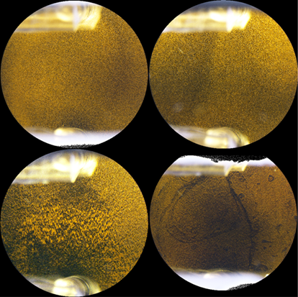

Figure S1. Micrographs of the quartz crystal resonator electrode at the end of the assay (t=70). Pictures show microparticles bound on the anti-IgE functionalised gold electrode a. IgE-microparticles (1.6µM IgE) bound via specific interactions. b. IgE-microparticles (0.16µM IgE) bound via specific interactions. c. IgG-microparticles (1.6µM IgG) bound via non-specific interactions. d. Blank or non-functionalised microparticles bound via non-specific interactions.

Table S1 shows the comparative set of signal-to-noise ratios across replicates for the highest IgE solution concentration (3.2uM) used in the work.

