# Supplementary Information

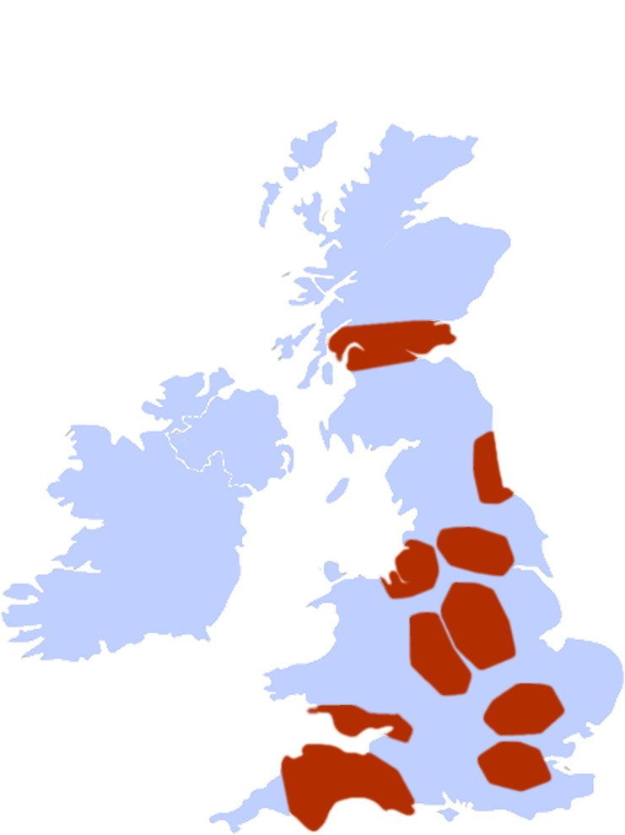

**Supplementary Figure 1.** Putative manufacturing centres used within this case study. Regions were identified using situation pressures identified in Supplementary Tables and the Science and Innovation Audits[36]. The shaded areas represent 68% of the UK population and each represents an area with one or more benefits to siting a decentralised manufacturing hub or node within that region. See also the results of the Science and Innovation Audit initiative[36]. Estimated population densities for UK regions were identified using PopulationExplorer[27] (Kimetrica™) and Landscan™[24], High Resolution global Population Data Set copyrighted by UT-Battelle, LLC, operator of Oak Ridge National Laboratory under Contract No. DE-AC05-00OR22725 with the United States Department of Energy. The United States Government has certain rights in this Data Set.



**Supplementary Table 1.** Key process and cost assumptions used.





**Supplementary Table 2.** Key office and facility assumptions used for central and decentralised facilities respectively.





**Supplementary Table 3.** Key labour assumptions used for central and decentralised facilities respectively.

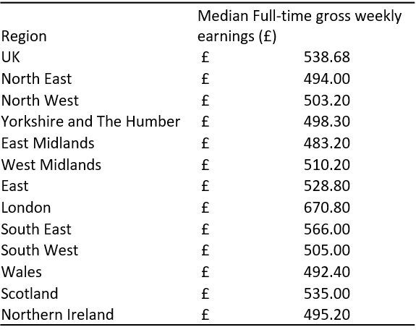

**Supplementary Table 4.** Median full-time gross weekly earnings and percentage change from previous year by UK regions. Obtained from the Annual Survey of Hours and Earnings (ASHE) - Office for National Statistics.



**Supplementary Table 5.** Salary bands were obtained from the UK National Health Service Pay Scales. These were then adjusted for each region using the Median full-time gross weekly earnings and percentage change from previous year by UK regions in Supplementary Figure 4.

|  |  |  |
| --- | --- | --- |
|  | **Estimated Population** | |
|  | **In 50KM Circle** | **In Shaded Area** |
| Birmingham | 4,610,427 | 4,550,147 |
| Nottingham | 3,289,396 | 3,937,783 |
| Liverpool | 4,186,300 | 5,585,641 |
| Leeds | 4,528,898 | 3,192,755 |
| Cardiff | 2,403,573 | 2,403,573 |
| Exeter | 2,208,892 | 2,208,892 |
| Edinburgh | 3,473,021 | 3,473,021 |
| Newcastle upon Tyne | 2,016,730 | 2,167,964 |
| Central London (city) | 12,768,649 | 12,768,649 |
| Cambridge | 2,716,464 | 2,716,464 |
| **Total** | **42,202,350** | **43,004,889** |

**Supplementary Table 6.** Estimated population by UK regions chosen for decentralised manufacturing. Obtained from PopulationExplorer and LandscanTM, a high-resolution population dataset produced by Oak Ridge National Laboratory, under a US Department of Defense contract.



**Supplementary Table 7.** Rateable Values of category “Laboratories” in UK regions. Average Rateable Values were adjusted by relative national change to account for the 2017 changes. A multiplier was extracted to apply to each of the UK regions.

|  |  |  |
| --- | --- | --- |
|  | **Business Rents /M2** | **Service Charge /M2** |
| **Birmingham** | £349.83 | £46.64 |
| **Nottingham** | £209.90 | £27.99 |
| **Liverpool** | £231.43 | £30.86 |
| **Leeds** | £301.39 | £40.19 |
| **Cardiff** | £236.81 | £31.57 |
| **Exeter** | £177.61 | £23.68 |
| **Edinburgh** | £322.92 | £43.06 |
| **Newcastle upon Tyne** | £247.57 | £33.01 |
| **Central London (city)** | £807.30 | £107.64 |
| **Cambridge** | £365.98 | £48.80 |
| **Average** | £325.07 | £43.34 |

**Supplementary Table 8.** Business rental values for grade A new build units in prime locations. Figures shown are an estimate or achievable rental rates taken from Colliers International National Office Rents Map 2016. Service charges were obtained from Simon Korn Commercial Property Consultants for London and extrapolated for other regions.



**Supplementary Table 9.** Assays used for QC of batches produced. Assay purpose, type and potential methodological approach are highlighted as well as the reasoning behind the choice. Example costings are highlighted for each battery of tests.