Appendix A.
Supplementary figures
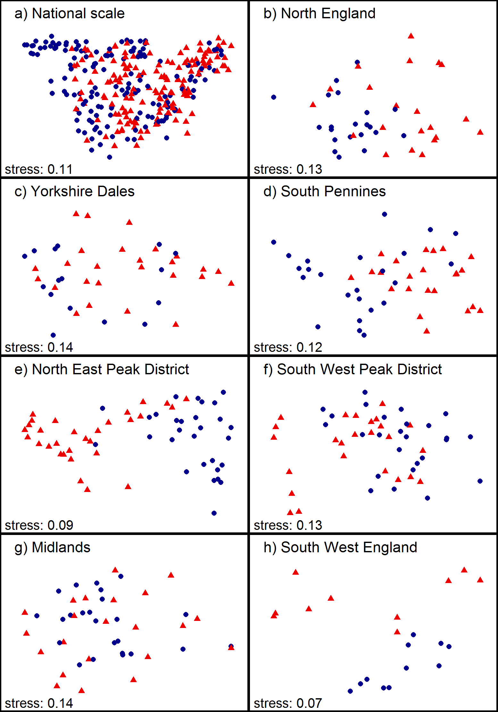
Figure S1. NMDS ordination results including all spring samples on national (panel a) and regional scale (panels b-h), labelled according to ‘Site type’ (Step 1). Blue dots = control sites, red triangles = downstream sites.

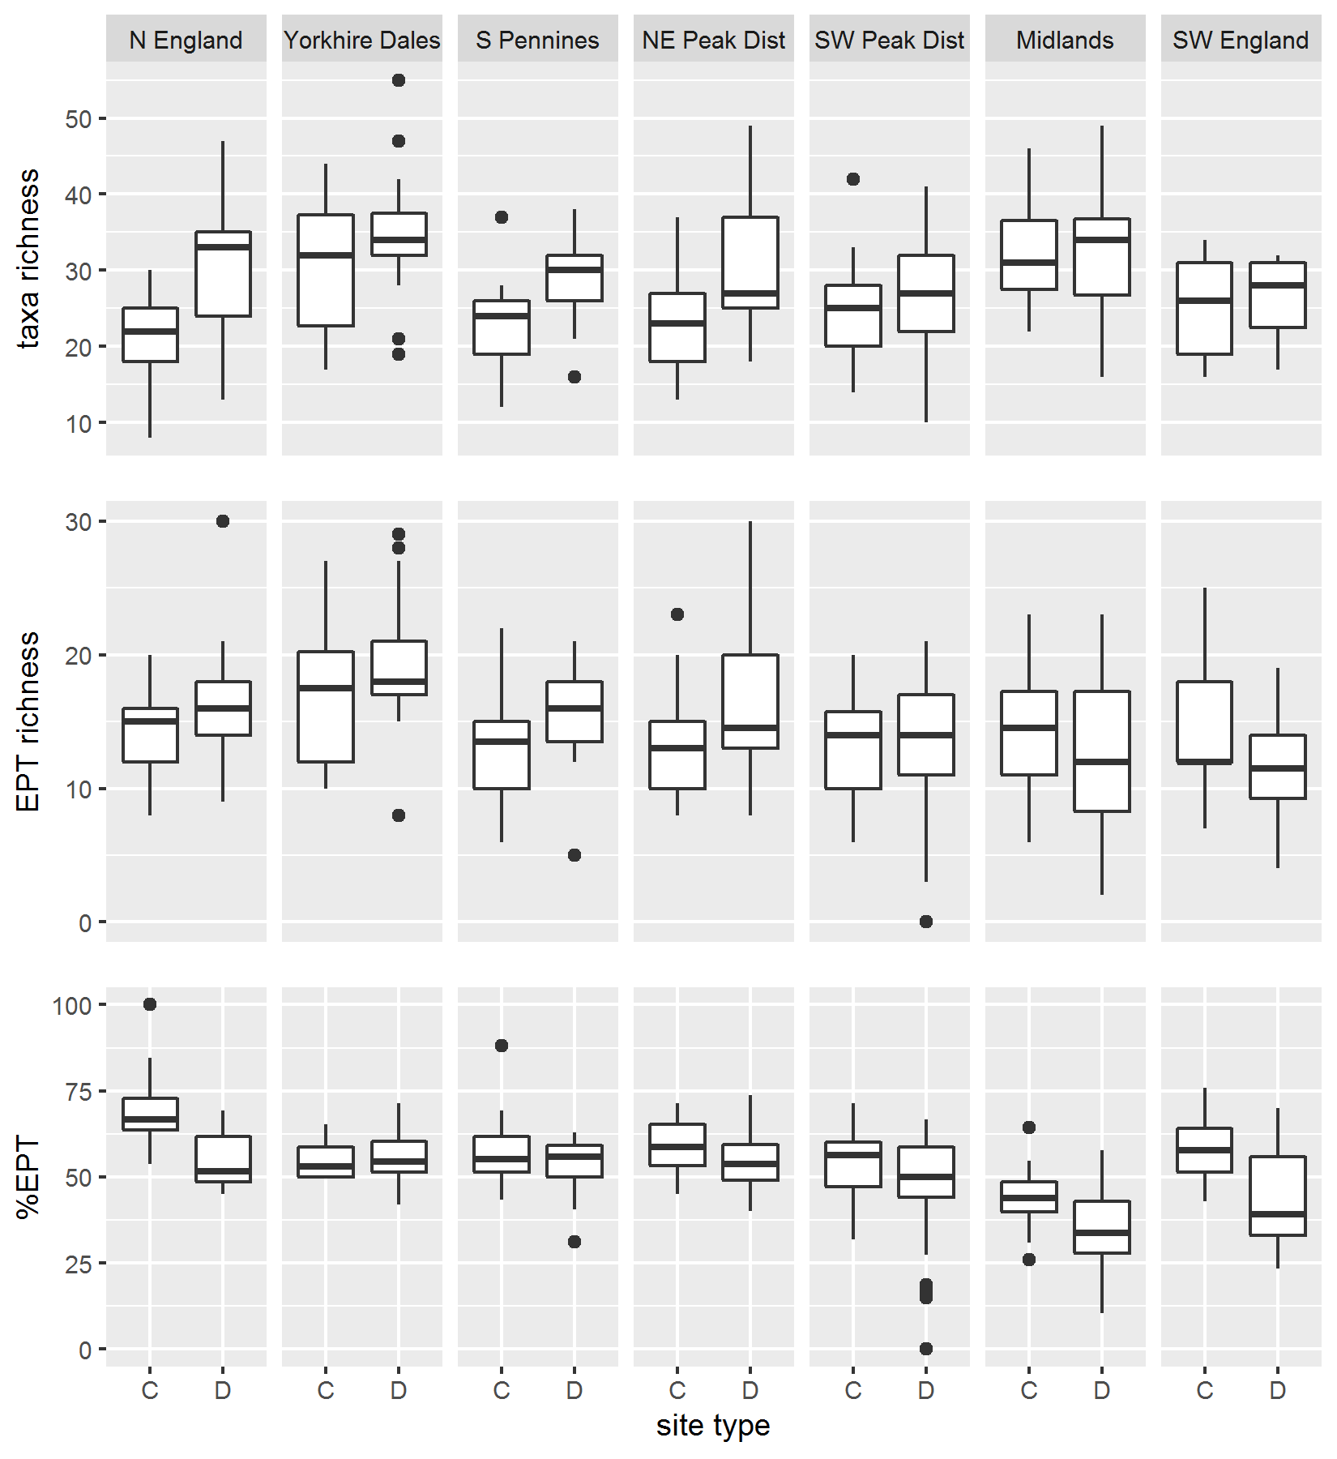
Figure S2. Regional-scale taxonomic richness values calculated on spring samples, per site type (C = control, D = downstream sites).

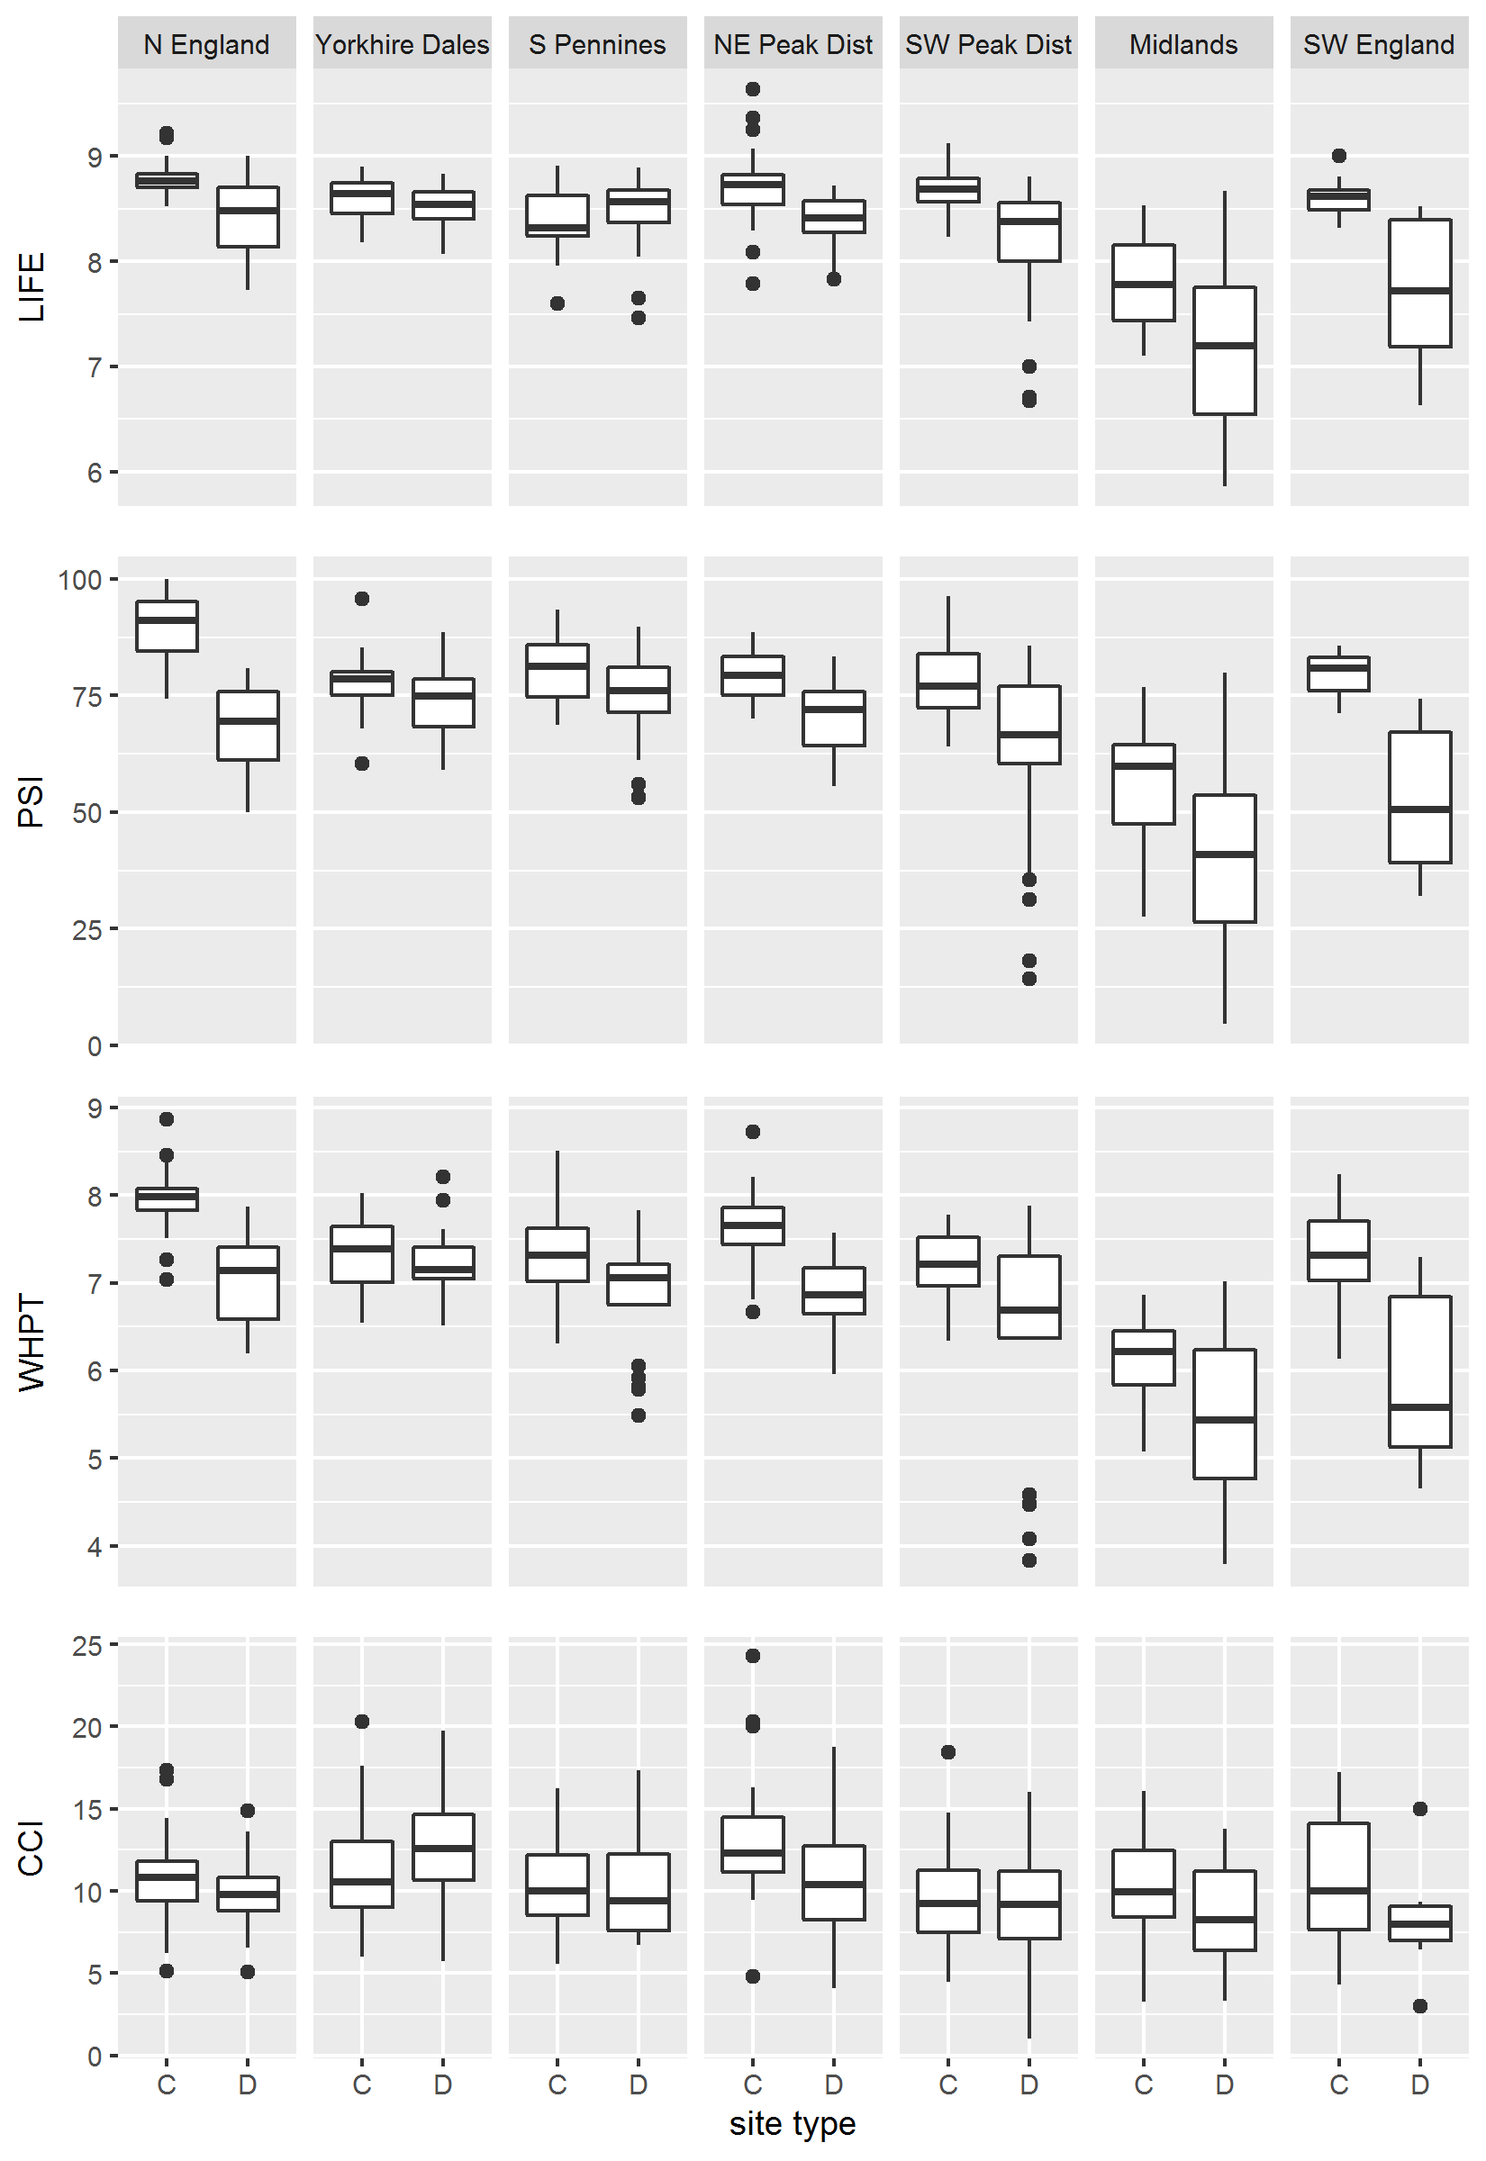
Figure S3. Regional-scale biomonitoring indices values calculated on spring samples, per site type (C = control, D = downstream sites).

Supplementary tables
Table S1. Results from PERMANOVA testing the significance of `Season' on community structure for separate control and downstream site samples (Step 2). NS = non-significant; *** = p ≤ 0.001; ** = p ≤ 0.01;* = p ≤ 0.05.
Region | Site type | Pseudo-F | R² | p
National scale | Control | 17.73 | 0.056 | 0.001 ***
 | Downstream | 14.48 | 0.044 | 0.001 ***
North England | Control | 4.42 | 0.104 | 0.001 ***
 | Downstream | 3.56 | 0.082 | 0.002 **
Yorkshire Dales | Control | 4.60 | 0.133 | 0.001 ***
 | Downstream | 6.15 | 0.108 | 0.001 ***
South Pennines | Control | 3.81 | 0.077 | 0.001 ***
 | Downstream | 3.95 | 0.081 | 0.001 ***
North East Peak District | Control | 18.23 | 0.249 | 0.001 ***
 | Downstream | 6.03 | 0.094 | 0.001 ***
South West Peak District | Control | 3.35 | 0.063 | 0.001 ***
 | Downstream | 2.72 | 0.053 | 0.001 ***
Midlands | Control | 2.11 | 0.043 | 0.016 *
 | Downstream | 2.30 | 0.053 | 0.011 *
South West England | Control | 2.78 | 0.122 | 0.013 *
 | Downstream | 1.17 | 0.064 | 0.311 (NS)

Table S2. Results from PERMANOVA testing the significance of `Year', ‘DC pair’ and ‘Region’ on community structure at control sites for separate spring (S) and autumn (A) samples (Step 3). NS = non-significant; *** = p ≤ 0.001; ** = p ≤ 0.01;* = p ≤ 0.05.
Region | Season | Year |  |  | DC pair |  |  | Region
 |  | Pseudo-F | R² | p | Pseudo-F | R² | p | Pseudo-F | R² | p
National scale | Spring | 0.58 | 0.016 | 0.991 (NS) | 6.07 | 0.657 | 0.001 *** | 10.25 | 0.30 | 0.001 ***
 | Autumn | 1.07 | 0.029 | 0.323 (NS) | 3.83 | 0.552 | 0.001 *** | 6.77 | 0.22 | 0.001 ***
North England | Spring | 0.64 | 0.138 | 0.917 (NS) | 3.94 | 0.496 | 0.001 ***
 | Autumn | 1.38 | 0.283 | 0.118 (NS) | 2.16 | 0.381 | 0.008 **
Yorkshire Dales | Spring | 0.67 | 0.195 | 0.957 (NS) | 3.56 | 0.640 | 0.001 ***
 | Autumn | 1.18 | 0.299 | 0.233 (NS) | 2.65 | 0.570 | 0.002 **
South Pennines | Spring | 0.63 | 0.118 | 0.966 (NS) | 6.44 | 0.576 | 0.001 ***
 | Autumn | 0.92 | 0.162 | 0.671 (NS) | 2.54 | 0.348 | 0.001 ***
North East Peak District | Spring | 0.51 | 0.079 | 0.983 (NS) | 5.17 | 0.585 | 0.001 ***
 | Autumn | 1.39 | 0.195 | 0.072 (NS) | 2.73 | 0.438 | 0.001 ***
South West Peak District | Spring | 0.76 | 0.126 | 0.866 (NS) | 2.61 | 0.395 | 0.001 ***
 | Autumn | 0.80 | 0.132 | 0.818 (NS) | 2.55 | 0.389 | 0.001 ***
Midlands | Spring | 0.74 | 0.135 | 0.883 (NS) | 2.81 | 0.371 | 0.001 ***
 | Autumn | 1.18 | 0.190 | 0.198 (NS) | 3.08 | 0.381 | 0.001 ***
South West England | Spring | 0.57 | 0.274 | 0.973 (NS) | 5.84 | 0.593 | 0.002 **
 | Autumn | 0.83 | 0.357 | 0.675 (NS) | 5.87 | 0.595 | 0.002 **

Table S3. Results from PERMANOVA testing the significance of `Year', ‘DC pair’ and ‘Region’ on community structure at downstream sites for separate spring (S) and autumn (A) samples (Step 3). NS = non-significant; *** = p ≤ 0.001; ** = p ≤ 0.01;* = p ≤ 0.05.
Region | Season | Year |  |  | DC pair |  |  | Region
 |  | Pseudo-F | R² | p | Pseudo-F | R² | p | Pseudo-F | R² | p
National scale | Spring | 1.02 | 0.026 | 0.423 (NS) | 4.90 | 0.595 | 0.001 *** | 4.86 | 0.16 | 0.001 ***
 | Autumn | 1.58 | 0.040 | 0.009 ** | 4.64 | 0.580 | 0.001 *** | 4.28 | 0.15 | 0.001 ***
North England | Spring | 0.57 | 0.125 | 0.979 (NS) | 4.97 | 0.554 | 0.001 ***
 | Autumn | 0.44 | 0.098 | 0.997 (NS) | 5.71 | 0.588 | 0.001 ***
Yorkshire Dales | Spring | 0.98 | 0.158 | 0.516 (NS) | 3.63 | 0.475 | 0.001 ***
 | Autumn | 1.17 | 0.175 | 0.235 (NS) | 2.87 | 0.406 | 0.001 ***
South Pennines | Spring | 1.36 | 0.232 | 0.089 (NS) | 2.55 | 0.362 | 0.001 ***
 | Autumn | 1.03 | 0.178 | 0.423 (NS) | 4.04 | 0.460 | 0.001 ***
North East Peak District | Spring | 0.51 | 0.076 | 0.982 (NS) | 6.22 | 0.619 | 0.001 ***
 | Autumn | 1.16 | 0.157 | 0.264 (NS) | 4.14 | 0.519 | 0.001 ***
South West Peak District | Spring | 0.54 | 0.098 | 0.991 (NS) | 4.84 | 0.560 | 0.001 ***
 | Autumn | 0.81 | 0.134 | 0.835 (NS) | 3.29 | 0.452 | 0.001 ***
Midlands | Spring | 0.74 | 0.149 | 0.885 (NS) | 3.33 | 0.440 | 0.001 ***
 | Autumn | 0.59 | 0.129 | 0.971 (NS) | 4.75 | 0.543 | 0.001 ***
South West England | Spring | 0.53 | 0.298 | 0.985 (NS) | 7.03 | 0.668 | 0.002 **
 | Autumn | 0.75 | 0.427 | 0.836 | 8.89 | 0.748 | 0.001

Table S4. Mean taxonomic richness values (control vs. downstream sites) and results from Kruskal-Wallis testing the significance of variable ‘Site type’ on taxonomic richness indices for separate spring and autumn samples. C = control sites, D = downstream sites. NS = non-significant; *** = p ≤ 0.001; ** = p ≤ 0.01;* = p ≤ 0.05.
Region | Season | Taxa richness |  |  | EPT richness |  |  | %EPT
 |  | C | D | p | C | D | p | C | D | p
National scale | Spring | 25 | 30 | 0.001 *** | 14 | 15 | 0.003 ** | 56 | 50 | 0.001 ***
 | Autumn | 24 | 28 | 0.001 *** | 11 | 12 | 0.014 * | 49 | 44 | 0.001 ***
North England | Spring | 21 | 31 | 0.001 *** | 14 | 16 | 0.066 (NS) | 69 | 54 | 0.001 ***
 | Autumn | 19 | 28 | 0.001 *** | 12 | 13 | 0.179 (NS) | 66 | 49 | 0.001 ***
Yorkshire Dales | Spring | 31 | 34 | 0.467 (NS) | 17 | 19 | 0.221 (NS) | 55 | 56 | 0.370 (NS)
 | Autumn | 23 | 31 | 0.001 *** | 12 | 15 | 0.003 ** | 50 | 50 | 0.538 (NS)
South Pennines | Spring | 23 | 29 | 0.001 *** | 13 | 16 | 0.003 ** | 57 | 54 | 0.418 (NS)
 | Autumn | 20 | 24 | 0.009 ** | 9 | 11 | 0.085 (NS) | 48 | 44 | 0.137 (NS)
North East Peak District | Spring | 23 | 30 | 0.001 *** | 13 | 16 | 0.032 * | 59 | 54 | 0.014 *
 | Autumn | 21 | 26 | 0.010 ** | 12 | 12 | 0.317 (NS) | 54 | 47 | 0.004 **
South West Peak District | Spring | 25 | 27 | 0.220 (NS) | 13 | 13 | 0.657 (NS) | 54 | 46 | 0.172 (NS)
 | Autumn | 23 | 26 | 0.103 (NS) | 11 | 12 | 0.317 (NS) | 48 | 41 | 0.374 (NS)
Midlands | Spring | 32 | 33 | 0.758 (NS) | 14 | 12 | 0.190 (NS) | 43 | 36 | 0.028 *
 | Autumn | 37 | 36 | 0.480 (NS) | 13 | 11 | 0.138 (NS) | 35 | 30 | 0.158 (NS)
South West England | Spring | 25 | 27 | 0.723 (NS) | 15 | 12 | 0.190 (NS) | 58 | 44 | 0.041 *
 | Autumn | 20 | 26 | 0.012 * | 10 | 10 | 0.818 (NS) | 50 | 40 | 0.053 (NS)
Table S5. Mean biomonitoring indices values (control vs. downstream sites) and results from Kruskal-Wallis testing the significance of variable ‘Site type’ on biomonitoring indices for separate spring and autumn samples. C = control sites, D = downstream sites. NS = non-significant; *** = p ≤ 0.001; ** = p ≤ 0.01;* = p ≤ 0.05.
Region | Season | LIFE |  |  | WPHT |  |  | PSI |  |  | CCI
 |  | C | D | p | C | D | p | C | D | p | C | D | p
National scale | Spring | 8.5 | 8.2 | 0.001 *** | 7.2 | 6.6 | 0.001 *** | 77 | 65 | 0.001 *** | 11 | 10 | 0.023 *
 | Autumn | 8.3 | 8.0 | 0.001 *** | 6.9 | 6.3 | 0.001 *** | 75 | 62 | 0.001 *** | 11 | 10 | 0.037 *
North England | Spring | 8.8 | 8.4 | 0.001 *** | 8.0 | 7.0 | 0.001 *** | 89 | 68 | 0.001 *** | 11 | 10 | 0.187 (NS)
 | Autumn | 8.7 | 8.3 | 0.001 *** | 7.6 | 6.7 | 0.001 *** | 89 | 68 | 0.001 *** | 11 | 11 | 0.116 (NS)
Yorkshire Dales | Spring | 8.6 | 8.5 | 0.238 (NS) | 7.3 | 7.2 | 0.300 (NS) | 78 | 74 | 0.126 (NS) | 11 | 13 | 0.154 (NS)
 | Autumn | 8.3 | 8.3 | 0.513 (NS) | 7.0 | 6.9 | 0.175 (NS) | 77 | 71 | 0.018 * | 11 | 13 | 0.200 (NS)
South Pennines | Spring | 8.4 | 8.5 | 0.148 (NS) | 7.3 | 6.8 | 0.008 ** | 80 | 74 | 0.015 * | 10 | 10 | 0.524 (NS)
 | Autumn | 8.4 | 8.2 | 0.256 (NS) | 6.9 | 6.4 | 0.004 ** | 78 | 70 | 0.002 ** | 10 | 8 | 0.005
North East Peak District | Spring | 8.7 | 8.4 | 0.001 *** | 7.6 | 6.8 | 0.001 *** | 79 | 70 | 0.001 *** | 13 | 11 | 0.005
 | Autumn | 8.5 | 8.2 | 0.001 *** | 7.1 | 6.4 | 0.001 *** | 81 | 66 | 0.001 *** | 13 | 10 | 0.004
South West Peak District | Spring | 8.7 | 8.2 | 0.001 *** | 7.2 | 6.4 | 0.011 * | 79 | 63 | 0.001 *** | 10 | 9 | 0.474 (NS)
 | Autumn | 8.5 | 8.0 | 0.001 *** | 6.8 | 6.0 | 0.007 ** | 75 | 55 | 0.001 *** | 10 | 10 | 0.770 (NS)
Midlands | Spring | 7.8 | 7.2 | 0.012 * | 6.1 | 5.5 | 0.026 * | 56 | 42 | 0.019 * | 10 | 8 | 0.073 (NS)
 | Autumn | 7.7 | 7.3 | 0.045 * | 5.9 | 5.4 | 0.041 * | 51 | 42 | 0.120 (NS) | 10 | 10 | 0.559 (NS)
South West England | Spring | 8.6 | 7.7 | 0.001 *** | 7.3 | 5.9 | 0.006 * | 79 | 53 | 0.001 *** | 11 | 8 | 0.218 (NS)
 | Autumn | 8.5 | 7.6 | 0.003 ** | 7.0 | 5.7 | 0.003 * | 75 | 48 | 0.003 ** | 9 | 10 | 0.676 (NS)

