Supplemental digital content 1 Significance levels of comparison of local sweat absorption data after 10 MIN of running
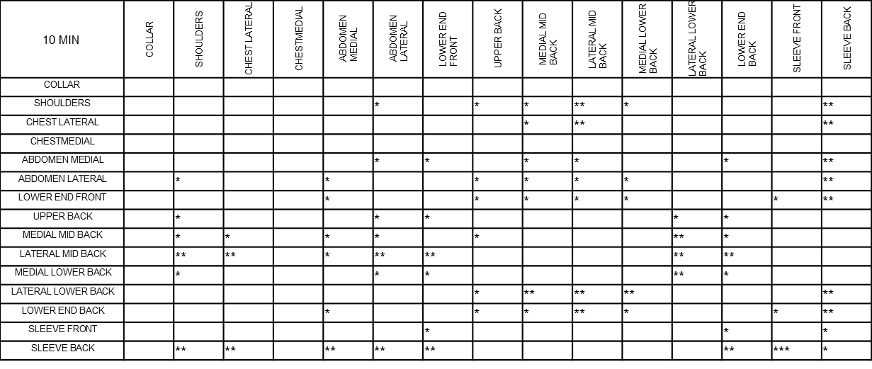
Data uncorrected for multiple comparisons: p ≤ 0.05 * p ≤ 0.01 ** p ≤ 0.001 ***
Data corrected (Bonferroni) for multiple comparisons: p ≤ 0.05 † p ≤ 0.01 †† p ≤ 0.001 †††

Supplemental digital content 2 Significance levels of comparison of local sweat absorption data after 20 MIN of running
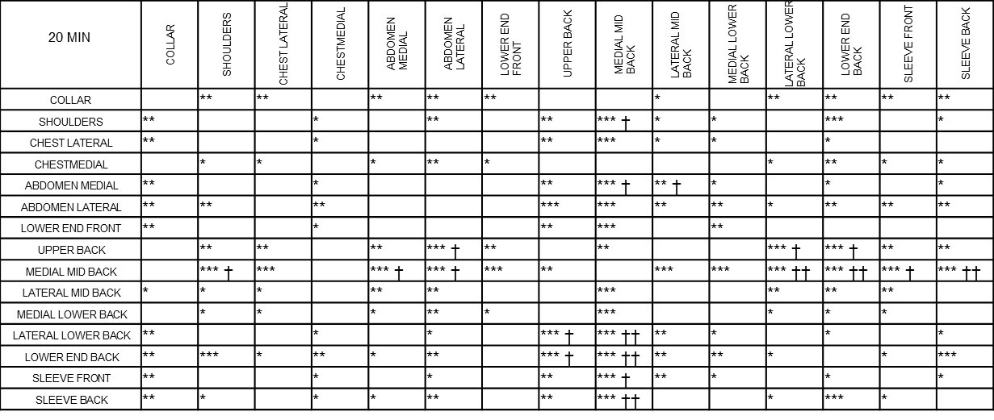
Data uncorrected for multiple comparisons: p ≤ 0.05 * p ≤ 0.01 ** p ≤ 0.001 ***
Data corrected (Bonferroni) for multiple comparisons: p ≤ 0.05 † p ≤ 0.01 †† p ≤ 0.001 †††

Supplemental digital content 3 Significance levels of comparison of local sweat absorption data after 30 MIN of running
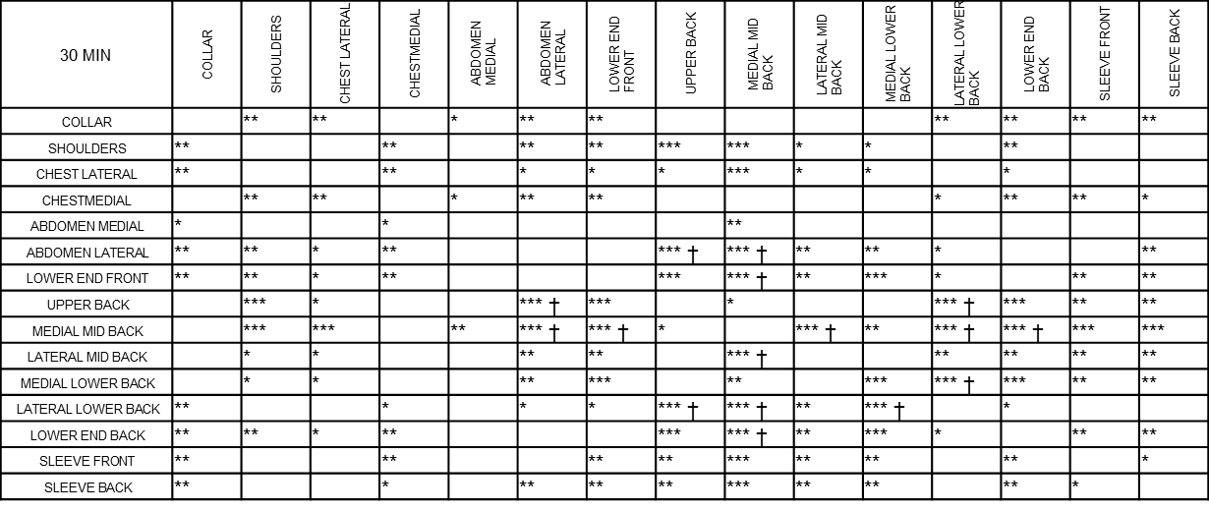
Data uncorrected for multiple comparisons: p ≤ 0.05 * p ≤ 0.01 ** p ≤ 0.001 ***
Data corrected (Bonferroni) for multiple comparisons: p ≤ 0.05 † p ≤ 0.01 †† p ≤ 0.001 †††

Supplemental digital content 4 Significance levels of comparison of local sweat absorption data after 40 MIN of running
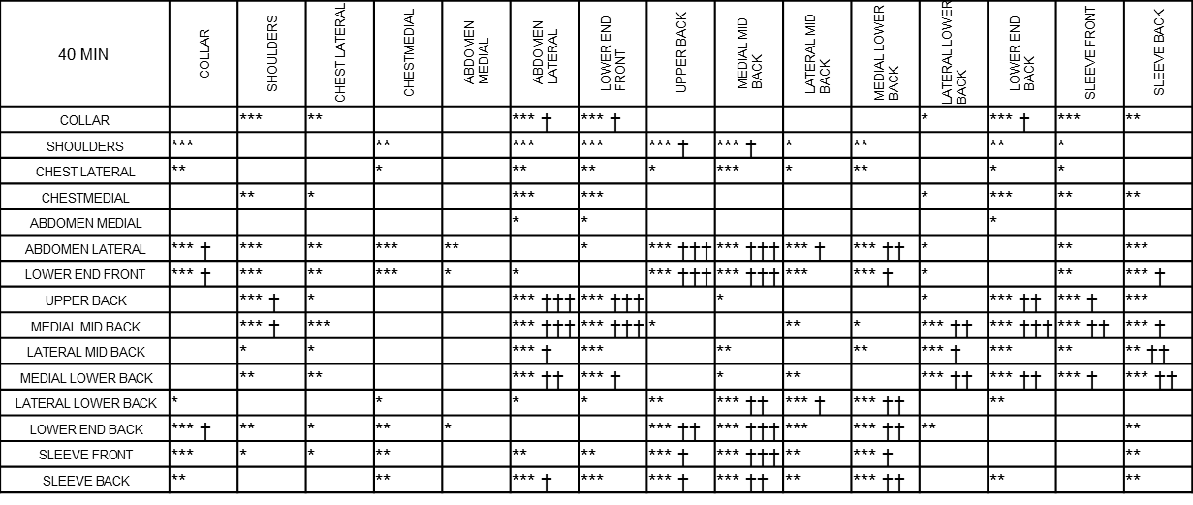
Data uncorrected for multiple comparisons: p ≤ 0.05 * p ≤ 0.01 ** p ≤ 0.001 ***
Data corrected (Bonferroni) for multiple comparisons: p ≤ 0.05 † p ≤ 0.01 †† p ≤ 0.001 †††

Supplemental digital content 5 Significance levels of comparison of local sweat absorption data after 50 MIN of running
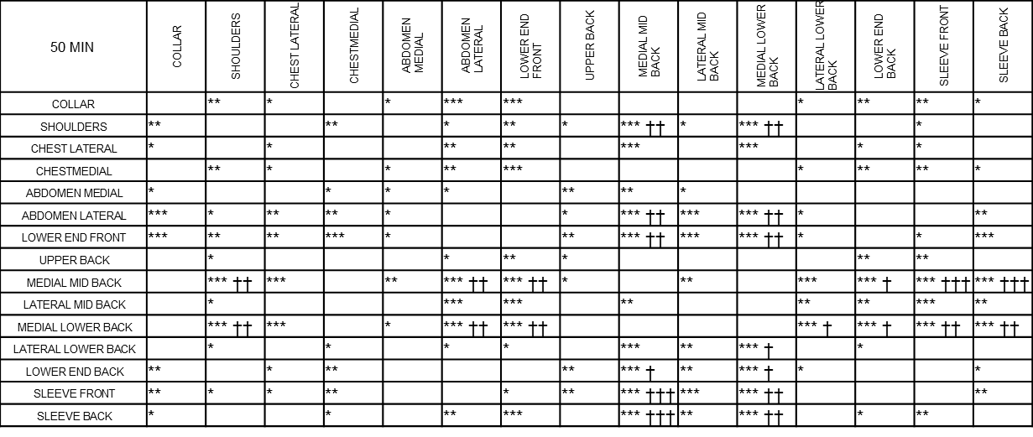
Data uncorrected for multiple comparisons: p ≤ 0.05 * p ≤ 0.01 ** p ≤ 0.001 ***
Data corrected (Bonferroni) for multiple comparisons: p ≤ 0.05 † p ≤ 0.01 †† p ≤ 0.001 †††

