Appendix A
ArcGIS Commands for method to select suitable roofs for minimum size PV installation:
- Preparation: Subtract Environment Agency digital terrain (DTM) LiDAR from the digital surface model (DSM) to obtain building height above ground level. Delete pixels with a lower height than 2 m. This removes rogue values whilst allowing for low eaves.
- Cut out buildings only. Prepared LiDAR DSM-DTM grid and buildings from OS Mastermap Topography layer as inputs: ArcToolbox > Spatial Analyst > Extraction > Extract by Mask.
- Spatial Analyst > Surface > Slope/Aspect. Create integer rasters to enable mode to be computed in the next step.
- Spatial Analyst Tools > Zonal > Zonal Statistics > Mean
- Spatial Analyst Tools > Zonal > Zonal Statistics > Mode
- Mode may be in the north, so carry out some swaps:
  - Swap mode raster values by 180:
Raster calculator:
    - Values between 90 and 270 are alright:
Con((“aspectmode” ≤ 270) & (“aspectmode” ≥ 90), “aspectmode”, 0)
    - Values between 0 and 90:
Con((“aspectmode” ≤ 90) & (“aspectmode” ≥ −1), (“aspectmode” +180), 0)
    - Values between 270 and 360:
Con((“aspectmode” ≤ 360) & (“aspectmode” ≥ 270), (“aspectmode” −180), 0)
    - “PVMode” = “Con1” + “Con2” + “Con3”
  - Optionally, switch by 90 east to west for 4-plane houses:
Con ((“Con4” ≥ 90) & (“Con4” ≤ 160), (“Con4” +90), “Con4”)
  - If the west mode generates a bigger polygon than the east, take that.
- Standard Deviation Bands: Spatial Analyst Tools > Zonal > Zonal Statistics > Std
Con ((“intaspect” ≥ “PVMode” − “StdAspect”/2) & (“intaspect” ≤ “PVMode” + “StdAspect”/2), 1, 0)
This makes a 1,0 raster of cells half std around the mode.
- Connectivity: ArcToolbox > Spatial Analyst Tools > Generalisation > Region Group
Four neighbours (for edges only, Rooks Case), Cross—exclude zero (“0”).
- Select Large Enough Areas
From Count because 1 × 1 m pixels. Reclassify as in Table A1 below and discard highest number which is areas not suitable for PV.
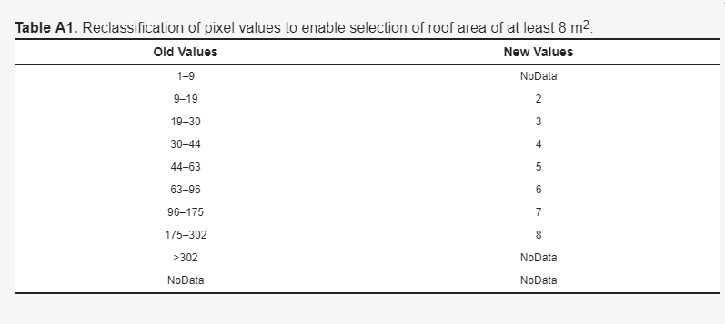

- Clean: Spatial Analyst Tools > Generalisation > Boundary Clean
No sort, run twice.
- Measure Roof Patch with homogeneous aspect (azimuth):
Zonal statistics sum points in raster.
(Add all the “1”s, not zeroes because “1”s are 1 m squares).
- To calculate a more accurate area allowing for the roof tilt:
Slope distance = horizontal distance/cosine(Tilt in degrees)
E.g., Slope distance = 21.2 m/cos [32°]

