Human Movement Science 32, 171-180, 2013

Is skilled technique characterised by high or low variability?
An analysis of high bar giant circles

Michael J. Hiley, Vitaly V. Zuevsky and Maurice R. Yeadon

School of Sport, Exercise & Health Sciences, Loughborough University, Loughborough, LE11 3TU, UK

ABSTRACT
There is conflicting evidence as to whether skilled performance is associated with lower or higher movement variability. The effect of skill level and task difficulty on movement variability during gymnastics swinging was investigated. Four male gymnasts ranging in skill from university standard through to international medallist performed 10 consecutive regular giant circles and 10 double straight somersault dismounts preceded by accelerated giant circles whilst kinematic data were recorded. Joint angle time histories of the hip and shoulder were calculated and the turning points between flexion and extension determined during each giant circle. Standard deviations of the time and magnitude of the angles at each turning point were calculated. The more elite gymnasts were found to have less variability in the mechanically important aspects of technique compared to the less elite gymnasts. The variability in the mechanically important aspects of technique was not statistically different between the two types of giant circles, whereas, the more elite gymnasts demonstrated more variability in some of the less mechanically important aspects.

1. Introduction
In gymnastics the timing of whole body co-ordinated movements is often crucial to the successful performance of the skill. When a gymnast performs the same skill a number of times it may be expected that he/she is attempting to use the same technique. However, it is also to be expected that within each attempt there will be some kinematic variability in the technique used (Newell and Corcos, 1993; Wilson, Simpson, van Emmerik, and Hamill, 2008). Many arguments exist for the reasons and the role of variability in human movement. One idea is that it is there for injury prevention (Bartlett, Wheat, and Robins, 2007; Hamill, van Emmerik, Heiderscheit, and Li, 1999). Since gymnastics skills are rarely repetitive cyclical movements, such as walking or running, the movement variability is unlikely to be due to strategies to prevent injury. Another suggestion is that variability occurs as a result of redundancy in the sensorimotor system (Newell and Corcos, 1993). Cohen and Sternad (2009) decomposed movement variability into components of noise (resulting from the motor system), tolerance (a measure of the width of the successful solution space) and covariation (variation that was compensated for by redundancy) in relation to the outcome for a throwing task. In addition to these three components, movements with longer duration will also contain kinematic variability due to the use of feedback control (Yeadon and Mikulcik, 1996).
The presence of more variability can be associated, through the process of releasing the degrees of freedom (Newell, 1985), with expert performance. This leads to the concept of functional variability where the presence of more variability in certain aspects of the movement plays a functional role in stabilising other aspects or to increasing the consistency of the movement outcome (Hamill et al., 1999; van Emmerik, Hamill, and McDermott, 2005). In other words the increased variability permits a certain degree of flexibility in the movement pattern that may allow it to cope with perturbations. However, care should be taken not to simply identify increased kinematic/movement variability and attribute it to higher levels of ability since it must be established how the observed variability is related to the success of the task.
Wilson et al. (2008) found a ‘U’ shape relationship between movement variability and skill level (standard of performance), proposing that the relative increase in variability between intermediate and expert triple jumpers was due to flexibility in the technique the athletes had developed allowing them to cope with perturbations. It could be interpreted that the elite jumpers were more consistent in terms of producing a successful performance despite perturbations which may have otherwise lead to a breakdown (failure to complete the task) in the novice and intermediate performances. In the triple jump large perturbations are likely to result from the flight and impact of the previous phase. For a gymnast circling the high bar, for example, there are no instants of rapid change. Therefore, we may ask does the ‘U’ shape relationship exist in giant circling skills or does the level of movement variability continually decrease with increasing skill level (standard of performance) as described by Newell, van Emmerik and Sprague (1993)?
There is very little information relating to the level of movement variability present in gymnastics whole body coordinated movements. Yeadon and Brewin (2003) used a computer simulation model to look at the effect of timing variability on residual swing in the final handstand position of elite performances of the backward longswing on rings. They found that the gymnasts’ techniques (i.e. the chosen method of completing the task) were able to cope with temporal variations of the order of 15 – 30 ms, suggesting that the gymnasts’ timing precision lay within this range. However, it was not possible to determine the actual level of movement variability present for any gymnast since the analysis was based on individual performances rather than repeated trials.
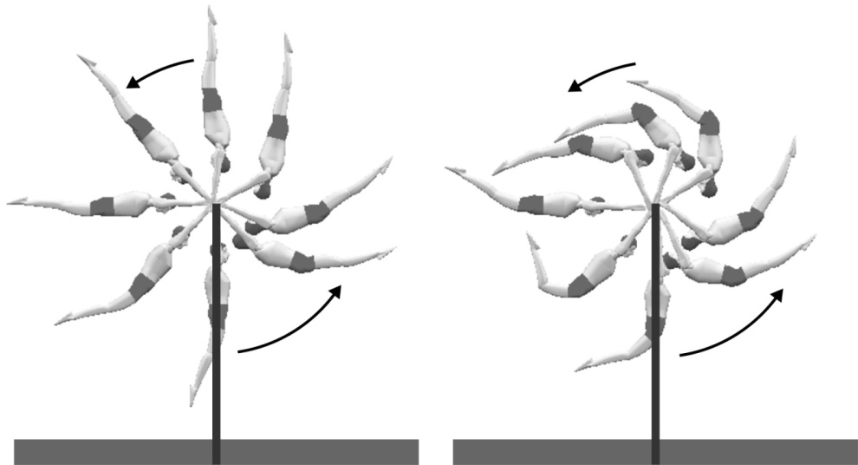
(a) (b)
Figure 1. Two types of backward giant circles performed on the high bar: (a) the regular giant circle and (b) accelerated giant circles.

In Men's Artistic Gymnastics a high bar routine consists of a number of circling movements, release and regrasp movements and a dismount. The backward giant circle is used to link the circling skills and to provide the necessary angular momentum and flight for the release and dismount skills. The basic technique of the backward giant circle comprises hip flexion and shoulder extension (closing) as the gymnast passes through the lower part of the circle and hip extension with shoulder flexion (opening) as the gymnast passes through the upper part. Energy is input to the system as the gymnast passes through the lowest part of the circle. However, poorly timed actions (at the hip and shoulder) can lead to energy being dissipated (Yeadon and Hiley, 2000). Giant circles used to link circling skills are often called “regular” giant circles (Cheetham, 1984), where the aim is to swing from handstand to handstand with minimal changes in body extension (Figure 1a), whereas giant circles for which the aim is to increase angular velocity are often called “accelerated” giant circles (Figure 1b). Accelerated giant circles are normally performed prior to a gymnast’s dismount.
In order to address the question of high or low variability in skilled technique: the three aims of the present study were to investigate (1) the nature of the relationship between movement variability and the skill level of the gymnast, (2) whether variability decreases with increased task difficulty and (3) whether gymnasts are less variable in the important aspects of swinging technique. The regular giant circle and the accelerated giant circles prior to dismounts were used as the low and high difficulty tasks as defined by the Code of Points (FIG, 2009) respectively.

2. METHODS
2.1 Participants
Four male gymnasts (age 21 ± 4 years, mass 68 ± 7 kg, height 1.70 ± 0.04 m) who all competed nationally gave informed consent to participate in the study which was approved by the University’s Ethical Advisory Committee. The ability of the gymnasts was rated by an international brevet judge (based on current performance and national ranking) and the gymnasts were placed into two groups (1) most elite and (2) less elite. The gymnasts in group 1 had both competed internationally with one having medalled internationally. The gymnasts in group 2 included a university team gymnast and a gymnast who had been a member of the national junior squad (aged 12-14 years) when he was younger.

2.2 Data Collection
Each gymnast performed 10 consecutive regular giant circles, performed with even tempo and good form, and 10 dismounts (all double straight somersault dismounts) on the high bar (complying to FIG norms). Only the accelerated giant circles prior to release were analysed from the 10 dismount trials. All trials were captured using 15 Vicon MX13 cameras operating at 300 Hz. Spherical reflective markers, 25 mm in diameter, were attached to the lateral side of the wrist, elbow, shoulder, hip, knee and ankle joint centres and toes on the left side of the body. Offset measurements from each marker centre to the adjacent joint centre were recorded for subsequent location of the joint centres. Additional markers were attached to each side of the gymnast's head (above the ear) and to the centre of the high bar. Prior to data collection a volume centred on the high bar spanning 2 m x 5 m x 5 m was wand calibrated using the motion analysis system.

2.3 Data Processing
Three-dimensional marker coordinates were reconstructed and joint centres were calculated using the measured offsets. Interpolating cubic splines were fit to the reconstructed coordinate data to up-sample the data series at 1000 Hz. The data were filtered using a Butterworth low pass filter (in both directions to prevent phase shift) with a cut-off frequency of 20 Hz. Joint angles were calculated from the joint centre coordinates (Figure 2). The orientation angle was defined as the angle made by the line joining the hip centre to the bar location and the upward vertical (Figure2).

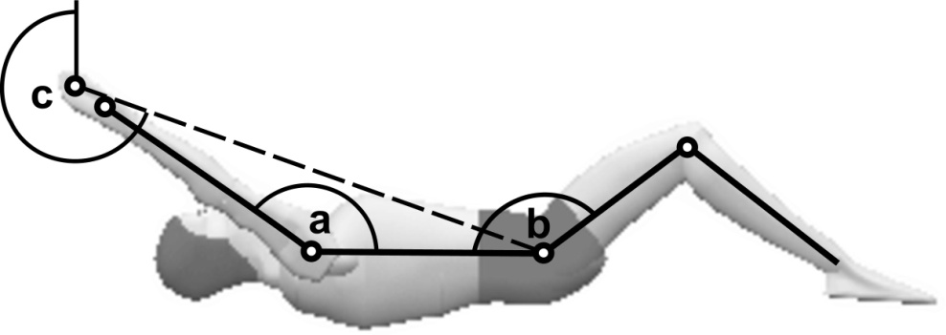
Figure 2. Definition of the (a) the shoulder, (b) hip and (c) rotation angle.

In order to determine the timing and angle variability of the gymnasts, the events of maximum and minimum hip and shoulder flexion and extension were identified from the respective joint angle time histories and times and angles were noted (Figure 3). In both the regular and accelerated giant circles, time zero corresponded to an orientation angle of 90° after the upward vertical (Figure 3). The regular giant circles were completed once the gymnast had rotated through a full 360º, whereas the accelerated giant circles were completed after the gymnast had released the bar (having rotated through approximately 540º, Figure 3). A Matlab script was written to identify the maximum and minimum values within specified time phases of the swing using first derivative information. The mean and standard deviation were calculated for each angle and time over the 10 trials.
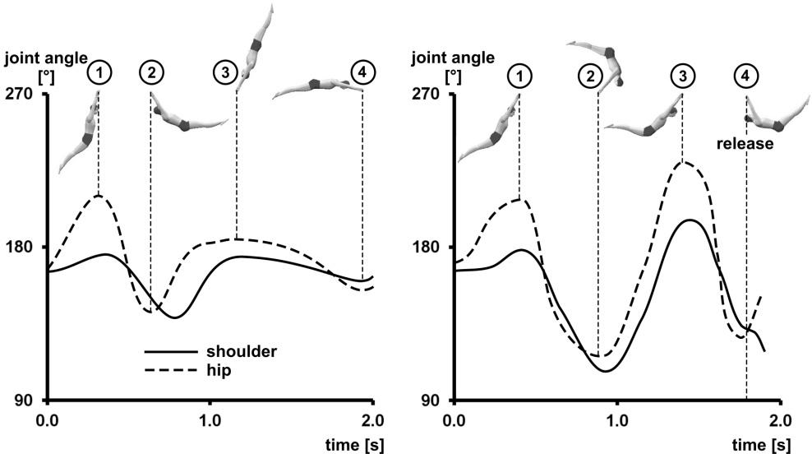
(a) (b)
Figure 3. Time histories of the hip and shoulder angles for (a) regular and (b) accelerated giant circles, with graphics to show the gymnast orientation.

For the analysis of the variability in relation to the mechanically important aspects of the giant circle technique, only the actions at the hip were considered since the end of the last shoulder extension (closing) in the accelerated circles was an inflexion rather than an extremum for three out of the four gymnasts. The inflexion occurred just after release where the arms continued to lower towards the body (Figure 3b). For the regular giant circles the first maximum hip extension and first minimum hip flexion angles (Figure 3a, points ① and ②) were considered to be the most important events, with the subsequent extension and flexion (Figure 3a, points ③ and ④) deemed less important to the successful performance of the skill (Arampatsiz and Brüggemann, 1999). For the accelerated giant circles the hip extension followed by flexion immediately before release (Figure 3b, points ③ and ④) were considered to be the most important events as these would directly affect the flight phase after release (Hiley and Yeadon, 2003).

2.4 Data Analysis
Point by point standard deviation (SD) was calculated for each gymnast across the 10 trials of each type of giant circle (James, 2004). All statistical tests were run in PASW Statistics 18 (SPSS). In order to address the first research aim (the relationship between movement variability and expertise) the skill level of the gymnasts, as described earlier, was coded as a nominal factor, i.e. most elite group and less elite group. In order to address the second research aim (the relationship between movement variability and task complexity) the type of giant circle was also coded as a nominal factor with two levels of complexity: high for the accelerated and low for the regular giant circles. A multivariate analysis of variance (MANOVA) was performed twice, once with the variability measures of the important aspects and the second time with the variability measures of the less important. To determine whether there was a significant difference in the variability between the important aspects and the less important aspects of both types of skills a student t-test was performed. In order to satisfy normality assumptions the data were first transformed to a log scale before performing the t-test.

3. RESULTS
The 10 analysed regular and accelerated backward giant circles for each gymnast were very consistent in terms of overall duration, timing and magnitude of the hip and shoulder actions (Table 1 and Figure 4). When the data from each trial were normalised to total duration the average standard deviations for the times at maximum and minimum joint angles changed by less than 1 ms.

Table 1. Point by point standard deviations for the shoulder and hip angles across all trials for each gymnast and giant circle type
Group | Regular SD |  | Accelerated SD
 | Shoulder [°] | Hip [°] | Shoulder [°] | Hip [°]
Most Elite | 0.9° | 1.4° | 1.5° | 1.9°
 | 1.4° | 1.5° | 1.4° | 1.7°
Less Elite | 1.3° | 1.4° | 1.1° | 1.5°
 | 1.7° | 3.1° | 1.1° | 1.7°
Mean | 1.4° | 2.0° | 1.3° | 1.7°

regular accelerated
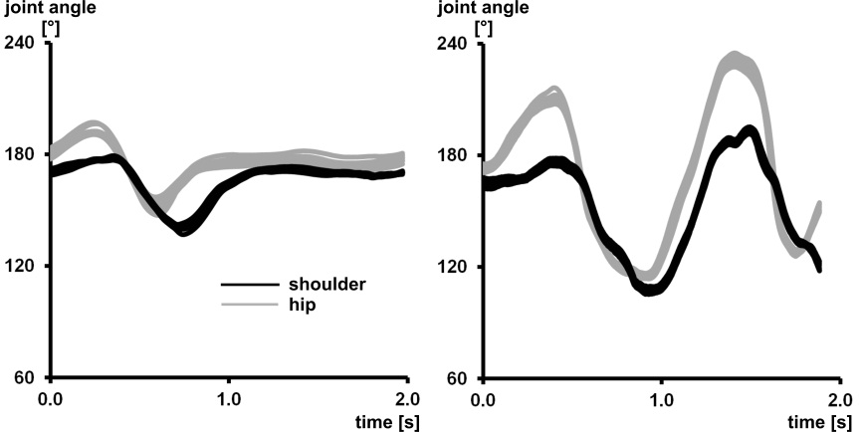
(a)
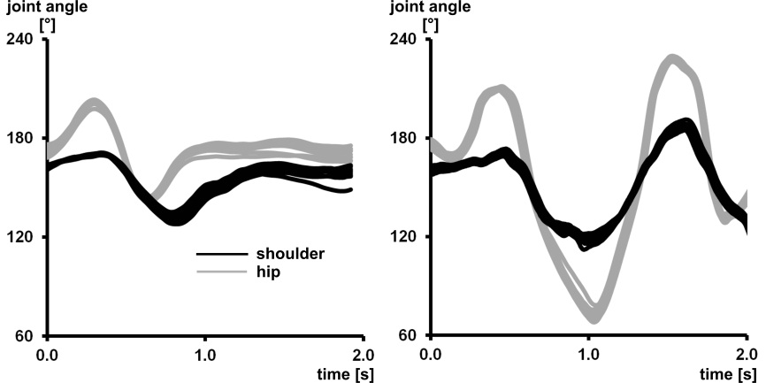
(b)
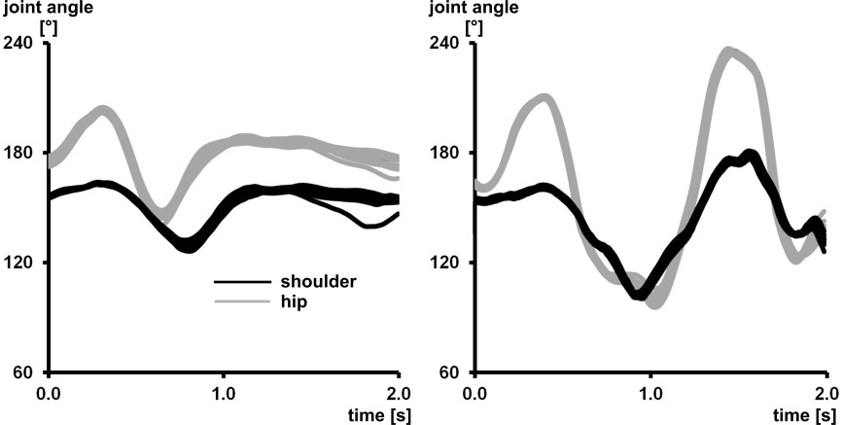
(c)
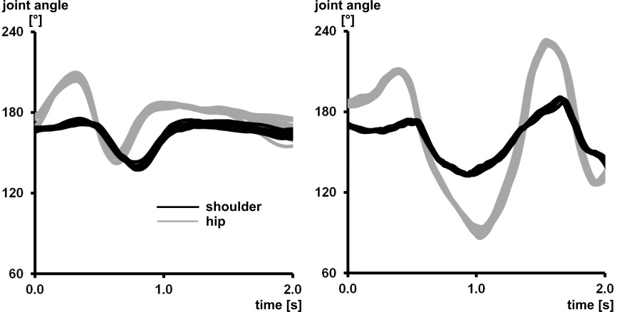
(d)
Figure 4. Time histories of the hip (grey lines) and shoulder (black lines) angles of all 10 trials for the regular and accelerated giant circles by (a) the most elite gymnast through to (d) the least elite gymnast.
For the regular giant circles the standard deviations at the instants of maximum and minimum hip and shoulder angle ranged from 5 – 192 ms and 1 - 5° for timings and angles respectively (Tables 2 and 3). For the accelerated giant circles the same ranges of standard deviations were 4 – 23 ms and 1 – 3° respectively (Tables 2 and 3). The deviations in the accelerated giant circles were relatively small for all gymnasts. The smallest temporal standard deviation for the most elite gymnast in group 1 was 4 ms for accelerated circles (Table 2, hip min ④). The corresponding range of deviations of the 10 trials about the average joint angle time history ranged from 1 – 9 ms. On the other hand, the range for his shoulder action with the largest temporal standard deviation, 18 ms for accelerated circles (Table 2, shoulder max ①), was 2 – 26 ms. The two corresponding ranges for the least elite gymnast in group 2 (less elite group) were 1 – 22 ms and 1 – 30 ms respectively.

Table 2. Standard deviation of the temporal instants of maximum and minimum hip and shoulder joint angle for both types of giant circles
Circle  type | Group | Hip Max  ① | Hip Min  ② | Hip Max  ③ | Hip Min  ④ | Shld Max  ① | Shld Min  ② | Shld Max  ③ | Shld Min/Inflex  ④
 |  | [ms] | [ms] | [ms] | [ms] | [ms] | [ms] | [ms] | [ms]
Reg. | Most  Elite | 10 | 5 | 174 | 65 | 31 | 14 | 72 | 34
 |  | 4 | 6 | 192 | 90 | 7 | 11 | 74 | 72
 | Less  Elite | 15 | 10 | 130 | 50 | 24 | 9 | 94 | 76
 |  | 15 | 9 | 36 | 112 | 34 | 9 | 66 | 104
 | Mean | 11 | 7 | 133 | 79 | 24 | 11 | 76 | 72
Accel. | Most  Elite | 6 | 18 | 7 | 4 | 18 | 11 | 6 | 12
 |  | 14 | 10 | 8 | 8 | 11 | 19 | 8 | 15
 | Less  Elite | 7 | 9 | 9 | 11 | 12 | 9 | 10 | 12
 |  | 17 | 11 | 15 | 13 | 21 | 13 | 14 | 23
 | Mean | 11 | 12 | 10 | 9 | 15 | 13 | 9 | 16

There was a significant difference in the movement variability of the important aspects of technique for both types of giant circles between the two groups of gymnasts (F(2, 5) = 10.2, p = 0.02). That is, the more elite gymnasts had lower movement variability than the less elite gymnasts in the mechanically important aspects of technique. There was, however, no significant difference between the movement variability of the less important aspects of both types of giant circles between the two groups of gymnasts (F(2, 5) = 0.07, p = 0.93). In other words, all gymnasts appeared to have a similar level of variability in the less important aspects, however, some of the differences do warrant further consideration.
Although the range of movement variability appeared to be larger during the regular giant circles (Table 2), there was no significant difference in the movement variability of the mechanically important aspects between the two types of giant circles (F(2,5) = 1.38, p = 0.33). That is, in the important aspects of technique the gymnasts had similar amounts of variability for both the high and low complexity tasks. There was, however, a significant difference in the level of movement variability between the two skills in the less important aspects (F(2,5) = 76.5, p < 0.01). That is, there was more variability in the less important aspects of the regular giant circles compared to the less important aspects of the accelerated giant circles.

Table 3. Standard deviation of the spatial instants of maximum and minimum hip and shoulder joint angle for both types of giant circles
Circle  type | Group | Hip Max  ① | Hip Min  ② | Hip Max  ③ | Hip Min  ④ | Shld Max  ① | Shld Min  ② | Shld Max  ③ | Shld Min/Inflex  ④
 |  | [°] | [°] | [°] | [°] | [°] | [°] | [°] | [°]
Reg. | Most  Elite | 2 | 2 | 1 | 1 | 1 | 1 | 1 | 2
 |  | 2 | 1 | 3 | 4 | 1 | 2 | 2 | 4
 | Less  Elite | 1 | 2 | 1 | 4 | 1 | 2 | 1 | 5
 |  | 3 | 3 | 1 | 4 | 2 | 2 | 1 | 2
 | Mean | 2 | 2 | 2 | 3 | 1 | 2 | 1 | 3
Accel. | Most  Elite | 3 | 1 | 2 | 1 | 2 | 1 | 1 | 1
 |  | 1 | 3 | 1 | 2 | 2 | 3 | 2 | 2
 | Less  Elite | 1 | 3 | 1 | 1 | 1 | 1 | 1 | 1
 |  | 1 | 3 | 1 | 1 | 1 | 1 | 1 | 1
 | Mean | 1 | 3 | 1 | 1 | 1 | 1 | 1 | 1

It was found that the variability was significantly lower in the mechanically important aspects of technique compared to the less important aspects (t(15) = 3.95, p < 0.01).

4. DISCUSSION
The aims of the present study were to determine the nature of the relationship between movement variability and the skill level of the gymnast, whether variability decreases with increased task difficulty, and whether gymnasts are less variable in the important aspects of swinging technique. It is acknowledged that the number of gymnasts used in the present study was small, due to the requirement of being able to perform the high difficulty task, but the four were representative of the range of gymnasts involved in high level artistic gymnastics.
It was found that the more elite gymnasts had lower temporal movement variability in the mechanically important aspects of technique than their less elite counterparts. Given that all gymnasts were sufficiently proficient at both types of giant circles to include them in a gymnastics routine this may not be an obvious result. In both types of backward giant circle (regular and accelerated) the instants of maximum extension and flexion as the gymnast passed through the lower part of the circle were identified as being mechanically the most important. The reason for the reduced movement variability can be explained using mechanics and the goal of the type of giant circle. The giant circles performed before a dismount form an integral part of the dismount since they are required to provide not only the necessary linear and angular momentum but also provide a sufficiently large timing window within which the gymnast can release the bar and successfully perform the aerial phase (Hiley and Yeadon, 2003; Hiley and Yeadon, 2005). The timing window is produced by the interaction of the gymnast’s movements and the movements of the bar; mistiming of the actions at the hip and shoulder prior to release may result in the gymnast having inappropriate linear or angular momentum. Since these actions have a direct mechanical link to the task outcome (Hiley and Yeadon, 2003), it makes sense that the gymnasts minimise the error in these movements. For the regular giant circle the aim is to swing from handstand to handstand with as little flexion and extension as possible. During the mechanically important actions the gymnast has to provide the necessary mechanical work to return back above the bar (Yeadon and Hiley, 2000). In general a giant circle could be performed with a variety of actions and/or timing of the extension to flexion. The requirement of good form and consistent technique, however, limits the possible techniques. Again it makes sense for the gymnasts to minimise the error in timing the mechanically important actions in both types of giant circle. If the gymnasts are trying to minimise the error in timing at these instants of technique it is not unreasonable that the more elite gymnasts are able to produce lower levels of movement variability than their less elite counterparts.
Previous research investigating the relationship between movement variability and skill level has found relationships in both directions: that is, increased skill level has been associated with both less and more movement variability. In a study using a ball bouncing task it was found that increased skill was associated with reduced movement variability, since the task required precise timing of the hands to coincide movements of the balls (Broderick and Newell, 1999). This is in line with the findings of the present study, if the actions have to be performed at precise times in order for the task to be successful, then it is advantageous to have low temporal movement variability. On the other hand Wilson et al. (2008) found that there was a “U” shaped relationship between skill level and movement variability, so that at the upper levels of skill movement variability increases. During learning, increased levels of variability may be observed as participants “discover” new strategies and techniques as demonstrated by Chow, Davids, Button, and Rein (2008). Indeed Williams, Irwin, Kerwin and Newell (2012) found that in a group of novice gymnasts learning to swing on bars, timing of the actions at the shoulder as the gymnasts passed through the lower part of the circle were “highly variable”. Then as a strategy is adopted, movement variability has been shown to decrease with practice (Cohen and Sternad, 2009). Whether this decrease continues or whether a “U” shaped is found with increasing skill level appears to depend on the task. Where precision is required, movement variability appears to continue to decrease (as in the present study and Broderick and Newell, 1999); where adaptability to unexpected perturbations is required (e.g. Wilson et al., 2008), movement variability increases. Although beyond the scope of the present study, it would be interesting to carry out a longitudinal study on how movement variability changes with practice to determine whether elite gymnasts have inherently less variability due to “noise” in their movements (Cohen and Sternad, 2009). That is, do gymnasts learn techniques specific to the level of temporal precision in their motor system (Harris and Wolpert, 1998; Wolpert, 2007), or does movement variability continue to decrease with practice (Cohen and Sternad, 2009).
The results of the present study suggest that for the mechanically important factors there was no statistically significant difference in movement variability between the regular and accelerated giant circles (i.e. task complexity). This result may be interpreted in two ways. It may be argued that there was no difference in task complexity between the two types of giant circle. However, this is unlikely as most gymnasts are capable of performing a regular giant circle whereas only elite gymnasts are normally able to perform a double layout somersault dismount. Alternatively, it may be argued that in aspects of technique important for successful performance movement variability is required to be low for both levels of task complexity.
The fact that less movement variability was found in the mechanically important aspects of technique compared with the less important aspects may provide evidence of feedback control being used by the gymnasts. This is probably more evident in the data from the regular giant circles. The important actions are the hip extension and flexion as the gymnast passes beneath the bar (Figure 3a) since these provide the necessary mechanical work to return the gymnast back above the bar (Yeadon and Hiley, 2000). The temporal movement variability in the subsequent extension and flexion is relatively large (Table 2). Part of this is due to the fact that the gymnast is rotating much slower as he passes through the upper part of the circle. However, in mechanical terms if the gymnast has input too much or too little energy into the system as he passes beneath the bar, the timing of the extension can be varied in order to compensate for this (i.e. too little energy, extend later and vice versa). Similarly the timing of the flexion during the first part of the downswing can be further manipulated to control the initial energy for the following swing (Figure 3a). In the hip extension as the gymnast passes through the upper part of the circle there is more variability in the timings of the most elite gymnasts (Table 2) which suggests that the more elite gymnasts are making greater adjustments than the less elite gymnasts (i.e. exhibiting more control over the task). In some respects this aspect of technique agrees with the “U” shaped theory demonstrated by Wilson et al. (2008). In this example the additional movement variability is associated with a mechanical description of how the movement is controlled.
While all four gymnasts generally used similar techniques in the backward giant circles, there was a notable difference in the amount of hip flexion adopted through the upper part of the accelerated giant circles (Figure 4). However, this phase has previously been identified as being of less mechanical importance than the subsequent hip extension and flexion as the gymnast passes beneath the bar (Hiley and Yeadon, 2003).
Although not a specific research question, a striking result from the present study is the precision with which all the gymnasts were able to co-ordinate whole body movements, both in terms of temporal and spatial precision (Table 2 and 3). Previous studies have reported the temporal variability (standard deviation) in simple button pressing activities where the participant synchronises the press with an auditory signal as 25 – 40 ms (Rao, Harrington, Haaland, Bobholz, Cox, and Binder, 1997). It might be expected that in a whole body movement it would be difficult to reach the levels of precision found in the present study (Table 2 and 3). The elite gymnasts do have the advantage that they are all highly trained compared to the general public. In addition further explanation may be taken from Bernstein’s (1967) description of the stages of learning and the mechanics of swinging on bars. After freezing and releasing the degrees of freedom Bernstein (1967) describes the third stage of learning as exploiting the mechanical and inertial properties of the degrees of freedom. A simple three link pendulum system, connected by pin joints, without joint torques when allowed to swing from the horizontal, will naturally perform an extension followed by a flexion as it passes through the lowest point (Yeadon and Hiley, 2000; Morlock and Yeadon, 1988). Due to the inertia of the segments the model arches on the downswing (hyper-extension) and then flexes as it passes through the lowest point of the swing. The gymnast can exploit the timing of these actions to add the desired amount of energy to the system (Yeadon and Hiley, 2000). In other words the gymnasts work with the natural mechanics of the system which provides additional information (including the force at the bar) to assist in performing the desired actions at the correct time. The timing of the hip and shoulder flexion and extension actions may vary depending on the subsequent skill to be performed, but the gymnast can time these in relation to the underlying mechanics of the system.

5. CONCLUSION
Gymnasts were found to be extremely consistent in their swinging movements. The reasons for this can be explained by the mechanics of swinging and the nature of the sport. It was found that the more elite gymnasts displayed less movement variability in the mechanically important aspects of technique. This can be understood in terms of timing precision being an advantageous trait in swinging. However, there was also evidence that the more elite gymnasts were more variable in the less mechanically important aspects. This can be understood in terms of the elite gymnasts using more feedback control compared to their less elite counterparts. In the less mechanically important aspects of swinging the gymnasts are likely to be making the necessary corrections to ensure that the mechanically important aspects are performed with high precision (and low variability). It may therefore be misleading to say that there is more variability (in the sense of “noise”) in the less mechanically important aspects since these variations are due to the gymnasts making the necessary corrections (with precision).
In answer to the question of whether skilled technique exhibits high or low variability, it may be stated that low variability should be expected in critical aspects of technique and that high variability should be expected in less important aspects since adjustments can be made here to ensure low variability in the important aspects.

ACKNOWLEDGEMENTS
The authors wish to thank the gymnasts and coaches who gave their time to participate in the study.

Conflict of interest statement
The authors wish to disclose that they have no financial or personal relationships with any people or organisations that could inappropriately influence this work.

REFERENCES
Arampatzis, D. and Brüggemann, G-P. (1999). Mechanical and energetic processes during the giant swing exercise before dismount and flight elements on the high bar and uneven parallel bars. Journal of Biomechanics, 32, 811-820.
Bartlett, R., Wheat, J. and Robins, M. (2007). Is movement variability important for sports biomechanists? Sports Biomechanics, 6, 224-243.
Bernstein, N. (1967). The coordination and regulation of movement. London. Pergamon.
Broderick, M.P. and Newell, K.M. (1999). Coordination patterns in ball bouncing as a function of skill. Journal of Motor Behaviour, 31, 165-188.
Cheetham, P.J. (1984). Horizontal bar giant swing centre of gravity motion comparisons. In Proceedings of the International Symposium of Biomechanics in Sports (Edited by Terauds, J., Bartheis, K., Mann, R. and Crakes, J.), pp. 99-108. ISBS. Colorado Springs.
Chow, J.Y., Davids, K., Button, C. and Rein, R. (2008). Dynamics of movement patterning in learning a multiarticular action. Motor Control, 12, 219-240.
Cohen, R.G. and Sternad, D. (2009). Variability in motor learning : relocating, channeling and reducing noise. Experimental Brain Research, 193, 69-83.
Fédération Internationale de Gymnastique. (2009). Code of Points. Moutier, Switzerland: F.I.G.
Hamill, J., van Emmerik, R.E.A., Heiderscheit, B.C. and Li, L. (1999). A dynamical systems approach to lower extremity running injuries. Clinical Biomechanics, 14, 297-308.
Harris, C.M. and Wolpert, D.M. (1998). Signal-dependent noise determines motor planning. Nature, 95, 780-784.
Hiley, M.J. and Yeadon, M.R. (2003). The margin for error when releasing the high bar for dismounts. Journal of Biomechanics, 36, 313-319.
Hiley, M.J. and Yeadon, M.R. (2005). The margin for error when releasing the asymmetric bars, Journal of Applied Biomechanics, 21, 223-235.
James, C.R. (2004). Considerations of movement variability in biomechanics research. In N. Stergiou (ed) Innovative analyses of human movement. Human Kinetics. Champaign, IL.
Morlock, M. and Yeadon, M.R. (1988). A mechanical model of a gymnast at the high bar. In C.E. Cotton et al. (Eds) Proceedings of the Canadian Society for Biomechanics (pp. 176-177). Spodym. London, Ont.
Newell, K.M. and Corcos, D.M. (1993). Issues in variability and motor control. In K.M. Newell and D.M. Corcos (eds) Variability and Motor Control. Human Kinetics. Champaign, IL.
Newell, K.M., van Emmerik, R.A.E. and Sprague, R.L., (1993). Stereotypy and variability. In K.M. Newell and D.M. Corcos (eds) Variability and Motor Control. Human Kinetics. Champaign, IL.
Rao, S.M., Harrington, D.L., Haaland, K.Y., Bobholz, J.A., Cox, R.W. and Binder, J.R. (1997). Distributed neural systems underlying the timing of movements. The Journal of Neuroscience, 17, 5528-5525.
van Emmerik, R.E.A., Hamill, J. and McDermott, W.J. (2005). Variability and coordinative function in human gait. Quest, 57, 102-123.
Williams, G., Irwin, G., Kerwin, D.G. and Newell, K.M. (2012). Kinematic changes during learning the longswing on high bar, Sports Biomechanics, 11, 20-33.
Wilson, C., Simpson, S.E., van Emmerik, R.A. and Hamill, J. (2008). Coordination variability and skill development in expert triple jumpers. Sports Biomechanics, 7, 2-9.
Wolpert, D.M. (2007). Probabilistic models in human sensorimotor control. Human Movement Science, 26, 551-524.
Yeadon, M.R. and Brewin, M.A. (2003). Optimised performance of the backward longswing on rings. Journal of Biomechanics, 36, 545-552.
Yeadon, M.R. and Hiley, M.J. (2000). The mechanics of the backward giant circle on the high bar. Human Movement Science, 19, 153-173.
Yeadon, M.R. and Mikulcik, E.C. (1996). The control of non-twisting somersaults using configuration changes, Journal of Biomechanics, 29, 1341-1348.

