Energy and electron transfer reactions of anthracene co-adsorbed with azulene on silica gel and titania-silica mixed oxide surfaces

Anisoara Vancea, Iain Kirkpatrick, David R. Worrall* and Siân L. Williams

Supplemental Data

**Fourier transformation infrared spectroscopy (FTIR)**

Fourier transform infrared (FTIR) measurements were performed using an instrument with a dedicated diamond attenuated total reflectance (ATR) single bounce accessory in the range 400 - 4000 cm-1. Sample wafers consisted of 100 mg dry KBr and *ca*. 1 mg sample. For each spectrum, 128 scans were accumulated at a spectral resolution of 8 cm-1. The spectrum of dry KBr was taken for background subtraction. The FTIR measurements were conducted with the kind help of Dr. Pik Leung Tang from the University of Strathclyde.

**Surface area and pore size**

The Brunauer-Elmett-Teller (BET) surface area (SBET) and desorption pore volume (VP) of calcined titania-silica mixed oxides were determined by N2 adsorption at 77 K using a Micrometrics TriStar 3000 instrument. The BET surface area measurements were conducted with the kind help of Mr. Andrew Lau from Department of Chemical Engineering, Loughborough University.

**FTIR spectra**

The effect of titania addition to silica, the degree of incorporation and dispersion of titanium ions in the silica matrix of the solid materials and the surface modification were evaluated by FTIR spectroscopy of the framework vibrations.

To gain information about the formation of Si—O—Ti linkages, or a better understanding of the chemical structure of the composite, the FTIR spectra of titania-silica mixed oxides with different titania content prepared by the sol-gel method and calcined in air at 450 oC were measured and presented in figure 1. The strong IR absorbance at 1046 cm-1 can be assigned to asymmetric υas (Si—O—Si) stretching vibrations.

Titania-silica mixed oxides are characterized by a typical band at ~ 953 cm-1, which is associated with the formation of Si—O—Ti bridges during the hydrolysis procedure, as is also reported for others sol-gel preparations of titania-silica mixed oxides1. This band is assigned to the tetrahedral coordinated Ti4+ ions which should substitute for Si4+ ions in the bulk matrix of titania-silica mixed oxides.

The band at ~ 800 cm-1 is attributed to the asymmetric and symmetric Si—C stretching modes, respectively. It shows in figure 1 a strong band in the region 3600 – 3000 cm-1 associated to H-bonding between water molecules and silanol groups. A small amount of silanols free from H-bonding is present and responsible for the residual sharp band at ~ 3740 cm-1.

Finally, this FTIR surface technique permits the quantitative evaluation of the exposed titanium on the surface. The OH spectral region plotted in the inset of Fig 1 shows that hydroxyl groups are present in calcined samples. The presence of Si—O—Ti species at ~953 cm-1 indicates good mixing of Ti and Si at the atomic level, which is an important factor in catalytic applications.



**Fig 1** FT-IR absorption spectra of titania-silica mixed oxides prepared by the sol-gel method with different titania content

**BET surface area**

The pore size distribution for titania-silica mixed oxides prepared by the sol-gel method were calculated by applying the Barret-Joyner-Halenda (BJH) method to the adsorption branches of the nitrogen isotherms. These distributions are given in Fig 2. The mesopore volume changes in the same way as BET surface area. Titania is a low porosity material and for this reason the increase in titania content results in a decrease in the mesopore volume and lower specific surface area. The pore size distribution extends from 2 to 50 nm.

All of the titania-silica samples have a narrow distribution of pore size. Although the average pore size of the synthesized titania-silica mixed oxides is in the range of mesoporous materials, their adsorption / desorption isotherms are similar to one of the mesoporous materials.



**Fig 2** Pore size distribution of titania-silica mixed oxides with different titania content prepared by calcination at 450 oC

The presence of silanol groups has an important role in the adsorption process of different organic compounds in the oxide surface. The hydroxyl groups of silica present a strongly hydrophilic environment limiting the access of organic substrates to the surface. The surface area of titania-silica mixed oxides, the pore volume or size and the particle size depend on the method of synthesis and the chemical composition of components. The size distribution is often important to ensure efficient transport of reactants and products to and from the active surface.

**Absorption spectrum of azulene**

The absorption spectrum of azulene in acetonitrile is shown in Fig 3 demonstrating that there is no significant absorption of 355 nm radiation by this molecule. This allows us to selectively excite anthracene at this wavelength without interference from azulene.

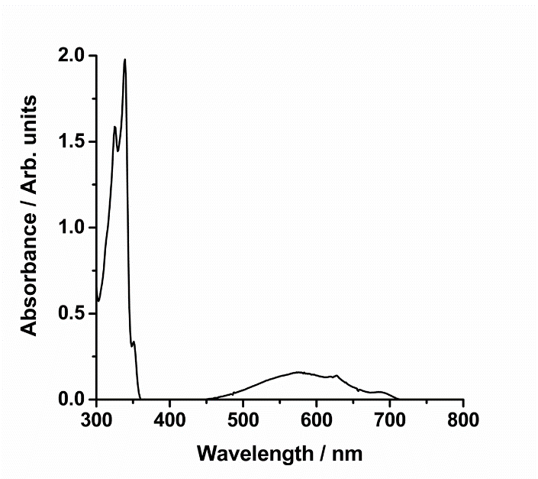

**Fig. 3** Absorption spectrum of azulene in acetonitrile. [azulene] = 4.5 x 10-4 mol dm-3

**Reference**

1 M. Schraml-Marth, K. L. Walther, A. Wokaun, B. E. Handy, A. Baiker, J. Non-Cryst. Solids 143, 93-111 (1992)