Highlights

- Glutaraldehyde cross-linked alpha, beta and gamma cyclodextrin membranes were prepared and studied for separation of resveratrol from plant extract.
- The membranes were characterized for thermal stability, hydrophilicity, morphology and surface charge.
- The transport of resveratrol through the membrane was explained by a model called “solid transport inside the membrane pores”.
- The permeation flux increases due to the decrease in mass transfer resistance.

Manuscript File

Separation of Resveratrol from Plant Extract: Nanofiltration by Cyclodextrine- Glutaraldehyde Cross Linked Membrane

Hirok Jyoti Borah1, Monti Gogoi1, Diganta B Das2and Swapnali Hazarika1,*

1Chemical Engineering Group, Engineering Science & Technology Division, CSIR-North East Institute of Science and Technology (NEIST), Jorhat – 785 006, Assam, India
(Phone: ++913762370012, Email: shrrljt@yahoo.com)

2 Chemical Engineering Department, Loughborough University, Loughborough LE11 3TU, Leicestershire, UK (Phone: ++ 441509222509; Email: D.B.Das@lboro.ac.uk)

*Author for correspondence (Phone: ++913762370012, Email: shrrljt@yahoo.com)

Graphical abstract

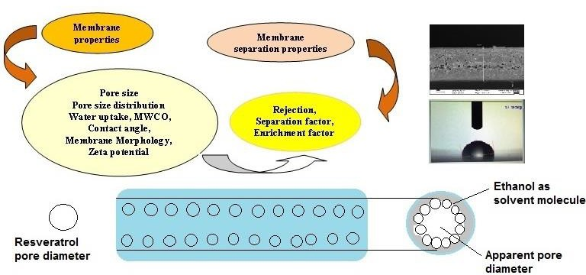

Separation of Resveratrol from Plant Extract: Nanofiltration by Cyclodextrine- Glutaraldehyde Cross Linked Membrane

Hirok Jyoti Borah1, Monti Gogoi1, Diganta B Das2 and Swapnali Hazarika1,*

1Chemical Engineering Group, Engineering Science & Technology Division, CSIR-North East Institute of Science and Technology (NEIST), Jorhat – 785 006, Assam, India
(Phone: ++913762370012; Email: shrrljt@yahoo.com)
2 Chemical Engineering Department, Loughborough University, Loughborough LE11 3TU, Leicestershire, UK (Phone: ++ 441509222509;Email: D.B.Das@lboro.ac.uk)

*Author for correspondence (Phone: ++913762370012, Email: shrrljt@yahoo.com)

Abstract:
Resveratrol has antibacterial, antioxidant, anthelmintic and insecticide properties. While the demands for resveratrol uses have increased, its separation and purification from its crude extract has not matured well-enough yet. Though nanofiltration (NF) can be used for the purification of the resveratrol molecules yet the extent to which this can be achieved is not known. In addressing this, glutaraldehyde cross-linked alpha, beta and gamma cyclodextrin NF membranes were prepared and studied for their performances in the separation of resveratrol from plant extract. The interplay of the effects of various permeation parameters on flux and rejection rate has been established. The transport of resveratrol was explained with a model of solute transport inside the membrane pores which depends on the hydrogen bonding contribution between the solvent, solute and membrane. It was observed that the rejection decreased when the feedstock flow rate goes up, which clearly indicated that the permeation flux increases.

Keywords: Resveratrol; Cyclodextrin; Glutaraldehyde; Membrane; Nanofiltration

Introduction
Resveratrol, which is a natural phenol and is used as a dietary supplement, is found in many plants such as grapes (1057µg/100mL), peanuts (5.1µg/g), and Itadori plants (68µg/100 mL) [1, 2]. Resveratrol has chemo-preventive and anti-tumor properties; it also acts as an antibacterial, antioxidant, anthelmintic and insecticide compound [3]. The quantity of resveratrol in its source may change depending on the fertility of the soil and different extraction processes [4]. However,the separation and purification of the biomolecule to its purest form (100% w/w) from its crude extract is not only a challenging task but also important as increasing interest has been given by the common people for uses of its herbal extract in pure form for their medicinal effect as discussed in our earlier studies [1]. In principle, it is possible that nanofiltration (NF) may be used for purification of resveratrol molecules, but the extent to which this can be achieved is not known. Furthermore, the preparation and characterisation of nanoporous membranes specifically for the purpose of resveratrol purification needs to be addressed. In resolving these issues, we report a series of experiments on the preparation of glutaraldehyde cross-linked alpha, beta and gamma cyclodextrin nanoporous membranes and their performances in separation of resveratrol from plant extract.

Nanofiltration (NF) is a pressure-driven membrane process applied in water softening and, analysis of industrial effluents infected by organic impurity etc. [5-6]. NF membranes have been shown to separate solvents, monovalent ions, small organic molecule from bivalent ions and larger groups [7]. Numerous analysts have improved various methods for synthesis of selective layer through polymerization [8-9]. The pore size of NF is typically 1–10 nm and the membrane can resist small organic compounds and has greater water permeability, lower energy exhaustion, higher flux rates and works at low pressure [10]. The pores of the nanofiltration membranes reject the small uncharged solutes and multivalent ions and allow permeation of monovalent ions. These properties make NF membranes suitable in the fractionation and careful elimination of solutes from complex mixtures. The improvement of NF process has led to an observable increase in its utilizations in a number of industries [11]. In this work, we explore nanofiltration for providing improved understanding of the resveratrol separation process and, subsequently, attempt to put the experimental results in the framework of a theoretical mass transport model (further discussion). As discussed above, although significant progress has been made in the field of NF membranes, their

applications for the separation of biomolecule such as resveratrol are yet to mature sufficiently. Therefore, the interplay between the effects of different factors of the solvent (e.g., viscosity, density), solute (e.g., molecular diffusivity) and membrane (e.g., pore size) which can influence the resveratrol transport through the membrane [12], are also established.

For the purpose of this work, we have developed cyclodextrins (CD)-glutaraldehyde crosslinked nanoporous membranes and characterized them through different analytical methods (discussed in the next sections).We have chosen CD as the membrane material because it has a hydrophilic outer part and a hydrophobic inner part and it forms host–guest complexes with organic components such as resveratrol, which are facilitated by their molecular diameters and physical attractions with organic compound [13,14]. CD also acts as a carrier of supra-molecule in organometallic reactions [15].Cyclodextrins are macrocyclic oligomers of D-glucose with primary and secondary hydroxyl groups. The glucose parts of CD are ordered in such a way that the hydroxymethylene groups are pointed downward, and the hydroxyl groups are pointed upward.

To get a better understanding of the binding effects with the substrate, various theoretical and experimental processes have been applied to analyze the CD complexes. Therefore, we have analyzed the membrane forming ability of CD with polysulfone. Glutaraldehyde cross linked alpha CD, beta CD and gamma CD membranes were prepared and characterized through different analytical methods. The membranes were tested for the separation of resveratrol from its crude extract which is then explained via a mass transport model specifically developed for transport of solid particles inside membrane pores.

Experimental
  - Materials
Polysulfone (average molecular weight 27,000dalton), polyethylene glycol (PEG 6000), alpha, beta and gamma cyclodextrin, N-methyl pyrrolidone (NMP), resveratrol (molecular weight 228 dalton), glutaraldehyde (molecular weight 100 dalton) and all other solvents were purchased from Sigma Aldrich, USA. All compounds and solvents were used without any further purification or dilution. The commercial grade resveratrol is used in this study as a standard for calibrating the experiments. However, we have used plant extracted resveratrol for the actual nanofiltration filtration experiments.

Methods
    - Preparation of Membrane
The nanoporous membranes were prepared by a wet phase inversion method as follows. Cyclodextrin glutaraldehyde cross-linked polysulfone membrane was prepared from a solution made by dissolving 23% polysulfone, 2% cyclodextrin (alpha, beta and gamma CD separately) in DMF and mixing the mass with 5 mL glutaraldehyde (50%) for 6h at 45°C until a homogenous solution was achieved. The polymer solution was evacuated to remove air bubbles before casting on a glass plate under controlled conditions of temperature (25–26°C) and relative humidity (30–35%). The prepared membrane was exposed to air for 60s before precipitation it in de-ionized water containing DMF (2%) and sodium lauryl sulphate (SLS) (0.1%). SLS being a surfactant provides proper wetting to the membrane and DMF being solvent of polymer provides progressive coagulation to get the desired membrane morphology. The membrane was removed from the precipitation solution after 30 min and was treated with 1N HCl solution at 70°C for 6 h to achieve the desired cross-linking of β-CD molecules. The reaction scheme is given in Figure 1.

2.2.2 Preparation of crude extract of resveratrol
Crude extract of resveratrol was prepared by treating 10g of dried ground sample of 150 µm in size of heartwood of ArtocarpusLakoochaRoxb. in 500 ml methanol under refluxed condition for 7h at constant temperature. After extraction the solution was filtered off and evaporated to dryness to get the solid product. The light brown coloured product was then filtered, washed with cool water and vacuum dried. The dried sample was characterized by FTIR, NMR and mass spectroscopy and concentrations of the sample solution were measured by using calibration curve of commercial sample.

2.2.3. Characterisation of membrane
Membranes were characterized by Fourier transform infra-red spectroscopy (FTIR) (Perkin Elmer System 2000), X-ray diffraction (XRD) (JDX-11P-3A, JEOL, Japan), thermal analysis (TGA-DTA) (Perkin Elmer PC Series DSC7), contact angle (Kyowa Interface Science Company Ltd., Japan), surface morphology by field-emission scanning electron microscopy (FESEM, LEO 1427 VP, UK) and high-resolution transmission electron microscopy (HRTEM, JEOL, Japan, JEM 2100), molecular weight cut off (MWCO), thickness, pore diameter and zeta potential measurement by SurPASSTMElectrokinetic Analyzer (Anton Paar, Austria). Brief descriptions of the characterization methods are mentioned in the supporting information.

2.2.4 Characterization of water uptake by membrane
The weight variation of the membranes before and after hydration was used to determine the water uptake of the prepared membranes. The membranes were dipped in deionised water at 25oC for 24 hours. The water contained on the membrane surface was cleaned and dried by tissue paper before weighing the wet membranes to obtain Wwet. Then, the wet membranes were dried at 100ºC overnight (12 hours) and weighed to obtain Wdry. The value of the water uptake was calculated from Eq.1.

Physical properties of the membranes before they are wetted are given in Table 1.
(1)

2.2. 5. Determination of Permeation Performance of Prepared Membrane
The membrane flux and percentage rejection were measured by using a two-compartment membrane cell similar to a Stokes-Einstein cell. The membranes used here are as described earlier. The effective membrane area was 19.62 cm2. Ethanolic solution of crude resveratrol was stirred continuously at 300 rpm using magnetic stirrer and circulated by peristaltic pump. For optimum conditions, the number of experiments was conducted at variable conditions such as concentration, pressure, etc. The experiments were carried out in a continuous mode for 5 hours. The sample solution was collected from permeate side at 1 hour interval. The collected samples were analysed by UV-VIS Spectrophotometer (EVOLUTION 201, Thermo Fischer ScientificLtd, Austria Ltd) without further processing. The concentration of resveratrol was determined using a calibration curve obtained from commercial resveratrol considering concentration (X) in the range of 2.41-7.63 mmol/L and absorbance (Y) at 306 nm using the regression equation [Y = 0.47797X + 0.1677 (R2= 0.99)].

Characterisation of Purified Resveratrol
The purified resveratrol was characterised by infrared (IR), nuclear magnetic resonance (NMR) and mass spectroscopy. IR spectra were recorded on PERKIN Elmer System 2000. 1H and 13C NMR spectra were recorded on an advanced DPX Bruker 270 MHz NMR Spectrometer. Mass spectra were obtained from TRACE GSQ GCMS instrument (M/S Thermo Fisher Scientific Austria Ltd).

Determination of permeation flux and rejection
The permeation flux and percentage rejection were evaluated for ethanolic solution of reseveratrol using the equations as follows [16].

The permeation flux,

J =

The percent rejection

V

AΔt

C
R% = 1- p
CF

(3)

Where, Cp and CF are the concentrations at the feed and permeate.

Results and Discussions
  - Chemical Compositionand Physical Characterisation of the Membrane
The FTIR spectra of beta CD and beta CD-Glu membrane are shown in Figure 2. The black line indicates the beta CD membrane and the red line indicates the cross-linked membrane. The band at 2969 cm-1 is for N-H stretching, 1584 cm-1 is due to C-O stretching, 1488 cm-1 is for C-H stretching, 1105 cm⁻¹ is due to C-C stretching and 1150 cm⁻¹ is due to C-SO2-C stretching. In the spectra of beta CD-Glu cross-linked membrane the band at 1724 cm−1 is attributed due to the formation of ether linkage (acetal) as a result of cross-linking took place between primary alcoholic groups at outer periphery of beta CD with glutaraldehyde and bands in the region of 2800–2700 cm−1 are due to un-reacted aldehyde group of glutaraldehyde present in the membrane. The absorbance in the region of 1150–1050 cm−1 is due to C-O-C and C-O stretch (alkyl-substituted ether) arose due to cross-linking of beta-CD with glutaraldehyde.

The diffraction methods of the membranes were analyzed by XRD spectra and are shown in Figure
3. The XRD analysis gives information about the structural changes during the formation of membranes. The patterns for the three membranes show broad peaks in the range of 15-30 of 2θ value. The broad peaks of the composite membrane denote the amorphous nature of membrane which also specifies the conformation of complete homogeneity of the membranes [17]. The full width half maxima values (FWHM) were interpreted and in addition to this. The relative degrees of the phase of the membranes are given in Table 2. The FWHM value of beta CD-Glu cross-linked

membrane is 10.3 which is bigger than that of alpha CD- Glu cross-linked (9.6) and gamma CD-Glu cross-linked (8.8) membrane which reveals that stronger hydrogen bonding interaction occurred between beta CD membranes as compared with alpha CD and gamma CD composite membrane.

The stability of the membrane against thermal stress was determined from the thermo gravimetric analysis which was performed under nitrogen atmosphere at a heating rate of 10°C min-1. The decomposition curves of three composite membranes are shown in Figure 4, wherein the derivative curves are shown in Figure 5. All three membranes give two step decompositions. For alpha CD- Glu, gamma CD-Glu andbeta CD-Glu cross-linked membrane decomposition occurs at 474.87 °C and 574.58 °C; 460.95 °C and 563.29 °C; and 516.26 °C and 571.57 °C respectively. Thus, it is seen that beta CD-Glu cross-linked membranes are thermally stable up to the temperature 516 °C. DSC analyses of the membranes were performed at a heating rate of 10 °C.min-1 under nitrogen atmosphere. Melting endothermic peaks obtained at different temperatures for composite membranes were shown in Figure 6. The change in glass transition temperature, Tg for composite membranes were strongly influenced by the membrane pore structure [18] because of glass transition temperature which took place on cooling due to the presence of domains of slow dynamics by thermally induced density fluctuations.

Figure 7 represents molecular weight cut off of the alpha, beta and gamma CD-Glu cross-linked membranes. The details of the experiments for determining the MWCO are not included in the main body and presented in SI as they are standard procedures. The surface charge density of the membranes depends on the composition of the polymeric top layer. Our results suggest that the membranes are slightly negatively charged at high pH, whereas they are slightly positively charged at low pH. Thus, the surface charge of the membrane is a function of pH in consistent with previous study [19]. From Figure 8, it is seen that the isoelectric point i.e., the pH at which the net charge of the membrane is equal to zero is located between the pH 3 to 3.5.

The wetting properties in general and, the hydrophilicity in specific, of the membranes were determined by measuring contact angles. Contact angle measurement is a well-known method to analyse the surface hydrophobicity of a membrane surface since hydrophobic membrane give rise to a higher contact angle [20]. The contact angles of alpha CD-Glu, beta CD-Glu and gamma CD-Glu cross-linked membranes were 83.8°, 91.9° and 82.7°, respectively with SD ±1, as given in Figure 9

as well as in Table 1. All contact angles were static measurements, and they confirm that the beta CD-Glu cross-linked membrane is the most hydrophobic membrane.

Membrane morphology for different CD membranes was studied by SEM and TEM analyses. The cross-section SEM images of the prepared membranes are given in the Figure 10(A.1-A.3). It is observed from the figure that the three prepared membranes have asymmetric structure with a dense top layer and a porous sub layer. The porous sub layer consists of finger-like cavities which are because of rapid demixing of membrane materials into the solvent [19, 21]. It is also seen from the figure that the beta CD-Glu cross-linked membrane shows more regular pore structure of surface morphology than the other two membranes. This is probably because of the difference in interaction between alpha CD-Glu, beta CD-Glu and gamma CD-Glu with casting solvent. More uniform cavities in beta CD-Glu cross-linked membrane indicate the instantaneous mixing of the compound in the solvent which also indicates that the better interaction of beta CD-Glu membrane. In case of alpha-Glu and gamma CD-Glu cross-linked membranes, this seems to be less and, hence, the cavities are not uniform. The SEM images of top surface of alpha-Glu, beta-Glu and gamma CD- Glu cross-linked membranes are shown in Figure 10(B.1-B.3). TEM pictures of the three prepared membranes are shown in Figure 10(C.1-C.3). From the figure, it is observed that more interstitial cavities are present in beta CD-Glu membrane than alpha CD-Glu and gamma CD-Glu membranes. The cavities in the interstitial sites of beta CD-Glu membranes are interconnected in the form of channels around the whole thickness of the membranes. Consequently, the creation of interstitial mesopores in polymeric nanocomposites plays a vital role in developing highly permeable membranes and in addition to this the aggregate structure was carefully designed [22].

The formation of the top membrane surface is expected to be affected by spinodal demixing because the diffusion process through the formation of the top layer are fast enough for the polymer solution to become a highly unstable and cross of the spinodal curve decomposition [21,23]. This results on a top surface with much better interconnected pores, which is more noticeable in beta CD-Glu cross- linked membrane.The pore distribution curve of beta CD-Glu cross-linked membrane, is given in Figure 11.

Evaluation of Membrane Performance for Separation of Resveratrol
Concentration of the feed solution has a great influence on the separation efficiency of the NF membranes. For studying the effect of concentration of resveratrol on the permeation process the experiments were carried out in the concentration range between 0.09 mmol.L-1 to 0.76 mmol.L-1 and results are shown in Figure 12(A). From the figure it can be seen that the membrane flux decreases slowly when the concentration of the feed solution increases. The permeation flux decreases before the concentration reaches 0.3 mmol.L-1. Eventually, the flux value falls slowly with rising concentration. The permeation flux reached 11.35 mmol.m-2.h-1 for beta CD-Glu cross- linked membrane at high concentration (0.76 mmol.L-1). The percentage of rejection is also high (98.02%) for beta CD-Glu cross-linked membrane and is also affected by concentration of resveratrol in the feed solution as shown in same Figure 12(A). With the increase in the concentration of feed solution, the percentage of rejection is also increased which indicate the performance of the membrane at higher concentration. Similar observation was reported by other researchers [24-27]. At this range of concentration, the effect of concentration polarisation is absent as is evident from the results as shown in the same figure.

The separation performance of the membrane is also affected by the operating pressure. When the applied pressure is high, the transmembrane pressure is also high [28]. The effect of feed pressure on membrane permeation flux and percentage of rejection is shown in Figure 12(B). The permeation flux for beta CD-Glu cross-linked membrane at 0.1 bar is 15.99 mmol.m-2.h-1 and increases to 27.29 mmol.m-2.h-1 at 2 bar. Similar behaviour of increasing permeation flux on increasing pressure is also reported earlier [29]. From the figure, it is seen that with the increase in pressure there is an increment in the rate of permeation. This is due to compressing effect of the membrane and this type of behaviour is seen in other separation processes involving membrane. At high pressure the average pore size of the active separation layer of membrane is diminished. Therefore, it delays the increase in transport rate for molecule and increases the rejection. Thus, an elevated pressure is not necessary in order to get higher transport rate. Besides this, an elevated pressure requires greater investment of equipment and more operational cost. The appropriate pressure for the prepared membrane is 2 bar. The permeation flux at this pressure is 27.29 mmol.m-2.h-1. From the figure the rejection of resveratrol was found to be 98%.

The feed flow rate plays a crucial role in the membrane flux. The velocity of fluid in close proximity to the membrane surface is very low. The flow is somewhat laminar and for each component the mass transfer coefficient is very less in the boundary layer. Therefore, the transport rate of the component from the bulk to the membrane surface is influenced by the thick boundary layer which also affects the permeation rate. Increasing viscosity of the solution, the width of the boundary layer also increases. An increase in the flow rate results in a favourable turbulent flow pattern which lessens the width of the boundary line. We envisage that the tangential and radial velocity of the feed solution also increases. Hence, an increase in the flow rate results in elevation of permeation flux. The effect of flow rate on separation of resveratrol from crude plant extract is depicted in Figure 12(C) which also includes the results of the percentage rejection of the three types of membranes. The variation in flow rate affects the permeation flux but has negligible impact on rejection. The increase in permeation flux indicates the existence of mass transfer resistance in the boundary layer which is reduced by the applied high flow rate. In our study the permeation flux increases from 16.99 mmol.m-2.h-1 to 28.29 mmol.m-2.h-1, which indicates that the boundary layer condition is not very thick.

The expected lifetime of membranes gives a clear insight about if these membranes can be used commercially. Some polymeric membrane has performed well in separation process but their resistance towards solvents is not good. In case of the prepared membranes, the solvent resistant property is found to be considerably reduced after a certain period of operation. To demonstrate the membrane stability and durability the experiments were carried out for a period of 5 months. It was observed from the Figure 12(D) that the separation properties of the membrane remain almost the same even after a long period of experiment observed daily. Permeation flux reduces from 28.29 mmol.m-2.h-1 to a steady state of 16.99 mmol.m-2.h-1. This is due to membrane compaction during the time of study. As the flux is not increased during the 5 months period it also implies that the physical integrity of the prepared membranes was maintained as physical breakage typically demonstrate sudden rise of the flux.

The separation factor of membrane, i.e., the ratio of concentration of permeates and retentate gives valuable information about the membrane separation process [30]. The separation factors of the membranes increase with increase in time as shown in Figure 13. In this figure we see that the percent separation of resveratrol from its crude extract increases with increasing time and reaches up

to 90%. Out of the three membranes, beta CD-Glu cross-linked membranes give maximum separation of resveratrol from the extracted solution. This is due to more uniform morphological structure of beta cyclodextrin membrane when compared with the other two membranes.

The enrichment factor of alpha, beta and gamma CD-Glu cross-linked membrane is shown in Figure
14. The membrane enrichment factor is calculated by following equation

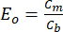
(6)

where Cm is the concentration of solute at the membrane surface and Cb is the concentration of solute at the bulk solution. From Figure 14, it is seen that beta CD-Glu cross-linked membrane has high enrichment of resveratrol separation. The characterization of recovered resveratrol is given in the supporting information. This is not discussed in detail as the main goal of the paper is discuss the separation efficiency of the membrane.

Further Discussion
Generally, the interactions between the solute and solvent in the membrane surface influence the solute transport across the membrane. The extent of hydrogen bonding between the solvent, solute and membrane depends on the solubility, dipole moment, surface energy, molecular size and dielectric constant of the feed solution. The hydrogen-bonding contribution is related to the Hansen solubility parameter (dh) for solvent, solute and membranes. The flux value of a membrane increases with increasing hydrogen bonding ability. In case of a hydrophilic membrane, with decreasing the value of dh, the flux decreases as well. Higher fluxes of a membrane result in a high solute rejection. Since ethanol has the hydrogen bonding capability and it comes the closest to the membrane and results in the highest flux. Again, the solute–membrane affinity depends upon the extent of the hydrogen bonding between them. As the membranes are of cylindrical pores and the size exclusion effect is given as,
(7)

It is known that due to the presence of irregular pores on the membrane surface the larger diameter solutes are not completely discarded and it has an indirect effect on the rejection of solutes. Thus, the solute size determines the differences in the rejection values.

Based on solute partitioning, the equation for size exclusion effect changes to

(8)

α is a membrane property depending on the solute size and its value is between 0 and 1. The α value is considered to be 1 in case of solute diameters which are larger than available pore size of membrane. Again, solute concentration inside the pores (Cinside) is related to the concentration outside the pores (Cm) and is represented as

The total solute flux, Js is related to the total volume flux, Jv by following equation:
Js= (average concentration of solutes inside pores) xJv or
(9)

(10)

Where is the concentration inside the membrane pores, Cm is the concentration at the membrane surface, Cp is the permeate concentration, ω is the viscous selectivity of solute in pores and can be calculated from
(11)

If > 1, then ω can be considered to be 1. We assume that in our system there is no change in concentration profile inside the pores. Thus, solute flux can be derived from the solvent flux by the equation,
(12)
There is a movement of solute particles into the pore centre and its velocity is more in comparison to that of the solvents [32]. The solutes move with the same velocity as that of the solvent when the size of the solute is smaller than the pore size. Figure 15 shows the solute velocity profile through the narrow pores. Table 3 represents the different parameters of proposed model by solvent flux and solute rejection through Beta CD-Glu membrane.

4. Conclusion
Alpha, beta and gamma CD-Glu cross-linked impregnated polysulfone membranes were prepared and characterized. The performances of the prepared membranes were evaluated by performing permeation experiment for separation of resveratrol from its crude extract. Effect of concentration, pressure and flow rate on flux and rejection were studied and optimum conditions were determined. The rejection decreases when the feedstock flow rate goes up, which clearly indicates that the permeation flux increases due to the decrease in mass transfer resistance, as a result high flow rate

was obtained. From the calculated and experimental values, it was established that pore flow model is well fitted to describe the separation of resveratrol from its crude extract where solute is transported inside the pores of the membrane.

Acknowledgement:
Authors acknowledged the financial support from CSIR New Delhi, India.

Conflict of interest statement:
There is no conflict of interest.

References:
- H.J. Borah, R. Singhal, S. Hazarika, ArtocarpuslakoochaRoxb: An untapped bio resource of resveratrol from North East India, its extractive separation and antioxidant activity, Industrial Crops and Products. 95 (2017) 75-82.
- J. Burn, T. Yokota, H. Ashihara, M. Lean, A. Crozier, Plant food and herbal Sources of resveratrol, J. Agric. Food Chem. 50 (2002) 3337-3340.
- A.I.P Romero, R.M. Lamuela-Ravento´s, A.L. Cristina, M.de la Carmen, B. Torre, Method for the quantitative extraction of resveratrol and piceid isomers in grape berry skins.Effect of powdery mildew on the stilbene content, J. Agric. Food Chem. 49 (2001) 210-215.
- Y.J. Cho, J.Y. Hong, H.S. Chun, S.K. Lee, H.Y. Min, Ultrasonication-assisted extraction of resveratrol from grapes, J. of Food Eng. 77 (2006) 725-730.
- E. Darnon, E. Morin, M.P. Belleville, G.M. Rios, Ultrafiltration within downstream processing; some process design consideration, Chem. Eng. Process. 42 (2003) 299-309.
- S.H. Yoo, J.Y. Jho, J. Won, H.C. Park, Y.S. Kang, Effect of solvent and co-solvent on the morphology and permeance of asymmetric polyimide membrane, J. Ind. Eng. Chem. 6 (2000) 129–132.
- P.J. Brown, S. Ying, J. Yang, Morphological structure of polyetherketone membranes for gas separation prepared by phase inversion, Autex Research J. 2 (2002)101-108.
- Y.C. Chiang, Y.Z. Hsub, R.C. Ruaan, C.J. Chuang, K.L. Tung, Nanofiltration membranes synthesized from hyperbranched polyethyleneimine network, J. Membr. Sci. 326 (2009)19-26.
- I.C. Kim, K.H. Lee, T.M. Tak, Preparation and characterization of integrally skinned uncharged polyetherimide asymmetric nanofiltration membrane, J. Membr. Sci. 183 (2001) 235–247.

- S. Lee, R.M. Lueptow, Reverse osmosis filtration for space mission wastewater: Membrane properties and operating conditions, J. Membr. Sci. 182 (2001) 77–90.
- J.M. Gozalvez, J. Lora, J.A. Mendoza, M. Sancho, Modelling of a low-pressure reverse osmosis system with concentrate recirculation to obtain high recovery levels, Desalination 144 (2002) 341–345.
- W.R. Bowen, J.S. Welfoot, Modelling the performance of membrane nanofiltration critical assessment and model development, Chem. Eng. Sci. 57 (2002) 1121–1137.
- J. Burn, T. Yokota, H. Ashihara, M. Lean, A. Crozier, Plant food and herbal Sources of resveratrol, J. Agric. Food Chem. 50 (2002) 3337-3340.
- A.I.P. Romero, R.M. Lamuela-Ravento´s, A.L. Cristina, M. de la, B. Carmen Torre, Method for the quantitative extraction of resveratrol and piceid isomers in grape berry skins.Effect of powdery mildew on the stilbene content, J. Agric. Food Chem. 49 (2001) 210-215.
- Y.J. Cho, J.Y. Hong, H.S. Chun, S.K. Lee, H.Y. Min, Ultrasonication-assisted extraction of resveratrol from grapes, J. of Food Eng. 77 (2006) 725-730.
- S. Norazanita, D.B. Das, V.M. Starov, Filtration of natural organic matter using ultrafiltration membranes for drinking water purposes: Circular cross-flow compared with stirred dead end flow, Chem. Eng. J. 276 (2015) 331-339.
- P. Rolling, M. Lamers, C. Staudt, Cross-linked membranes based on acrylated cyclodextrins and polyethylene glycol dimethacrylates for aromatic/aliphatic separation, J. Membr. Sci. 362 (2010) 154–163.
- L.Y. Jiang, T.S. Chung, Homogeneous polyimide/cyclodextrin composite membranes for pervaporation dehydration of Isopropanol, J Membr Sci. 346 (2010) 45-58.
- K. Baruah, S. Hazarika, Separation of acetic acid from dilute aqueous solution by nanofiltration membrane, Appl Polymer Sci. 131 (2014) 40537-40542.
- T.C. Chao, T.O. Arjmandi, D.B. Das, V.M. Starov, Simultaneous spreading and imbibition of blood droplets over porous substrates in the case of partial wetting, Colloids and Surfaces A: Physicochemical and Engineering Aspects. 505 (2016) 9-17.
- G. Crini, M. Morcellet, Synthesis and applications of adsorbents containing cyclodextrins, J. Sep. Sci. 25 (2002) 789–813.
- K. Baruah, S. Hazarika, S. Borthakur, N.N. Dutta, Preparation and characterization of Polysulfone-Cyclodextrin Composite NF Membrane : Solvent Effect, J. Applied Polymer Science. 125 (2012) 3388-3898.

- S. Hazarika, N.N. Dutta, P.G. Rao, A Quantitative Structure Activity Relationship Study on Permeation of Amino acids in Enantioselective Membranes, J. Appl. Membr Sci. Tech. 2(2006) 13-29.
- C. Zhaoan, D. Maicun, C. Yong, H. Gaohong, W. Ming, W. Junde, Preparation and performance of cellulose acetate/polyethyleneimine blend microfiltration membranes and their applications, J. Membr. Sci. 235 (2004) 73-86.
- Z. Ding, X. Liu, Y. Liu, L. Zhang, Enhancing the compatibility hydrophilicity and mechanical properties of polysulfone ultrafiltration membranes with lignocelluloses nanofibrils, Polymers. 8 (2016) 349-366.
- P. Fievet, M. Sbai, A. Szymczyk, A. Vidonne, Determining the zeta-potential of plane membranes forms tangential streaming potential measurements: effect of the membrane body conductance, J. Membr. Sci. 226 (2003) 227–236.
- K. Baruah, R. Goswami, M. Gogoi, S. Hazarika, Performance Evaluation of Nanofiltration Membrane for Separation of Primary Alcohols from Dilute Solutions, J. Membr. Sci. Technol. 8 (2018).
- T. Uragami, T. Meotoiwa, T. Miyata, Effects of Morphology of Multicomponent Polymer Membranes Containing Calixarene on Permselective Removal of Benzene from a Dilute Aqueous Solution of Benzene, Macromolecules. 36 (2003) 2041-2048.
- R.W. Baker, Membrane Technology and Applications, Wiley: England, 2004.
- J.P. Robinson, E.S. Tarleton, C.R. Millington, A. Nijmeijer, Solvent flux through dense polymeric nanofiltration membranes, J. Membr. Sci. 230 (2004) 29-37.
- C. Cheng, P. Li, K. Shen, T. Zhang, X. Cao, B. Wang, X. Wang, B.S. Hsiao, Integrated polyamide thin-film nanofibrous composite membrane regulated by functionalized interlayer for efficient water/isopropanol separation, J. Membr. Sci. 553 (2018) 70-81.
- A. Dobrak, B. Verrecht, H.V. den Dungen, A. Buekenhoudt, I.F.J. Vankelecom, B.Van der. Bruggen, Solvent flux behaviour and rejection characteristics of hydrophilic and hydrophobic mesoporous and microporous TiO2 and ZrO2 membranes, J. Membr. Sci. 346 (2010) 344–352.

List of Tables

Table 1: Composition and physical properties of composite NF membrane

Membrane | Average membrane thickness  (µm) | Pure water permeability (Lm-2h-1) | Water uptake (%) | MWCO (250 Da) | Contact angle (o)
Alpha CD-Glu | 55.30 | 45x10-5 | 8.35 | 93.18% | 83.8
Beta CD-Glu | 11.20 | 40x10-5 | 6.30 | 96.20% | 91.9
Gamma CD-Glu | 60.50 | 38x10-5 | 4.90 | 90.17% | 82.7

Table 2: XRD analysis result of alpha, beta and gamma CD-Glu membranes

Sample | 2θ | d (Armstrong) | Full width  (FWHM) | half maxima values
Alpha CD-Glu | 20.1 | 1.529 | 9.6
Beta CD-Glu | 20.1 | 1.529 | 10.3
Gamma CD-Glu | 20.1 | 1.529 | 8.8

Table 3: Different parameters of proposed model by solvent flux and solute rejection through Beta CD-Glu membrane

Name Parameters | Parameter values
Average pore size | 650 nm
MWCO | 240 Da
Solute | Resveratrol
Solute diameter | 189.30 nm
Solvent | Ethanol
Diameter of Solvent molecule (nm) | 0.34
Ѱ x Diameter of Solvent molecule (nm) | 0.034
k | 0.502
α | 1
ω | 1.412
Cin | 0.766 mm0lL-1
Cout | 0.755 mmol L-1
Calculated rejection value | 98%
Experimental rejection value | 98.56%

List of figures
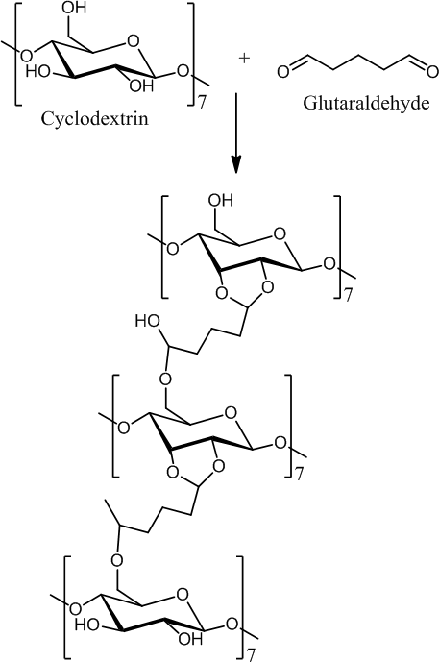

Figure 1: Cyclodextrin and glutaraldehyde cross-linked reaction scheme

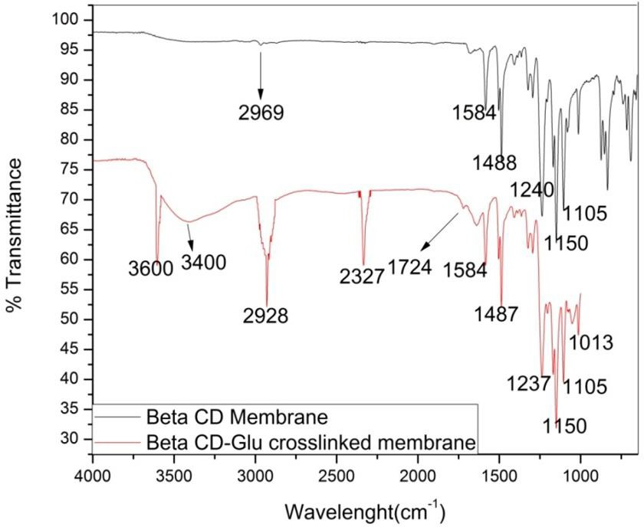

Figure 2: FTIR spectra of beta CD and beta CD-Glu cross-linked membrane

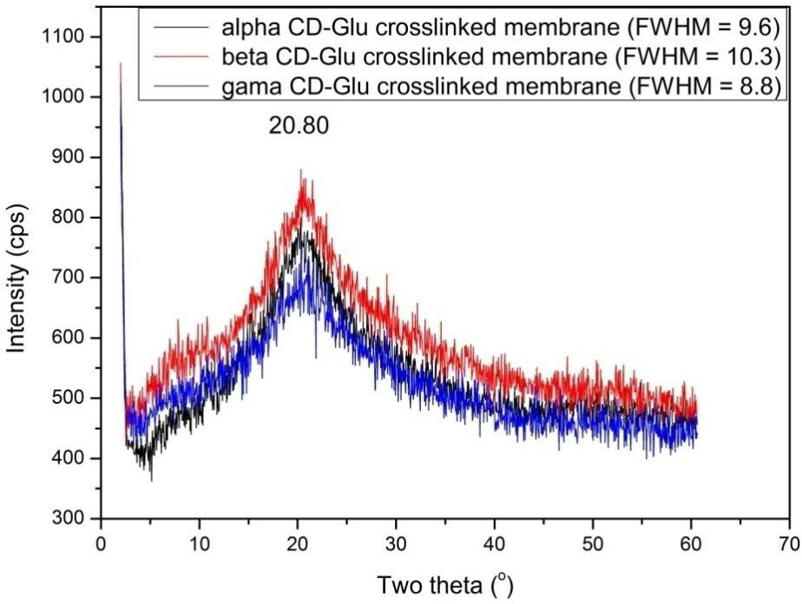

Figure 3: XRD pattern of alpha, beta and gamma CD-Glu cross-linked membranes

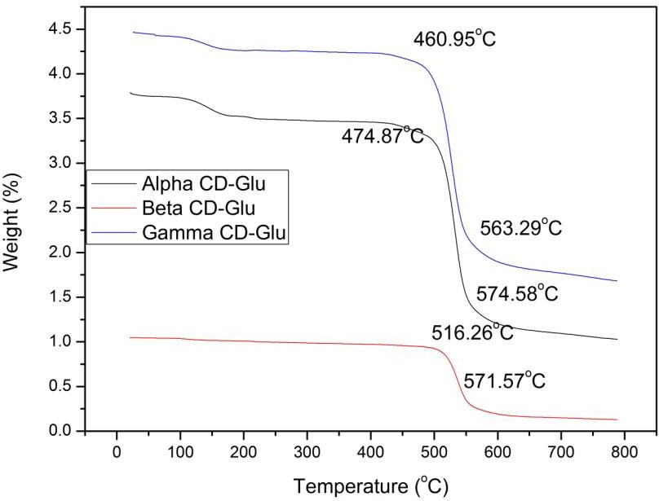

Figure 4: TGA of alpha, beta and gamma CD-Glu cross-linked membranes

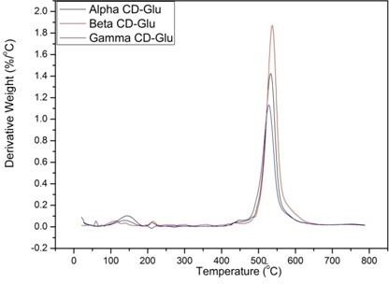

Figure 5: DTA of alpha, beta and gamma CD-Glu crosslinked membranes

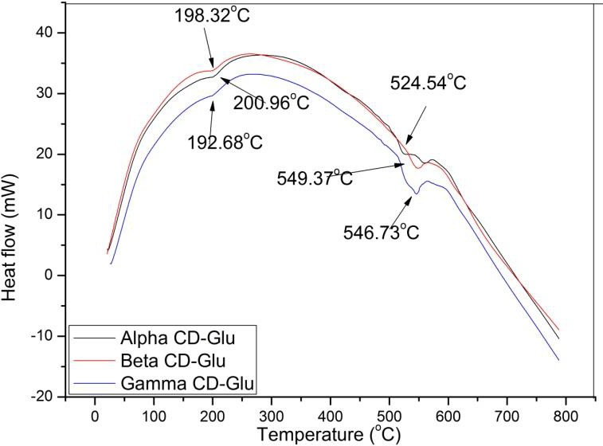

Figure 6: DSC of alpha CD-Glu, beta CD-Glu and gamma CD-Glu cross-linked Membrane

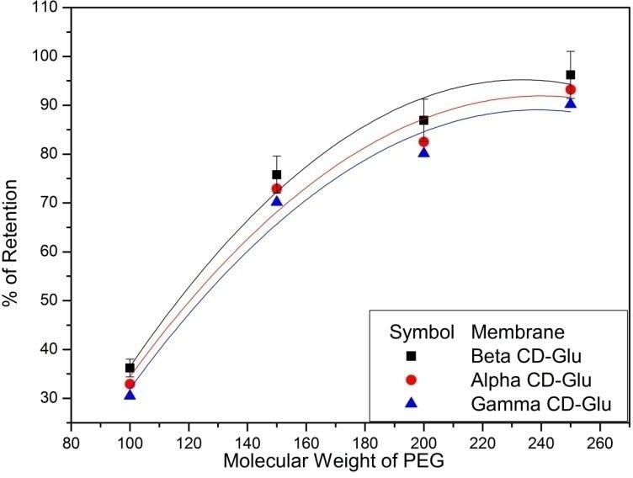

Figure 7: MWCO of the alpha, beta and gamma CD-Glu cross-linked membranes

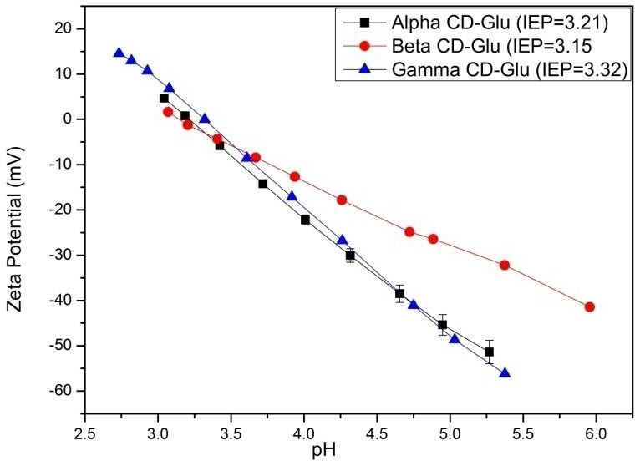

Figure 8: Zeta potential as a function of pH

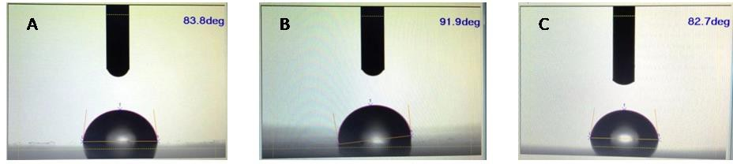
Fi gure 9: Contact angle of (A) alpha CD-Glu (B) beta CD-Glu (C) gamma CD-Glu cross-linked membrane

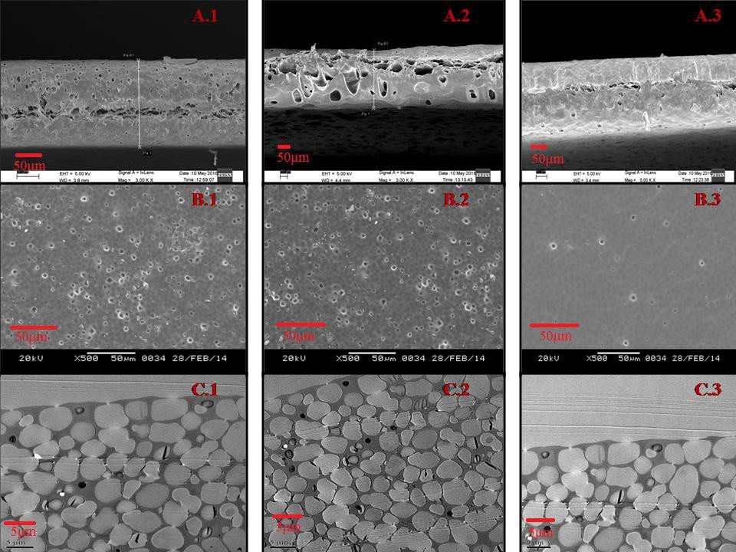
Figure 10: SEM photograph of side view (A.1, A.2, and A.3), top view (B.1, B.2, and B.3) and TEM photograph (C.1, C.2, and C.3) of (A) alpha (B) beta and (C) gamma CD-Glu cross-linked membranes

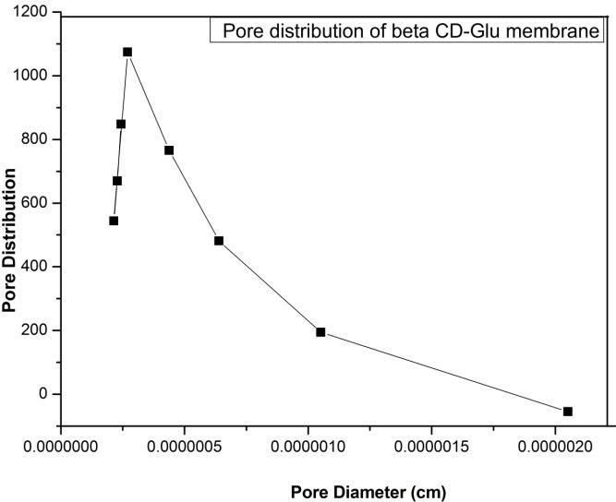

Figure 11: Pore distribution as a function of pore diameter of beta CD-Glu crosslinked membranes

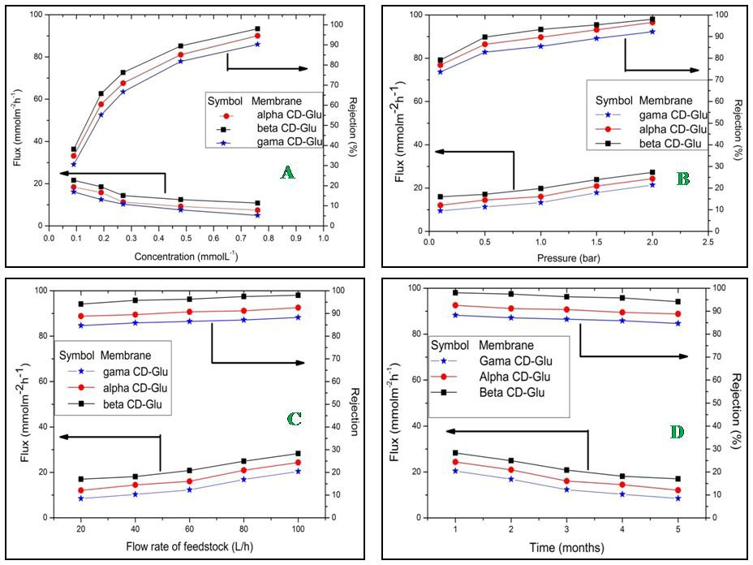

Figure 12: Membrane flux (1st y-axis) and rejection (2nd y-axis) as functions of (A) concentration
(B) pressure (C) flow rate (D) operation time

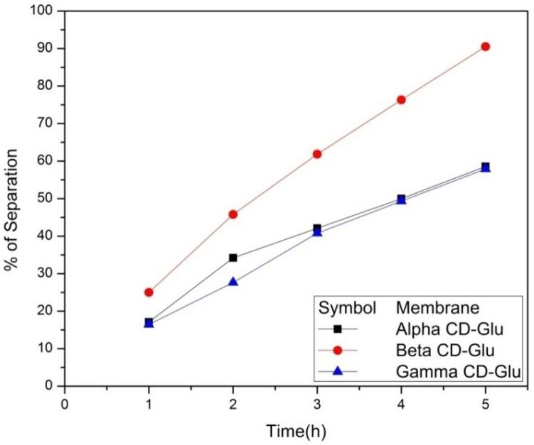

Figure 13: % of separation as a function of alpha, beta and gamma CD-Glu cross-linked

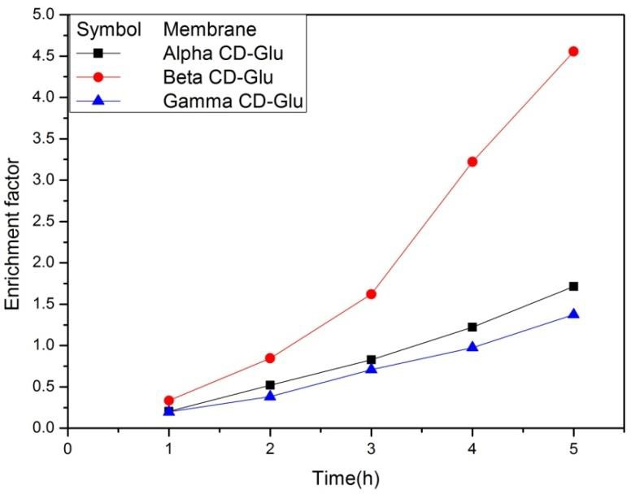

Figure 14: Enrichment factor of alpha, beta and gamma CD-Glu cross-linkedmembrane

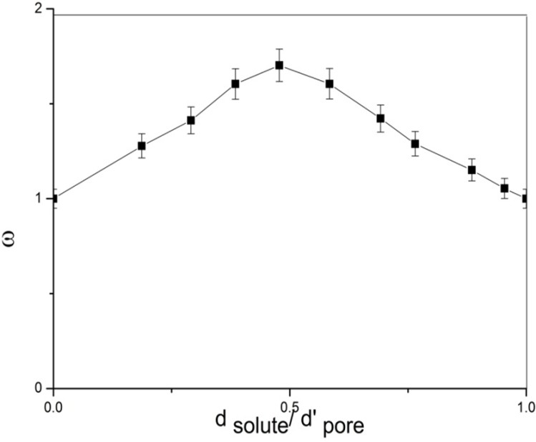
Figure 15: Solute velocity profile through narrow pore

Supplementary Material

‹ /Øð\ ÿSupplementaryPlaceholder R ÿÿ EÏlé

Click here to access/download
Supplementary Material Supporting Information.doc

