Supplementary Material - A Method to Assess the Feasibility of Implementing Distributed Localised Manufacturing Strategies in the Food Sector

Pedro Gimenez-Escalante^{1,2}, Guillermo Garcia-Garcia^{1,3}, Shahin Rahimifard^{1,*}
¹Centre for Sustainable Manufacturing and Recycling Technologies (SMART), Loughborough University, LE11 3TU, UK
²Cervezas Smach, Polígono de Raos, Parcela 11F36, Camargo, Cantabria 39600, Spain
³Department of Chemical and Biological Engineering, The University of Sheffield, S10 2TN, UK
* Corresponding author
E-mail addresses: P.Gimenez@smach.es (P. Gimenez-Escalante), G.Garcia-Garcia@sheffield.ac.uk (G. Garcia-Garcia), S.Rahimifard@lboro.ac.uk (S. Rahimifard)

This Supplementary Material shows more details of each Stage within the DLM Method and its application in a case study. The contents of the Supplementary Material are listed below.

1 Stage 1, Step 1.1: Calculation of DLM assessment metrics ratings 2
1.1 Product metrics for DLM vs CM ratings 2
1.1.1 Formulation 2
1.1.2 Shelf life (SL) 4
1.1.3 Procurement costs 8
1.2 Process metrics for DLM vs CM ratings 8
1.2.1 Waste 8
1.2.2 Energy requirements 10
1.2.3 Processing costs 12
1.3 System metrics for DLM vs CM ratings 13
1.3.1 Food Miles (FMs) 13
1.3.2 Market Potential (MP) 15
1.3.3 Distribution costs 17
1.4 Integrated costs rating 18
2 Stage 1, Step 1.3: Calculation of aggregated DLM suitability score 20
3 Criteria for the development of Stage 2 20
3.1 Primary DLM criteria 21
3.2 Secondary product DLM criteria 22
3.3 Secondary process DLM criteria 22
3.4 Secondary system DLM criteria 23
3.5 The DLM decision-support hierarchy 23
4 Design and coding of the MATLAB tool to support Stage 2 24
5 Case study: SMACH 37
5.1 Collected data 38
5.2 Analysis of the nine metrics for Stage 1 40
5.2.1 Formulation 41
5.2.2 Shelf life (SL) 41
5.2.3 Waste 42
5.2.4 Energy 43
5.2.5 Food miles (FMs) 43
5.2.6 Market potential 44
5.2.7 Costs 45
5.3 Collection of experts’ judgements for Stage 2 46

Stage 1, Step 1.1: Calculation of DLM assessment metrics ratings

Product metrics for DLM vs CM ratings
This section provides a detailed description and calculation process for the identified ‘product’ metrics required for Step 1.1 of the Stage 1 of the ‘Distributed Localised Manufacturing’ (DLM) Method, which include formulation, shelf life and procurement costs.

Formulation
The ingredients used to manufacture a Food Product (FP) determine its formulation. In some cases, ingredients cannot be replaced or because strict recipes or legislative requirements (e.g. essential function in the FP structure, ‘protected designation of origin’ (PDO), ‘protected geographical indication’ (PGI), or ‘traditional specialities guaranteed’ (TSG)). Nevertheless, replacing ingredients is allowed within specific limits in some cases. In order to understand the potential for an ingredient to be replaced and how this could affect the final FP, it is important to determine its role in the FP. An ingredient is a significant part of the FP when it conforms a majority regarding the final FP formulation. This relative majority can be defined following two different approaches:
- Weight significance over final product: certain ingredients represent a large portion of the finalised FP weight (e.g. rice in a ready meal).
- Cost significance over final product: some ingredients can be a minimal part of the final FP formulation but can have large associated costs (e.g. high-value essential ingredients such as spices).
Weight significance has been identified as the most relevant factor for the DLM vs CM decision-making due to associated transport costs and environmental impact reduction potential, which closely align to DLM objectives. For instance, ingredients supply might require impactful transportation due to characteristics such as large volumes or high water contents (e.g. potatoes), energy intense conditioning requirements (e.g. meat), or speed requirements due to high perishability (e.g. dairy products). Consequently, the importance of a given ingredient is calculated based on its relative weight over the final FP to obtain a significance ratio, by using Equation 1.
 | $$F_{i}=\frac{w_{i}}{PW}$$ | Equation 1
Where:
- $F_{i}$: is formulation rating for the ingredient i.
- $W_{i}$: is the weight of ingredient i.
- $PW$: is the total FP weight
Once an ingredient relative formulation importance has been identified, it is necessary to identify its characteristic role in the FP to support the assessment of the most suitable manufacturing strategy (i.e. Centralised Manufacturing (CM) or DLM). This is done through a basic analysis of the potential for formulation alteration, which is undertaken by categorising the ingredient within the FP recipe. The characteristics to support this categorisation process include:
- Core ingredients: ingredients essential for the FP manufacture that cannot be replaced without critically affecting FP distinctive characteristics. Food manufacturers involved in the assessment process should be capable of identifying which ingredients could fall in this category considering their expertise and FP understanding. Ingredients within this category should be further classified within two different groups in support of DLM vs CM decision-making:
  - Majority with local sourcing alternatives (potential to enable DLM)
  - Majority cannot be locally sourced (more suitable for CM)
To decide whether an ingredient can be locally sourced means assessing whether the FP can be sourced within a 50-100 miles radius (Jones et al., 2004). This threshold was selected based on a literature review and is proposed in the DLM Method as an indicative threshold; however it could be adjusted if deemed necessary in certain cases.
- Substitutable/replaceable ingredients: ingredients which could have alternatives to fulfil the same role in the FP recipe without significantly affecting its final characteristics (e.g. in terms of texture, quality or flavour).
Figure 1 shows the logic of the decision-making process for the FP formulation metric. For those ingredients that are replaceable, or not replaceable but can be locally sourced, DLM would potentially be suitable. Alternatively, CM is more suitable when ingredients representing a majority are core for the FP and cannot be locally sourced.
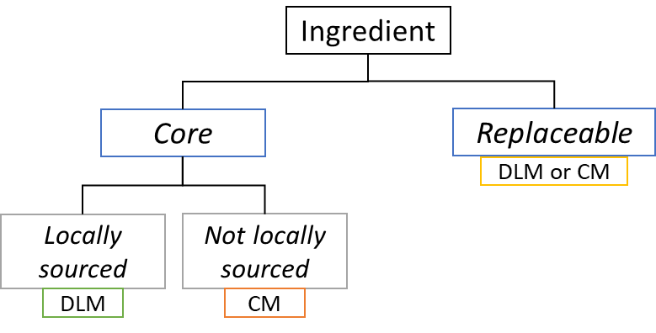
Figure 1. FP formulation decision tree
Each suitability value is translated to a quantitative value S_{i} using the following rules:
$$S_{i}=1 if DLM$$
$$S_{i}=-1 if CM$$
$$S_{i}=0.5 if both are applicable$$
The result for the formulation metric ($I$) is obtained by multiplying the weight significance ($F_{i}$) by their suitability value ($S_{i}$) and then adding all the individual results, as shown in Equation 2. If the total result of the formulation metric ($I$) is positive, DLM is suitable, otherwise CM is more suitable from a FP formulation perspective.
 | $$I=\sum_{i=1}^{n}{(S_{i}*F_{i})}$$ | Equation 2

Shelf life (SL)
Many FPs have SL, within which they are safe for human consumption (Aramyan et al., 2007; Hammond et al., 2015). SL is essential in operations management and therefore can support decision-making regarding the selection of alternative manufacturing strategies. SL is FP specific and needs to be carefully quantified to avoid potential health concerns. Ingredients also frequently present high perishability and limited SL. Therefore, it is essential to consider the SL of both FPs and their ingredients during DLM suitability assessments. Figure 2 depicts the four potential alternative scenarios that can be defined from a SL perspective alongside example ingredients and FPs that can be categorised within these scenarios. These four scenarios are defined below:
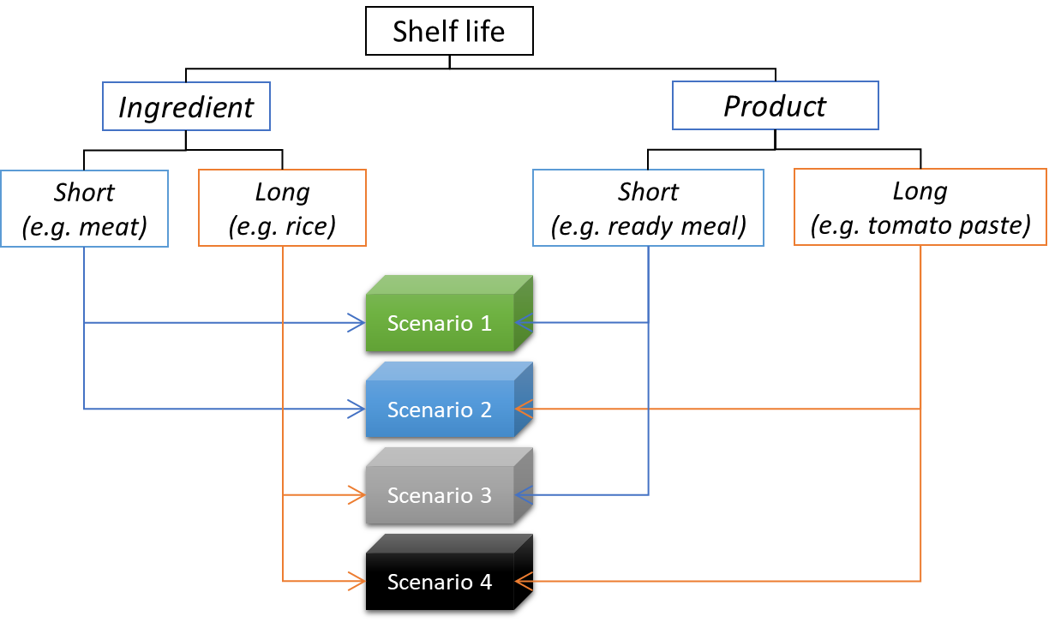
Figure 2. FP and ingredients potential SL related scenarios
- Scenario 1: short I_{SL} and short P_{SL}: fast response on processing and distribution operations could minimise underutilised or wasted SL. Ingredients that need to be processed rapidly (e.g. fresh fish) could avoid the need for conditioned transportation and storage (e.g. cold transportation, chilled storage), to ensure their quality before being processed. FPs with short SL (e.g. liquid yogurts) could also be directly placed in the market and distributed among local consumers avoiding the need for long transportation among multiple actors to reach their final destinations.
- Scenario 2: short I_{SL} and long P_{SL}: it might be more sensible to rapidly gather perishable ingredients in one central location to then market-to-stock the FPs efficiently for later distribution. However, manufacturing closer to ingredient providers gives potential for better management in cases with extremely short SL ingredients that can be easily damaged during transportation or that require conditioned transportation with its associated energy requirements.
- Scenario 3: long I_{SL} and short P_{SL}: although ingredients might not represent a major management concern, a short FP SL could become a competitive advantage for DLM applications considering the reduction in the need for longer times to place products in the market and the minimisation of the need for conditioned distribution systems. FPs could be manufactured closer to consumer in a market-to-stock approach avoiding the need for production forecast and special storage conditions.
- Scenario 4: long I_{SL} and long P_{SL}: centralised food systems directly suits FPs without SL constraints. Large capabilities to store both ingredients and FPs can frequently be more efficient compared to multiple facilities to fulfil equivalent processing capabilities because of economies of scale and globalised Food Supply Chains (FSCs).
Considering the above-defined scenarios, it is necessary to classify FPs and ingredients under short and long SL categories. In this research, 16 main FP categories, as stipulated by the FAO in the Codex Alimentarius (2018), have been considered as listed in Table 1. This table also shows the most constraining SL for some of the FPs contained within each category, and the most common preservation requirements for each food category.
Table 1. FP categories, example SLs and preservation requirements
FP category | Most constraining shelf life examples | Preservation conditioning requirements
Dairy | 5 days | Chilling essential for most products
Fats and oils and fat emulsions | 2 months | Not essential for fats and oils. Emulsions might require chilling.
Edible ices | 6 months | Freezing is essential
Fruits and vegetables, seaweeds, nuts and seeds | 3 days | Not essential
Confectionery | 30 days | Not required
Cereals and cereal products | 3 months | Not required
Bakery wares | 5 days | Not required
Meat and meat products, including poultry and game | 1 day | Chilling is essential
Fish and fish products, including molluscs, crustaceans, and echinoderms | 2 days | Chilling is essential
Eggs and egg products | 3 weeks | Not required
Sweeteners, including honey | More than 1 year | Not required
Salts, spices, soups, sauces, salads, protein products | 3 days for salads, soups or sauces.  More than 1 year for salts, spiced protein products. | Essential for salads, soups or sauces.  Not required for salts, spices and protein products.
Foodstuffs intended for particular nutritional uses | 3 months | Not required
Beverages, excluding dairy products | 2 days | Not essential for most products
Ready-to-eat savouries | 2 months | Not required
Prepared foods | 3 days | Essential chilling. Freezing widely applied

Due to the lack of any threshold values to define what FP or ingredient presents a short or long SL, it is necessary to make the following assumptions for FPs’ SL:
- Sometimes ‘natural’ SL is extended by means of preservation technologies (i.e. freezing and chilling). In the DLM Method, FPs requiring these technologies as part of their essential processing activities are considered as long SL products, while FPs that do not require these technologies for their manufacture, but which are dependent on them to extend their SL, are considered as short SL products.
- Fresh FPs with less than two-weeks SL are considered as having short SL.
Regarding ingredients’ SL, the following assumptions are proposed:
- Food ingredients sourced frozen and/or chilled are included in the short SL category. In general, it can be assumed that these ingredients could be locally sourced in a fresh state even though they would have a short SL. This approach would minimise the need for preservation technologies and therefore increase the environmental sustainability of the FP.
- There are numerous ingredients managed in a fresh state (e.g. vegetables or fruits) or traditionally dried (e.g. cereals, roots and tubers or pulses), without specific SL constraints influencing their management and utilisation for food manufacture. These are considered as long SL ingredients, unless they have a storage period of less than one week in the production facilities.
FPs and ingredients can therefore be characterised into short or long SL groups following the assumptions above. Once all the ingredients and the FPs have been characterised, the next step involves the identification of different scenarios for each of ingredient and FP. It can be assumed that short SL FPs are most frequently benefiting from DLM strategies and therefore any SL FP could be suitable to be manufactured following DLM. On the other hand, for FPs with long SL, it is necessary to consider the different ingredients and their associated SL scenarios. Accordingly, if more than half of the ingredients qualify within Scenario 4, CM is more suitable for the manufacture of that FP. Otherwise, the FP could be manufactured within a DLM system. Table 2 summarises these assumptions and the results that should be generated from the analysis of SL.
Table 2. Interpretation of SL assessment results
Product | Ingredients | Scenario | Recommended manufacturing strategy
Short SL | Short SL | 0-100% 1 | DLM
 | Long SL | 0-100% 3
Long SL | Short SL | >50% 2 | DLM
 | Long SL | >50% 4 | CM
 | Long-Short SL | 50% 2 & 50% 4 | DLM or CM

Procurement costs
Procurement or sourcing activities seek to find the most efficient and reliable suppliers to support the manufacture of a FP. These activities consider multiple factors including price, reliability, quality and flexibility. Procurement costs, also referred to as provision costs, have a significant influence in the final FP price. From a manufacturing perspective, it is essential that economically sustainable strategies are followed to support long-term food provision. In this context, procurement costs are highly relevant for decision-making regarding FP potential for DLM vs CM.
Procurement costs include costs associated with sourcing of required ingredients and materials (e.g. packaging) from upstream members of the FSC. The costs can be fixed or variable depending on business strategies towards management of supply (e.g. fixed scheduled deliveries versus a delivery based on inventory levels). FP procurement costs are calculated by adding these costs using Equation 3.
 | $$C_{P}=\sum_{i=1}^{n}{C_{Ii}}+\sum_{j=1}^{m}{C_{Mj}}$$ | Equation 3
Where:
- $C_{P}$: are the procurement costs
- $C_{Ii}$: is the cost for ingredient i
- $C_{Mj}$: is the cost for material j
It is proposed to considered procurement costs in conjunction with processing and distribution costs, as manufacturing systems costs are closely interlinked. The DLM vs CM decision-making process logic for these costs metrics is therefore detailed later in this Section 1.4 of this Supplementary Material.

Process metrics for DLM vs CM ratings
This section provides a detailed description and calculation process for the identified ‘process’ metrics required for Step 1.1 of the Stage 1 of the DLM Method. These include processing waste, processing energy needs and processing costs.

Waste
Waste is a highly impactful factor, and its reduction could greatly benefit the food sector from environmental, economic and social perspectives. Therefore, its assessment in DLM vs CM scenarios is essential for the suitability decision-making process. Three areas can be identified from which process-related waste can emerge:
- Pre-production: it frequently consists of separate ingredients that have gone off because of inappropriate storage conditions, poor scheduling, lack of demand, production stoppages or trimmings. Pre-production waste includes packaging.
- Production: it can be in form of partially processed FPs, mixed ingredients, overcooked or undercooked FPs, FPs not meeting quality standards, or overproduction.
- Post-production: it consists of cooked and packaged products with safety concerns, quality faults or not enough consumer demand for the scheduled production.
From a waste perspective, the decision regarding suitability for DLM vs CM is supported by comparing the three waste sources and their relative volumes. Waste calculations can be conducted in terms of weight or cost proportion over the final FP. In the DLM Method, weight has been selected prioritising an environmental perspective over a purely economic view. The three proposed waste ratios ($r_{W1}$, $r_{W2}$ and $r_{W3}$) are calculated using Equation 4, Equation 5 and Equation 6. Materials other than ingredients and FPs (e.g. plastics, cardboard, boxes) must be included in the calculations of these ratios.
 | $$r_{W1}=\frac{\sum{W_{pre}}}{\sum{W}}×100$$ | Equation 4
 | $$r_{W2}=\frac{\sum{W_{pro}}}{\sum{W}}×100$$ | Equation 5
 | $$r_{W3}=\frac{\sum{W_{post}}}{\sum{W}}×100$$ | Equation 6
Where:
- $\sum{W_{pre}}$: total weight of pre-production waste
- $\sum{W_{pro}}$: total weight of waste from production
- $\sum{W_{post}}$: total weight of post-production waste
- $\sum{W}$: total waste from the manufacturing facility
- $r_{W1}$: proportion of waste from pre-production activities
- $r_{W2}$: proportion of waste from production activities
- $r_{W3}$: proportion of waste from post-production activities
The proposed ratios will allow decision makers to highlight where the highest amount of waste is generated within processing facilities. Once the calculations have been made, the ratios must be compared to identify the most suitable manufacturing strategy (Figure 3). When any of these three categories alone represents more than a third of the total waste, they are identified as ‘highly representative’ with respect to the other areas. The following assumptions are made to support the selection of the manufacturing strategy that can be more suitable based on the waste metric:
- In cases where r_{W1} or r_{W3} are highly representative, DLM should be suitable since it could potentially minimise those wastes occurring because of problems with scheduling or storage issues or excessive packaging usage.
- If r_{W2} is the most relevant waste, CM should still be the most suitable strategy because multiple processing facilities could increase the amount of waste emerging from this stage compared to individual locations considering the same FP output volumes.
- When there is no major waste source, both strategies could be efficiently applied for that FP family.
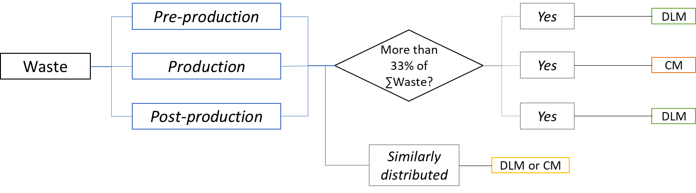
Figure 3. Waste metric decision-making logic

Energy requirements
Figure 4 shows a breakdown of the energy usage in manufacturing classified into different categories depending on where and how it is utilised. These types of energy are described below for food-manufacturing environments.
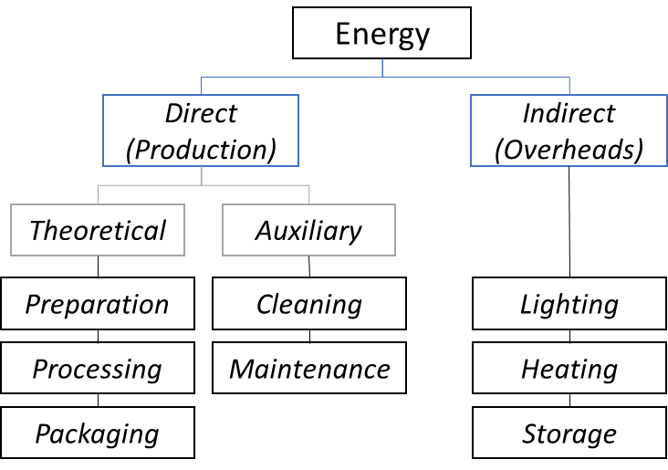
Figure 4. Types of energy in a factory (Rahimifard, Seow & Childs, 2010)
- Direct energy or production energy (DE): it includes the energy consumed within a food processing facility directly related to the manufacture of FPs. This energy can be divided into theoretical and auxiliary depending on whether it is essential for the production, or it is demanded by supporting tasks required to enable production runs.
  - Theoretical energy (TE): this is the minimum energy required based on the theoretical best-case scenario for the processing of a FP considering optimum processes performance. This category includes the energy required for ingredients preparation, FP processing and FP packaging. The TE is calculated by adding these individual energies as shown in Equation 7.
 | $$TE=\sum{(E_{i}+E_{pr}+E_{pa})}$$ | Equation 7
Where:
- $E_{i}$: is the energy required to prepare ingredients and material for processing.
- $E_{pr}$: is the energy utilised during the processing of a FP.
- $E_{pa}$: is the energy utilised to package a FP.
  - Auxiliary energy (AE): this is the energy required to support production, including equipment cleaning, room conditioning and other similar activities that require an energy input to function. The AE is calculated by adding these individual energies as shown in Equation 8.
 | $$AE=\sum{{(E}_{c}+E_{m}+E_{co})}$$ | Equation 8
Where:
- $E_{c}$: is the energy required for cleaning processing equipment and surfaces.
- $E_{m}$: is the energy necessary for the routine maintenance of the machinery.
- $E_{Co}$: is the energy required for shop floor conditioning.
- Overheads energy or indirect energy (IE): it includes the energy required by other activities than production, such as energy used in offices, lighting and heating, and ingredients and FP storage. This energy is calculated by adding these individual energies as shown in Equation 9.
 | $$IE=\sum{(E_{o}+E_{lh}+E_{is}+E_{prs})}$$ | Equation 9
Where:
- $E_{o}$: is the energy utilised within offices environment.
- $E_{lh}$: is the energy required for lighting and heating of the processing facilities.
- $E_{is}$: is the energy necessary to store ingredients.
- $E_{prs}$: is the energy essential for FP storage.
The following assumptions are made to facilitate the assessment of different cases regarding their suitability for DLM vs CM:
- The higher IE is the more suited for DLM, considering the potential that a MTO approach and a reduction in facilities size could minimise the IE required to manufacture the same FP.
- Regarding the DE and the impact that different manufacturing scales could have on it:
  - TE could be the same required for DLM and CM. The resizing and redistribution of processing operations would theoretically imply the breaking down of TE into the different facilities. This factor might serve as an indicator of DLM requirements for future applications.
  - AE could be reduced through a reduction in facilities size, which could reduce maintenance energy requirements as well as cleaning requirements by proportionally downsizing them. However, it is important to consider the possibility that it could rise when increasing number of facilities and processing lines opposed to individual larger capacity facilities.
In this context, the assessment of the energy usage breakdown has been identified as the most comprehensive approach to understand suitability of manufacturing strategies from a processing energy perspective. Thus, once the three major groups of energy have been calculated through data gathering and processing, the total energy figures must be compared to make the decision regarding DLM vs CM suitability. The comparison is carried out through the Energy Ratio ($r_{E}$), which is calculated using Equation 10.
 | $$r_{E}=\frac{AE+IE}{TE+AE+IE}$$ | Equation 10
Where:
- TE: theoretical energy
- IE: indirect energy
- AE: auxiliary energy
When $r_{E}$ > 0.33 there is potential suitability of DLM based on energy utilisation. This limit is proposed because $r_{E}$ values closer to 1 would indicate that current practices are not energy efficient therefore there is an apparent potential to benefit from a restructuring approach towards the DLM strategy.

Processing costs
The processing costs, frequently referred as operating costs ($C_{O}$), can be broken down into four separate categories including: ingredients and materials (previously defined as procurement costs, $C_{P}$), utilities (e.g. electricity or gas), labour and miscellaneous (e.g. patents). $C_{O}$ can be calculated using Equation 11.
 | $$C_{O}=C_{P}+\sum_{j=1}^{m}{C_{Uj}}+\sum_{k=1}^{s}{C_{Lk}}+\sum_{i=1}^{n}{C_{Misci}}$$ | Equation 11
Where:
- $C_{O}$: are the operating costs
- $C_{P}$: are the procurement costs
- $C_{Uj}$: is the cost for utility j
- $C_{Lk}$: is the labour costs for activity k
- $C_{Misci}$: is the cost for miscellaneous item i
The relevant contributing factors to these costs need to be carefully identified for every situation being assessed. This research has selected the following assumptions as the most relevant to support the calculation of $C_{o}$ and assist the decision-making process regarding alternative manufacturing strategies suitability:
- Procurement costs: they have been previously defined in Section 1.1.3 of the Supplementary Material. One of the most relevant factors that can indicate suitable manufacturing strategies is suppliers’ geographical location (i.e. international or local), together with their associated relevance over the total procurement costs, which might be demanding additional transportation costs.
- Utilities costs: they generally include costs for water and energy (e.g. electricity and gas) required to manufacture a FP. The required resources to manufacture a FP should be approximately the same only breaking them down and changing where they are utilised. Therefore, the total utilities costs per FP are expected to be similar in most cases independently of the adopted manufacturing strategy. However, local demand, availability and access to these utilities may influence the overall costs in some applications.
- Labour costs: they mostly depend on wages, number of employees and operating times. The most relevant factor to understand regarding labour and the potential to impact manufacturing costs is whether these are associated to management, supervision or monitoring (e.g. employees controlling that machinery is running correctly, employees in the supervisory team) or to production tasks (e.g. labour involved in producing a sandwich). These costs can highlight if a more distributed strategy could be competitive or else if grouping the production activities is more efficient. These costs are not considered as a limiting factor for either CM or DLM approach.
- Miscellaneous costs: they are associated with equipment downtime, maintenance and royalties. Excessive values for downtime and maintenance can be indicative of problems with scale and lack of flexibility derived from large-scale food production activities and therefore the breakdown of these costs should be considered to understand what potential benefits a change in the manufacturing strategy could have. Nevertheless, in support of the decision-making methodology these costs are considered as fixed and similar for both CM and DLM strategies.
In the same way as with the procurement costs, the processing costs assessment for DLM vs CM suitability is carried out in conjunction with the other costs metrics and is detailed in Section 1.4.

System metrics for DLM vs CM ratings
This section provides a description and calculation process for the identified ‘system’ metrics required for Step 1.1 of the Stage 1 of the DLM Method. These include food miles, market potential and distribution costs.

Food Miles (FMs)
FMs are calculated to show the amount of transportation required for the provision of a FP to its consumption location, including all associated activities from raw materials production and transportation to the production facilities, up to post-production distributions to reach consumers. The FMs of a FP can be calculated using Equation 12.
 | $$FM=\sum_{i=1}^{n}{M_{Ii}}+\sum_{j=1}^{m}{M_{Pj}}$$ | Equation 12
Where:
- $M_{Ii}$: miles for ingredient i transportation
- $M_{Pj}$: average miles for FP j distribution
- $FMs$: total food miles
Current systems carry out some activities that could be potentially avoided in support of more sustainable systems from an environmental perspective. This is because several transportation activities may be non-value adding, e.g. distribution between warehouses, depots, and facilities in which the FP and/or ingredients do not go through any value-adding process from a nutritional or structural perspective. DLM can efficiently reduce the total FM, and therefore environmental impacts, by having suppliers within shorter ‘local’ reach rather than using centralised and globalised approaches. It is also important to understand how sourcing strategies (e.g. one farm supplying large quantities or multiple farms supplying smaller quantities) affect this metric. The theoretical approach proposed in the DLM Method does not consider transportation emissions, which could eventually be addressed with implementation phases of DLM, e.g. using electric vehicles or alternative shared transportation strategies. The pure distance consideration can provide a systems overview that can be complemented with the additional DLM metrics being measured within the DLM vs CM suitability assessment.
The FMs that can potentially be avoided must be identified to support the assessment process regarding the impact that they have in the organisation of a manufacturing system. The following assumptions are used to assess whether specific FM can be considered ‘potentially avoidable’ (Figure 5):
- Transportation of ingredients with sources that significantly contribute to the total FMs could potentially be avoided through local suppliers. The supply availability (i.e. local or international) must be assessed considering an unrestricted scenario in which business factors are not constraining the sourcing strategies (e.g. costs or current supplier relationships).
- FMs incurred to transport products to wholesalers or distributors (i.e. indirect customers) which do not perform any processing activities. From an environmental sustainability viewpoint, distribution to wholesalers and big retail groups could be avoided when non-value adding processes need to be carried out by them. In those cases, food consumers could be supplied by other production facilities closer to them.
After identifying the total avoidable FMs, this value can be used to calculate the avoidable FM ratio ($r_{FM})$, using Equation 13.
 | $$r_{FM}=\frac{AFM}{FMs}$$ | Equation 13
Where:
- $AFM$: potentially avoidable food miles
- $FMs$: total food miles
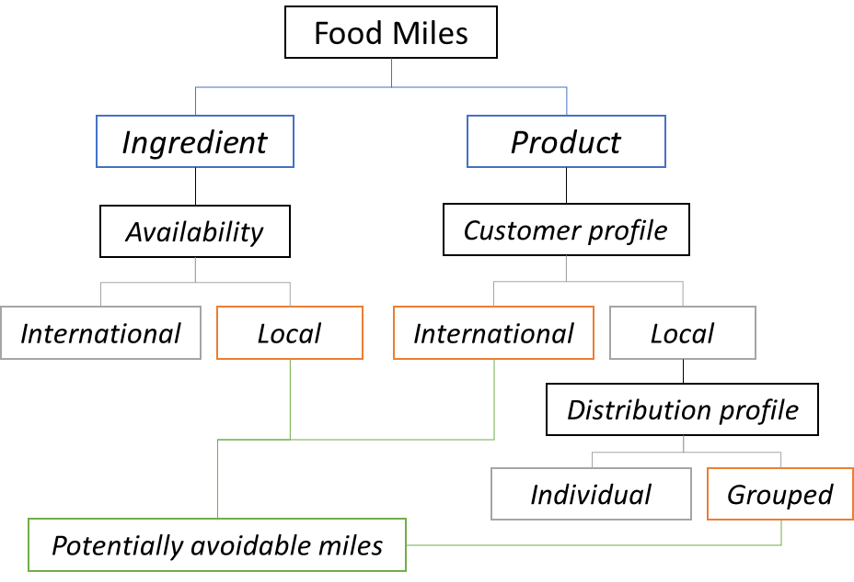
Figure 5. FMs breakdown highlighting those with potential to be avoided
$r_{FM}$ ranges from 0 to 1, where values closer to 1 show cases most suitable for DLM due to the potential to avoid FM, and values closer to 0 would mean that current practices are efficiently managing total FM of a FP. The DLM method uses a threshold value of 0.33 for $r_{FM}$ to indicate the suitability of DLM. Clearly, this will be highly dependent on organisations structure, FP requirements, and current operations; therefore, the proposed threshold value may need to be altered for specific FPs and FSCs.

Market Potential (MP)
MP can be used to assess a specific FP market by analysing the linkages between production capacity and Sales Figures (SF). Thus, to evaluate the MP, two production capacity categories should be calculated for any given manufacturing system: the ‘theoretical production capacity’ and the ‘practical production capacity’, defined as:
- Theoretical production capacity ($T_{PC}$): maximum theoretical production that can be generated under ideal conditions considering design specifications and limitations of production systems.
- Practical production capacity ($P_{PC}$): production capacity level achieved under practical operating conditions, including maintenance needs, labour limitations, bottlenecks and any other limiting factor.
Once the production capacities have been characterised for a food production system, the SF must be collected and analysed in support of the MP analysis. SF represents the number of FPs sold within a specific time, for instance monthly sales. The average monthly SF ($\overline{S}$) can be calculated using Equation 14.
 | $$\overline{S}=\frac{\sum_{i=1}^{12}{S_{i}}}{12}$$ | Equation 14
Where:
- S_{i}: represents the number of FPs sold in month i
- $\overline{S}$: is the average monthly sales
Once the capacity and SF have been calculated, the system efficiency ratio ($r_{SE}$) must be calculated using Equation 15.
 |  | $$r_{SE}=\frac{\overline{S}}{P_{PC}}$$ | Equation 15
Where:
- $P_{PC}$: is the standard monthly practical production capacity
- $\overline{S}$: is the average monthly sales
A threshold value of $r_{SE}$ = 0.8 is proposed to indicate whether DLM can be suitable. Therefore, $r_{SE}$ values lower than 0.8 would indicate that current SF could be managed in a DLM system, while when $r_{SE}$ > 0.8 significant pressures would be placed in the potential DLM system to be able to manage the SF consistently, and consequently CM would be more suitable based on the MP metric.
In addition to the $r_{SE}$ decision factor, ‘seasonality’ should be considered when assessing MP. Seasonality is considered to evaluate the impacts of ingredient availability and market demand during different climatological seasons (i.e. spring, summer, autumn and winter). Accordingly, a seasonal production efficiency ratio ($r_{SPEx}$) should be calculated to identify how practical production capacity is linked to actual SF on a ‘season’ basis, as shown in Figure 6. The $r_{SPE}$ can be calculated using Equation 16.
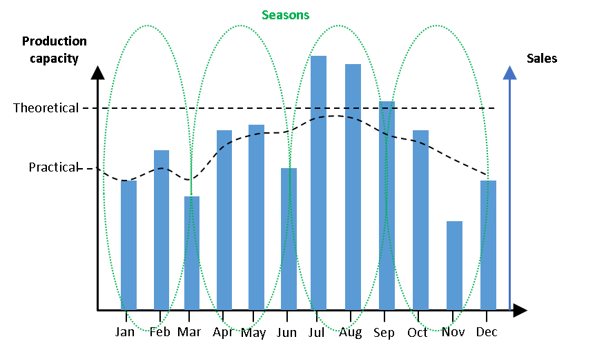
Figure 6. Illustration of MP decision factors
 | $$r_{SPEx}=\sum_{i=1}^{3}{\left(\frac{S_{i}}{\overline{S}}-\frac{P_{PCi}}{T_{PC}}\right)}$$ | Equation 16
Where:
- $r_{SPEx}$: is the seasonal production efficiency ratio in season x
- $S_{i}$: represents the number of products sold in month i
- $\overline{S}$: is the average monthly sales
- $P_{PCi}$: represents the practical production capacity reached in month i
- $T_{PC}$: is the theoretical monthly production capacity
$r_{SPEx}$ must be calculated for each of the four seasons over an entire year. This ratio shows how frequently the production capacity has been optimally matched to the SF over a specific season. In this context, when the production capacity is greater than the SF the facility is over-producing in comparison to the sales over that season. This indicates that there is a need for the processing facility to overproduce during specific seasons in support of seasonal demand peaks for the assessed FP. Therefore, when $r_{SPEx}$ < 1 during more than one season, CM would be more suitable. In summary, from a MP perspective, DLM would be suitable for specific FPs when their demand is not highly seasonal, and therefore SF can be appropriately managed throughout the year without the need for extensive adjustments in the production system.

Distribution costs
These costs are associated with post-production transportation and distribution. They include expenses associated to final FP delivery from the production facility to the end customer (i.e. wholesaler, distributor and retailer). The distribution costs can be either fixed, emerging from scheduled deliveries of stipulated FP quantities, or variable, which include the fluctuating distribution costs from FP delivery-to-order. The distribution costs can be broken down into three different categories: from production facilities to wholesalers, from transportation from wholesalers to distributors, and from distributors to retail. Consequently, distribution costs are calculated by Equation 17.
 | $$C_{D}=\sum_{j=1}^{m}{C_{Wj}}+\sum_{k=1}^{s}{C_{Dk}}+\sum_{i=1}^{n}{C_{Ri}}$$ | Equation 17
Where:
- $C_{D}$: are the distribution costs
- $C_{Wj}$: is the cost associated to wholesaler j
- $C_{Dk}$: is the cost associated to distributor k
- $C_{Ri}$: is the cost associated to retailer i
In this context, the distribution costs characteristic that supports the DLM vs CM decision-making is related to the associated geographic reach of the distribution as follows:
- Local: transportation costs to customers located within a range considered as local (i.e. 50-100 miles radius). Closer distribution frequently has lower associated costs per mile due to the lower total mileage and shorter transportation times. This distribution approach provides more time for manufactures to plan and prepare their FPs thanks to the reduction in transportation time.
- National/International: distribution costs emerging from FP deliveries to customers located further away from the manufacturing facilities. These costs are frequently associated to more volumetric orders which can be profitable thanks to economies of scale, which otherwise would significantly increase FP price.
This characteristic factor needs to be considered for any FP under assessment. The DLM Method assumes that if the distribution costs are associated to national/international customers, a change in location and scale could potentially benefit the business and system being assessed and therefore DLM could be suitable. Accordingly, as indicated within the other defined economic sustainability metrics (described in Section 1.1.3 and 1.2.3), the distribution costs need to be assessed concurrently with the other costs as detailed in Section 1.4.

Integrated costs rating
An example to reduce food-manufacturing costs is sourcing widely available ingredients from lower cost international suppliers (e.g. chicken sourced by UK food manufacturers from Thailand). However, this approach overlooks the quality of ingredients supplied by local providers, the greater customer acceptance of locally sourced ingredients, and their generally reduced environmental impact.
These considerations highlight the importance of assessing the range of metrics discussed in Section 1 of the Supplementary Material in support of selecting the most sustainable manufacturing strategy covering the three pillars simultaneously (i.e. economic, social and environmental). In this context, accumulating procurement costs, processing costs, and the distribution costs is essential to calculate a costs ratio that can indicate whether DLM or CM is more cost efficient. Targetable costs ($C_{t}$) for potential reduction by using a DLM strategy include:
- $C_{Di}$: international customers distribution costs. These could be reduced through the implementation of a DLM approach and the distribution of the production facilities to transition these costs towards lower local distribution costs.
- $I_{j}$: costs associated to an internationally sourced ingredient. These costs could be reduced through the development of more competitive local economies or the development of cooperatives.
- $M_{k}$: costs associated to an internationally sourced material. These costs could be targeted by manufacturers thanks to the development of local economies that could support economically competitive material suppliers within closer distances.
In this context, the total targetable cost reduction through the adoption of a DLM strategy can be calculated using Equation 18.
 | $$C_{t}=\sum_{i=1}^{n}{C_{Di}}+\sum_{j=1}^{m}{I_{j}}+\sum_{k=1}^{r}{M_{k}}$$ | Equation 18
Where:
- $C_{t}$: are the targetable costs
- $C_{Di}$: are the distribution costs for international customer i
- $I_{j}$: is the cost for international ingredient j
- $M_{k}$: is the cost for international material k
Once these costs have been calculated, the targetable costs ratio ($r_{Cost}$) can be obtained comparing current costs (C) (Equation 19), with the $C_{t}$ (Equation 20).
 | $$C=\sum{({C_{P}+C}_{O}+C_{D})}$$ | Equation 19
 | $$r_{Cost}=\frac{C_{t}}{C}$$ | Equation 20
Where:
- $C$: are the total current costs
- $C_{P}$: are the procurement costs
- $C_{O}$: are the operating costs
- $C_{D}$: are the distribution costs
- $C_{t}$: are the targetable costs
The higher the $r_{Cost}$ is, the greater the positive effect that a DLM approach would have. The closer to 0, the lower the impact a change in manufacturing strategy could generate in FP costs due to the importance that current fixed operating costs have. Accordingly, the proposed decision-making logic is that when $r_{Cost}$ > 0.2 there is enough evidence that there could be economic potential to support DLM implementations. The redistribution of manufacturing, the transition in suppliers and customers towards local actors, and processes re-scaling, could hypothetically support, with the same production costs, an improvement in the economic sustainability of the system. This could be achieved by offsetting additional costs that could be emerging from changes in the system (e.g. local supplier of ingredients) through the optimisation of other metrics.

Stage 1, Step 1.3: Calculation of aggregated DLM suitability score
Table 3 summarises the main results of Step 1.1, including the different DLM metrics ratios thresholds and factors that need to be established, as well as how these are linked to the DLM vs CM suitability indicator.
Table 3. Summary of different Step 1.1 metrics thresholds values
Metric | Suitability indicator | CM Threshold | DLM Threshold
Formulation | $$I^{*}$$ | $$I^{*}<0$$ | $$I^{*}≥0$$
Shelf life | Scenario | >50% Scenario 4 | Scenarios 1, 2 and 3
Energy | $$r_{E}$$ | $$r_{E}<0.33$$ | $$r_{E}≥0.33$$
Waste | $r_{W1}$, $r_{W2}$, $r_{W3}$ | $$r_{W2}>0.33$$ | $$r_{W1}>0.33$$  or $r_{W3}>0.33$
Food miles | $$r_{FM}$$ | $$r_{FM}<0.33$$ | $$r_{FM}≥0.33$$
Market potential | $r_{SE}$ and $r_{SPEx}$ | $$r_{SE}>0.8$$  or $r_{SPEx}<1$ more than one season | $$r_{SE}≤0.8$$  and $r_{SPEx}≥1$ three or more seasons
Costs | $$r_{Cost}$$ | $$r_{Cost}<0.2$$ | $$r_{Cost}≥0.2$$

Criteria for the development of Stage 2
The criteria for the development of Stage 2 is based on previous work by the authors (Gimenez-Escalante and Rahimifard (2019)). The first requirement to assess suitability of DLM system models for the manufacture of a specific FP family is to identify and define specific assessment criteria that consider all the sustainability dimensions. The appropriate assessment criteria for the evaluation of the DLM system models should:
- Represent DLM thoroughly without losing details due to changing elements.
- Cover the environment surrounding the DLM system models.
- Support the identification of key parameters that can solve the DLM system model selection problem.
- Make clear the necessary expert skills required to help during DLM assessments.
Moreover, it was decided that the criteria should be qualitative because of the lack of existing quantitative DLM applications. It is almost infeasible to model complex food manufacturing systems to obtain quantitative estimations of potential DLM system models behaviour since this would require a case-by-case simulation model building. Considering these premises, it was decided that there should be two levels of assessment criteria:
- Primary criteria: these are the principal considerations that on the highest-level perspective need to be analysed. They include the three key aspects that can support the identification of potential strengths and weaknesses of a specific FP family to be manufactured following a DLM strategy (i.e. product, process and system). These parameters were chosen based on the understanding gathered during a review of the food-manufacturing sector.
- Secondary criteria: these include more detailed parameters that are necessary to evaluate DLM in different scenarios. A three-step methodology was applied to select these criteria. The first step was to conduct a comprehensive literature review to identify several food sector specific characteristics that could influence decision-making processes concerning the analysis of potential suitability of the DLM system models. The second step involved the consolidation of the initial set of criteria into a manageable list including only the most representative factors. In the third step, the overlapping factors were identified and reduced to the final nine criteria described in this section.
Although the criteria presented in this section might resemble the assessment metrics described in Stage 1 of the DLM Method it must be noted that the objective of the qualitative assessment in Stage 2 entails the abstraction of these essential aspects in view of a future DLM system model. In spite of the DLM assessment metrics from Stage 1, the assessment of the criteria utilised in Stage 2 of the DLM Method is based on the projection of their value in a food system that cannot be substantially measured. Therefore, these DLM assessment criteria are intrinsically different from the metrics evaluated during Stage 1, as described below.

Primary DLM criteria
The identified primary criteria to support DLM system models assessment are product, process and system, which are the three pillars of manufacturing management operations. Product considerations are essential to ensure that businesses correctly address societal needs. Process operations are important to ensure that current and future capabilities can support a manufacture according to product design specifications. On the other hand, systems need to be capable of enabling the product supply and distribution, while supporting process operations in terms of factors such as energy or market demand for products.
Most environmental, social and economic impacts from any food business can be categorised under these three DLM criteria. However, these primary criteria needs additional secondary criteria to support more detailed assessments of the DLM system models. Accordingly, each of the identified DLM criteria includes three sub-criteria to provide more valuable insights regarding different suitability of FP families for DLM. These additional secondary criteria are described below.

Secondary product DLM criteria
A product level perspective is essential for the assessment of the suitability of the DLM system models for a given FP family. The selected secondary product DLM criteria are:
- Shelf life (SL): as previously discussed for Stage 1, SL is the available time for safe consumption of a FP.
- Customisation: it is used to consider the demand for variations and personalisation of FPs in the decision-making process. Changing consumer desires have increased the need for more product variety and therefore manufacturing capabilities to tailor the characteristics of foods to support individual needs (Geyer et al., 2003).
- Seasonality: it is defined as the availability and ease of access to required ingredients for the manufacture of a FP family. Compared to other sectors, the raw ingredients utilised for food manufacturing present natural variability throughout the year due to climatological conditions and the natural biological cycles of plants. These factors have been identified as essential drivers or challenges which can affect the implementation and operation of the different DLM system models (Aramyan et al., 2007).

Secondary process DLM criteria
Manufacturing organisation strategies need to consider multiple processing parameters to ensure the safe and undisrupted supply of FPs. The identified secondary process DLM criteria are:
- Food Waste (FW): as previously discussed for Stage 1, FW is any food material which was originally intended to feed humans, but which did not ultimately meet this original purpose.
- Flexibility: it is used to consider the capabilities of food processes to adapt to shifting FP specifications and potential to adapt to ingredients diversity and variability. These factors have been highlighted as important variables which will influence the transition towards localised food systems (Beach et al., 2000).
- Safety: it includes factors such as specific regulatory requirements that have been designed to safely manufacture specific FPs, and their applicability in DLM. Safety risks are very different for FP families (Trienekens and Zuurbier, 2008).

Secondary system DLM criteria
System level considerations are essential to ensure the long-term suitability of the DLM system models. The following system secondary criteria are proposed for the analysis of DLM system models suitability, and to ensure long-term sustainability of future implementations:
- Food Miles (FM): as previously discussed for Stage 1, it is defined as the measurement of the transportation requirements for the manufacture and distribution of a FP, including ingredients and raw materials supply (Mundler and Criner, 2016). The transport mode must also be considered when assessing different DLM system models.
- Market Size: it is used to consider local market demand volume. Localising activities towards the different DLM system models will be greatly influenced by the market size in which the localisation is to be achieved (Thilmany et al., 2008).
- Consumer Demand: it is used to assess the profile of the demand for specific FP families, considering factors such as demographic distribution, consumption trends, special dietary needs and health related requirements (e.g. FPs for the elderly, spicy foods, gluten free foods, low salt products) (Cleveland et al., 1997).

The DLM decision-support hierarchy
The DLM hierarchy, presented in Figure 7, illustrates the relationships between the primary and secondary criteria that must be considered during the analytical assessment of the suitability of DLM system models.
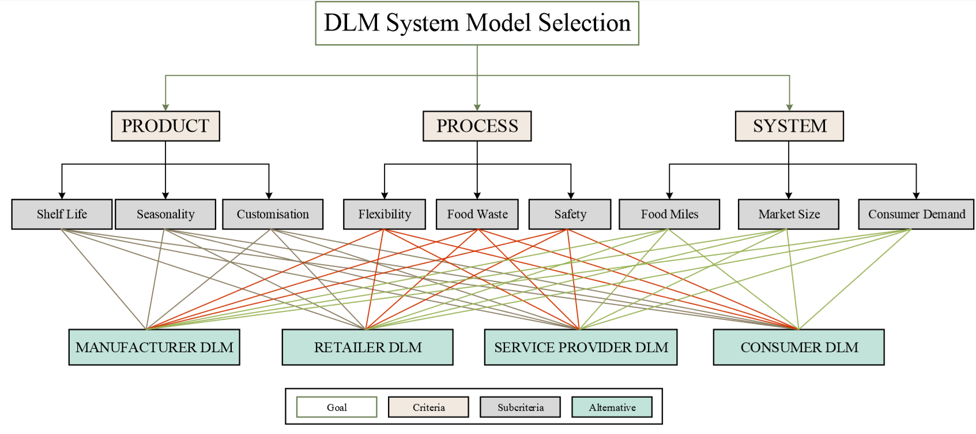
Figure 7. The DLM Hierarchy
The DLM hierarchy has been designed with the following four different levels to support the structured analysis of the primary criteria, secondary criteria and the DLM system models:
- Goal: includes the final aim of the Stage 2 assessment method highlighting what the output of the application of the AHP methodology will be.
- Criteria: gathers the three primary DLM assessment criteria (i.e. product, process and system).
- Sub-Criteria: includes the nine secondary DLM criteria whose relative significance must be assessed in support of the three overarching primary criteria.
- Alternatives: involve the four developed DLM system models laying out the final options that need to be ranked based on their suitability for the FP family being assessed.
The DLM hierarchy supports the provision of homogeneous comparable expert judgements. This hierarchy is a fundamental component for the application and utilisation of the Stage 2 of the DLM Method as explained in the main article.

Design and coding of the MATLAB tool to support Stage 2
The MATLAB-based software tool developed for Stage 2 has been developed to be applicable to all product families independently of the number of experts involved in the decision-making process. The tool is based on the Equations 4-10 defined in the main article. The algorithm for this tool is shown in Figure 8.
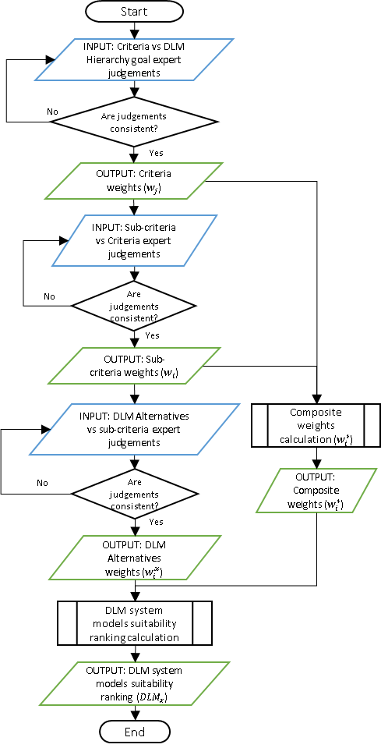
Figure 8. Flowchart representing the algorithm of the DLM decision-support tool developed for Stage 2
The MATLAB DLM tool firstly requires the import of the expert judgements regarding the DLM criteria. Afterwards, the next window requests the user to input the judgements of the DLM sub-criteria with respect to the criteria. Finally, the last steps need the input of the expert judgements’ values of the four DLM system models considering each of the 9 sub-criteria. These steps are done through a number of input windows that enable the storage of the information in the software. Once the data import has been completed, the MATLAB code automatically calculates the final alternatives ratios that provide the ranking of the four DLM system models. The results contain the ranking of the four DLM system models according to the expert judgements that have provided their respective view regarding the system models suitability for the manufacture of the FP family being assessed. The tool delivers the results to the user through the command window, which can be printed, exported to a text file or an Excel file. These results should be then further analysed by the user and other decision-makers involved in the assessment process.
The code used within MATLAB to build the AHP-based decision-support tool in support of the implementation of the Stage 2 of the DLM Method can be found below.
function Final_Code()
% DLM Method Stage 2
% This model supports the analysis of DLM System Models suitability following the
% methodology described within Stage 2 of the DLM Method

% Initial judgements of DLM vs Product-Process-System
%DLM vs Product-Process-System
x1 = {'Product vs Process:','Product vs System:','Process vs System:'};
title1 = 'DLM Judgements';
answer1 = inputdlg(x1,title1,[1 50]);
J1=str2num(answer1{1});
J2=str2num(answer1{2});
J3=str2num(answer1{3});
%Critera with respect to the goal
disp('DLM Goal Judgements')
Goal=[1,J1,J2;...
1/J1,1,J3;...
1/J2,1/J3,1]
%eGoal=Eigen vector of the Product Process System Judgements
eGoal=calc_eig(Goal)
CRGoal=calc_cr(Goal)
while CRGoal>0.1
x1 = {'Product vs Process:','Product vs System:','Process vs System:'};
title1 = 'DLM Judgements';
answer1 = inputdlg(x1,title1,[1 50]);
J1=str2num(answer1{1});
J2=str2num(answer1{2});
J3=str2num(answer1{3});
disp('DLM Goal Judgements');
Goal=[1,J1,J2;...
1/J1,1,J3;...
1/J2,1/J3,1]
eGoal=calc_eig(Goal)
CRGoal=calc_cr(Goal)
if CRGoal<0.1
break
end
end
[Value,I]=max(eGoal);
if I==1
disp('Product has the highest priority')
elseif I==2
disp('Process has the highest priority')
else
disp('System has the highest priority')
end
Value
filename = 'Stage 2 Results.xlsx';
xlswrite(filename,Goal,1,'B2:D4')
xlswrite(filename,eGoal,1,'F2:F4')
xlswrite(filename,CRGoal,1,'G2')
%Product priorities
%Product Secondary Criteria Matrix
x2 = {'Shelf life vs Seasonality:','Shelf life vs Customisation',...
'Seasonality vs Customisation:'};
title2 = 'Product Judgements';
answer2 = inputdlg(x2,title2,[1 50]);
W1=str2num(answer2{1});
W2=str2num(answer2{2});
W3=str2num(answer2{3});
%Secondary critera with respect to Product
disp('Product Subcriteria Judgements');
Product=[1,W1,W2;...
1/W1,1,W3; ...
1/W2,1/W3,1]
%eProduct=Eigen vector of the Product Secondary Criteria Judgements
eProduct=calc_eig(Product)
CRProduct=calc_cr(Product)
while CRProduct>0.1
x2 = {'Shelf life vs Seasonality:','Shelf life vs Customisation',...
'Seasonality vs Customisation:'};
title2 = 'Product Judgements';
answer2 = inputdlg(x2,title2,[1 50]);
W1=str2num(answer2{1});
W2=str2num(answer2{2});
W3=str2num(answer2{3});
disp('Product Subcriteria Judgements');
Product=[1,W1,W2;...
1/W1,1,W3; ...
1/W2,1/W3,1]
eProduct=calc_eig(Product)
CRProduct=calc_cr(Product)
if CRProduct<0.1
break
end
end
[Value,I]=max(eProduct);
if I==1
disp('Shelf life has the highest priority')
elseif I==2
disp('Seasonality has the highest priority')
elseif I==3
disp('Customisation has the highest priority')
end
Value
xlswrite(filename,Product,2,'B2:D4')
xlswrite(filename,eProduct,2,'F2:F4')
xlswrite(filename,CRProduct,2,'G2')
% Process priorities
%Process Secondary Criteria Matrix
x3 = {'Flexibility vs Waste:','Flexibility vs Safety:',...
'Waste vs Safety:'};
title3 = 'Process Judgements';
answer3 = inputdlg(x3,title3,[1 50]);
W11=str2num(answer3{1});
W12=str2num(answer3{2});
W13=str2num(answer3{3});
%SubCritera with respect to Process
disp('Process Subcriteria Judgements');
Process=[1,W11,W12;...
1/W11,1,W13; ...
1/W12,1/W13,1]
%eProcess=Eigen vector of the Process Secondary Criteria Judgements
eProcess=calc_eig(Process)
CRProcess=calc_cr(Process)
while CRProcess>0.1
x3 = {'Flexibility vs Waste:','Flexibility vs Safety:',...
'Waste vs Safety:'};
title3 = 'Process Judgements';
answer3 = inputdlg(x3,title3,[1 50]);
W11=str2num(answer3{1});
W12=str2num(answer3{2});
W13=str2num(answer3{3});
disp('Process Subcriteria Judgements');
Process=[1,W11,W12;...
1/W11,1,W13; ...
1/W12,1/W13,1]
eProcess=calc_eig(Process)
CRProcess=calc_cr(Process)
if CRProcess<0.1
break
end
end
[Value,I]=max(eProcess);
if I==1
disp('Flexibility has the highest priority')
elseif I==2
disp('Waste has the highest priority')
elseif I==3
disp('Safety has the highest priority')
end
Value
xlswrite(filename,Process,3,'B2:D4')
xlswrite(filename,eProcess,3,'F2:F4')
xlswrite(filename,CRProcess,3,'G2')
% System priorities
%System Secondary Criteria Matrix
x4 = {'Food Miles vs Market Size:','Food Miles vs Consumer Demand:',...
'Market Size vs Consumer Demand:'};
title4 = 'System Judgements';
answer4 = inputdlg(x4,title4,[1 50]);
W111=str2num(answer4{1});
W112=str2num(answer4{2});
W113=str2num(answer4{3});
%SubCritera with respect to System
disp('System Subcriteria Judgements');
System=[1,W111,W112;...
1/W111,1,W113; ...
1/W112,1/W113,1]
%eSystem=Eigen vector of the System Secondary Criteria Judgements
eSystem=calc_eig(System)
CRSystem=calc_cr(System)
while CRSystem>0.1
x4 = {'Food Miles vs Market Size:','Food Miles vs Consumer Demand:',...
'Market Size vs Consumer Demand:'};
title4 = 'System Judgements';
answer4 = inputdlg(x4,title4,[1 50]);
W111=str2num(answer4{1});
W112=str2num(answer4{2});
W113=str2num(answer4{3});
disp('System Subcriteria Judgements');
System=[1,W111,W112;...
1/W111,1,W113; ...
1/W112,1/W113,1]
eSystem=calc_eig(System)
CRSystem=calc_cr(System)
if CRSystem<0.1
break
end
end
[Value,I]=max(eSystem);
if I==1
disp('Food Miles has the highest priority')
elseif I==2
disp('Market Size has the highest priority')
elseif I==3
disp('Consumer Demand has the highest priority')
end
Value
xlswrite(filename,System,4,'B2:D4')
xlswrite(filename,eSystem,4,'F2:F4')
xlswrite(filename,CRSystem,4,'G2')
% Alternatives priorities vs the 9 secondary criteria
% 9 matrix of 4x4 one for each criterion vs the 4 DLM system models
% 3 Matrices of Product subcriteria
disp('Product Subcriteria Judgements vs DLM Models');
%Shelf life Criteria Matrix
C1 = {'M-DLM vs R-DLM:','M-DLM vs S-DLM:','M-DLM vs C-DLM:',...
'R-DLM vs S-DLM:','R-DLM vs C-DLM:',...
'S-DLM vs C-DLM:'};
titleC1 = 'Shelf life Judgements';
answerC1 = inputdlg(C1,titleC1,[1 50]);
P1=str2num(answerC1{1});
P2=str2num(answerC1{2});
P3=str2num(answerC1{3});
P4=str2num(answerC1{4});
P5=str2num(answerC1{5});
P6=str2num(answerC1{6});
%Alternatives with respect to Subcriteria
Shelflife=[1,P1,P2,P3;...
1/P1,1,P4,P5;...
1/P2,1/P4,1,P6;...
1/P3,1/P5,1/P6,1]
%eShelflife=Eigen vector of the Shelf life Criterion Judgement
eShelflife=calc_eig(Shelflife)
CRShelflife=calc_cr(Shelflife)
while CRShelflife>0.1
titleC1 = 'Shelf life Judgements';
answerC1 = inputdlg(C1,titleC1,[1 50]);
P1=str2num(answerC1{1});
P2=str2num(answerC1{2});
P3=str2num(answerC1{3});
P4=str2num(answerC1{4});
P5=str2num(answerC1{5});
P6=str2num(answerC1{6});
%Alternatives with respect to Subcriteria
Shelflife=[1,P1,P2,P3;...
1/P1,1,P4,P5;...
1/P2,1/P4,1,P6;...
1/P3,1/P5,1/P6,1]
%eShelflife=Eigen vector of the Shelf life Criterion Judgement
eShelflife=calc_eig(Shelflife)
CRShelflife=calc_cr(Shelflife)
if CRShelflife<0.1
break
end
end
%Seasonality Criteria Matrix
titleC2 = 'Seasonality Judgements';
answerC2 = inputdlg(C1,titleC2,[1 50]);
P7=str2num(answerC2{1});
P8=str2num(answerC2{2});
P9=str2num(answerC2{3});
P10=str2num(answerC2{4});
P11=str2num(answerC2{5});
P12=str2num(answerC2{6});

Seasonality=[1,P7,P8,P9;...
1/P7,1,P10,P11;...
1/P8,1/P10,1,P12;...
1/P9,1/P11,1/P12,1]

eSeasonality=calc_eig(Seasonality)
CRSeasonality=calc_cr(Seasonality)
while CRSeasonality>0.1
titleC2 = 'Seasonality Judgements';
answerC2 = inputdlg(C1,titleC2,[1 50]);
P7=str2num(answerC2{1});
P8=str2num(answerC2{2});
P9=str2num(answerC2{3});
P10=str2num(answerC2{4});
P11=str2num(answerC2{5});
P12=str2num(answerC2{6});

Seasonality=[1,P7,P8,P9;...
1/P7,1,P10,P11;...
1/P8,1/P10,1,P12;...
1/P9,1/P11,1/P12,1]

eSeasonality=calc_eig(Seasonality)
CRSeasonality=calc_cr(Seasonality)
if CRSeasonality<0.1
break
end
end
%Customisation Criteria Matrix
titleC3 = 'Customisation Judgements';
answerC3 = inputdlg(C1,titleC3,[1 50]);
P13=str2num(answerC3{1});
P14=str2num(answerC3{2});
P15=str2num(answerC3{3});
P16=str2num(answerC3{4});
P17=str2num(answerC3{5});
P18=str2num(answerC3{6});
Customisation=[1,P13,P14,P15;...
1/P13,1,P16,P17; ...
1/P14,1/P16,1,P18;...
1/P15,1/P17,1/P18,1]

eCustomisation=calc_eig(Customisation)
CRCustomisation=calc_cr(Customisation)
while CRCustomisation>0.1
titleC3 = 'Customisation Judgements';
answerC3 = inputdlg(C1,titleC3,[1 50]);
P13=str2num(answerC3{1});
P14=str2num(answerC3{2});
P15=str2num(answerC3{3});
P16=str2num(answerC3{4});
P17=str2num(answerC3{5});
P18=str2num(answerC3{6});
Customisation=[1,P13,P14,P15;...
1/P13,1,P16,P17;...
1/P14,1/P16,1,P18;...
1/P15,1/P17,1/P18,1]

eCustomisation=calc_eig(Customisation)
CRCustomisation=calc_cr(Customisation)
if CRCustomisation<0.1
break
end
end
% 3 Matrices of Process subcriteria
disp('Process Subcriteria Judgements vs DLM Models');
%Flexibility Criteria
titlePR3 = 'Flexibility Judgements';
answerPR3 = inputdlg(C1,titlePR3,[1 50]);
PR13=str2num(answerPR3{1});
PR14=str2num(answerPR3{2});
PR15=str2num(answerPR3{3});
PR16=str2num(answerPR3{4});
PR17=str2num(answerPR3{5});
PR18=str2num(answerPR3{6});
%Flexibility Criteria Matrix
Flexibility=[1,PR13,PR14,PR15;...
1/PR13,1,PR16,PR17;...
1/PR14,1/PR16,1,PR18;...
1/PR15,1/PR17,1/PR18,1]

eFlexibility=calc_eig(Flexibility)
CRFlexibility=calc_cr(Flexibility)
while CRFlexibility>0.1
titlePR3 = 'Flexibility Judgements';
answerPR3 = inputdlg(C1,titlePR3,[1 50]);
PR13=str2num(answerPR3{1});
PR14=str2num(answerPR3{2});
PR15=str2num(answerPR3{3});
PR16=str2num(answerPR3{4});
PR17=str2num(answerPR3{5});
PR18=str2num(answerPR3{6});
Flexibility=[1,PR13,PR14,PR15;...
1/PR13,1,PR16,PR17;...
1/PR14,1/PR16,1,PR18;...
1/PR15,1/PR17,1/PR18,1]

eFlexibility=calc_eig(Flexibility)
CRFlexibility=calc_cr(Flexibility)
if CRFlexibility<0.1
break
end
end
%Waste Criteria
titlePR4 = 'Waste Judgements';
answerPR4 = inputdlg(C1,titlePR4,[1 50]);
PR19=str2num(answerPR4{1});
PR20=str2num(answerPR4{2});
PR21=str2num(answerPR4{3});
PR22=str2num(answerPR4{4});
PR23=str2num(answerPR4{5});
PR24=str2num(answerPR4{6});
%Waste Criteria Matrix
Waste=[1,PR19,PR20,PR21;...
1/PR19,1,PR22,PR23;...
1/PR20,1/PR22,1,PR24;...
1/PR21,1/PR23,1/PR24,1]

eWaste=calc_eig(Waste)
CRWaste=calc_cr(Waste)
while CRWaste>0.1
titlePR4 = 'Waste Judgements';
answerPR4 = inputdlg(C1,titlePR4,[1 50]);
PR19=str2num(answerPR4{1});
PR20=str2num(answerPR4{2});
PR21=str2num(answerPR4{3});
PR22=str2num(answerPR4{4});
PR23=str2num(answerPR4{5});
PR24=str2num(answerPR4{6});
Waste=[1,PR19,PR20,PR21;...
1/PR19,1,PR22,PR23;...
1/PR20,1/PR22,1,PR24;...
1/PR21,1/PR23,1/PR24,1]

eWaste=calc_eig(Waste)
CRWaste=calc_cr(Waste)
if CRWaste<0.1
break
end
end
%Safety Criteria
titlePR5 = 'Safety Judgements';
answerPR5 = inputdlg(C1,titlePR5,[1 50]);
PR25=str2num(answerPR5{1});
PR26=str2num(answerPR5{2});
PR27=str2num(answerPR5{3});
PR28=str2num(answerPR5{4});
PR29=str2num(answerPR5{5});
PR30=str2num(answerPR5{6});
%Safety Criteria Matrix
Safety=[1,PR25,PR26,PR27;...
1/PR25,1,PR28,PR29;...
1/PR26,1/PR28,1,PR30;...
1/PR27,1/PR29,1/PR30,1]

eSafety=calc_eig(Safety)
CRSafety=calc_cr(Safety)
while CRSafety>0.1
titlePR5 = 'Safety Judgements';
answerPR5 = inputdlg(C1,titlePR5,[1 50]);
PR25=str2num(answerPR5{1});
PR26=str2num(answerPR5{2});
PR27=str2num(answerPR5{3});
PR28=str2num(answerPR5{4});
PR29=str2num(answerPR5{5});
PR30=str2num(answerPR5{6});
Safety=[1,PR25,PR26,PR27;...
1/PR25,1,PR28,PR29;...
1/PR26,1/PR28,1,PR30;...
1/PR27,1/PR29,1/PR30,1]

eSafety=calc_eig(Safety)
CRSafety=calc_cr(Safety)
if CRSafety<0.1
break
end
end
% 3 Matrices of System subcriteria
disp('System Subcriteria Judgements vs DLM Models');
%Food Miles Criteria
titleS2 = 'Food Miles Judgements';
answerS2 = inputdlg(C1,titleS2,[1 50]);
S7=str2num(answerS2{1});
S8=str2num(answerS2{2});
S9=str2num(answerS2{3});
S10=str2num(answerS2{4});
S11=str2num(answerS2{5});
S12=str2num(answerS2{6});
%Food Miles Criteria Matrix
Food=[1,S7,S8,S9;...
1/S7,1,S10,S11;...
1/S8,1/S10,1,S12;...
1/S9,1/S11,1/S12,1]
eFood=calc_eig(Food)
CRFood=calc_cr(Food)
while CRFood>0.1
titleS2 = 'Food Miles Judgements';
answerS2 = inputdlg(C1,titleS2,[1 50]);
S7=str2num(answerS2{1});
S8=str2num(answerS2{2});
S9=str2num(answerS2{3});
S10=str2num(answerS2{4});
S11=str2num(answerS2{5});
S12=str2num(answerS2{6});
%Food Miles Criteria Matrix
Food=[1,S7,S8,S9;...
1/S7,1,S10,S11;...
1/S8,1/S10,1,S12;...
1/S9,1/S11,1/S12,1]
eFood=calc_eig(Food)
CRFood=calc_cr(Food)
if CRFood<0.1
break
end
end
%Market Size Criteria
titleS3 = 'Market Size Judgements';
answerS3 = inputdlg(C1,titleS3,[1 50]);
S13=str2num(answerS3{1});
S14=str2num(answerS3{2});
S15=str2num(answerS3{3});
S16=str2num(answerS3{4});
S17=str2num(answerS3{5});
S18=str2num(answerS3{6});
%Market Size Criteria Matrix
Market=[1,S13,S14,S15;...
1/S13,1,S16,S17;...
1/S14,1/S16,1,S18;...
1/S15,1/S17,1/S18,1]

eMarket=calc_eig(Market)
CRMarket=calc_cr(Market)
while CRMarket>0.1
titleS3 = 'Market Size Judgements';
answerS3 = inputdlg(C1,titleS3,[1 50]);
S13=str2num(answerS3{1});
S14=str2num(answerS3{2});
S15=str2num(answerS3{3});
S16=str2num(answerS3{4});
S17=str2num(answerS3{5});
S18=str2num(answerS3{6});
Market=[1,S13,S14,S15;...
1/S13,1,S16,S17;...
1/S14,1/S16,1,S18;...
1/S15,1/S17,1/S18,1]

eMarket=calc_eig(Market)
CRMarket=calc_cr(Market)
if CRMarket<0.1
break
end
end
%Consumer Demand Criteria
titleS4 = 'Consumer Demand Judgements';
answerS4 = inputdlg(C1,titleS4,[1 50]);
S19=str2num(answerS4{1});
S20=str2num(answerS4{2});
S21=str2num(answerS4{3});
S22=str2num(answerS4{4});
S23=str2num(answerS4{5});
S24=str2num(answerS4{6});
%Consumer Demand Criteria Matrix
Demand=[1,S19,S20,S21;...
1/S19,1,S22,S23;...
1/S20,1/S22,1,S24;...
1/S21,1/S23,1/S24,1]

eDemand=calc_eig(Demand)
CRDemand=calc_cr(Demand)
while CRDemand>0.1
titleS4 = 'Consumer Demand Judgements';
answerS4 = inputdlg(C1,titleS4,[1 50]);
S19=str2num(answerS4{1});
S20=str2num(answerS4{2});
S21=str2num(answerS4{3});
S22=str2num(answerS4{4});
S23=str2num(answerS4{5});
S24=str2num(answerS4{6});
Demand=[1,S19,S20,S21;...
1/S19,1,S22,S23;...
1/S20,1/S22,1,S24;...
1/S21,1/S23,1/S24,1]

eDemand=calc_eig(Demand)
CRDemand=calc_cr(Demand)
if CRDemand<0.1
break
end
end

% Summary and Calculcation of Ranking
%Synthesis matrix of priority weights
%disp('Matrix including all the priority weights of the subcriteria vs the models');
Synthesis=[eShelflife,eSeasonality,eCustomisation,eFlexibility,eWaste,eSafety,eFood,eMarket,eDemand];
filename = 'Stage 2 Results.xlsx';
xlswrite(filename,Synthesis,5,'B3:J6')
%Product-Process-System priority weights vector
%disp('Vector including all the priority weights of the criteria vs DLM');
PPSvector=[eProduct',eProcess',eSystem'];
%Summary table
Summary=[PPSvector;...
Synthesis];
%Ranking of DLM Models/alternatives
%Multiply eGoal by the PPSvector in order to incorporate the priority of PPS
PPSvector2=[(eProduct.*eGoal(1))',(eProcess.*eGoal(2))',(eSystem.*eGoal(3))'];
disp('DLM Models Ranking')
Ranking=[sum(PPSvector2.*Synthesis(1,:));...
sum(PPSvector2.*Synthesis(2,:));...
sum(PPSvector2.*Synthesis(3,:));...
sum(PPSvector2.*Synthesis(4,:))]
RankingPercentage=Ranking*100
filename = 'Stage 2 Results.xlsx';
xlswrite(filename,Ranking,6,'B2:B5')
[~,I]=max(Ranking);
if I==1
disp('Manufacturer DLM is the most suitable model')
elseif I==2
disp('Retailer DLM is the most suitable model')
elseif I==3
disp('Service Provider DLM is the most suitable model')
else
disp('Consumer DLM is the most suitable model')
end
function [consistency]=calc_cr(M)
%Consistency ratio calculation algorithm
e=eig(M); % Calculation of eigenvalues
eMax=max(e); % Identification of maximum eigenvalue
[m n]=size(M);
CI=(eMax-n)/(n-1); % Consistency index
% CR=CI/RI; % Consistency ratio
if n==3
CR=CI/0.58; % Consistency ratio
% RI=0.58 % As defined by Saaty 1987
elseif n==4
CR=CI/0.9;
elseif n==5
CR=CI/1.12;
% RI=1.12 % As defined by Saaty 1987
end
consistency=CR;
if CR<0.1 % According to Saaty (1987) CR<0.10
disp('Consistent judgements');
else
disp('Inconsistent judgements');
end
end
function [eigvect] = calc_eig(M)
% According to (Saaty 1990) the eigenvectors can be calculated by:
% 1. Raising pairwise matrix to powers that are successively squared
% 2. Adding and normalising the rows
% 3. Stopping when the difference between the sums in two consecutive iterations is smaller than the tolerance
c=1;
[m n]=size(M);
nrM(m,:)=10000; tolmet=0; tolerance=.1;
while tolmet<1
c=c+1; % Counter
M=M^2; % Pairwise matrix^2
sr1M = sum(M,2); % Sum rows
sr2M = sum(sr1M); % Sum of sum rows
nrM(:,c) = sr1M./sr2M; % Normalise
tol(c)=sum(abs(nrM(:,c) - nrM(:,c-1))); % Tolerance calculation
if tol < tolerance % Is the tolerance met?
tolmet=1; % Tolerance met, stop iterations
elseif sum(sum(M))>=10e30
tolmet=1; % Tolerance unlikely, stop iterations
end
end
disp('Matrix Eigenvector');
% Calcualted eigenvector of the inputted Matrix
eigvect = nrM(:,end);
end
end

Case study: SMACH
This section shows the collected data from SMACH, the analysis of the nine identified metrics for Stage 1 and the collection of experts’ judgements.

Collected data
The most relevant primary data collected during the site visits and interviews are shown in Tables 4-9.
Table 4. Product procurement costs, formulation, shelf life and food miles associated data
Ingredients and materials | Cost | Importance | Amount per 1000 L batch | Shelf life | Storage requirements | Sourcing locations | Transportation mode
Malted barley | 0.95 €/kg | Replaceable | 220 kg | 24 months | Dry unconditioned | Distributor in Barcelona  Manufacturer in Germany | Truck
Water | 0.003 €/l | Core | 1400 l | N/A | N/A | N/A | N/A
Yeast | 81€/kg | Core | 560 g | 36 months | Chilled <3⁰C | Distributor in Barcelona  Manufacturer in Belgium | Truck
Sugar | 2.3 €/kg | Replaceable | 8 kg | >36 months | Dry unconditioned | Manufacturer in Burgos | Truck
Hops | 25 €/kg | Replaceable | 3.5 kg | 33 months | Chilled <3⁰C | Distributor in Barcelona  Farmed and processed in Czech Republic | Truck
Glass bottle | 0.15 €/unit | Replaceable | ≈2500 | N/A | N/A | Distributor in Valencia  Manufacturer in Turkey | Ship and Truck
Label | 0.038 €/unit | Replaceable | ≈2500 | N/A | N/A | Manufacturer in Navarra | Truck
Bottle cap | 0.0154 €/unit | Replaceable | ≈2500 | N/A | N/A | Manufacturer in Girona | Truck
Cardboard box for 12 bottles | 0.22 €/unit | Replaceable | ≈200 | N/A | N/A | Manufacturer in Cantabria | Truck

Table 5. Waste data from a 1,000 L batch of Pale Ale
Inedible
Pallets | 3
Cardboards | ≈1 kg
Plastics | ≈500 gr
Bottles | ≈5
Bottle caps | ≈100
Bottle labels | ≈35
Production wastes
Spent grain | ≈200 kg
Waste beer | 100 l
Trub | ≈200 kg
Water | ≈900 l
Finished product for testing | 12 bottles

Table 6. Energy usage for the production of a 1,000 L batch of Pale Ale. Energy usage for the gas oil consumption for boiler assumes that 1 litre of diesel oil is equivalent to 10 kWh
Area / Process | Operating time | Energy usage
Production
4 kW motor for malt milling | 20 minutes | 1.32 kWh
Gas oil consumption for boiler | 50 l | 500 kWh
1.5 kW Manual pump | 3 hours | 4.5 kWh
0.3 kW Bottling pump | 4 hours | 1.2 kWh
1.3 kW Bottling machine | 4 hours | 5.2 kWh
2.2 kW Maturation room conditioning equipment | 2 weeks | 739.2 kWh
5 kW Mashing and boiling pumps and motors | 3 hours | 15 kWh
Cleaning
Gas oil | 10 l | 100 kWh
5 kW Mashing and boiling pumps and motors for recirculation purposes | 80 minutes | 6.5 kWh
1.5 kW Manual pump for cleaning fermenters and conditioning tank | 80 minutes | 1.95 kWh
Lighting 7x450W | 9 hours | 28.35 kWh

Table 7. Processing costs
Utilities, €/product |  |  | Labour, €/product | Miscellaneous, €/year
Energy | Water | Diesel | Wages | Boiler maintenance | Conditioning equipment maintenance
0.013 | 0.001 | 0.72 €/l | 0.083 | 110 | 300

Table 8. Distribution costs
Customer type | Cost | Type | Geographical reach
Individual | 20% Product value | Fixed | Local
Grouped | 20% Product value | Variable (commission) | National
Internet sales | 0.50 €/product | Fixed | International

Table 9. Market data for 2018
Month | Sales (litres of product) | Practical production capacity (litres of product)
January | 450 | -
February | 415 | 1000
March | 760 | 2000
April | 2560 | 3000
May | 2880 | -
June | 750 | 2000
July | 3100 | 3000
August | 1100 | 2000
September | 2375 | 1000
October | 900 | -
November | 525 | 1000
December | 545 | 1000
Theoretical production capacity |  | 10000

Analysis of the nine metrics for Stage 1
This subsection shows the results from the analysis of the nine identified metrics for Stage 1, described in Section 1 of this Supplementary Material.

Formulation
The beer formulation rating can be found in Table 10. Water and malted barley are the core ingredients considering their importance factor values. Water can be locally sourced. Malted barley is not currently locally sourced due to unavailability of local supply, but it could be potentially sourced locally considering its farming and processing requirements. Yeast and hops are not currently locally sourced, but due to their processing and farming requirements (i.e. technology and climate requirements) they could be locally produced and sourced in a DLM system. Finally, sugar is not currently locally sourced, but there are no technological or agricultural barriers for its local production and sourcing. The final rating for the formulation metric is 1.98, which indicates that DLM could be suitable for the production of beer in Spain mainland from the formulation perspective.
Table 10. Formulation suitability assessment for SMACH. ªThis value takes into account the total amount of water but there is a net water loss during the production including evaporation and other wastages; therefore, a correction on the importance factor was used. ^{b}The sugars are consumed by the yeast inside the bottle, producing ethanol and carbon dioxide
Product weight PW |  | ≈330 gr
Ingredient | Quantity required to manufacture one product W | Importance F ${(F}_{i}=\frac{W_{i}}{PW})$ | Suitability S
Malted barley | ≈88 gr | 0.267 | 1
Water | ≈564 mlª | 1.709 => 0.719ª | 1
Yeast | ≈0.2 gr | 0.001 | 0.5
Sugar | ≈3.2gr^{b} | 0.010 | 0.5
Hops | ≈1.4gr | 0.004 | 0.5
Formulation rating $(I=\sum_{i=1}^{n}{S_{i}*F_{i})}$ |  |  | 1.98
Suitable strategy |  |  | DLM

Shelf life (SL)
According to SMACH, the SL value of their product is 1 year without conditioning. Considering the threshold values defined in Section 1.1.2 of this Supplementary Material, this SL indicates that beer in general can be categorised as a long SL product. Table 11 classifies each ingredient into one of the two SL categories. Results show that there is no majority of scenario 4, which indicates that DLM could be suitable.
Table 11. SL suitability assessment for SMACH
Product shelf life |  | 1 year | Long SL
Ingredient | Shelf life | Storage requirements | Categorisation | Scenario
Malted barley | 24 months | Dry unconditioned | Long SL | 4
Water | N/A | N/A | N/A | -
Yeast | 36 months | Chilled <3⁰C | Short SL | 2
Sugar | >36 months | Dry unconditioned | Long SL | 4
Hops | 33 months | Chilled <3⁰C | Short SL | 2
Suitable strategy |  |  |  | DLM

Waste
The results obtained from the calculations made from the waste data can be seen in Table 12. No waste was identified during pre-production because of the long SL of ingredients. The SL of hops and yeast is extended via chilling. Post-production waste is also negligible. The waste related to the bottling process is the only significant waste related to the post-cooking process. Therefore, production waste was identified as the most significant waste, representing more than 95% of the waste expected in a standard Pale Ale production run in SMACH. Considering the waste metric thresholds established in Section 1.2.1, results indicate that a CM strategy could be more suitable for beer production because an increase in the number of processing facilities could cause larger waste quantities.
Table 12. Waste suitability assessment for 1,000 L Pale Ale batch production in SMACH. ªassuming a pallet weight of 18kg/unit, ^{b}assuming a beer and water density of 1 kg/m, ^{c}assuming a bottle weight of 218 g, ^{d}assuming a cap weight of 2.18 g, ^{e}assuming a label weight of 4 g
Total waste weight W |  | ≈ 1456 kg
Waste type | Weight | Waste occurrence | Ratios
Pallets | 54 kgª | Pre-production | $$r_{W1}=\frac{\sum{W_{pre}}}{\sum{W}}×100$$  r_{w1} | 3.8%
Cardboard | 1 kg | Pre-production
Plastic | 0.5 kg | Pre-production
Spent grain | 200 kg | Production | $$r_{W2}=\frac{\sum{W_{pro}}}{\sum{W}}×100$$  r_{w2} | 95.8%
Waste beer | 100 kg^{b} | Production
Trub | 200 kg | Production
Water | 900 kg^{b} | Production
Bottles | 1.09 kg^{c} | Post-production | $$r_{W3}=\frac{\sum{W_{post}}}{\sum{W}}×100$$  r_{w3} | 0.4%
Bottle caps | 0.2 kg^{d} | Post-production
Bottle labels | 0.14 kg^{e} | Post-production
Product for testing | 3 kg^{b} | Post-production
Suitable strategy |  |  | CM

Energy
The Energy results in Table 13 show that a CM approach is more suitable. The energy ratio value of 25% is lower than the energy metric threshold defined in Section 1.2.2 of this Supplementary Material, which means that the current energy management is sound.
Table 13. Energy breakdown for the production of 1,000 L Pale Ale batch production in SMACH, ªassuming one-month period for production and storage of ingredients and finished products till the whole batch is sold
Category | Value
Theoretical energy TE | 2005.62 kWh
Auxiliary energy AE | 108.45 kWh
Indirect energy IE | 577.8 kWhª
$$r_{E}=\frac{AE+IE}{\sum{(TE+AE+IE)}}$$ | 25 %
Suitable strategy | CM

Food miles (FMs)
The approximate FMs required to manufacture a bottle of Pale Ale at SMACH can be seen in Table 14. Current FMs are typical of a globalised systems approach in which costs drive procurement decisions. The FMs associated to the distribution of the final product to customers is also in Table 14. The final $r_{FM}$ of 0.95, compared to the DLM threshold value for FMs of 0.33, shows a high suitability for DLM due to its potential to reduce the total FMs.
Table 14. Food miles suitability assessment for 1,000 L Pale Ale batch production in SMACH
Ingredients and materials | Sourcing locations | Transportation mode | Estimated food miles | Category
Malted barley | Distributor in Barcelona  Manufacturer in Germany | Truck | 1360 | Avoidable
Water | N/A | N/A | N/A | -
Yeast | Distributor in Barcelona  Manufacturer in Belgium | Truck | 1275 | Avoidable
Sugar | Manufacturer in Burgos | Truck | 100 | Unavoidable
Hops | Distributor in Barcelona  Farmed and processed in Czech Republic | Truck | 1500 | Avoidable
Glass bottle | Distributor in Valencia  Manufacturer in Turkey | Ship and Truck | 3200 | Avoidable
Label | Manufacturer in Navarra | Truck | 200 | Unavoidable
Bottle cap | Manufacturer in Girona | Truck | 475 | Avoidable
Cardboard box for 12 bottles | Manufacturer in Cantabria | Truck | 4 | Unavoidable
Customers | Location
Local bars | Santander | Van | ≈10 miles radius | Unavoidable
Regional bars | Cantabria | Van | ≈100 miles radius | Unavoidable
National bars | Madrid | Van | ≈300 miles | Avoidable
Wholesaler | Madrid | Truck | ≈300 miles | Avoidable
Avoidable food miles |  | 8410 | $$r_{FM}=\frac{AFM}{FM}$$ | 0.95
Unavoidable food miles |  | 414
Suitable strategy |  |  |  | DLM

Market potential
Table 15 shows that current market has a certain level of seasonality, with higher production in the warmer months of the year, from April to September. Even though the seasonality analysis highlights potential for DLM based on the thresholds established (Section 1.3.2 of Supplementary Material), the $r_{SE}$ value of 1.03 signposts that CM is more adequate. Nevertheless, SMACH is a relatively young business, which could rapidly change sales and production values. Therefore, it is paramount to iterate this assessment process due to the potential influence that any potential business breakthrough can have in the system efficiency ratio.
Table 15. Market potential suitability assessment for Pale Ale production in SMACH
Parameter | Value
Average monthly sales $(\overline{S}=\frac{\sum_{i=1}^{12}{S_{i}}}{12})$ | 1367 l
System efficiency $(r_{SE}=\frac{\overline{S}}{P_{PC}})$ | 1.03
Seasonal production efficiency ratio $(r_{SPEx}=\frac{\sum_{i=1}^{3}{S_{i}}}{\overline{S}}-\frac{\sum_{i=1}^{3}{P_{PCi}}}{T_{PC}})$
January | 0.89
February
March
April | 4.03
May
June
July | 4.24
August
September
October | 1.24
November
December
Suitable strategy | CM

Costs
The procurement costs have been calculated using data from Table 4, the processing costs using data from Table 7, and the distribution costs using data from Table 8. The majority of the distribution costs for SMACH were associated with small customers within local reach, and therefore the distribution costs are already within the DLM theoretical geographical area of influence. The final assessment results for these costs can be seen in Table 16. The resulting ratio for the potential costs that could be impacted with a DLM approach is 0.38 (larger than the threshold), which means that DLM could be suitable.
Table 16. Processing and distribution costs for 1,000 L Pale Ale batch production in SMACH, ªassuming three batches per month and even distribution of the maintenance costs, ^{b}assuming that malted barley, yeast, hops and bottles associated costs can be avoidable due to the current international sourcing
Procurement C_{p} | €
Ingredients I | 364.46
Materials M | 665.2
Utilities U | €
Energy | 39
Water | 3
Diesel | 41.15
Labour L | €
Wages | 249
Miscellaneous Misc | €
Boiler maintenance | 3.1ª
Conditioning equipment maintenance | 8.3ª
Total processing C_{O} | 1373.2
Targetable costs C_{t} | 791.86^{b}
Customer type | Distribution Costs | Percentage of products | Value
Individual | 0.20 €/product | 35% | 210 €
Grouped | 0.25 €/product | 60% | 450 €
Internet sales | 0.50 €/product | 5% | 75 €
Total distribution C_{d} |  | 735 €
$r_{Cost}$ $(r_{Cost}=\frac{C_{t}}{C})$ | 0.38 | Suitable strategy | DLM

Collection of experts’ judgements for Stage 2
The worksheets that the authors used to collect judgements from the four experts can be found below.
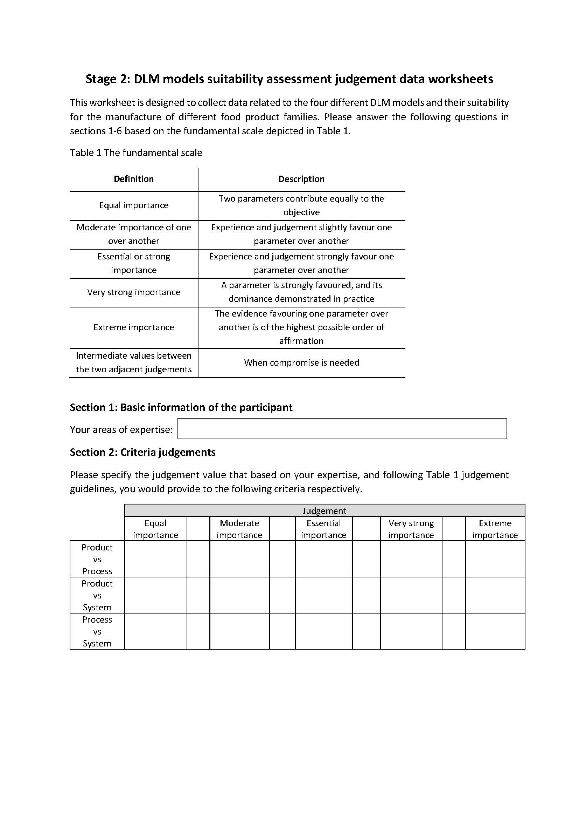
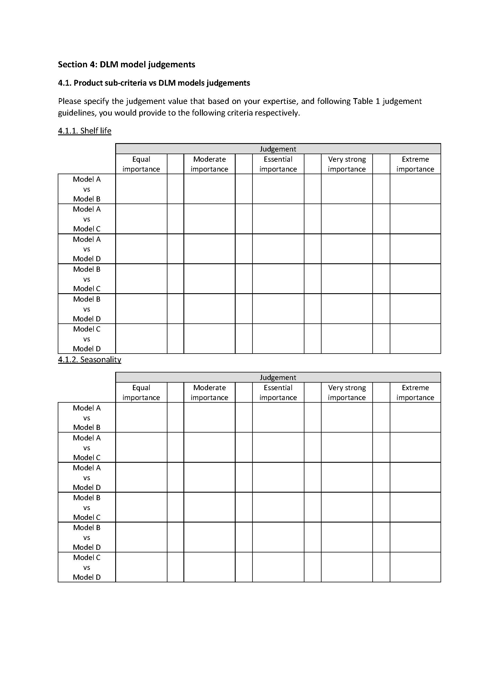

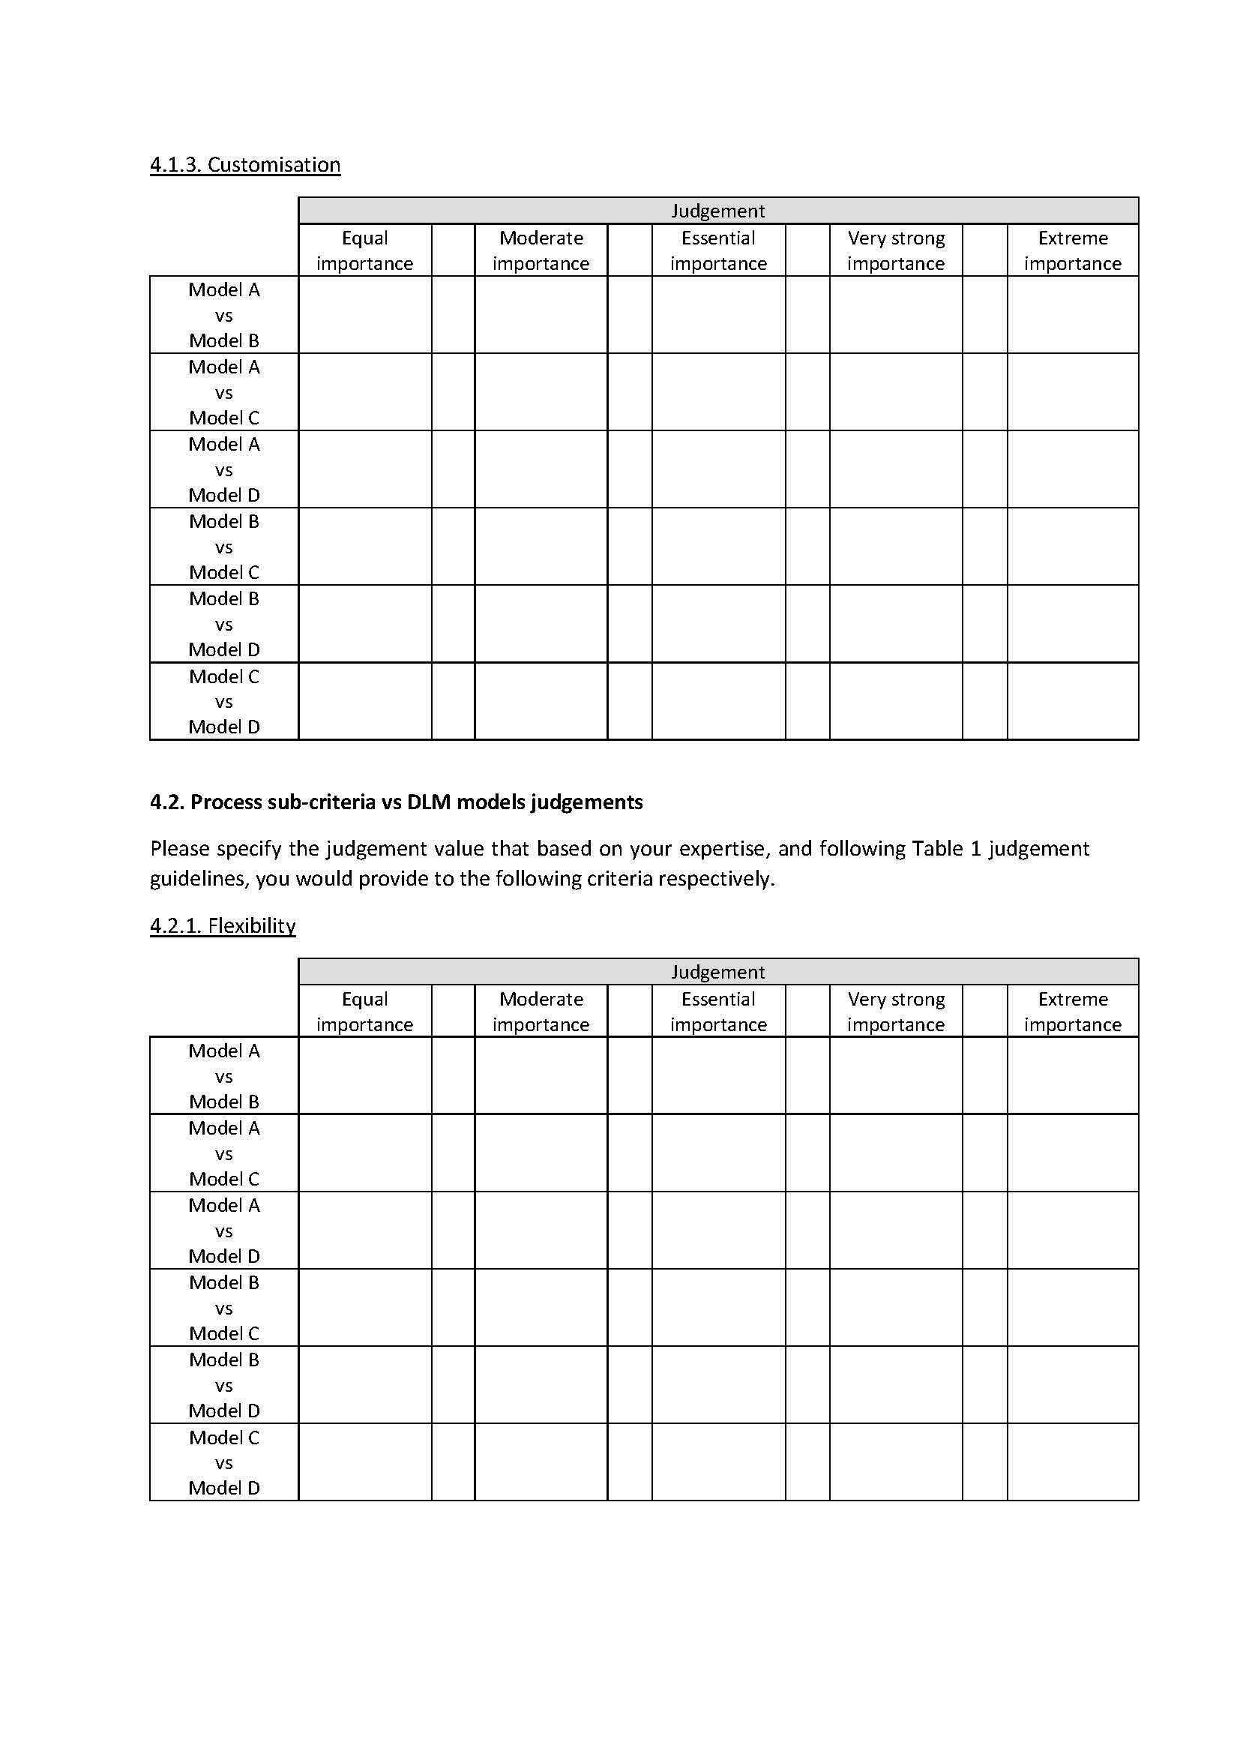

The judgement data collected from the four experts, as well as the geometric mean data, can be found in Tables 17-21.

Table 17. Expert 1’s judgement data
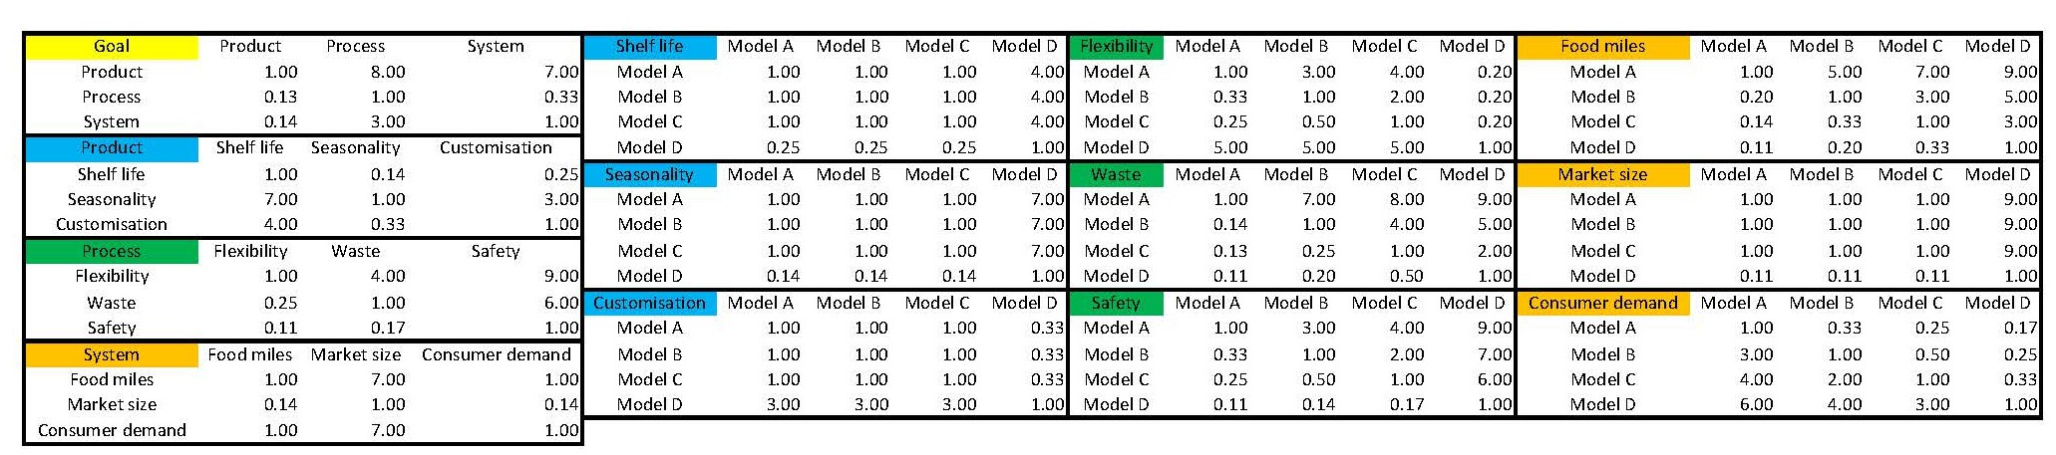

Table 18. Expert 2’s judgement data
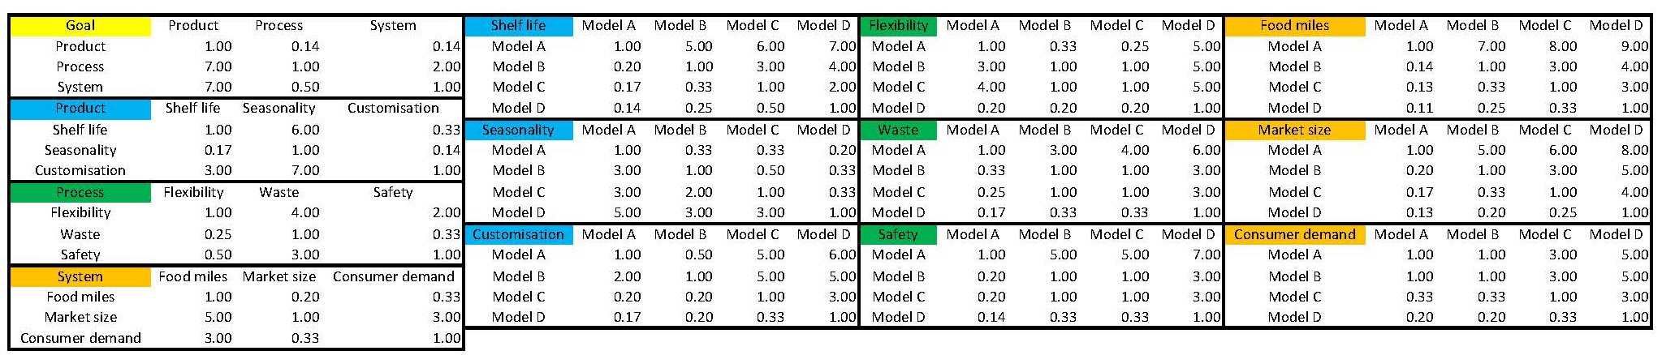

Table 19. Expert 3’s judgement data
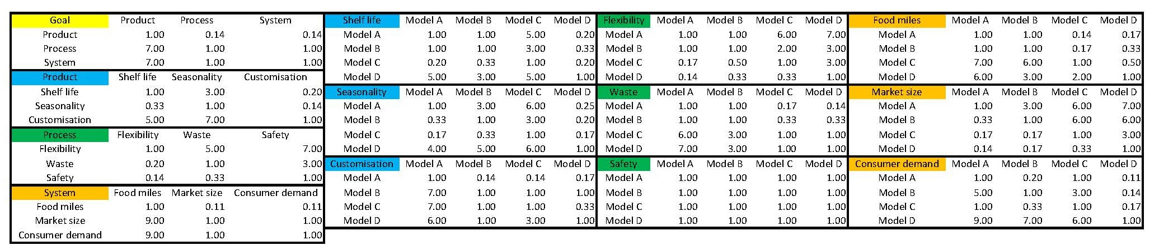

Table 20. Expert 4’s judgement data
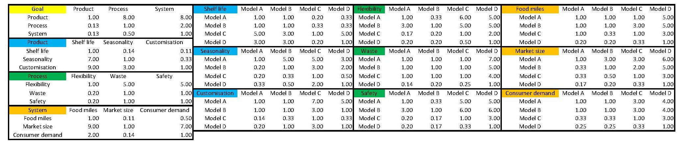

Table 21. Geometric mean of the experts’ judgement data
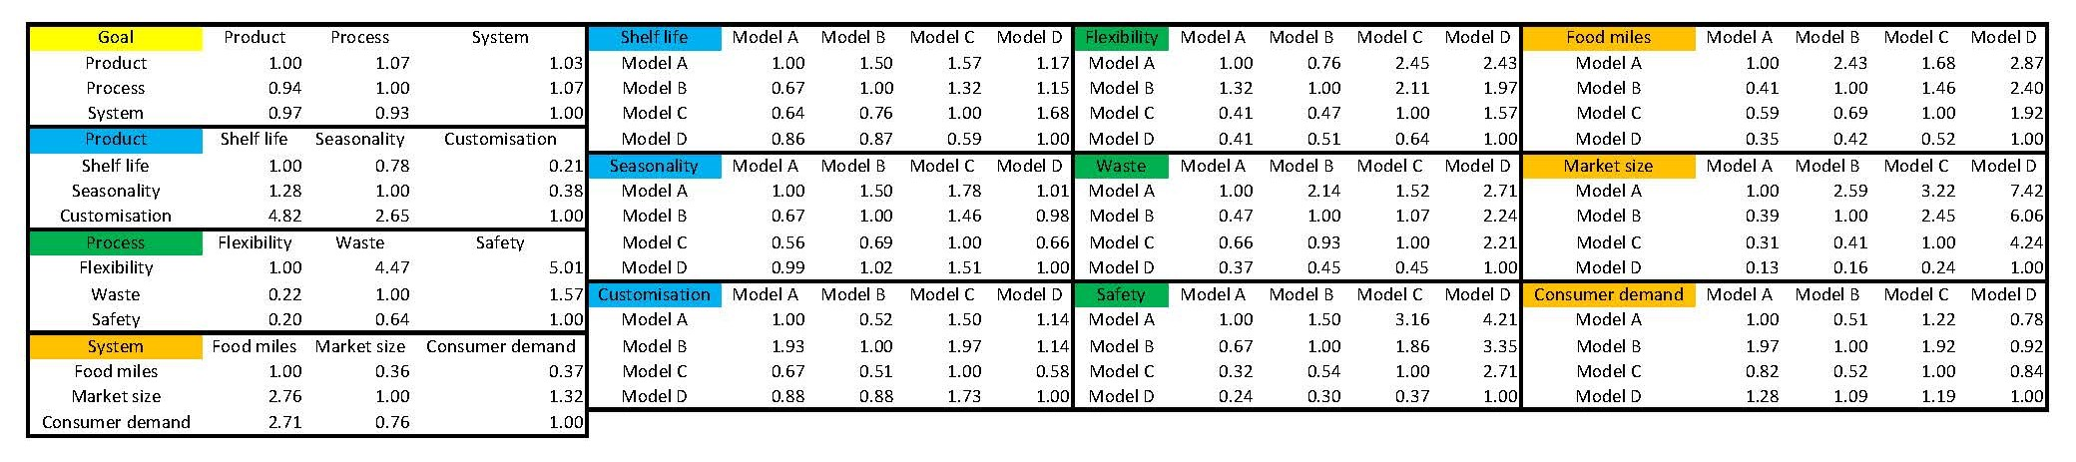

References
Aramyan, L.H., Lansink, A.O., Vorst, J. der, Kooten, O. van, 2007. Performance measurement in agri-food supply chains: a case study. Supply Chain Manag. 12, 304–315. https://doi.org/10.1108/13598540710759826
Beach, R., Muhlemann, A.P., Price, D.H.R., Paterson, A., Sharp, J.A., 2000. A review of manufacturing flexibility. Eur. J. Oper. Res. 122, 41–57. https://doi.org/10.1016/S0377-2217(99)00062-4
Bunse, K., Vodicka, M., Schönsleben, P., Brülhart, M., Ernst, F.O., 2011. Integrating energy efficiency performance in production management – gap analysis between industrial needs and scientific literature. J. Clean. Prod. 19, 667–679. https://doi.org/10.1016/j.jclepro.2010.11.011
Cleveland, L.E., Cook, D.A., Krebs-Smith, S.M., Friday, J., 1997. Method for assessing food intakes in terms of servings based on food guidance. Am. J. Clin. Nutr. 65, 1254S-1263S. https://doi.org/10.1093/ajcn/65.4.1254S
Food and Agriculture Organization of the United Nations, World Health Organization, 2018. Food categories. CODEX Alimentarius.
Geyer, A., Scapolo, F., Boden, M., Döry, T., Ducatel, K., 2003. The Future of Manufacturing in Europe 2015-2020 The Challenge for Sustainability, Technical Report Series.
Gimenez-Escalante, P., Rahimifard, S., 2019. Metrics for identifying the most suitable strategy for distributed localised food manufacturing. Procedia Manuf. 33, 586–593. https://doi.org/10.1016/j.promfg.2019.04.073
Hammond, S.T., Brown, J.H., Burger, J.R., Flanagan, T.P., Fristoe, T.S., Mercado-Silva, N., Nekola, J.C., Okie, J.G., 2015. Food Spoilage, Storage, and Transport: Implications for a Sustainable Future. Bioscience 65, 758–768. https://doi.org/10.1093/biosci/biv081
Jones, P., Comfort, D., Hillier, D., 2004. A case study of local food and its routes to market in the UK. Br. Food J. 106, 328–335. https://doi.org/10.1108/00070700410529582
Mundler, P., Criner, G., 2016. Food Systems: Food Miles, in: Encyclopedia of Food and Health. Elsevier, pp. 77–82. https://doi.org/10.1016/B978-0-12-384947-2.00325-1
Rahimifard, S., Seow, Y., Childs, T., 2010. Minimising embodied product energy to support energy efficient manufacturing. CIRP Ann. - Manuf. Technol. 59, 25–28. https://doi.org/10.1016/j.cirp.2010.03.048
Thilmany, D., Bond, C.A., Bond, J.K., 2008. Going Local: Exploring Consumer Behavior and Motivations for Direct Food Purchases. Am. J. Agric. Econ. 90, 1303–1309. https://doi.org/10.1111/j.1467-8276.2008.01221.x
Trienekens, J., Zuurbier, P., 2008. Quality and safety standards in the food industry, developments and challenges. Int. J. Prod. Econ. 113, 107–122. https://doi.org/10.1016/j.ijpe.2007.02.050

