Supplementary material
Table S1: List and description of nutrition and food security indicators used
Indicator | Description | Level
The Women Diet Diversity Minimum (MDD-W) | MDD-W is a dichotomous indicator defined as the proportion of women 15–49 years of age who consumed food items from at least five out of ten defined food groups the previous day or night.¹ | Woman
The Food Consumption Score (FCS) | FCS describes the current status of the household food consumption. It is a composite indicator based on dietary diversity, food frequency and nutritional importance of different food groups consumed the seven days before the interview.² In Myanmar, households with a FCS less than 38.5 are considered to have an inadequate diet (poor less than 21 and borderline more than 21 less than 38.5). | Household
Household with inadequate food consumption | Percentage of households with poor or borderline food consumption as measured by FCS. | Household
Household with low diet diversity | Proportion of households consuming 3 or less food groups the 24 hours prior to the survey which can be demonstrative of a poor quality of diet and a high risk of micronutrient deficiency. | Household
The Food Consumption Score – nutrition (FCS-N): | FCS-N looks at how often a household ate foods rich in a certain nutrient; Protein, Vitamin A and Iron (hem iron) primarily for their nutritional importance. The thesis of FCS-N is that although the nutrient, for example Vitamin A, can be obtained from many foods, the number of times a household ate food particularly rich in this nutrient can be used to assess likely adequacy of that nutrient. | Household
The Household Food Insecurity Access Scale Score (HFIAS Score) | The indicator is composed of a set of nine questions used and tested in several countries and aim to distinguish food insecure from food secure households. HFIAS can be used to assess the access component of food insecurity and the prevalence of household food insecurity.³ The HFIAS score is a continuous measure of the degree of food insecurity (access) in the household in the past four weeks (30 days). The higher the score, the more food insecurity (access) the household experienced. The lower the score, the less food insecurity (access) a household experienced | Household
The Household Food Insecurity Access Prevalence (HFIAP) | The HFIAP indicator categorizes households into four levels of household food insecurity (access); food secure, and mild, moderately and severely food insecure. | Household
The Wealth index | Households are given scores based on the number and kinds of consumer goods they own, ranging from a television to a bicycle or car, plus housing characteristics such as source of drinking water, toilet facilities, and flooring materials. These scores are derived using principal component analysis. Wealth quintiles are compiled by assigning the household score and then dividing the distribution into five equal categories, each with 20% of the population. | Household
References:
1. FAO and FHI 360. 2016. Minimum Dietary Diversity for Women: A Guide for Measurement. Rome: FAO.
2. WFP. 2008. Food consumption analysis Calculation and use of the food consumption score in food security analysis. http://documents.wfp.org/stellent/groups/public/documents/manual_guide_proced/wfp197216.pdf [accessed 2017]
3. Coates J., A. Swindale and P. Bilinsky. 2007. Household Food Insecurity Access Scale (HFIAS) for Measurement of Household Food Access: Indicator Guide (v. 3). Washington, D.C.: FHI 360/FANTA.

Table S2: Demographics and location of the participants (n=546)
Variable | (n=546) | Percent or Mean
Living with family or in a hostel | With family | 37.4
 | In a hostel/rented apartment | 62.6
Number of persons living in your household | Mean | 3
Age (in years) | 18 years | 33.7
 | 19 years | 66.3
Marital Status | Single | 90.5
 | Married | 9.3
 | Separated/divorced | .2
Education (the highest level completed) | Primary | 10.4
 | Middle | 40.7
 | High School | 47.4
 | Vocational school | 1.5
Distance from the factory (driving time) | Less than half an hour away from the factory | 84.8
 | From half – hour to 1 hour away from the factory | 14.5
 | From 1 – 2 hours from the factory | .7
Means of getting to work | Walk | 32.6
 | Moto | 2.7
 | Bicycle | 2.2
 | Bus shuttle factory | 40.8
 | Bus | .5
 | Ferry | 21.1
Women always lived here (Yangon city) | Yes, always lived here | 18.1
 | No, did not always live here | 81.9
Main reason for moving to Yangon | Find better job opportunities/income | 98.4
Year of relocation | Before 2016 | 11.3
 | 2016 | 11.3
 | 2017 | 20.7
 | 2018 | 56.7
Duration in the job | Less than 6 months | 59.5
 | 6 months to less than 1 year | 24.9
 | 1 year to less than 3 years | 15.0
 | 3 years to less than 10 years | .6
Number of hours worked in a week | 0 hour | .2
 | Less than 40 hours | 28.8
 | 40 – 48 hours | 9.7
 | 49+ hours | 61.4
Paid monthly | Cash monthly | 100.0
Daily pay | Mean | 8497
Received skill training | No | 84.1
 | Yes | 15.9
Reasons for being absent | Vacations | 16.9
 | Maternity leave | 1.7
 | Sickness | 50.8
 | Education leave | 1.7
 | Other personal leave | 23.7
 | Other | 5.1
Experienced fainting at work | No | 97.8
 | Yes | 2.2

Table S3: Reasons for not consuming food per meal type in the last 24 hours
 | No time to eat | No time to prepare | No money | No food available | Not hungry | Other (sick,...)
Breakfast | 41.1 | 1.8 | 3.6 | 0 | 53.6 | .0
Lunch | .0 | 7.7 | 7.7 | 0 | 69.2 | 15.4
Snack | 8.1 | 1.3 | 17.0 | 1.8 | 69.1 | 2.7
Dinner | .0 | .0 | .0 | .0 | 85.7 | 14.3

Figure S1: Sources of food per meal type

Figure S2: Mean consumption over the last 7 days per food group classified per food consumption score (FCS) groups poor, borderline and adequate (percent) (refer to Table 2 for FCS definition)

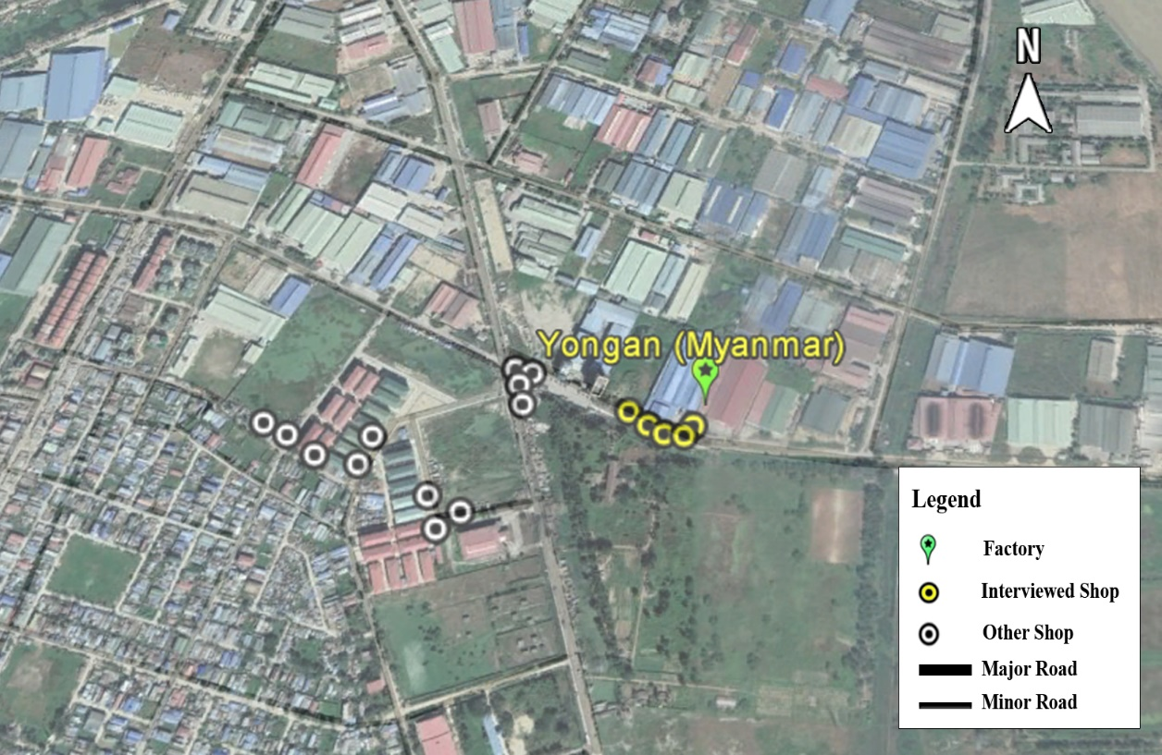
Figure S3: Example of a food walk near a factory

Figure S4: Food items sold near the factory (percent)

