After a decade of austerity, does the UK have an income safety net worth its name?

Donald Hirsch
ABSTRACT
Since 2010, the income safety net for working age households has been undermined in three distinguishable ways. First, general levels of entitlement have deteriorated relative to general incomes and prices, making them less ‘adequate’ relative to prices, general incomes and the cost of meeting minimum needs. Second, additional restrictions on entitlements have been imposed, detaching them from family needs and costs, through arbitrary limits imposed for example on larger families and those with high housing costs. Third, new impediments to accessing a safety-net income include a tougher sanctions regime and waiting periods for Universal Credit.
This article looks at the first two of these factors – those affecting the minimum amount that a household is in principle entitled to if they meet the requirements of work conditionality. It combines publicly-available data on benefit rates and recent research findings from the Minimum Income Standard to provide an assessment of the current UK income safety nets. The results show that, while the safety net level has never been systematically linked to need, the latest period has been particularly harsh on certain demographic groups and on those deemed to have made unacceptable choices in terms of the size of their families and/or the size and rent level of their homes. As a consequence, the article concludes, the principle of a safety net allowing everyone in the UK at least to have access to a very basic level of income lies in tatters.

Introduction
The term ‘safety net’, applied to minimum incomes, is seductively reassuring. It expresses a principle that no matter what their circumstances, the state will ensure that citizens will receive an income enabling them to survive, at least at a subsistence level. Structurally, the United Kingdom’s social security system provides such a safety net for all its citizens: some variant of Income Support is available to all categories of working age adults, and Pension Credit to those above state pension age, to guarantee a minimum level of income to those without other resources. Moreover, the system was designed to provide a given level of disposable income - after covering expenses that vary across households including rent, local taxes and the cost of disability, all of which are covered in separate benefits based on individual circumstances.
In practice, there are three big problems with this system: the lack of any empirical link between support levels and need, the inconsistent treatment of different groups and the exclusion of particular households or groups from a basic level of support. As argued below, each of these problems have always existed, but all are getting worse, and the third is being applied in new forms..
Firstly, what counts as a ‘safety net’ has no systematic relationship with what it actually costs to live, whether at a subsistence or other level. While the present rates originated, after the Second World War, from some notional calculation of subsistence (Bradshaw, 2013), any relationship with contemporary minimum needs is today theoretical. And even to the extent that the rates have been regarded politically as being just enough to live on, recent real-terms cuts in working-age benefits have made this assumption invalid. The argument that ‘at least in the UK you’re guaranteed enough for some form of subsistence’ does not hold if there is nothing to stop means-tested support from falling well below a subsistence level.
Secondly, while entitlements under the system originally related to some assumptions (however faulty) about household needs, the relationship of entitlements to needs has more recently become increasingly compromised. Since the 1990s, some more ‘deserving’ groups have seen their entitlements rise faster than others’ so that today a child, a working age adult and a pensioner have entitlements whose respective levels vary dramatically relative to their needs. Moreover, throughout the 2010s, a growing range of claimants have not even been able to access the level of disposable income implied by standard entitlements rates. The capping of benefits according to households’ circumstances, including the number of children and the level of their housing costs, has greatly weakened the relationship between safety-net income and levels of need.
A third flaw relates to ‘holes’ in the safety-net, which have always existed but are growing in size and number. Households can spend periods without income, or having to rely on income much lower than promised by the system, if for example they fail to meet conditionality rules or the administration of the system fails to provide income in a timely way. Universal Credit systematically creates the latter situation, as new claimants spend time waiting for payment (Foley, 2017, National Audit Office, 2018). Emergency hardship payments have been cut back, and are not always available. Conditionality has always existed, but has been imposed in a more draconian way. These and other changes since 2010 that cause people to be left without support were summed up by Perry et al. (2015) [Add references evidence from other chapters in present volume?]
Much attention has rightly been given to the worst situations where people find that they have no safety net at all, due to payment delays or sanctions (National Audit Office, 21018; Dwyer, 2018). Among the growing number of visitors to food banks, the single most cited driving force is having problems with receiving their benefits. Not surprisingly, it is where people find themselves without money for a period that they are most likely to resort to food banks. However even among those facing the desperate situation of not having enough food, another widely cited factor is that benefits are simply too low to make ends meet: most food bank managers now cite this as a high or very high impact factor affecting food bank users (Sosenko et al, 2019).This chapter’s focus is on the changes that austerity has brought to safety-net entitlements themselves. Among those not being sanctioned and whose benefits are delivered in a timely manner, to what extent are they protecting households against severe poverty and hardship?
The level of basic entitlements
Origins of safety-net levels, and change over time
William Beveridge’s 1942 report on the future of social security recommended setting National Assistance entitlements at rates compatible with fulfilling minimal dietary and other physical requirements, informed by a prewar Ministry of Labour survey based on the expenditure of working-class households. Slightly adapted in the National Assistance Act of 1948, this formed the benchmark for the means-tested safety net that later transformed into Supplementary Benefit and then Income Support (Bradshaw, 2013). Annual increments in their levels were subsequently based on political decisions, and at various times pegged to earnings or prices, rather than any new assessment of need. Thus, levels of safety-net income guarantees today have no meaningful empirical grounding in the actual cost of subsistence or a minimum living standard.
At a stretch, it could be asserted that safety-net benefits in one sense have come to represent a subsistence level, as an official view of what the poorest groups should live on, uprated annually at least in line with living costs. However, if this view ever had any validity, this has been fatally undermined by the breaking of the inflation link: if benefits are deemed to be just enough to live on and then decline in real value, they must logically become too little to live on. In 2012, the link between inflation and working-age benefit uprating was abandoned, replaced first by three years of fixed-rate 1% increases, and then by a four-year freeze (Osborne, 2012 and 2015). Between April 2012 and April 2019, benefits thus rose 3% in total, while the Consumer Prices Index rose by a cumulative 13%. If Income Support/Jobseekers Allowance rates were assumed exactly to provide subsistence in 2012, they therefore fell 10% short of doing so by 2019.
Changing relativities: (i) Comparing children, working age and pensioner entitlements
If the minimum incomes supported by benefit entitlements provided just enough for ‘minimum needs’, we might expect the relative amounts given to different demographic groups to remain similar over time. Over the past 20 years, however, these relativities have changed dramatically. Under the New Labour government, safety-net benefits for children and for pensioners rose significantly faster than inflation, in particular through the Child Tax Credit (CTC) and Pension Credit (PC), while adult safety-net benefits (notably IS/JSA) had inflation-only upratings. This was driven by stated government objectives of ending child and pensioner poverty , with no equivalent for tackling working-age poverty (Joyce and Sibieta, 2013). Since 2010, Pension Credit has continued to rise, while both IS/JSA and CTC has fallen, in real terms. This has resulted in a dramatic change in the relative entitlements of different groups, illustrated in Figure 1.
One comparison made in Figure 1 is between minimum benefits received by an adult without children and the amount allocated per child. The latter is calculated as the average for the first two children, and includes ‘family’ benefits, triggered by having any children. In 1997, the amount per child was under half the amount per adult; by 2010, it was similar amounts for each, triggered by a rising support for children and stagnating support for adults. Over the same period, safety-net benefit rate for a pensioner rose from about a third above that of working age adult to around double the rate. Since the onset of austerity, pensioner benefits have risen in real terms while both working age adults and children have seen a fall, further widening the gap between pensioner and other benefits.

Notes: Benefits for a "child" calculated as difference between entitlements of a couple with two children aged under 11 and a couple without children, divided by two. Since benefits for the first child is greater than for subsequent children, per-child benefits are somewhat higher than shown for a single-child family and lower for 3+ child family; also, 1997 entitlements are £12.10 a week higher (2019 prices) for children over 11. However, the broad pattern illustrated by this graph applies to all family types.
Working age adult is IS/JSA for a single person
Pensioner is IS/Pension Credit minimum guarantee, single rate

Sources: Institute of Fiscal Studies, 2019; ONS CPI data; author calculations

Changing relativities: (ii) The safety net compared to earnings
If the safety net is supposed to protect households against loss of earnings and other entitlements, one way of considering its adequacy over the long term is to compare it to average earnings levels. While means-tested benefits are not the same as insurance benefits protecting workers against loss of earnings, their level relative to what people can earn is an indicator of how far society is willing to go in protecting people against misfortune. Rising earnings are one indicator of growing prosperity, and benefits relative to earnings help determine the relative incomes of the poorest members of society, and hence relative deprivation. In short, they show how much we are willing to see the poorest fall behind.
The simplest indicator of safety net benefits relative to earnings is a comparison of the weekly single rate of Income Support or its predecessors Supplementary Benefit and National Assistance with average weekly earnings. This shows what minimum income single person is guaranteed if they have no income from work compared to what they would earn as an average worker. An advantage of this indicator is that it can be shown in consistent form over a very long period, and Figure 2 does so over the past half century.
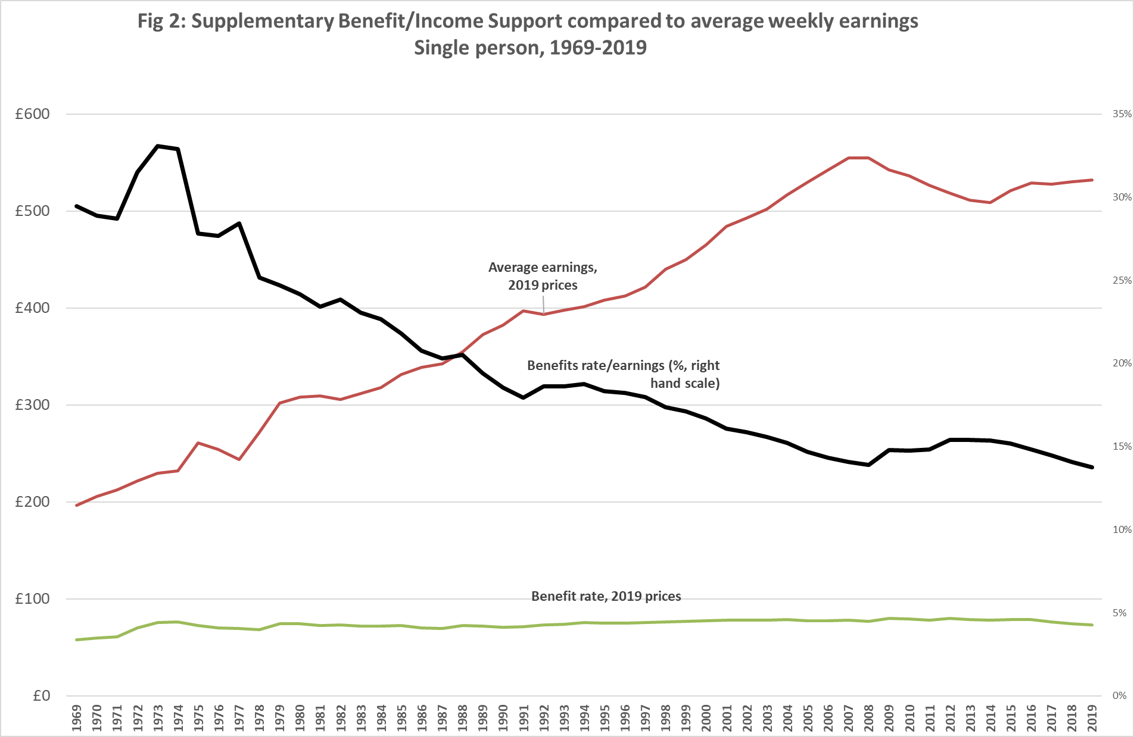
Sources: Institute of Fiscal Studies (2019); ONS (2019) and CPI data; author calculations
Figure 2 shows that since the late 1970s there has been a dramatic and almost continuous decline in the basic level of minimum benefits for a single person relative to average earnings. Before that time, the benefit level had been between a quarter and a third of earnings, whereas now it is only a seventh. The clear-cut cause of this decline is that benefits were mainly pegged to prices, but earnings rose substantially in real terms. Up until the late 1990s, this relative decline affected pensioner and children’s benefits as well as working-age adult rates, although as shown in Figure 1 above, pensioners and children have since risen substantially in real terms. One interesting aspect of Figure 2 is that there have been only two periods since 1980 when single adults’ benefits have slightly improved relative to earnings: in the recessions of the early 1990s and the late 2000s, when earnings were falling in real terms but benefits were still being uprated by inflation. A significant effect of the latter case is that during 2010-2012, inflation was relatively high, at a time when earnings were stagnating, and the effect was for benefit rates to be better insulated against the effect of recession than pay. This trend was used by the Chancellor of the Exchequer, George Osborne to recast the notion of ‘fairness’ and justify a restriction of benefit increases to below inflation, declaring in his 2012 Autumn Statement:
”We have to acknowledge that over the last five years those on out of work benefits have seen their incomes rise twice as fast as those in work.
“With pay restraint in businesses and government, average earnings have risen by around 10% since 2007.
“Out of work benefits have gone up by around 20%.
“That’s not fair to working people who pay the taxes that fund them.
“Those working in the public services, who have seen their basic pay frozen, will now see it rise by an average of 1%.
“A similar approach of a 1% rise should apply to those in receipt of benefits.
“That’s fair and it will ensure that we have a welfare system that Britain can afford.”
This statement was of great significance because it justified breaking the rule, for the first time since the Second World War, that benefits should rise at least in line with prices. After 2012, three years of 1% rises in most working-age benefits were followed by four years of zero increases. In introducing this change, the Chancellor correctly asserted that people on benefits had been shielded from real-term falls seen by working age people during a recession, but conveniently ignored that over the long term, the former had become far worse off relative to the latter. Thus, by 2019, the relative value of the safety-net had returned to its all time low.
Changing relativities (iii) Entitlements compared to the Minimum Income Standard
Comparing the safety-net benefits to average earnings, like comparisons to average household incomes, give a broad picture of the extent of protection relative to current norms. However, they do not show whether recipients can meet their needs in the context of contemporary society. Since 2008, the Minimum Income Standard (MIS) has produced more direct benchmarks showing the income needed for a social minimum. MIS set out to operationalise Townsend’s (1979) concept that in order to escape poverty, you need to be able to participate in society and have what is considered essential according to contemporary norms. The MIS method comprises detailed deliberations among groups of member of the public to identify the content of budgets sufficient to allow different household types to reach a minimum, defined in terms of both meeting material needs and having the opportunities and choices required to participate in society. These budgets are costed to show how much households require to reach a minimum acceptable living standard (Hirsch, 2019; Davis et al., 2017).
Figure 3 shows how safety-net incomes have fared against this standard. It confirms that the adequacy of the safety net varies greatly from one group to the next, with pensioners getting approximately what they need, families with children slightly over half and a single person without children only a third. The graph also shows how, for all groups, benefits have declined against this adequacy benchmark.
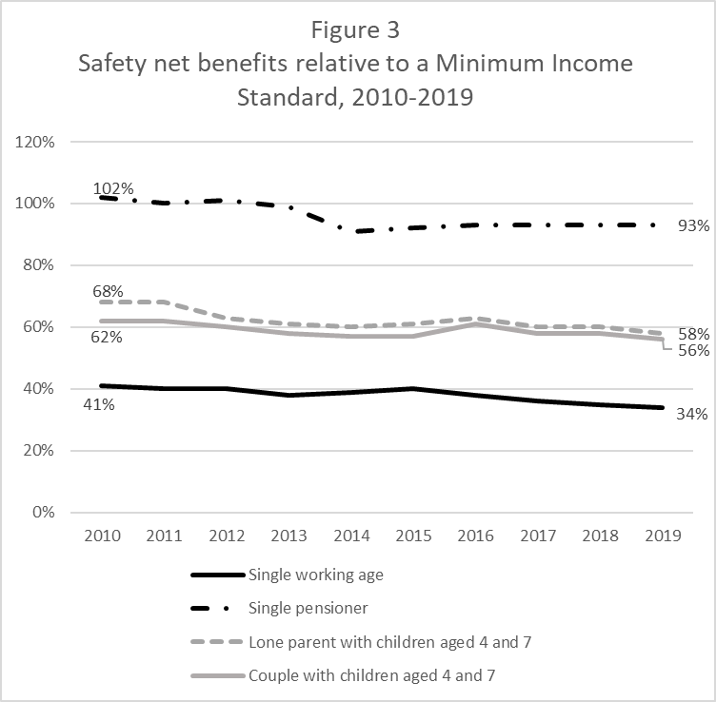
Notes:
Comparison based on budgets net of rent, childcare and council tax. Income does not include benefits associated with those items. However, the fact that since 2013, council tax support does not fully cover council tax is taken into account, by subtracting the typical shortfall from safety-net benefit income.

Source: MIS database

For pensioners a slight deterioration in minimum benefit adequacy may seem surprising, given that their main safety net benefit, Pension Credit, has risen with earnings or CPI inflation, whichever is greatest. However, minimum pensioner costs overall have risen faster than CPI, partly because some items such as domestic fuel that figure prominently in pensioner budgets have high inflation rates; and partly because certain specifications, set by members of the public in the MIS research, have increased, for example because of a growing emphasis on pensioners being able to participate fully in society. However, pensioners’ minimum needs remain mainly covered by minimum benefits, and are largely stable in these terms. In contrast, for working age adults with and without children an already inadequate package has declined substantially since 2010. In particular, over the past nine years, the adequacy of income support for a single person has declined from an already austere situation of getting less than half, to now getting only one third of what they need. Most of this has occurred because benefits have risen more slowly than costs, and been frozen since 2016. A further factor taken into account in Figure 3 is that, since 2013, all working age applicants have had to contribute to the cost of council tax an amount that is not fully reimbursed through Council Tax Support, and therefore systematically reduces disposable income.
Breaking the link between entitlement and need
Up to here, safety net benefits have been reported as if they are paid according to a consistent schedule based on the amounts assigned to the different types of individuals who live in a ‘benefit unit’ (single, couple or family with dependent children), each of whom has a standard entitlement. Increasingly, however, benefits do not provide a disposable income based on these amounts, either because basic benefits are restricted or because housing-related benefits do not pay for the full amount incurred in rent, and the shortfall needs to be made up from basic benefits.
Four particular cases of this are:
- The Benefit Cap, restricting the total level of benefits any one family can receive, currently to £442 a week in London and £385 outside London. This measure ‘punishes’ families for having multiple children, or high housing costs, or both, by greatly restricting the support available to cover the costs that these circumstances generate. Moreover, when the cap’s arbitrary level was reduced in 2016 from its original level of £500, its reach extended to hit more or less all families of five or more, and some four-person families (such as a couple with two children) who face private sector rents (Hirsch, 2015). Thus, it is no longer just families with exceptional circumstances whose benefits are being curtailed by the cap.

- The ‘two child limit’, under which the calculation of means tested benefits stops taking account of third or subsequent children born after April 2017. Since 29% of all children, and 42% of children in non-working families, have at least two siblings (Author calculation from Family Resources Survey), this will have extremely wide-ranging effects - even were it to have some behavioural effect by deterring people from having additional children. Like the Benefit Cap, this policy will result in larger families falling much further short of meeting their needs on benefits, although it is being introduced more slowly, so some existing three-child families will remain unaffected until the early 2030s under present rules. For many families affected, the Benefit Cap will become less significant, since the two-child limit will cause benefits to fall below the cap. Conversely, even those larger families unaffected by the two-child limit because they were created before 2017 are likely to be hit by the Benefit Cap.

- For social tenants, the ‘bedroom tax’ rule which deducts Housing Benefit for those considered to be ‘under-occupying’ their homes. The deductions are 14% of rent for one ‘spare’ bedroom and 25% for two or more. To avoid this deduction, families may need to be highly adaptable in their living arrangements, and persuade their landlords to make this possible. For example, a family with a boy and a girl would need to occupy a two bedroom home until the oldest child turns ten, and then move to a three bedroom property: yet in practice, social housing transfers are highly contingent on availability. Those unable to avoid the bedroom tax must cover their rent from sources other than Housing Benefit.

- For private tenants, caps to the Local Housing Allowance, the limit to the rent levels that can be reimbursed through Housing Benefit. Originally set at levels sensitive to local rent levels, the levels of the allowance have been detached from market rents since 2012 and have been frozen since 2015. This means that anyone living in a home with a rent at the limit of eligibility in 2012, which has since risen at an average rate, now has to find 7% of that rent from general benefits outside London, and 10% in London (author calculation based on ONS rent index). More usually, it has increased an existing shortfall: even before the LHA freeze, the assumption that the state would usually cover the rent for non-working households renting privately was out of date, with most having to contribute out of their basic benefits. The Resolution Foundation estimates that on average HB now covers just 55 per cent of the housing costs of non-working, private renting ‘millennial’ families (born 1981-2000) at age 25; the equivalent figure for ‘generation X’ families (born 1966-1980) at the same age was 77 per cent (Judge and Tomlinson, 2018).
Each of these measures in some sense penalises a household that has not ‘behaved’ in a prescribed way, either in terms of how many children they have or what steps they take to limit their housing costs. Such penalties depart from the principle of basing benefits on needs, and take no account of how much control households have in practice over costs such as rent. Together, they help create a safety net that varies greatly in its adequacy according to the individual circumstances of households.
Figure 4 illustrates this by showing how claimants are typically affected by the above measures, in terms of what proportion of minimum income is provided by benefits. It is worth recalling that, even without the four restrictions to benefits shown here, the adequacy of benefits has been deteriorating, as shown in Figure 3 above: in 2010, they typically provided almost two thirds of minimum requirements for families with children, and the trend has been for this to decline to not much more than half. The first section of the graph shows that for those currently hit by the Benefit Cap, this already falls to below half, and for those hit by the two-child policy it falls further. Reductions in adequacy due to the bedroom tax and the LHA freeze are less steep, yet still significant, and add to the extent to which benefits fall short of meeting needs. For a single person without children, shown here because they are particularly likely to be renting in the private sector, the LHA freeze brings benefits below a third of required disposable income.
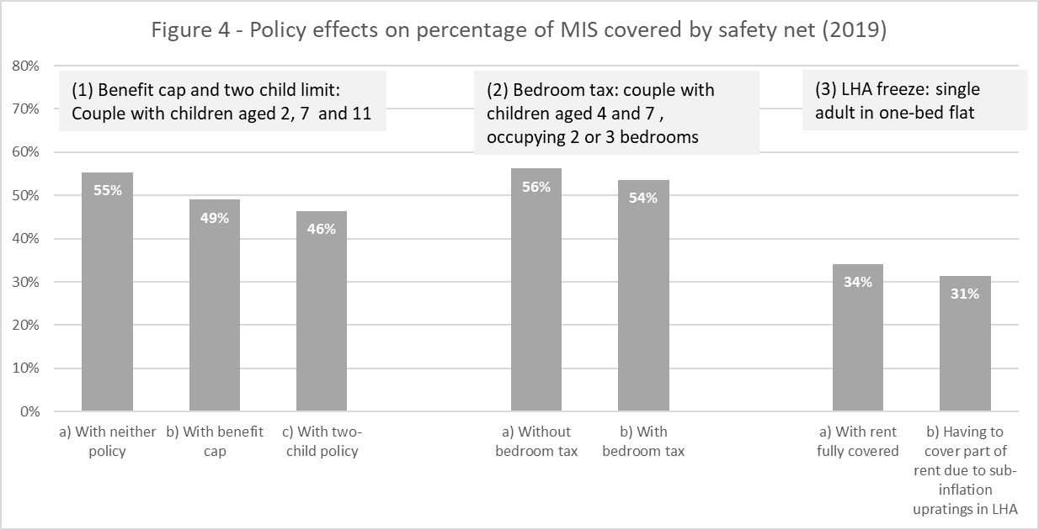
Source: author calculations from MIS data
The safety net and subsistence – an illustration
The above analysis has shown that the UK’s ‘safety net’ benefits, which have never maintained a systematic link with subsistence, have recently become both less adequate and more arbitrary in terms of enabling claimants to make ends meet at some basic level. It is clear that they leave many people well short of what the public consider necessary as a minimum. But how low have they become in relation to subsistence?
A more tangible way to consider this question than the percentages presented above is to take the example of a single person, aged over 35, living in a rented one-bedroom flat, on means-tested Jobseekers’ Allowance. Using the last case in Figure 4, where recent sub-inflation increases in Local Housing Allowance have necessitated a contribution to rent out of basic benefits, and also where a contribution has to be made to help cover Council Tax, this person’s £72.10 a week headline benefit entitlement translates into £64.25 disposable income (all figures for 2019). After subtracting the utility bills estimated for this case in the MIS research (water, gas and electricity), this reduces to £44 in their pocket, compared to over £180 that is needed, after bills, for a minimum standard of living. This remaining £44 is lower even than the £49.64 allocated just to food in the MIS single person’s budget. Around £5 of this is allocated to occasionally eating out; even if this is excluded, the food budget is just above the single person’s £44 total spending money after bills. So in this case, disposable income on benefits is not even enough to meet a food budget, let alone the wide range of other things you need to buy. Many of these are not optional, even in relation to nutrition: you need to spend money on transport just to get to the shops to buy the food, on clothing to look presentable when you get there and on household goods that allow you to sit down, cook and eat what you have bought. In other words, the safety net income for a single person is too low even to fund a reasonable diet, let alone a decent life.
Conclusion
This chapter has shown how the ‘safety net’ originally designed to prevent people in the UK from being left without the means of subsistence is no longer providing any systematic form of protection. The most that can be said is that all groups have some entitlement to safety net income, rather than to zero, although sanctions and waiting periods can nevertheless leave some people without income for significant amounts of time.
One aspect of this disintegration of the safety net is that there is no ‘floor’ below which its level cannot fall. The fact that benefits can be arbitrarily frozen during periods of inflation destroys any notion that they support some living standard, even one of subsistence. In the worst cases, benefit rates are now not even sufficient to maintain a sufficient diet, regardless of how frugal other areas of spending become.
The other aspect of disintegration is the detachment of entitlement from need in a range of individual circumstances related to family size and to housing. A wide range of claimants have their normal entitlements affected by the Benefit Cap, the two-child limit, the ‘bedroom tax’, the LHA freeze or a combination of these. Such restrictions are not just exceptions but are becoming the ‘new norm’. Two of these policies in particular have increasing ‘bite’ over time: the LHA limits on rents eligible for benefits, as rising rent levels are not matched by rises in these limits; and the Benefit Cap, which has been lowered, and at its present rate will increasingly affect not just larger families but those with as few as two children. It is possible to envisage a future where a lifting of the freeze on benefit rates but not on the Benefit Cap means that a growing number of families continue to have their benefits frozen at the level of the cap, while their costs rise with inflation.
Far from affecting only a few selected groups, this detachment of entitlement from need could actually end up impacting the majority of families requiring safety-net benefits. As well as the four in ten children in non-working families who have at least two siblings, and are therefore likely to be impacted by the two-child limit and/or the Benefit Cap, over a quarter (27)% live in private rented accommodation, vulnerable to the effect of LHA limits, which are increasingly out of line with rents. The majority of children in non-working families (58%) are affected by at least one of these two characteristics – a large family or a private tenancy (Author calculations from Family Resources Survey). Behavioural responses (having fewer children; moving to cheaper accommodation) could potentially reduce these proportions. Whether or not this occurs in the future, these figures suggest that standard safety-net incomes are being restricted for most claimants based on current living patterns. This is a gloomy picture, that would not be resolved only by piecemeal reforms such as abolishing individual policies like the two child limit. A safety net worth its name would need to create a new, systematic relationship between basic household needs and the delivery of an income guarantee. For pensioners, the Pension Credit, combined with the new, more adequate, single-tier pension come close to achieving this. For working age households unable to support themselves by their own means, the present system comes nowhere near providing an adequate system of protection.
REFERENCES
Bradshaw, J. (2013), Jonathan Bradshaw, Selected Writings 1972-2011. York: University of York
Davis, A., Hirsch, D. and Padley, M. (2017) ‘The Minimum Income Standard as a benchmark of a ‘participatory social minimum’’, Journal of Poverty and Social Justice.
Dwyer, P. (2018), ‘Punitive and ineffective: benefit sanctions within social security.’ Journal of Social Security Law. pp. 142-157
Foley, B. (2017) Delivering on Universal Credit, London: Citizens Advice.
Institute for Fiscal Studies (2019, Fiscal Facts, https://www.ifs.org.uk/tools_and_resources/fiscal_facts , accessed 02/12/19
Judge, L. and Tomlinson, D. (2018), Home Improvements. London: Resolution Foundation/Intergenerational Commission.
Hirsch, D. (2015), The cost of a child in 2015. London: Child Poverty Action Group
Hirsch,D. (2019), A minimum income for the United Kingdom in 2019. York: Joseph Rowntree Foundation
National Audit Office (2018), Rolling out Universal Credit.
Office for National Statistics (2019), Average weekly earnings: https://www.ons.gov.uk/employmentandlabourmarket/peopleinwork/earningsandworkinghours/datasets/averageweeklyearnings , accessed 02/12/19
Osborne, G. (2012), Autumn statement. London: HM Treasury, https://www.gov.uk/government/speeches/autumn-statement-2012-chancellors-statement
Osborne, G. (2015), Summer budget speech. London: HM Treasury
Perry, J., Purcell, L. and Cooper, N. (2015), Restoring Faith in the Safety Net. London: Church Action on Poverty
Robert Joyce and Luke Sibieta (2013), ‘Labour's record on poverty and inequality’, Observation. London: Institute for Fiscal StudiesSosenko, F., Littlewood, M., Bramley, G., Fitzpatrick, S., Blenkinsopp, J. and Wood, J. (2019, forthcoming), The State of Hunger, Year 1 main report. London: Trussell Trust
Townsend, P. (1979). Poverty in the United Kingdom. London: Penguin.

