Supporting Information: A quartz crystal resonator for cellular phenotyping

Carlos da Silva Granja¹, Katie Glen¹, Niklas Sandström², Victor P Ostanin³, Rob J. Thomas¹, Sourav K Ghosh¹*
1 Centre for Biological Engineering, Loughborough University, UK
2 Micro and Nanosystems, KTH Royal Institute of Technology, Sweden
3 Department of Chemistry, University of Cambridge, UK
* Corresponding author

S1. Deriving analytical expressions for shifts in resonance frequency and dissipation of a plate in shear oscillation due to viscous liquid loading

S1.1. Dynamics of viscous liquid trapped between oscillatory parallel planes
We first consider the classical case of an infinite plane oscillating in-plane parallel to a stationary infinite plane above it with a viscous liquid trapped in between them (Figure S1).

Figure S1. Infinite plane in in-plane oscillation parallel to a stationary infinite plane above it with a viscous liquid trapped in between.

The velocity of oscillation of the bottom plane is given by $v_{q}e^{iωt}$, where $v_{q}$ and $ω$ are the velocity amplitude and angular frequency of oscillation (rad/s) respectively. The distance (or height) between the two planes is taken as $h$. The differential equation of one-dimensional shear oscillation of any layer of liquid between the two afore-mentioned planes at a height $x$ from the oscillatory bottom plane is given by

$$η\frac{d^{2}v(t,x)}{dx^{2}}=ρ\frac{dv(t,x)}{dt}$$ | (1)

where $η$ and $ρ$ are absolute viscosity and density of the liquid, respectively. We assume no slip at the liquid-plane interfaces of both the planes, i.e. the boundary conditions for the above differential equation are given by $v\left(t,0\right)=v_{q}e^{iωt}$ and $v\left(t,h\right)=0$. Solving Eq.1 analytically using Wolfram Mathematica 10.3, we have

$$v\left(t,x\right)=v_{q}e^{iωt}cosech\left(\left(1+i\right)h\sqrt{\frac{ρω}{2η}}\right)sinh\left(\left(1+i\right)(h-x)\sqrt{\frac{ρω}{2η}}\right)$$ | (2)

In the special case, when the stationary upper plane is absent, i.e. $h→∞$, Eq.2 assumes the Kanazawa-Gordon’s classical solution (Eq.3) (Keiji Kanazawa and Gordon, 1985).

$$v\left(t,x\right)=v_{q}ⅇ^{-x\sqrt{\frac{ρω}{2η}}} .e^{i(ωt-x\sqrt{\frac{ρω}{2η}})}$$ | (3)

Eq.3 suggests that the velocity of shear oscillation of the liquid assumes an exponential decay profile with distance from the oscillating bottom plane (Figure 1c of the main Article). The magnitude of velocity of shear oscillation ($v_{q}ⅇ^{-x\sqrt{\frac{ρω}{2η}}}$) drops down $ⅇ$ times at every height unit of $\sqrt{\frac{2η}{ρω}}$ from the oscillating plane. This height is referred to as the acoustic shear wave penetration depth. Here, we term this height unit as the Kanazawa Unit (KU). For water on a 14.3 MHz quartz crystal resonator, 1 KU = 140.7 nm.

Coming back to our two parallel plane case, the shear stress on any layer of liquid parallel to the oscillating bottom plane at a height $x$ from can be evaluated from Eq. 2 as follows.

$$τ(t,x)=η\frac{dv\left(t,x\right)}{dx}$$  $$=-(1+i)v_{q}e^{iωt}\sqrt{\frac{ηρω}{2}} cosech\left(\left(1+i\right)h\sqrt{\frac{ρω}{2η}}\right)cosh\left(\left(1+i\right)(h-x)\sqrt{\frac{ρω}{2η}}\right)$$ | (4)

From Eq. 4, the shear stress at the liquid-plane interface near the oscillating bottom plane (i.e. $x=0$) is given by

$$τ(t,0)=-(1+i)v_{q}e^{iωt}\sqrt{\frac{ηρω}{2}} coth\left(\left(1+i\right)h\sqrt{\frac{ρω}{2η}}\right)$$ | (5)

Using Eq. 5, the load impedance ($z_{L}$) of the liquid layer driven by the oscillating bottom plane is given by

$$z_{L}=\frac{τ(t,0)}{v_{q}e^{iωt}}=-(1+i)\sqrt{\frac{ηρω}{2}} coth\left(\left(1+i\right)h\sqrt{\frac{ρω}{2η}}\right)$$ | (6)

S1.2. Shifts in acoustic response of an oscillating plate due to viscous liquid loading
We could now consider an elastic plate in thickness shear oscillation, for instance a quartz crystal resonator, of thickness $t$, the upper plane of which models an oscillating plane driving a layer of liquid as described in Section S1.1, and the bottom plane of which is free. For small-load approximation, the complex frequency shift of the oscillating plate, $∆F^{*}=∆F+i∆Γ$, due to the liquid loading is given by

$$\frac{∆F+i∆Γ}{f_{0}}≈\frac{iz_{L}}{πz_{p}}$$

Using the expression of load impedance ($z_{L}$) derived in Eq. 6, we have
$$\frac{∆F+i∆Γ}{f_{0}}≈-i\left(1+i\right)\frac{\sqrt{ηρω}}{\sqrt{2}πz_{p}} coth\left(\left(1+i\right)h\sqrt{\frac{ρω}{2η}}\right)$$ | (7)

where $∆F$ and $∆Γ$ are the shifts in resonance frequency and dissipation (half-bandwidth) respectively, $f_{0}$ is the fundamental resonance frequency and $z_{p}$ is the acoustic impedance of the plate (Tellechea et al., 2009). Replacing $X=h\sqrt{\frac{ρω}{2η}}$ in Eq. 7, i.e. normalising the height $h$ of the liquid layer by $\sqrt{\frac{2η}{ρω}}$ to express it in units of $\sqrt{\frac{2η}{ρω}}$ (Kanazawa Unit), we have

$$\frac{∆F+i∆Γ}{f_{0}}=\frac{\sqrt{ηρω}}{\sqrt{2}πz_{p}} \frac{\left(Sin(2X)-Sinh(2X)\right)+i\left(Sin(2X)+Sinh(2X)\right)}{Cos(2X)-Cosh(2X)}$$ | (8)

Comparing the real and imaginary components in Eq.8, we have

$$-∆F=-\left(f_{0}\frac{\sqrt{ηρω}}{\sqrt{2}πz_{p}}\right) \frac{Sin(2X)-Sinh(2X)}{Cos(2X)-Cosh(2X)}$$  $$∆Γ=\left(f_{0}\frac{\sqrt{ηρω}}{\sqrt{2}πz_{p}}\right) \frac{Sin(2X)+Sinh(2X)}{Cos(2X)-Cosh(2X)}$$  $$\frac{∆Γ}{-∆F}=-\frac{Sin(2X)+Sinh(2X)}{Sin(2X)-Sinh(2X)}$$ | (9)

S2. Cell size and count method with ImageJ analysis

This method was adapted from (ImageJ 2007). Automatic particle analyses with “Analyze Particles” requires a binary image (Image>Type>8-bit) before colour threshold is applied. Adjusting the thresholds was found to be easier after flattening (Image>Overlay>Flatten) and subtracting background (Process>Subtract Background) due to reflective nature of the gold electrode. Automatic colour threshold was then applied to the image (Image>Adjust>Color Threshold) followed by delineation of close objects with watershed (Process>Binary>Watershed). Before cell count (Analyze>Analyze Particles), an area in the field of view deprived of scratches was selected. The settings for particle size and circularity were set to 30-infinity and 0.1-1 respectively.

Figure S2. Flow cytometric analysis of human CD34+ cells differentiated into erythroid cells. Histograms show CD34+ cells on Day 2 (red), 6 (blue), 9 (orange) and 17 (green) of erythroid differentiation stained with CD36 (a), CD44 (b) and corresponding IgG (inserts on a and b respectively).

S3. Specificity of binding
Figure S3 shows the surface micrographs of the CD71 QCR (Figure S3a) and CD36 QCR (Figure S3b) after cryopreserved erythroblasts are flowed under continuous flow at a concentration of 5.5 x 10⁴ mL⁻¹ in PBS for 45 min. The respective insets show the antigen expression levels of CD71 (Figure S3a inset) and CD36 (Figure S3b inset). The experiment shows that the number of cells bound to the QCR with a certain antibody correlates with the expression levels of the antigen to which the antibody is specific. When the antigen expression levels are near cut-off (as with CD36), the number of cells bound to the QCR with antibody specific to that antigen is also negligible, suggesting low non-specific binding or physical adsorption.
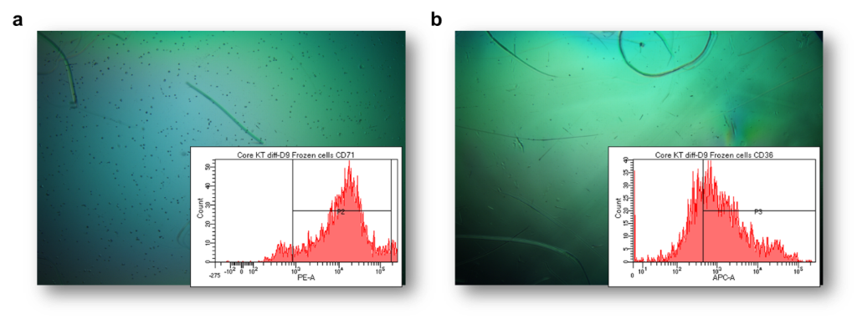
Figure S3. Effect of cryopreservation on erythroblast surface marker expression and cell binding on anti-CD71- (a) and anti-CD36 (b) antibody functionalised QCRs.

S4. QCR micrographs after 45 min of cell injection on various culture days
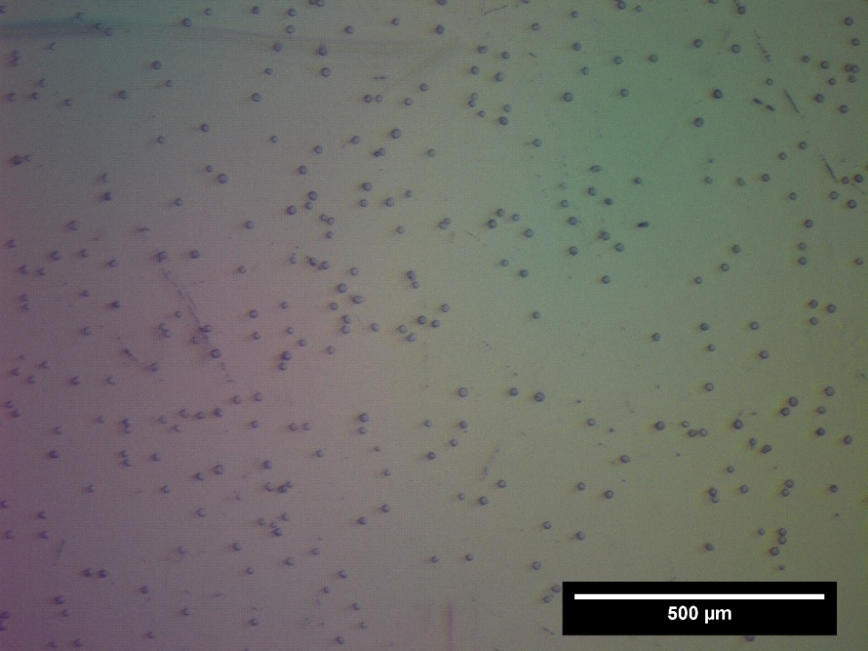
Figure S4. Micrograph of QCR surface on Day 2

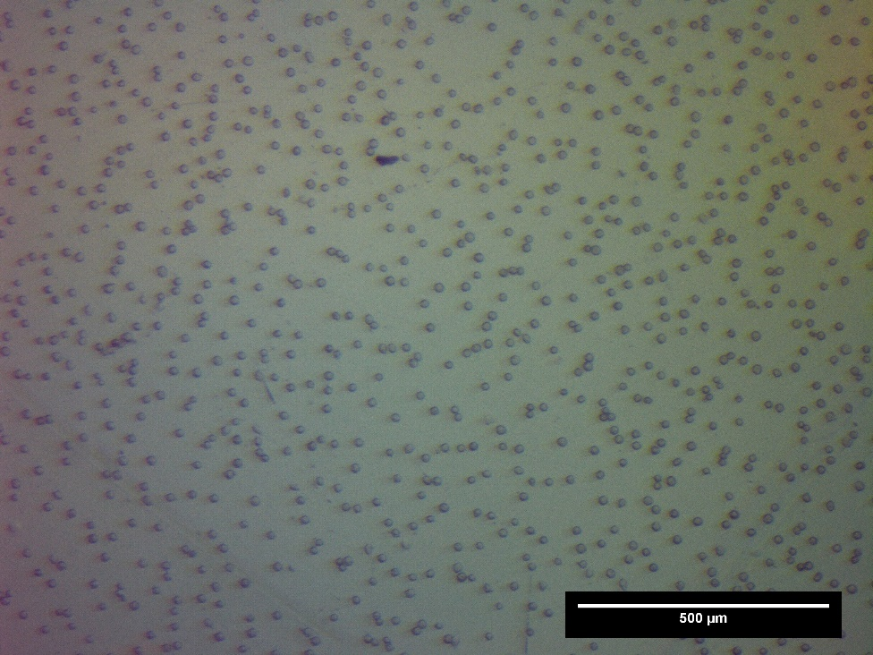
Figure S5. Micrograph of QCR surface on Day 6

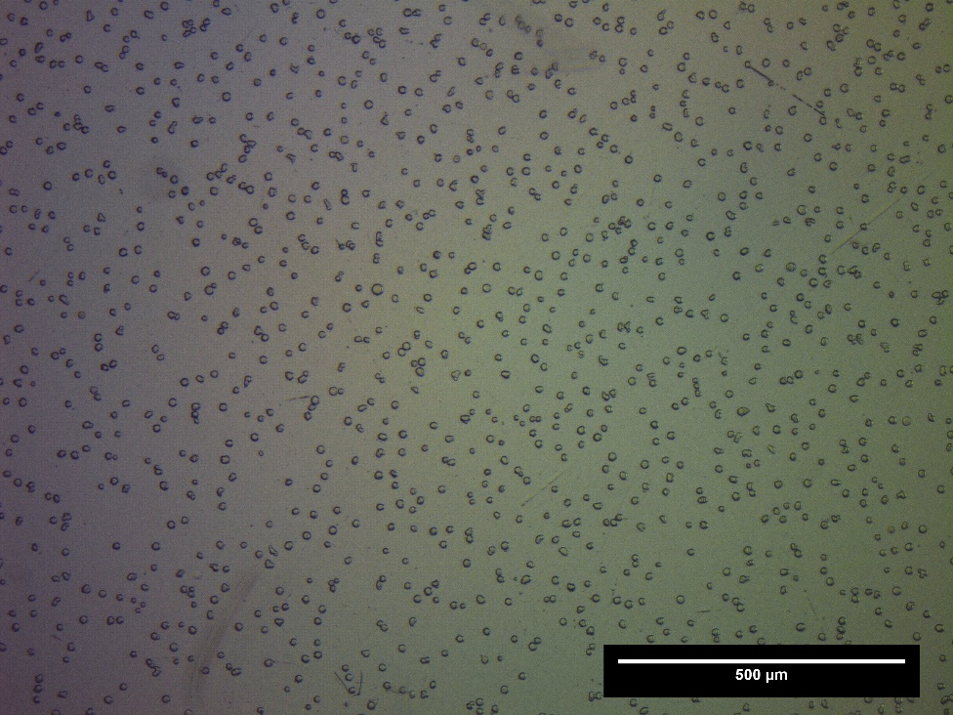
Figure S6. Micrograph of QCR surface on Day 9

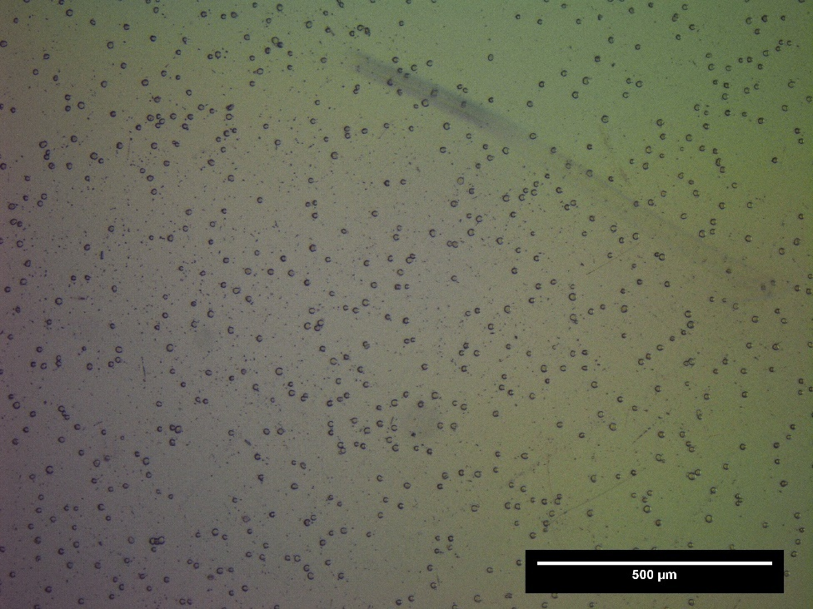
Figure S7. Micrograph of QCR surface on Day 13

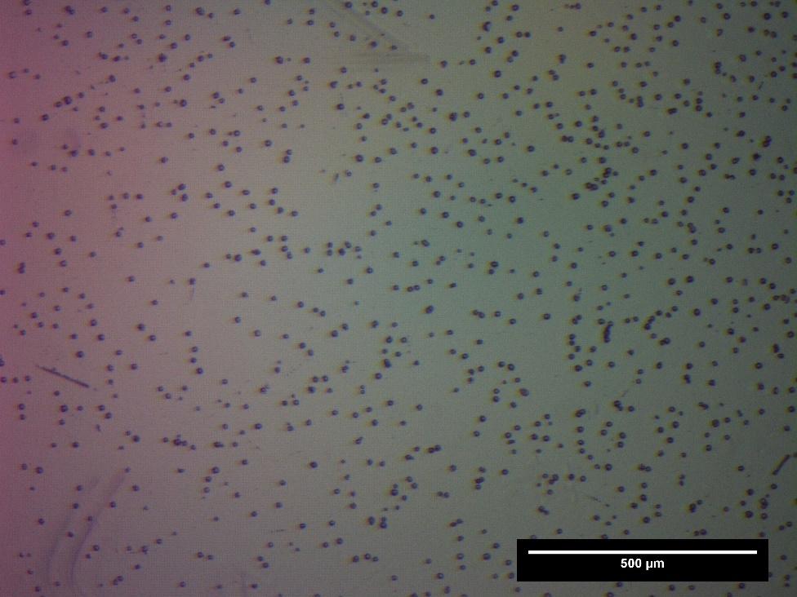
Figure S8. Micrograph of QCR surface on Day 17

S5. Admittance spectra on various culture days
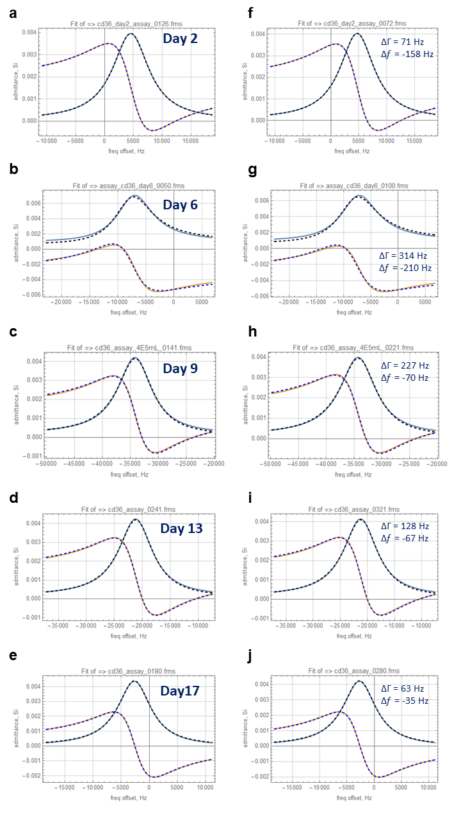
Figure S9. Admittance vs. frequency offset from 14.3 MHz. The graphs show the real (blue) and imaginary (purple) parts of admittance for a set of frequency sweeps taken during the erythroblast detection experiments. Dashed black lines represent fitting function used to derive acoustic parameters. The fitting was done using the Butterworth-Van Dyke (BVD) equivalent circuit model for a quartz crystal resonator. (a-e) show graphs for Days 2, 6, 9, 13 and 17, respectively, before erythroblast injection (t=0). (f-j) show graphs for Days 2, 6, 9, 13 and 17, respectively, after erythroblast injection (t=45). The shifts in resonance frequency and dissipation after 45 min of injection for each Day as determined from the fitting are shown on the graphs (f-j).

References
Keiji Kanazawa, K. and Gordon, J. G. (1985) ‘The oscillation frequency of a quartz resonator in contact with liquid’, Analytica Chimica Acta. Elsevier, 175(C), pp. 99–105. doi: 10.1016/S0003-2670(00)82721-X.
Tellechea, E. et al. (2009) ‘Model-independent analysis of QCM data on colloidal particle adsorption’, Langmuir. American Chemical Society, 25(9), pp. 5177–5184. doi: 10.1021/la803912p.

