Supporting Information
for

In-situ Synthesis of Cross-linked Imidazolium Functionalized Poly(styrene-b-isobutylene-b-styrene) for Anion Exchange Membranes
Rui Yang,ª Pei Dai,ª Shu Zhang,ª Ri-Wei Xu,ª Song Hong,^{b} Wen-Feng Lin^{c} and Yi-Xian Wu*ª
a. State Key Laboratory of Chemical Resource Engineering, Beijing University of Chemical Technology, Beijing 100029, China
b. Center for Instrumental Analysis, Beijing University of Chemical Technology, Beijing 100029, China
c. Department of Chemical Engineering, Loughborough University, Loughborough, Leicestershire LE11 3TU, UK
Corresponding Author: Yi-Xian Wu. E-mail: wuyx@mail.buct.edu.cn

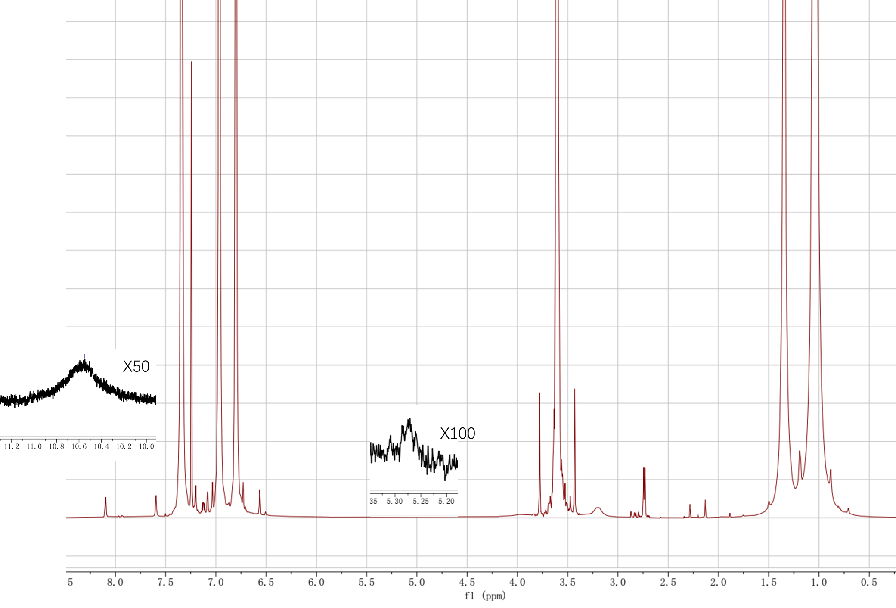
Fig. S1. ¹H NMR spectrum of uncrosslinked ISIBS in Cl₂CH₂CH₂Cl₂/D₂O

