Supporting Information

S vacancy modulated Zn_{x}Cd_{1-x}S/CoP quantum dots for efficient H₂ evolution from water splitting under visible light

Qi Xie,^{1,+} Min Wang,^{1,+} Yong Xu,¹ Xiaoke Li,¹ Xin Zhou,^{2,}* Liang Hong,³ Luhua Jiang,^{1,}* Wen-Feng Lin^{3,}*
¹ Nanomaterials and Electrocatalysis Laboratory, College of Materials and Engineering, Qingdao University of Science and Technology, 53 Zhengzhou Road, Qingdao 266042, P. R. China;
² College of Environment and Chemical Engineering, Dalian University, 10 Xuefu Street, Dalian Economic Technological Development Zone, Dalian 116622, P. R. China.
³ Department of Chemical Engineering, Loughborough University, Loughborough, Leicestershire LE11 3TU, UK
⁺ Q. Xie and M. Wang contribute equally to this work.
* Corresponding authors. E-mail addresses: luhuajiang@qust.edu.cn (L. Jiang); zhouxin@dlu.edu.cn (X. Zhou) ; w.lin@lboro.ac.uk (W. F. Lin).

Table S1 The surface element composition analyzed from the XPS spectra in Figure S4

Elements | ZCS  (At%) | ZCS_{v}  (At%) | ZCS_{v}/CoP QDs  (At%) | ZCS_{v}/CoP QDs  (At%)*
Cd | 9.4 | 8.73 | 5.77 | 14.18
Zn | 17.08 | 18.58 | 15.79 | 40.80
S | 16.19 | 14.06 | 9.70 | 33.39
P | - | 4.05 | 8.37 | 10.66
Co | - | - | - | 0.47
*Obtained from the EDS mapping analysis.

XPS of S 2p of the as-synthesized ZCS , ZCS_{v} and ZCS_{v}/CoP QDs.
Smaple | ZCS | ZCSv | ZCSv/CoP QDs
161.11 eV | 19.94% | 46.94% | 33.12%
161.49 eV | 20.80% | 52.00% | 27.20%
162.51 eV | 17.67% | 21.21% | 31.12%

Table S2 Comparison of H₂ evolution rate for ZCS_{v}/CoP QDs with other Zn_{x}Cd_{1-x}S/TMPs photocatalysts.

Catalyst | H₂ evolution rate  （mmol g⁻¹h⁻¹） | Ref.
CoP/Zn_{0.5}Cd_{0.5}S | 14.68 | [1]
ZCS/10% CoP NWs | 12.17 | [2]
Ni₂P-Zn_{0.5}Cd_{0.5}S | 9.12 | [3]
Ni₂P/Zn_{0.5}Cd_{0.5}S | 23.45 | [4]
1.5 wt%Ni₂P-Cd_{0.5}Zn_{0.5}S | 7.00 | [5]
FeP/Zn_{0.5}Cd_{0.5}S-P | 24.45 | [6]
SiO₂/Ni₂P/rGO/Cd_{0.5}Zn_{0.5}S | 11.65 | [7]

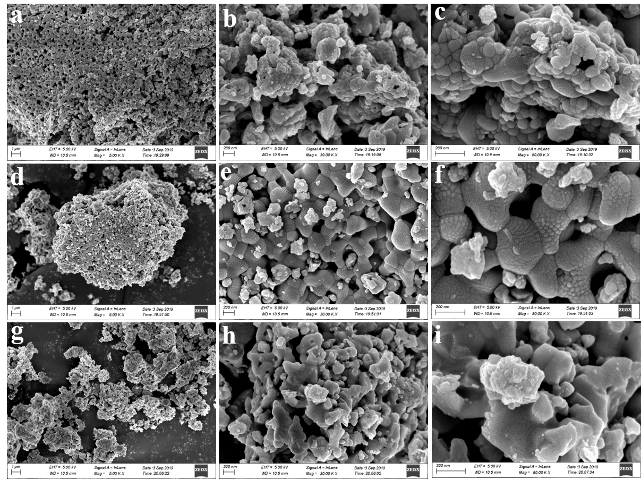

Fig S1 SEM images of ZCS (a, b, c), ZCS_{v} (d, e, f) and ZCS_{v}/CoP QDs (g, h, i)

Fig S2. SEM and elemental mapping images of ZCS_{v}.

Fig S3 SEM and elemental mapping images of ZCS_{v}/CoP QDs.

Fig S4 HRTEM images of ZCS_{v}/CoP QDs.

Fig S5 Survey XPS spectra of ZCS (a), ZCS_{v} (b) and ZCS_{v}/CoP QDs (c).

Fig S6 Co 2p XPS spectrum of ZCS_{v}/CoP QDs.

For the high resolution XPS spectra of Co 2p, two main peaks at 778.52 and 781.51 eV can be assigned to Co-P and oxidized Co species of Co 2p 3/2 in CoP, while one main peak at 793.34 eV corresponds to Co-P of Co 2p 1/2 [8]

Fig S7 Configuration of ZCS_{v}/CoP based on DFT calculations. (a) side view and (b) top view.

Fig S8 TG-DTA (thermo gravimetric and differential thermal analysis) spectra of ZCS under N₂ atmosphere.

Fig S9 EPR profiles for ZCS-N₂ and ZCS_{v}

Fig S10 The H₂ evolution photoactivity of the ZCS, ZCS-N₂ and ZCS_{v}.
Fig S11 The H₂ evolution photoactivity of the ZCS_{v}-T catalysts prepared at different phosphating temperatures of 350, 500 and 700 °C as indicated in the figure.

Fig S12 EPR profiles for ZCS_{v}-350 and ZCS_{v}-500.

Fig S13 The photoactivity of H₂ evolution of the ZCS_{v}/Pt and ZCS_{v}/CoP QDs.

Fig S14 The photoactivity of H₂ evolution of the ZCS_{v}/CoP QDs with different CoP QDs loadings and different treatment temperatures.

Fig S15 Cycle runs for the photocatalytic H₂ evolution on ZCS_{v}/CoP QDs.

References
[1] D. Dai, H. Xu, L. Ge, C. Han, Y. Gao, S. Li, Y. Lu, In-situ synthesis of CoP co-catalyst decorated Zn_{0.5}Cd_{0.5}S photocatalysts with enhanced photocatalytic hydrogen production activity under visible light irradiation, Appl. Catal. B Environ., 217 (2017) 429-436.
[2] P. Wang, S. Zhan, H. Wang, Y. Xia, Q. Hou, Q. Zhou, Y. Li, R.R. Kumar, Cobalt phosphide nanowires as efficient co-catalyst for photocatalytic hydrogen evolution over Zn_{0.5}Cd_{0.5}S, Appl. Catal. B Environ., 230 (2018) 210-219.
[3] Z. Shao, Y. He, T. Zeng, Y. Yang, X. Pu, B. Ge, J. Dou, Highly efficient photocatalytic H₂ evolution using the Ni₂P-Zn_{0.5}Cd_{0.5}S photocatalyst under visible light irradiation, J. Alloys Compd., 769 (2018) 889-897.
[4] D. Dai, L. Wang, N. Xiao, S. Li, H. Xu, S. Liu, B. Xu, D. Lv, Y. Gao, W. Song, L. Ge, J. Liu, In-situ synthesis of Ni₂P co-catalyst decorated Zn_{0.5}Cd_{0.5}S nanorods for high-quantum-yield photocatalytic hydrogen production under visible light irradiation, Appl. Catal. B Environ., 233 (2018) 194-201.
[5] L. Xiao, T. Su, Z. Wang, K. Zhang, X. Peng, Y. Han, Q. Li, X. Wang, Enhanced Photocatalytic Hydrogen Evolution by Loading Cd_{0.5}Zn_{0.5}S QDs onto Ni₂P Porous Nanosheets, Nanoscale Res Lett, 13 (2018) 31.
[6] X. Zhu, S. Yu, X. Gong, C. Xue, In Situ Decoration of Zn_{x} Cd_{1-x} S with FeP for Efficient Photocatalytic Generation of Hydrogen under Irradiation with Visible Light, Chempluschem, 83 (2018) 825-830.
[7] P. Zhang, C. Xue, Y. Li, S. Guo, X. Zhang, P. Zhang, G. Shao, Rational regulation on charge spatial separation and directional migration in the yolk-shell structural SiO₂/Ni2P/rGO/Cd_{0.5}Zn_{0.5}S nanoreactor for efficient photocatalytic H₂ evolution, Chem. Eng. J., (2020) 126497.
[8] Y. Pan, K. Sun, S. Liu, X. Cao, K. Wu, W.C. Cheong, Z. Chen, Y. Wang, Y. Li, Y. Liu, D. Wang, Q. Peng, C. Chen, Y. Li, Core-Shell ZIF-8@ZIF-67-Derived CoP Nanoparticle-Embedded N-Doped Carbon Nanotube Hollow Polyhedron for Efficient Overall Water Splitting, J. Am. Chem. Soc., 140 (2018) 2610-2618.

