Supporting information

The effect of print speed and material aging on the mechanical properties of a self-healing nanocomposite hydrogel
Nathalie Sällström¹, Athanasios Goulas¹, Simon Martin², Daniel Engstrøm¹
¹ Wolfson School of Mechanical Electrical & Manufacturing Engineering, Loughborough University, Loughborough, Leicestershire, LE11 3TU, United Kingdom
² Department of Materials, Loughborough University, Loughborough, Leicestershire, LE11 3TU, United Kingdom

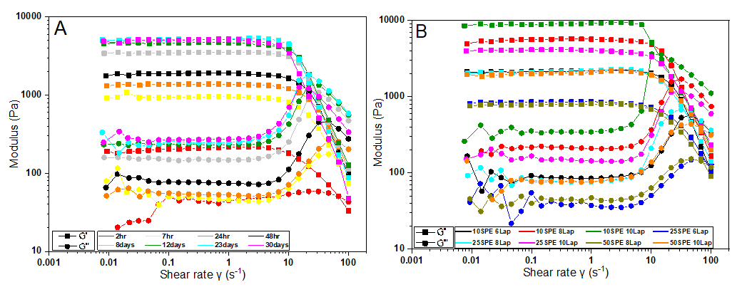
Supplementary Figure 1: Complete rheological data for A - different curing times and B - different compositions. G’ data represented using squares while G’’ is represented with circles.

Supplementary Table 1: Yield point for different compositions of the rheological data recorded (where G'=G''). Increasing the Laponite resulted in higher yield points while increase in monomer showed the reverse.
Composition | τ₀ (Pa) | $\dot{γ}$ (s⁻¹)
10 wt.% SPE 6 wt.% Laponite | 557.2 | 41.8
10 wt.% SPE 8 wt.% Laponite | 1630.1 | 28.3
10 wt.% SPE 10 wt.% Laponite | 3579.3 | 13.0
25 wt.% SPE 6 wt.% Laponite | 140.9 | 81.1
25 wt.% SPE 8 wt.% Laponite | 645.2 | 35.9
25 wt.% SPE 10 wt.% Laponite | 1153.6 | 32.1
50 wt.% SPE 8 wt.% Laponite | 145.5 | 69.6
50 wt.% SPE 10 wt.% Laponite | 390.5 | 64.7

Supplementary Table 2: Yield point for different aging times recorded (where G'=G'') for 10wt% 6wt% Laponite composition. An increase in aging time showed and increased yield point.
Aging time | τ₀ (Pa) | $\dot{γ}$ (s⁻¹)
2 hr | 50.6 | 68.3
7 hr | 159.9 | 60.8
24 hr | 255.2 | 59.2
48 hr | 557.2 | 41.8
8 days | 1045.5 | 28.5
12 days | 1344.6 | 25.9
23 days | 1735.0 | 19.6
30 days | 1231.9 | 18.5

Supplementary Table 3: Tensile data of samples printed at different speeds that were either cured during printing (CDP) or only post cured (PC) at different aging times compared to cast samples.
Printing speed  mm/s | Aging (days) | Curing  (CDP or PC) | Stress at failure (kPa) | UTS (kPa) | Strain at failure (%) | Young’s modulus (kPa)
5 | 2 | CDP | 8.76 ± 2.69 | 32.4 ± 6.91 | 284.1 ± 111.2 | 0.764 ± 0.130
10 | 2 | CDP | 28.8 ± 3.3 | 31.4 ± 8.9 | 762.3 ± 120.4 | 0.945 ± 0.198
10 | 2 | PC | 20.8 ± 2.5 | 28.2 ± 2.5 | 105.3 ± 34.4 | 1.188 ± 0.230
20 | 2 | CDP | 21.0 ± 4.0 | 25.8 ± 4.0 | 119.6 ± 25.1 | 0.690 ± 0.068
20 | 0.2 | PC | 15.0 ± 1.1 | 20.0 ± 3.5 | 119.8 ± 19.3 | 0.862 ± 0.227
20 | 2 | PC | 16.7 ± 2.11 | 25.6 ± 2.5 | 91.9 ± 15.0 | 1.362 ± 0.174
20 | 12 | PC | 10.1 ± 2.3 | 19.5 ± 3.9 | 38.0 ± 3.9 | 1.141 ± 0.111
30 | 2 | CDP | 15.2 ± 4.7 | 23.0 ± 2.0 | 130.7 ± 14.6 | 0.680 ± 0.067
0 (cast) | 0 | PC | 34.4 ± 7.49 | 35.1 ± 5.66 | 898.3 ± 248.8 | 0.164 ± 0.004
0 (cast) | 2 | PC | 28.7 ± 6.3 | 32.7 ± 4.2 | 239.7 ± 51.2 | 0.737 ± 0.008

Supplementary Figure 2: Effect of curing time on strain at failure. Graph shows that lower curing time resulted in higher strain at failure.
Supplementary Figure 3: Effect of curing intensity during printing on tensile properties. Lower intensity samples displayed slightly reduced strain at failure and a significant decrease was seen for the samples which were not cured during printing.
Supplementary Figure 4: Effect of aging on tensile properties (samples printed at 20mm/s with only postcuring). A – 5-9 hr aged, B – 48hr aged and C – 12 days aged.
Supplementary Figure 5: Effect of printing speed on tensile properties. A – 5mm/s, B –10mm/s, C – 20mm/s and D – 30mm/s (samples were cured during printing).
Supplementary Figure 6: Comparison of printed samples (20mm/s) which has been A – postcured only and B – cured during printing.

Supplementary Figure 7: Comparison of printed samples (20mm/s) and cast samples which were aged for 48hr.

Supplementary Table 4: Combined data of compression tests of all variables. (CDP-Cured During Printing, PC-Postured).
Printing speed  (mm/s) | Age time (Days) | Curing | Maximum load (N) | Maximum stress (kPa) | Maximum strain (%) | Compression  modulus (kPa)
10 | 2 | CDP | 29.1± 1.3 | 47.3 ± 2.1 | 80 | 0.205 ± 0.008
20 | 2 | CDP | 40.2 ± 5.1 | 65.2 ± 8.3 | 80 | 0.229 ± 0.009
20 | 2 | PC | 47.7 ± 1.4 | 76.5 ± 2.3 | 80 | 0.257 ± 0.004
20 | 12 | CDP | 54.8 ± 3.7 | 89.0 ± 6.0 | 80 | 0.314 ± 0.025
20 | 12 | PC | 53.9 ± 4.5 | 87.4 ± 7.4 | 80 | 0.335 ± 0.031
30 | 2 | CDP | 41.9 ± 2.7 | 68.11 ± 4.4 | 80 | 0.245 ± 0.002
0 (Cast) | 0 | PC | 17.0 ± 1.6 | 27.5 ± 2.6 | 80 | 0.107 ± 0.028
0 (Cast) | 2 | PC | 43.6 ± 2.1 | 70.9 ± 3.5 | 80 | 0.298 ± 0.013

