Supplementary Information

Rapid microwave-assisted bulk production of high-quality reduced graphene oxide for lithium ion batteries

Jianshen Wu, Jiawei Zhao, Bala Vaidhyanathan *, Hongtao Zhang, Aashu Anshuman, Avias Nare, Sina Saremi-Yarahmadi

Department of Materials, Loughborough University, Loughborough, Leicestershire, LE11 3TU, U.K.
* To whom correspondence should be addressed, E-mail: B.Vaidhyanathan@lboro.ac.uk

Experimental Details

Synthesis of GO. The graphene oxide (GO) was synthesized through three temperature regimes (low temperature, medium temperature and high temperature) to accelerate the reaction kinetics and precisely control the oxidation of graphitic flake, which was helpful to facilitate the exfoliation of GO. All the chemicals were used without further purification.

Typically, pristine graphite (2.5 g, Alfa Aesar) and NaNO₃ (1.2 g, > 99.0%, Sigma Aldrich) were slowly added in concentrated H₂SO₄ (55 ml, 97%, Sigma Aldrich) contained in a three-necked flask which was immerged in ice bath (< 4 ℃). Then, KMnO₄ (7.5 g, > 99.0%, Sigma Aldrich) was slowly added in order to maintain the system temperature below 4 ℃ in the ice bath.

Low temperature reaction: The solution was magnetically stirred for 90 min and the temperature was controlled below 4 ℃.
Medium temperature reaction: The temperature of the solution was raised to 36 ℃ and hold for 30 mins. After the oxidation, the solution turned into a viscous brown suspension.
High temperature reaction: Deionized water (110 ml) was then added in the solution and the system temperature was found to rise by ~20 ℃ due to large released heat. External heating was then applied to increase the suspension temperature at 80 ℃ for 60 mins.

Afterwards, the oxidation reaction was terminated by adding 30 wt% H₂O₂ (10 ml, Perhydrol® EMSURE), followed by a natural cooling. The color of the suspension turned into yellowish brown. In order to remove the residual metal ions, the suspension was washed for three times using 10 wt% HCl solution (Sigma Aldrich) by centrifugation at 2000 rpm. Finally, the resultant GO cake was copiously purified with deionized water for several times till the pH values of the supernatant were in the range of 6-7 [1].

GO coagulation bath. The GO suspension was diluted to the concentration of 15 mg ml⁻¹ and was then extruded into 1 wt% CaCl₂ (Sigma Aldrich) coagulation bath containing with 5 wt% ethanol (Fisher Chemical) at the speed of 2.00 ml min⁻¹ using a syringe pump to form GO beads. The addition of ethanol helped to reduce the surface tension of coagulation solution so that GO beads were able to maintain the original bead-shape upon going through the solution surface [2]. The freshly formed GO beads were soaked in the CaCl₂ solution for 24 hours in order to achieve robust structure. The formation of GO beads within CaCl₂ coagulation bath is shown in Movie S2 (Supporting information) and the images of bead-like GO are given in Fig. S2. The GO beads were then washed with deionized water for 3 times to remove the residual CaCl₂ salt, followed by drying at 50 ℃ overnight to obtain as-prepared GO.

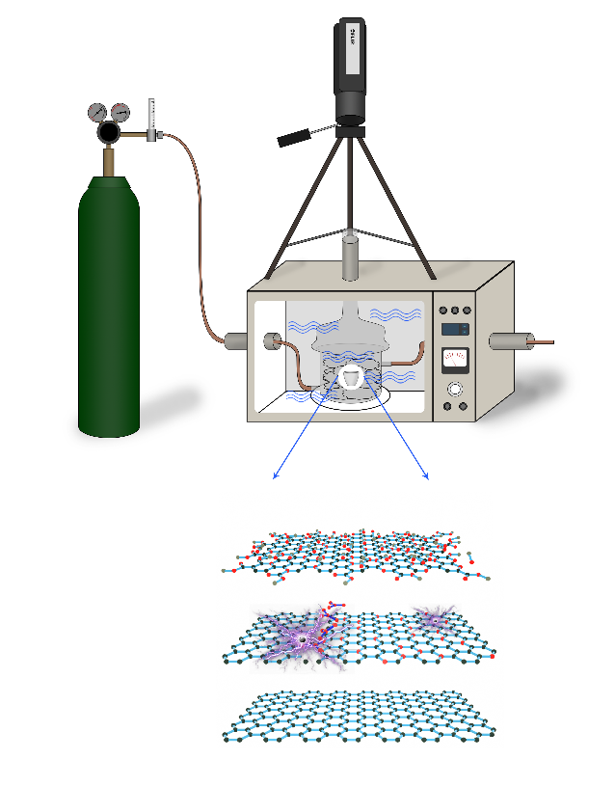
Fig. S1. Schematic illustration of microwave-assisted reduction of GO in which microwave arc takes place on the annealed GO surface.

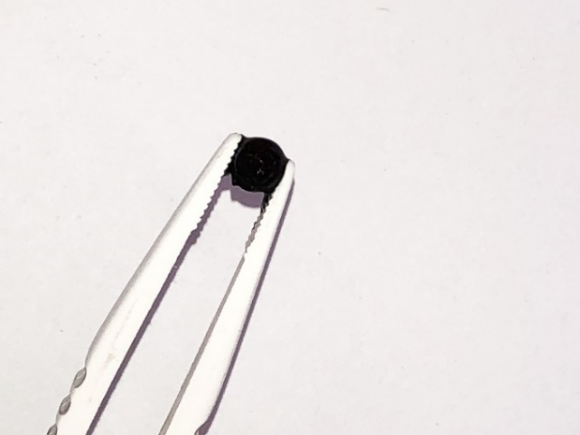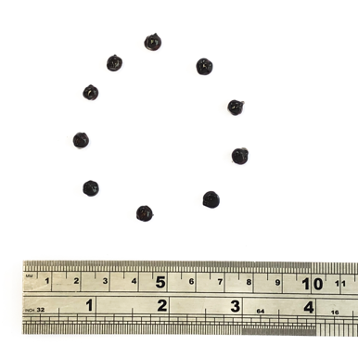
b
a
Fig. S2. Photographs of GO beads formed in 1wt% CaCl₂ coagulation bath after 24 hours immersion, depicting that (a) the GO beads are robust enough and (b) the bead size of GO beads is about 6 mm.
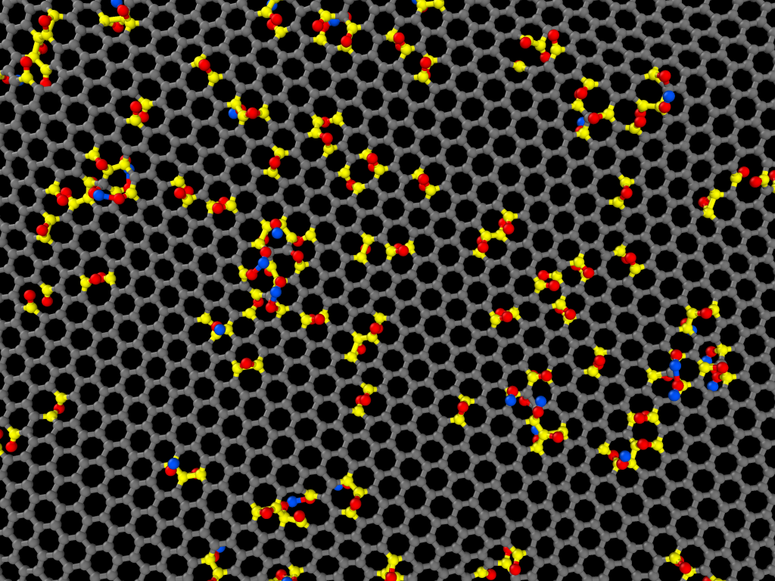
Fig. S3. A microwave localized heating simulation of GO sheet on which only polarized carbon atoms were heated up (grey for unpolarized carbons, yellow for polarized carbons, red for oxygens and blue for hydrogens).

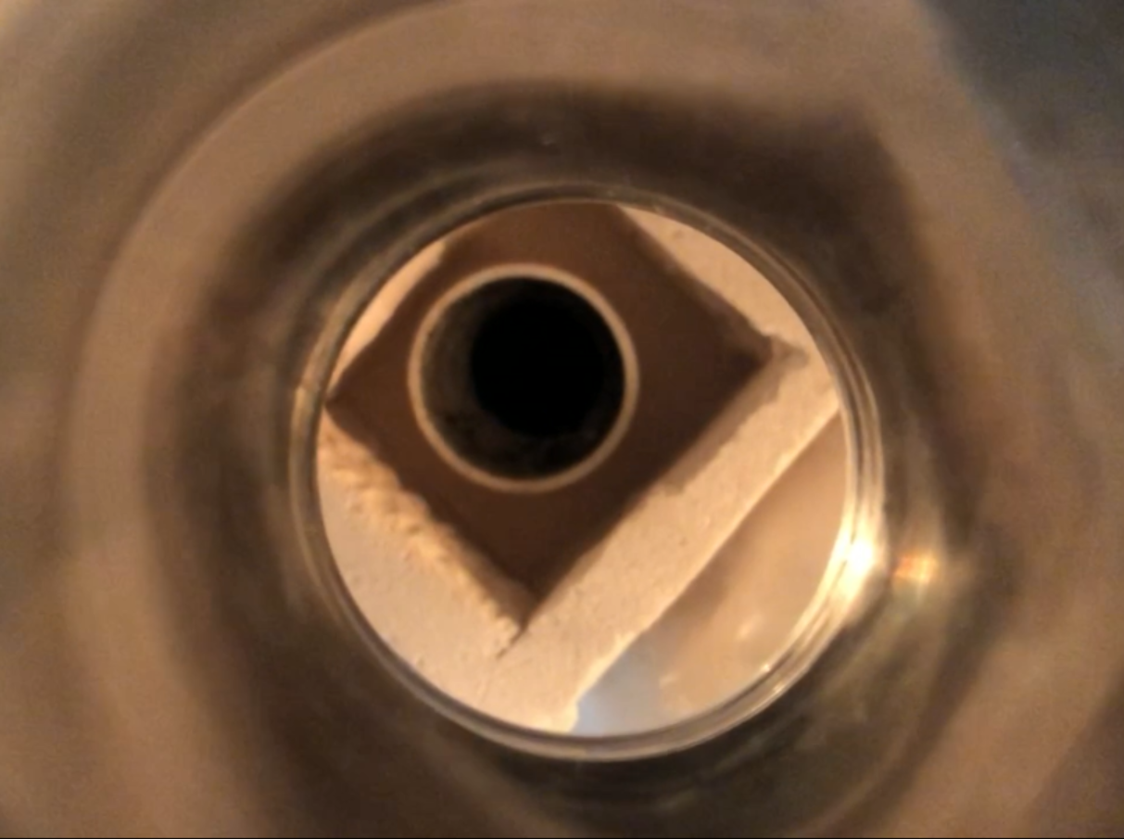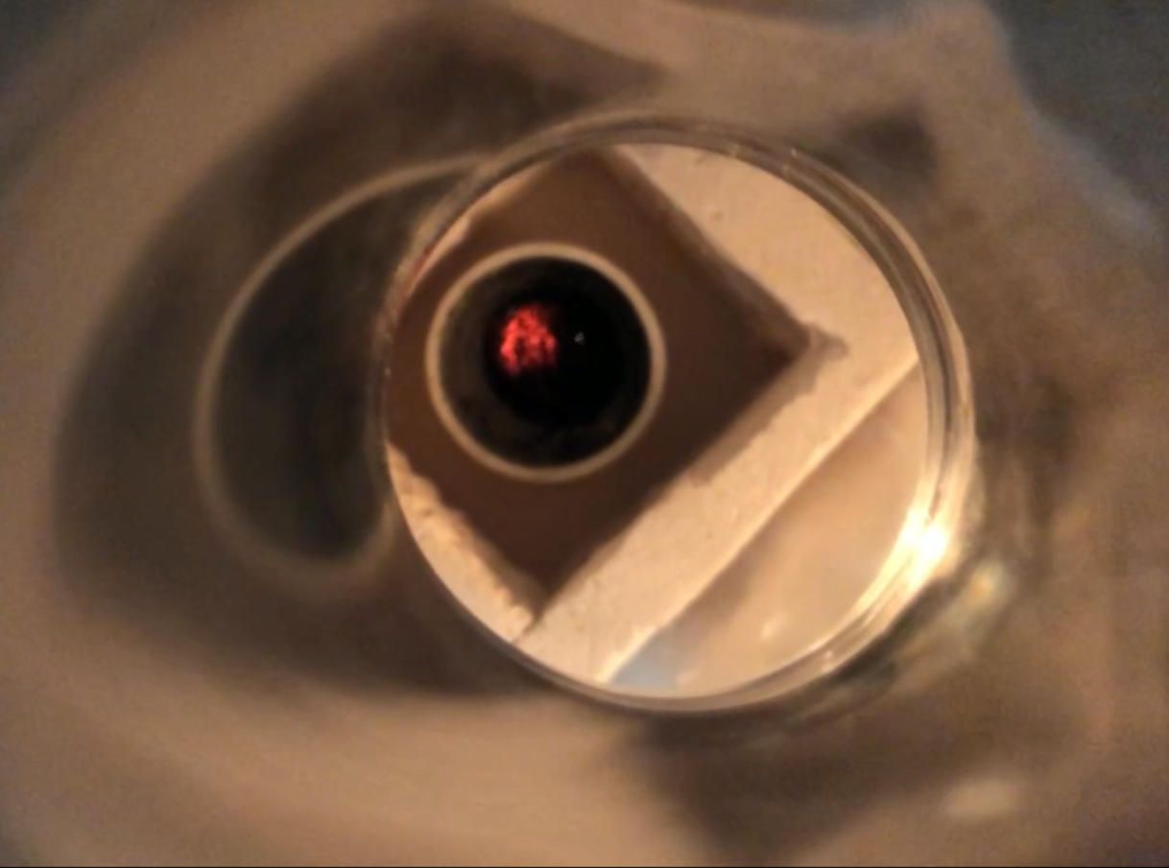
b
a
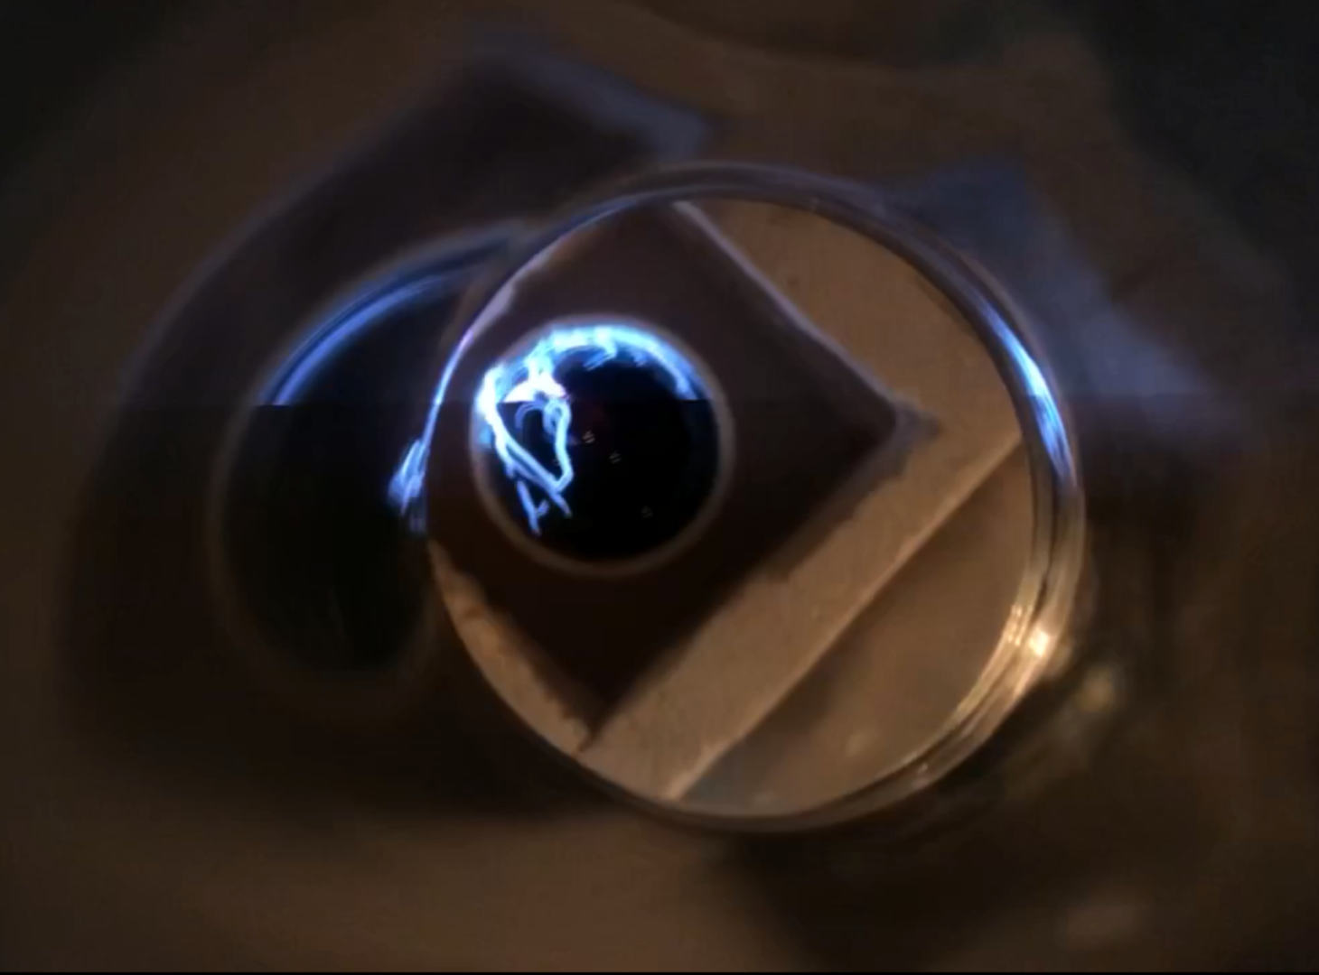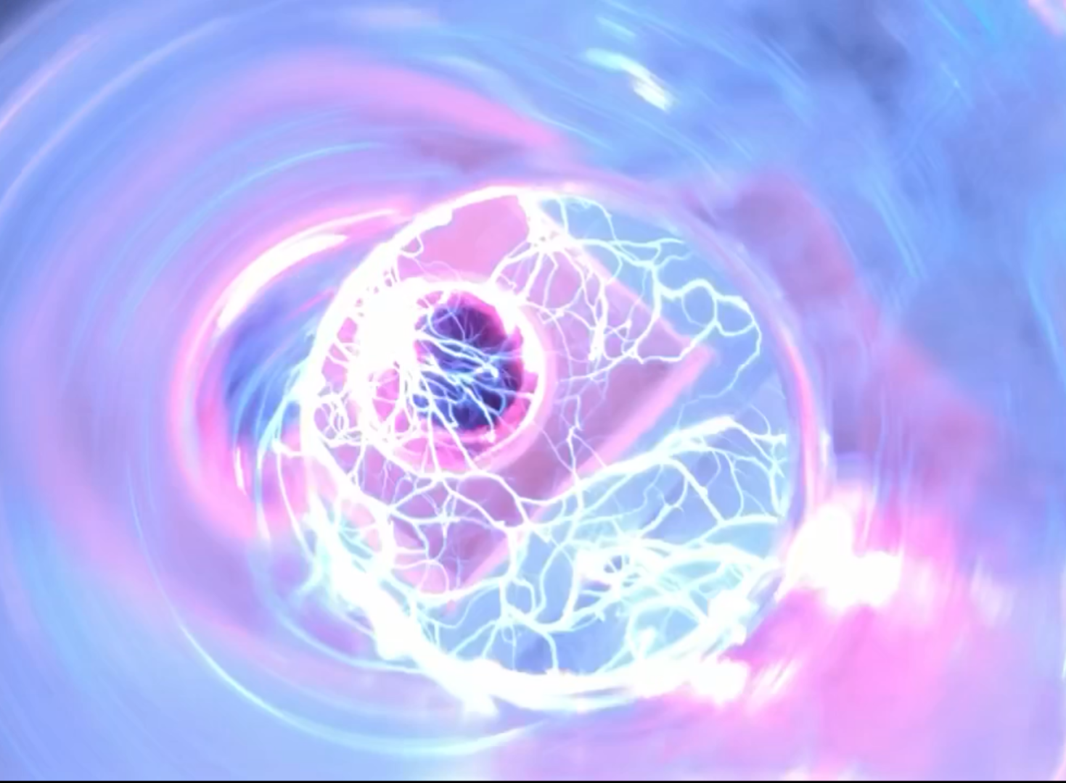
d
c
Fig. S4. Digital photographs of the occurrence of arc upon microwave irradiation of annealed GO. (a) Before microwave irradiation. (b) Heating up of annealed GO by microwave irradiation. (c) The initiation of arc arising from annealed GO surface. (d) the development of strong arcs with extended microwave irradiation.
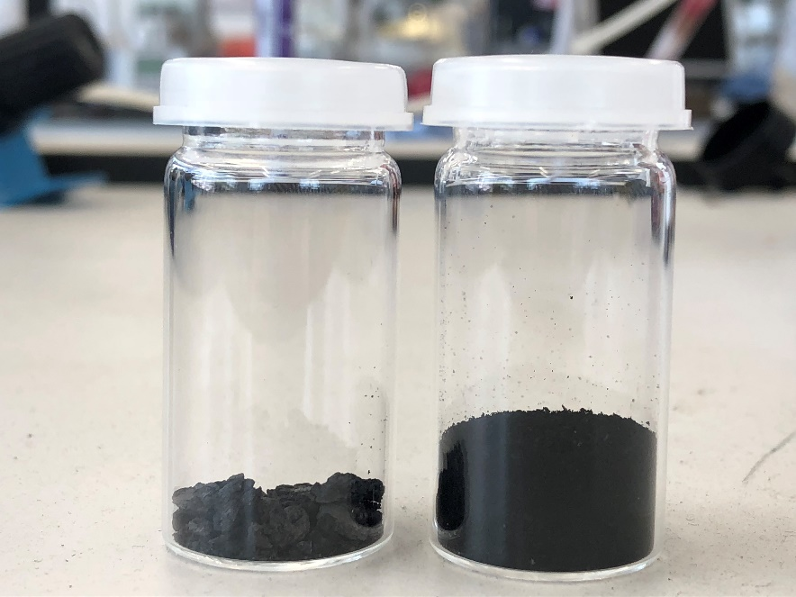
Fig. S5. Photos of 100 mg of (left) unannealed GO and (right) fluffy annealed GO, showing the large volume expansion (almost doubles the apparent volume) upon annealing at 250 ℃ in argon atmosphere, which implied the GO were efficiently exfoliated to a very large extent.

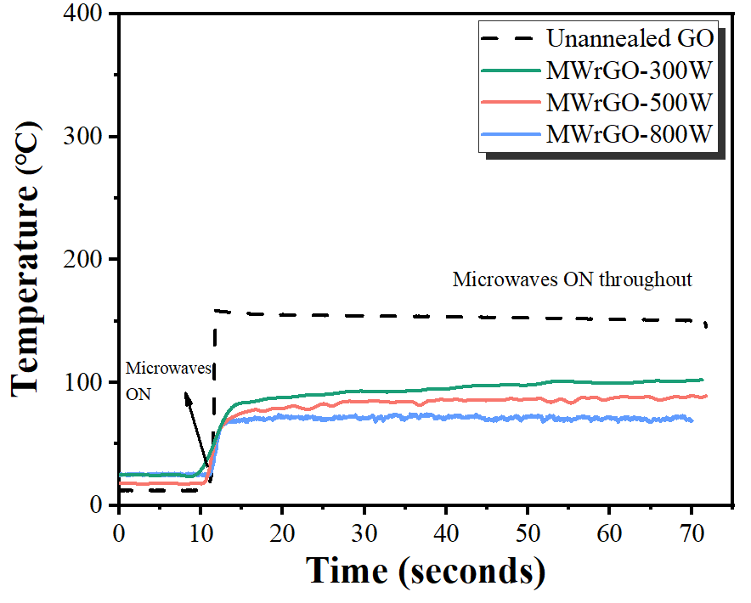
Fig. S6. The time-temperature profiles of MWrGO-300W, MWrGO-500W and MWrGO-800W samples irradiated against with microwaves at 800 W. It also includes the heating profile of unannealed GO for comparison.
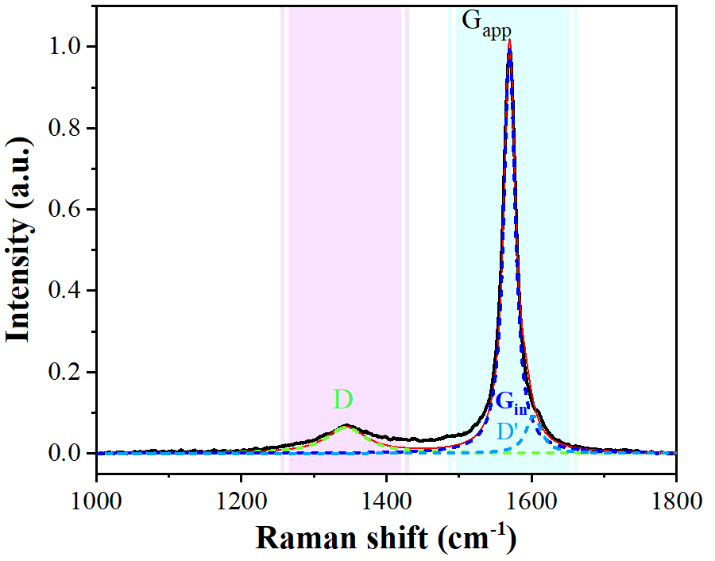
Fig. S7. Peak fitting of G_{App} peak of MWrGO-800W in the Raman spectrum.

The G_{App} peak is theoretically regarded as simple sum of intrinsic G peak (G_{in}) and D’ peak, as explained in the main text. The position of D’ peak can be determined by halving the position of the 2D’ peak because the 2D’ peak is the overtone mode of D’ peak and it is distinctly far away from other Raman peaks [3]. Once the position of D’ peak is determined, the intensity contribution of D’ peak can be subtracted from G_{App} peak by peak fitting. The peak fitting was analyzed using Voigt deconvolution function till Chi-square is greater than 0.98.
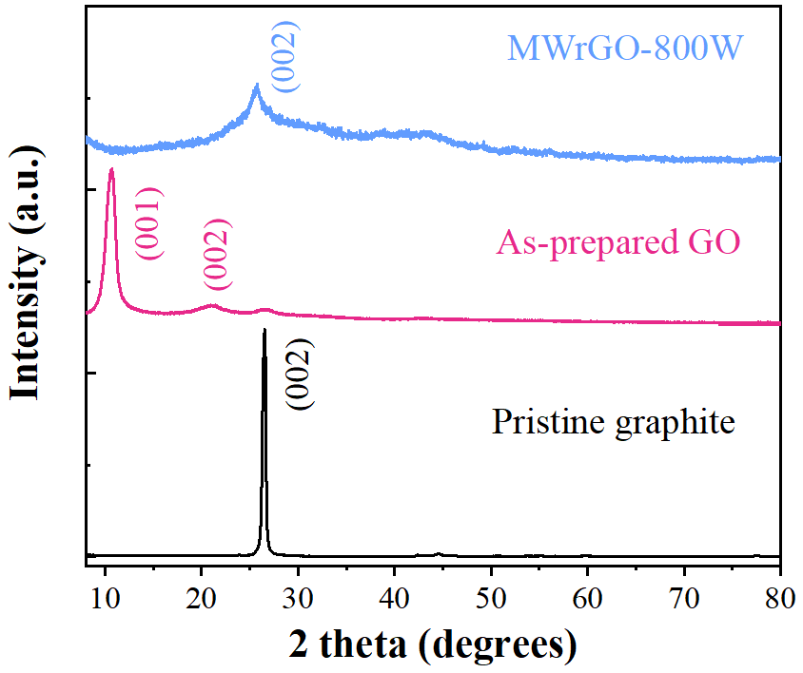
Fig. S8. XRD patterns of pristine graphite, unannealed GO and MWrGO-800W.

XRD is a powerful tool to investigate the structural evolutions of carbon-based materials in the perspective of interlayer spacing. The ‘fingerprint’ peak of pristine graphite shifted from 26° to 10.5° after the modified Hummer’s method, implying the successful intercalation of oxygen functional groups between adjacent graphitic sheets. After being subjected to annealing treatment and microwave irradiation, the (001) peak of as-prepared GO completely vanished and a broad (002) peak appeared at ~26° on MWrGO-800W, which was suggestive of the efficient removal of covalently bond oxygen functional groups by microwave irradiation.

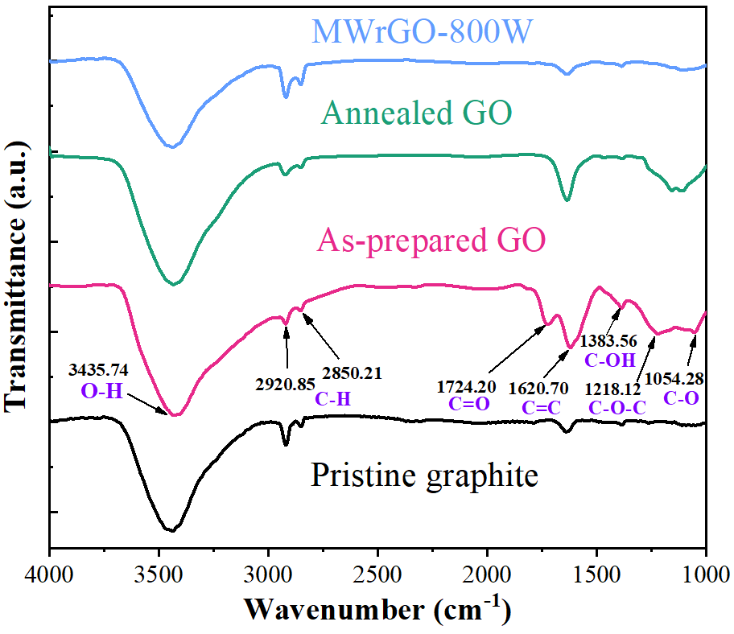
Fig. S9. FTIR spectra of pristine graphite, as-prepared GO, annealed GO, and MWrGO-800W.

The pristine graphite only exhibits four main bands: (i) A broad band at ~3435.74 cm⁻¹ which can be assigned to the stretching vibration mode of O-H from the trapped moisture in graphite powder, (ii) Two stretching vibration modes of C-H; symmetric band at 2920.85 cm⁻¹ and asymmetric band at 2850.21 cm⁻¹, and (iii) An in-plane vibration mode of C=C at 1620.70 cm⁻¹ which originates from the C=C component of aromatic structures [4-6].

After the modified Hummer’s method, numerous oxygen-related bands were formed on as-prepared GO: (i) a stretching vibration mode of C=O at 1724.20 cm⁻¹, which was attributed to carbonyl and carboxyl groups, (ii) a stretching vibration mode of C-O-C at 1218.12 cm⁻¹, which represented the epoxy functional groups, (iii) a stretching vibration mode of C-OH at 1383.56 cm⁻¹, which is related to hydroxyl groups, and (iv) a stretching vibration mode of C-O in the low IR region ranging from 1044 to 1100 cm⁻¹ [6, 7]. After annealing treatment, it is observed that peak intensities related to the oxygen functional groups other than the thermally stable C-O groups were significantly reduced, indicating the restoration of conjugated network. Notably, all the oxygen-rich groups, particularly C-O groups, were removed after microwave irradiation, indicating the feasibility of microwave-assisted reduction of annealed GO.

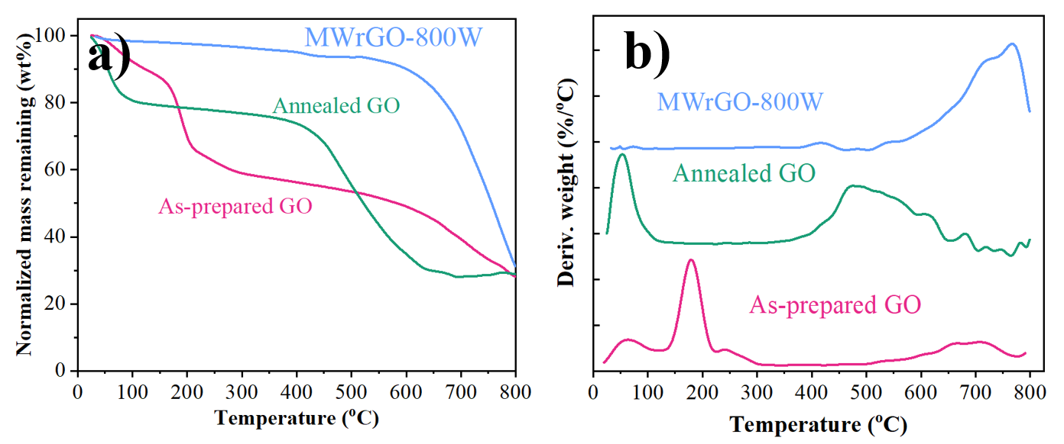
Fig. S10. (a) Normalized TGA plots and (b) DTG plots for as-prepared GO, annealed GO, and MWrGO-800W at the heating rate of 5 ℃ min⁻¹.

It is recognized that the as-prepared GO was thermally unstable and three-stage weight loss was observed against increasing temperature. The initial weight loss was ca. 10 wt% up to 100 ℃, which was ascribed to the evaporation of the interlamellar water [8]. The second stage weight loss was consisted of one sharp slope (100 ℃ to 200 ℃) and one slow slope (200 ℃ to 600 ℃), and the weight loss reached at 50 wt% at 600 ℃. The sharp slope was attributed to the decomposition of the labile oxygen-containing functional groups, such as hydroxyl groups and carbonyl groups. It led to the vigorous release of CO, CO₂, and vapor [4, 8, 9]. The slow slope was principally due to the decomposition of epoxy groups, as a result of strong dipole moment between oxygen and carbon atoms [4, 10]. The third stage weight loss happening above 600 ℃ resulted in a char residue of ca. 30 wt% and was related to the pyrolysis of carbon skeleton [8]. The three-stage weight loss were distinctly represented by three main peaks in the DTG plot of as-prepared GO shown in Figure S9b.

After annealing treatment, annealed GO only experienced first stage decomposition (moisture removal), partial second stage decomposition (decomposition of epoxy groups), and third stage decomposition (pyrolysis of carbon skeleton) upon heating to 800 ℃. It clearly indicated that the decomposition of labile hydroxyl and carbonyl groups was completed after annealing at 250 ℃, which is evidenced by the absence of the peak at about 190 ℃ in Figure S9b. The TGA result of MWrGO-800W showed an excellent thermal stability up to 600 ℃ with a small weight loss of only 10 wt%, meaning the effective elimination of various functional groups by microwave irradiation. Pyrolysis of carbon skeleton of MWrGO-800W started at the identical decomposition temperature (~600 ℃) as the as-prepared GO and the annealed GO. It led to a similar char residue of 30 wt% at 800 ℃. The DTG of MWrGO-800W merely featured a prominent peak above 600 ℃ related to the pyrolysis of carbon skeleton.

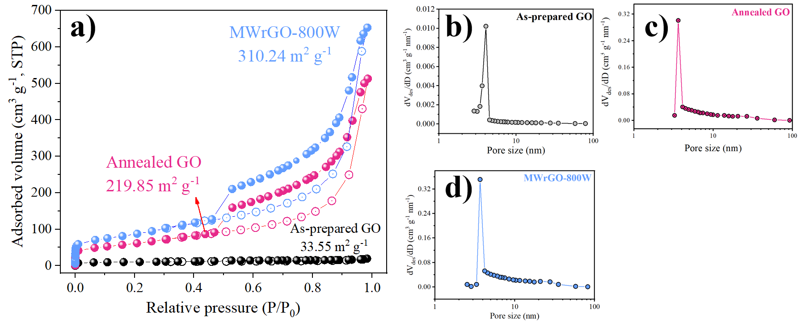
Fig. S11. Nitrogen adsorption/desorption hysteresis of as-prepared GO, annealed GO, and MWrGO-800W, giving the specific surface area and pore size distribution based on Branauer-Emmett-Teller method (BET) and Barrer-Joyner-Halenda (BJH) method, respectively.

In strong contrast with annealed GO and MWrGO-800W, as-prepared GO possessed an extremely low specific surface area (S_{BET}) of ~33.55 m² g⁻¹ which indicated a tightly packed microstructure as shown in Figure 2a. The annealed GO and MWrGO-800W possessed an increased S_{BET} values of ~219.85 m² g⁻¹ and ~310.24 m² g⁻¹, respectively. The high S_{BET} of MWrGO-800W (310.24 m² g⁻¹) implied that the removed oxygen functional groups provided more accessible nitrogen adsorption/desorption sites. They exhibited typical type IV isotherm curves with a rapid nitrogen adsorption at a high relative pressure region of 0.85-0.99, which are characteristic evidences of the presence of nanopore geometry after annealing treatment and microwave reduction. Figure S10b-d) also display the pore size distributions calculated based on the desorption data branch of adsorption-desorption isotherm. A narrow pore size range was found centering at 3.52 nm and 3.69 nm for annealed GO and MWrGO-800W, respectively.

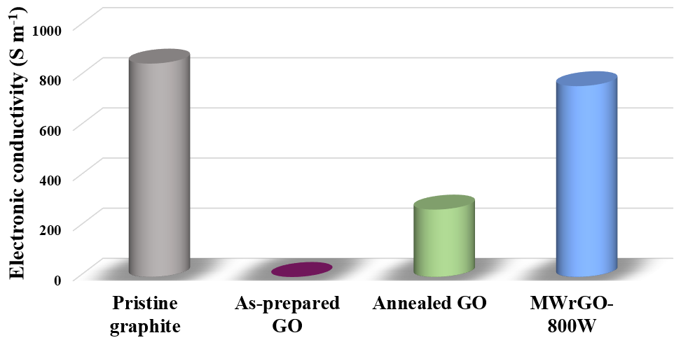
Fig. S12. The bar chart of the electronic conductivities of pristine graphite, as-prepared GO, annealed GO, and MWrGO-800W.

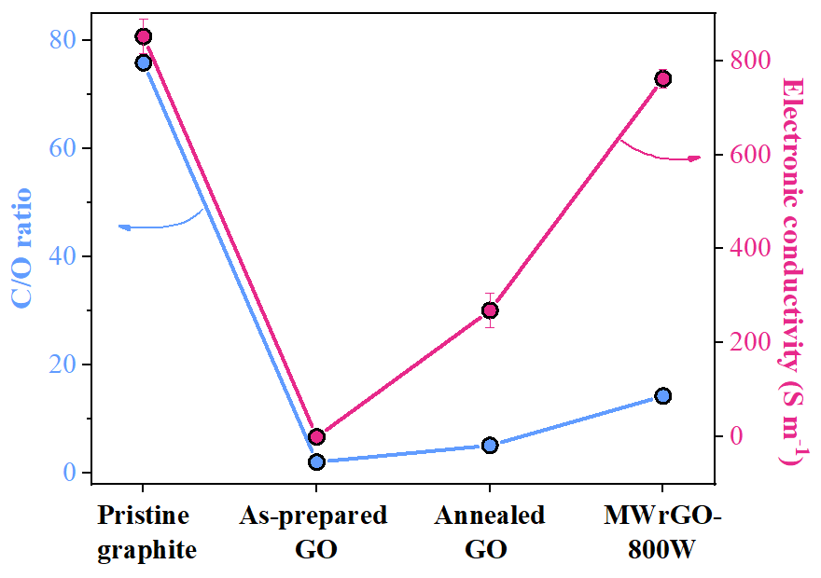
Fig. S13. The plotting of C/O ratios and electronic conductivities of pristine graphite, as-prepared GO, annealed GO and MWrGO-800W.
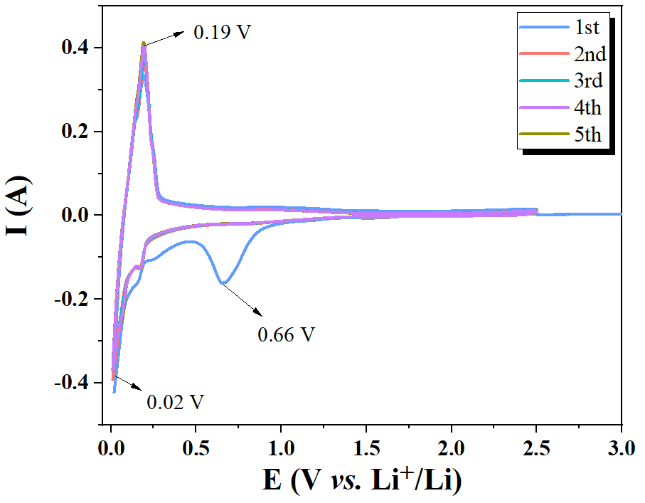
Fig. S14. The CV curves of MWrGO-800W electrode at the scan rate of 0.1 mV s⁻¹ between 0.01 and 2.5 V

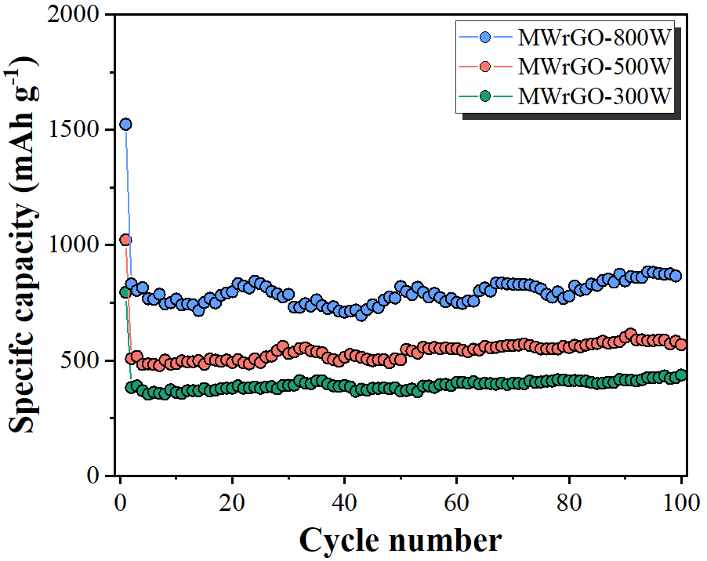
Fig. S15. The cycling performances of MWrGO-300W, MWrGO-500W, and MWrGO-800W at the current density of 0.2 A g⁻¹.

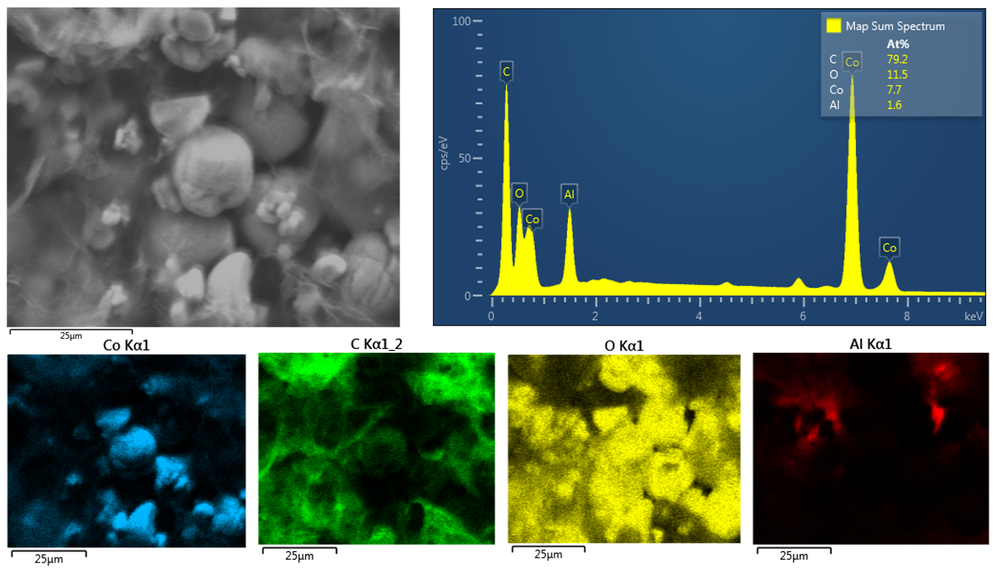
Fig. S16. EDS compositional mapping of the LCO-MWrGO cathode along with EDS spectrum of the whole area. The Al signal in the spectrum is a result of the Al substrate used for current collector.

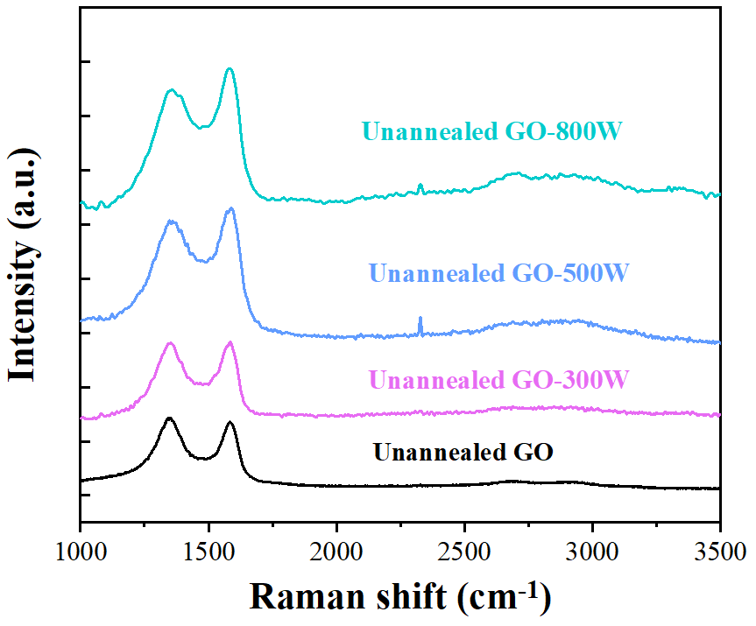
Fig. S17. Raman spectra of unannealed GO sample and unannealed GO which has been microwave treated in different powers

Table S1. Calculated Raman spectral features of pristine graphite, unannealed GO, annealed GO, and MWrGO/unannealed GO synthesized at different microwave powers
 | I_{D}/I_{G-in} | L_{a} (nm)ª
Pristine Graphite | ~0 | N/A
Unannealed GO | 1.258 | 13.307
Annealed GO | 0.906 | 18.492
MWrGO-800W | 0.062 | 267.197
MWrGO-500W | 0.251 | 66.633
MWrGO-300W | 0.392 | 42.781
Unannealed GO-800W^{b} | 1.005 | 17.228
Unannealed GO-500W^{b} | 1.148 | 14.268
Unannealed GO-300W^{b} | 1.217 | 13.396
ª The crystalline domain sizes (L_{a}) are empirically calculated from the intensities of D peak and G peak, as given [11]:

$L_{a}(nm)=(2.4×{10}^{-10})×λ^{4}×{\left(\frac{I_{D}}{I_{G}}\right)}^{-1}$ Equation (1)
where $λ$ is the wavelength of the Raman excitation laser (in nm)
I_{D} and I_{G} represent the intensities of the D peak and G peak, respectively.

^{b} The values are calculated from Figure S17

Table S2. XPS analysis of oxygen functional groups on pristine graphite, unannealed GO, annealed GO, and MWrGO-800W.
 | Pristine graphite | Unannealed GO | Annealed GO | MWrGO-800W
C/O | 75.9 | 2.05 | 5.04 | 14.29
C1s C-C | 81.96 | 24.59 | 50.56 | 61.39
C1s C-O | 15.75 | 2.30 | 13.65 | 13.52
C1s C=O | 1.38 | 33.13 | 8.07 | 6.01
C1s O-C=O | - | 6.42 | 5.2 | 5.03
C1s π-π | - | - | 6.49 | 6.97
O1s | 0.91 | 33.55 | 16.02 | 7.08

Table S3. Summary of electronic conductivities of rGO reduced by various chemical agents.
Preparation method | Electronic conductivity (S m⁻¹) | References
rGO by hydrazine | 2.0 × 10² | [12]
rGO by 15 mM NaBH₄  rGO by 50 mM NaBH₄  rGO by 150 mM NaBH₄ | 1.5 × 10⁻⁴  1.7 × 10¹  4.5 × 10¹ | [13]
rGO by hydrazine | 2.0 × 10² | [14]
rGO by NaPO₂H₂ | 3.8 × 10² | [15]
rGO by hydrazine | 2.0 × 10² | [9]
rGO by urea | 4.3 × 10¹ | [16]
rGO by urea hydrolysable tannin | 4.2 × 10² | [17]
rGO by N₂H₄ | 1.5 × 10² | [18]
rGO by L-ascorbic acid | 8.0 × 10² | [19]
rGO by hydrazine | 1.0 × 10² | [20]
MWrGO by microwave-assisted reduction in this work | 7.6 × 10²

Table S4. Independent components of the LCO-MWrGO and LCO-CNT electrodes analysed using an equivalent circuit.
Sample | Original |  |  | After 100 cycles
 | R_{s} | R_{ct} | Z_{w} | R_{s} | R_{ct} | Z_{w}
LCO-MWrGO | 0.9329 | 17 | 10 | 1.098 | 19.1 | 14
LCO-CNT | 0.92 | 46 | 11 | 1.58 | 49 | 45

References
[1] W. Chen, L. Yan, P.R. Bangal, Preparation of graphene by the rapid and mild thermal reduction of graphene oxide induced by microwaves, Carbon 48(4) (2010) 1146-1152.
[2] C. Bao, S. Bi, H. Zhang, J. Zhao, P. Wang, C.Y. Yue, J. Yang, Graphene oxide beads for fast clean-up of hazardous chemicals, J. Mater. Chem. A 4(24) (2016) 9437-9446.
[3] A.A.K. King, B.R. Davies, N. Noorbehesht, P. Newman, T.L. Church, A.T. Harris, J.M. Razal, A.I. Minett, A new raman metric for the characterisation of graphene oxide and its derivatives, Sci. Rep. 6 (2016) 19491.
[4] S.A. El-Khodary, G.M. El-Enany, M. El-Okr, M. Ibrahim, Preparation and characterization of microwave reduced graphite oxide for high-performance supercapacitors, Electrochim. Acta 150 (2014) 269-278.
[5] C.D. Zangmeister, Preparation and evaluation of graphite oxide reduced at 220 °C, Chem. Mater. 22(19) (2010) 5625-5629.
[6] V. Ţucureanu, A. Matei, A.M. Avram, FTIR spectroscopy for carbon family study, Crit. Rev. Anal. Chem. 46(6) (2016) 502-520.
[7] J. Yang, C. Zang, L. Sun, N. Zhao, X. Cheng, Synthesis of graphene/Ag nanocomposite with good dispersibility and electroconductibility via solvothermal method, Mater. Chem. Phys. 129(1) (2011) 270-274.
[8] M. Fathy, T. Abdel Moghny, M.A. Mousa, A.H.A. El-Bellihi, A.E. Awadallah, Absorption of calcium ions on oxidized graphene sheets and study its dynamic behavior by kinetic and isothermal models, Appl. Nanosci. 6(8) (2016) 1105-1117.
[9] S. Stankovich, D.A. Dikin, R.D. Piner, K.A. Kohlhaas, A. Kleinhammes, Y. Jia, Y. Wu, S.T. Nguyen, R.S. Ruoff, Synthesis of graphene-based nanosheets via chemical reduction of exfoliated graphite oxide, Carbon 45(7) (2007) 1558-1565.
[10] M. Ibrahim, A.A. Mahmoud, Computational notes on the reactivity of some functional groups, J. Comput. Theor. Nanos. 6(7) (2009) 1523-1526.
[11] L.G. Cançado, K. Takai, T. Enoki, M. Endo, Y.A. Kim, H. Mizusaki, A. Jorio, L.N. Coelho, R. Magalhães-Paniago, M.A. Pimenta, General equation for the determination of the crystallite size La of nanographite by Raman spectroscopy, Appl. Phys. Lett. 88(16) (2006) 163106.
[12] M.D. Stoller, S. Park, Y. Zhu, J. An, R.S. Ruoff, Graphene-based ultracapacitors, Nano Lett. 8(10) (2008) 3498-3502.
[13] H. Shin, K. Kim Ki, A. Benayad, S. Yoon, K. Park Hyeon, I. Jung, H. Jin Mei, H. Jeong, M. Kim Jong, J. Choi, H. Lee Young, Efficient reduction of graphite oxide by sodium borohydride and its effect on electrical conductance, Adv. Funct. Mater. 19(12) (2009) 1987-1992.
[14] Y. Xu, H. Bai, G. Lu, C. Li, G. Shi, Flexible graphene films via the filtration of water-soluble noncovalent functionalized graphene sheets, J. Am. Chem. Soc. 130(18) (2008) 5856-5857.
[15] X. Wang, W. Xing, B. Yu, X. Feng, L. Song, Y. Hu, A facile and cost-effective approach to the reduction of exfoliated graphite oxide using sodium hypophosphite under acidic conditions, J. Mater. Chem. C 1(4) (2013) 690-694.
[16] Z. Lei, L. Lu, X.S. Zhao, The electrocapacitive properties of graphene oxide reduced by urea, Energ. Environ. Sci. 5(4) (2012) 6391-6399.
[17] Y. Lei, Z. Tang, R. Liao, B. Guo, Hydrolysable tannin as environmentally friendly reducer and stabilizer for graphene oxide, Green Chem. 13(7) (2011) 1655-1658.
[18] D. Luo, G. Zhang, J. Liu, X. Sun, Evaluation criteria for reduced graphene oxide, J. phys. Chem. C 115(23) (2011) 11327-11335.
[19] X. Zhou, J. Zhang, H. Wu, H. Yang, J. Zhang, S. Guo, Reducing graphene oxide via hydroxylamine: a simple and efficient route to graphene, J. phys. Chem. C 115(24) (2011) 11957-11961.
[20] Y. Wang, Z. Shi, Y. Huang, Y. Ma, C. Wang, M. Chen, Y. Chen, Supercapacitor devices based on graphene materials, J. phys. Chem. C 113(30) (2009) 13103-13107.

