Supporting Information
For
An Open Source Toolkit for 3D Printed Fluidics

Contents
1. Print settings 2
1.1. Flangeless male nut 2
1.2. Unions and connectors 2
1.3. Luer adapter 2
2. Print filament and Commercial fittings suppliers and costs. 4
3. DOI: part numbers 5

Print settings

Print settings vary between component categories; therefore, the parts have been grouped as, flangeless male nut, unions and connectors and luer adapter. All settings refer to those assigned within the slicer software; Ultimaker CURA, ver. 4.5.0 and unless stated otherwise, print settings remain as the pre-programmed factory default settings. For reference, in all parts stated, material 1 is PLA and material 2 is PP, no other filament materials were required for the toolkit. All support scaffolds and build plate adhesion brims were printed in PLA. In all cases, the material 1 flow rate was 100%, and the material 2 flow rate was 110%

Flangeless male nut
As the flangeless male nut is a single material, non-wetted part, it can be printed directly in contact with the build plate (Fig. 8A), the build plate temperature should remain as the default PLA glass transition temperature of 60ºC, to ensure this, the material 2 extruder should be disabled prior to printing. No support scaffold is required. All optional settings available in table 7.

Unions and connectors
Unions and connectors consist of the Low-Pressure Tee connector, cross connector, and Y Connector Bodies all consisting of a 0.039" Bore and a 1/4-28 Flat Bottom. All parts consist of a wetted Polypropylene core and a non-wetted polylactic acid, thread baring shell. In all cases, a PLA support scaffold is required to prevent the distortion of the thread (Fig. 8B-E). Over extrusion of the PP core material is also necessary to prevent leakage from the core channel. All optional settings available in Table 7. Combination of both core and shell parts involves uploading of both parts in one slicer window. Core parts must be rotated, positioned and orientated such that the inner channels position accordingly with the centre of the thread bases (untick ‘Automatically drop models to build plate’ option in the Configure Cura preferences window). Upon suitable positioning, both parts must be selected and grouped. The grouped part must then be raised 10 mm above the build plate to allow room for the support scaffold to generate. Ensure that the scaffold is assigned only to parts touching the build plate and that no internal scaffolds form within the channel voids, or female threads. Thread ceilings have a <45º overhang when printed and therefore do not require the need of a support, generating such will cause obstructions in the thread cavities.

Luer adapter
The Luer adapter consists of a PP body that houses a PLA threaded region. The part should be printed directly onto the build plate with a PLA adhesion brim and should be positioned upright, in the Z directions (Fig. 8F). A PLA support scaffold with 100% infill is required to uphold the central 90º PP overhang of the channel core with a smooth surface finish to prevent leaking during usage. A PP material flow extrusion rate of 110% is required to adequately seal inter-layer boundaries between print beads.
Table 1. List of user defined print settings required for each toolkit component
Part | Layer Height (mm) | Infill Density Material 1(%) | Infill density Material 2 (%) | Support infill density (%) | Brim width (mm)
Flangeless Male Nut | 0.1 | 100 | N/A | N/A | 10
Union | 0.1 | 100 | 110 | 15 | 10
Tee Connector | 0.1 | 100 | 110 | 15 | 10
Cross Connector | 0.1 | 100 | 110 | 15 | 10
Y Connector | 0.1 | 100 | 110 | 15 | 10
Luer Adapter | 0.1 | 100 | 110 | 100 | 15

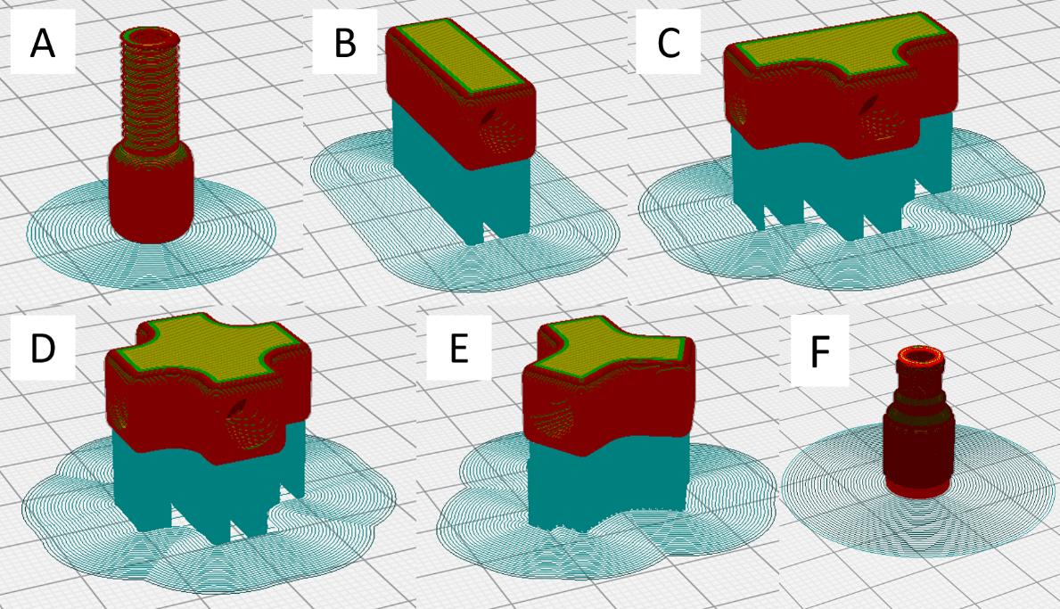
Figure 1. Sliced finalized models of all toolkit parts demonstrating their orientation and layout upon the build plate, (A-F) Flangeless male nut, union, tee, cross and y - connectors and luer adapter, respectively.

Print filament and Commercial fittings suppliers and costs.

Table 2. List of 3D printing filaments and original toolkit parts used in study, along with suppliers and costs (correct as of July 2020).
Name | Supplier | Part Number | Price (£) inc VAT
Ultimaker 2.85mm Natural PP 3D Printer Filament, 500g, 88 m | RS Components | 1785 | 46.40
Ultimaker 2.85mm Black PLA 3D Printer Filament, 750g, 95 m | RS Components | 1609 | 39.00
Idex P-330X Flangeless Male Nut, Standard Knurl, Natural PEEK, 1/8" OD Tubing, 1/4-28 Flat-Bottom; 10/PK | Cole-Parmer | WZ-02007-66 | 33.36
Idex P-702-01 Low-Pressure Union, Female Straight, Natural PEEK, 0.020" Bore, 1/4-28 Flat Bottom; 1/EA | Cole-Parmer | WZ-02023-70 | 14.65
Idex P-632-01 Low-Pressure Tee Body, Natural ETFE, 0.020" Bore, 1/16" OD Tubing, 1/4-28 Flat Bottom; 1/EA | Cole-Parmer | WZ-02023-48 | 30.58
Idex P-722-01 Low-Pressure Cross Body, Natural PEEK, 0.020" Bore, 1/16" OD Tubing, 1/4-28 Flat Bottom; 1/EA | Cole-Parmer | WZ-02023-79 | 27.52
Idex P-512-01 Low-Pressure Y Connector Body, Natural PEEK, 0.020" Bore, 1/16" OD Tubing, 1/4-28 Flat Bottom; 1/EA | Cole-Parmer | WZ-02023-30 | 24.43
Idex P-658 Threaded Luer Adapter, Red PEEK, 0.050" Bore, Female Luer x Female 1/4-28 Flat Bottom; 1/EA | Cole-Parmer | WZ-02014-14 | 14.20

All prices were as stated on supplier website, date accessed 02/03/2020.

DOI: part numbers

Part | DOI
Male threaded nut | https://doi.org/10.17028/rd.lboro.12613100.v1
Union connector (CORE) | https://doi.org/10.17028/rd.lboro.12613118.v1
Union connector (SHELL) | https://doi.org/10.17028/rd.lboro.12613124.v1
Tee-connector (CORE) | https://doi.org/10.17028/rd.lboro.12613127.v1
Tee-connector (SHELL) | https://doi.org/10.17028/rd.lboro.12613133.v1
Cross-connector (CORE) | https://doi.org/10.17028/rd.lboro.12613136.v1
Cross-connector (SHELL) | https://doi.org/10.17028/rd.lboro.12613139.v1
Y-connector (CORE) | https://doi.org/10.17028/rd.lboro.12613142.v1
Y-connector (SHELL) | https://doi.org/10.17028/rd.lboro.12613145.v1
Luer adapter (BODY) | https://doi.org/10.17028/rd.lboro.12613148.v1
Luer adapter (INSERT) | https://doi.org/10.17028/rd.lboro.12613151.v1
Male Thread Test Board | https://doi.org/10.17028/rd.lboro.12751730.v1
Female Thread Test Board | https://doi.org/10.17028/rd.lboro.12751739.v1
Print Resolution Test Board | https://doi.org/10.17028/rd.lboro.12751745.v1
Fluidic Reactor Chip (.gh) | https://doi.org/10.17028/rd.lboro.12765686.v1

