- Supporting information

Table 1 (Oligonucleotide primer sequences for qPCR)
Gene | Function | Species | Forward Primer (5’-3’) | Reverse Primer (5’-3’)
GADPH | Housekeeping gene | Canis lupus | aacatcatccctgcttccac | gaccacctggtcctcagtgt
ATPA1 | Na⁺/K⁺ ATPase | Canis lupus | tcagagtggtgtctcgttcg | gcacagctcgatgcatttta
ZO-1 | Tight junction marker | Canis lupus | cggtaccagctcctctcttg | cggtttggtggtctgaaagt
CD-133 | Microvilli marker | Canis lupus | ttgtctgctgtttgctgacc | ctgattccaactccgaccat
CA9 | Hypoxia marker | Canis lupus | taagcagctccacaccctct | ggactggctcaaaagacctg
KIM-1 | Kidney injury molecule | Canis lupus | gtggagtcacaaccatgtgc | caacacggcaacaatactgg
Ki-67 | Proliferation marker | Canis lupus | ctgcttgtttggaaggggta | gcacaggctcatcaatagca
Mdr1a | P-gp renal transporter | Rattus norvegicus | cgttgcctacatccaggttt | tggagacgtcatctgtgagc

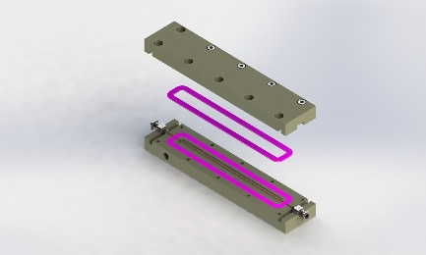
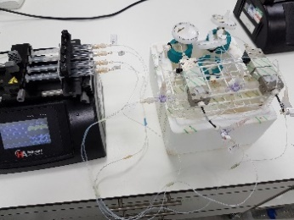
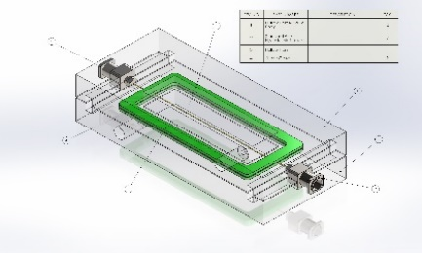
A
B
C
ELS Bypass (to waste)
LUMEN Collection
ELS Collection
Stainless steel needle (30G)
LUMEN Bypass (to waste)
4-way stopcock
4-way stopcock
Stainless steel needle (30G)
Module
O ring
ELS chamber
P1LX HF
ELS INPUT
LUMEN INPUT
Supp. Fig.1: 3D design of renal modules (A,B) and photo of a complete set up with syringe pump (C). A schematic of a renal module with a HF in the ECS chamber and media flow directions (D).

D

