Sediment flux driven channel geometry adjustment of bedrock and mixed gravel-bedrock rivers – Supplementary Information
Edwin R.C. Baynes^{1, 2, 3*}, Dimitri Lague¹, Philippe Steer¹, Stéphane Bonnet⁴, Luc Illien^{1, a}

¹ Univ Rennes, CNRS, Géosciences Rennes - UMR 6118, 35000 Rennes, France
² Department of Civil and Environmental Engineering, University of Auckland, Auckland, New Zealand
³ Geography and Environment, Loughborough University, Loughborough, United Kingdom
⁴ GET, Université de Toulouse, CNRS, IRD, UPS(Toulouse), France

ª Now at: GFZ German Research Centre for Geosciences, Telegrafenberg, Potsdam, Germany

*Corresponding author email address: e.baynes@lboro.ac.uk

Supplementary Information

Section S1: Rainfall data
Table S1: Rainfall data provided by Horizons Regional Council, used in calculation of orographic rainfall pattern. In the station name column, (R) indicates a station located in the Ruahine, and (MC) indicates a station located in the main catchment.
Station Name | Coordinates |  | Mean annual rainfall (mm)
 | Longitude (E) | Latitude (S)
Kawhatau Catchment at Upper Kawhatau (R) | 176.02471 | 39.76606 | 1389
Oroua at Rangiwahia (R) | 175.96353 | 39.89023 | 1495
Pohangina at Delaware Ridge (R) | 175.97716 | 40.06832 | 2246
Pohangina at Range View Farm (R) | 175.92097 | 40.04363 | 1201
Forest Rd Drain at Drop Structure (MC) | 175.25613 | 40.25233 | 952
Hautapu at Alabasters (MC) | 175.78086 | 39.65688 | 878
Makohine at Zohs Road (MC) | 175.73458 | 39.78236 | 1138
Porewa Catchment at Tututotara (MC) | 175.48075 | 40.02874 | 1017
Rangitikei at Erewhon Station (MC) | 176.00287 | 39.50796 | 922
Tapuae at Waituna West (MC) | 175.72299 | 39.99436 | 1140
Turakina at Ruanui (MC) | 175.62441 | 39.62092 | 1039
Tutaenui at Green Haven Farm (MC) | 175.39335 | 40.07656 | 1023
Tutaenui at Ribby Farm (MC) | 175.39862 | 40.00114 | 1130

Section S2: Sediment grain size data
Table S2: Sediment grain size information, including site location, site characteristics and grain size data.
River | Coordinates (Decimal Degrees) | Drainage area (km²) | Mean daily discharge (m³ s⁻¹) | Channel width (m) | Shortest transport distance from Ruahine (km). Number in brackets is distance along trunk channel, if different. | % catchment draining greywacke | D₅₀ (mm) | D₉₀ (mm) | Critical shear stress (Pa)
Hikurangi | 39.79075 S, 175.99078 E | 22 | 0.6 | 41.4 | 5.0 | 75 | 22 | 72 | 7.1
 |  |  |  |  |  |  | 75 | 217 | 24.3
Kawhatau | 39.79005S, 175.99183 E | 70 | 1.9 | 24.8 | 5.4 | 76 | 20 | 73 | 6.5
 |  |  |  |  |  |  | 48 | 206 | 15.5
Kiwitea | 40.08965 S, 175.65841 E | 159 | 3.1 | 12.8 | 48.2 | 0 | 35 | 105 | 11.3
Mangawharariki | 39.86917 S, 175.94159 E | 30 | 0.8 | 10.6 | 7.4 | 39 | 74 | 171 | 24.0
 |  |  |  |  |  |  | 48 | 126 | 15.5
Mangoira | 39.92183 S, 175.94658 E | 18 | 0.5 | 20.2 | 4.3 | 60 | 62 | 181 | 20.1
Oroua | 40.17349 S, 175.65615 E | 314 | 6.2 | 15.7 | 63.2 | 26 | 72 | 170 | 23.3
 | 39.93846 S, 175.92612 E | 90 | 2.4 | 29.6 | 8.8 | 78 | 82 | 210 | 26.5
 |  |  |  |  |  |  | 79 | 166 | 25.6
 | 40.19885 S, 175.64333 E | 321 | 6.2 | 24.8 | 67.4 | 25 | 46 | 97 | 14.9
Pohangina | 40.08393 S, 175.90425 E | 112 | 2.9 | 41.6 | 9.8 | 44 | 112 | 275 | 36.3
 |  |  |  |  |  |  | 1 | 153 | 0.3
 | 40.05237 S, 175.93848 E | 97 | 2.6 | 35.6 | 4.5 | 51 | 205 | 510 | 66.4
 |  |  |  |  |  |  | 78 | 153 | 25.3
 | 40.05237 S, 175.93848 E | 476 | 11.0 | 79.7 | 8.3 (33.0) | 32 | 65 | 155 | 21.0
 | 40.14900 S, 175.84064 E | 359 | 8.8 | 91.8 | 7.7 (23.1) | 35 | 33 | 85 | 10.7
 | 40.12334 S, 175.85049 E | 353 | 8.7 | 47.3 | 2.8 (18.2) | 36 | 39 | 134 | 12.6
 |  |  |  |  |  |  | 17 | 203 | 5.5
 |  |  |  |  |  |  | 19 | 104 | 6.2
Pourangaki | 39.81041 S, 175.96146 E | 58 | 1.6 | 19.3 | 8.4 | 72 | 29 | 88 | 9.4
 |  |  |  |  |  |  | 33 | 229 | 10.7
Rangitikei | 39.82797 S, 175.78369 E | 2727 | 62.2 | 71.9 | 35.1 (55.1) | 33 | 50 | 150 | 16.2
 |  |  |  |  |  |  | 43 | 109 | 13.9
 | 39.81163 S, 175.80870 E | 2698 | 63.3 | 50.5 | 30.3 (50.3) | 33 | 77 | 185 | 24.9
 |  |  |  |  |  |  | 56 | 212 | 18.1
 |  |  |  |  |  |  | 51 | 199 | 16.5
 | 39.68945 S, 176.00160 E | 1005 | 28.6 | 86.6 | 14.5 | 58 | 75 | 252 | 24.3
 |  |  |  |  |  |  | 56 | 167 | 18.1
 |  |  |  |  |  |  | 65 | 169 | 21.0
 | 39.75629 S, 175.83810 E | 1956 | 47.3 | 67.2 | 38.6 | 39 | 131 | 274 | 42.4
 |  |  |  |  |  |  | 97 | 268 | 31.4
 | 39.93380 S, 175.63948 E | 2977 | 57.0 | 65.0 | 66.8 (86.8) | 30 | 18 | 47 | 5.8
 |  |  |  |  |  |  | 33 | 69 | 10.7

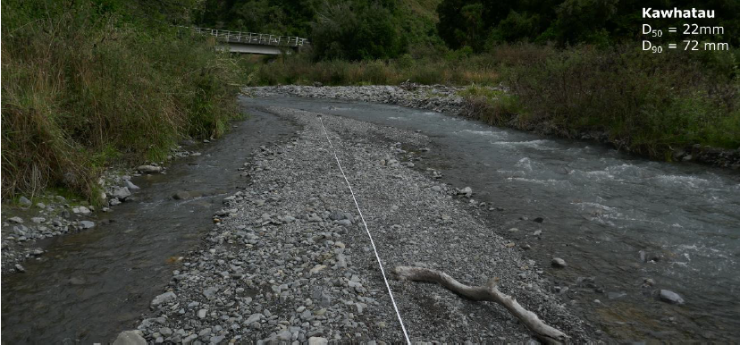
Figure S1: Sediment grain size measurement site on the Kawhatau River.
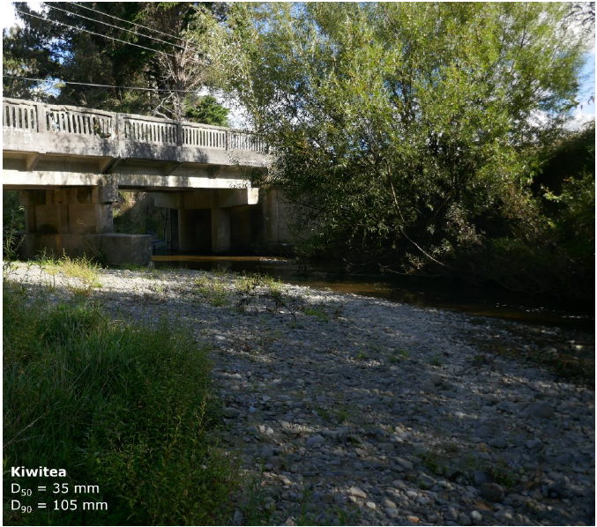
Figure S2: Sediment grain size measurement site on the Kiwitea River.
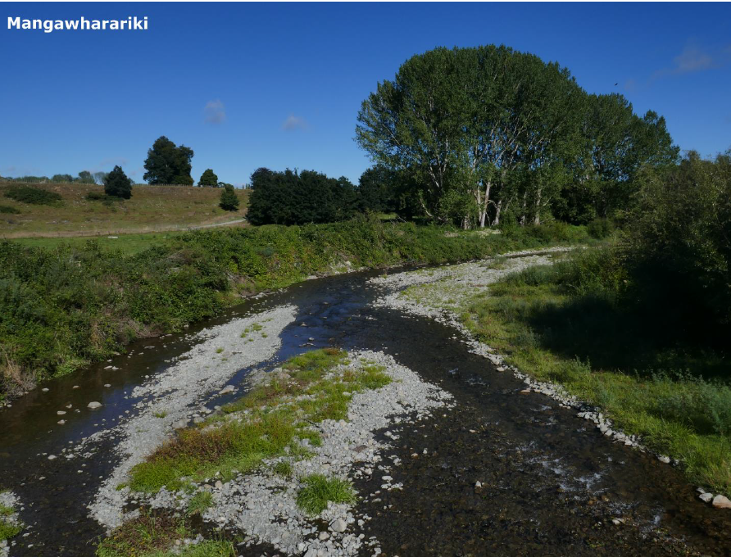
Figure S3: Sediment grain size measurement site on the Mangawharariki River.
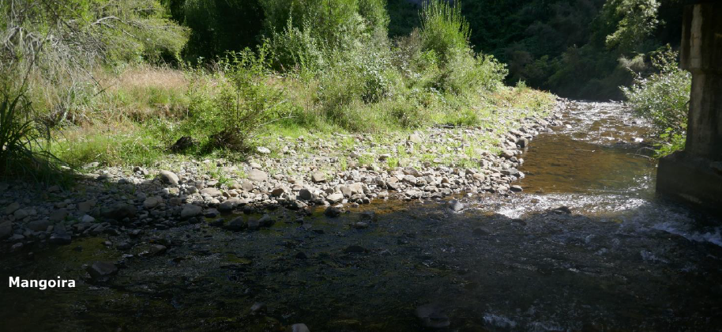
Figure S4: Sediment grain size measurement site on the Mangoira River
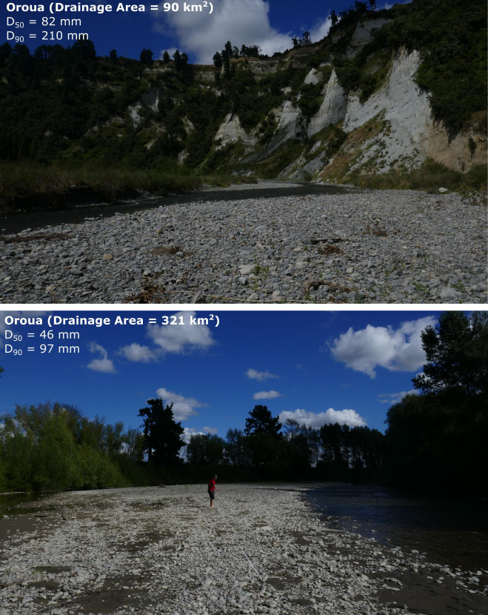
Figure S5: Selected sediment grain size measurement sites on the Oroua River
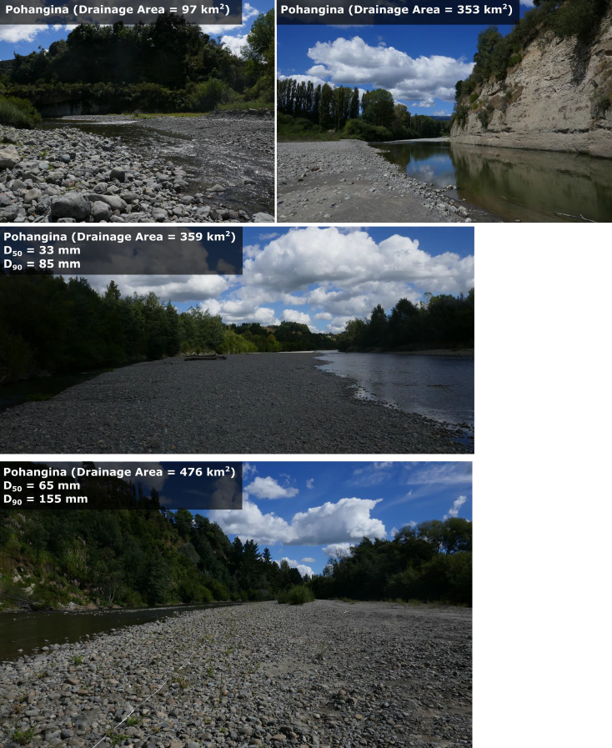
Figure S6: Selected sediment grain size measurement sites on the Pohangina River
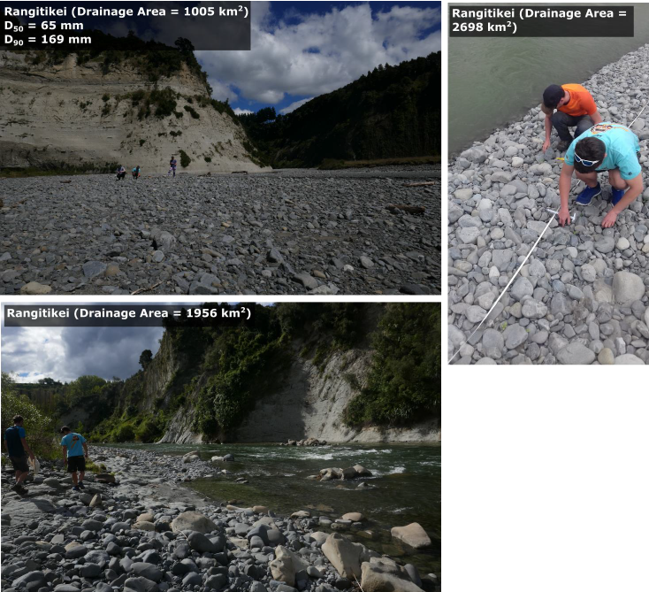
Figure S7: Selected sediment grain size measurement sites on the Rangitikei River

Section S3: Calculation of bankfull discharge in the Rangitikei
To allow the comparison of the observations of the channel geometry from the Rangitikei region and the analogue experiments to theoretical predictions of channel geometry for a give discharge and sediment grain size (Fig. 12), we converted the mean daily discharge in the Rangitikei to the bankfull discharge for the each of the locations where we collected grain size data. There exists no universal scaling between Q_{bf} and Q_{m,} due to spatially variable hydrological conditions such as the frequency and magnitude of flood events or a strongly seasonal climate (Williams, 1978; Croissant et al., 2019). Here, we estimated a site-specific scaling between Q_{m} and Q_{bf} at Mangaweka using high resolution topographic data and the river stage data from the gauging station at this location. We measured the difference in elevation between the water surface and the top of the river bank (i.e., elevation of the water surface at bankfull conditions) from a Terrestrial Laser Scanner survey collected on 24th February 2009. The water surface elevation was 2 m below bankfull, giving a river stage at bankfull conditions of 5.2 m (river stage on 24th February 2009 added to 2 m). The Rangitikei river reached this river stage on 24th July 2009, with a corresponding discharge of 270 m³ s⁻¹, which is ~4.5 times the mean daily discharge (63 m³ s⁻¹). As there are no other constraints to allow the robust estimation of the bankfull conditions in other locations across the study region, we estimated the bankfull conditions by applying this factor for all locations where we collected grain size data: Q_{bf} = 4.5Q_{m}. This scaling factor is similar to that used in other studies where the climate is similar (e.g. factor of 5 used by Croissant et al. 2019).
SI Section S4: Coverage of experimental channels with sediment
Figure S8 shows images from the mounted camera above the experiment at the ‘representative width’ conditions for each of the sediment supply conditions (except Q_{s} = 10 g/l where the camera failed during the experiment). For Q_{s} ≥ 6.66 g/l, the channel bed was fully covered by sediment. For Q_{s} = 2.5 and 5 g/l, the bed was partially covered, with the white silica ‘bedrock’ surface visible within the channel.
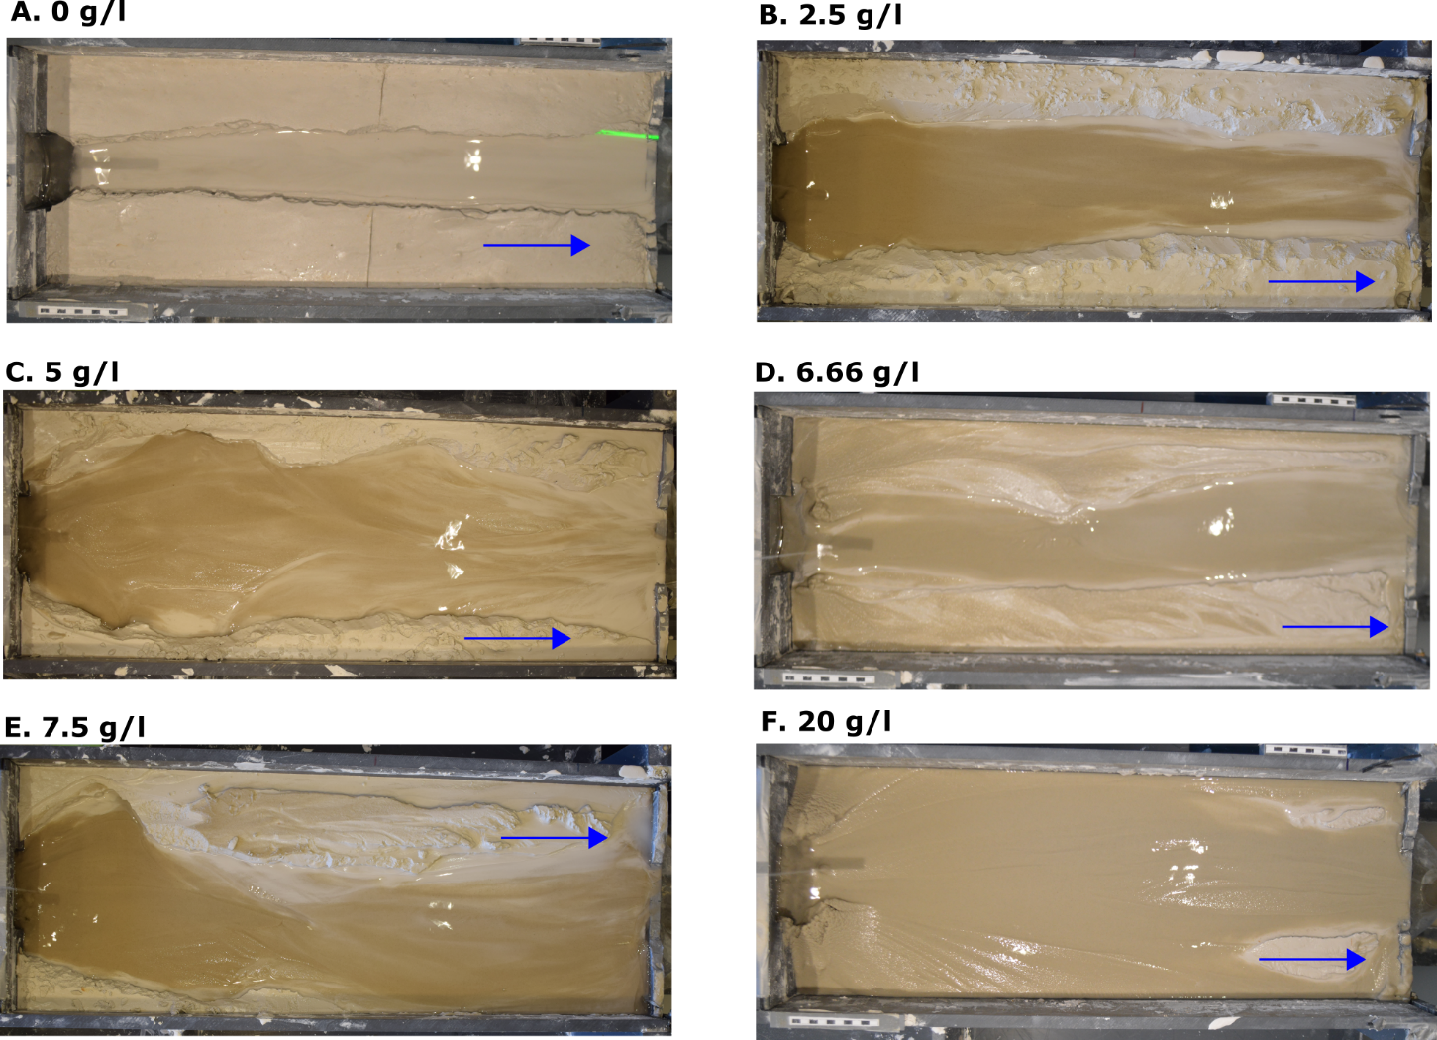
Figure S8: Images from the mounted camera at ‘representative width’ conditions for each of the experimental conditions, with the exception of Q_{s} = 10 g/l where the camera failed, and no images were collected.

Supplementary references
Croissant, T., Lague, D., Davy, P., 2019. Channel Widening Downstream of Valley Gorges Influenced by Flood Frequency and Floodplain Roughness. Journal of Geophysical Research: Earth Surface 124, 154-174
Williams, G.P., 1978. Bank-full discharge of rivers. Water Resources Research 14, 1141-1154.

