Supplementary materials

Bioanode enrichment and performance tests
A microbial fuel cell (MFC) was prepared as described in Section 2.1 (Figure 1 (b)) except the cathode was replaced with a Pt-coated titanium mesh. A 10 Ω load was used to complete the circuit by connecting the anode and cathode. The anolyte and catholyte consisted of the same ingredients as described in Section 2.1 except 3.0 g/L NaCl was substituted by 50 mM phosphate buffer (PBS) at pH 7.0 to ensure that the best quality bioanode was enriched. Effluent obtained from a parent MFC operated over a year served as the starting inoculum [17]. The inoculum was then mixed with the anolyte in a 1:1 ratio and purged with 99.999% N₂ (BOC) for 10 minutes before injecting the mixture into the anode chamber. Catholyte was recycled at a 2.5 mL/min flow rate through a 1.0 L constantly air-sparged reservoir. The enrichment was performed in duplicate.
The enriched bioanode was subjected to several tests to check its performance under actual treatment conditions. Two parameters were chosen in this study: (i) batch vs. flow-through anode mode (Test Parameter 1) and (ii) with vs. without PBS in the anode (Test Parameter 2) (Table S 1). The first parameter was carried out to find a solution to alleviate the unstable cathode potential caused by anode substrate depletion and mass transport limitation. PBS was removed as the second test parameter. The idea was to study the contribution of PBS to electrolyte conductivity and find an alternative to replace the use of PBS. However, the conductivity of the wastewater would be low without PBS, thus causing low bioanode performance. Cell and electrode potentials, current density and electrolyte pH were monitored during the tests. For the flow-through anode mode, the anolyte was continuously fed into the anodic chamber from a 1.0 L reservoir under a specified flow rate as described in (Table 2). All tests were performed in duplicate at room temperature (22±3°C).

Table S 1 Test parameters of the bioanode performance on mass transport and conductivity
Test | Parameter 1  (mass transport effect)
1 | Batch mode anode
2 | Flow-through anode mode (0.60 mL/min)
3 | Flow-through anode mode (1.25 mL/min)
4 | Flow-through anode mode (1.67 mL/min)
5 | Flow-through anode mode (2.50 mL/min)
6 | Flow-through anode mode (5.00 mL/min)
Test | Parameter 2  (conductivity effect)
7 | PBS (50 mM) -based medium
8 | NaCl (3.0 g/L) -based medium

Bioanodes play a crucial role in powering BES and assisting metal ion reduction at the cathode [5,6]. In laboratory set-ups, the electrolytes used usually contain synthetic phosphate buffer (50mM PBS equivalents to conductivity of 5.5 mS/cm) that maintains electrolyte’s ionic strength and conductivity. In order to develop an applicable technology, realistic electrolytes were tested in the following experiments.
Figure S1 shows the profiles of current density, cell and electrodes potentials during the development of bioanodes. Bioanodes were initially enriched using phosphate buffered medium. As can be seen, current density increased after day 4 to peak at 0.06 A/m², indicating the growth of electrochemically active microbes at the anode. The current decreased to nearly zero at day 7, and then increased back instantly after the medium replacement to remain stable at 0.11 A/m² for a day. At the anode, batch cycle was changed to continuous mode at day 9 with 0.6 mL/min flow rate. In the continuous mode, the current remained stable at 0.11 A/m² for the next 6 days instead of following the batch cycle.
When phosphate buffer was removed at day 15, the current dropped significantly to 0.03 A/m². Monitored potentials showed the increase of anode potential from around -0.20 to +0.15 V indicating the loss of performance of the bioanode. The results also indicated that both anolyte and catholyte pH were maintained between 7.0 and 7.5 (Figure S2) which made the pH changes insignificant under the continuous mode. Therefore, the main issue affected the performance drop was due to the decreases of electrolytes’ conductivity causing overpotentials in the system. Studies have proved that the ionic conductivity in MFCs can be improved using saline electrolytes such as seawater or NaCl [30,47]. Therefore, a saline solution of similar ionic strength (3.0 g/L NaCl equivalents to 5.7 mS/cm) was prepared to replace phosphate buffer as background electrolyte for subsequent Zn removal tests.
The second test was performed at flow rates between 0.60 and 2.50 mL/min to check the effect of mass transport in the absence of phosphate buffer. The test was started at day 18 when the flow rate was increased from 0.60 to 1.25 mL/min. However, no significant change in cell potential nor current was monitored even at higher the flow rates of 2.50 and 5.00 mL/min; showing that the flow rate did not have a significant effect when the MFC was operated without phosphate buffer. Both anolyte and catholyte pH remained stagnant over the whole test (Figure S2). However, the cell potential decreased and the anode potential increased when the anolyte was switched from batch to continuous mode. There are evidences that batch or fed-batch mode actually lead to better performance than continuous mode and could subsequently increase bioanode performance over time [48,49]. Electrogenic species like Shewanella sp. depend on soluble mediators to perform electron transfer mechanisms between outer membrane cytochromes and electrode. Low hydraulic retention time could cause wash out of the mediators which can in turn reduce electron transfer rate.
The current density produced from our MFC was lower than some studies reported in the literature. Other studies showed that the current density produced in MFC-based metal removal can reach up to 7.00 A/m² under specific external loads [12,50]. Recently, Rodenas et. al [19] reported high energy production rate in their copper removal BES system. In the repeated study, they successfully increased microbial fuel cell performance by, at least, 5 times compared with previous study [29]. The improved setup not only had higher electrode surface area but also lower internal resistance which largely contributed to voltage loss. Maximum current density of 23.00 A/m² with power density of 5.50 W/m² were achieved with high copper concentration (2.0 g/L) at cathode (Cu/Cu²⁺ E°' = +0.34 V vs. SHE). In our study, the bioanode was enriched using Pt-coated cathode to reduce oxygen (O₂/OH⁻ E°' = +0.40 V vs. SHE) at cathode. The standard reduction potentials of Cu/Cu²⁺ and O₂/OH⁻ are almost similar. However, saturated oxygen concentration in water at 25°C is about 8.0 mg/L which limiting the flow of electrons (electrical current) due to the available reactant in cathode. At the end of the enrichments, the bioanode generated about 2.0-3.0 A/m² of maximum current density under 10 Ω load as shows in Figure S1. The bioanode was then used for Zn recovery experiments.

Figure S1 Profiles of potentials and current density of enriched MFC to be used for Zn recovery.

Figure S2 Profile of electrolyte pH relatives to non-PBS (NaCl) medium.

Reactants crossover in abiotic cell experiments
Figure S3 shows the concentration profile of Zn²⁺ and acetate in anolyte and catholyte separated by an anion exchange membrane. Initially, only Zn²⁺ (1.9mM) and acetate (12.5mM) was added into the anolyte and catholyte, respectively. A range of current density from 0 to 5.56 A/m² was applied between anode and cathode. The impact of the current to the substance crossovers was analysed. Based on Figure S3 (a), a very small amount of Zn²⁺ (< 0.04 mM or 2.1 %) was found in the anolyte sample at the end of each experiments. The trends of Zn²⁺ concentration showed slight increment over time. Meanwhile, significant acetate crossover (> 2.0 mM or 16 %) was observed in Figure S3 (a). However, there is no noticeable pattern that could related to the effect of the current density or potential gradient to the acetate crossover. It indicated that the concentration gradient was predominated in the acetate crossover while potential gradient in the Zn²⁺ crossover.

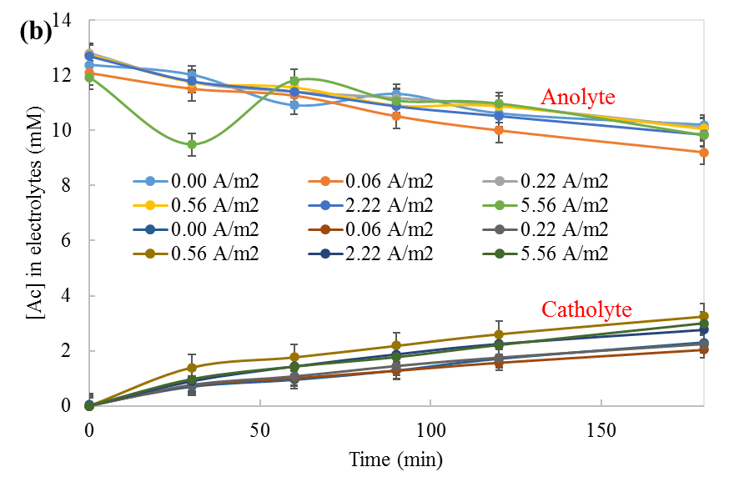
Figure S3 Abiotic half-cell tests: (a) Zn²⁺ concentration in anolyte, and (b) acetate concentration in anolyte and catholyte. Note: Anion exchange membrane was used as separator, [Zn²⁺_{o}]_{anolyte} = 0; [Zn²⁺_{o}]_{catholyte} = 1.9 mM; [Ac_{o}]_{anolyte} = 12.5 mM; [Zn²⁺_{o}]_{catholyte} = 0.

Line fitting of rate law and rate constant for Zn²⁺ removal
Figure S4 shows the linear form line fitting of the rate law and rate constanst based on the Table 5.

Figure S4 Line fitting of the Zn²⁺ removal as (a) zero (abiotic cell test) and (b) its rate constant correlates to current density (c) first (MFC mode) and (d) second order reaction

