SUPPLEMENTARY MATERIAL

Electrochemical Modelling
The electrochemical cathodic, anodic and overall reactions that occur during electrolysis are given by equations 1 to 3. The reactions occur at the three phase boundaries (TPB) comprised of the electrocatalyst, electrolyte and gas boundaries [18].
$$H_{2}O+{2e}^{-}→H_{2}+O^{2-}$$ | 1
$$O^{2-}→0.5O_{2}+2e^{-}$$ | 2
$$H_{2}O→H_{2}+0.5O_{2}$$ | 3
The electrochemical anodic, cathodic and overall reactions that occur during fuel cell operation of an ammonia fuelled RSOFC are given by equations 4 to 6.
$$H_{2}+O^{2-}→H_{2}O+2e^{-}$$ | 4
$$O_{2}+4e^{-}→O^{2-}$$ | 5
$${4NH}_{3}+3O_{2}→{2N}_{2}+6H_{2}O$$ | 6
The reversible cell voltage (equation 7) can be obtained from the Nernst equation which takes into consideration the gas compositions and pressures that take place in a real system [17].
$$V_{N}=-\frac{∆G\left(T\right)}{nF}+\frac{RT}{2F}\ln\left(\frac{x_{H_{2}}P\sqrt{X_{O_{2}}P}}{x_{H_{2}O}P}\right)$$ | 7
Where $∆G\left(T\right)$ is the change in Gibbs free energy at standard pressure (bar) and temperature (K), R is the universal gas constant (8.314 J/mol.K), $P$ is the operating pressure (bar), $x$ is the molar fraction of the gasses at the fuel and oxygen electrode, $n$ is the number of electrons transferred per mole during electrochemical reactions (2 for hydrogen) and $F$ is the Faraday constant (96485 C/mol). The temperature variation of the Gibbs free energy can be calculated by a tertiary polynomial (8) according to Petipas, Brisse and Bouallou [19].
$$∆G\left(T\right)=244800-49.18×T-2.72×{10}^{-3}×T^{2}$$ | 8
The thermal neutral voltage, ohmic heat flux and the magnitude of heat transfer required to achieve isothermal operation can be determined from equation 9 to 11.
$$V_{TN}=\frac{∆H}{2F}$$ | 9
$$Q_{ohm}=I\left(V_{OP}-V_{N}\right)=IV_{ohm}$$ | 10
$$Q_{TH}=I(V_{TN}-V_{OP})$$ | 11
Where $V_{OP}$, $I$, and $V_{ohm}$ are the operating cell voltage, current and overpotential voltages respectively. Even though the thermal-neutral voltage is a function of temperature, it only increases slightly by 0.005 V from 1.287 V at 1073 K to 1.282 V at 1273 K [20].

Voltage Overpotentials
The overpotentials are categorised as activation ($V_{Act}$), ohmic ($V_{Ohm}$) and concentration ($V_{Conc}$) overpotentials. The cell operation voltage ($V_{op}$) in electrolysis and fuel cell operation are given by equations 12 and 13 respectively.
$$V_{op,SOEC}=V_{Nernst}+V_{Act}+V_{Ohm}+V_{Conc}$$ | 12
$$V_{op,SOFC}=V_{Nernst}-V_{Act}-V_{Ohm}-V_{Conc}$$ | 13

Activation Overpotential
Activation overpotentials are calculated by the general governing equation for the activation overpotential known as the Butler-Volmer equation [21]. The hyperbolic sine function shown as equation 14 produces accurate results over a wide range of current densities [16].
$$V_{Act,m}={\frac{RT}{nFα} \sinh^{-1}\left[\frac{j}{2j_{0,m}}\right]}_{ }$$ | 14
Where $n$ is the number of electrons transferred during the reaction i.e., 2 and 4 for the fuel and oxygen electrodes respectively, $j$ is the current density through a single cell (A/m²) and $j_{0}$ is the exchange current density (A/m²). The exchange current density is a function of cell materials, structural and chemical characteristics and temperature [21]; 16]; [20]; [22]. The Arrhenius relationship in equation 15 is typically used.
$$j_{0,m}=γ_{0,m}e^{\frac{-E_{act,m}}{RT}}$$ | 15
Where the pre-exponential factor $B_{0}$ (A/m²) and the activation energy $E_{act}$ (J/mol) are empirical values, and the index $m$ represents the fuel or oxygen electrode.

Ohmic Overpotential
The total ohmic resistance is divided into two parts and can be expressed as given in equation 16.
$$V_{Ohm}={j(}_{ }r_{ohm,el}+r_{ohm,const})$$ | 16
Where $r_{ohm,el}$ is the ohmic specific resistance through the electrolyte (ohm.m²) and $r_{ohm,const}$ is the ohmic specific resistance through the wires, interconnectors, etc (Ω.m²). The ohmic specific resistance responsiveness to temperature change is small and can be treated as a constant [16]. The electrolyte resistance can be calculated by equation 17.
$$r_{ohm,el}=\frac{δ_{el}}{σ_{el}}=\frac{δ_{el}}{σ_{0,el}exp⁡(\frac{-E_{act,el}}{RT})}$$ | 17
Where $δ_{el}$ is the electrolyte thickness (m) and $σ_{0,el}$ is the pre-exponential factor (Ω⁻¹m⁻¹). The ohmic resistance can also be calculated by neglecting the electrode resistance due to their high conductivity [23], equation 18.
$$V_{ohm}=2.99×{10}^{-1}jδ_{el}\left(\frac{10300}{T}\right)$$ | 18

Concentration Overpotential
The concentration overpotential in the oxygen and fuel electrode during EC and FC operation are given by equation 19 to 22.
$$V_{Conc,EC,OE}=\frac{RT}{4F}ln⁡\left(1+\frac{jRT}{4F}\left(\frac{δ_{OE}}{D_{eff,O_{2}}.x_{O_{2}}.P}\right)\right)$$ | 19
$$V_{Conc,FC,OE}=\frac{RT}{4F}ln⁡\left(\frac{1}{1-\frac{jRT}{4F}\left(\frac{δ_{OE}}{D_{eff,O_{2}}.x_{O_{2}}.P}\right)}\right)$$ | 20
$$V_{Conc,EC,FE}=\frac{RT}{2F}ln⁡\left(\frac{1+\frac{jRT}{2F}\left(\frac{δ_{FE}}{D_{eff,H_{2}O}.x_{H_{2}}.P}\right)}{1-\frac{jRT}{2F}\left(\frac{δ_{FE}}{D_{eff,H_{2}O}.x_{H_{2}O}.P}\right)}\right)$$ | 21
$$V_{Conc,FC,FE}=\frac{RT}{2F}ln⁡\left(\frac{1+\frac{jRT}{2F}\left(\frac{δ_{FE}}{D_{eff,H_{2}}.x_{H_{2}O}.P}\right)}{1-\frac{jRT}{2F}\left(\frac{δ_{FE}}{D_{eff,H_{2}}.x_{H_{2}}.P}\right)}\right)$$ | 22
$P_{b}$ and $P_{TPB}$ are the partial pressures (Pa) of the species in the bulk flow and at the TPB respectively, $δ_{x}$ (m) is the thickness of the fuel and oxygen electrode, $D_{eff,x}$ (m²s⁻¹) is the effective diffusion coefficient for species x in the electrode and is a function of electrode porosity $ε$ and tortuosity $τ$, $x$ is the molar fraction of the gas species and $P$ is the cell operating pressure (bar). The effective diffusion coefficient can be obtained by equation 23 since both molecular and Knudsen diffusion mechanisms are present in planar SOCs.
$$D_{eff,m}=\frac{ε}{τ}⁡\left(\frac{D_{m-n}D_{kl,m}}{D_{m-n}+D_{kl,m}}\right)$$ | 23
Where $D_{m-n}$ is the binary diffusion coefficient between component m and n (m²s⁻¹) and $D_{kl,m}$ is the Knudsen diffusion coefficient of component m. The Knudsen component in the fuel electrode is H₂ and H₂O during FC and EC respectively and is O₂ in the oxygen electrode if air is used. The Knudsen diffusion can be obtained from equation 24.
$$D_{kl,m}=\frac{d_{p}}{3}\sqrt{\frac{8RT}{πM_{m}}}$$ | 24
Where $d_{p}$ is the pore diameter, $M_{m}$ is the molar mass (g/mol) of the component m and R is the universal gas constant with units of J/Kmol.K, 8314. The binary diffusion coefficient in the electrode is calculated by equation 25.
$$D_{m-n}=\frac{1.43×{10}^{-7}T^{1.75}}{P\sqrt{\frac{2}{M_{m}^{-1}+M_{n}^{-1}}}{\left(V_{d,m}^{1/3}+V_{d,n}^{1/3}\right)}^{2}}$$ | 25
Where P (bar) is the gas pressure, $V_{d}$ is the dimensionless diffusion volume of the gas species. The diffusion volumes from [24] are given in Table S-1, supplementary material.
Equation 2-25 is valid for binary systems which is the case for the oxygen electrode where only oxygen is present, the presence of other inert components such as nitrogen can be neglected [16]. The binary coefficient is neglected if the nitrogen content is less than 5% and the oxygen diffusion coefficient becomes a function of Knudsen diffusion coefficient, porosity and tortuosity only, 26.
$$D_{eff,O_{2}}=\frac{ε}{τ}⁡\left(D_{kl,O_{2}}\right)$$ | 26
The bulk concentration is assumed to be constant along the SOC channel and is determined by the average of the inlet and outlet concentration [16].

Current, Power and Efficiencies
The current and current density in a SOC are a function of the fuel utilisation where it is a percentage fraction of reactant (inlet fuel) that undergoes electrochemical reaction [17], (equation 27).
$$U_{F}=\frac{Fuel Consumed}{Inlet Fuel}$$ | 27
Current and current density can be calculated by equation 28 and 29 respectively.
$$i=2F\dot{n_{H_{2}}}U_{F}$$ | 28
$$j=\frac{i}{A}$$ | 29
Where $\dot{n}$ is the molar flow of hydrogen ($mol/s$).
The power consumed in electrolysis or produced in fuel cell is a product of a single cell multiplied by the number of cells ($N$) in the stack to give the total voltage from the series connections of the cell and the current given in equation 30.
$$Power=iV_{OP}N$$ | 30

Diffusion Volumes

Molecule | Diffusion Volume
H₂ | 6.12
H₂O | 13.1
N₂ | 18.5
O₂ | 16.3
Table S-1 Diffusion Volumes

SOEC Simulation Validation Parameters

Parameter | Unit | Value
$$T$$ | $$K$$ | $$1121$$
$$P$$ | $$bar$$ | $$1$$
$$N_{fuel}$$ | $$mol/min$$ | $$0.03275$$
$$X_{H_{2}O}$$ | $$-$$ | $$0.25$$
$$X_{O_{2}}$$ | $$-$$ | $$0.75$$
$$X_{N_{2}}$$ | $$-$$ | $$0.79$$
$$δ_{fuel}$$ | $$m$$ | $$2.625×{10}^{-5}$$
$$δ_{oxygen}$$ | $$m$$ | $$3.1×{10}^{-5}$$
$$A$$ | $$m^{2}$$ | $$4.5×{10}^{-3}$$
$$r_{p}$$ | $$m$$ | $$1×{10}^{-6}$$
$$ε$$ | $$-$$ | $$0.3$$
$$τ$$ | $$-$$ | $$5$$
$$γ_{fuel}$$ | $$Am^{2}$$ | $$1.344{×10}^{10}$$
$$γ_{oxygen}$$ | $$Am^{2}$$ | $$2.051{×10}^{9}$$
$$E_{act,fuel}$$ | $$J/mol$$ | $$1×{10}^{5}$$
$$E_{act,oxygen}$$ | $$J/mol$$ | $$1.2×{10}^{5}$$
Table S-2 SOEC simulation validation parameters

SOEC Validation

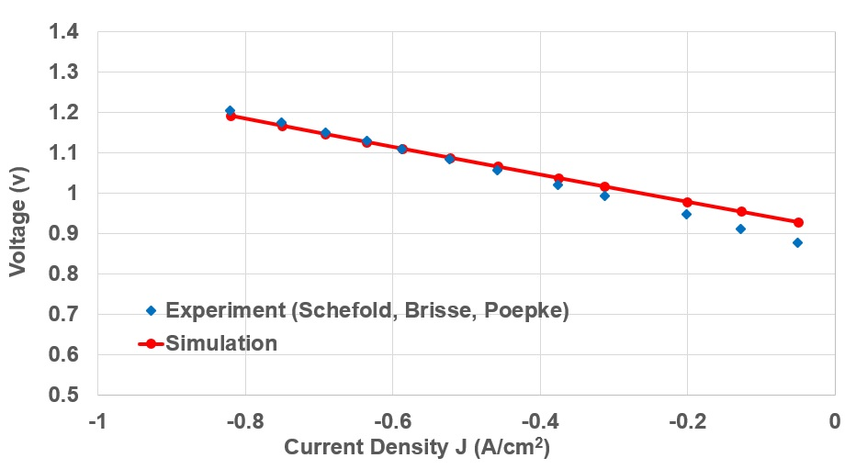
Figure S-1 RSOFC-EC Validation

SOFC Simulation Validation Parameters
Parameter | Unit | Value
$$T$$ | $$K$$ | $$1123$$
$$P$$ | $$bar$$ | $$1$$
$$N_{fuel}$$ | $$mol/min$$ | $$0.01859$$
$$X_{H_{2}O}$$ | $$-$$ | $$0.5$$
$$X_{H_{2}}$$ | $$-$$ | $$0.5$$
$$X_{O_{2}}$$ | $$-$$ | $$1$$
$$X_{N_{2}}$$ | $$-$$ | $$0$$
$$δ_{fuel,eff}$$ | $$m$$ | $$3.2×{10}^{-5}$$
$$δ_{oxygen}$$ | $$m$$ | $$1.75×{10}^{-5}$$
$$r_{ohmic,const}$$ | $${Ωcm}^{2}$$ | $$0.057$$
$$σ_{0,el}$$ | $${Ω^{-1}cm}^{-1}$$ | $$333.3$$
$$A$$ | $$m^{2}$$ | $$16×{10}^{-2}$$
$$r_{p}$$ | $$m$$ | $$1.1×{10}^{-6}$$
$$ε$$ | $$-$$ | $$0.3$$
$$τ$$ | $$-$$ | $$5$$
$$γ_{fuel}$$ | $$Am^{2}$$ | $$1.344{×10}^{10}$$
$$γ_{oxygen}$$ | $$Am^{2}$$ | $$2.051{×10}^{9}$$
$$E_{act,fuel}$$ | $$J/mol$$ | $$1×{10}^{5}$$
$$E_{act,oxygen}$$ | $$J/mol$$ | $$1.2×{10}^{5}$$
$$E_{act,el}$$ | $$J/mol$$ | $$8.5634×{10}^{4}$$
Table S-3 SOFC Simulation Validation parameters

SOFC Validation
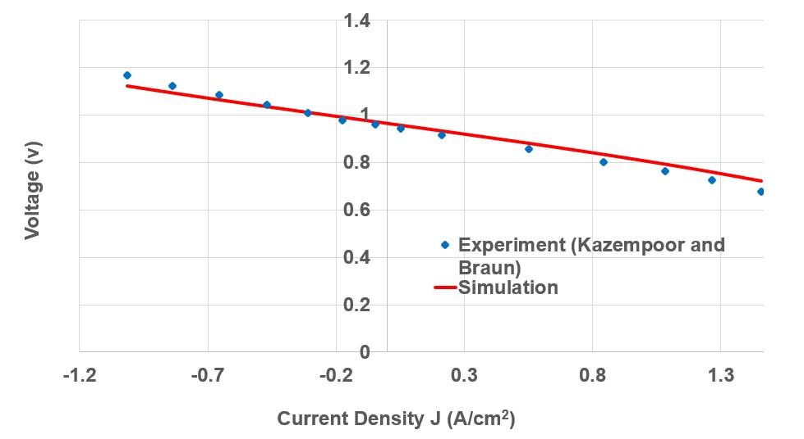
Figure S-2 RSOFC-FC Validation

Pressure Swing Adsorption Unit
Nitrogen for ammonia synthesis is produced in a pressure swing adsorption unit (PSA). The PSA flowsheet was simplified by omitting steps such as carbon capture [4]. The PSA unit, Figure S-3 in supplementary material, was modelled as a compressor with a mechanical efficiency of 53% and operating at 20 bar, and a separator with split fractions of 0.987 nitrogen, 0.0127 argon and 0.0003 oxygen.
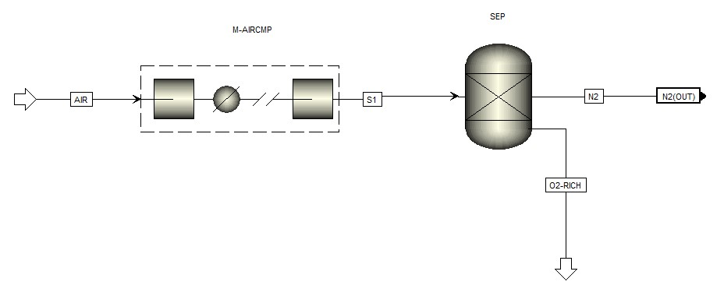
Figure S-3 Pressure Swing Adsorption Unit

Ammonia Synthesis Unit
Ammonia production unit (Figure S-4) was modelled using the Haber Bosch process. Nitrogen, hydrogen mix with the recycle loop gases (RL) and are compressed in a five-stage compressor from 301 K and 1 bar to 112 bar and 298 K. Compressing the recycle loop in the main compressor accounts for any pressure drop in the system. The mixed gases are heated to 520 K in the recuperator (RCP) before being heated to the reactor operation temperature of 533 K. The ammonia synthesis reactor was modelled as an RGibbs reactor operating at 533 K and 112 bar which can be facilitated by using a Ru/Ba-Ca(NH₂)₂ catalyst [36]. The products pass through the recuperator and are cooled to 362 K before cooled further to 253 K in the cooler. 99.5% of liquid ammonia is removed from the bottom of the separator column (SEP), which is modelled as a separator block. The rest is recycled in the recycle loop.

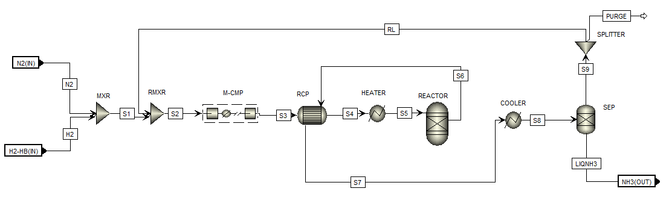
Figure S-4 Haber Bosch Process

Model Integration
The integrated model is shown in Figure S-5, where stream integrations depend on RSOFC operation mode. RSOFC-EC denotes electrolysis mode while RSOFC-FC denotes fuel cell mode. PSA, HB, BT and MGH denote pressure swing adsorption, Haber Bosch, buffer tank and medium grade heat respectively. Hydrogen produced during EC mode is split by a splitter block where a portion is channelled to the Haber Bosch process and the remainder is stored in a buffer tank for use during FC mode. The split fraction is determined the minimum capacity of the Haber Bosch process. The amount of nitrogen produced in the PSA unit is determined the amount of hydrogen passed towards the Haber Bosch process by a design specification block in order to maintain the hydrogen to nitrogen ratio at 3. Similarly, the amount of nitrogen from the RSOC nitrogen rich exhaust gas in FC mode is determined by the amount of hydrogen from the buffer tank in order to maintain the hydrogen to nitrogen ratio into the Haber Bosch at 3:1 via a design specification block.
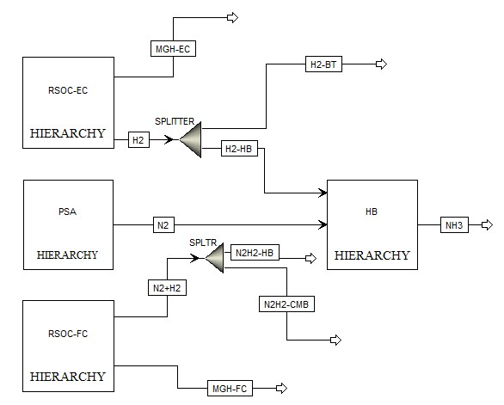
Figure S-5 Integrated Model

Temperature Sensitivity Analysis
The effect of temperature on energy efficiency of RSOFC in EC and FC mode is shown in Figure S-6 and Figure S-7 at a fixed current density of 0.6 A/cm². In EC mode, the system efficiency slightly reduces from 80.1 to 79.5%. The system efficiency in EC mode reduces due to increase in thermal energy required to split water.
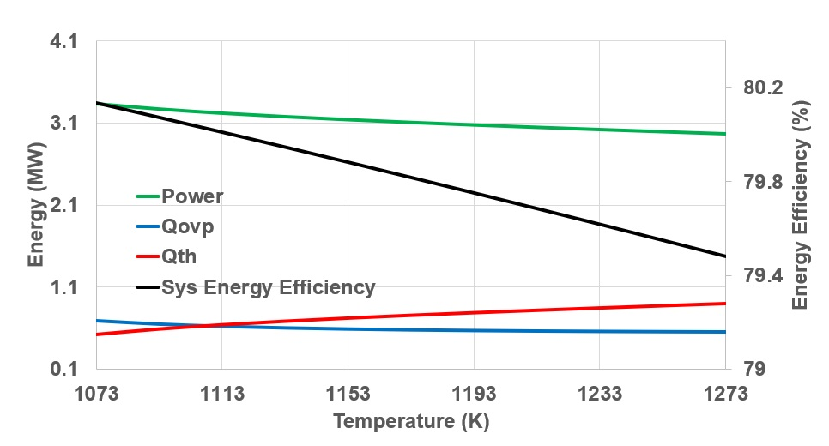
Figure S-6 Effect of temperature on energy efficiency in EC mode
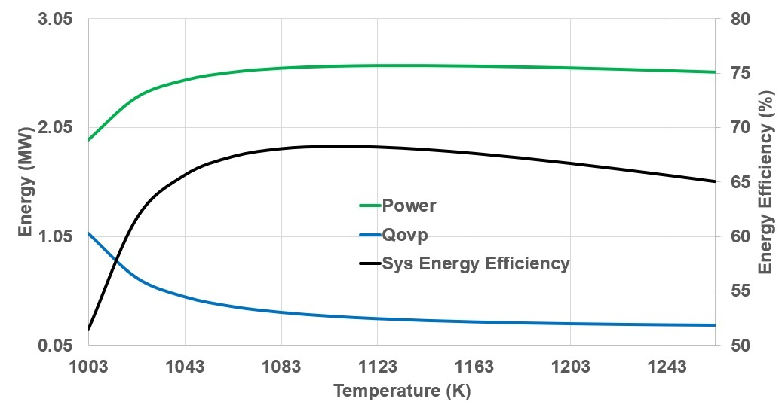
Figure S-7 Effect of temperature on energy efficiency in FC mode

No external heat would have been needed below 1113 K if the stack was operating a voltage close to thermal neutral voltage since overpotential heat is higher than thermal energy required for electrolysis. Though the ohmic overpotential is larger than the other overpotentials, oxygen electrode activation overpotential is mainly responsible for drop in overpotential heat since ohmic, concentration and fuel electrode overpotentials fairly remain constant, Figure S-8. In FC mode, system efficiency increases sharply to 68.3% at 1103 K, Figure S-7, due to steep reduction of oxygen electrode activation overpotential, Figure S-10. System efficiency reduces after 1103 K due to indistinct drop in activation overpotential and increase in concentration overpotential.
In FC mode, the efficiency increases up to 68.3% at 1103 K before starting to reduce as temperature increases. The overpotential heat reduces with temperature increment in both EC and FC modes. The effect of temperature on voltage, power density and overpotentials in EC and FC mode is shown in Figure S-8 to Figure S-11 at a fixed current density of 0.6 A/cm². These results agree with the results of [16]; [27]; [32].
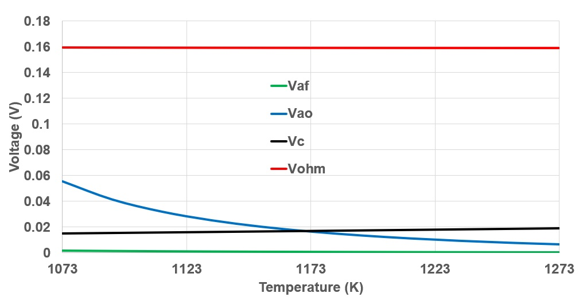
Figure S-8 Effect of temperature on overpotentials in EC mode
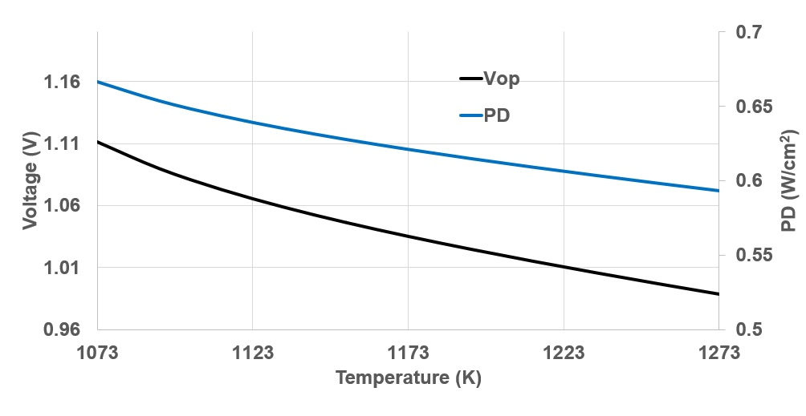
Figure S-9 Effect of temperature on cell voltage and power density in EC mode
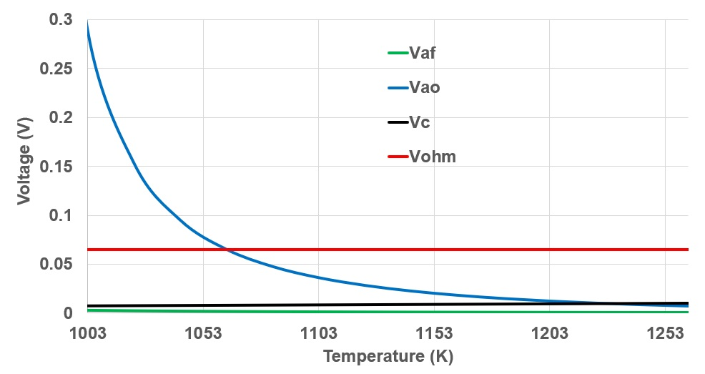
Figure S-10 Effect of temperature on overpotentials in FC mode

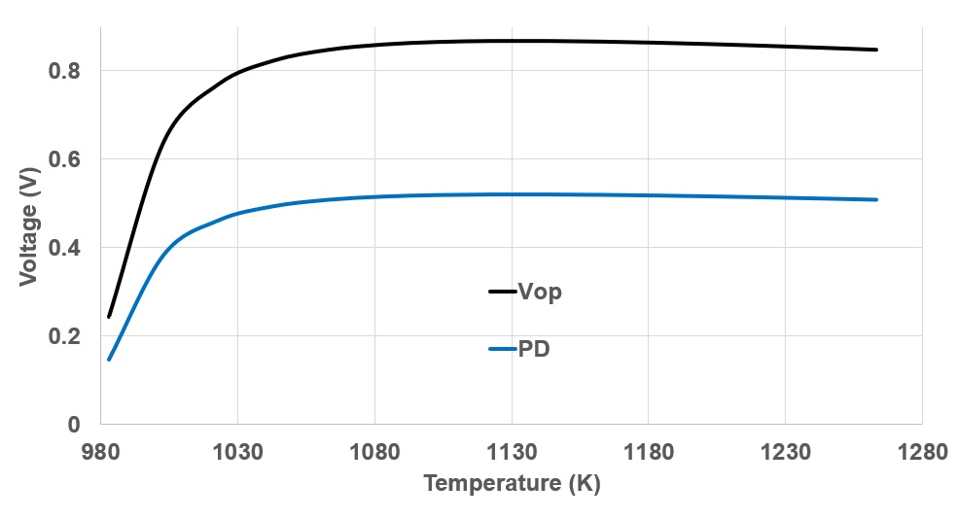
Figure S-11 Effect of temperature on cell voltage and power density in FC mode

Current Density Sensitivity Analysis
The effect of current density on energy efficiency of RSOFC in EC and FC mode is shown in Figure S-12 and Figure S-13 at a fixed temperature of 1113 K. In EC mode; power and overpotential heat increase as current density increases from 0.5 MW to 6.1 MW and 0.017MW to 1.8 MW respectively. The thermal energy required increases from 0.2 MW to negative 0.6 MW at a current density of 0.7 A/cm² before reducing to 0.3 MW. The energy efficiency nearly remains constant at 80% with increase in current density from 0.1 to of 1 A/cm². Though the amount of hydrogen produced increases as current density increases, the parasitic load and overpotential losses increases by about 90% and 99% respectively over the current density range.

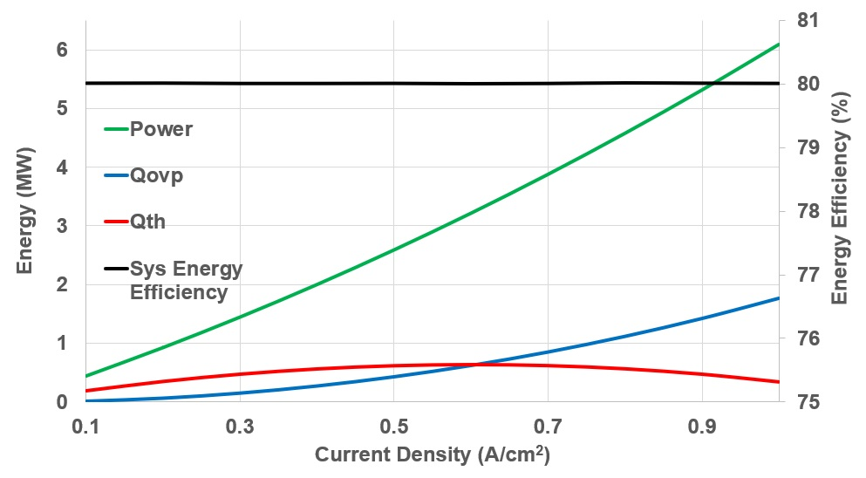
Figure S-12 Effect of current density on energy efficiency in EC mode

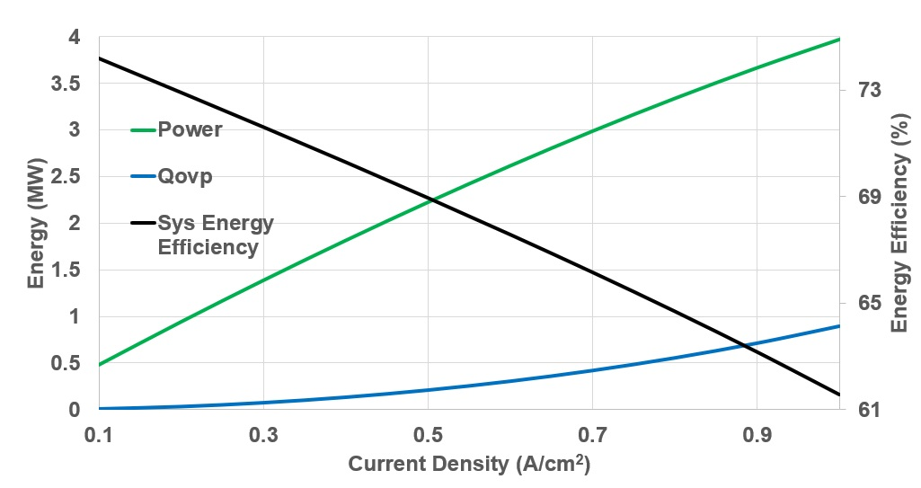
Figure S-13 Effect of current density on energy efficiency in FC mode
In FC mode, power and overpotential heat increases from 0.5 MW to 4 MW and 0.008 MW to 0.9 MW respectively as current density increases. The system energy efficiency reduces from 74 to 61%. The effect of current density on voltage, overpotentials and power density in EC and FC mode is shown in Figure S-14 to Figure S-17 at a fixed temperature of 1103 K. These results agree with the results of [16]; [32]; [27].
The system efficiency drops steadily with increase in current density. Ohmic overpotential is dominant in both EC and FC modes, Figure S-14 and Figure S-16. These results agree with the results of [32].
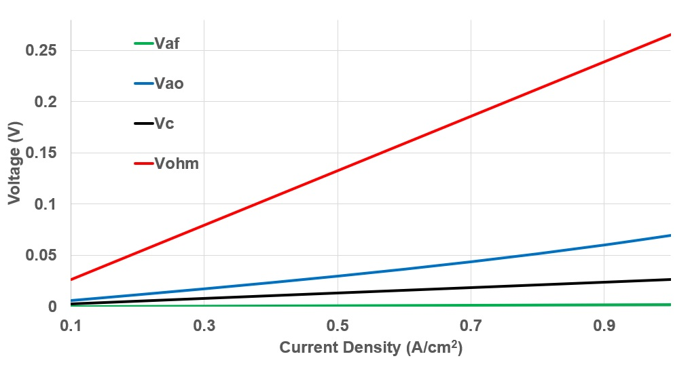
Figure S-14 Effect of current density on overpotentials in EC mode
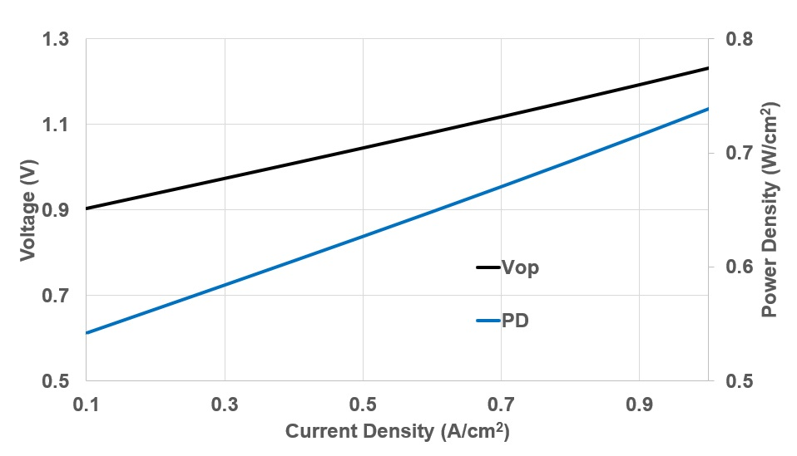
Figure S-15 Effect of current density on voltage and power density in EC mode

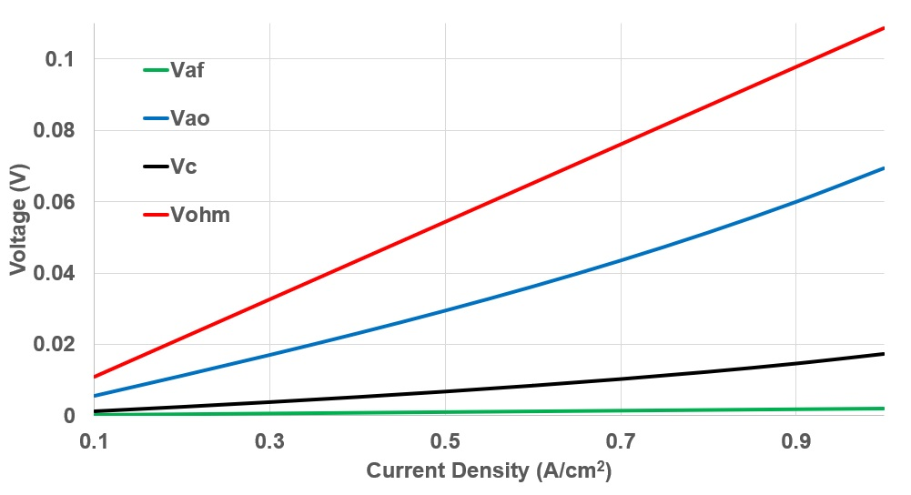
Figure S-16 Effect of current density on overpotentials in FC mode
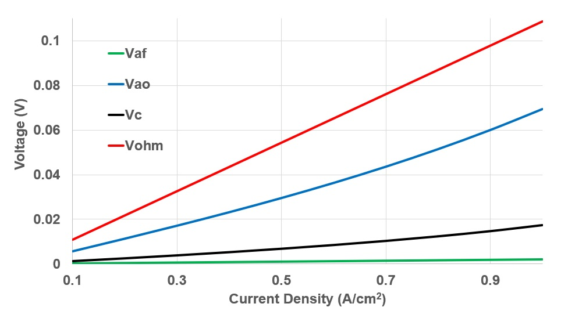
Figure S-17 Effect of current density on voltage and power density in FC mode

