Electronic Supplementary Material
- Shoulders
- Lateral upper chest
- Medial upper chest
- Lateral mid anterior torso
- Medial mid anterior torso
- Sides
- Lower anterior torso
- Lateral posterior upper torso
- Medial posterior upper torso
- Lateral posterior mid upper
- Lateral posterior mid lower
- Centre posterior mid
- Posterior lower torso
- Anterior upper leg
- Medial upper leg
- Posterior upper leg
- Lateral upper leg
- Lateral lower leg
- Medial lower leg
- Posterior lower leg
- Anterior upper arm
- Posterior upper arm
- Anterior lower arm
- Posterior lower arm
- Hands
- Centre dorsal foot
- Medial dorsal foot
- Lateral dorsal foot
- Plantar foot
- Forehead
- Armpits
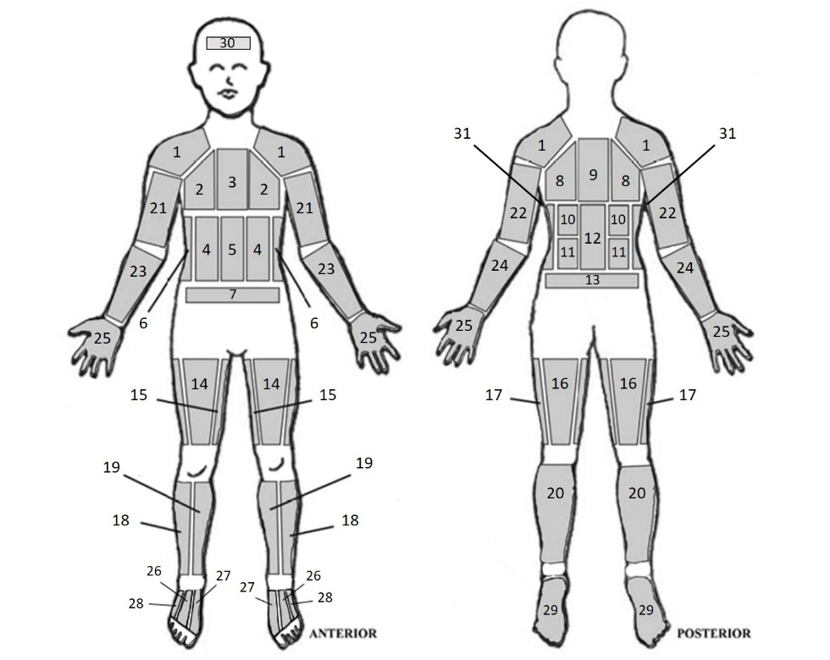

ESM1. The location and numeration of each absorbent pad on a participant (adapted from Smith, 2011). All the numbers correspond to a pad except for 25 which were cotton gloves. Numbers 31 are armpit pads.

ESM2. Mean ± SD pre- and post-skin temperature changes after the application of the absorbent pads. *Statistically significant changes from pre- to post-absorbent pad application P≤ 0.05
 | Skin temperature (℃)
Location | Pre- | SD | Post- | SD | Change | SD
Forehead | 34.0 | 0.5 | 34.1 | 0.6 | 0.1 | 0.3
Torso | 34.3 | 0.6 | 34.8 | 0.6 | 0.5* | 0.2
Back | 34.3 | 0.9 | 34.6 | 0.8 | 0.3* | 0.3
Front right arm | 33.2 | 0.6 | 34.1 | 0.6 | 0.8* | 0.3
Back right arm | 33.5 | 0.5 | 34.3 | 0.5 | 0.8* | 0.4
Front left arm | 33.1 | 0.6 | 34.0 | 0.6 | 0.9* | 0.3
Back left arm | 33.5 | 0.5 | 34.3 | 0.4 | 0.8* | 0.4
Front right hand | 34.3 | 0.7 | 34.4 | 0.8 | 0.2 | 0.4
Back right hand | 33.4 | 0.7 | 33.8 | 0.7 | 0.4* | 0.3
Front left hand | 34.2 | 0.7 | 34.3 | 0.8 | 0.1 | 0.3
Back left hand | 33.3 | 0.7 | 33.7 | 0.8 | 0.4 | 0.4
Front right leg | 33.1 | 0.6 | 33.7 | 0.8 | 0.6* | 0.3
Back right leg | 33.4 | 0.7 | 34.2 | 0.7 | 0.8* | 0.3
Front left leg | 33.0 | 0.6 | 33.7 | 0.8 | 0.7* | 0.4
Back left leg | 33.4 | 0.6 | 34.2 | 0.7 | 0.8* | 0.3
Dorsal right foot | 34.8 | 0.6 | 34.8 | 0.7 | 0.0 | 0.4
Plantar right foot | 33.9 | 0.8 | 34.1 | 0.7 | 0.2 | 0.7
Dorsal left foot | 34.8 | 0.6 | 34.9 | 0.7 | 0.1 | 0.3
Plantar left foot | 33.9 | 0.7 | 33.9 | 0.7 | 0.1 | 0.7

