**Evaluating the Activity and Stability of Perovskite LaMO3-based Pt Catalysts in the Aqueous Phase Reforming of Glycerol Supplementary Information**

Donald R. Inns1, Alexander J. Mayer1,2, Vainius Skukauskas3,4, Thomas E. Davies5, June Callison4,5 and Simon A. Kondrat1*

1. Department of Chemistry, Loughborough University, Epinal Way, Loughborough, Leicestershire, LE11 3TU, UK
2. Diamond Light Source Ltd, Harwell Science and Innovation Campus, Fermi Ave, Didcot OX11 0DE
3. School of Chemistry, University of Glasgow, Joseph Black Building, Glasgow, G12 8QQ, UK
4. UK Catalysis Hub, Research Complex at Harwell, Rutherford Appleton Laboratory, Harwell, Oxfordshire OX11 0FA, UK
5. Cardiff Catalysis Institute, School of Chemistry, Cardiff University, Main Building, Park Place, Cardiff, CF10 3AT, UK

* Email: [S.Kondrat@lboro.ac.uk](mailto:S.Kondrat@lboro.ac.uk)

**Table S1.** Database ICDD PDF patterns for materials

|  |  |
| --- | --- |
| **Material** | **ICDD PDF Pattern No.** |
| Al2O3 | PDF 29-0063 |
| LaAlO3 | PDF 31-0022 |
| LaCrO3 | PDF 33-0701 |
| LaCrO4 | PDF 36-0093 |
| LaMnO3 | PDF 32-0484 |
| LaFeO3 | PDF 37-1493 |
| LaCoO3 | PDF 25-1060 |
| LaNiO3 | PDF 34-1181 |
| NiO | PDF 47-1049 |
| Ni | PDF 04-0850 |
| LaCO3OH | PDF 26-0815 |
| La2O(CO3)2.xH­2O | PDF 28-0512 |
| Fe3O4 | PDF 03-0863 |
| La(OH)3 | PDF 36-1481 |
| Co(OH)2 | PDF 30-0443 |

**Figure S1.** Thermogravimetric analysis (TGA) of combusted precursor powders of LaAlO3 (black), LaCrO3 (red), LaMnO­3 (blue), LaFeO3 (green), LaCoO3 (pink), and LaNiO3 (orange). 

**Table S2.** Normalised TOF values

|  |  |  |
| --- | --- | --- |
| Catalysta | TOF glycerol  (mol/mol of surface Pt/h) | Hydrogen Formation Rate  (umol/min/m2(Pt)) |
| Pt/γ-Al2O3 | 665.6 | 1996.3 |
| Pt/LaAlO3 | 1359.48 | 2752.1 |
| Pt/LaCrO3 | 581.9 | 1484.5 |
| Pt/LaMnO3 | 750.4 | 3039.7 |
| Pt/LaFeO3 | 513.0 | 1691.3 |
| Pt/LaCoO3 | 443.4 | 2279.4 |
| Pt/LaNiO3 | 847.1 | 1549.2 |

**Figure S2.** TEM micrograph of fresh a) Pt/LaAlO3,b) Pt/LaCoO3, c) Pt/LaNiO3

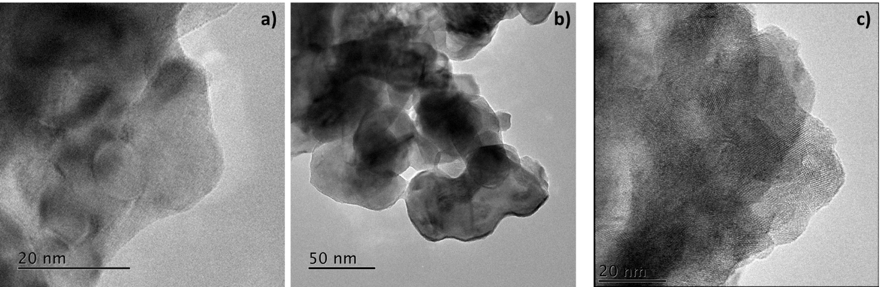

**Figure S3.** Pt L3 edge EXAFS Fourier Transform χR (left) and χk (right) of Pt/Al2O3 *a) Fresh, b) Used.*

 

**Figure S4.** Pt L3 edge EXAFS Fourier Transform χR (left) and χk (right) of PtLaAlO3 *a) Fresh, b) Used.*

 

**Figure S5.** Pt L3 edge EXAFS Fourier Transform χR (left) and χk (right) of PtLaCrO3 *a) Fresh, b) Used.*

 

**Figure S6.** Pt L3 edge EXAFS Fourier Transform χR (left) and χk (right) of PtLaCoO3 *a) Fresh, b) Used.*

 

**Figure S7.** Pt L3 edge EXAFS Fourier Transform χR (left) and χk (right) of PtLaFeO3 *a) Fresh, b) Used.*

 

**Figure S8.** Pt L3 edge EXAFS Fourier Transform χR (left) and χk (right) of PtLaMnO3 *a) Fresh, b) Used.*



**Figure S9.** Pt L3 edge EXAFS Fourier Transform χR (left) and χk (right) of PtLaNiO3 *a) Fresh, b) Used.*



**Figure S10.** XRD patterns of Pt/Al2O3 (black), Pt/LaAlO3 (red), Pt/LaCrO3 (blue), Pt/LaMnO3 (green), and Pt/LaNiO3 (orange) post reaction 2 (left) and 3 (right). Phases:  γ-Al2O3;  LaCO3OH;  perovskite; Ni.

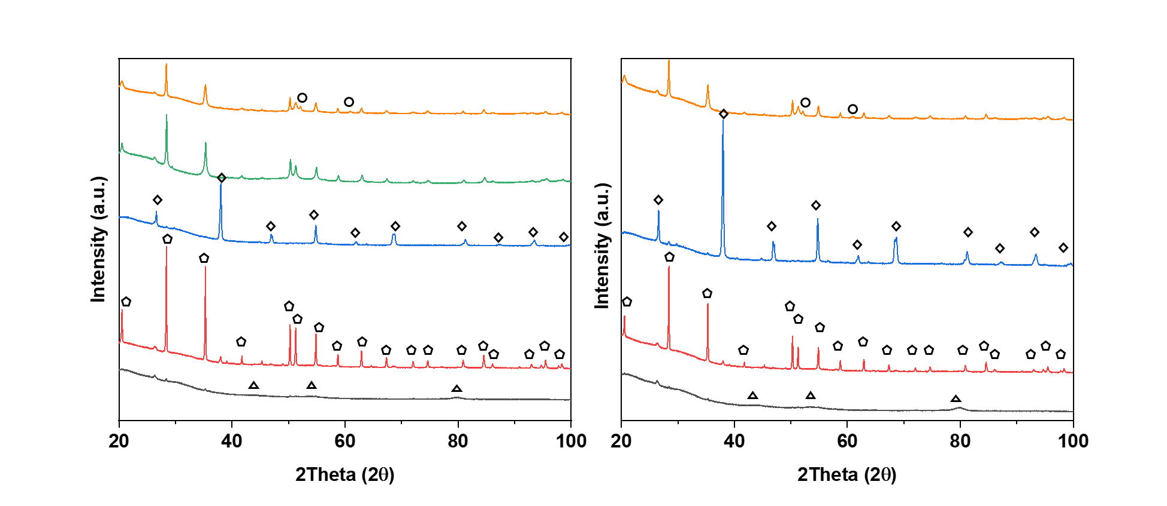

**Figure S11.** XPS Cr 2p region for fresh and recycled catalysts up to 3 cycles.



**Figure S12.** Pt L3 edge EXAFS Fourier Transform χR (left) of PtLaNiO3 Used *a) Pt-Ni path, b) Pt-Pt path, c) Pt-Ni and Pt-Pt path.*



**Table S3.** EXAFS fitting for Pt L3 edge of PtLaNiO3 Used *a) Pt-Ni path, b) Pt-Pt path, c) Pt-Ni and Pt-Pt path.*

|  |  |  |  |  |  |  |
| --- | --- | --- | --- | --- | --- | --- |
| Fit | Scattering Path | Coordination Number | *2σ2* (Å2) | *R* (Å) | *Ef* (eV) | *R*factor |
| a) | Pt-Ni | 7.1(8) | 0.0067(9) | 2.54(6) | -3(1) | 0.021 |
| b) | Pt -Pt 1.1 | 12(6) | 0.007(3) | 2.50(3) | -27(5) | 0.30 |
| c) | Pt-Ni  Pt-Pt 1.1 | 6(1)  2(2) | 0.005(1)  0.005(5) | 2.530(9)  2.66(3) | -3(2) | 0.014 |
| Fixed parameters : So2 = 0.81 | | | | | | |

**Figure S13.** TEM micrograph of a) Pt/LaMnO3 post reaction 2, b) Pt/LaNiO3 post reaction 3

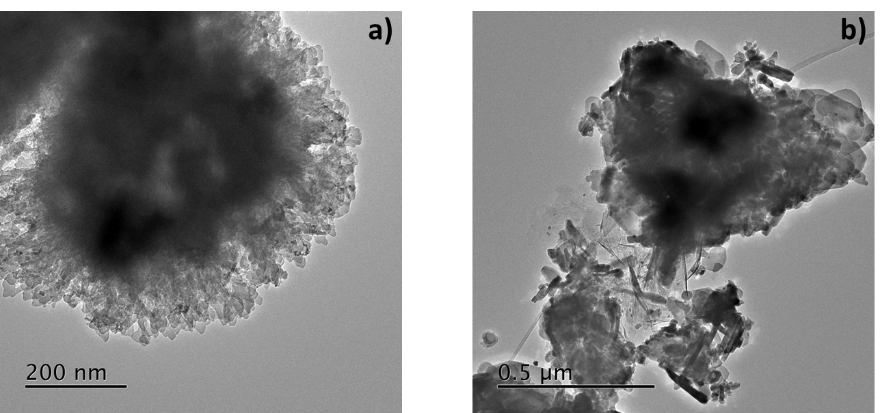

**Table S4.** *Bond Dissociation Energies in Diatomic Cations at 298 K; Data is from* CRC Comprehensive Handbook of Chemical Bond Energies [1]

|  |  |  |  |  |  |  |
| --- | --- | --- | --- | --- | --- | --- |
|  | Al+-O | Cr+-O | Mn+-O | Fe+-O | Co+-O | Ni+-O |
| Do298 kJmol-1 | 166.7 ± 12.0 | 359 | 285 ± 13 | 334 ± 6 | 317.3 ± 4.8 | 275.9 ± 7.7 |

1. Luo YR (2007) Comprehensive Handbook of Chemical Bond Energies, 1st ed. CRC Press, Boca Raton, FL

**Figure S14.** Calculated Pourbaix diagram for LaAlO3

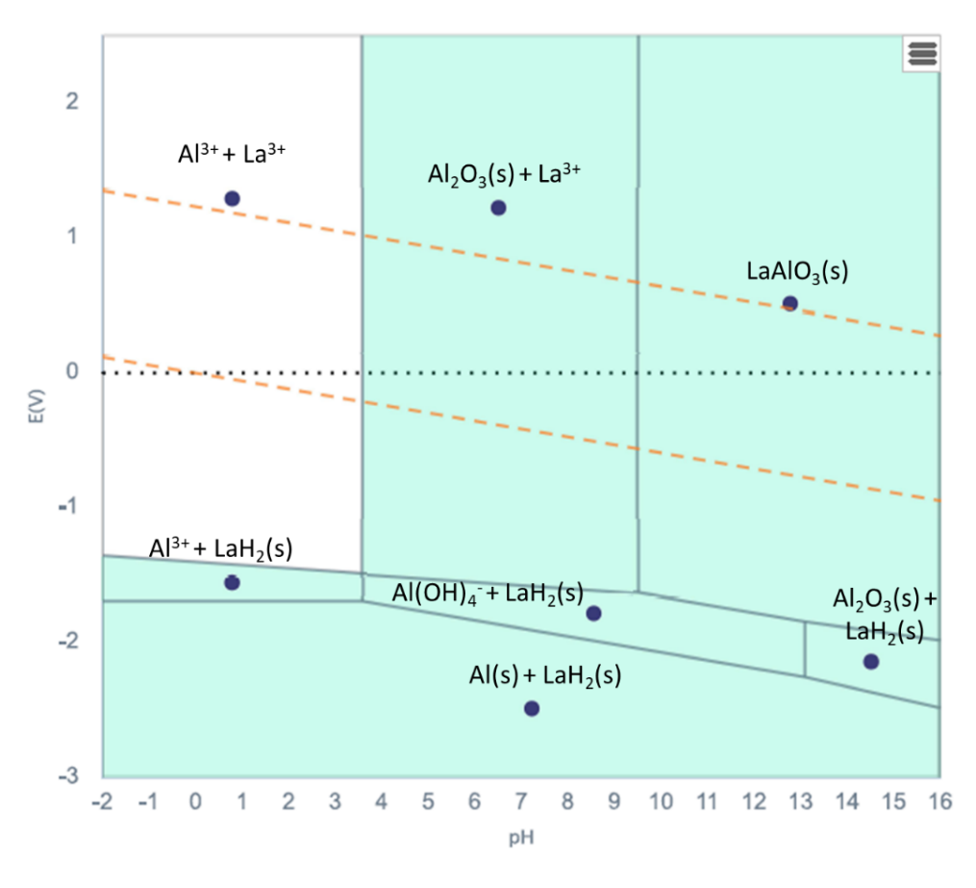

**Figure S15.** Calculated Pourbaix diagram for LaCrO3

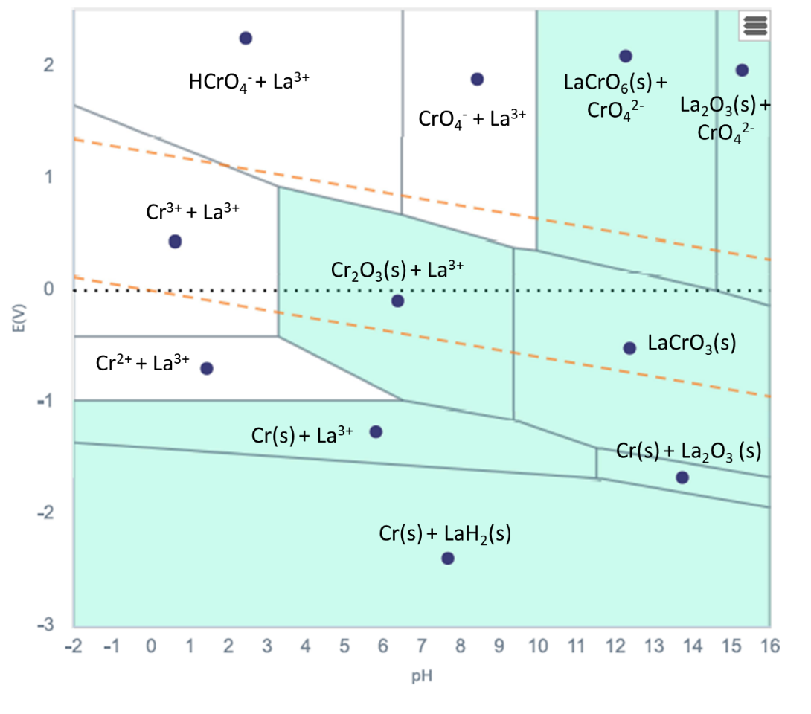

**Figure S16.** Calculated Pourbaix diagram for LaMnO3

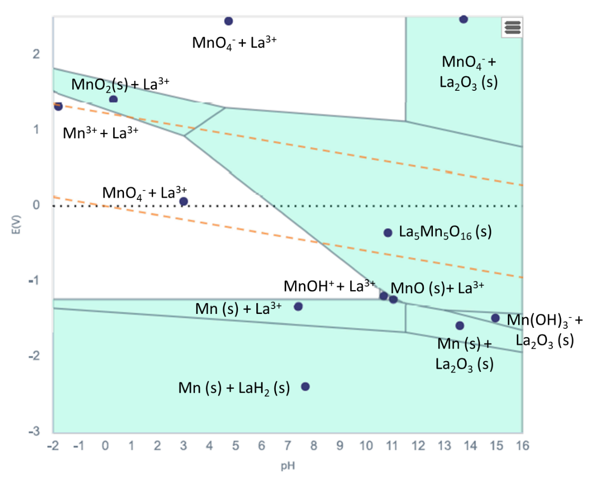

**Figure S17.** Calculated Pourbaix diagram for LaFeO3

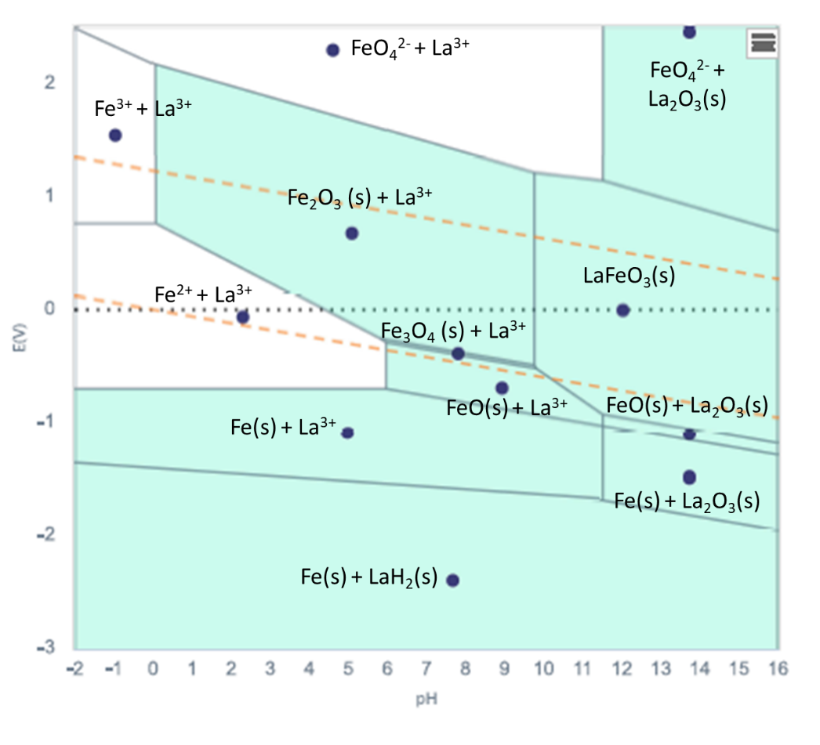

**Figure S18.** Calculated Pourbaix diagram for LaCoO3

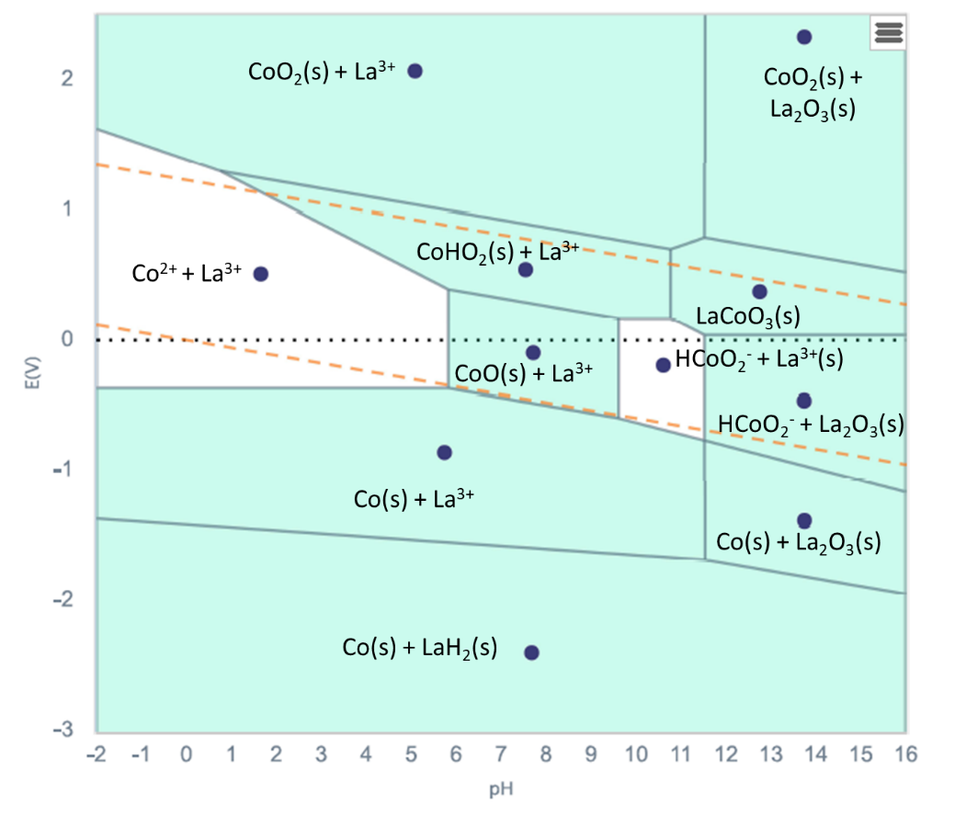

**Figure S19.** Calculated Pourbaix diagram for LaNiO3

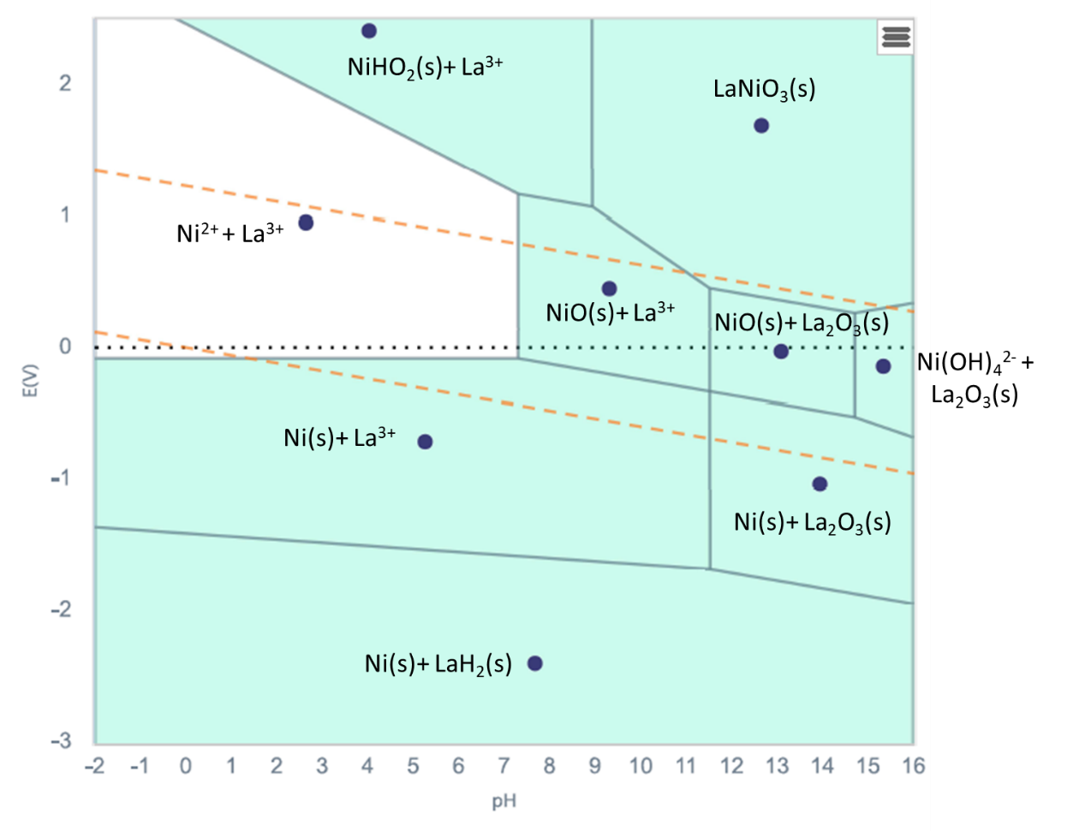

**Figure S20.** Calculated Pourbaix diagram for Al2O3

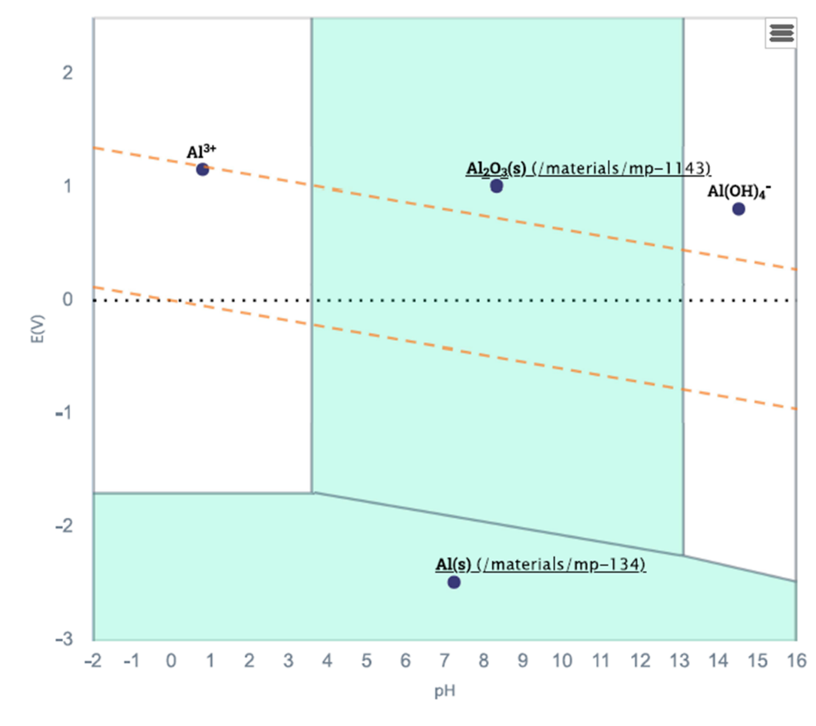

**Figure S21.** Calculated Pourbaix diagram for Lanthanum-carbon species

