JGR: Earth Surface
Supporting Information for
Aquatic insect bioconstructions modify fine-sediment entrainment and mobility
R. J. Mason¹, ², S. P. Rice², M. F. Johnson³, P. J. Wood² and D. Vettori⁴
¹Umeå University, ²Loughborough University, ³University of Nottingham, ⁴Politecnico di Torino

Contents of this file

Text S1
Figures S1 to S2
Tables S1

Additional Supporting Information (Files uploaded separately)
Movie S1

Introduction
Case building caddisfly (Trichoptera) are small aquatic insects, which build structures from fine sediment and silk. We undertook a hydraulic flume experiment to quantify the effect of caddisfly case construction on sediment transport in rivers.

Text S1.
Velocity data post-processing and calculation of shear stress

Velocity time series data were post-processed using phase-space thresholding to remove spikes, which were replaced by linear interpolation (Biron et al., 2004; Goring & Nikora 2002) using the Velocity Signal Analyser tool developed by Jesson et al. (2015). Whilst ADV measurements had to be taken close to the bed to estimate the flow velocity and shear stress the caddisfly larvae were exposed to, this resulted in reduced data quality due to increased turbulence, shear, and reflection near the boundary (Martin et al., 2002; McLelland & Nicholas, 2000; Nikora et al., 2014; Voulgaris & Trowbridge, 1998). Data with a correlation of less than 60% and signal to noise ratio (SNR) less than 10 were removed. Whilst these thresholds are lower than recommended for turbulence calculations (recommended correlation = 70%, SNR = 15; Nortek, 2009), they are an acceptable compromise when working close to the bed (McLelland & Nicholas, 2000). Any velocity time series with more than 20% data removed from any axis was discarded. This left 5-6 replicates of 2 minute, 50Hz, time series velocity data for each discharge step.

Bed shear stress was calculated via the turbulent kinetic energy (TKE) approach using turbulence measurements for a single point close to the bed (Biron et al., 2004). TKE was calculated from the intensity of the velocity fluctuations in three dimensions as:
 | $$E=\frac{(u^{'2}+v^{'2}+ w^{'2}) }{2}$$ | (1)
Where $u^{'2},v^{'2}$ and $w^{'2}$ are the second order moment statistics for velocity in the streamwise, cross-stream and vertical directions, respectively. Subsequently, bed shear stress $τ_{b}$ (N m⁻²) was estimated according to:

 | $$τ_{b}=C_{1}ρ_{w}E$$ | (2)

Where constant $C_{1}$ = 0.19 (Soulsby, 1983; Stapleton & Huntley, 1995) and, $ρ_{w}$ is water density = 1000 kg m^{-3.}

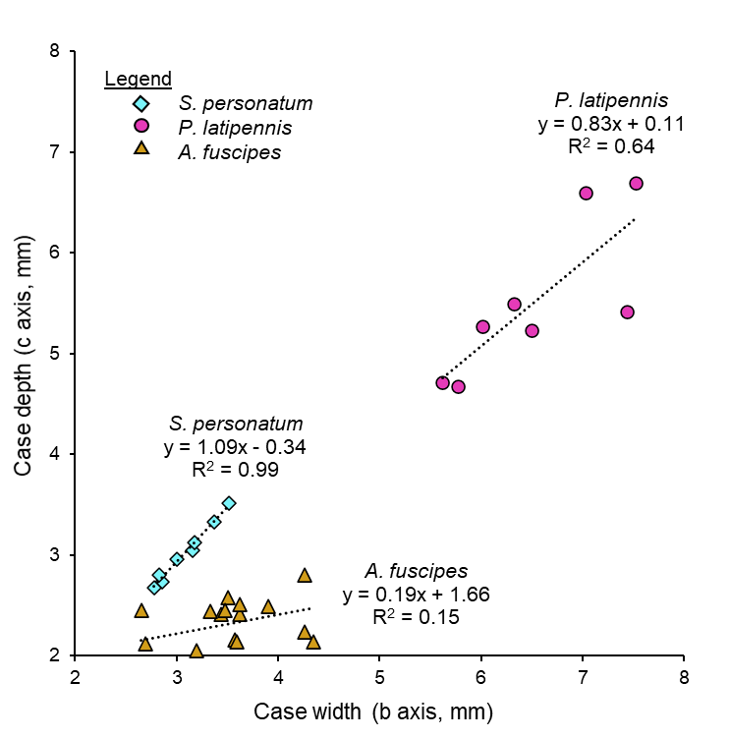

Figure S1. Association between width (b axis) and depth (c axis) of cases of each species. A linear trend between b and c was used to estimate the unknown c axis of caddisfly used in the flume experiments. The trend is weaker for P. latipennis and particularly A. fuscipes due to variability in case design between species. However, it provides a sufficiently accurate method to calculate case volume for the analysis in this paper because it distinguishes between species.

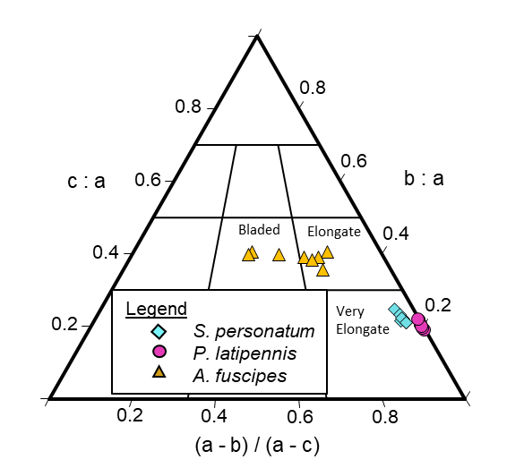

Figure S2. Tertiary diagram of particle shape (after Graham & Midgley, 2000). Shape classifications are based on Sneed and Folk (1958). Distinct differences in shape are evident between the rod-shaped cases of P. latipennis and S. personatum, which are very elongate and A. fuscipes cases, which are less elongate. As the length of the three axis are more similar for A. fuscipes, they also plot over a wider range.

<Flow stage | Bed slope | Depth (m) | Q (m³ s⁻¹) | U (m s⁻¹) | Re | Fr | U_{b}  (m s⁻¹) | $τ_{b}$ (N m⁻²)
1 | 0.02 | 0.081 | 0.0005 | 0.02 | 1152⁺ | 0.025 | 0.02* | 0.0030
2 | 0.02 | 0.081 | 0.0010 | 0.04 | 2199⁺ | 0.047 | 0.03* | 0.0114
3 | 0.02 | 0.081 | 0.0018 | 0.08 | 3976 | 0.085 | 0.06* | 0.0412
4 | 0.02 | 0.079 | 0.0025 | 0.11 | 5532 | 0.121 | 0.08* | 0.0668
5 | 0.02 | 0.082 | 0.0032 | 0.13 | 6918 | 0.147 | 0.10* | 0.1125*
6 | 0.02 | 0.080 | 0.0042 | 0.18 | 9091 | 0.197 | 0.13* | 0.1599*
7 | 0.02 | 0.082 | 0.0051 | 0.21 | 10900 | 0.229 | 0.15* | 0.2287*
8 | 0.03 | 0.081 | 0.0060 | 0.27 | 12955 | 0.276 | 0.18* | 0.2830*
9 | 0.05 | 0.082 | 0.0070 | 0.29 | 15118 | 0.320 | 0.19* | 0.3432*
10 | 0.06 | 0.081 | 0.0085 | 0.35 | 18351 | 0.393 | 0.24* | 0.4907*
11 | 0.08 | 0.080 | N/A | N/A | N/A | N/A | 0.28* | 0.7277*

Table S1. Flume and hydraulic measurements for each discharge step (1-11). All hydraulic measurements are the mean of replicate flow measurement runs. Discharge, velocity and bed shear stress increased with each run, whilst depth remained constant. Depth average velocity (U) was based on a replicate (n = 3) single point velocity measurements taken at 60% depth (independent of TKE estimates) but, unfortunately, were not successfully collected for discharge step 11. Near bed velocity U_{b} was centred at 10 mm above the bed (n = 5-6). For near bed velocity and shear stress ($τ_{b}$), * indicates that the stage was significantly different from both neighbouring discharge steps according to a Tukey Honest Significant Difference test (adjusted p < 0.05). For the Reynolds number ⁺ indicates that flow is transitional according to 500<Re<2500. All other discharge steps were fully turbulent. Froude numbers reveal that all discharge steps were subcritical (Fr<1).

Captions

Movie S1. Transport of caddisfly case (P. latipennis) (right) compared to the fine sediment incorporated into the case. During the course of the video, bed shear stress and flow velocity are gradually increased until both the case and sediment are mobilized. Timings are not perfectly synced between videos but P. latipennis cases moved at lower flow stages than fine sediment and can be observed to turn perpendicular to the flow and roll off the measurement platform.

