Supplementary Figures
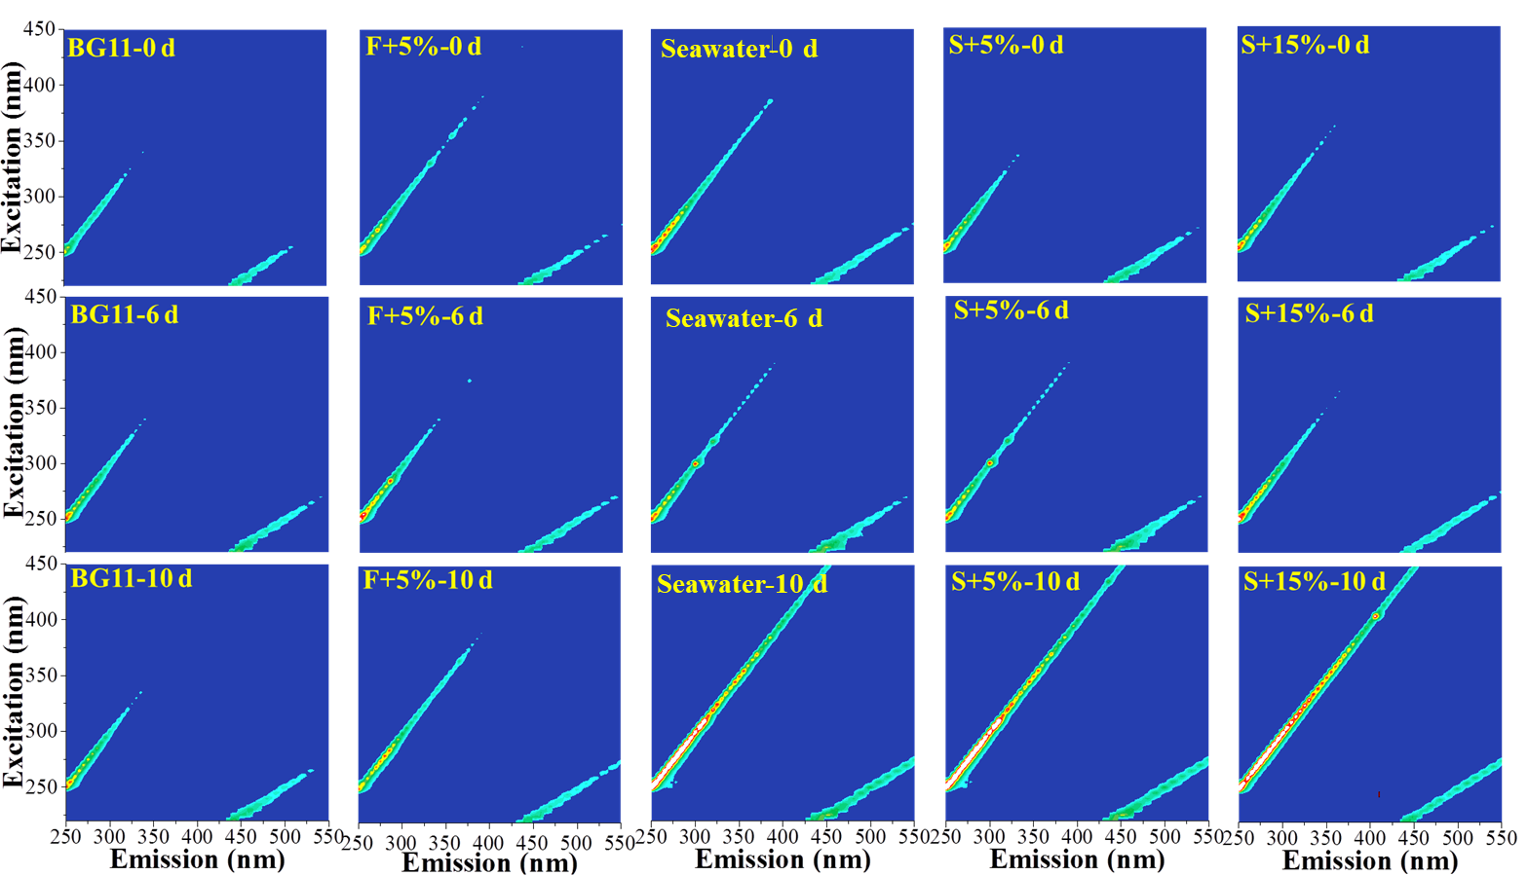

Fig. S1. Fluorescence spectra of soluble EPS (SL-EPS) from Chlorella sorokiniana SDEC-18 cultivated in BG11 medium, freshwater medium (F+5%), and seawater-based media (Seawater, S+5% and S+15%) on the start day (0 d), 6th day (6 d) and 10th day (10 d).
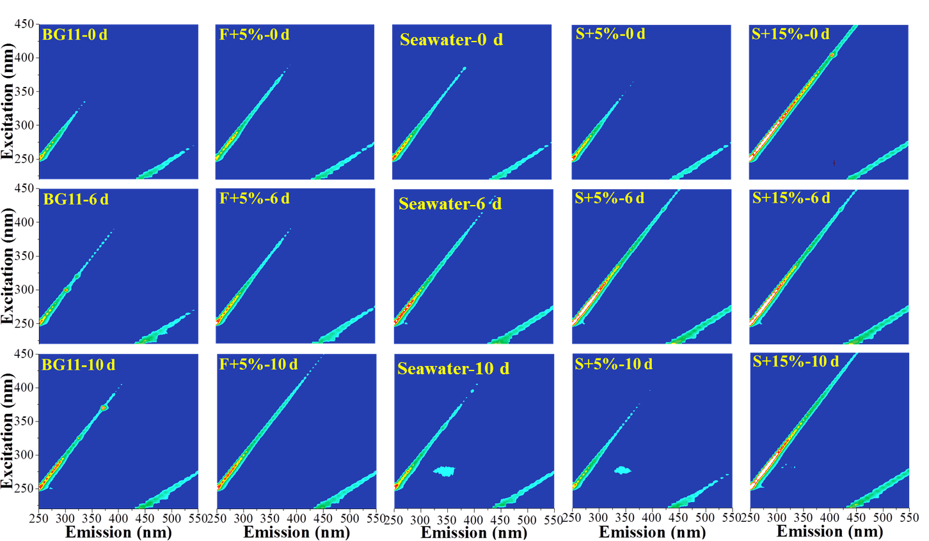

Fig. S2. Fluorescence spectra of loosely bound EPS (LB-EPS) from Chlorella sorokiniana SDEC-18 cultivated in BG11 medium, freshwater medium (F+5%), and seawater-based media (Seawater, S+5% and S+15%) on the start day (0 d), 6th day (6 d) and 10th day (10 d).

