Supplementary information
Polycarbene-Bearing Membrane Surface Containing Silver Species for Size and Charge Selective Molecular Separation
Nagaraj S. Naik¹, Prajwal Sherugar¹, Vishnumurthy K. A², G. Athanareshwar³, Diganta B. Das² Mahesh Padaki¹*
¹ Centre for Nano and Material Sciences, Jain University, Jain Global Campus, Kanakapura, Ramanagaram, Bangalore 562112, India
²Department of Chemistry, RV College of Engineering, Bengaluru, Karnataka
560059, India
³Membrane Research Laboratory, Department of Chemical Engineering, National Institute of,
Technology, Tiruchirappalli 620015, Tamil Nadu, India
⁴Department of Chemical Engineering, Loughborough University (LU), Loughborough LE11 3TU, Leicestershire, UK
*Corresponding author. Tel.: +918027577212 (186), Email: sp.mahesh@jainuniversity.ac.in

- Methodology
  - Synthesis of N-Vinyl-4-sulfonyl-1-butaneimidazolium (SBVI) monomer
1-Vinyl imidazole (5 g, 0.053 mol) was dissolved in 50 mL of acetonitrile in a 3-necked round-bottom flask. Added 7.23 g (0.053 mol) of butane sultone to this solution and allowed it to react for 24 h. The obtained white precipitate (Scheme. S1) was filtered and washed with ethyl acetate. The filtered product was dried in a vacuum oven at 70 ºC. The product yield was 11.95g and was further used in the next step without any purification.
Scheme S1. Synthesis of N-Vinyl-4-sulfonyl-1-butaneimidazolium.
  - Synthesis of PIL copolymer
The poly(ionic liquid) based copolymers were prepared through the radical co-polymerization of SBVI, styrene, and itaconic acid (ICA) as sketched in Scheme S2. In a typical synthesis, ICA (0.038 mol), styrene (0.028 mol), SBVI (0.022 mol), and azobisisobutyronitrile (AIBN, 0.1 wt.%) were dissolved in methanol (25 mL) in a two-necked round bottom flask under a nitrogen environment. The mixture was refluxed using a condenser for 48 h along with continuous stirring. The sticky solid was obtained by adding diethyl ether into the viscous solution. Further ether was decanted and the sticky solid was repeatedly washed with deionized water and ethyl acetate to obtain the polymer. The obtained product was dried under a vacuum at 60 °C.
Scheme S2. Synthesis of poly(itaconic acid-co-styrene-co-sulfobetainevinylimidazole) (PIL).

Table S1. Composition of PILs for membrane preparation.
Name of the membrane | PIL (wt.%) | PSf (wt. %) | NMP (mL)
M1 (10% PIL/PSf) | 10 | 90 | 16
M2 (20% PIL/PSf) | 20 | 80 | 16

  - Molecular weight cut-off study
The molecular weight cut-off (MWCO) of all membranes was established as the molecular weight of a test dye molecule with a rejection of >95% [1, 2]. The MWCO was measured using multiple dye molecules (with MWs ranging from 300 to 600 Da) with different electric charges at 10 mg/L dye concentration at ambient temperature under 0.2 MPa pressure to ensure more accurate analysis and minimize probable dye charge interference during the NF process.
  - Membrane characterization
Prepared PIL copolymer was characterized by using ¹H and ¹³C NMR (Bruker Avance 400 S) spectral technique recorded with D₂O and DMSO-d₆ as a solvent and tetramethylsilane (TMS) as the standard. The attenuated total reflectance infrared (ATR-IR) (Bruker, ALPHA, 200619) spectral technique was used to determine the chemical functional groups present on the PIL co-polymer and membrane. The in-plane and cross-sectional surface morphology were analyzed using field emission-scanning electron microscopy (FE-SEM) (JEOL Model-JSM7100F). The surface roughness of the membranes was investigated using an atomic force microscope (AFM) (Agilent Technologies, Model:5000) in non-contact mode. The Zeta potential instrument (SurPASSTM 3 Eco from Anton Paar GmbH, Austria) was used to investigate the surface charges of the membrane. Raman spectra of the blend and surface-modified membranes were analyzed by commercial portal Raman spectrometer (i-Raman plus with 785nm laser excitation). The hydrophilicity of the membrane was observed by using contact angle measurement (Tech Inc, Instrument, India). The concentration of all the dyes was quantified by a UV-vis spectrophotometer (SHIMADZU, UV-1800, A11454907691) using a 10 mm quartz cuvette.
Figure S1. Schematic representation of dead-end filtration unit
- Results and discussion
  - Synthesis and characterization of PIL
In a radical polymerization process, polymerization occurs between the SBVI, itaconic acid, and styrene in the presence of AIBN as an initiator to get a PIL (Scheme S2). The PIL provides surface hydrophilicity and molecular separation properties to the membrane. The structure of the newly synthesized polymer was characterized by various analytical techniques. The ¹H -NMR spectra of PIL were shown in Figure S2, the broad peak at δ11.2 -12.5 ppm due to the acidic proton (-COOH) from the polymerized itaconic acid moiety. The aromatic protons of the imidazolium ring were observed in the range δ 8.2 to 9.4 ppm. The peaks at δ 3.5 to 4.5 ppm in the aliphatic region indicate the presence of -CH- and -CH₂- proton adjacent to tertiary and quaternary ammonium groups in the imidazolium ring. The presence of aromatic protons around δ 6.2-7.8 ppm confirms the presence of aromatic moiety of styrene units. Also, the broad peaks around δ1 to 3 ppm can be assigned to the protons on -CH- and -CH₂- from a polymerized vinyl group of all the monomers. Furthermore, ¹³C NMR carbon peaks of PIL were assigned in Figure S3 and confirmed all the expected carbon peaks in the range.
Figure S2. ¹H-NMR spectrum of PIL co-polymer.
Figure S3. ¹³C NMR of PIL co-polymer.
The ATR-FTIR spectra of the newly synthesized PIL are represented in Figure S4a. The appearance of a peak at 2943 cm⁻¹ confirms the stretching vibrations of -CH- and -CH₂- in the main chain of the polymer backbone. The peaks around 1453 and 1493 cm⁻¹ confirm the presence of aromatic -C=C- and -CH groups respectively. The strong absorption peak at 1703 cm⁻¹ is due to the carbonyl stretching vibration of the –COOH functional group of itaconic acid, and it confirms the presence of the same in the polymer backbone. The characteristic band at 1034 and 1173 cm⁻¹ are responsible for the asymmetric and symmetric vibrations of the O=S=O and C-O groups present in the polymer matrix. ¹H NMR, ¹³C NMR, and FTIR results confirm the structure of the newly synthesized PIL.
The thermal properties of PIL were strongly dependent on the interactions between cations/anion and counter ions and the TGA presented in Figure S4b confirms the same. There is an isothermal water (or bound water) loss at 100 to 150 °C in PIL. Further, 10% of weight loss was observed at 180 to 300 °C due to the CO₂ elimination from polymerized itaconic acid moiety (Scheme S2), also this weight loss may be attributed to the extermination of a sulfonic acid functional group into water and sulfur dioxide [3]. Complete degradation of the polymer chain occurred between C310 °C to 600 °C while leaving the residue around 20% owing to the carbon in the N₂ atmosphere. All the above results clarify that the synthesized PIL has excellent structural and thermal properties, which could be beneficial for the modification of polysulfone membrane for molecular separation applications.
The molecular weight of PIL was measured using Gel permeation chromatography (GPC). The measurement was run for different molecular weights ranging from 220 Da to 200 kDa. The maximum peak was found at 8.34 min with weight average molecular weight (Mw) of ≈7000-7500 Da and number average molecular weight (Mn) of ≈3000-3500 Da with a polydispersity index of 2.3 (Figure S5).
Figure S4. a) ATR-IR spectrum, b) TGA of PIL.
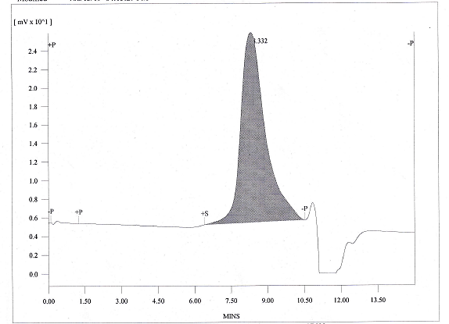
Figure S5. GPC Curve of PIL

Figure S6. XPS core-level spectra of M1 a) C 1s, b) O 1s, c) S2p a and d) N 1s, and M2 e) C 1s, f) O 1s, g) S2p a and h) N 1s, respectively.
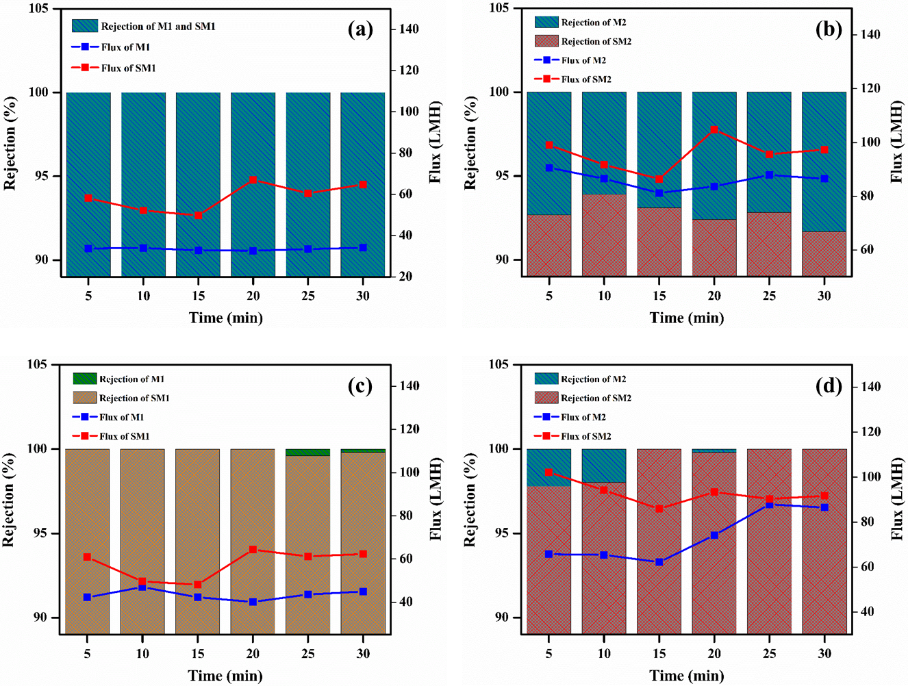
Figure S7: Time-dependent flux and rejection a) EBT dye of M1 and SM1 b) EBT dye M2 and SM2 c) CV dye of M1 and SM1 and d) CV dye of M2 and SM2.
Figure S8. Dye rejection by blend membranes as a function of dye Molecular Weight at 0.2 MPa bar. The MWCO is determined from the dashed lines shown (1 Da=1 g/mol).
Additional discussion of figure S5. Molecular weight cut-off (MWCO) of blend membranes was determined as the MW of a test dye molecule that has a average rejection of >95% [1, 2]. To more accurately ensure the analysis and eliminate possible interference of dye charge during nanofiltration, the MWCO was measured by using several dye molecules (with the MWs in the range of 300−600 Da) with the same electric charge at 10 mg/L dye concentration at room temperature under the pressure of 0.1 to 0.3 MPa. The dyes used were Methyl Orange (327.33 Da, negatively charged), Chrome black T (461.38 Da, negatively charged), Congo Red (696.68 Da, negatively charged), Methylene blue (319.85, positively charged), Malachite green (364.91, positively charged) and Crystal violet (407.97, positively charged) . The results were shown in Fig. S3. It can be observed that the blend and surface-modified membranes reach >95% rejection at an MW of about 408 Da, which is then taken as the MWCO.

. References
[1] S. Zeidler, P. Puhlfürß, U. Kätzel, I. Voigt, Preparation and characterization of new low MWCO ceramic nanofiltration membranes for organic solvents, Journal of Membrane Science 470 (2014) 421-430.
[2] F. Rashidi, N.S. Kevlich, S.A. Sinquefield, M.L. Shofner, S. Nair, Graphene Oxide Membranes in Extreme Operating Environments: Concentration of Kraft Black Liquor by Lignin Retention, ACS Sustainable Chemistry & Engineering 5 (2016) 1002-1009.
[3] S.D. Ganesh, M.N.K. Harish, B.J. Madhu, H. Maqbool, K.V. Pai, M.Y. Kariduraganavar, Poly(Arylene Ether Sulfone)s with HEPES Pendants: Synthesis, Thermal, and Dielectric Studies, ISRN Polymer Science 2013 (2013) 1-7.

