Substantial size reduction of banana fibres and enhancement of fibre properties achieved through a single mechanical treatment
P.D. Emrith¹*, H. Ramasawmy¹, D. Surroop², D.B Das³
¹Mechanical and Production Engineering Department, University of Mauritius, Reduit, Mauritius,
²Department of Chemical and Environmental Engineering, University of Mauritius, Reduit, Mauritius
³Department of Chemical Engineering, Loughborough University, Loughborough LE11 3TU, UK
*Corresponding author e-mail: piyushaa.emrith@gmail.com; Full Postal Address: Mechanical and Production Engineering Department, Faculty of Engineering, University of Mauritius, Reduit 80837, Mauritius

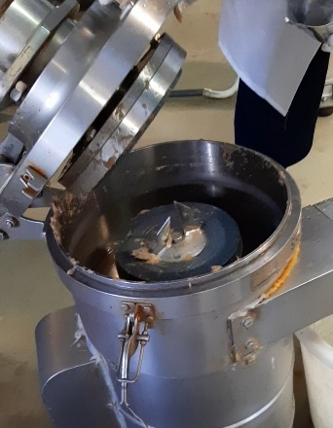  (a) | 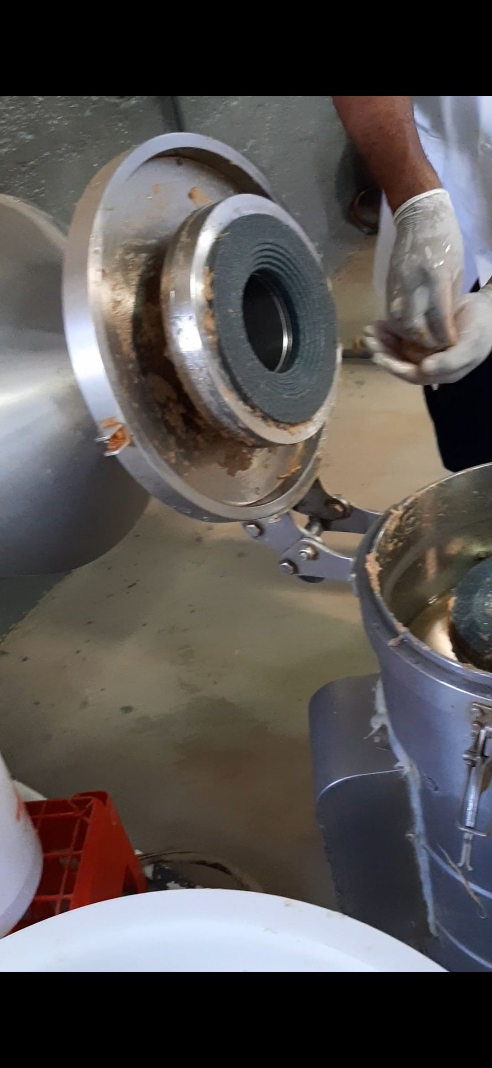  (b)  Measurement of internal space between Grinding Stone and Cover
Figure showing: (a) Commercial Wet Grinder; (b) Illustration of the internal space that was varied in order to change the gap size between the grinding discs (Scale: 1:80)
1
2
3
4
5

Figure showing the different locations on the sample holder at which SEM images were taken for each sample
Fibre Diameter Distribution for all fibre samples
Figures showing fibre diameter distribution for all ground fibre samples (FSN 1 to FSN 12) with x-axes giving the size ranges in microns and y-axes giving the number of diameter measurements made

Using iodine solution to test whether the fibre samples contain starch:
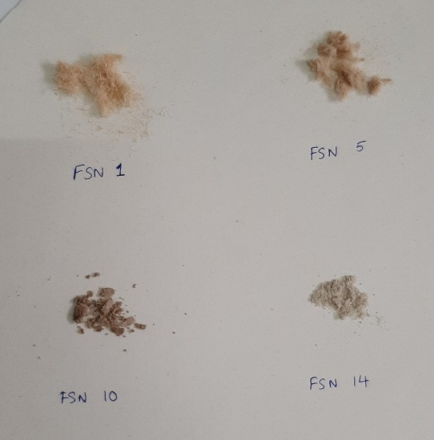 Figure showing Fibre samples used for the iodine test
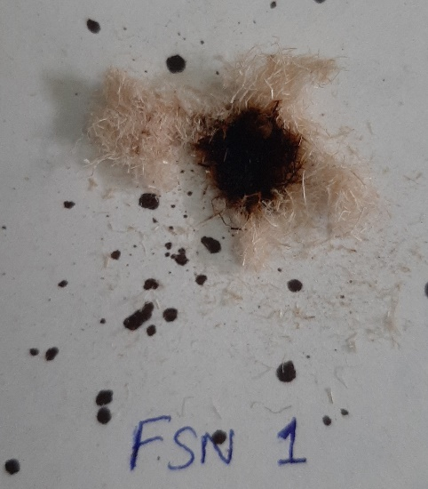  FSN 1 | 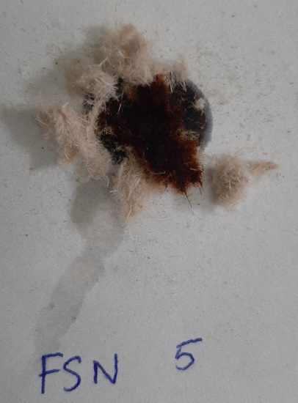  FSN 5
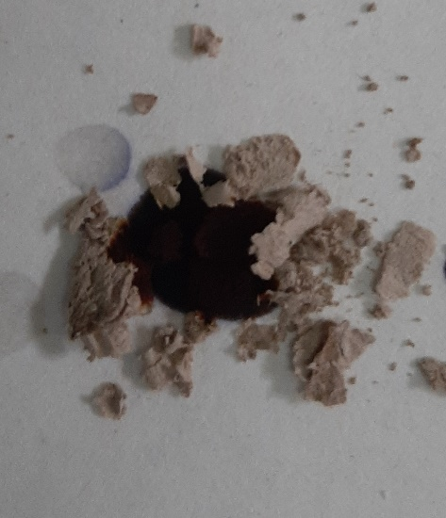  FSN 10 | 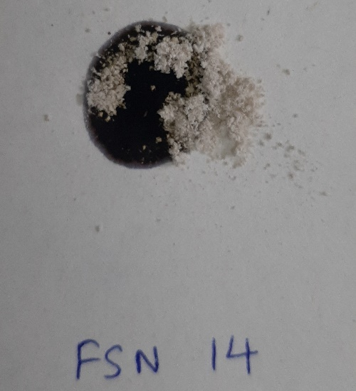  FSN 14
Figure showing fibre samples after iodine test: No blue-black colour determined. Thus, the fibres do not contain starch.

FTIR Full Spectra
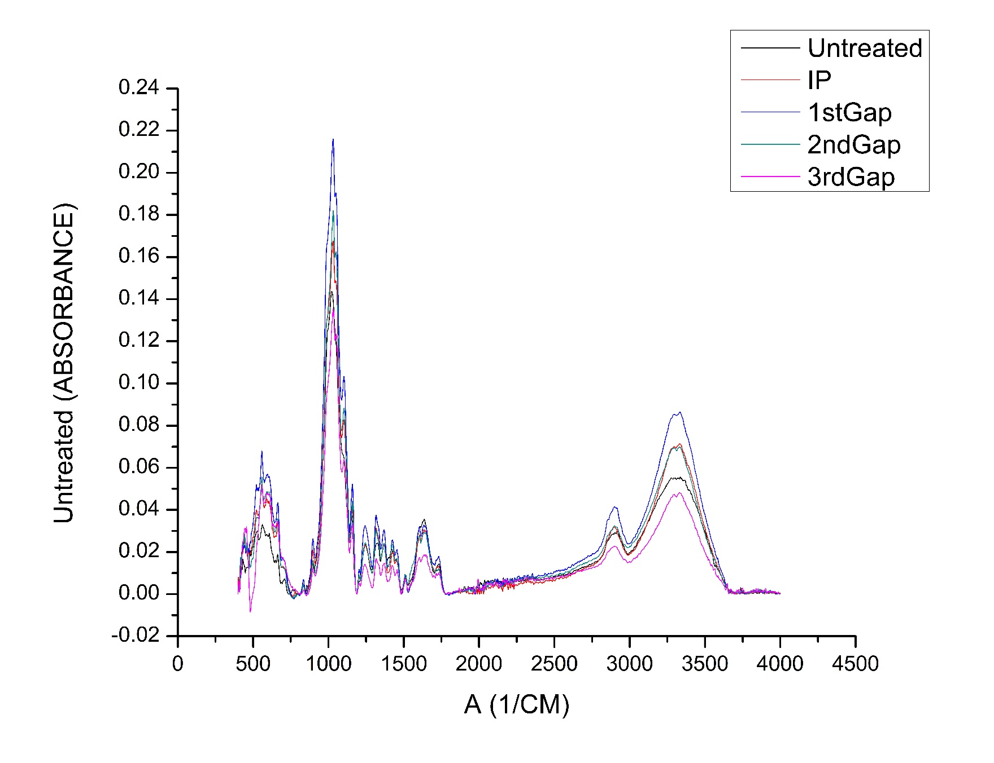
(a)

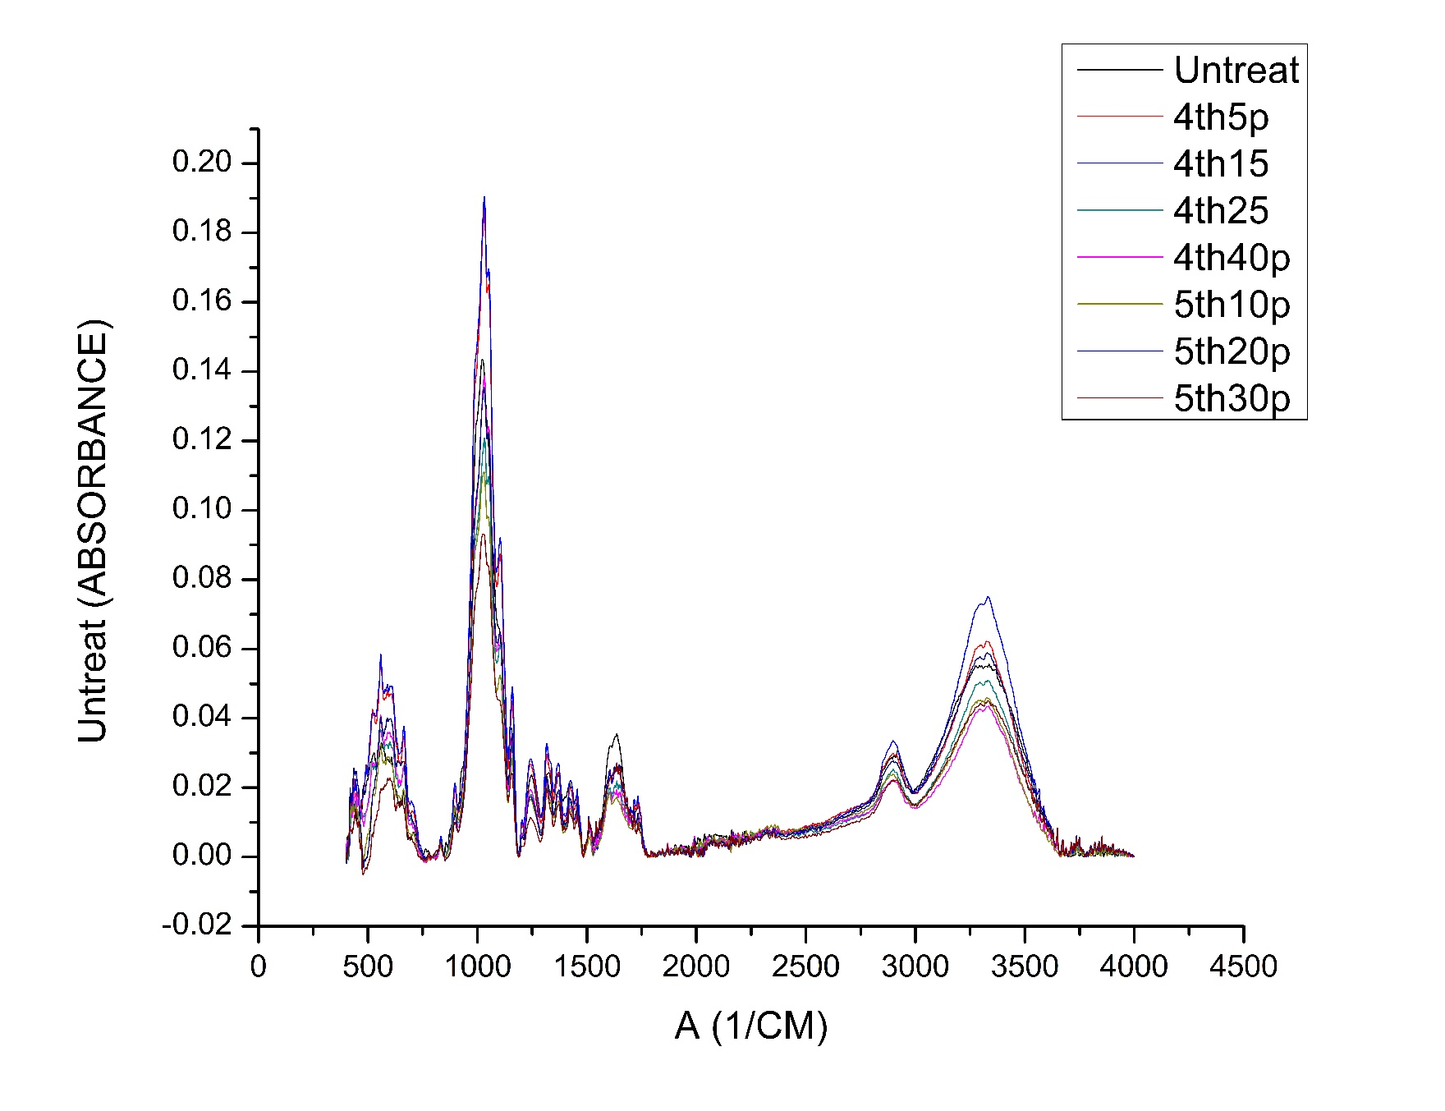
(b)

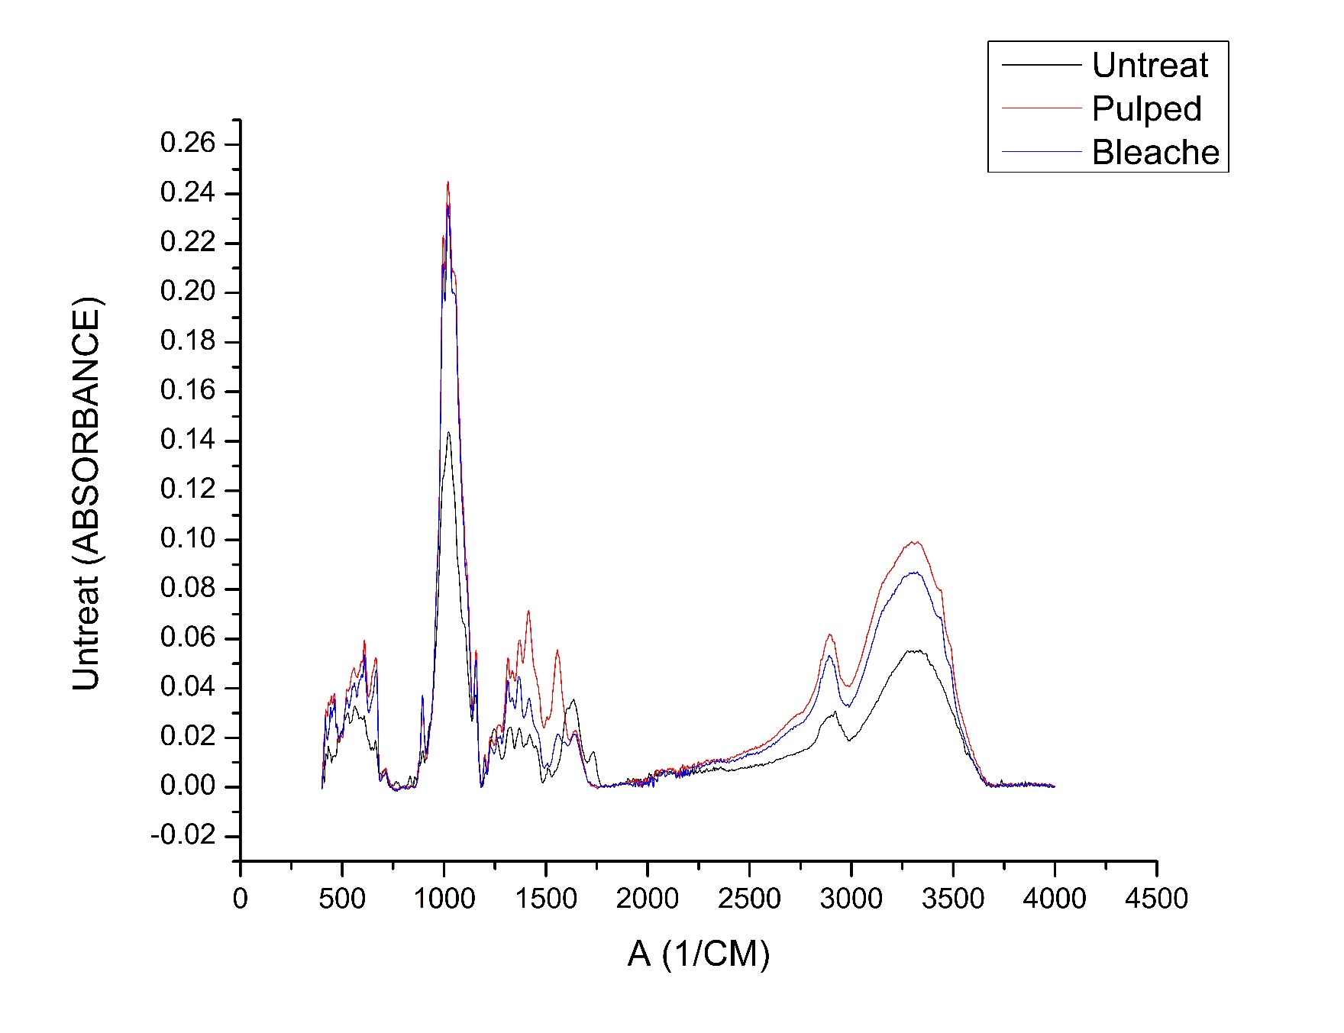
(c)
Figure showing FTIR full spectra from 400 to 4000 cm⁻¹ for: (a) FSN 1, 2, 3, 4, 5; (b) FSN 1, 6, 7, 8, 9, 10, 11, 12; (c) FSN 1, 13, 14

Table showing detailed XRD results for peaks at 2θ = 15° and 22°
 | 2θ(°) | FWHM | Peak Height | I_{min} | Peak Area | %Crystallinity | Crystallite Size (Å) | d-spacing (Å)
FSN 1 | 15.88 | 5.62 | 25.72 | 15.82 | 136.02 | 61.08 | 14.91 | 5.58
 | 22.34 | 3.99 | 40.65 |  | 178.06 |  | 21.21 | 3.98
FSN 2 | 15.53 | 5.02 | 20.38 | 11.27 | 98.18 | 67.18 | 16.70 | 5.71
 | 22.67 | 3.65 | 34.34 |  | 141.55 |  | 23.20 | 3.92
FSN 3 | 15.65 | 4.90 | 19.57 | 12.29 | 94.51 | 65.31 | 17.11 | 5.66
 | 22.46 | 3.84 | 35.42 |  | 151.24 |  | 22.06 | 3.96
FSN 4 | 15.34 | 4.69 | 16.77 | 10.71 | 77.86 | 69.97 | 17.86 | 5.78
 | 22.25 | 3.71 | 35.66 |  | 160.34 |  | 22.81 | 3.99
FSN 5 | 16.16 | 4.65 | 11.00 | 7.01 | 47.73 | 71.80 | 18.04 | 5.48
 | 22.54 | 3.58 | 24.86 |  | 97.48 |  | 23.67 | 3.94
FSN 6 | 15.14 | 4.97 | 18.61 | 11.24 | 89.37 | 67.40 | 16.85 | 5.85
 | 22.48 | 3.65 | 34.47 |  | 143.07 |  | 23.19 | 3.95
FSN 7 | 15.61 | 5.00 | 16.12 | 9.30 | 77.34 | 65.58 | 16.77 | 5.68
 | 22.16 | 3.91 | 27.03 |  | 106.97 |  | 21.63 | 4.01
FSN 8 | 15.57 | 4.48 | 17.92 | 11.12 | 78.58 | 67.22 | 18.70 | 5.69
 | 22.52 | 3.84 | 33.93 |  | 144.80 |  | 22.04 | 3.95
FSN 9 | 15.16 | 4.57 | 14.45 | 8.25 | 63.43 | 74.30 | 18.32 | 5.84
 | 22.58 | 3.33 | 32.10 |  | 123.81 |  | 25.42 | 3.94
FSN 10 | 14.80 | 3.90 | 8.19 | 4.19 | 29.05 | 78.12 | 21.49 | 5.99
 | 22.40 | 3.38 | 19.15 |  | 71.96 |  | 25.05 | 3.97
FSN 11 | 14.86 | 2.92 | 7.45 | 3.38 | 19.33 | 80.20 | 28.64 | 5.96
 | 22.36 | 3.13 | 17.08 |  | 61.22 |  | 27.05 | 3.98
FSN 12 | 14.84 | 3.66 | 8.24 | 4.38 | 26.70 | 76.44 | 22.86 | 5.97
 | 22.30 | 3.23 | 18.59 |  | 67.85 |  | 26.18 | 3.99

Table showing detailed results for peaks at 2θ values of corundum material
 | 2θ (°) | FWHM | Peak Height | Peak Area | Average Peak Height | Average Peak Area
FSN 1 | - | - | - | - | - | -
FSN 2 | 43.65 | 0.57 | 9.55 | 7.38 | 9.55 | 7.38
FSN 3 | 25.21 | 0.67 | 16.21 | 8.32 | 10.05 | 7.94
 | 34.94 | 1.79 | 10.42 | 15.06
 | 57.47 | 0.09 | 3.51 | 0.44
FSN 4 | 34.76 | 2.76 | 9.42 | 22.18 | 6.34 | 11.25
 | 43.84 | 1.97 | 6.45 | 10.44
 | 57.75 | 0.29 | 3.15 | 1.11
FSN 5 | 25.57 | 1.42 | 11.48 | 13.80 | 7.67 | 10.14
 | 35.31 | 2.17 | 11.89 | 18.14
 | 37.83 | 1.75 | 6.80 | 9.96
 | 43.26 | 1.66 | 8.54 | 11.48
 | 52.65 | 0.84 | 3.30 | 3.24
 | 57.55 | 1.05 | 4.00 | 4.21
FSN 6 | - | - | - | - | - | -
FSN 7 | - | - | - | - | - | -
FSN 8 | 25.92 | 0.85 | 12.14 | 9.35 | 7.95 | 9.89
 | 35.01 | 2.42 | 9.98 | 20.99
 | 43.99 | 1.24 | 6.92 | 7.24
 | 57.75 | 0.22 | 2.76 | 2.00
FSN 9 | 25.88 | 1.06 | 11.58 | 10.10 | 9.54 | 10.71
 | 34.72 | 3.39 | 9.48 | 24.25
 | 43.44 | 0.27 | 17.34 | 12.21
 | 52.81 | 0.33 | 4.17 | 3.07
 | 57.88 | 0.68 | 5.11 | 3.94
FSN 10 | 25.51 | 0.73 | 12.24 | 7.58 | 10.03 | 8.48
 | 35.07 | 0.65 | 15.24 | 17.21
 | 37.85 | 0.64 | 8.55 | 6.22
 | 43.32 | 0.72 | 12.54 | 11.57
 | 52.39 | 0.52 | 4.58 | 3.25
 | 57.33 | 0.65 | 7.06 | 5.04
FSN 11 | 25.51 | 0.69 | 11.70 | 8.18 | 10.32 | 8.36
 | 35.11 | 0.64 | 14.31 | 15.39
 | 37.63 | 0.61 | 7.45 | 6.36
 | 43.24 | 0.64 | 13.01 | 10.54
 | 52.47 | 0.56 | 5.47 | 3.35
 | 57.49 | 0.53 | 9.95 | 6.36
FSN 12 | 25.47 | 0.45 | 16.35 | 9.63 | 13.13 | 9.54
 | 35.05 | 0.48 | 17.83 | 16.57
 | 37.71 | 0.51 | 8.77 | 7.44
 | 43.22 | 0.52 | 17.62 | 12.93
 | 52.39 | 0.44 | 5.99 | 3.48
 | 57.37 | 0.52 | 12.18 | 7.16
FSN 13 | 25.51 | 1.40 | 11.06 | 13.57 | 8.81 | 12.95
 | 29.42 | 2.50 | 10.80 | 23.99
 | 34.84 | 1.75 | 11.62 | 16.08
 | 37.67 | 1.52 | 8.96 | 10.84
 | 42.93 | 1.56 | 7.90 | 10.89
 | 56.98 | 0.77 | 2.51 | 2.35
FSN 14 | 25.55 | 1.83 | 11.57 | 17.71 | 8.96 | 13.28
 | 35.21 | 2.44 | 12.58 | 21.99
 | 43.38 | 1.63 | 7.98 | 10.82
 | 57.47 | 0.61 | 3.72 | 2.61

