Statistical power

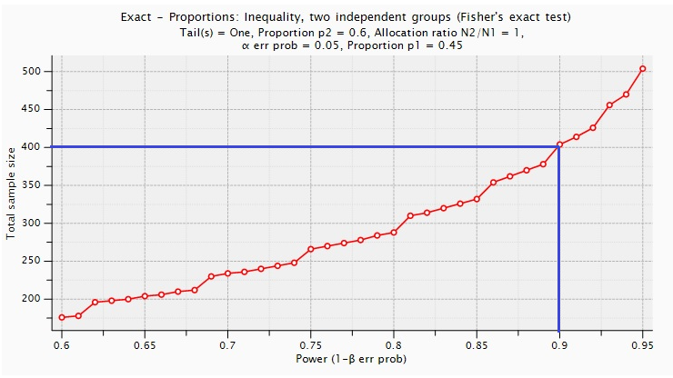

Power of the study was calculated using Cohen’s D=0.5 and significance=0.05

rs10754558
AMPLICON
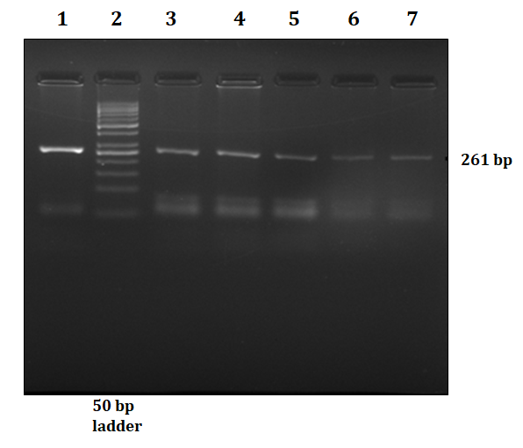
Genotypes
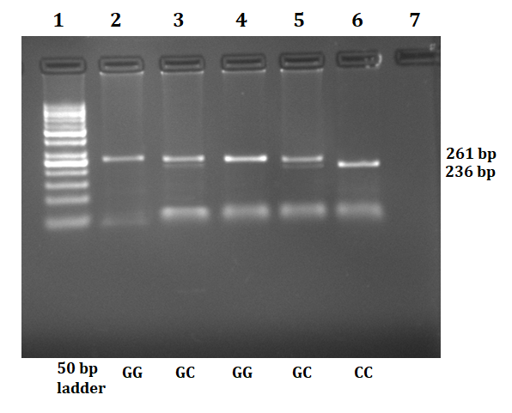

rs4612666
AMPLICON
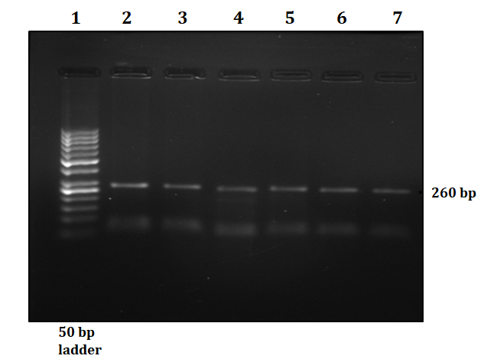
Genotypes
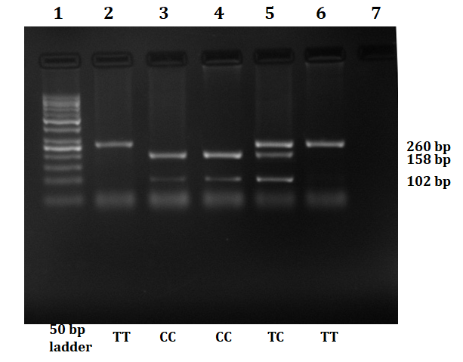

rs2027432
AMPLICON
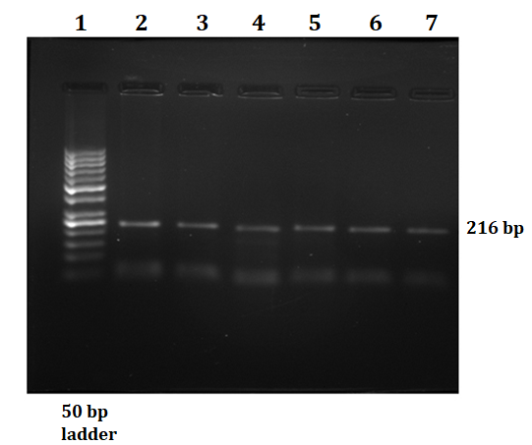
Genotypes
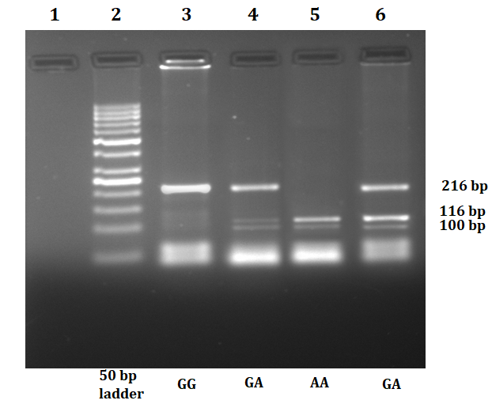

rs3738448
AMPLICON
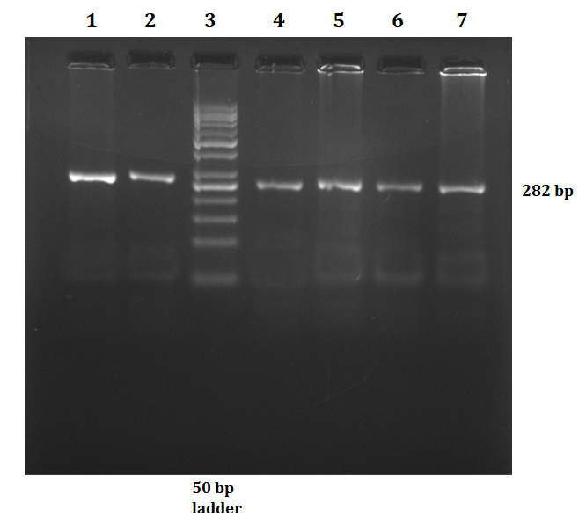
Genotypes
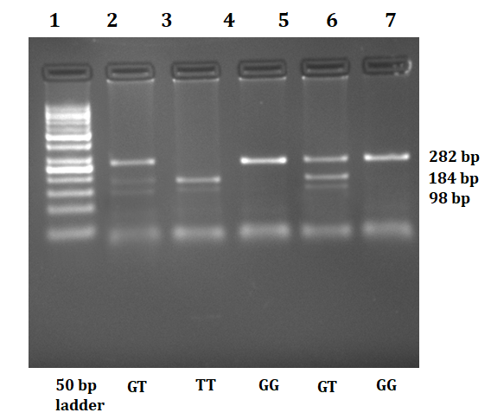
rs1539019
AMPLICON
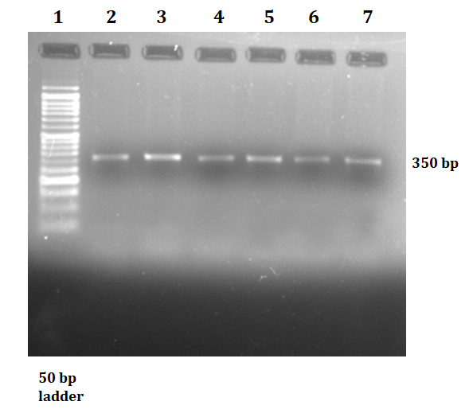
Genotypes
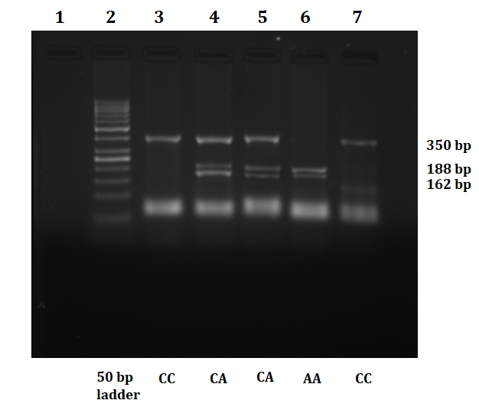
Correlation coefficient (R²) and pairwise LD (D’) |  |  |  |  |  | 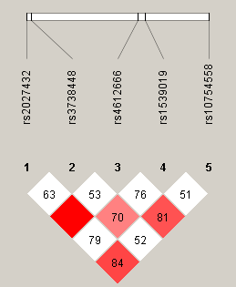
dbSNP | rs2027432 | rs3738448 | rs4612666 | rs1539019 | rs10754558
rs2027432 | ----- | 0.72 | 0.94 | 0.62 | 0.76
rs3738448 | 0.63 | ----- | 0.61 | 0.79 | 0.49
rs4612666 | 1.00 | 0.53 | ----- | 0.71 | 0.77
rs1539019 | 0.79 | 0.70 | 0.76 | ------ | 0.50
rs10754558 | 0.84 | 0.52 | 0.81 | 0.51 | -----
Table 1 Pair wise linkage disequilibrium between SNPs of NLRP3 gene.

