Supplementary Materials
Appendix 1: PRISMA 2020 Checklist
PRISMA 2020 Checklist
Section and Topic | Item # | Checklist item | Location where item is reported
TITLE
Title | 1 | Identify the report as a systematic review. | Front page
ABSTRACT
Abstract | 2 | See the PRISMA 2020 for Abstracts checklist. | Abstract (p2)
INTRODUCTION
Rationale | 3 | Describe the rationale for the review in the context of existing knowledge. | p3-5
Objectives | 4 | Provide an explicit statement of the objective(s) or question(s) the review addresses. | p5
METHODS
Eligibility criteria | 5 | Specify the inclusion and exclusion criteria for the review and how studies were grouped for the syntheses. | Table 1 (p31) and throughout sub-group analysis.
Information sources | 6 | Specify all databases, registers, websites, organisations, reference lists and other sources searched or consulted to identify studies. Specify the date when each source was last searched or consulted. | Figure 1 (p36) and p6
Search strategy | 7 | Present the full search strategies for all databases, registers and websites, including any filters and limits used. | Figure 1 (p36) and p6. Search string in Appendix.
Selection process | 8 | Specify the methods used to decide whether a study met the inclusion criteria of the review, including how many reviewers screened each record and each report retrieved, whether they worked independently, and if applicable, details of automation tools used in the process. | p6, 8, 10
Data collection process | 9 | Specify the methods used to collect data from reports, including how many reviewers collected data from each report, whether they worked independently, any processes for obtaining or confirming data from study investigators, and if applicable, details of automation tools used in the process. | p7
Data items | 10a | List and define all outcomes for which data were sought. Specify whether all results that were compatible with each outcome domain in each study were sought (e.g. for all measures, time points, analyses), and if not, the methods used to decide which results to collect. | p7 and discussed on p18
 | 10b | List and define all other variables for which data were sought (e.g. participant and intervention characteristics, funding sources). Describe any assumptions made about any missing or unclear information. | p6, discussed on p18, with missing or unclear info see appendices 9 & 10
Study risk of bias assessment | 11 | Specify the methods used to assess risk of bias in the included studies, including details of the tool(s) used, how many reviewers assessed each study and whether they worked independently, and if applicable, details of automation tools used in the process. | p7, p10-12, Appendix 8and discussed across Results
Effect measures | 12 | Specify for each outcome the effect measure(s) (e.g. risk ratio, mean difference) used in the synthesis or presentation of results. | Figure 2 (p37)
Synthesis methods | 13a | Describe the processes used to decide which studies were eligible for each synthesis (e.g. tabulating the study intervention characteristics and comparing against the planned groups for each synthesis (item #5)). | See sub-group analysis
 | 13b | Describe any methods required to prepare the data for presentation or synthesis, such as handling of missing summary statistics, or data conversions. | p8, 10-11, appendix 9 & 10 for missing data
 | 13c | Describe any methods used to tabulate or visually display results of individual studies and syntheses. | Figure 2 (p37)
 | 13d | Describe any methods used to synthesize results and provide a rationale for the choice(s). If meta-analysis was performed, describe the model(s), method(s) to identify the presence and extent of statistical heterogeneity, and software package(s) used. | Results – meta analysis discussed over p8, p10-14
 | 13e | Describe any methods used to explore possible causes of heterogeneity among study results (e.g. subgroup analysis, meta-regression). | p8 & appendix 5. Discussed through-out sub-groups.
 | 13f | Describe any sensitivity analyses conducted to assess robustness of the synthesized results. | P8, 10-11 & appendix 5
Reporting bias assessment | 14 | Describe any methods used to assess risk of bias due to missing results in a synthesis (arising from reporting biases). | Missing data appendix 9 & 10, Risk of bias illustrated in appendix 8, AMSTAR used for quality assurance
Certainty assessment | 15 | Describe any methods used to assess certainty (or confidence) in the body of evidence for an outcome. | See appendix 8, MMAT bias tool
RESULTS
Study selection | 16a | Describe the results of the search and selection process, from the number of records identified in the search to the number of studies included in the review, ideally using a flow diagram. | Fig 1 (p36) for search and selection process (PRISMA diagram)
 | 16b | Cite studies that might appear to meet the inclusion criteria, but which were excluded, and explain why they were excluded. | Appendices 9 & 10
Study characteristics | 17 | Cite each included study and present its characteristics. | Table 2 (p32-35)
Risk of bias in studies | 18 | Present assessments of risk of bias for each included study. | Pages 15 & 16, appendix 8
Results of individual studies | 19 | For all outcomes, present, for each study: (a) summary statistics for each group (where appropriate) and (b) an effect estimate and its precision (e.g. confidence/credible interval), ideally using structured tables or plots. | Figure 2 (p37)
Results of syntheses | 20a | For each synthesis, briefly summarise the characteristics and risk of bias among contributing studies. | See sub-group analysis
 | 20b | Present results of all statistical syntheses conducted. If meta-analysis was done, present for each the summary estimate and its precision (e.g. confidence/credible interval) and measures of statistical heterogeneity. If comparing groups, describe the direction of the effect. | Fig 2 and discussed across results
 | 20c | Present results of all investigations of possible causes of heterogeneity among study results. | Heterogeneity scores indicated with I2&t2 throughout results.
 | 20d | Present results of all sensitivity analyses conducted to assess the robustness of the synthesized results. | p10-11, appendices 4, 5 & 6
Reporting biases | 21 | Present assessments of risk of bias due to missing results (arising from reporting biases) for each synthesis assessed. | Missing data appendix 9 & 10, Risk of bias illustrated in appendix 8, AMSTAR used for quality assurance
Certainty of evidence | 22 | Present assessments of certainty (or confidence) in the body of evidence for each outcome assessed. | See appendix 8, MMAT bias tool
DISCUSSION
Discussion | 23a | Provide a general interpretation of the results in the context of other evidence. | p14-18
 | 23b | Discuss any limitations of the evidence included in the review. | p16,18
 | 23c | Discuss any limitations of the review processes used. | p18
 | 23d | Discuss implications of the results for practice, policy, and future research. | p18
OTHER INFORMATION
Registration and protocol | 24a | Provide registration information for the review, including register name and registration number, or state that the review was not registered. | See title page – Protocol registered to PROSPERO.
 | 24b | Indicate where the review protocol can be accessed, or state that a protocol was not prepared.
 | 24c | Describe and explain any amendments to information provided at registration or in the protocol.
Support | 25 | Describe sources of financial or non-financial support for the review, and the role of the funders or sponsors in the review. | See title page.
Competing interests | 26 | Declare any competing interests of review authors. | See title page.
Availability of data, code and other materials | 27 | Report which of the following are publicly available and where they can be found: template data collection forms; data extracted from included studies; data used for all analyses; analytic code; any other materials used in the review. | See title page.
From: Page MJ, McKenzie JE, Bossuyt PM, Boutron I, Hoffmann TC, Mulrow CD, et al. The PRISMA 2020 statement: an updated guideline for reporting systematic reviews. BMJ 2021;372:n71. doi: 10.1136/bmj.n71
For more information, visit: http://www.prisma-statement.org/

Appendix 2: Search String
"sleep quality" OR "sleep disorder*" OR "sleep disturb*" OR "disturbed sleep*" OR "insomnia*" OR "hypersomnia*" OR "sleep apnea" OR "daytime sleep*" OR "sleepiness" OR "napping" OR "sleep time" OR "sleep duration" OR "sleep problem*" OR "sleep hygiene" OR "circadian*" OR "circadian rhythm disorder*" AND "forensic*" OR "prison population*" OR "secure setting*" OR "psychiatric hospital*" OR "psychiatric patient*" OR "psychiatric inpatient*" OR "psychiatric outpatient*" OR "mental health patient*" OR "mental health inpatient*" OR "mental health outpatient*" OR "service user*" OR "severe mental illness*" OR "psychiatric disorder*" OR "psychiatric*" OR "forensic psych*" OR "anxiety" OR "depress*" OR "personality disorder*" OR "bipolar*" OR "post traumatic*" OR "PTSD" OR "schizo*" OR "psychosis"

A literature search for relevant studies was conducted across four electronic databases: Cochrane Library, Scopus, PubMed and ProQuest, using title, abstract and keywords with search terms including truncation (*) where relevant, to accommodate different word variants and plurals. As ProQuest does not allow for the use of * as a prefix, the search terms “insomnia” OR “hypersomnia” were added individually. This is illustrated in the above search string. Where use of * as a prefix was allowed, the search string searched for “*somnia” only.

Appendix 3: List of all Included Papers (Systematic Review)
Baune BT, Caliskan S, Todder D. Effects of adjunctive antidepressant therapy with quetiapine on clinical outcome, quality of sleep and daytime motor activity in patients with treatment-resistant depression. Hum Psychopharmacol. 2007
Benedetti F, Dallaspezia S, Fulgosi MC, Barbini B, Colombo C, Smeraldi E. Phase advance is an actimetric correlate of antidepressant response to sleep deprivation and light therapy in bipolar depression. Chronobiol Int. 2007;24(5):921–37.
Brupbacher G, Zander-Schellenberg T, Straus D, Porschke H, Infanger D, Gerber M, et al. The acute effects of aerobic exercise on nocturnal and pre-sleep arousal in patients with unipolar depression: Preplanned secondary analysis of a randomized controlled trial. J Clin Med. 2021;10(17):1–12.
Cameron C, Watson D, Robinson J. Use of a synthetic cannabinoid in a correctional population for posttraumatic stress disorder-related insomnia and nightmares, chronic pain, harm reduction, and other indications: A retrospective evaluation. J Clin Psychopharmacol. 2014;34(5):559–64.
Canazei M, Bassa D, Jimenez P, Papousek I, Fink A, Weiss E. Effects of an adjunctive, chronotype-based light therapy in hospitalized patients with severe burnout symptoms - a pilot study. Chronobiol Int . 2019;36(7):993–1004.
Chien HC, Chung YC, Yeh ML, Lee JF. Breathing exercise combined with cognitive behavioural intervention improves sleep quality and heart rate variability in major depression. J Clin Nurs. 2015;24(21–22):3206–14.
Chu S, McNeill K, Wright KM, Hague A, Wilkins T. The impact of a night confinement policy on patients in a UK high secure inpatient mental health service. J Forensic Pract. 2015;17(1):21–30.
de Niet, G., Tiemens, B., & Hutschemaekers G. Can mental healthcare nurses improve sleep quality for inpatients? Br J Nurs. 2010;19(17):1100–5.
Ellis TE, Rufino KA, Nadorff MR. Treatment of Nightmares in Psychiatric Inpatients With Imagery Rehearsal Therapy: An Open Trial and Case Series. Behav Sleep Med . 2019;17(2):112–23.
Ferszt GG, Miller RJ, Hickey JE, Maull F, Crisp K. The impact of a mindfulness based program on perceived stress, anxiety, depression and sleep of incarcerated women. Int J Environ Res Public Health. 2015;12(9):11594–607.
Göder R, Hinrichsen I, Seeck-Hirschner M, Pfeiffer R, Weinhold SL, Baier PC, et al. Sleep at baseline and after electroconvulsive therapy in patients with major depression. Psychiatry Res. 2016;246(July):683–7.
Haynes PL, Parthasarathy S, Kersh B, Bootzin RR. Examination of insomnia and insomnia treatment in psychiatric inpatients. Int J Ment Health Nurs. 2011;20(2):130–6.
Hegde D, Bhargav P, Bhargav H, Babu H, Varsha K, Raghuram N. Feasibility and pilot efficacy testing of integrated yoga and Shirodhara (Ayurvedic oil-dripping) intervention on clinical symptoms, cognitive functions and sleep quality of adults with anxiety disorder. Int J Yoga. 2020;13(1):32.

Hemmeter U, Hatzinger M, Brand S, Holsboer-Trachsler E. Effect of flumazenil-augmentation on microsleep and mood in depressed patients during partial sleep deprivation. J Psychiatr Res. 2007;41(10):876–84.
Henriksen TEG, Grønli J, Assmus J, Fasmer OB, Schoeyen H, Leskauskaite I, et al. Blue-blocking glasses as additive treatment for mania: Effects on actigraphy-derived sleep parameters. J Sleep Res. 2020;29(5):1–11.
Holzinger B, Saletu B, Klösch G. Cognitions in Sleep: Lucid Dreaming as an Intervention for Nightmares in Patients With Posttraumatic Stress Disorder. Front Psychol. 2020 Aug 21;11:1826.
Hsu HM, Chou KR, Lin KC, Chen KY, Su SF, Chung MH. Effects of cognitive behavioral therapy in patients with depressive disorder and comorbid insomnia: A propensity score-matched outcome study. Behav Res Ther . 2015;73:143–50.
Huang, W., Shi, Z., & Yan Z. Effect of systematic psychological nursing on sleep quality of schizophrenic patients with sleep disorders. Int J Clin Exp Med. 2019;12(10):12472–9.
Kluge M, Himmerich H, Wehmeier PM, Rummel-Kluge C, Dalal M, Hinze-Selch D, et al. Sleep propensity at daytime as assessed by Multiple Sleep Latency Tests (MSLT) in patients with schizophrenia increases with clozapine and olanzapine. Schizophr Res . 2012;135(1–3):123–7.
Laguna-Parras JM, Jerez-Rojas MR, García-Fernández FP, Carrasco-Rodríguez MSOSCD, Nogales-Vargas-Machuca I. Effectiveness of the “sleep enhancement” nursing intervention in hospitalized mental health patients. J Adv Nurs. 2013;69(6):1279–88.
Li M, Lang B. The effects of systematic psychological nursing on the sleep quality of schizophrenic patients with sleep disorders. Am J Transl Res. 2021;13(6):7263–9.
Loebel AD, Siu CO, Cucchiaro JB, Pikalov AA, Harvey PD. Daytime sleepiness associated with lurasidone and quetiapine XR: Results from a randomized double-blind, placebo-controlled trial in patients with schizophrenia. CNS Spectr. 2014;19(2):197–205.
Lu MJ, Lin ST, Chen KM, Tsang HY, Su SF. Acupressure improves sleep quality of psychogeriatric inpatients. Nurs Res. 2013;62(2):130–7.
Martin D, Hurlbert A, Cousins DA. Sleep Disturbance and the Change from White to Red Lighting at Night on Old Age Psychiatry Wards: A Quality Improvement Project. Arch Psychiatr Nurs . 2018;32(3):379–83.
Moon JH, Cho CH, Son GH, Geum D, Chung S, Kim H, et al. Advanced Circadian Phase in Mania and Delayed Circadian Phase in Mixed Mania and Depression Returned to Normal after Treatment of Bipolar Disorder. EBioMedicine . 2016;11:285–95.
Nakamura M& TN. Neuroendocrine, autonomic, and Metabolic Responses to an Orexin Antagonist , Suvorexant , in Psychiatric Patients with Insomnia. Innov Clin Neurosci. 2017;14(3–4):30–7.
Nishida M, Kikuchi S, Nisijima K, Suda S. Actigraphy in patients with major depressive disorder undergoing repetitive transcranial magnetic stimulation an open label pilot study. J ECT. 2017;33(1):36–42.

Okkels N, Jensen LG, Skovshoved LC, Arendt R, Blicher AB, Vieta E, et al. Lighting as an aid for recovery in hospitalized psychiatric patients: a randomized controlled effectiveness trial. Nord J Psychiatry . 2020;74(2):105–14.
Pyrke RJL, McKinnon MC, McNeely HE, Ahern C, Langstaff KL, Bieling PJ. Evidence-Based Design Features Improve Sleep Quality Among Psychiatric Inpatients. Heal Environ Res Des J. 2017;10(5):52–63
Randall C, Nowakowski S, Ellis JG. Managing Acute Insomnia in Prison: Evaluation of a “One-Shot” Cognitive Behavioral Therapy for Insomnia (CBT-I) Intervention. Behav Sleep Med . 2019;17(6):827–36.
Reiter H, Humphreys L. Exposure, Relaxation, and Rescripting Therapy for Trauma-Related Nightmares With Psychiatric Inpatients: A Case Series. Clin Case Stud. 2021;20(1):3–21.
Schäfer L, Schellong J, Hähner A, Weidner K, Hüttenbrink KB, Trautmann S, et al. Nocturnal Olfactory Stimulation for Improvement of Sleep Quality in Patients With Posttraumatic Stress Disorder: A Randomized Exploratory Intervention Trial. J Trauma Stress. 2019;32(1):130–40.
Sheaves B, Freeman D, Isham L, McInerney J, Nickless A, Yu LM, et al. Stabilising sleep for patients admitted at acute crisis to a psychiatric hospital (OWLS): An assessor-blind pilot randomised controlled trial. Psychol Med. 2018;48(10):1694–704.
Sloane PD, Williams CS, Mitchell CM, Preisser JS, Wood W, Barrick AL, et al. High-intensity environmental light in dementia: Effect on sleep and activity. J Am Geriatr Soc. 2007;55(10):1524–33.
Stanton R, Donohue T, Garnon M, Happell B. The relationship between exercise intensity and sleep quality in people hospitalised due to affective disorders: A pilot study. Issues Ment Health Nurs. 2016;37(2):70–4.
Tsekou H, Angelopoulos E, Paparrigopoulos T, Golemati S, Soldatos CR, Papadimitriou GN, et al. Sleep EEG and spindle characteristics after combination treatment with clozapine in drug-resistant schizophrenia: A pilot study. J Clin Neurophysiol. 2015;32(2):159–63.
Zhou Q, Yu C, Yu H, Zhang Y, Liu Z, Hu Z, et al. The effects of repeated transcranial direct current stimulation on sleep quality and depression symptoms in patients with major depression and insomnia. Sleep Med . 2020;70:17–26.
Zhu D, Dai G, Xu D, Xu X, Geng J, Zhu W, et al. Long-term effects of Tai Chi intervention on sleep and mental health of female individuals with dependence on amphetamine-type stimulants. Front Psychol. 2018;9(Aug):1–11.

Appendix 4: Forest Plot for Identification and Removal of Outliers
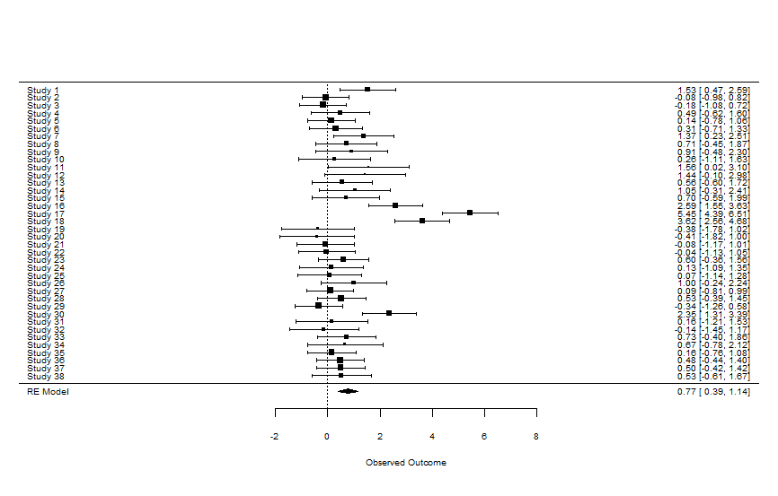

Appendix 5: Baujat Plot for Sensitivity Analysis (for Identification and Removal of Outliers)
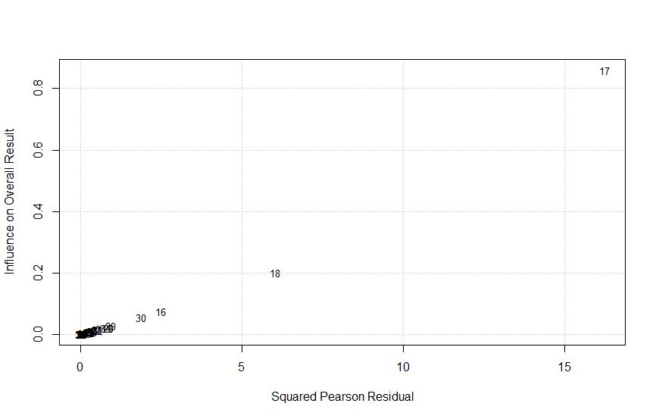
Appendix 6: Funnel Plot for Publication Bias (for Identification and Removal of Outliers) 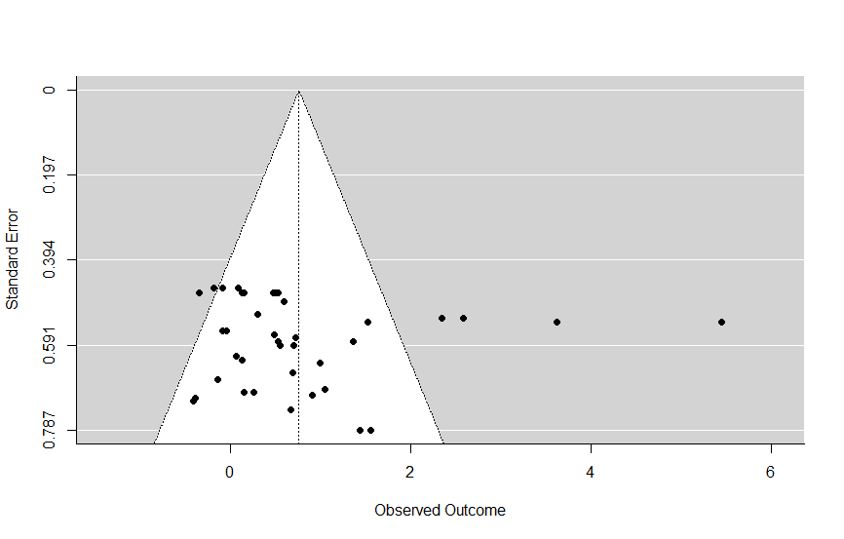
Appendix 7: Quality Assessment

Selection bias was not an item on our quality assessment tool, (MMAT).
Not all the included studies had a comparison group as we included within subject designs.

Appendix 8: Risk of Bias
NB: Risk of bias quality score was conducted using the MMAT. Due to the eligibility criteria of this review stating that only quantitative data was eligible for inclusion, where a study reported mixed methods data, only the quantitative data was used to create an MMAT score.

Appendix 9: Literature Retrieved but Not Discussed.
This list includes citations of papers referenced in the systematic review that were not incorporated into the meta-analysis due to not using one of the established primary outcomes.

Cameron et al., 2014 – Did not incorporate PSQI, ISI, SE or TST as outcome.
de Niet et al., 2019 – Did not incorporate PSQI, ISI, SE or TST as outcome.
Hegde et al., 2021 - Did not incorporate PSQI, ISI, SE or TST as outcome.
Hemmeter et al., 2007 - Did not incorporate PSQI, ISI, SE or TST as outcome.
Kluge et al., 2012 - Did not incorporate PSQI, ISI, SE or TST as outcome.
Laguna-Parras et al., 2013 – Did not incorporate PSQI, ISI, SE or TST as outcome.
Loebel et al., 2014 – Did not incorporate PSQI, ISI, SE or TST as outcome.
Reiter & Humphreys, 2021 – Case series of two participants, cannot analyse in the same manner.
Stanton et al., 2016 – Did not incorporate PSQI, ISI, SE or TST as outcome.

Appendix 10: Authors Contacted for Missing Data
This list includes both authors who were contacted to gather data for whole study entry into the meta-analysis and authors who were contacted to gather data for separate trial entry into the meta-analysis.

Benedetti et al., 2007 – Did not hear back from author regarding further data needed for analysis.
Henriksen et al., 2020: TST data - Further data needed for analysis was not available to author in time to provide to us.
Hsu et al., 2015 - Did not hear back from author regarding further data needed for analysis.
Huang et al., 2019 - Did not hear back from author regarding further data needed for analysis.
Li & Lang, 2021 – Did not hear back from author regarding further data needed for analysis.
Okkels et al., 2019 - Did not hear back from author regarding further data needed for analysis.
Tsekou et al., 2015: SE data - Did not hear back from author regarding further data needed for analysis.

