SUPPLEMENTARY MATERIALS
(SM1-SM10)

for the manuscript “The Campaign Disinformation Divide: Believing and Sharing News in the UK 2019 General Election”

CONTENTS
SM1: SAMPLING AND SAMPLE COMPOSITION 2
SM2: HEADLINES EMPLOYED IN THE SURVEYS AND DEBRIEFING NOTES 4
SM3: PCA AND CFA FOR SOURCES OF CAMPAIGN NEWS, DISTRIBUTION OF THE VARIABLES IN THE SAMPLE, AND ALTERNATIVE CFA SPECIFICATIONS 12
SM4: INFORMATION ON THE CONTROL VARIABLES INCLUDED IN THE MODELS 18
SM5: ROBUSTNESS CHECK FOR TABLE 1 WITH CFA MEDIA FACTORS 20
SM6: ROBUSTNESS CHECK FOR MODEL A-B IN TABLE 2 WITH CFA MEDIA FACTORS 21
SM7: ROBUSTNESS CHECK FOR MODELS A-C IN TABLE 2 CONTROLLING FOR GENERAL USE OF SOCIAL MEDIA 22
SM8: ROBUSTNESS CHECK FOR TABLE 1 INTEGRATING INTERACTION TERMS BETWEEN HEADLINE FALSE VS. TRUE AND EDUCATION, LIKELIHOOD OF VOTING IN THE 2019 GENERAL ELECTION, AND HEADLINE ATTACKS PREFERRED PARTY POSITION 23
SM9: ROBUSTNESS CHECK FOR TABLE 2 INTEGRATING INTERACTION TERMS BETWEEN HEADLINE FALSE VS. TRUE AND EDUCATION, LIKELIHOOD OF VOTING IN THE 2019 GENERAL ELECTION, AND HEADLINE ATTACKS PREFERRED PARTY POSITION 24
SM10: ROBUSTNESS CHECK FOR INDIVIDUAL SOURCES OF CAMPAIGN NEWS 25
REFERENCES 33

NOTE
In addition to the information in this document, the following files are available at https://osf.io/xfked/?view_only=f3df4b38d106460e84eaf86352b1a3e3:
- Data: “GE2019_raw_data_wave1.Rda” + “GE2019_raw_data_wave2.Rda”
- Commented R-script: “FOR_SHARING_R-Script_GE2019-UPDATED.R”

SM1: SAMPLING AND SAMPLE COMPOSITION

The general election took place on December 12, 2019. Shortly before the election, we conducted two online surveys. The first (n = 2,018) was fielded November 27–29. The second (n = 2,000) was held December 7–9 (combined n_{respondents} = 4,018). Both studies were administered by Opinium Research and resembled the UK adult population in terms of gender, age, education, and region. Thirty-eight respondents participated in both surveys and we control for this (see SM4).
We ran our two surveys with Opinium Research’s online panel of over 40,000 UK adults. The panel mirrors the socio-demographic characteristics of the UK adult population. Panel members receive invitations to take part in surveys via email and are incentivised with small payments. We recruited respondents via a random sampling method that ensured our sample was representative of the UK adult population based on key demographic variables such as age, gender, and region of residence.
Responses for the first survey were collected November 27–29, 2019. Opinium sent invitations to 7,000 members of their panel, of which 2,381 started the interview, 94 were screened out based on quotas, and 2,051 completed the interview. Opinium subsequently excluded 33 respondents due to quality issues. A total of 2,018 valid completed interviews remained, which took on average 15 minutes to complete.
Responses for the second survey were collected December 7–9, 2019. Opinium sent invitations to 7,000 members of their panel, of which 2,560 started the interview, 600 were excluded based on quotas, and 2,039 completed the interview. Opinium subsequently excluded 39 respondents due to quality issues. A total of 2,000 valid completed interviews remained, which took on average 21 minutes to complete.

Table SM1. Comparison of key demographic variables of the samples with the UK adult population
Measure | UK adult population | Both samples combined | Sample survey 1 (n = 2,018) | Sample survey 2  (n = 2,000)
Age
Median (in years) | 48 | 48 | 47 | 49
Gender
Women | 50.6% | 50.5% | 50.6% | 50.4%
Men | 49.4% | 49.5% | 49.4% | 49.6%
Educational attainment
Level 2 (GCSE) or below | 36% | 26.2% | 27.8% | 24.4%
Level 3 (A-Levels or  equivalent) | 20% | 29.9% | 29.4% | 30.5%
Level 4 (Undergraduate  Degree) or higher | 44% | 43.9% | 42.8% | 45.1%
Party preferences (2019)
Conservative | 43.6% | 37.2% | 36% | 38.5%
Labour | 32.1% | 33% | 33.6% | 32.5%
Liberal-Democrats | 11.5% | 14.2% | 14.3% | 14.2%
Scottish National Party | 3.9% | 3.8% | 3.9% | 3.7%
Green Party | 2.7% | 2.6% | 3.5% | 2.9%
Brexit Party | 2% | 4.7% | 5.8% | 6%
Other parties | 4.2% | 4.5% | 2.9% | 2.2%
Vote in the 2016 referendum
Remain in the EU | 48.1% | 51.8% | 52.1% | 51.4%
Leave the EU | 51.9% | 48.2% | 47.9% | 48.6%
Note. Data on age and gender of adult UK population in 2019 from the UK Office for National Statistics (ONS) https://www.ons.gov.uk/peoplepopulationandcommunity/populationandmigration/populationestimates/datasets/populationestimatesforukenglandandwalesscotlandandnorthernireland, Data on education of UK adult population in 2019 from the UK Government: https://explore-education-statistics.service.gov.uk/find-statistics/education-and-training-statistics-for-the-uk. Data on the 2019 General Election results from the UK House of Commons Library: https://researchbriefings.files.parliament.uk/documents/CBP-8749/CBP-8749.pdf. Data on the 2016 referendum results from the UK Electoral Commission: https://www.electoralcommission.org.uk/who-we-are-and-what-we-do/elections-and-referendums/past-elections-and-referendums/eu-referendum/results-and-turnout-eu-referendum. 38 respondents from the second survey also participated in the first survey.
Opinium research is a member of and abides by the codes of conduct of the British Polling Council (https://www.britishpollingcouncil.org/) and the Market Research Society (https://www.mrs.org.uk). The MRS Code of Conduct, which provides strict ethical guidelines on respondents’ rights to anonymity, research design, data collection, analysis and reporting, and data storage, is available at https://www.mrs.org.uk/standards/code_of_conduct.

SM2: HEADLINES EMPLOYED IN THE SURVEYS AND DEBRIEFING NOTES

Table SM2a. Categorization and average values for the key outcomes of the 12 headlines used in survey 1
Headline (survey 1) | True / False | Covered policy issue(s) | Attacked party/position | Recognizing the headline (0-1) | Perceived accuracy (1-5)
Since 2010, corporations and wealthy individuals have received tax cuts amounting to £100 billion. | False | Economy, inequality | Conservatives | .26 | 3.40
The Conservative Party will raise the state pension age to 75. | False | Public services | Conservatives | .23 | 3.01
Boris Johnson was loudly booed outside his home on November 4, as the election got underway. | False | N/A | Conservatives | .31 | 3.50
Jeremy Corbyn has close ties with the IRA and Sinn Fein, as demonstrated by photos showing he attended the funerals of some of their militants. | False | Terrorism | Labour | .50 | 3.46
Labour's immigration plans will increase net migration into the UK to 840,000 people a year, four times what it is now. | False | Immigration | Labour | .26 | 3.14
Labour shadow Brexit secretary Keir Starmer stuttered and could not answer when he was asked to explain his party's position on Brexit during an interview on ITV’s Good Morning Britain. | False | EU/Brexit | Labour | .35 | 3.32
Leaked documents reveal that Russia colluded with the Conservative party to interfere in the 2016 Brexit referendum and the 2017 general election. | False* | EU/Brexit | Conservatives, Leave | .39 | 3.20
A video taken backstage at the ITV leaders debate and widely shared on social media shows Jeremy Corbyn saying “I don’t really care whether we leave the EU or not.” | False* | EU/Brexit | Labour, Remain | .20 | 3.22
NHS Accident & Emergency waiting times in England have hit their worst levels on record. | True | Health/NHS | Conservatives | .66 | 3.93
A Labour government will hold a second referendum on EU membership but the Party has not said whether it would campaign for Leave or Remain. | True | EU/Brexit | Labour | .69 | 3.92
In 2018, the European Commission donated 3.5 million Euros to an organization run by the husband of Liberal-Democrat leader Jo Swinson. | False | EU/Brexit | Liberal-Democrats, Remain | .24 | 3.27
BBC Question Time hired the son of a BBC producer to say pro-Brexit statements during the Question Time programme. | False | EU/Brexit | Conservatives, Leave | .20 | 3.20
Note. *Placebo. Independent fact-checks collected via BBC Reality Check (https://www.bbc.co.uk/news/reality_check), Channel 4 Fact Check (https://www.channel4.com/news/factcheck), Full Fact (https://fullfact.org/), and First Draft (https://firstdraftnews.org/latest/tag/uk-general-election/).

Table SM2b. Categorization and average values for the key outcomes of the 12 headlines used in survey 2
Headline (survey 2) | True / False | Covered policy issue(s) | Attacked party/ position | Recognizing the headline (0-1) | Perceived accuracy (1-5) | Intention to share (1-5)
In the aftermath of the November London Bridge terrorist attack, Jeremy Corbyn said on Twitter: “A man was murdered by British Police in Broad daylight. #LondonBridge.” Corbyn then immediately deleted his tweet. | False | Terrorism, crime | Labour | .23 | 2.91 | 2.20
Jeremy Corbyn has said that he will abolish the UK security service MI5. | False | Defence, terrorism | Labour | .22 | 2.73 | 2.02
Labour will cut the 25% discount on Council Tax for single occupants, costing three million pensioners an average of £300 per year. | False | Housing, economy | Labour | .21 | 2.94 | 2.18
Foreign Secretary Dominic Raab called Scotland “one of England’s regions” in a tweet and then deleted the tweet. | False | Constitution/ devolution | Conservatives | .15 | 3.04 | 2.12
Under the Conservatives’ plans for a US-UK trade deal after Brexit the NHS will have to pay an extra £500 million a week to big US drugs companies. | False | Health/NHS, EU/Brexit, foreign affairs | Conservatives, Leave | .31 | 2.98 | 2.21
The UK has the lowest rate of recycling in Europe. | False | Environment | Conservatives | .19 | 3.02 | 2.12
SNP leader Nicola Sturgeon says she wants Scotland to join the Euro, the European Union's single currency. | False | Constitution/ devolution, EU/Brexit | SNP | .29 | 3.19 | 2.12
Young people are being excluded from voting in the 2019 general election because local councils have used pre-printed postal voting slips that make it impossible to vote by post if you are under the age of 20. | False | Constitution/ devolution, EU/Brexit | Labour, Remain | .16 | 2.85 | 2.21
Ephraim Mirvis, the UK’s Chief Rabbi, strongly criticised Labour for not doing enough to root out anti-Semitism. | True | Inequality, foreign affairs | Labour | .59 | 3.85 | 2.19
The Conservative Government cancelled plans to make all new homes zero carbon. | True | Housing, environment | Conservatives | .13 | 2.96 | 2.08
A leaked video, taken backstage after a BBC One interview and widely shared on social media, shows Boris Johnson saying “I can’t believe people believe everything I say.” | False* | N/A | Conservatives | .16 | 2.91 | 2.25
Leaked documents reveal that the Labour Party has been secretly negotiating with the European Union to secure a large-scale economic aid package in exchange for abandoning Brexit. | False* | EU/Brexit | Labour, Remain | .19 | 2.92 | 2.21
Note. *placebo. Independent fact-checks collected via BBC Reality Check (https://www.bbc.co.uk/news/reality_check), Channel 4 Fact Check (https://www.channel4.com/news/factcheck), Full Fact (https://fullfact.org/), and First Draft (https://firstdraftnews.org/latest/tag/uk-general-election/).

Debriefing Note for Survey 1

Thank you for your participation in our study. We greatly appreciate your contribution. This page contains important information on the survey you just completed. Please read carefully through to the end of this page and answer "I agree" to complete the survey.

One of the purposes of this study was to understand how people make sense of true and false news about politics that they may encounter during a UK election campaign. In particular, we aimed to understand how different kinds of true and false news statements about a campaign spread among the British population.

We have shown you a list of true and false news statements about the campaign and asked if you recalled seeing them and if you thought they were true.

We showed you ten news statements that are false. In eight cases, we took these false statements from publicly available fact checking reports by independent news organizations such as the BBC, Channel 4 News, Full Fact and First Draft, where the fact checkers had established that the statements were false. We provide links to these fact-checking reports in the list below. In two cases, we (the researchers) made the statements up ourselves, but they are false. The other two news statements we showed you are true.

To have reliable findings from our study, we could not inform you prior to your participation that some of these statements were false. We needed to ensure that your responses were spontaneous and not influenced by prior knowledge about the purpose of the study. If we had told you that our study aimed to understand how different kinds of true and false news statements spread among the British population, your ability to freely evaluate the statements would have been affected and this would have undermined the reliability of the survey. We are now showing you the true and false statements so that you will have the correct information.

You can print this page for your future reference.

News statement | True or false | Fact-check
Since 2010, corporations and wealthy individuals have received tax cuts amounting to £100 billion | False | https://www.channel4.com/news/factcheck/factcheck-labours-misleading-100bn-tax-cut-claim
The Conservative party will raise the state pension age to 75 | False | https://fullfact.org/economy/conservative-pension-age-plans/
Boris Johnson was loudly booed outside his home on November 4, as the election got underway | False | https://firstdraftnews.org/latest/uk-general-election-2019-doctored-videos-fake-accounts-and-suspicious-ads-surface-in-the-second-week/
Jeremy Corbyn has close ties with the IRA and Sinn Fein, as demonstrated by photos showing he attended the funerals of some of their militants | False | https://fullfact.org/online/gerry-adams-jeremy-corbyn/
Labour's immigration plans will increase net migration into the UK to 840,000 people a year, four times what it is now | False | https://fullfact.org/election-2019/labour-free-movement-policy/
Labour shadow Brexit secretary Keir Starmer stuttered and could not answer when he was asked to explain his party's position on Brexit during an interview on ITV’s Good Morning Britain | False | https://fullfact.org/online/keir-starmer-gmb-facebook/
Leaked documents reveal that Russia colluded with the Conservative party to interfere in the 2016 Brexit referendum and the 2017 general election | False | Invented by the researchers for the purposes of enhancing the validity of this part of the survey.
A video taken backstage at the ITV leaders debate and widely shared on social media shows Jeremy Corbyn saying “I don’t really care whether we leave the EU or not.” | False | Invented by the researchers for the purposes of enhancing the validity of this part of the survey.
NHS Accident & Emergency waiting times in England have hit their worst levels on record | True | https://fullfact.org/election-2019/accident-emergency-waiting-2019/
A Labour government will hold a second referendum on EU membership but the Party has not said whether it would campaign for Leave or Remain | True | https://www.bbc.co.uk/news/uk-politics-45640548
In 2018, the European Commission donated 3.5 million Euros to an organization run by the husband of Liberal-Democrat leader Jo Swinson | False | https://www.bbc.com/news/blogs-trending-50160148
BBC Question Time hired the son of a BBC producer to say pro-Brexit statements during the Question Time programme | False | https://fullfact.org/online/question-time-actor/

Your data will be kept entirely confidential. We have not collected any data that can lead anyone to identify you. All of the data is completely anonymous and will remain so.

Opinium Research Ltd is a member of and abides by the rules of disclosure of the British Polling Council http://www.britishpollingcouncil.org

If you have any questions or concerns regarding this study, its purpose or its procedures, or if you have a research-related problem, please feel free to contact Professor Andrew Chadwick, Loughborough University (a.chadwick@lboro.ac.uk) and Professor Cristian Vaccari, Loughborough University (c.vaccari@lboro.ac.uk).

We thank you again for your participation.

Click on “I agree” to complete the survey.

***************************************************************************

Debriefing Note for Survey 2

Thank you for your participation in our study. We greatly appreciate your contribution. This page contains important information on the survey you just completed. Please read carefully through to the end of this page and answer "I agree" to complete the survey.

One of the purposes of this study was to understand how people make sense of true and false news about politics that they may encounter during a UK election campaign. In particular, we aimed to understand how different kinds of true and false news statements about a campaign spread among the British population.

We have shown you a list of true and false news statements about the campaign and asked if you recalled seeing them and if you thought they were true.

We showed you ten news statements that are false. In eight cases, we took these false statements from publicly available fact checking reports by independent news organizations such as the BBC, Channel 4 News, Full Fact and First Draft, where the fact checkers had established that the statements were false. We provide links to these fact-checking reports in the list below. In two cases, we (the researchers) made the statements up ourselves, but they are false. The other two news statements we showed you are true.

To have reliable findings from our study, we could not inform you prior to your participation that some of these statements were false. We needed to ensure that your responses were spontaneous and not influenced by prior knowledge about the purpose of the study. If we had told you that our study aimed to understand how different kinds of true and false news statements spread among the British population, your ability to freely evaluate the statements would have been affected and this would have undermined the reliability of the survey. We are now showing you the true and false statements so that you will have the correct information.

You can print this page for your future reference.

News statement | True or false | Fact-check
In the aftermath of the November London Bridge terrorist attack, Jeremy Corbyn said this on Twitter: “A man was murdered by British Police in Broad daylight. #LondonBridge.” Corbyn then immediately deleted his tweet. | False | https://fullfact.org/online/fake-jeremy-corbyn-did-not-tweet-london-bridge-attacker-was-murdered-police/
Jeremy Corbyn has said that he will abolish the UK security service MI5. | False | https://www.bbc.co.uk/news/election-2019-50624056
Labour will cut the 25% discount on Council Tax for single occupants, costing three million pensioners an average of £300 per year. | False | https://fullfact.org/election-2019/labour-policy-council-tax/
Foreign Secretary Dominic Raab called Scotland “one of England’s regions” in a tweet and then deleted the tweet. | False | https://fullfact.org/online/supposed-dominic-raab-tweet-not-real/
Under the Conservatives’ plans for a US-UK trade deal after Brexit the NHS will have to pay an extra £500 million a week to big US drugs companies. | False | https://fullfact.org/health/500-million-nhs-drug-prices/ and https://fullfact.org/election-2019/is-the-nhs-up-for-sale/
The UK has the lowest rate of recycling in Europe. | False | https://fullfact.org/election-2019/corbyn-recycling-food-waste/
SNP leader Nicola Sturgeon has said she wants Scotland to join the Euro, the European Union's single currency. | False | https://www.bbc.co.uk/news/reality_check (scroll down BBC page to the November 26 entry: ‘Was Johnson right to say Sturgeon wants Scotland to join the euro?’)
Young people are being excluded from voting in the 2019 general election because local councils have used pre-printed postal voting slips that make it impossible to vote by post if you are under the age of 20. | False | https://fullfact.org/online/councils-arent-using-pre-filled-postal-ballots-suppress-youth-vote/
Ephraim Mirvis, the UK’s Chief Rabbi, strongly criticised Labour for not doing enough to root out anti-Semitism. | True | https://www.bbc.co.uk/news/election-2019-50552068
The Conservative Government cancelled plans to make all new homes zero-carbon. | True | https://www.bbc.co.uk/news/reality_check (scroll down BBC page to the November 28 entry: ‘Did the Conservatives scrap plans to make all new homes zero carbon?’
A leaked video taken backstage after a BBC One interview and widely shared on social media shows Boris Johnson saying “I can’t believe people believe everything I say.” | False | Invented by the researchers for the purposes of enhancing the validity of this part of the survey.
Leaked documents reveal that the Labour Party has been secretly negotiating with the European Union to secure a large-scale economic aid package in exchange for abandoning Brexit. | False | Invented by the researchers for the purposes of enhancing the validity of this part of the survey.

Your data will be kept entirely confidential. We have not collected any data that can lead anyone to identify you. All of the data is completely anonymous and will remain so.

Opinium Research Ltd is a member of and abides by the rules of disclosure of the British Polling Council http://www.britishpollingcouncil.org

If you have any questions or concerns regarding this study, its purpose or its procedures, or if you have a research-related problem, please feel free to contact Professor Andrew Chadwick, Loughborough University (a.chadwick@lboro.ac.uk) and Professor Cristian Vaccari, Loughborough University (c.vaccari@lboro.ac.uk).

We thank you again for your participation.

Click on “I agree” to complete the survey.

SM3: PCA AND CFA FOR SOURCES OF CAMPAIGN NEWS, DISTRIBUTION OF THE VARIABLES IN THE SAMPLE, AND ALTERNATIVE CFA SPECIFICATIONS

As our data reveal, most citizens do not rely on a single source of news but combine different channels. Our conceptual and theoretical framework helps explain the observable statistical patterns that run through these choices. Hence, rather than analyze the associations between our dependent variables and the use of each channel separately, our analytical strategy aimed to assess the distinctive roles of professional and social media as conceptually coherent and empirically observed combinations of news sources.

Entering individual media as separate predictors in our models would have provided estimates of the unique associations between our outcomes and the use of each media in isolation, above and beyond the associations between the use of all other channels and said outcomes. However, this strategy would be less valid for the purposes of our analysis because, based on our theoretical and conceptual framework, we expect similar mechanisms and associations to be at work for sources that we conceptualize as related. Our hypotheses do not address whether using a specific professional or social media source is associated with perceived accuracy of and intention to share misinformation in different ways compared with using another specific professional or social media source. Rather, we aim to shed light on whether and how the overall features of professional and social media channels are associated with our outcome variables. Thus, we categorized our media use variables into theoretically grounded and empirically validated superordinate media types, which we expected to exhibit distinct associations with our outcomes. To do so, we employed PCA to establish whether respondents’ patterns of campaign news use are actually structured along our expected categories of professional and social media sources.

As we show below (SM10), additional models where we entered individual sources of campaign news as separate predictors yield largely consistent results with the findings that we obtained based on the models presented in the manuscript, where we used PCA-derived scores as predictors. However, there were exceptions to this pattern, particularly as regards use of tabloids and Twitter for campaign news. These differences highlight that, as is the case with every statistical method, there are advantages and disadvantages to using PCA to empirically identify combinations of individual variables. The gains that PCA offers in terms of reduction of complexity come at the cost of potentially overshadowing some nuances that can be revealed by more specific analyses. See SM10 below for additional details.

Table SM3a shows the results of the PCA and Table SM3b shows the results of a Confirmatory Factor Analysis (CFA) based on the same variables. Table SM3c and Figures SM3d-e illustrate the distribution of the PCA-derived variables in our dataset and the correlation between them.

Table SM3a. Principal component analysis for sources of campaign news (surveys 1 and 2 combined)
Media source | Components
 | Social media | Professional media
Facebook | .72 | (-.01)
Twitter | .67 | (.11)
Instagram | .86 | (-.09)
YouTube | .78 | (.04)
Private messaging apps | .81 | (.01)
Broadsheets | (.32) | .49
Tabloids | (.31) | .43
Television | (-.11) | .77
Radio | (-.04) | .77
Professional news websites | (.13) | .63
Eigenvalue | 4.17 | 1.30
Cumulative variance explained | .33 | .55
Note. Factor loadings after oblique rotation, loadings lower than .40 are shown in parentheses, factors correlate with r = .40, n = 4,018
The distribution of the first component equates to M = 2.10 and SD = 1.12 when using an average item score index of the five variables that constitute this factor (range 1-5). The distribution of the second component equates to M = 2.86 and SD = 0.99 when using an average item score index of the five variables that constitute this factor (range 1-5).
The two factors correlated with r = .40 (p < .001). This moderate correlation did not cause multicollinearity issues in our regression models, as their Variance Inflation Factor was always lower than 2.
Table SM3b. Confirmatory factor analysis for sources of campaign news (surveys 1 and 2 combined)
Media source | Factor
 | Social media | Professional media
Facebook | .62
Twitter | .65
Instagram | .76
YouTube | .76
Private messaging apps | .75
Broadsheets |  | .70
Tabloids |  | .61
Television |  | .42
Radio |  | .50
Professional news websites |  | .57
Note. MLR estimator used, error correlation allowed between Facebook and private messaging apps and between television and radio, CFI = .951, TLI = .932, RMSEA = .062, SRMR = .037, factors correlate with r = .72, n = 4,018

Table SM3c. 10%-quantiles for professional and social media use (as PCA factor scores and as average item score indices)
Variable | 10% | 20% | 30% | 40% | 50% | 60% | 70% | 80% | 90% | 100%
Use of professional media for election news (PCA) | -1.46 | -.91 | -.51 | -.20 | .07 | .33 | .61 | .90 | 1.28 | 2.28
Use of social media for election news (PCA) | -.98 | -.89 | -.77 | -.57 | -.33 | .00 | .36 | .89 | 1.62 | 2.84
Use of professional media for election news (average item score index) | 1.54 | 2.00 | 2.40 | 2.60 | 2.80 | 3.20 | 3.40 | 3.80 | 4.20 | 5.00
Use of social media for election news (average item score index) | 1.00 | 1.00 | 1.20 | 1.40 | 1.80 | 2.20 | 2.60 | 3.20 | 3.80 | 5.00
Note. n = 4,018

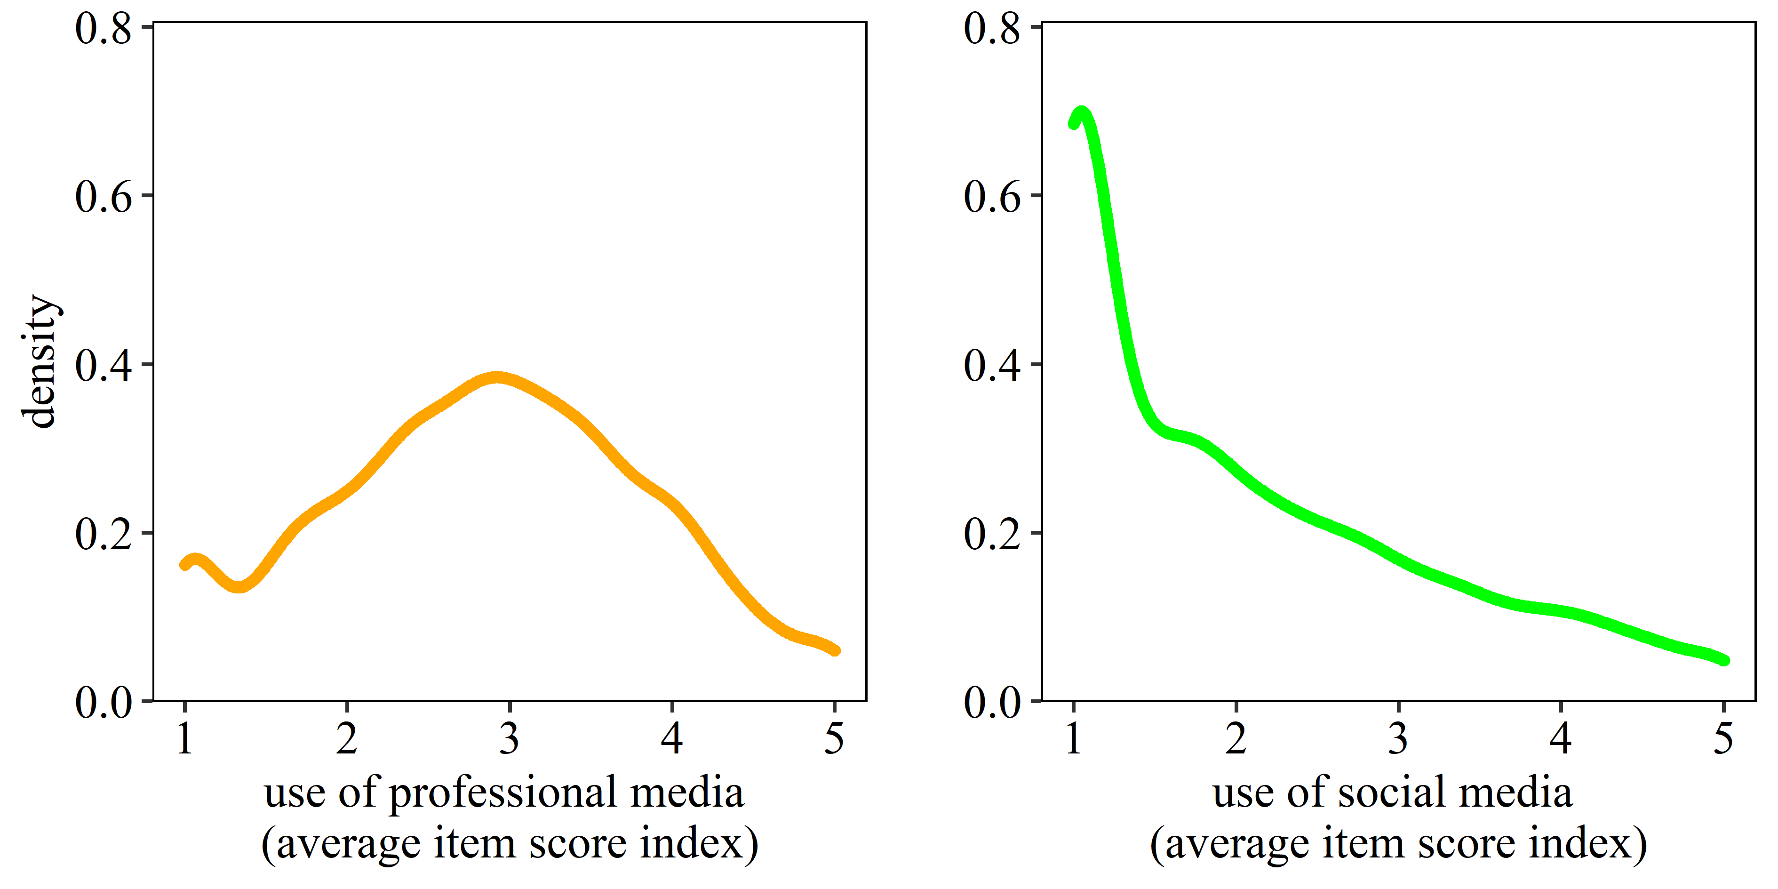
Figure SM3d. Density plots for the use of professional media and social media (as average item score indices)
Note. n = 4,018

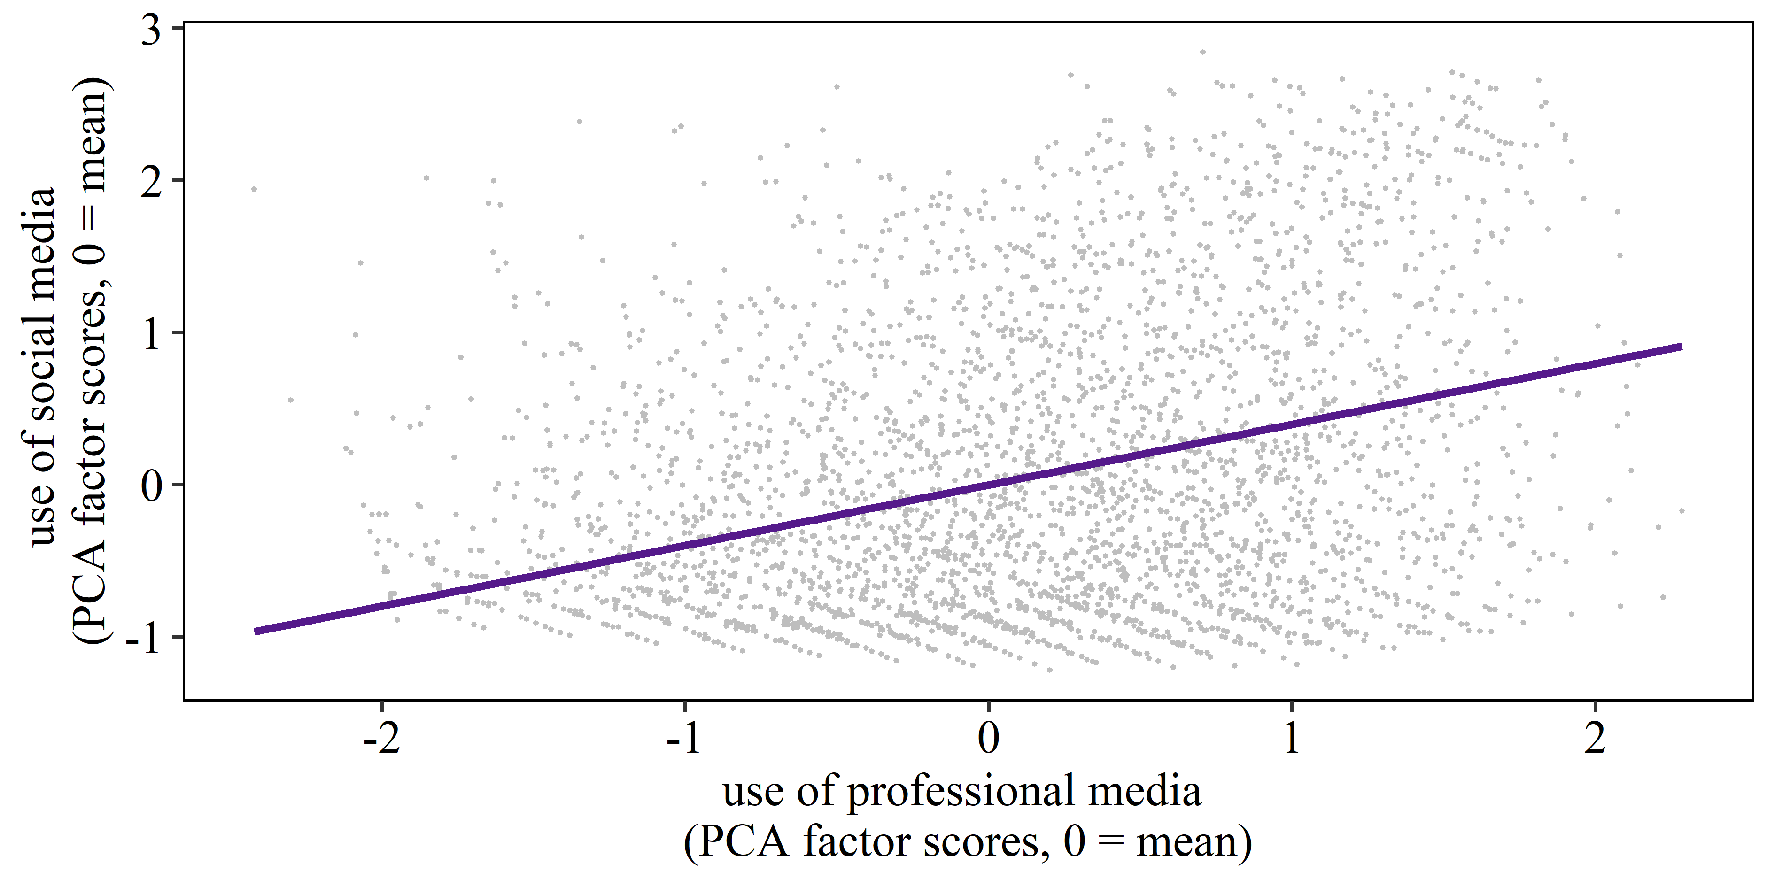
Figure SM3e. Scatterplot for the use of professional media and social media (as PCA factor scores)
Note. The purple line indicates the correlation between the two PCA factors with r = .40, p < .001, n = 4,018.
In Tables SM3f-I, below, we present some alternative specifications of the CFA that combine individual news sources in different ways. The results show no evidence that the model fit of these alternative CFAs is superior to that obtained with the theoretically informed CFA presented above in Table SM3b.

Table SM3f. Confirmatory factor analysis for sources of campaign news, without private messaging apps and tabloids (surveys 1 and 2 combined)
Media source | Factor
 | Social media | Professional media
Facebook | .63
Twitter | .67
Instagram | .77
YouTube | .75
Broadsheets |  | .66
Television |  | .42
Radio |  | .52
Professional news websites |  | .63
Note. MLR estimator used, CFI = .952, TLI = .925, RMSEA = .068, SRMR = .037.

Table SM3g. Confirmatory factor analysis for sources of campaign news, with private messaging apps and tabloids considered as individual factors (surveys 1 and 2 combined)
Media source | Factor
 | Social media | Professional media | Tabloids | Private messaging apps
Facebook | .65
Twitter | .65
Instagram | .76
YouTube | .75
Broadsheets |  | .70
Television |  | .43
Radio |  | .51
Professional news websites |  | .59
Tabloids |  |  | 1.00
Private messaging apps |  |  |  | 1.00
Note. MLR estimator used, CFI = .948, TLI = .922, RMSEA = .067, SRMR = .037.

Table SM3h. Confirmatory factor analysis for sources of campaign news with private messaging apps considered as an individual factor and without tabloids (surveys 1 and 2 combined)
Media source | Factor
 | Social media | Professional media | Private messaging apps
Facebook | .65
Twitter | .65
Instagram | .75
YouTube | .75
Broadsheets |  | .67
Television |  | .42
Radio |  | .52
Professional news websites |  | .63
Private messaging apps |  |  | 1.00
Note. MLR estimator used, CFI = .956, TLI = .933, RMSEA = .064, SRMR = .036.

Table SM3i. Confirmatory factor analysis for sources of campaign news with tabloids considered as an individual factor and without private messaging apps (surveys 1 and 2 combined)
Media source | Factor
 | Social media | Professional media | Tabloids
Facebook | .62
Twitter | .66
Instagram | .77
YouTube | .75
Broadsheets |  | .70
Television |  | .43
Radio |  | .52
Professional news websites |  | .59
Tabloids |  |  | 1.00
Note. MLR estimator used, CFI = .942, TLI = .913, RMSEA = .070, SRMR = .039.

SM4: INFORMATION ON THE CONTROL VARIABLES INCLUDED IN THE MODELS

Recognizing the headline. Respondents’ prior awareness of our news headlines may have affected their responses. To account for this, we asked participants to indicate whether they recognized the headline (“Have you heard about this news story in the last few weeks?”) to which they could either answer “no” (scored 0, n_{observations} = 33,930) or “yes” (scored 1, n_{observations} = 14,286). As for all other control variables, we asked the same question in both surveys.
Incorrectly recognizing placebo headlines. Given that some of our false headlines were placebos that did not circulate during the campaign, we constructed a variable that measured recognition of these headlines. When participants incorrectly said they recognized any of the placebo headlines, which they could not possibly have seen because we invented them, we scored them 1 on this variable (n_{respondents} = 2,574). If they correctly said they did not recognize any placebo headline, we scored them 0 (n_{respondents} = 1,444). The fact that a majority of participants inaccurately recalled at least one placebo headline, possibly due to acquiescence or trust in our survey requests or a “truthiness” effect (Berinsky, 2017) resulting from exposure to the headlines through our study, highlights the importance of including placebos as controls.
Headline covers policy issue important to respondent. The perceived accuracy of headlines and intention to share them may also depend on how important participants consider the issue mentioned in the headlines (Tandoc et al., 2020). Hence, we constructed a variable that matched the topic of the headline with a measure of the perceived relevance of this topic. In doing so, we employed a question that measured the importance respondents attributed to various policy issues by asking them to choose, among a list of 17 topics, the three topics they considered as the most relevant (“Which of the following are the most important issues facing the country?”). The 17 topics were: Constitutional issues / Devolution, Crime, Defense, Economy, Education, Energy / Power, Environmental issues, European Union and Brexit, Foreign affairs (excluding the EU), Health / NHS, Housing / House prices, Immigration, Inequality, Public services / benefits, Terrorism, Transport, Unemployment / Jobs. If the topic of the headline (see SM2 above) matched one of the topics a participant named as important, we assigned the score 1 on this variable (n_{observations} = 17,028). If not, we assigned the score 0 (n_{observations} = 27,170). If a headline covered more than one issue, we assigned the score 1 whenever the participant had indicated at least one of the topics of the headline as being important. In each survey, one headline did not cover a policy issue and we assigned a missing value to it.
Headline attacks preferred party/position. Prior research suggests that people are more likely to believe in false information online if it reinforces their partisan and ideological preferences (Vegetti & Mancosu, 2020). Because the headlines we showed participants featured negative rather than positive news about the main parties and the government, we reasoned that participants may be less likely to consider as accurate and be less inclined to share those headlines that attacked their preferred political party or issue position. First, before showing respondents the headlines, we measured their party preference in the upcoming general election (“And if you were voting in the general election for which party would you vote?”). Second, due to the overwhelming importance of Brexit in the 2019 election, we asked for participants’ current position on Brexit (“Which of the following best describes your stance towards Brexit?”) with the following response modes: “Supportive of remaining in the EU,” “Supportive of a Brexit where the UK is closely aligned with the EU,” “Supportive of a Brexit where the UK has a clear break from the EU,” and “Don’t know.” Whenever the headline attacked respondents’ preferred party or position on Brexit (see SM2), we assigned the score 1 to the new variable (n_{observations} = 16,581), while otherwise assigning a score of 0 (n_{observations} = 31,635). For the position on Brexit, we only considered “Supportive of remaining in the EU” as clear support for remaining, and “Supportive of a Brexit where the UK has a clear break from the EU” as clear support for leaving. When respondents preferred a moderate form of Brexit or answered “I don’t know,” we did not treat pro- or anti-Brexit headlines as an attack on those participants’ preferences. If a headline attacked a party and a specific position on Brexit, we assigned a score of 1 when either the preferred party was attacked or the preferred position on Brexit was attacked or both. We also successfully ran a robustness check to ensure that our key relationships of interest were not affected by the interaction between whether the headline attacked the respondent’s preferred party or position and whether the headline was true or false. See SM8-9 below for results.
Likelihood of voting in 2019 general election. We measured likelihood of voting as a proxy for participants’ overall interest in politics (for which we did not have direct measures in the survey). We asked: “There is going to be a general election held on December 12, 2019. How likely are you to vote in that election?”. Scores ranged from 1 = “Definitely WON'T vote” to 11 = “Definitely WILL vote” (M = 9.92, SD = 2.29). We also successfully ran a robustness check to ensure that our key relationships of interest were not affected by the interaction between the likelihood of voting in the 2019 general election and whether the headline was true of false. See SM8-9 below for results.
Demographics. As standard demographic control variables, we measured participants’ gender (n_{women} = 2,030, n_{men} = 1,988; a non-binary option was also provided but no respondent chose it), age (M = 48.48, SD = 16.59), educational attainment (n_{Level 2 or below (“low”)} = 1,051, n_{Level 3 (“medium”)} = 1,203, n_{Level 4 or higher (“high”)} = 1,764), and the number of cars in their household as a proxy for income (M = 1.23, SD = .87). Car ownership has been successfully employed as a proxy for income in the UK (Galobardes, 2006). We also successfully ran a robustness check to ensure that our key relationships of interest were not affected by the interaction between levels of education and whether the headline was true of false. See SM8-9 below for results.
Lastly, to account for potential learning effects for the small number of respondents (38) who participated in both surveys, we included a variable that differentiates them from those who participated only once. To control for changes in the campaign context, the models predicting perceived headline accuracy also control for whether respondents participated in the first or the second survey.

SM5: ROBUSTNESS CHECK FOR TABLE 1 WITH CFA MEDIA FACTORS

Table SM5. Mixed linear regression model explaining perceived headline accuracy using the CFA factors for media use (surveys 1 and 2 combined)
Predictor | b | SE | p
Survey (1 = survey 2) | -.213*** | .02 | < .001
Participation in both surveys (1 = yes) | -.252*** | .06 | < .001
Gender (1 = men) | -.076*** | .02 | < .001
Age | .001 | .00 | .137
Number of cars (proxy for income) | .010 | .01 | .309
Low education vs. medium education | -.054* | .02 | .016
Low education vs. high education | -.124*** | .02 | < .001
Likelihood of voting in 2019 general election | -.001 | .00 | .726
Use of professional media for election news (CFA) | -.104*** | .02 | < .001
Use of social media for election news (CFA) | .179*** | .02 | < .001
Recognizing the headline (1 = yes) | .743*** | .01 | < .001
Incorrectly recognizing a placebo headline (1 = yes) | .070*** | .02 | < .001
Headline covers policy issue important to respondent (1 = yes) | .053*** | .01 | < .001
Headline attacks preferred party/position (1 = yes) | -.305*** | .01 | < .001
Headline false vs. true (1 = true) | .359*** | .01 | < .001
Headline false vs. true (1 = true)  X Use of professional media for election news (CFA) | .293*** | .02 | < .001
Headline false vs. true (1 = true)  X Use of social media for election news (CFA) | -.350*** | .02 | < .001
Note. Nakagawa’s marginal R² = .225, displayed are only fixed effects but model includes random intercepts for each participant, n_{observations} = 41,415, n_{respondents} = 3,730, lower n due to missing values on control variables, * p < .05, *** p < .001.

SM6: ROBUSTNESS CHECK FOR MODEL A-B IN TABLE 2 WITH CFA MEDIA FACTORS

Table SM6. Mixed linear regression models explaining intention to share headlines using the CFA factors for media use (only survey 2)
 | Model A |  |  |  | Model B
Predictor | b | SE | p |  | b | SE | p
Participation in both surveys  (1 = yes) | -.203 | .14 | .154 |  | -.153 | .14 | .266
Gender (1 = men) | .062 | .04 | .129 |  | .083* | .04 | .035
Age | -.002 | .00 | .096 |  | -.003 | .00 | .055
Number of cars (proxy for  income) | -.044 | .02 | .064 |  | -.046* | .02 | .043
Low education vs.  medium education | -.163** | .05 | .003 |  | -.148** | .05 | .005
Low education vs. high education | -.242*** | .05 | < .001 |  | -.223*** | .05 | < .001
Likelihood of voting in 2019  general election | -.023* | .01 | .014 |  | -.021* | .01 | .019
Use of professional media for  election news (CFA) | -.066 | .04 | .138 |  | -.040 | .04 | .350
Use of social media for election  news (CFA) | .548*** | .05 | < .001 |  | .507*** | .04 | < .001
Recognizing the headline  (1 = yes) | .232*** | .01 | < .001 |  | .077*** | .01 | < .001
Incorrectly recognizing a placebo  headline (1 = yes) | .432*** | .05 | < .001 |  | .418*** | .05 | < .001
Headline covers policy issue  important to respondent (1 = yes) | .053*** | .01 | < .001 |  | .049*** | .01 | < .001
Headline attacks preferred  party/position (1 = yes) | -.170*** | .01 | < .001 |  | -.114*** | .01 | < .001
Headline false vs. true (1 = true) | -.058*** | .01 | < .001 |  | -.122*** | .01 | < .001
Perceived headline accuracy | / | / | / |  | .195*** | .01 | < .001
Headline false vs. true (1 = true)  X Use of professional media  for election news (CFA) | .063* | .03 | .016 |  | .013 | .03 | .610
Headline false vs. true (1 = true)  X Use of social media for  election news (CFA) | -.086*** | .03 | < .001 |  | -.023 | .02 | .350
Note. Nakagawa’s marginal R²_{Model-A} = .238, Nakagawa’s marginal R²_{Model-B} = .266, displayed are only fixed effects but model includes random intercepts for each participant, n_{observations} = 20,658, n_{respondents} = 1,878, lower n due to missing values on control variables, * p < .05, ** p < .01, *** p < .001.

SM7: ROBUSTNESS CHECK FOR MODELS A-C IN TABLE 2 CONTROLLING FOR GENERAL USE OF SOCIAL MEDIA
Table SM7. Mixed linear regression models explaining intention to share headlines controlling for general use of social media (only survey 2)
 | Model A |  |  | Model B |  |  | Model C
Predictor | b | SE | p | b | SE | p | b | SE | p
Participation in both surveys (1 = yes) | -.196 | .14 | .167 | -.147 | .14 | .284 | -.145 | .14 | .288
Gender (1 = men) | .062 | .04 | .130 | .081* | .04 | .040 | .082* | .04 | .037
Age | -.003 | .00 | .080 | -.003* | .00 | .035 | -.004* | .00 | .034
Number of cars (proxy for income) | -.031 | .02 | .196 | -.033 | .02 | .147 | -.034 | .02 | .144
Low education vs. medium education | -.154** | .05 | .004 | -.140** | .05 | .007 | -.138** | .05 | .008
Low education vs. high education | -.229*** | .05 | < .001 | -.210*** | .05 | < .001 | -.208*** | .05 | < .001
Likelihood of voting in 2019 general election | -.020* | .01 | .026 | -.019* | .01 | .032 | -.018* | .01 | .037
General use of social media | -.078** | .03 | .006 | -.082** | .03 | .003 | -.082** | .03 | .003
Use of professional media for election news (PCA) | -.022 | .02 | .374 | -.006 | .02 | .815 | -.006 | .02 | .813
Use of social media for election news (PCA) | .525*** | .03 | < .001 | .500*** | .03 | < .001 | .497*** | .03 | < .001
Recognizing the headline (1 = yes) | .231*** | .01 | < .001 | .077*** | .01 | < .001 | .090*** | .01 | < .001
Incorrectly recognizing a placebo headline (1 = yes) | .426*** | .05 | < .001 | .412*** | .05 | < .001 | .404*** | .05 | < .001
Headline covers policy issue important to respondent (1 = yes) | .053*** | .01 | < .001 | .049*** | .01 | < .001 | .046*** | .01 | < .001
Headline attacks preferred party/position (1 = yes) | -.169*** | .01 | < .001 | -.113*** | .01 | < .001 | -.113*** | .01 | < .001
Headline false vs. true (1 = true) | -.058*** | .01 | < .001 | -.122*** | .01 | < .001 | .110** | .04 | .009
Perceived headline accuracy | / | / | / | .195*** | .01 | < .001 | .209*** | .01 | < .001
Headline false vs. true (1 = true)  X Use of professional media for election news (PCA) | .036* | .01 | .011 | .008 | .01 | .556 | .014 | .01 | .323
Headline false vs. true (1 = true)  X Use of social media for election news (PCA) | -.050*** | .01 | < .001 | -.015 | .01 | .277 | -.013 | .01 | .356
Headline false vs. true (1 = true)  X Perceived headline accuracy | / | / | / | / | / | / | -.070*** | .01 | < .001
Note. Nakagawa’s marginal R²_{Model-A}² = .244, Nakagawa’s marginal R²_{Model-B} = .272, Nakagawa’s marginal R² = .273, displayed are only fixed effects but model includes random intercepts for each participant, n_{observations} = 20,658, n_{respondents} = 1,878, lower n due to missing values on control variables. We measured general use of social media with five items (“About how often do you use…”): Facebook, Twitter, Instagram, WhatsApp, and Snapchat. Response modes were “Several times a day” (scored 5), “About once a day” (4), “About once a week” (3), “Less often” (2), and “Never” (1). We combined the five items into an average item score index measuring general use of social media (M = 2.57, SD = 1.09). * p < .05, ** p < .01, *** p < .001.

SM8: ROBUSTNESS CHECK FOR TABLE 1 INTEGRATING INTERACTION TERMS BETWEEN HEADLINE FALSE VS. TRUE AND EDUCATION, LIKELIHOOD OF VOTING IN THE 2019 GENERAL ELECTION, AND HEADLINE ATTACKS PREFERRED PARTY POSITION

Table SM8. Mixed linear regression model explaining perceived headline accuracy using the PCA factors for media use (surveys 1 and 2 combined)
Predictor | b | SE | p
Survey (1 = survey 2) | -.216*** | .02 | < .001
Participation in both surveys (1 = yes) | -.250*** | .06 | < .001
Gender (1 = men) | -.071*** | .02 | < .001
Age | .001* | .00 | .028
Number of cars (proxy for income) | .012 | .01 | .216
Low education vs. medium education | -.063** | .02 | .005
Low education vs. high education | -.150*** | .02 | < .001
Likelihood of voting in 2019 general election | -.008* | .00 | .039
Use of professional media for election news (PCA) | -.056*** | .01 | < .001
Use of social media for election news (PCA) | .123*** | .01 | < .001
Recognizing the headline (1 = yes) | .732*** | .01 | < .001
Incorrectly recognizing a placebo headline (1 = yes) | .073*** | .02 | < .001
Headline covers policy issue important to respondent (1 = yes) | .055*** | .01 | < .001
Headline attacks preferred party/position (1 = yes) | -.314*** | .01 | < .001
Headline false vs. true (1 = true) | -.159** | .05 | .001
Headline false vs. true (1 = true)  X Low education vs. medium education | .065* | .03 | .020
Headline false vs. true (1 = true)  X Low education vs. high education | .162*** | .03 | < .001
Headline false vs. true (1 = true)  X Likelihood of voting in 2019 general election | .042*** | .00 | < .001
Headline false vs. true (1 = true)  X Headline attacks preferred party/position (1 = yes) | .054* | .02 | .018
Headline false vs. true (1 = true)  X Use of professional media for election news (PCA) | .127*** | .01 | < .001
Headline false vs. true (1 = true)  X Use of social media for election news (PCA) | -.182*** | .01 | < .001
Note. Nakagawa’s marginal R² = .228. Displayed are only fixed effects but model includes random intercepts for each participant, n_{observations} = 41,415, n_{respondents} = 3,730, lower n due to missing values on control variables. * p < .05, ** p < .01, *** p < .001.

SM9: ROBUSTNESS CHECK FOR TABLE 2 INTEGRATING INTERACTION TERMS BETWEEN HEADLINE FALSE VS. TRUE AND EDUCATION, LIKELIHOOD OF VOTING IN THE 2019 GENERAL ELECTION, AND HEADLINE ATTACKS PREFERRED PARTY POSITION
Table SM9. Mixed linear regression models explaining intention to share headlines using the PCA factors for media use (survey 2 only)
 | Model A |  |  | Model B |  |  | Model C
Predictor | b | SE | p | b | SE | p | b | SE | p
Participation in both surveys (1 = yes) | -.190 | .14 | .180 | -.141 | .14 | .305 | -.139 | .14 | .310
Gender (1 = men) | .076 | .04 | .059 | .096* | .04 | .014 | .098* | .04 | .013
Age | -.001 | .00 | .380 | -.002 | .00 | .237 | -.002 | .00 | .241
Number of cars (proxy for income) | -.039 | .02 | .096 | -.042 | .02 | .064 | -.042 | .02 | .063
Low education vs. medium education | -.158** | .05 | .004 | -.141** | .05 | .007 | -.139** | .05 | .001
Low education vs. high education | -.226*** | .05 | < .001 | -.202*** | .05 | < .001 | -.200*** | .05 | < .001
Likelihood of voting in 2019 general election | -.023* | .01 | .014 | -.020* | .01 | .028 | -.019* | .01 | .030
Use of professional media for election news (PCA) | -.020 | .02 | .416 | -.005 | .02 | .836 | -.005 | .02 | .837
Use of social media for election news (PCA) | .473*** | .03 | < .001 | .445*** | .03 | < .001 | .441*** | .03 | < .001
Recognizing the headline (1 = yes) | .228*** | .01 | < .001 | .075*** | .01 | < .001 | .090*** | .01 | < .001
Incorrectly recognizing a placebo headline (1 = yes) | .429*** | .05 | < .001 | .414*** | .05 | < .001 | .406*** | .05 | < .001
Headline covers policy issue important to respondent (1 = yes) | .054*** | .01 | < .001 | .049*** | .01 | < .001 | .045*** | .01 | < .001
Headline attacks preferred party/position (1 = yes) | -.144*** | .01 | < .001 | -.090*** | .01 | < .001 | -.085*** | .01 | < .001
Headline false vs. true (1 = true) | -.094 | .06 | .126 | -.052 | .06 | .388 | .206** | .07 | .004
Headline false vs. true (1 = true)  X Low education vs. medium education | -.009 | .03 | .790 | -.024 | .03 | .469 | -.026 | .03 | .438
Headline false vs. true (1 = true)  X Low education vs. high education | -.060 | .03 | .062 | -.087** | .03 | .006 | -.087** | .03 | .005
Headline false vs. true (1 = true)  X Likelihood of voting in 2019 general election | .012* | .01 | .045 | .002 | .01 | .677 | .005 | .01 | .428
Headline false vs. true (1 = true)  X Headline attacks preferred party/position (1 = yes) | -.157*** | .03 | < .001 | -.147*** | .03 | < .001 | -.175*** | .03 | < .001
Perceived headline accuracy | / | / | / | .195*** | .01 | < .001 | .212*** | .01 | < .001
Headline false vs. true (1 = true)  X Use of professional media for election news (PCA) | .039** | .01 | .008 | .018 | .01 | .213 | .024 | .01 | .093
Headline false vs. true (1 = true)  X Use of social media for election news (PCA) | -.044** | .01 | .002 | -.010 | .01 | .466 | -.007 | .01 | .623
Headline false vs. true (1 = true)  X Perceived headline accuracy | / | / | / | / | / | / | -.082*** | .01 | < .001
Note. Nakagawa’s marginal R²_{Model-A} = .243, Nakagawa’s marginal R²_{Model-B} = .271, Nakagawa’s marginal R²_{Model-C} = .272. Displayed are only fixed effects but model includes random intercepts for each participant, n_{observations} = 20,658, n_{respondents} = 1,878, lower n due to missing values on control variables. * p < .05, ** p < .01, *** p < .001.

SM10: ROBUSTNESS CHECK FOR INDIVIDUAL SOURCES OF CAMPAIGN NEWS

To further expand our understanding of how different media outlets contribute to the campaign disinformation divide, we ran additional regression models where, instead of our theoretically constructed and statistically validated PCA scores, we entered as key predictors the ten individual variables measuring frequency of use of different campaign news sources. Unlike the models reported in Tables 1 and 2 of the manuscript, the coefficient for each campaign news source in these additional models control for the use of all other news sources and, thus, capture the statistical associations between each news source and the dependent variable in isolation from the other sources of campaign news and beyond the associations that other, comparable news sources have with the outcome.

The models predicting perceived accuracy of news headlines (available in Table SM10a and visualized in Figures SM10b-c below) suggest that higher use of broadsheets, television, and news websites for campaign news is significantly associated with a greater likelihood to accurately perceive true headlines as true and false headlines as false, as proposed by H1. By the same token, higher use of Instagram, YouTube, and private messaging apps is associated with higher perceived accuracy of false news headlines than true news headlines, consistent with H2. There are, however, two important differences. Higher use of tabloids for campaign news is associated with higher perceived accuracy of false than true headlines and use of Twitter for campaign news is associated with higher perceived accuracy of true than false news headlines.

The models predicting the intention to share (Model A in Table SM10d, visualized in Figures SM10e-f below) confirm the weaker relationship between different campaign news sources and this key outcome, as shown in Table 2 in the manuscript. The only significant correlations we found involved use of television for campaign news, which was associated with a higher intention to share true than false news (consistent with H3), and use of Instagram, which predicted a higher intention to share false than true news (consistent with H4). As with the previous analysis, however, use of Twitter for campaign news was significantly associated with a higher intention to share true than false news.

Finally, when we added to the model predicting the intention to share news headlines the variable measuring perceived accuracy of the headline and the interaction between perceived accuracy and true vs. false (Models B and C in Table SM10d below), the results were fully consistent with those reported in Models B and C of Table 2. That is, none of the coefficients for sources of campaign news were significant but there was a strong, positive and significant association between perceived accuracy and the intention to share headlines (consistent with H5) and the interaction term between perceived accuracy and true vs. false was negative and significant (consistent with our answer to RQ1).

Table SM10a. Mixed linear regression model explaining perceived headline accuracy with individual news sources entered as separate predictors (surveys 1 and 2 combined)
Predictor | b | SE | p
Survey (1 = survey 2) | -.219*** | .02 | < .001
Participation in both surveys (1 = yes) | -.260*** | .06 | < .001
Gender (1 = men) | -.059*** | .02 | < .001
Age | .001* | .00 | .036
Number of cars (proxy for income) | .009 | .01 | .341
Low education vs. medium education | -.037 | .02 | .089
Low education vs. high education | -.089*** | .02 | < .001
Likelihood of voting in 2019 general election | .003 | .00 | .378
Sources of campaign news
Broadsheets | -.035*** | .01 | < .001
Tabloids | .050*** | .01 | < .001
Television | -.039*** | .01 | < .001
Radio | .000 | .01 | .978
Professional news websites | -.022*** | .01 | < .001
Facebook | .007 | .01 | .298
Twitter | -.025*** | .01 | < .001
Instagram | .078*** | .01 | < .001
YouTube | .024** | .01 | .003
Private messaging apps | .018* | .01 | .022
Recognizing the headline (1 = yes) | .730*** | .01 | < .001
Incorrectly recognizing a placebo headline (1 = yes) | .066*** | .02 | < .001
Headline covers policy issue important to respondent (1 = yes) | .052*** | .01 | < .001
Headline attacks preferred party/position (1 = yes) | -.304*** | .01 | < .001
Headline false vs. true (1 = true) | .201*** | .03 | < .001
Headline false vs. true (1 = true) X Broadsheets | .051*** | .01 | < .001
Headline false vs. true (1 = true) X Tabloids | -.057*** | .01 | < .001
Headline false vs. true (1 = true) X Television | .062*** | .01 | < .001
Headline false vs. true (1 = true) X Radio | .007 | .01 | .374
Headline false vs. true (1 = true) X Professional News Websites | .084*** | .01 | < .001
Headline false vs. true (1 = true) X Facebook | -.012 | .01 | .139
Headline false vs. true (1 = true) X Twitter | .034*** | .01 | < .001
Headline false vs. true (1 = true) X Instagram | -.089*** | .01 | < .001
Headline false vs. true (1 = true) X YouTube | -.070*** | .01 | < .001
Headline false vs. true (1 = true) X Private messaging apps | -.034*** | .01 | < .001
Note. Nakagawa’s marginal R² = .234. Displayed are only fixed effects but model includes random intercepts for each participant, n_{observations} = 41,415, n_{respondents} = 3,730, lower n due to missing values on control variables. * p < .05, ** p < .01, *** p < .001.

Figure SM10b. Perceived accuracy of true vs. false headlines by use of individual professional media sources for getting news about the election (surveys 1 and 2 combined) 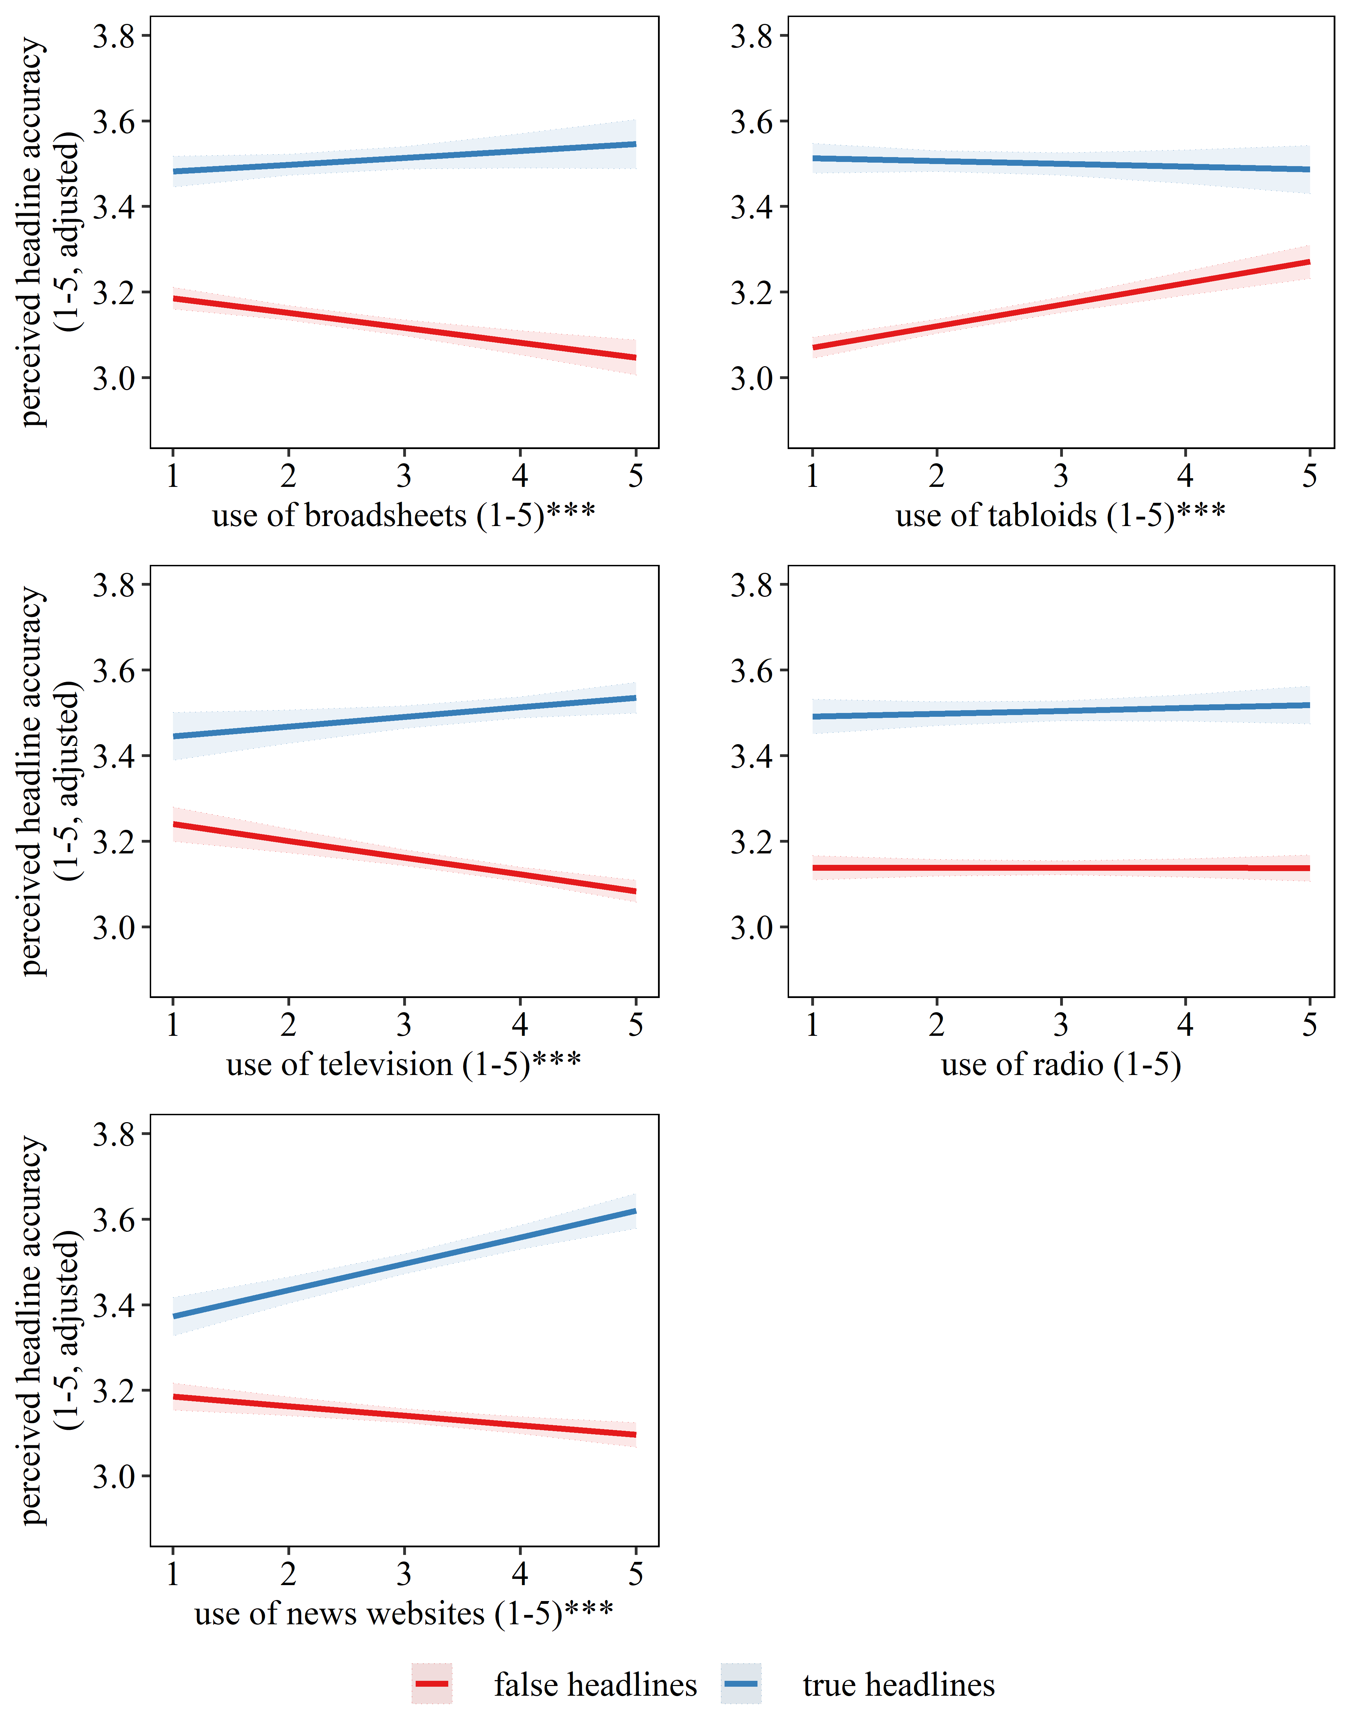
Note. Use of professional media as single sources. Each individual plot displays perceived headline accuracy adjusted for the use of all other professional and social media entered as single sources in the model and adjusted for all other control variables, n_{observations} = 41,415, n_{respondents} = 3,730, lower n due to missing values on control variables, colored areas around bold lines indicate 95% confidence intervals, *** interaction with true/false significant at p < .001.

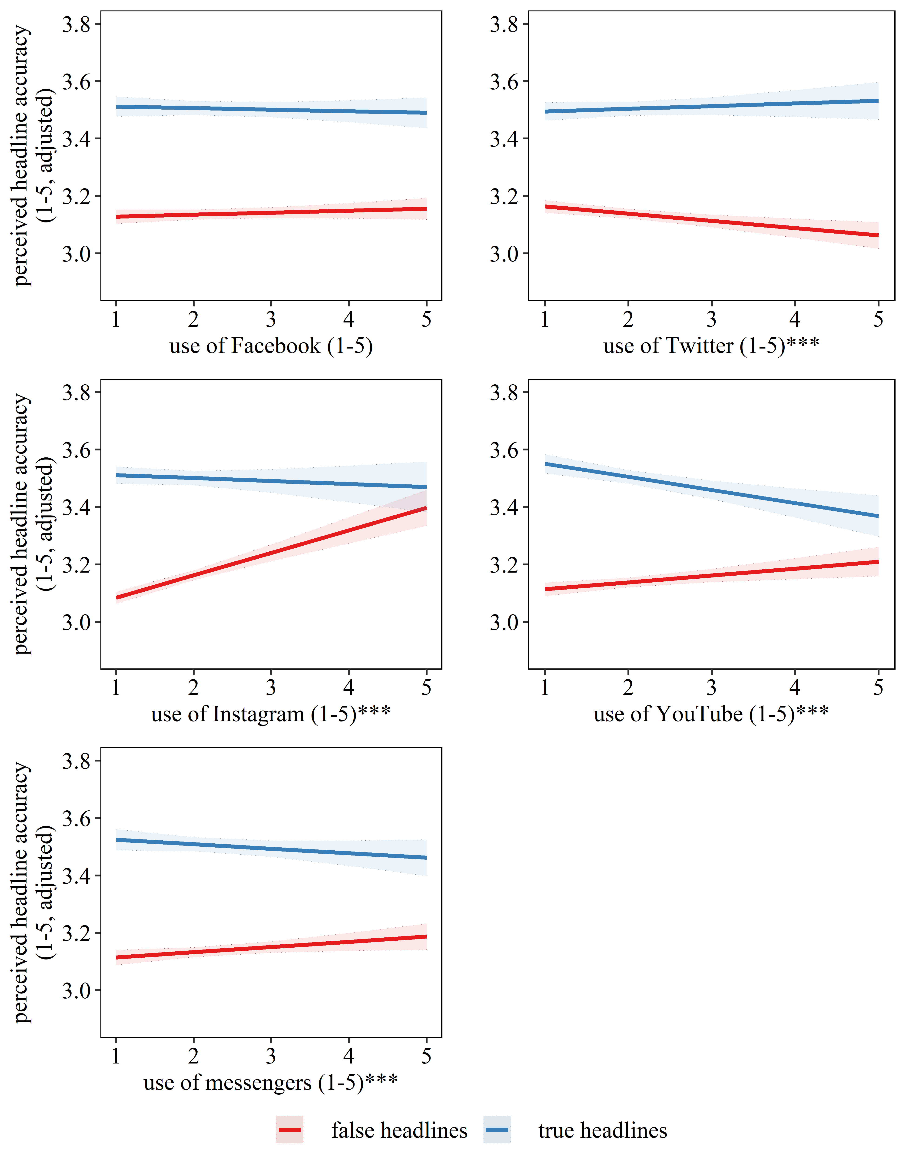
Figure SM10c. Perceived accuracy of true vs. false headlines by use of individual social media sources for getting news about the election (surveys 1 and 2 combined)
Note. Use of social media as single sources. Each individual plot displays perceived headline accuracy adjusted for the use of all other professional and social media entered as single sources in the model and adjusted for all other control variables, n_{observations} = 41,415, n_{respondents} = 3,730, lower n due to missing values on control variables, colored areas around bold lines indicate 95% confidence intervals, *** interaction with true/false significant at p < .001.

Table SM10d. Mixed linear regression models explaining intention to share headlines with individual news sources entered as separate predictors (survey 2 only)
 | Model A |  |  | Model B |  |  | Model C
Predictor | b | SE | p | b | SE | p | b | SE | p
Participation in both surveys (1 = yes) | -.199 | .14 | .159 | -.145 | .14 | .290 | -.143 | .14 | .296
Gender (1 = men) | .087* | .04 | .033 | .105** | .04 | .008 | .106** | .04 | .007
Age | -.002 | .00 | .129 | -.003 | .00 | .068 | -.003 | .00 | .069
Number of cars (proxy for income) | -.040 | .02 | .089 | -.043 | .02 | .062 | -.043 | .02 | .061
Low education vs. medium education | -.136* | .05 | .012 | -.124* | .05 | .017 | -.124* | .05 | .018
Low education vs. high education | -.197*** | .05 | < .001 | -.183*** | .05 | < .001 | -.181*** | .05 | < .001
Likelihood of voting in 2019 general election | -.018 | .01 | .054 | -.017 | .01 | .055 | -.017 | .01 | .062
Sources of campaign news
Broadsheets | .040* | .02 | .022 | .044** | .02 | .009 | .044** | .02 | .009
Tabloids | .054** | .02 | .002 | .048** | .02 | .004 | .047** | .02 | .005
Television | -.020 | .02 | .241 | -.013 | .02 | .451 | -.012 | .02 | .460
Radio | -.019 | .02 | .212 | -.017 | .01 | .264 | -.017 | .01 | .262
Professional news websites | -.035* | .02 | .025 | -.031* | .02 | .040 | -.031* | .02 | .041
Facebook | .090*** | .02 | < .001 | .089*** | .02 | < .001 | .089*** | .02 | < .001
Twitter | .003 | .02 | .863 | .011 | .02 | .513 | .012 | .02 | .496
Instagram | .105*** | .02 | < .001 | .084*** | .02 | < .001 | .083*** | .02 | < .001
YouTube | .092*** | .02 | < .001 | .088*** | .02 | < .001 | .088*** | .02 | < .001
Private messaging apps | .090*** | .02 | < .001 | .084*** | .02 | < .001 | .084*** | .02 | < .001
Recognizing the headline (1 = yes) | .231*** | .01 | < .001 | .078*** | .01 | < .001 | .091*** | .01 | < .001
Incorrectly recognizing a placebo headline (1 = yes) | .397*** | .05 | < .001 | .387*** | .05 | < .001 | .380*** | .05 | < .001
Headline covers policy issue important to respondent (1 = yes) | .055*** | .01 | < .001 | .051*** | .01 | < .001 | .048*** | .01 | < .001
Headline attacks preferred party/position (1 = yes) | -.170*** | .01 | < .001 | -.114*** | .01 | < .001 | -.114*** | .01 | < .001
Headline false vs. true (1 = true) | -.087* | .04 | .034 | -.132*** | .04 | < .001 | .076 | .05 | .165
Perceived headline accuracy | / | / | / | .195*** | .01 | < .001 | .209*** | .01 | < .001
Headline false vs. true (1 = true) X Broadsheets | -.005 | .01 | .626 | -.013 | .01 | .216 | -.011 | .01 | .296
Headline false vs. true (1 = true) X Tabloids | .020 | .01 | .066 | .028** | .01 | .007 | .029** | .01 | .006
Headline false vs. true (1 = true) X Television | .028** | .01 | .008 | .019 | .01 | .063 | .020 | .01 | .054
Headline false vs. true (1 = true) X Radio | -.005 | .01 | .618 | -.008 | .01 | .410 | -.007 | .01 | .462
Headline false vs. true (1 = true) X Professional News Websites | -.003 | .01 | .730 | -.016 | .01 | .098 | -.014 | .01 | .157
Headline false vs. true (1 = true) X Facebook | -.009 | .01 | .409 | -.006 | .01 | .579 | -.006 | .01 | .556
Headline false vs. true (1 = true) X Twitter | .025* | .01 | .028 | .016 | .01 | .131 | .016 | .01 | .138
Headline false vs. true (1 = true) X Instagram | -.045** | .01 | .002 | -.024 | .01 | .077 | -.022 | .01 | .105
Headline false vs. true (1 = true) X YouTube | -.018 | .01 | .153 | -.010 | .01 | .428 | -.011 | .01 | .372
Headline false vs. true (1 = true) X Private messaging apps | .002 | .01 | .885 | .009 | .01 | .463 | .009 | .01 | .442
Headline false vs. true (1 = true)  X Perceived headline accuracy | / | / | / | / | / | / | -.069*** | .01 | < .001
Note. Nakagawa’s marginal R²_{Model-A} = .248, Nakagawa’s marginal R²_{Model-B} = .276, Nakagawa’s marginal R²_{Model-C} = .277. Displayed are only fixed effects but model includes random intercepts for each participant, n_{observations} = 20,658, n_{respondents} = 1,878, lower n due to missing values on control variables. * p < .05, ** p < .01, *** p < .001.

Figure SM10e. Intention to share true vs. false headlines by use of individual professional media sources for getting news about the election (only survey 2)
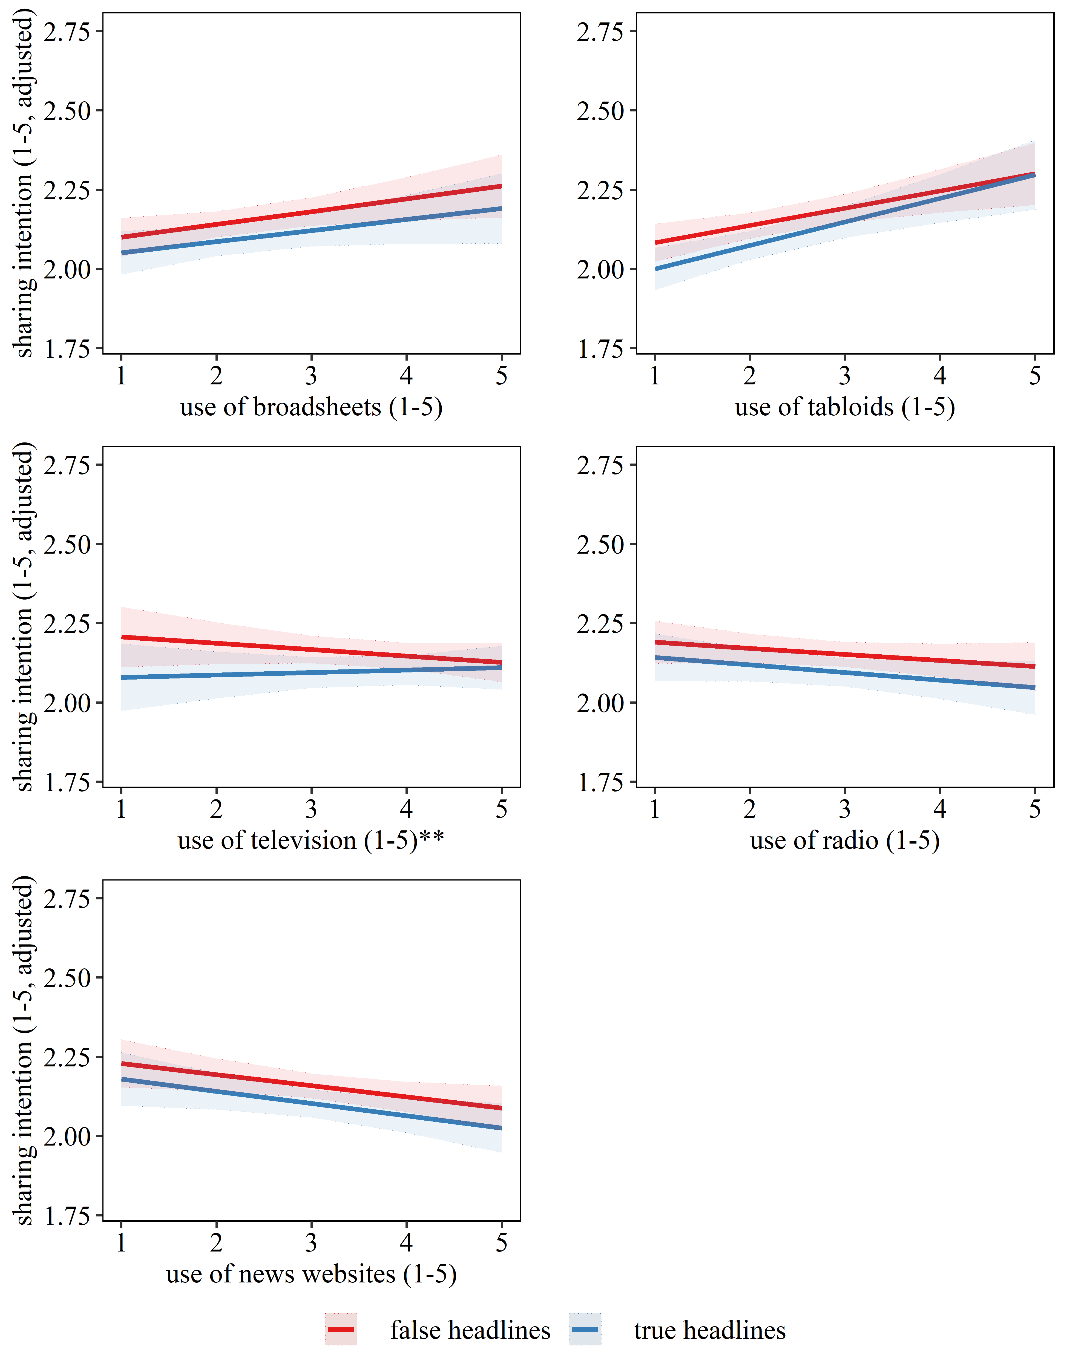
Note. Use of professional media as single sources. Each individual plot displays intention to share headlines adjusted for the use of all other professional and social media entered as single sources in the model and adjusted for all other control variables, n_{observations} = 20,658, n_{respondents} = 1,878, lower n due to missing values on control variables, colored areas around bold lines indicate 95% confidence intervals, ** interaction with true/false significant at p < .01.

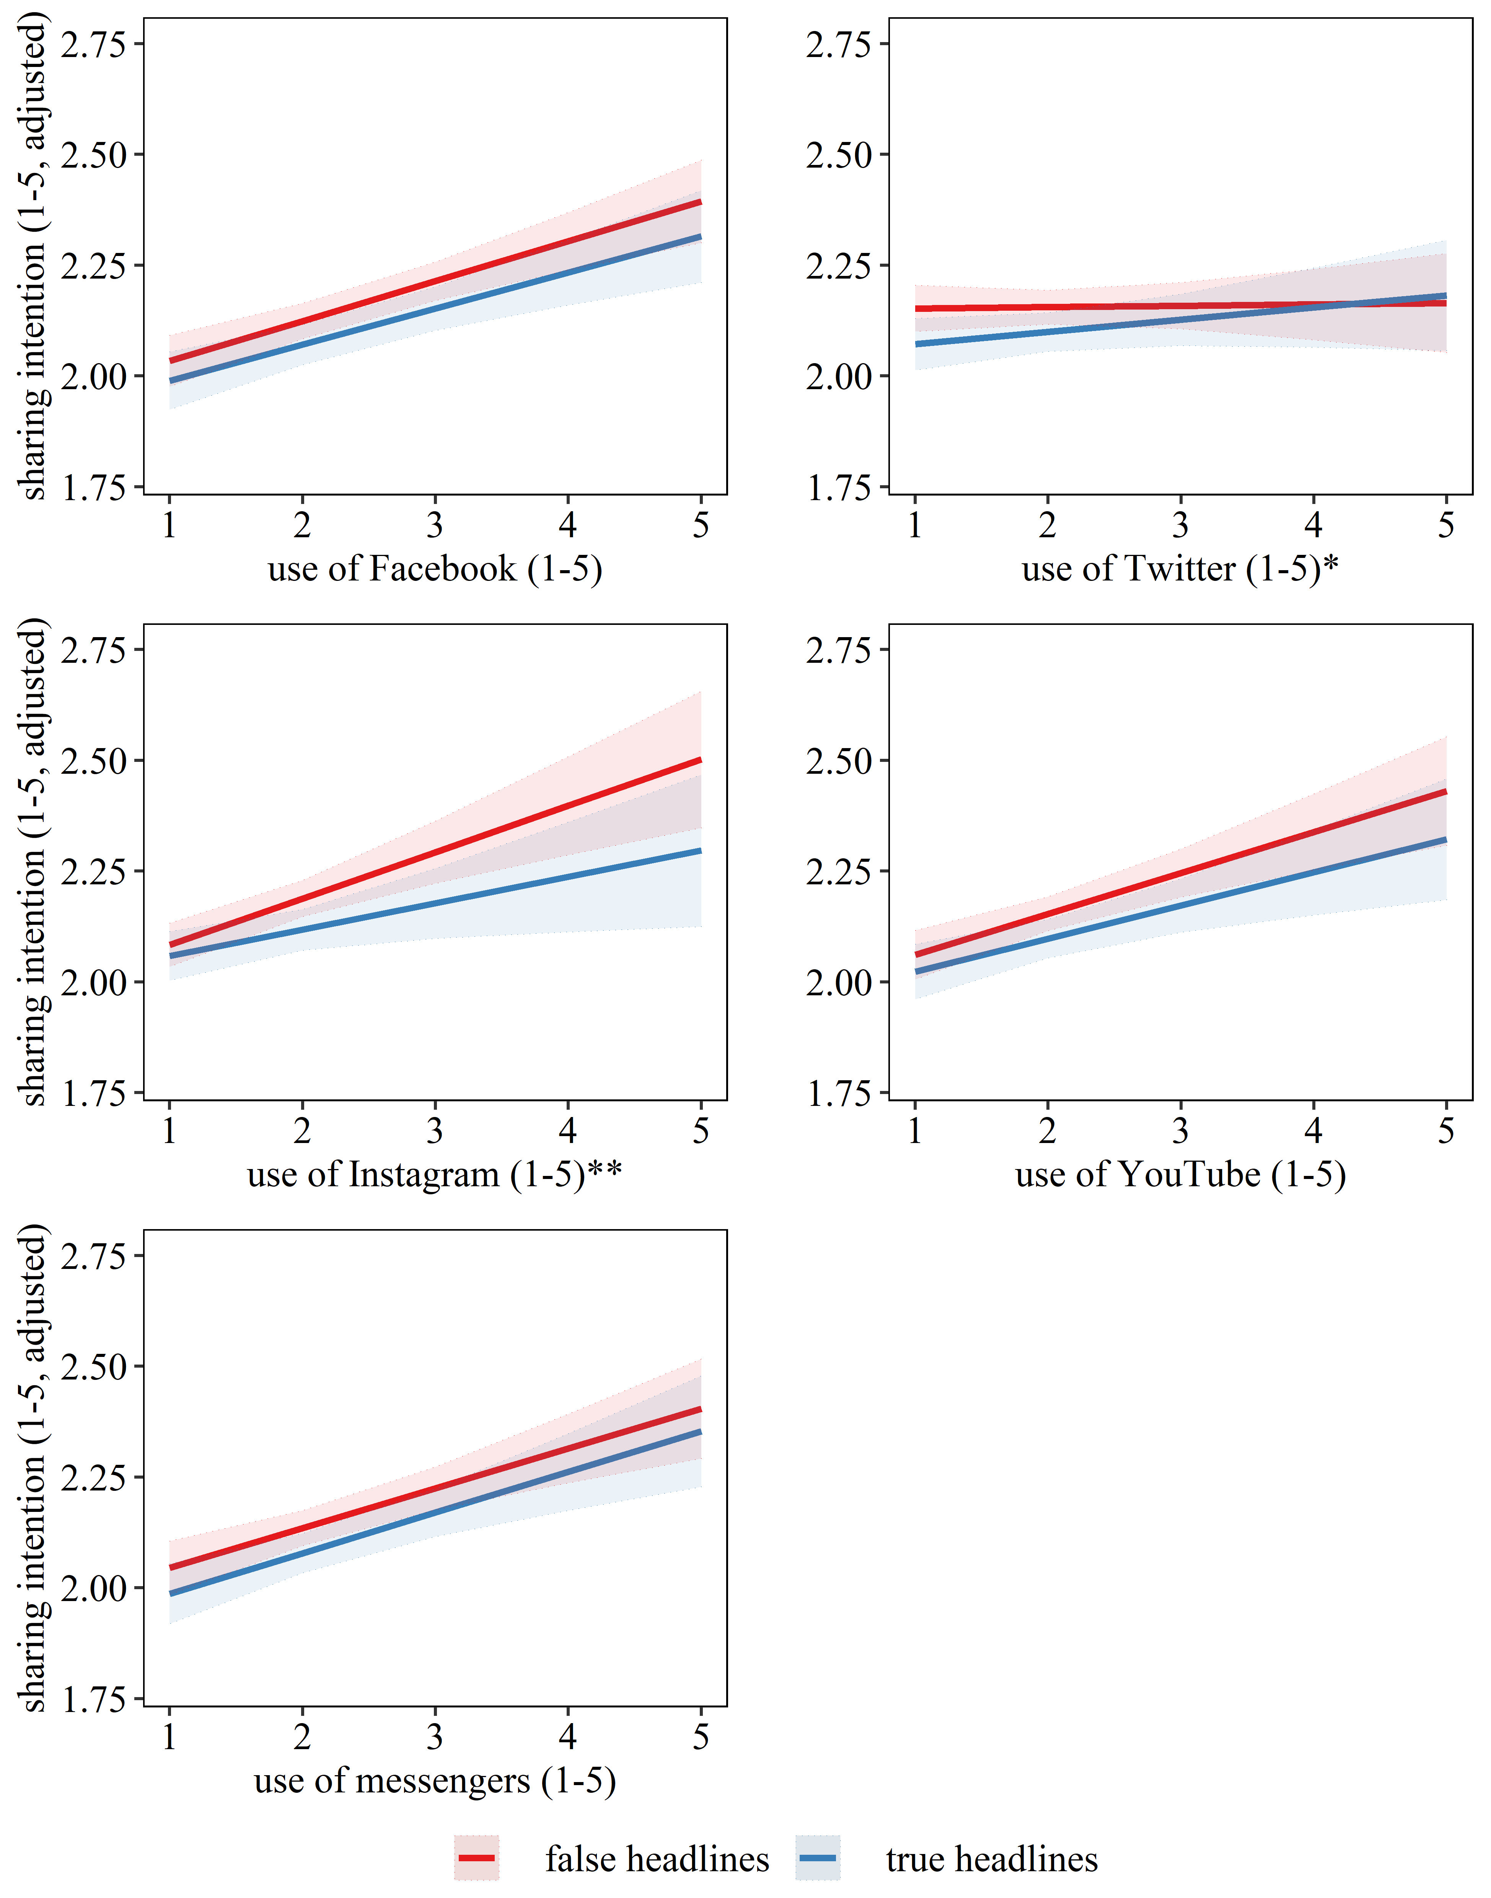
Figure SM10f. Intention to share true vs. false headlines by use of individual social media sources for getting news about the election (only survey 2)
Note. Use of social media as single sources. Each individual plot displays intention to share headlines adjusted for the use of all other professional and social media entered as single sources in the model and adjusted for all other control variables, n_{observations} = 20,658, n_{respondents} = 1,878, lower n due to missing values on control variables, colored areas around bold lines indicate 95% confidence intervals, */** interaction with true/false significant at p < .05 / p < .01.

REFERENCES

Berinsky, A. J. (2017). Rumors and Health Care Reform: Experiments in Political Misinformation. British Journal of Political Science, 47(2), 241-262.
Galobardes, B. (2006). Indicators of socioeconomic position (part 1). Journal of Epidemiology & Community Health, 60(1), 7–12. https://doi.org/1.1136/jech.2004.023531
Tandoc, E. C., Lim, D., & Ling, R. (2020). Diffusion of Disinformation: How Social Media Users Respond to Fake News and Why. Journalism, 21, 381–398.
Vegetti, F., & Mancosu, M. (2020). The Impact of Political Sophistication and Motivated Reasoning on Misinformation. Political Communication, 37(5), 678-695.

