SUPPLEMENTARY INFORMATION
Hydrothermal Co-liquefaction of Biomass and Plastic Wastes into Biofuel: Study on Catalyst Property, Product Distribution and Synergistic Effects
Swathi Mukundan,^{a,b,*} Jonathan L. Wagner,ª Pratheep K. Annamalai,^{c} Devika Sudha Ravindran,^{b} Girish Kumar Krishnapillai,^{b} and Jorge Beltramini^{d}
ª Loughborough University, UKRI National Interdisciplinary Centre for Circular Chemical Economy, Department of Chemical Engineering, Epinal way, Loughborough, Leicestershire, UK, LE11 3TU.
^{b} Cochin University of Science and Technology, Department of Applied Chemistry, University Road, Kalamassery, Kochi– 682022, Kerala, India.
^{c} The University of Queensland, Australian Institute for Bioengineering & Nanotechnology, St Lucia, QLD- 4072, Australia.
^{d} Queensland University of Technology, Centre for Agriculture and the Bioeconomy, Brisbane, QLD– 4000, Australia.
*Corresponding author E–mail address– s.mukundan@lboro.ac.uk

Calculations

$$\text{Yield of Bio-oil (Wt. \%)}=\frac{Mass of bio-oil \left(g\right)}{Mass of feed \left(g\right)}*\text{100}$$
$$\text{Yield of Solids (Wt. \%)}=\frac{Mass of solid collected after reaction (g)}{Mass of feed (g)}*\text{100}$$
$$\text{Yield of Gas (Wt. \%)}=\frac{Mass of gas collected after reaction (g)}{Mass of feed (g)}*\text{100}$$
$$Yield of aqueous phase \left(\%\right)=100-yield of (bio-oil+solids+gas)$$
$$Deoxgenation \left(\%\right)=\frac{Molar ratio of\frac{O}{C} in feed- Molar ratio of\frac{O}{C}in bio-oil}{Molar ratio of\frac{O}{C} in feed}*100$$
$$Carbon recovery \left(\%\right)=\frac{Mass of C in bio-oil}{Mass of C in feed}*100$$
$\text{HHV (MJ/Kg)}=$(0.363302*C)+(1.087033*H)-(0.100992*O)

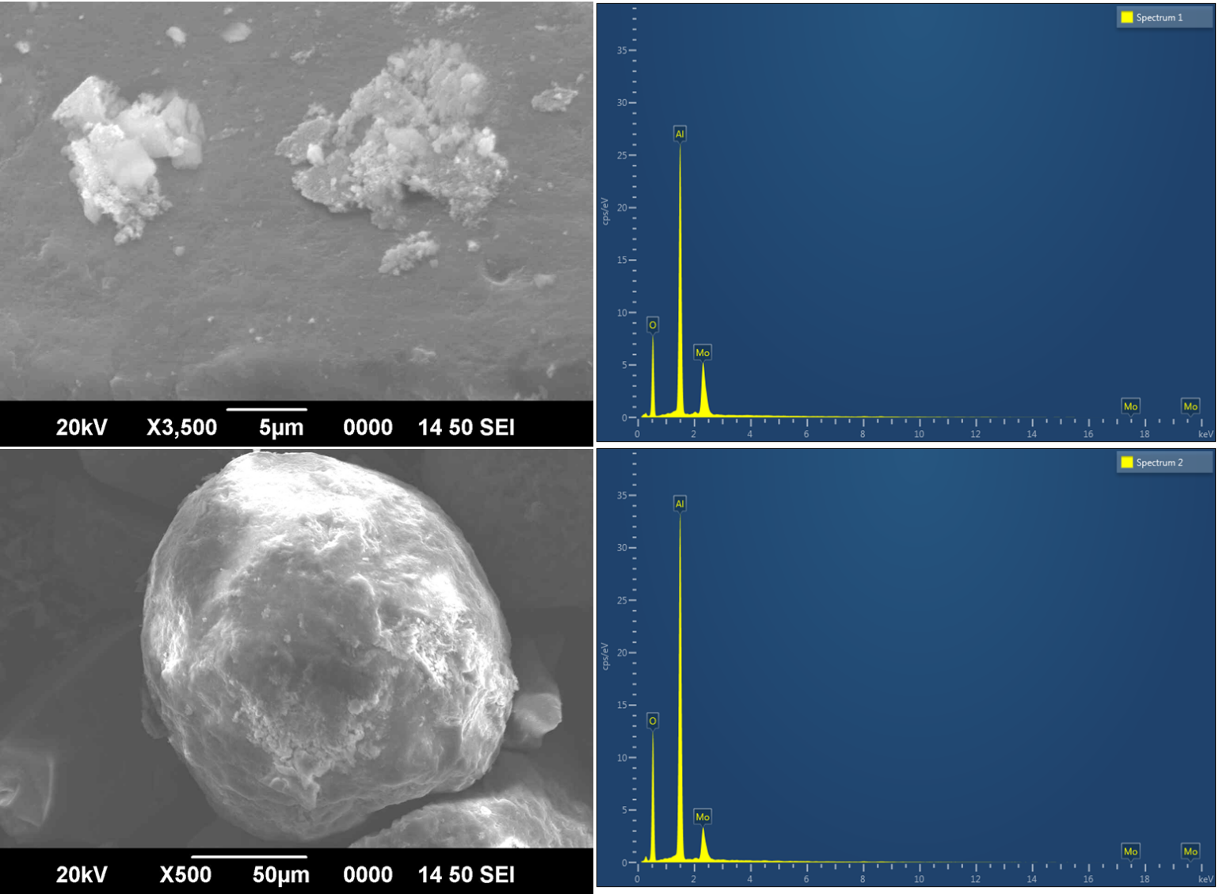
Fig. S1a. SEM–EDAX of Mo/alumina catalyst

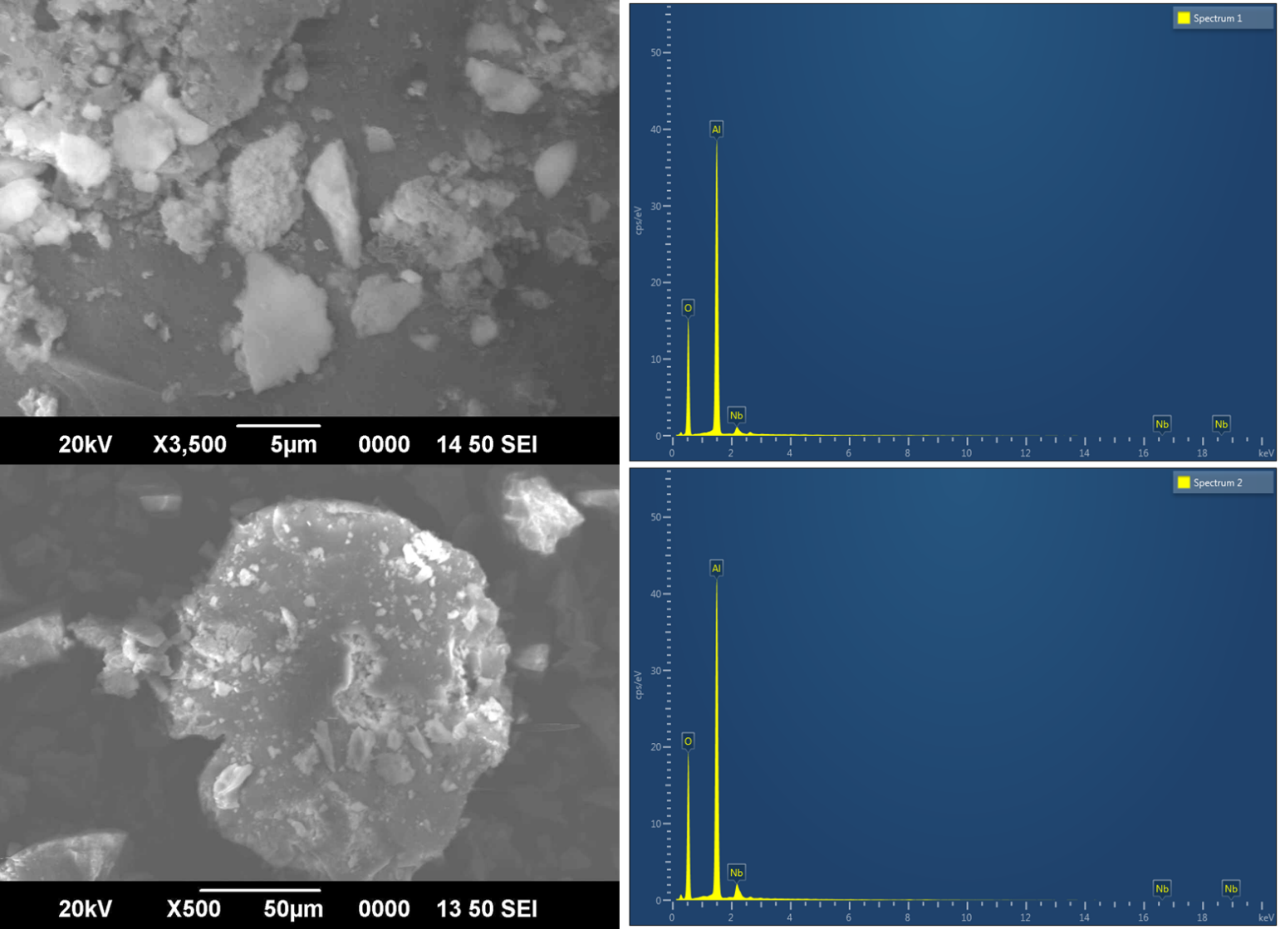
Fig. S1b. SEM–EDAX of Nb/alumina catalyst

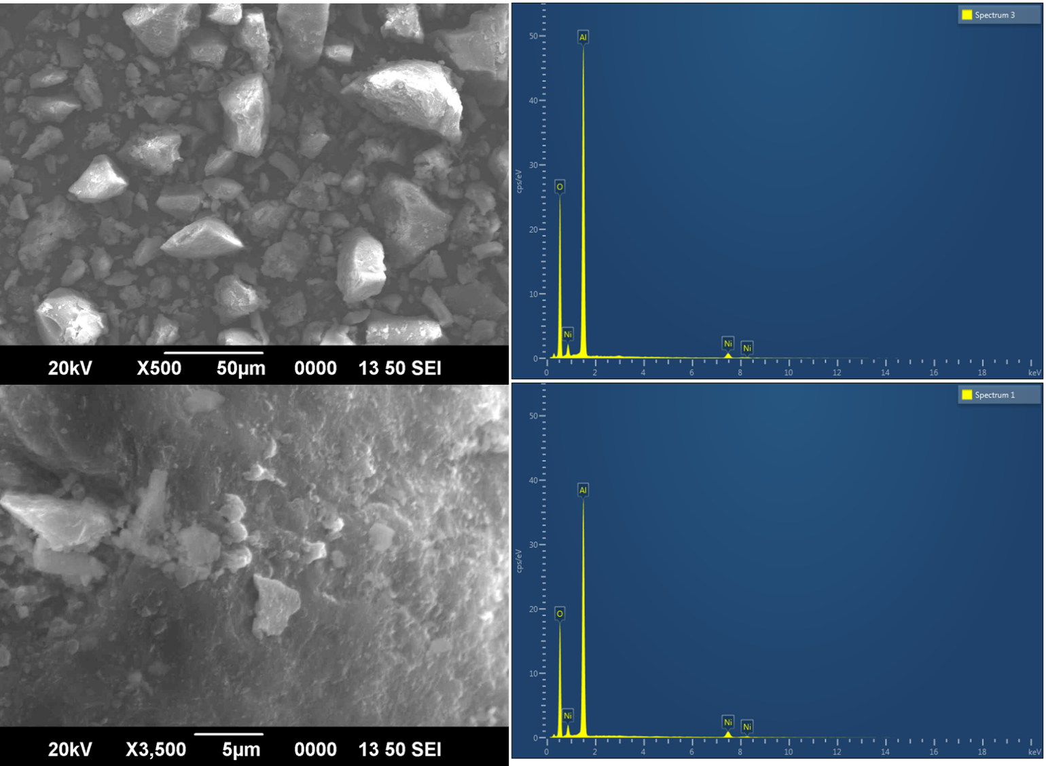
Fig. S1c. SEM–EDAX of Ni/alumina catalyst

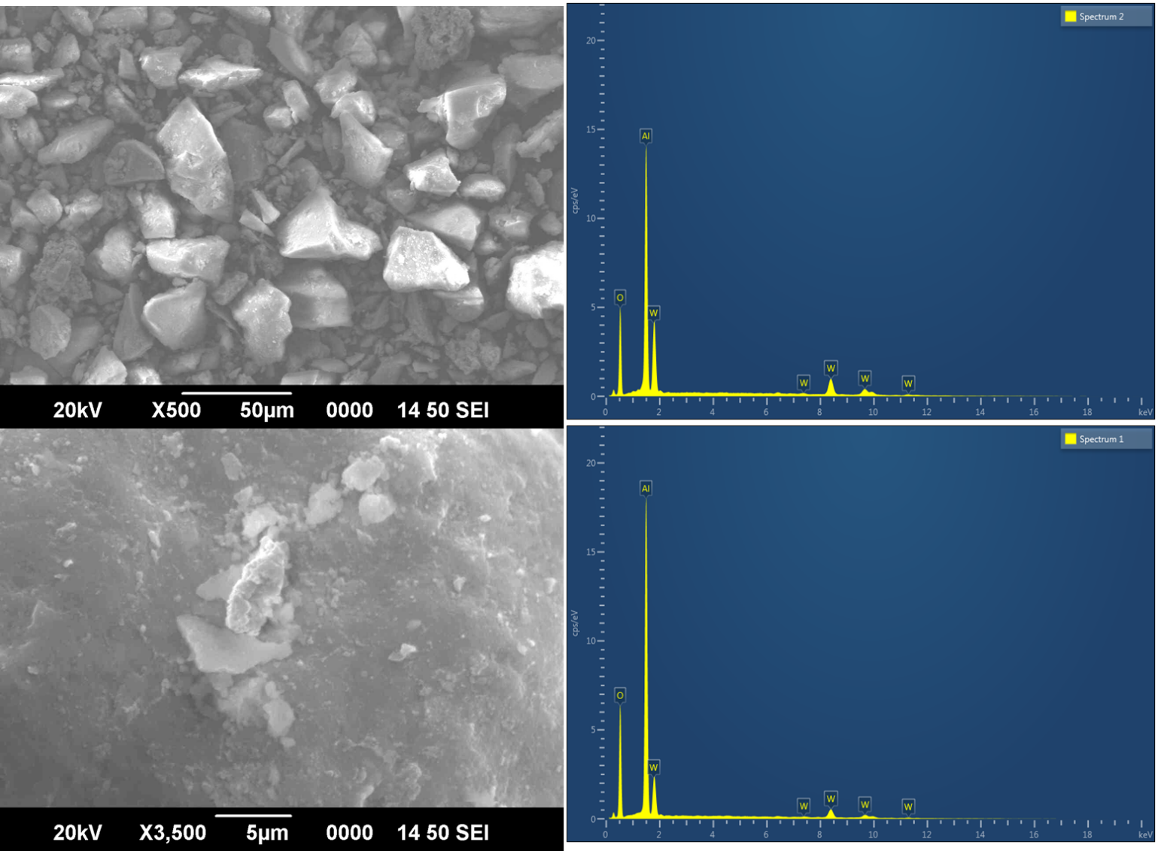
Fig. S1d. SEM–EDAX of W/alumina catalyst

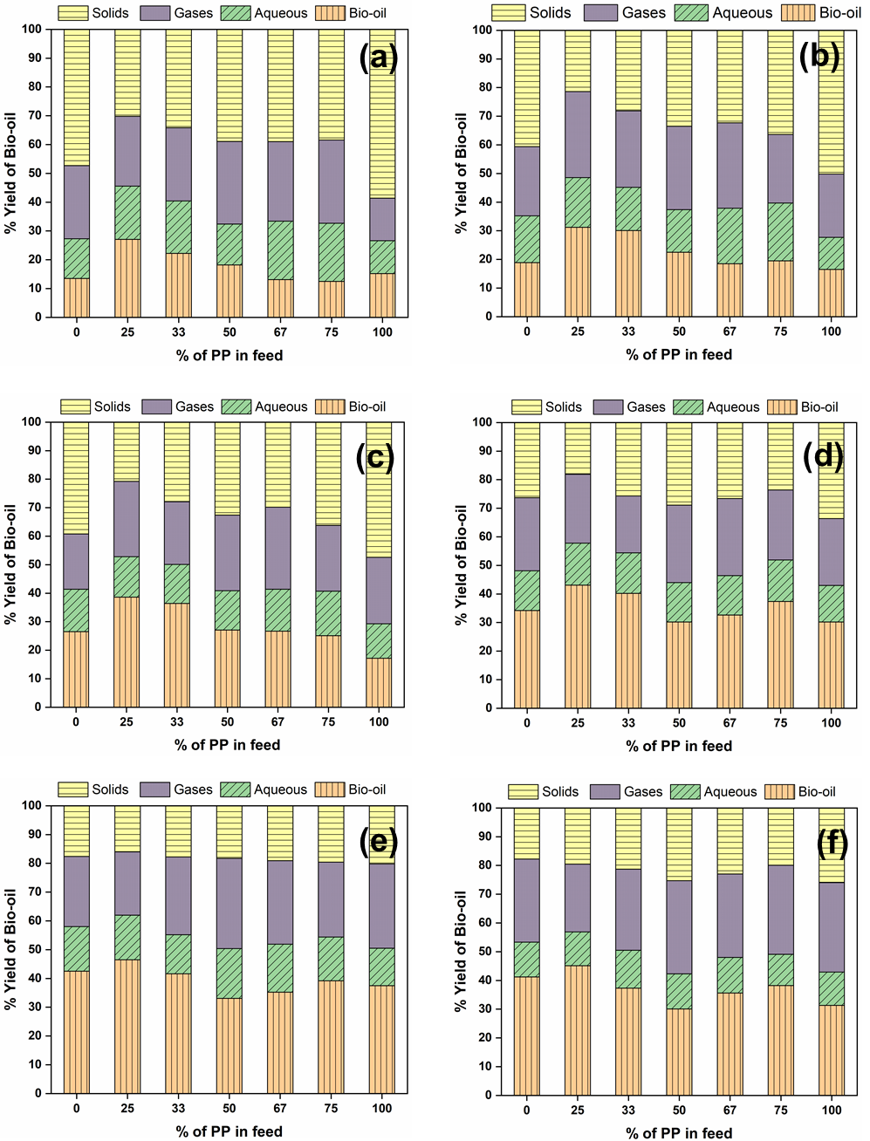
Fig. S2. The yield % of bio-oil, aqueous, gas and solid products obtained from the hydrothermal co-liquefaction of Prosopis juliflora (PJ) and with the addition of polypropylene (PP) in different percentage (25 %, 33 %, 50 %, 67 %, 75 %) at temperature of (a) 340 ˚C, (b) 360 ˚C, (c) 380 ˚C, (d) 400 ˚C, (e) 420 ˚C, and (f) 440 ˚C for 60 min (non-catalytic reactions).

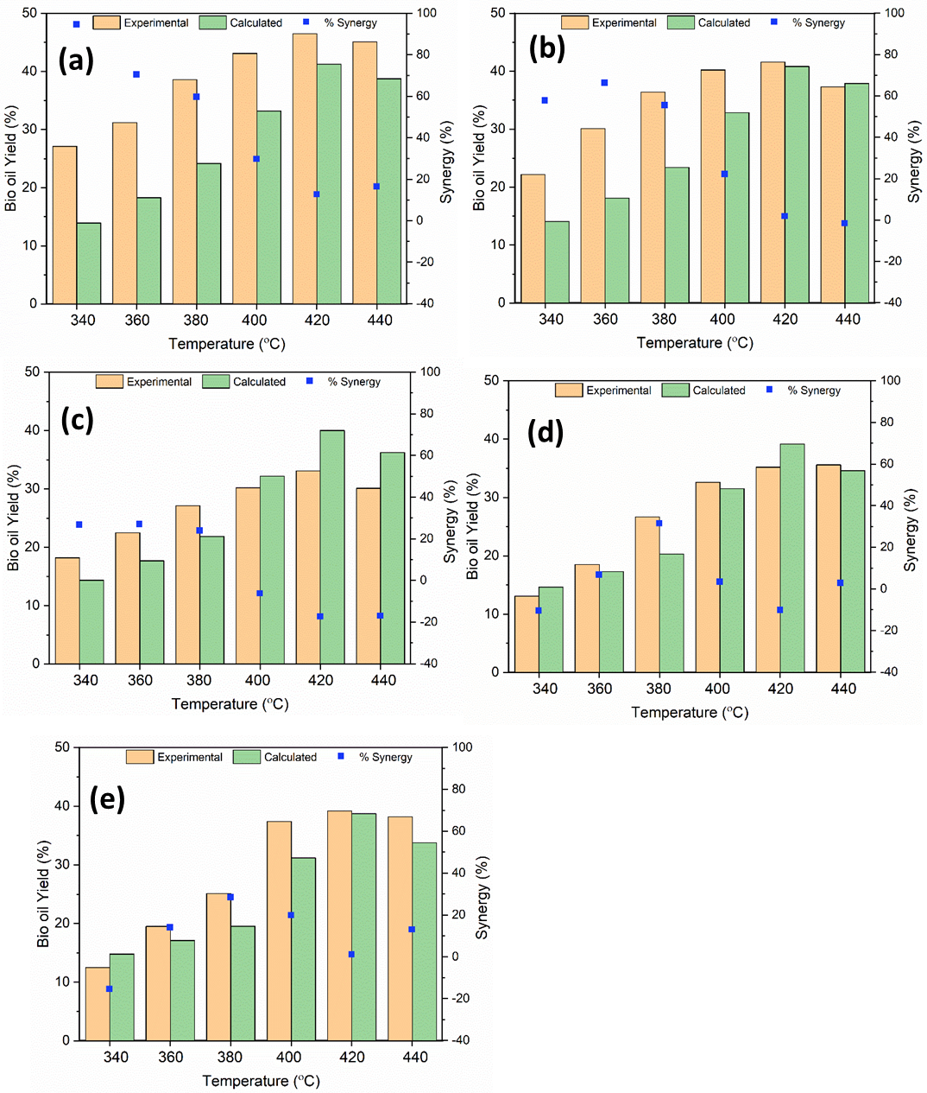
Fig. S3. Comparison of the obtained bio-oil yield (%) and the calculated (anticipated) bio-oil yield (%) obtained with different PP addition to PJ (a) 25 %, (b) 33 %, (c) 50 %, (d) 67 %, and (e) 75 % at temperature of 340 ˚C, 360 ˚C, 380 ˚C, 400 ˚C, 420 ˚C, and 440 ˚C for 60 min (non-catalytic reactions).
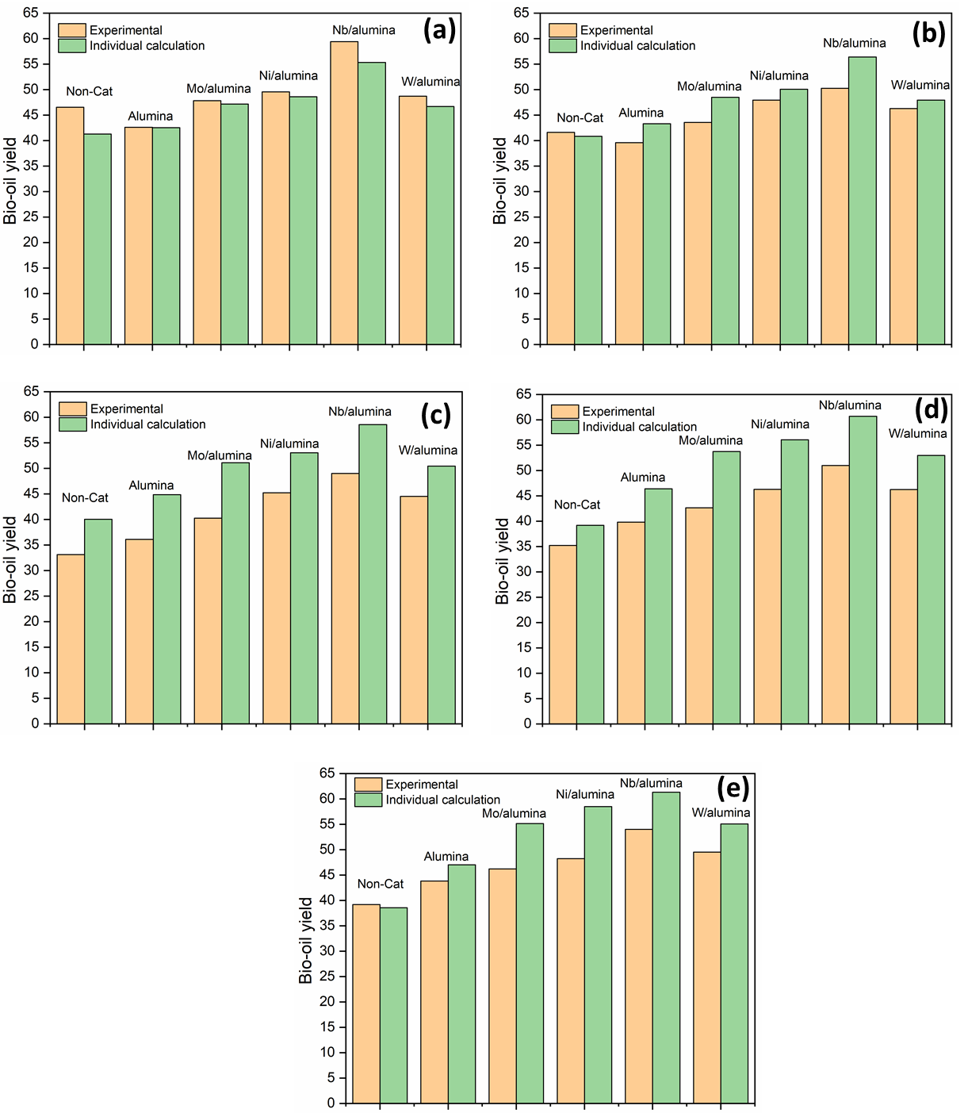
Fig. S4. Comparison of the obtained yield of bio-oil with the calculated anticipated yield from the hydrothermal co-liquefaction of Prosopis juliflora (PJ) and with the addition of polypropylene (PP) in different PP percentage of (a) 25 %, (b) 33 %, (c) 50 %, (d) 67 %, (e) 75 % at 420 ˚C for 60 min in the presence of catalysts.

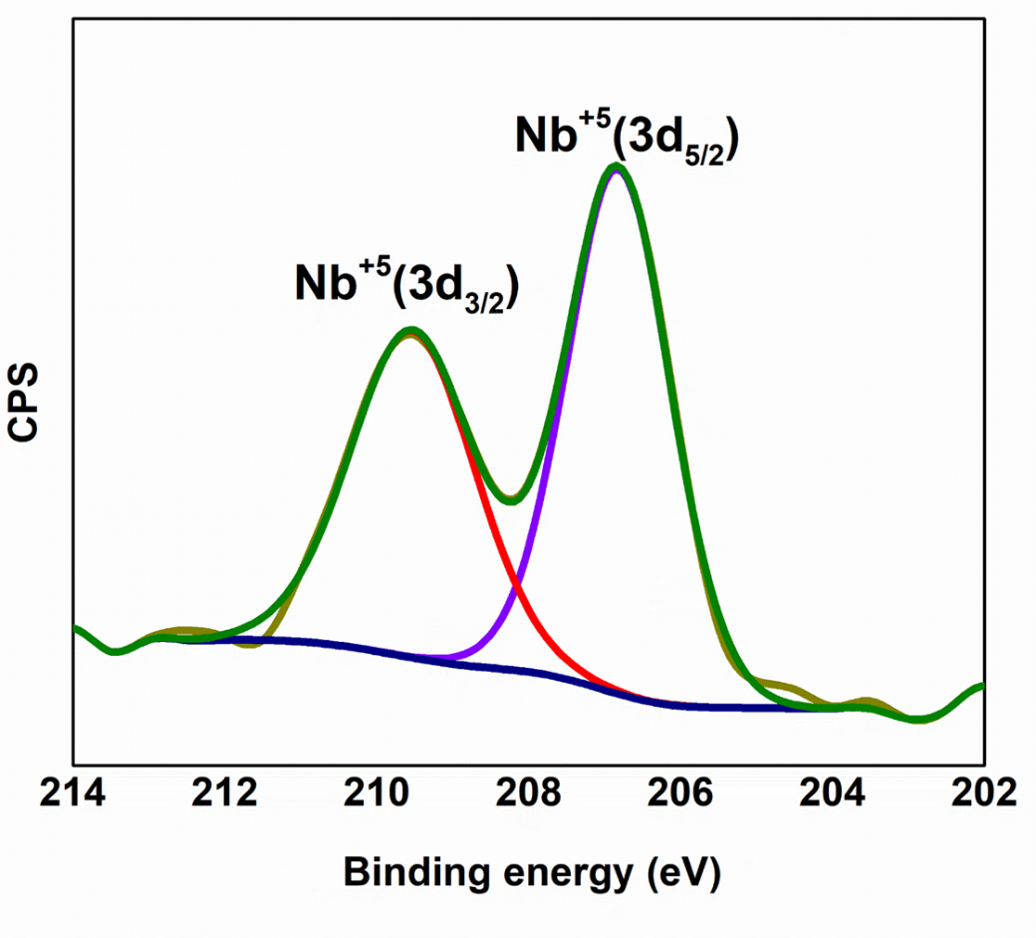
Fig. S5. Deconvoluted spectra of Nb 3d region of Nb/alumina catalyst

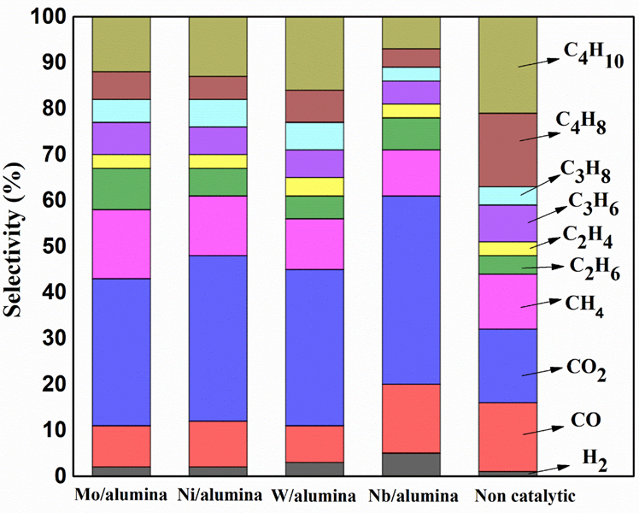
Fig. S6. % Selectivity of products in gas for the hydrothermal liquefaction of 1:3 (PP: PJ) with non-catalytic and Mo/alumina, Ni/alumina, Nb/alumina, and W/alumina catalysts (Catalyst: feed= 1: 50, Temperature= 420 °C, time= 60 min).

