Supplementary Information
Date | Day of report | Same day | 24 hours | 48 hours | 72 hours | 96 hours
14/10/2000 | Saturday | 1.2 | 90.3 | 91.5 | 105.5 | 114.3
30/08/2001 | Thursday | 0 | 21.4 | 21.4 | 21.4 | 21.4
21/09/2001 | Friday | 25.4 | 11.4 | 36.8 | 38.3 | 58.3
07/05/2002 | Tuesday | 2 | 48.5 | 50.5 | 50.5 | 56.9
18/11/2002 | Monday | 15.6 | 0 | 15.6 | 15.9 | 75.8
28/04/2003 | Monday | 26 | 72 | 98 | 98 | 98
02/12/2003 | Tuesday | 45 | 0 | 45 | 45.3 | 51.3
12/12/2003 | Friday | 2.5 | 16 | 18.5 | 36.6 | 40.6
25/11/2004 | Thursday | 53 | 17.5 | 70.5 | 70.7 | 97.1
12/06/2006 | Monday | 2.4 | 0 | 2.4 | 2.4 | 2.5
29/07/2007 | Sunday | 12.5 | 0 | 12.5 | 12.5 | 13.2
17/11/2007 | Saturday | 10.1 | 27 | 37.1 | 72.5 | 80.4
28/03/2008 | Friday | 16.3 | 11.7 | 28 | 105 | 105
31/05/2008 | Saturday | 6.8 | 2.3 | 9.1 | 9.1 | 47.2
04/01/2010 | Monday | 13.2 | 0 | 13.2 | 13.2 | 15.9
09/01/2010 | Saturday | 0 | 0 | 0 | 3.7 | 3.7
22/02/2010 | Monday | 30 | 12.6 | 42.6 | 44.6 | 75.8
09/05/2010 | Sunday | 9.2 | 19.4 | 28.6 | 28.6 | 52
25/10/2010 | Monday | 0 | 5 | 5 | 20 | 27.4
11/04/2011 | Monday | 0 | 0 | 0 | 0 | 18
23/04/2011 | Saturday | 0 | 2 | 2 | 73.2 | 77.5
11/05/2011 | Wednesday | 0 | 10.3 | 10.3 | 10.3 | 16.3
30/05/2011 | Monday | 0 | 0 | 0 | 0.7 | 1.1
28/06/2011 | Tuesday | 44.2 | 0.8 | 45 | 45 | 45.7
09/07/2011 | Saturday | 0 | 0 | 0 | 0 | 0
07/09/2011 | Wednesday | 0.3 | 22.1 | 22.4 | 34 | 42.1
14/09/2011 | Wednesday | 29.2 | 20.4 | 49.6 | 49.6 | 50.2
04/11/2011 | Friday | 16.5 | 0.1 | 16.6 | 16.6 | 16.6
28/11/2011 | Monday | 2.1 | 50.1 | 52.2 | 52.2 | 71.3
20/02/2012 | Monday | 1 | 42.8 | 43.8 | 69.4 | 69.4
25/06/2012 | Monday | 60.7 | 7.8 | 68.5 | 77 | 77
07/02/2013 | Thursday | 35 | 0 | 35 | 35 | 35
09/06/2014 | Monday | 37.7 | 2.6 | 40.3 | 40.4 | 40.6
07/08/2014 | Thursday | 15.8 | 0.9 | 16.7 | 16.7 | 21.2
01/09/2014 | Monday | 0.3 | 48.8 | 49.1 | 50.3 | 118
21/11/2014 | Friday | 0.7 | 56 | 56.7 | 101.2 | 119.2
01/05/2015 | Friday | 0 | 0 | 0 | 0 | 1.8
05/07/2015 | Sunday | 0.2 | 0.2 | 0.4 | 18.2 | 18.5
19/11/2015 | Thursday | 13.2 | 15.4 | 28.6 | 32.3 | 89.3
03/03/2016 | Thursday | 0.7 | 31.5 | 32.2 | 32.2 | 32.2
13/04/2016 | Wednesday | 18.8 | 45.7 | 64.5 | 69.5 | 97.1

Table S1 Media reports of surface water flooding in Kampala for which daily precipitation amounts on the same day as well as previous (24 to 96 hour) totals were available. Italics denote suspected under-reporting of catchment-wide rainfall by the single gauge.

Date | Day of report | Same day | 24 hours | 48 hours | 72 hours | 96 hours
10/04/1988 | Sunday | 7.2 | 6.5 | 13.7 | 29.2 | 46.7
08/04/1996 | Monday | 27.7 | 2.8 | 30.5 | 43.1 | 49.3
04/01/2003 | Saturday | 0 | 27.5 | 27.5 | 30.7 | 30.9
23/10/2006 | Friday | 0.9 | 5.6 | 6.5 | 6.8 | 11.1
29/12/2006 | Wednesday | 80.9 | 3.1 | 84 | 111 | 111.6
01/07/2009 | Wednesday | 2.1 | 0 | 2.1 | 3.9 | 3.9
23/09/2009 | Wednesday | 67.4 | 2 | 69.4 | 103.7 | 106.2
24/08/2011 | Tuesday | 0 | 0 | 0 | 0 | 4.0
02/04/2013 | Wednesday | 0 | 2.4 | 2.4 | 72.4 | 74.6
03/04/2013 | Tuesday | 3.3 | 0 | 3.3 | 5.7 | 77.4
16/04/2013 | Wednesday | 0 | 2 | 2 | 2 | 33.3
26/03/2014 | Friday | 0 | 2.5 | 2.5 | 48.5 | 70.7
03/04/2015 | Monday | 53.1 | 6.3 | 59.4 | 59.4 | 103.7
06/04/2015 | Wednesday | 0.6 | 1.5 | 2.1 | 15.8 | 75.2
08/04/2015 | Tuesday | 11.1 | 3.2 | 14.3 | 14.9 | 30.1
28/04/2015 | Friday | 23.8 | 0.5 | 24.3 | 42.5 | 58.7
29/05/2015 | Tuesday | 0 | 0 | 0 | 7.2 | 64.3
03/11/2015 | Tuesday | 3.7 | 33.5 | 37.2 | 38.2 | 65.7
17/11/2015 | Thursday | 1.5 | 25.1 | 26.6 | 26.6 | 26.6
26/11/2015 | Monday | 7.9 | 0 | 7.9 | 8.4 | 8.4
02/05/2016 | Sunday | 7.8 | 0 | 7.8 | 45.4 | 55.9
08/05/2016 | Monday | 2.5 | 2.5 | 5 | 8.4 | 34.3
09/05/2016 | Wednesday | 62.6 | 2.5 | 65.1 | 67.6 | 95.0

Table S2 As in Table S1 but for Kisumu.

Temporal scaling model | AWS | UNMA | P25* | CP4* | NCEP-SDSM | P25-SDSM | CP4-SDSM
Moments
η | -0.813 | -0.812 | -0.633 | -0.458 | -0.759 | -0.631 | -0.645
Parameters
μ_{d} | 27.131 | 28.020 | 15.384 | 16.419 | 25.877 | 10.190 | 11.604
α | -0.750 | -0.746 | -0.570 | -0.571 | -0.745 | -0.504 | -0.534
σ_{d} | 14.027 | 15.207 | 8.162 | 0.263 | 7.414 | 56.224 | 51.361
β | -0.951 | -1.106 | -0.801 | 0.093 | -0.799 | -1.314 | -1.312
c | 0.333 | 0.333 | 0.333 | 0.333 | 0.333 | 0.333 | 0.333

Table S3 Gumbel and temporal scaling parameters for the moment and parameter scaling methods based on observed and downscaled daily rainfall series for Kampala. Coefficients for SDSM are based on downscaling predictor suite P taken from NCEP, P25, and CP4. All model variants are for d_{u} = 48h. * denotes bias correction of mean annual 1-day maximum using the meteorological station series.

Temporal scaling model | KMD | P25* | CP4* | NCEP-SDSM | P25-SDSM | CP4-SDSM
Moments
η | -0.637 | -0.519 | -0.602 | -0.734 | -0.603 | -0.590
Parameters
μ_{d} | 21.254 | 10.663 | 16.409 | 24.983 | 9.611 | 9.494
α | -0.633 | -0.399 | -0.547 | -0.722 | -0.469 | -0.475
σ_{d} | 9.577 | 111.211 | 7.770 | 6.916 | 74.585 | 43.861
β | -0.805 | -1.718 | -0.770 | -0.765 | -1.407 | -1.251
c | 0.333 | 0.333 | 0.333 | 0.333 | 0.333 | 0.333

Table S4 As in Table S3 but for Kisumu. Note that there are no AWS data for this site.
Figure S1 Distribution of wet-day precipitation amounts (grey bars) greater than 1 mm in Kampala (upper) and Kisumu (lower) compared with the gamma distribution (black line). The full record was used in each case.

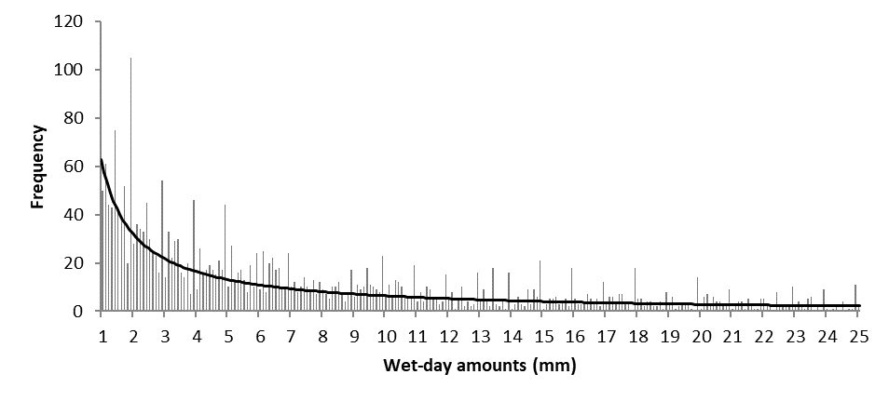
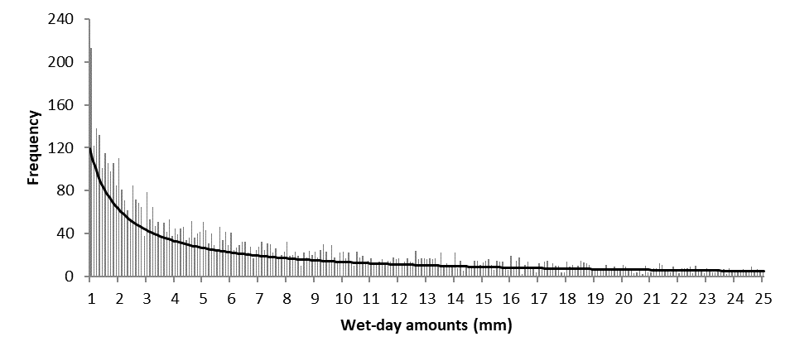

Figure S2 Day of week variations in (a) wet-day frequency as percentage of all days (>0.1 mm/day), (b) mean wet-day rainfall total, (c) frequency of days >30 mm or (d) >60 mm in Kampala (left) and Kisumu (right). The full record was used in each case.

 | Kampala | Kisumu
(a) | 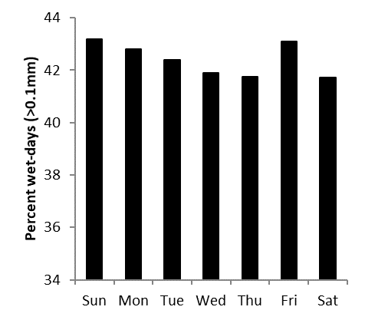 | 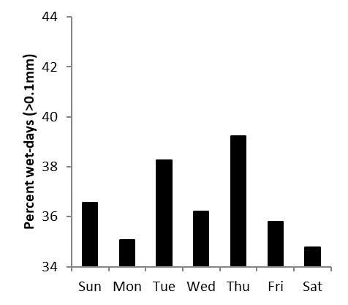
(b) | 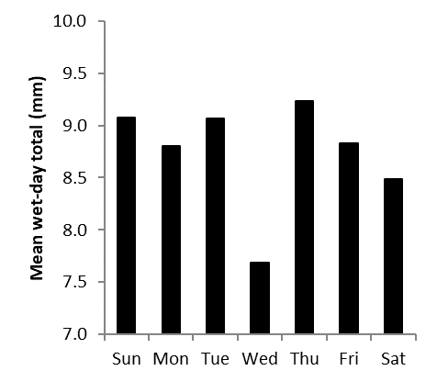 | 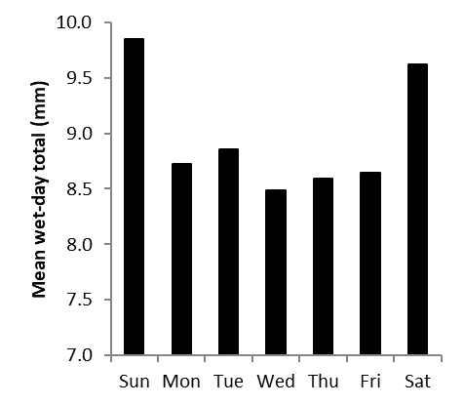
(c) | 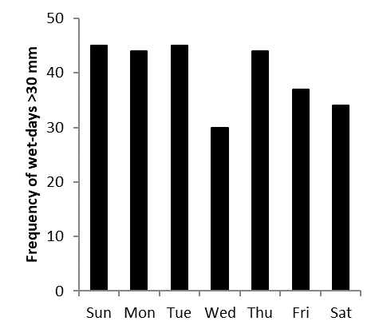 | 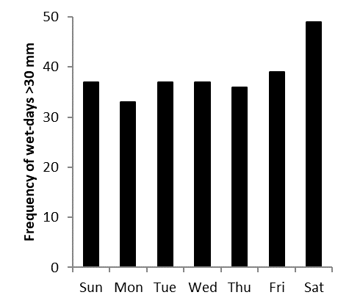
(d) | 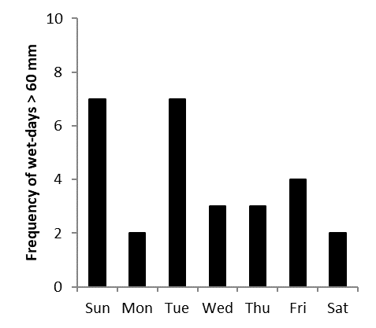 | 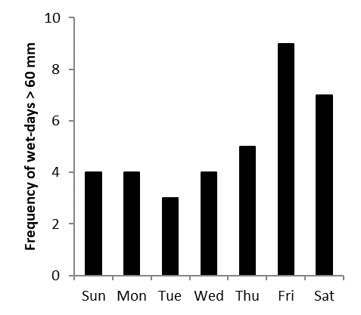

Figure S3 Observed (black) and SDSM (red) daily precipitation diagnostics for Kisumu 1993-2015 produced by predictor suite P. T-bars denote the standard deviation of the SDSM ensemble. The wet-day threshold is 1 mm.
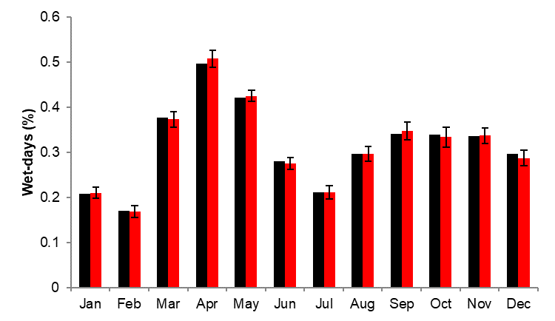 | 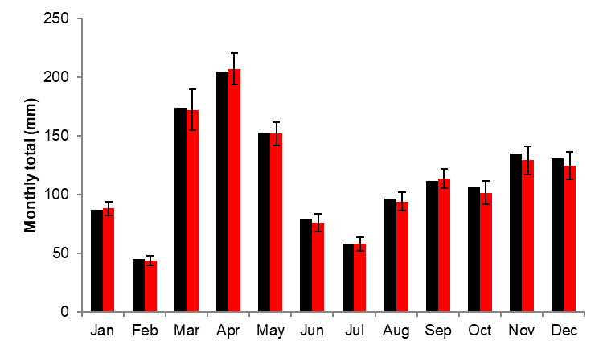
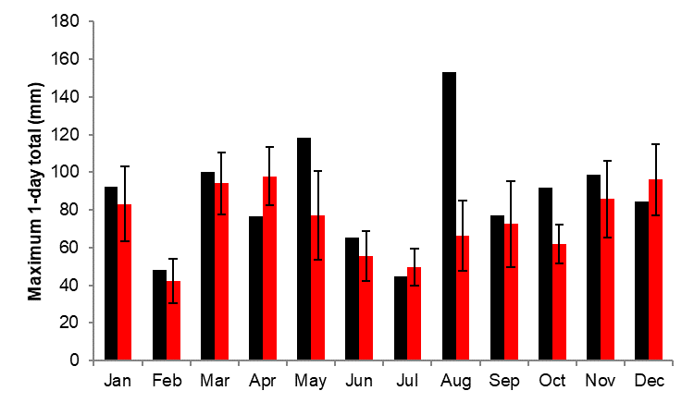 | 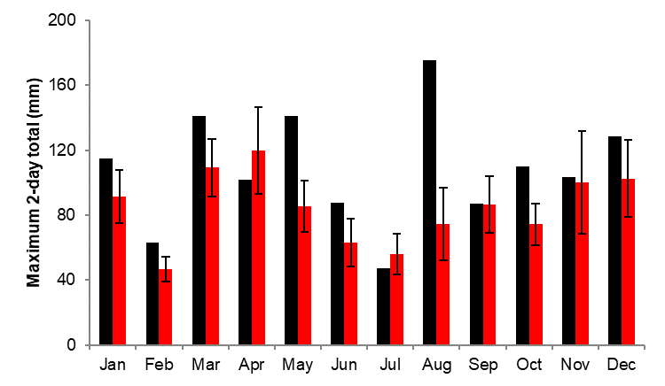

Figure S4 Evidence of multi-scaling of rainfall intensity simulated by CP4 under present (blue) and changed (orange) climate conditions at Kampala over durations of 1h to 96h.
