**ELECTRONIC SUPPLEMENTARY MATERIAL**

**Development of a rapid *in-situ* analysis method using sheath-flow probe electrospray ionisation-mass spectrometry (sfPESI-MS) for the direct identification of cocaine metabolites in dried blood spots**

Ayoung Kima,*, Paul F. Kellya, Matthew A. Turner a and James C. Reynoldsa,*.

a Centre for Analytical Science, Department of Chemistry, Loughborough University, LE11 3TU, UK

* Corresponding author: [a.kim2@lboro.as.uk](mailto:a.kim2@lboro.as.uk) and [j.c.reynolds@lboro.ac.uk](mailto:j.c.reynolds@lboro.ac.uk)

1. **(b) (c)**

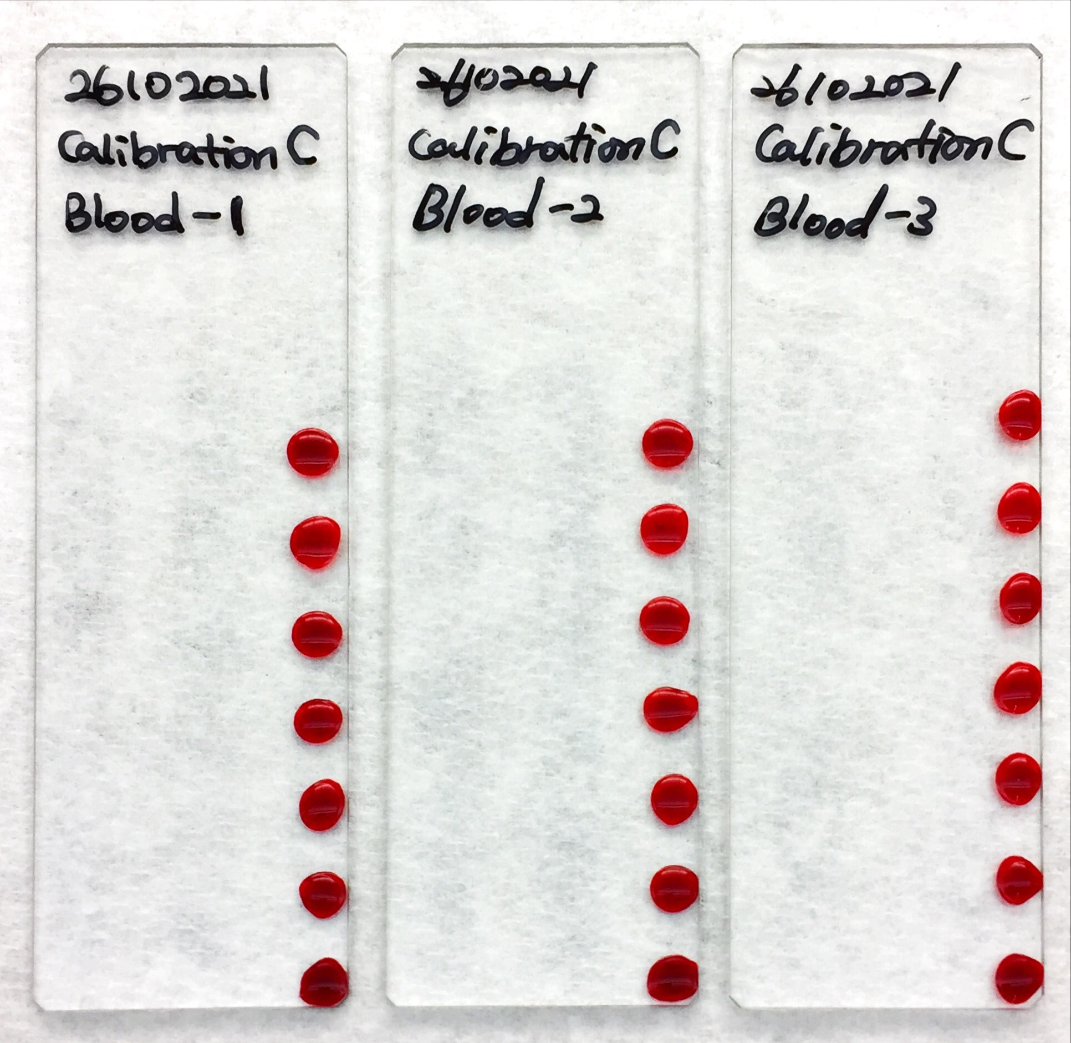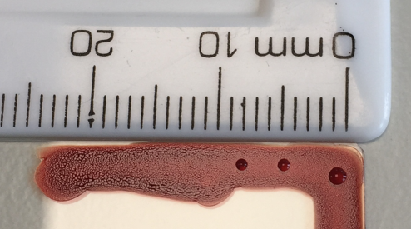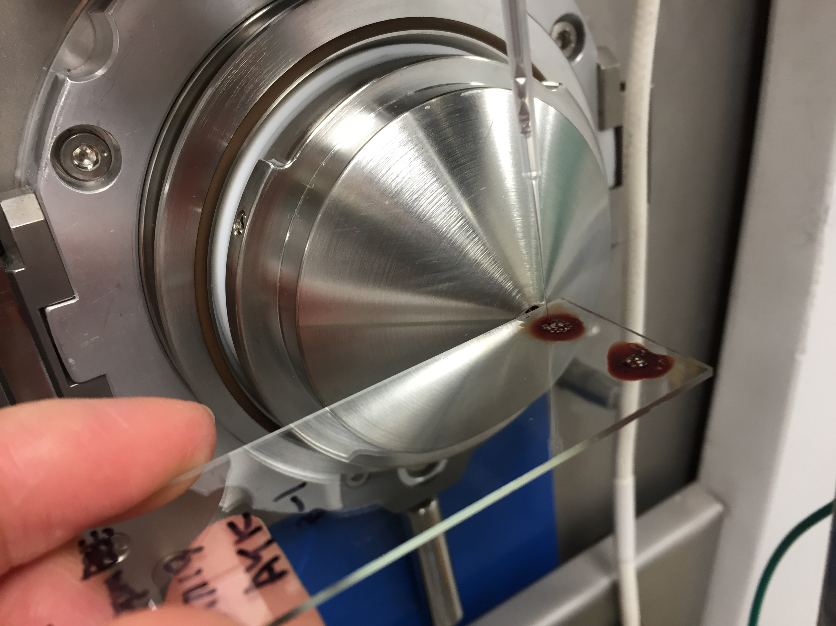

**Figure S1.** Example of blood spots: **(a)** 3 sets of deposited dried blood spots (DBS) to analyse, **(b)** estimation of spatial resolution (0.03 mm2 ≤ area ≤ 0.79 mm2) of the sfPESI probe and **(c)** actual DBS sampling model using a sfPESI probe

**Table S1.** Optimised Parameters of Orbitrap MS

| Parameters | | Values | Units |
| --- | --- | --- | --- |
| Scan  parameters | Scan Mass range | 50 - 450 | a *m/z* |
| Mass Resolution | 25,000 | - |
| Scan Rate (Average) | 2.4 | b scans/sec |
| Polarity | Positive | - |
| Ion source  parameters | Capillary Temperature | 300 | °C |
| Capillary Voltage | 32.5 | c V |
| Tube Lens Voltage | 90.0 | V |
| Skimmer Voltage | 28.0 | V |

a *m/z*: mass-to-charge ratio, b sec: second and c V: volts

**Table S2.** Comparative data showing the effect of extraction solvent chemical modification using 0.1% formic acid on the replicate (n=10) sfPESI-MS analysis of a 5 μg/mL liquid standard solution containing benzoylecgonine (BZE).

|  |  |  |  |  |  |
| --- | --- | --- | --- | --- | --- |
| Molecular Ion Form  of adducted BZE | Target Mass | Mass Spectrum  Intensity (c/s) | Concentration of Formic Acid | | |
| 0 % | 0.1 % | 0.5 % |
| [M+H]+ | *m/z* 290 | M (n= 10) | 1.42.E+05 | 4.37.E+06 | 2.78.E+06 |
| STDEV | 1.12.E+05 | 1.88.E+06 | 1.61.E+06 |
| % RSD | 79 | 43 | 58 |
| [M+Na]+ | *m/z* 312 | M (n= 10) | 4.33.E+05 | 6.74.E+05 | 2.35.E+05 |
| STDEV | 3.11.E+05 | 4.32.E+05 | 1.69.E+05 |
| % RSD | 72 | 64 | 72 |
| [M+K]+ | *m/z* 328 | M (n= 10) | 7.79.E+04 | 1.79.E+05 | 5.84.E+04 |
| STDEV | 6.23.E+04 | 8.48.E+04 | 3.22.E+04 |
| % RSD | 80 | 47 | 55 |

M: mean or average, n: the number of measurements, STDEV: standard deviation and % RSD: relative standard deviation

**Table S3.** Comparative data showing the effect of extraction solvent chemical modification using 0.5 mM sodium acetate on the replicate (n=10) sfPESI-MS analysis of a 5 μg/mL liquid standard solution containing benzoylecgonine (BZE).

|  |  |  |  |  |  |  |  |
| --- | --- | --- | --- | --- | --- | --- | --- |
| Molecular Ion Form  of adducted BZE | | [M+H]+ | | [M+Na]+ | | [M+K]+ | |
| Target Mass | | *m/z* 290 | | *m/z* 312 | | *m/z* 328 | | |
| Concentration of Sodium Acetate | | 0 mM | 0.5 mM | 0 mM | 0.5 mM | 0 mM | 0.5 mM | |
| Mass  Spectrum  Intensity  (c/s) | M (n= 10) | 1.42.E+05 | 1.38.E+04 | 4.33.E+05 | 1.20.E+06 | 7.79.E+04 | 4.45.E+04 | |
| STDEV | 1.12.E+05 | 3.31.E+03 | 3.11.E+05 | 3.84.E+05 | 6.23.E+04 | 1.69.E+04 | |
| % RSD | 79 | 24 | 72 | 32 | 80 | 38 | |

M: mean or average, n: the number of measurements, STDEV: standard deviation and % RSD: relative standard deviation

mM(10-3 mol/L): millimolar (Molar concentration is units of moles of solute per litre of solution)

**Table S4.** Comparative data showing the effect of extraction solvent chemical modification using 0.5 mM sodium acetate and 0.1% formic acid on the replicate (n=10) sfPESI-MS analysis of a 5 μg/mL liquid standard solution containing benzoylecgonine (BZE), ecgonine methyl ester (EME) and cocaethylene (CE).

|  |  |  |  |  |  |  |  |  |  |
| --- | --- | --- | --- | --- | --- | --- | --- | --- | --- |
| Molecular Ion Form | | [BZE+H]+ | | [BZE+Na]+ | | [EME+H]+ | | [CE+H]+ | |
| Target Mass | | *m/z* 290 | | *m/z* 312 | | *m/z* 200 | | *m/z* 318 | | |
| Chemical Modifier | | None | 0.1% FA  0.5mMSA | None | 0.1% FA  0.5mMSA | None | 0.1% FA  0.5mMSA | None | 0.1% FA  0.5mMSA | |
| Mass  Spectrum  Intensity  (c/s) | M (n=10) | 6.21E+05 | 2.07E+06 | 1.23E+05 | 4.09E+05 | 1.57E+06 | 3.54E+06 | 8.54E+05 | 1.88E+06 | |
| STDEV | 5.04E+05 | 6.66E+05 | 8.03E+04 | 1.58E+05 | 8.65E+05 | 1.07E+06 | 8.42E+05 | 6.84E+05 | |
| % RSD | 81 | 32 | 65 | 39 | 55 | 30 | 99 | 36 | |

M: mean or average, n: the number of measurements, STDEV: standard deviation and % RSD: relative standard deviation

mM(10-3 mol/L): millimolar (Molar concentration is units of moles of solute per litre of solution)



**Figure S2.** An Example of calibration obtained for the [M+H]+ ion of cocaethylene (*m/z* 318.17) each data point is calculated from 10 replicate measurements (n=10): LoD = 0.15 μg/mL and R2 = 0.9948.



**Figure S3.** An Example of calibration obtained for the [M+H]+ ion of ecgonine methyl ester (*m/z* 200.13) each data point is calculated from 10 replicate measurements (n=10): LoD = 1.31 μg/mL and R2 = 0.9895.

*The circled point at 1 μg/mL was determined to be below the experimental limit-of-detection as determined by 3σ/m (σ: the standard deviation in the sample response at the lowest sample concentration and m: the slope value of the linear correlation graph).

**Table S5.** Calibration and reproducibility data obtained from replicate dried blood spot analyses (n=10) for ecgonine methyl ester (EME), benzoylecgonine (BZE) and cocaethylene (CE)

|  |  |  |  |  |  |  |  |
| --- | --- | --- | --- | --- | --- | --- | --- |
| Metabolite | Concentration | 0 µg/mL | 0.5 µg/mL | 1 µg/mL | 2 µg/mL | 5 µg/mL | 10 µg/mL |
| EME  *m/z* 200.13 | M (n=10) | 0 | 7.33E+03 | 1.26E+04 | 1.55E+04 | 4.46E+04 | 7.05E+04 |
| STDEV | 0 | 0.00E+00 | 3.36E+03 | 1.91E+03 | 1.31E+04 | 1.05E+04 |
| % RSD | 0 | 0 | 27 | 12 | 29 | 15 |
| BZE  *m/z* 290.14 | M (n=10) | 0 | 7.24E+03 | 1.35E+04 | 3.02E+04 | 6.97E+04 | 1.46E+05 |
| STDEV | 0 | 1.36E+03 | 3.81E+03 | 8.40E+03 | 1.34E+04 | 2.67E+04 |
| % RSD | 0 | 19 | 28 | 28 | 19 | 18 |
| CE  *m/z* 318.17 | M (n=10) | 0 | 4.03E+04 | 1.00E+05 | 2.05E+05 | 5.50E+05 | 9.78E+05 |
| STDEV | 0 | 5.31E+03 | 1.56E+04 | 3.35E+04 | 1.17E+05 | 1.83E+05 |
| % RSD | 0 | 13 | 16 | 16 | 21 | 19 |

M: mean or average, n: the number of measurements, STDEV: standard deviation and % RSD: relative standard deviation