**Studies on Anode Mass Composition and Cathode Flow Field Design for Small-Scale to Large-Scale Direct Methanol Fuel Cell Stack Systems**

Thanarajan Kumaresan,1 Karthikeyan Palaniswamy,1,a) Ashley Fly,2 and Senthilarasu Sundaram3,

1Fuel Cells and Energy Systems Laboratory, Department of Automobile Engineering, PSG College of Technology, Coimbatore-641004, India

2Department of Aeronautical and Automotive Engineering, Loughborough University, Loughborough-LE11 3TT, United Kingdom

3Department of Electrical and Electronics Engineering, School of Engineering and the Built Environment, Edinburgh Napier University, Merchiston Campus, Edinburgh EH10 5DT UK

a)Corresponding Author E-mail address: [apk.auto@psgtech.ac.in](mailto:apk.auto@psgtech.ac.in)

**Material Synthesis Procedure:**

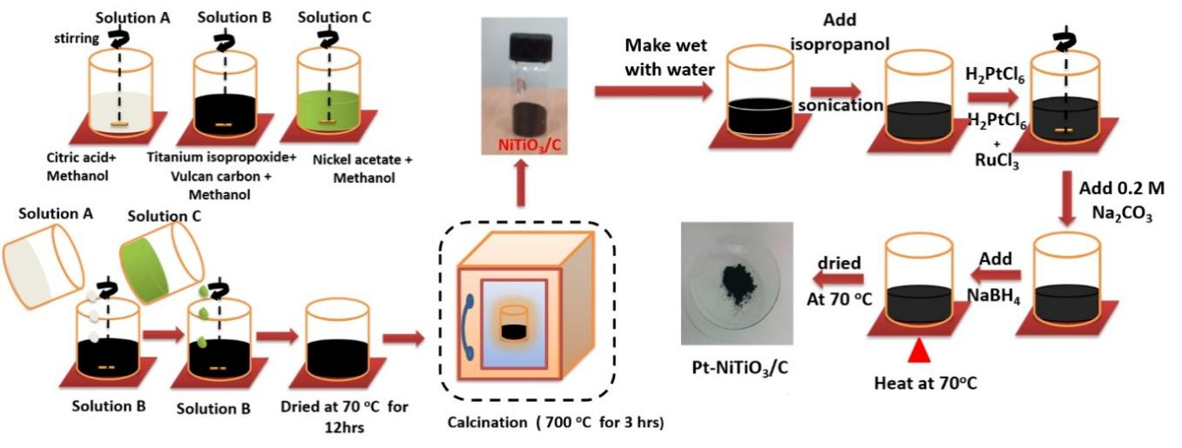

**FIG. S1.** Schematic depiction for the preparation of Pt-NiTiO3/C

**E-Dax Pattern for Mass Composition**

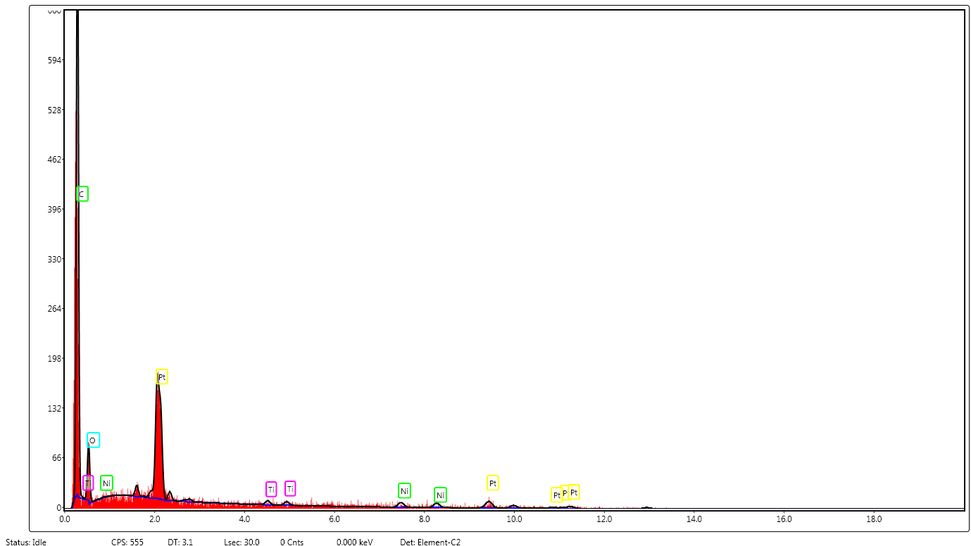

**FIG. S2.** EDX analysis of PtNiTiO3/C electrocatalyst

**TABLE S1.** Material composition of PtNiTiO3/C electrocatalyst from EDX analysis

|  |  |  |  |  |  |
| --- | --- | --- | --- | --- | --- |
| **Wt. % of Material Composition** | **Weight percentage of Elements** | | | | |
| **Carbon** | **Oxygen** | **Platinum** | **Nickel** | **Titanate** |
| 20 % Pt on Pt-NiTiO3/C | 64.08 | 11.09 | 16.5 | 3.11 | 5.23 |
| 40 % Pt on Pt-NiTiO3/C | 42.56 | 12.5 | 36.89 | 2.89 | 5.17 |
| 60 % Pt on Pt-NiTiO3/C | 27.3 | 11.93 | 52.4 | 3.33 | 5.05 |

The materials that are accessible for the catalyst powder are depicted in Fig. S2. The availability of platinum, nickel, titanite, oxides, and carbon were clearly demonstrated by the peaks on the graph, which can be seen in the picture. According to Table S1, the mass of each material present in the catalyst powder was calculated. The first composition contained 20 % platinum, 20 % NITiO3, and 60 % carbon. The second composition contained 40 % platinum, 20 % NITiO3, and 40 % carbon. In accordance with the proportion of available platinum mass composition availability, this composition was calculated to contain 20 % platinum, while the other compositions were calculated to include 40 and 60 % platinum, respectively.

**X-ray Diffraction Pattern**

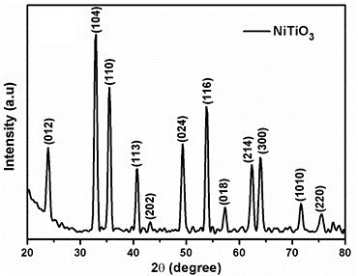

**FIG. S3.** XRD patterns of NiTiO3

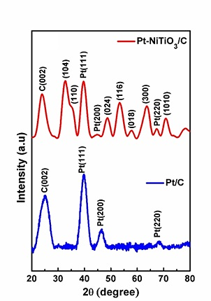

**FIG. S4.** XRD patterns of Pt/C and PtNiTiO3/C electrocatalyst

The peaks of the X-ray diffraction pattern reported in Fig. S3. confirms the presence of the rhombohedral phase of NiTiO3; these identified data points are consistent with the database (JCPDS ID 33-0960).

Diffraction patterns of the Pt-NiTiO3/C and the Pt/C catalysts as showcased in Fig. S4. identifies broad peaks of carbon (002) at 2θ = ${25}^{0}$; wide-span of these peaks indicates an increase of the crystal size of the prepared oxide when supported on the vulcan carbon. The three diffraction peaks at about 2θ = ${40}^{0}$, ${46.5}^{0}$ and ${68.1}^{0}$, corresponds to the Pt crystal planes (111), (200), (220) and this is a characteristic of a Face Centred Cube (Pt) (JCPDS ID 04-802) which is conformed. This exhibition is an effect of reduction in the size of Pt to nano-ranges because of the existing NiTiO3/C. The size of these crystals calculated from the Debye-Scherrer formula, and it estimates an average size of 2.5 and 4.6 nm correspondingly for Pt/C and Pt/ NiTiO3/C.

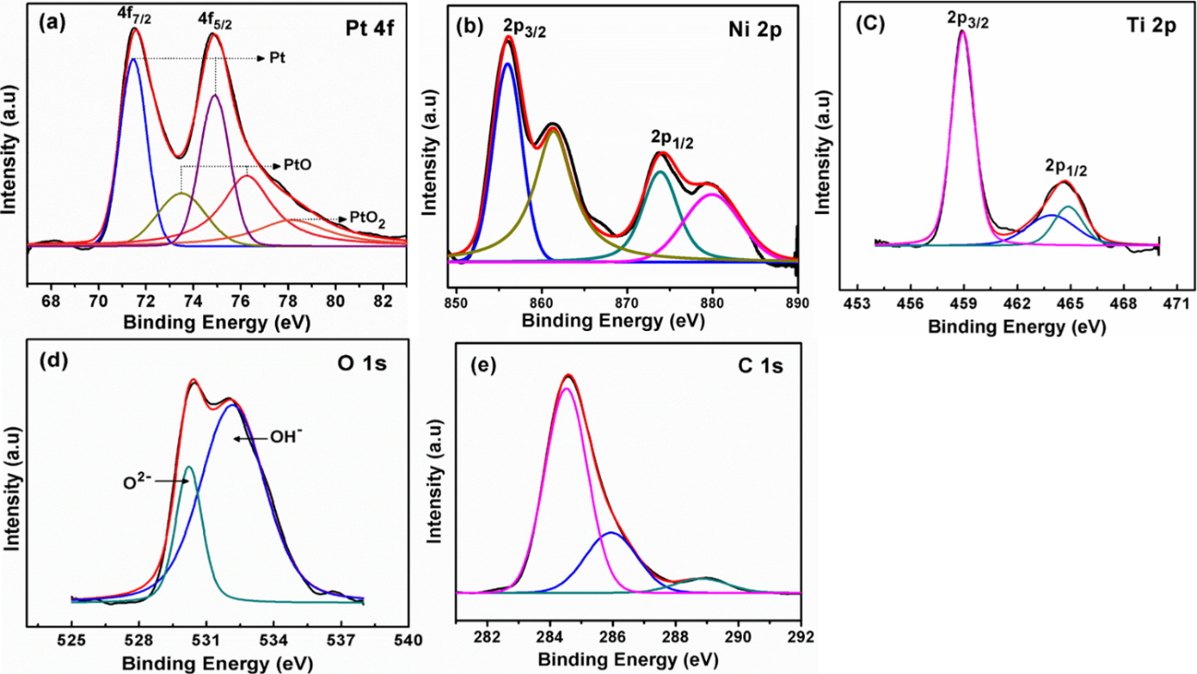

**FIG. S5.** Core XPS spectra of (a) Pt 4f (b) Ni 2p (c) Ti 2p (d) O 1s (e) C 1s in Pt-NiTiO3/C.

X-ray photoelectron spectroscopy (XPS) analysis was undertaken to investigate the material composition in the catalyst surface, and derive conclusions about the potential behaviour of the cell. FIG. S5. [a-e] illustrates the core XP Spectra of the definite chemical elements (Pt, Ni, Ti, O, C) in the catalyst - Pt-NiTiO3/C.

Following conclusions were made,

1. Pt (0) species is predominant along with oxides of Pt (composition) that are present in the surface.
2. NiTiO3 is formed as an ilmenite structure, as Ni and Ti are present in octahedral sites bonded to 6 oxygen atoms.
3. O2- and OH- species are present in the catalyst surface.
4. C-C bonds are identified by the peak at 284.8 eV; two subsequent peaks can correspond to C-O and O-C=O, they are weak peaks because of the less bond strength in the latter.

This illustrates a possibility that NiTiO3 will supply a larger quantity of active oxygen atoms to the nearest Pt nano-particles and promote MOR activity by accelerating the electro-oxidation on the surface of Pt according to the bi-functional mechanism as described in equations (1) and (2).

NiTiO3 + H2O → NiTiO3-x (OH) + H+ + e- (1)

Pt–COads + NiTiO3-x (OH) → Pt + NiTiO3-x+ CO2 + H+ + e- (2)

**Flow Distribution Analysis of Three Stack**



**Fig. S6.** (a) Velocity plot (b) Pressure plot of three cell stack

The velocity of cathode flow field was analyzed numerically on the three cells assembled in series and the results were shown in Fig. S6 (a). In this study the flow path was only considered for numerical analysis. From the results, it is confirmed that the velocity in each flow channel was evenly distributed. This minor difference in velocity will result in a pressure differential, allowing for improved inter-channel diffusion of the reactants. Bends in the flow channel will amplify this effect. In flow fields where the flow velocity is low, there is less degradation of the catalyst.1 The velocity profile was examined in order to comprehend the fluid's dynamics as a result of bends. In a sinuous flow field with two inlets/outlets of 100 cm2 active areas, the deviation in normalized velocity of each channel is comparable to that of a 25 cm2 active area.2 The inclination and velocity gradients enhance water transportation from the entrance to the exit, resulting in reduced water collection in the flow channels. The combined effects of gradient and syphoning reduce water lodging in channels and land area, respectively.

The pressure at the cathode flow channels was shown in Fig. S6 (b). Due to the shorter distance between inlet and outlet, the pressure loss in the sinuous flow field is typically low when compared with the serpentine flow field. This shows that the flow is more consistent, resulting in even distribution over the GDL and also which helps to increase the reactant consumption. From our previous studies, more than four bends were not taken into account in this study since they would result reduction in pressure.

Hence the nominal velocity drop with respect to the pressure drop was found in cathode flow channels for three cells. From this study, it is proved that the flow channels with two inlets and outlets was good for cathode in 3-cell stack.

**References**

1 M. Mayur, M. Gerard, P. Schott, and W.G. Bessler, Energies **11**, (2018).

2 M. kannan V, Design and Development of High Performance Scaled up Pem Fuel Cell by Flow Channel Modifications, Anna University, 2020.