Supporting Information
A light-management film layer induces dramatically enhanced acetate production in photo-assisted microbial electrosynthesis systems
Weifeng Kong¹, Liping Huang^{1,*}, Xue Quan¹, Gianluca Li Puma^{2,*}
1. Key Laboratory of Industrial Ecology and Environmental Engineering, Ministry of Education (MOE), School of Environmental Science and Technology, Dalian University of Technology, Dalian 116024, China
College of Chemistry, Dalian University of Technology, Dalian 116024, China
2. Environmental Nanocatalysis & Photoreaction Engineering, Department of Chemical Engineering, Loughborough University, Loughborough, LE11 3TU, United Kingdom

lipinghuang@dlut.edu.cn (Huang L.)
g.lipuma@lboro.ac.uk (G. Li-Puma)

Pages: 13
Tables: 3
Figures: 17
S2 Materials and methods
S2.1 Synthesis of MnFe₂O₄/AZO and MnFe₂O₄/ g-C₃N₄/AZO photocathodes
Pure g-C₃N₄ was synthesized by heating melamine (99.8%) at 550 °C for 2 h in muffle furnace. This g-C₃N₄ was added into 50 mL deionized water and ultrasonicated for 1 h. 0.132 g MnCl₂⋅4H₂O, 0.301 g FeCl₃.6H₂O and 0.164 g urea were dissolved into the above solution with 0.5 h magnetic stirring. Then the pH was adjusted to 12 using 5 M NaOH while stirring further for 1 h. After that, the solution was transferred to a 100 mL Teflon autoclave, heated at 200 °C for 8 h to prepare the MnFe₂O₄/g-C₃N₄ photocatalyst. The as-prepared photocatalyst was added into the aged sol with a molar ratio at 1:3 and ultrasonicated for 1 h, dried at 80 °C for 12 h. Thereafter, the mixture was finally annealed at 400 ℃ for 1 h to obtain MnFe₂O₄/g-C₃N₄/AZO in powder form.
1.5 g of the MnFe₂O₄/g-C₃N₄/AZO powder was dispersed in 1 L deionized water and ultrasonicated for 10 h. The supernatant was attained by centrifuging the above suspension for 10 min at 5000 r/min, and then 2.0 × 2.0 × 0.25 cm graphite felts (Sanye Co., Beijing, China) were immersed in the supernatant overnight and dried at 60 ℃ for 12 h to obtain the MnFe₂O₄/g-C₃N₄/AZO cathodes. Finally, the cathodes were calcined at 300 °C for 2 h in muffle furnace with a heating rate of 2 °C /min. The MnFe₂O₄/AZO cathode was fabricated by the same procedures except the addition of g-C₃N_{4.}

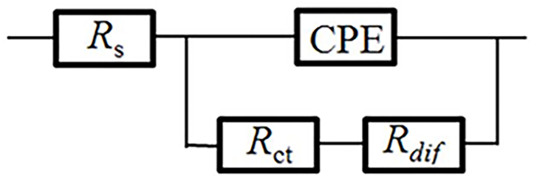
R_{s}: A series resistance for ohmic transport in the electrolyte and other contact effects;
R_{ct}: charge transfer resistance;
R_{dif}: diffusion resistance;
CPE: constant phase elecment.

Fig. S1 Equivalent circuits of the EIS Nyquist plots.

Fig. S2 Radiation spectrum of the lamp.

Fig. S3 The schematic diagram of the photo-assisted MES.

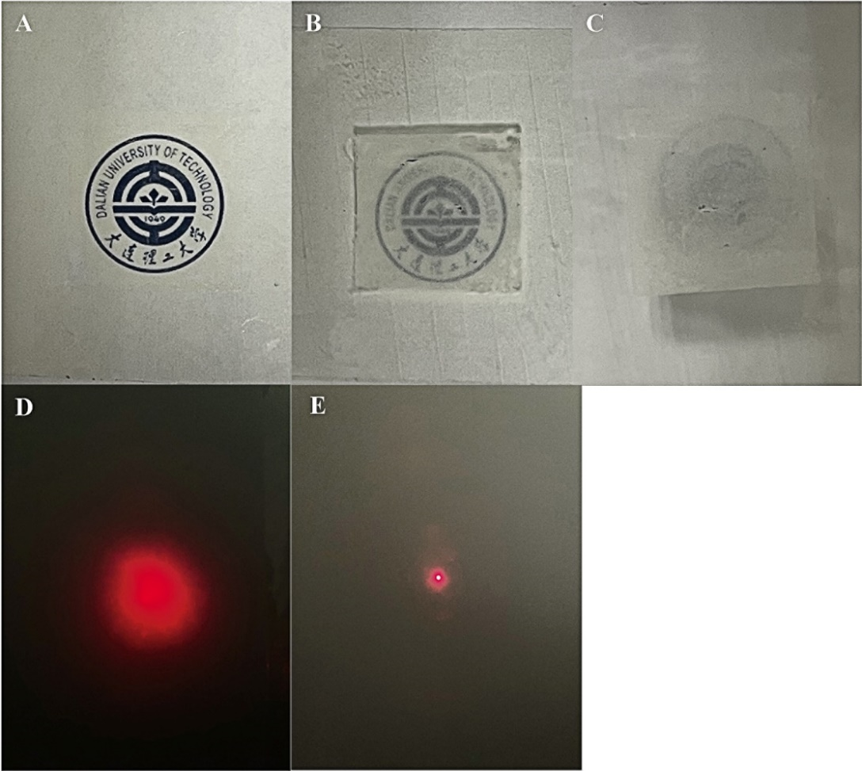
Fig. S4 Photographs show the printed image as seen through the AZO film, while the film is placed apart from the image by a distance of 0 cm (A), 1 cm (B), and 3 cm (C). Visual images of light scattering effect by a red laser for the AZO film (D) and glass substrate (E).

Fig. S5 Mott-Schottky plots of g-C₃N₄/AZO (A), AZO (B) and g-C₃N₄ (C).

Fig. S6 Photoluminescence spectra under 400 nm excitation of various photocatalysts.
Fig. S7 The schematic diagram of transient photocurrent response and light reflecting behaviors of g-C₃N₄/AZO (A), AZO (B) and g-C₃N₄ (C) by UV-vis incident light with different incident angles.

Fig. S8 Element mapping images of g-C₃N₄/AZO.

Fig. S9 Flow cytometry analysis of live/dead electrotrophs on the photocathodes of g-C₃N₄/AZO (A), AZO (B) and g-C₃N₄ (C). The controls of electrotrophs without propidium iodide staining (D).

Fig. S10 High resolution XPS spectra of g-C₃N₄/AZO, AZO or g-C₃N₄.

Fig. S11 Acetate production (A), residual H₂ (B), CE_{acetate} (C) and inorganic carbon consumption (D) for g-C₃N₄/AZO at different ratios.

Fig. S12 Acetate production (A), residual H₂ (B), CE_{acetate} (C) and inorganic carbon consumption (D) for g-C₃N₄/AZO at different dip-coating cycles.

Fig. S13 Acetate production (A), residual H₂ (B), CE_{acetate} (C) and inorganic carbon consumption (D) for g-C₃N₄/AZO with different OD₆₀₀.

Fig. S14 Acetate production (A), residual H₂ (B), CE_{acetate} (C) and solar-to-acetate efficiency (D) of various photocathodes at different cathode potentials with 400 nm UV-cut filters.

Fig. S15 Time course of acetate production (A), residual H₂ (B), CE_{acetate} (C), inorganic carbon consumption (D) and Nyquist plots of EIS spectra (E and F) for different cathodes (operational time: 2.5 d).

Fig. S16 Nyquist plots of EIS spectra (A) and residual inorganic carbon (B) for different cathodes over a 12 day operation with periodical addition of bicarbonate. SEM image (C) and EDS spectrum (D) of g-C₃N₄/AZO bio-photocathode at the end of the 12 days operation.

Fig. S17 XRD patterns of the g-C₃N₄/AZO photocathode before and after DPV.

Table S1 EIS parameters obtained from Nyquist plots and DPV data of various cathodes.
 |  |  | EIS |  |  |  |  |  |  |  |  |  | DPV
 |  |  | R_{s} (Ω) |  | R_{ct} (Ω) |  | R_{dif} (Ω) |  |  |  |  |  | E_{p-acetate} (V) |  | I_{p-acetate} (mA) |  | E_{p-cytochrome c} (V) |  | I_{p-cytochrome c} (mA)
g-C₃N₄/AZO |  |  |  | 12.1 |  | 48 |  | 36.6 |  |  |  |  |  | -0.51 |  | -2.57 |  | 0.028 |  | -0.76
g-C₃N₄/AZO-filter |  |  |  | 12.1 |  | 70 |  | 36.8 |  |  |  |  |  | -0.53 |  | -2.12 |  | 0.026 |  | -0.62
g-C₃N₄/AZO-no light |  |  |  | 12.6 |  | 76 |  | 37.2 |  |  |  |  |  | -0.60 |  | -1.92 |  | 0.012 |  | -0.50
g-C₃N₄/AZO-abiotic |  |  |  | 11.3 |  | 88 |  | 37.5 |  |  |  |  |  | --- |  | --- |  | --- |  | ---
AZO |  |  |  | 11.8 |  | 94 |  | 36.4 |  |  |  |  |  | -0.55 |  | -1.63 |  | 0.024 |  | -0.52
g-C₃N₄-filter |  |  |  | 13.5 |  | 104 |  | 37.1 |  |  |  |  |  | -0.55 |  | -1.58 |  | 0.022 |  | -0.48
Bare glass |  |  |  | 10.3 |  | 153 |  | 38.5 |  |  |  |  |  | -0.56 |  | -0.93 |  | 0.020 |  | -0.35

Table S2 Comparison of EIS parameters obtained from Nyquist plots as a function of operational time.
 | R_{s} (Ω) | R_{ct} (Ω) | R_{dif} (Ω)
g-C₃N₄/AZO-0.5 d | 12.2 | 49 | 37
g-C₃N₄/AZO-1.0 d | 12.2 | 49 | 50
g-C₃N₄/AZO-1.5 d | 12.3 | 49 | 928
g-C₃N₄/AZO-2.0 d | 12.3 | 49 | 1248
g-C₃N₄/AZO-2.5 d | 12.4 | 50 | 2034
g-C₃N₄/AZO-filter-0.5 d | 12.1 | 70 | 37
g-C₃N₄/AZO-filter-1.5 d | 12.3 | 71 | 64
g-C₃N₄/AZO-no light-0.5 d | 12.7 | 76 | 37
g-C₃N₄/AZO-no light-1.5 d | 12.7 | 76 | 51
AZO-0.5d | 11.8 | 94 | 37
AZO-1.5d | 11.9 | 95 | 47
g-C₃N₄-filter-0.5d | 13.5 | 109 | 38
g-C₃N₄-filter-1.5d | 13.6 | 120 | 44
Bare glass-0.5d | 10.4 | 153 | 39
Bare glass-1.5d | 10.5 | 153 | 41

Table S3 Comparison of EIS parameters obtained from Nyquist plots of different cathodes with interval supplementary bicarbonate.
 | R_{s} (Ω) | R_{ct} (Ω) | R_{dif} (Ω)
g-C₃N₄/AZO-0.5 d | 12.2 | 49 | 37
g-C₃N₄/AZO-6 d | 12.5 | 49 | 39
g-C₃N₄/AZO-12 d | 12.7 | 50 | 38
g-C₃N₄/AZO-filter-0.5 d | 12.1 | 70 | 37
g-C₃N₄/AZO-filter-6 d | 12.5 | 71 | 39
g-C₃N₄/AZO-filter-12 d | 12.8 | 72 | 38
g-C₃N₄/AZO-no light-0.5 d | 12.7 | 76 | 37
g-C₃N₄/AZO-no light-6 d | 12.8 | 77 | 37
g-C₃N₄/AZO-no light-12 d | 12.9 | 77 | 38
AZO-0.5d | 11.8 | 94 | 37
AZO-6 d | 12.0 | 96 | 38
AZO-12 d | 12.4 | 96 | 37
g-C₃N₄-filter-0.5d | 13.5 | 109 | 38
g-C₃N₄-filter-6 d | 13.6 | 131 | 38
g-C₃N₄-filter-12 d | 13.2 | 142 | 37
Bare glass-0.5d | 10.4 | 153 | 39
Bare glass-6 d | 11.0 | 153 | 37
Bare glass-12 d | 11.3 | 154 | 38

