Supplementary Information

Table 1 The curing parameters and calculated optimum exposure times for all mixtures.
Binder |  | Layer Thickness | Curing Parameters |  |  | Exposure Time
Type of Mixture |  | C_{d} | D_{p} | E_{C} |  | Calculated | Applied
 |  | [μm] | [µm] | [mJ cm⁻²] |  | [ms] | [ms]
Binder Mixtures
B-37 at 25,35,45 and 55 °C |  | 50 | 183.1 | 503.3 |  | 20504 | 26000
B-42 at 25,35,45 and 55 °C |  | 50 | 184.4 | 491.3 |  | 12503 | 16000
Ceramic Suspensions
B-37 loaded with 61.2 vol.% of EB01 at 25,35,45 and 55 °C |  | 50 | 49.8 | 95.6 |  | 18473 | 28000
 |  | 100 | 49.8 | 95.6 |  | 50265 | 75000
B-42 loaded with 61.2 vol.% of EB01 at 25,35,45 and 55 °C |  | 50 | 56.6 | 107.4 |  | 16119 | 25000
 |  | 100 | 56.6 | 107.4 |  | 38000 | 58000

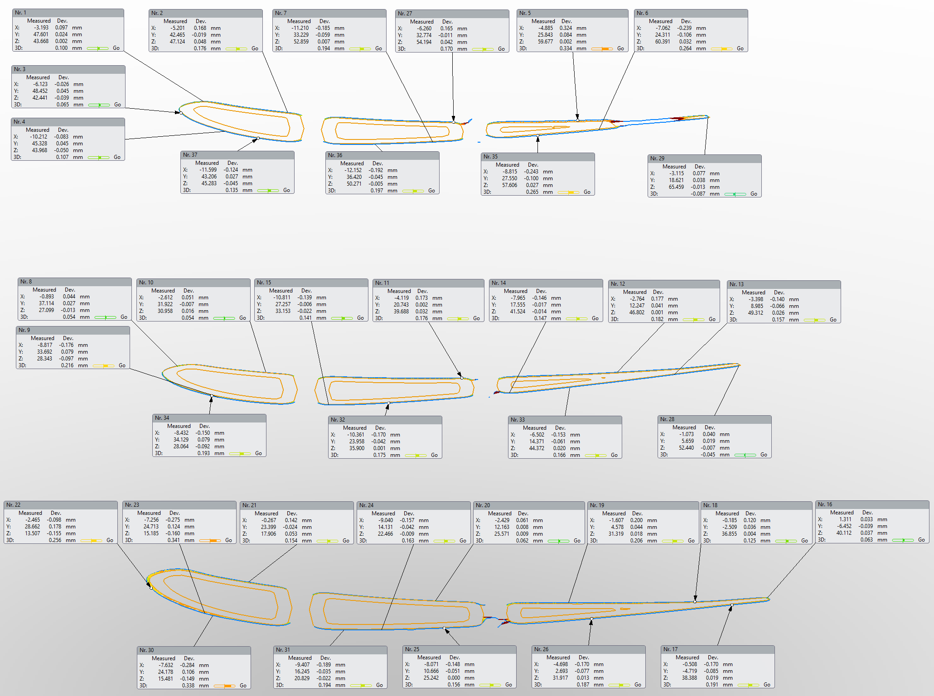
Figure 1 The comparison of the bottom, middle and top cross-sections and the dimensional accuracy of randomly selected points in these cross-sections

