Supplementary Material
Hydrogen technology adoption analysis in Africa using a Doughnut-PESTLE hydrogen model (DPHM)
Mulako Dean Mukelabai^{a*}, Upul Wijayantha^{b,c}, Richard E. Blanchardª
ªCentre for Renewable Energy Systems Technology (CREST), Wolfson School of Mechanical, Electrical, and Manufacturing Engineering, Loughborough University, Epinal Way, Loughborough, Leicestershire, LE11 3TU, UK
^{b}Centre for Renewable Energy Systems, Cranfield University, College Road, Cranfield, MK43 0AL
^{c}Wolfson School of Mechanical, Electrical, and Manufacturing Engineering, Loughborough University, Epinal Way, Loughborough, Leicestershire, LE11 3TU, UK

Cite this as: Mukelabai et al., Hydrogen technology adoption analysis in Africa using a Doughnut-PESTLE hydrogen model (DPHM), International Journal of Hydrogen Energy, https://doi.org/10.1016/j.ijhydene.2022.07.076

The PESTLE aspect of the model was validated by analyzing the same indicators in countries located in South Asia, East Asia, and the Pacific region. The region was selected because it has a perfect mix of advanced and developing countries. Most importantly, advanced countries such as Japan and South Korea are well-known global leaders in the hydrogen economy. Therefore, the PESTLE landscape in this region can be directly translated into the PESTLE landscape in regions such as Africa and South America.
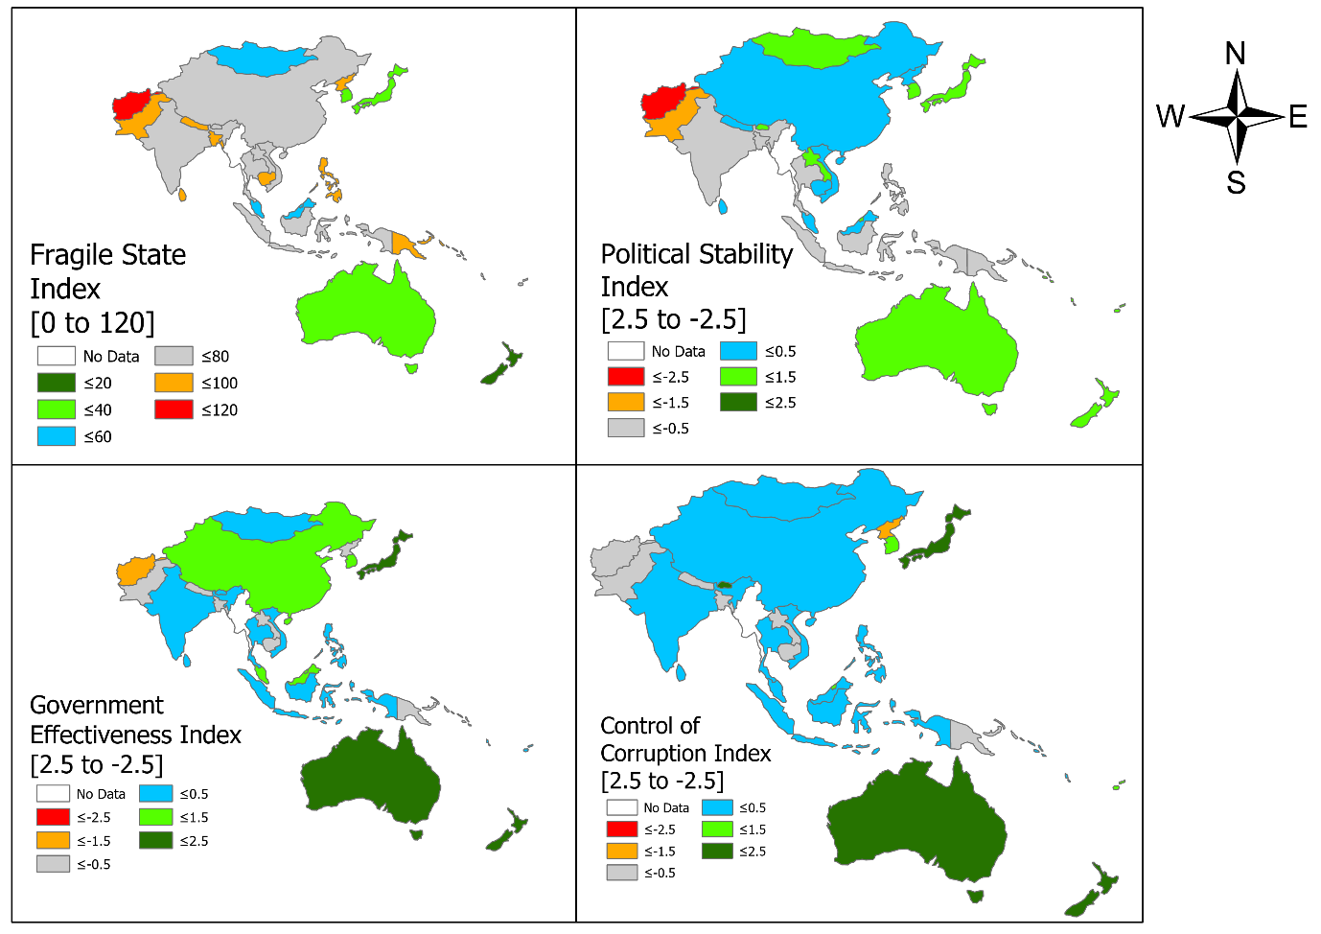
Figure S 1 South, East Asia, and Pacific political indicators
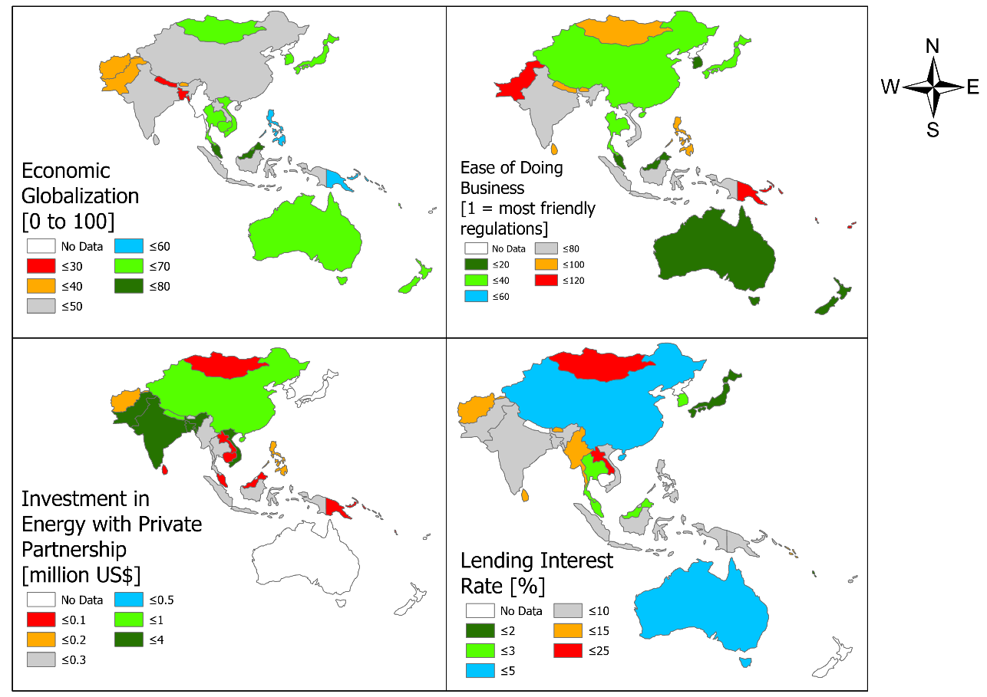
Figure S 2 South, East Asia, and Pacific economic indicators
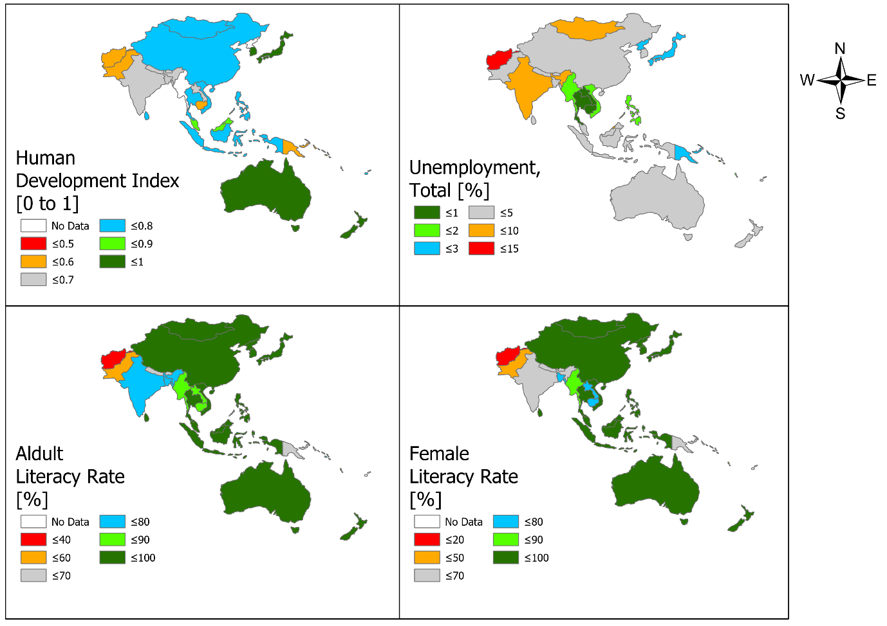
Figure S 3 South, East Asia, and Pacific social indicators
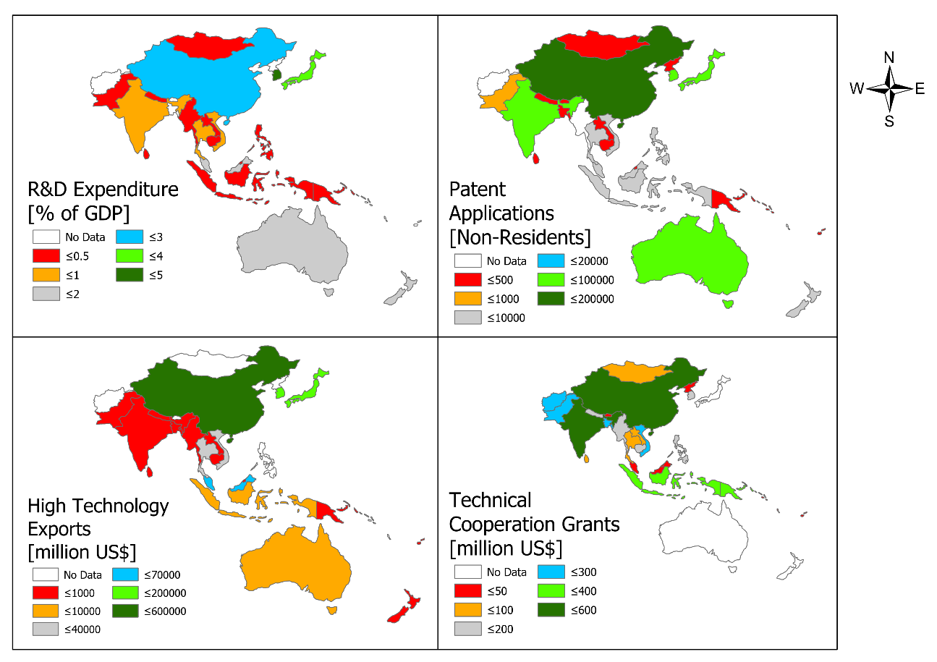
Figure S 4 South, East Asia, and Pacific technological indicators
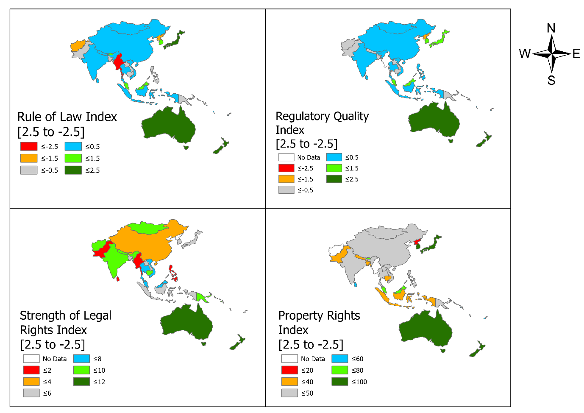
Figure S 5 South, East Asia, and Pacific legal indicators
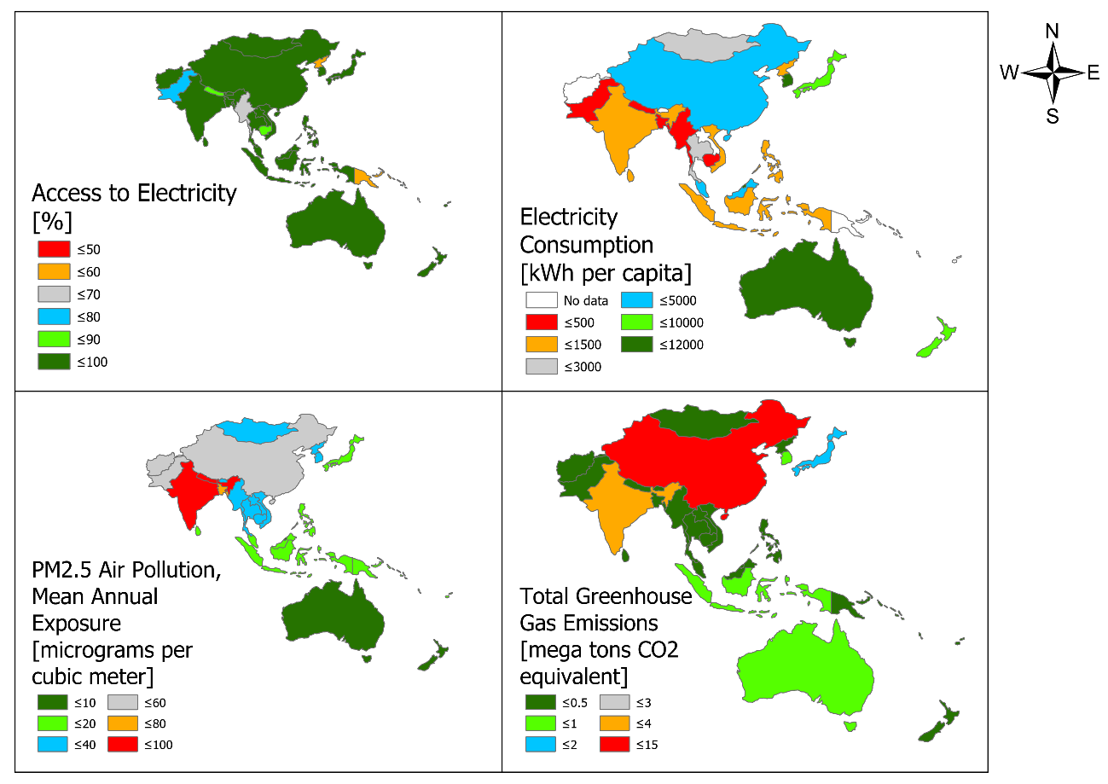
Figure S 6 South, East Asia, and Pacific environmental indicators
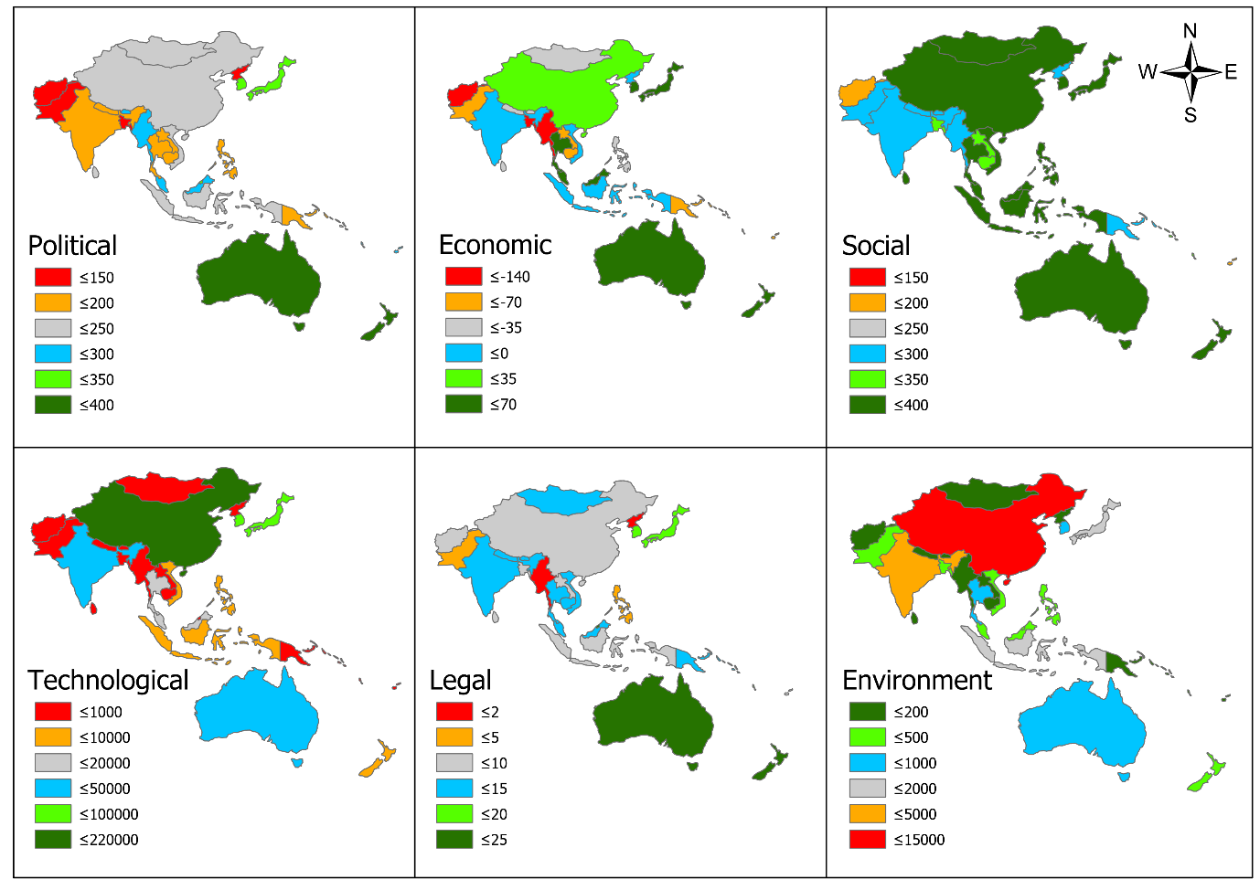
Figure S 7 South, East Asia, and Pacific overlayed PESTLE indicators
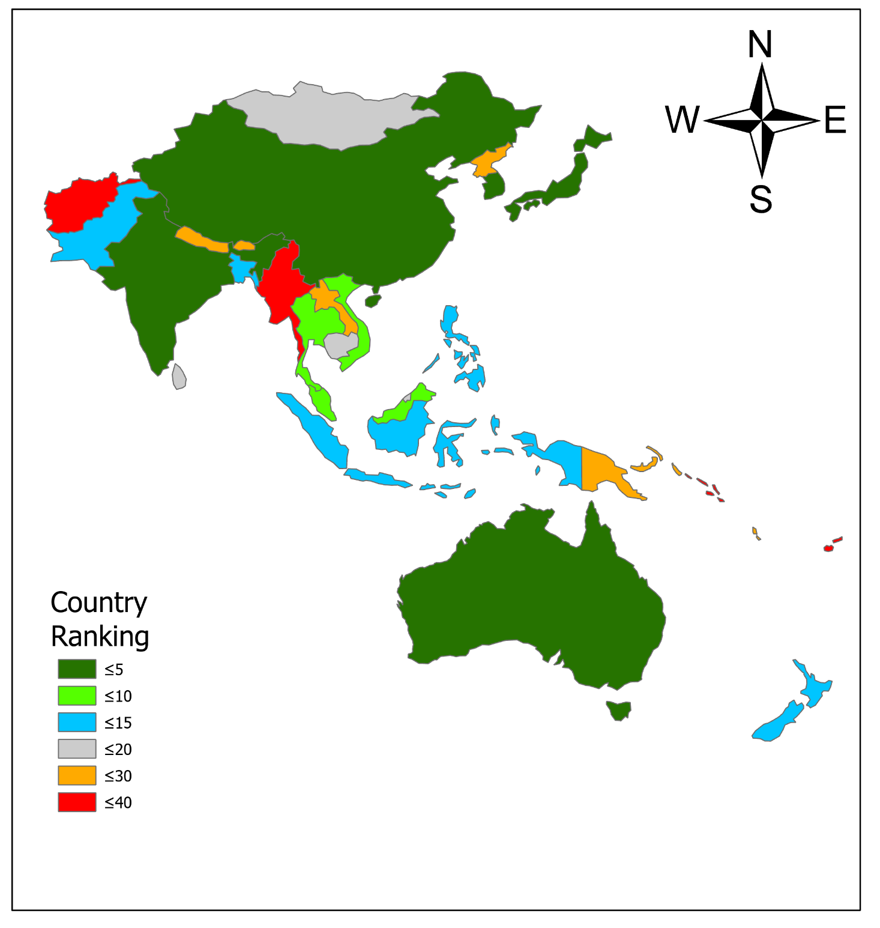
Figure S 8 South, East Asia, and Pacific country ranking

