Sustainable Valorisation of Agri-food Waste from Open-Air Markets in Kampala, Uganda via Standalone and Integrated Waste Conversion Technologies

Supplementary Information

AUTHORS
Somorin, T.¹, Campos, L.C.², Kinobe, J.R.³, Kulabako, R.N.³, Afolabi, O.O.D.^{4*}

AFFILIATIONS
- Department of Chemical and Process Engineering, University of Strathclyde, Glasgow, G1 1XQ, UK.
- Department of Civil, Environmental and Geomatic Engineering, University College London, London, WC1E 6BT, UK.
- Department of Civil and Environmental Engineering, Makerere University College of Engineering, Design, Art and Technology, P. O. Box 7062, Kampala, Uganda.
- School of Architecture, Building and Civil Engineering, Loughborough University, Loughborough, LE11 3TU, UK.

* CORRESPONDING AUTHOR’S EMAIL: O.O.D.AFOLABI2@LBORO.AC.UK

Supplementary Information
SI-1 Integrative Assessment Modelling Approach
Material Flow Analysis (MFA) is a mass balance approach for designing, characterising, and quantitatively assessing resource flows (from inputs to outputs, including emissions and accumulations retained) within a waste/waste-to-energy management system (WMS), providing evidence to support strategic interventions/sustainability targets. The types of material resource flow enabled by the MFA analysis include ‘goods’ (i.e., entities' economic value, e.g., residues, by-products) and ‘substances’ (i.e., chemical elements, such as heavy metals) [1]. Previous studies [2, 3] have shown that deploying MFA at ‘goods’, and ‘substances’ levels provides evidence to assess the magnitude of resource flow rates and hence the potential capacities of a WMS. Additionally, this enables the evaluation of the functionalities and performance of interlinked processes behind the metabolism of specific chemical elements (and emissions) within a WMS that could be of economic value or represent a hazardous risk to health and the environment. This purports substance flow analysis is critical from economic and environmental perspectives, enabling adequate resource recovery and plugging hazardous substances into the environment. However, while MFA enables the identification and quantification of resource flow within a WMS, it is limited because it does not provide an understanding of the likely environmental impact assessments associated with the flows, especially potentially hazardous ‘goods’, and ‘substances’. In this respect, the Life Cycle Analysis (LCA), a distinguished assessment tool for quantifying and categorising environmental impacts, provides short, medium, and long-term impacts of processes and resource flow (e.g., hazardous substances) throughout their life cycle to enable a comprehensive and holistic assessment. Further, optimised inputs, outputs, and operating parameters enabled by waste-to-energy process modelling & simulation provide theoretical evidence of the performance and efficiencies of conversion processes for WMS planning and implementation [4, 5]. Integrating MFA, LCA, and waste-to-energy process modelling thus provides a rigorous scientific basis for comparative evaluation of performance, resource recovery and environmental impact assessment of technology-based solutions for managing agri-food waste, in this study, from open-air markets.

SI-2 Agri-food waste characterisations and analyses
Properties | Parameters | Analytical techniques/ equipment | Standard Methods Reference
Physical | Moisture content, MC | Thermogravemetric analyser | APHA (2005) [6]
 | Total solids, TS | Drying method, (Dried at 105°C)
 | Volatile solids, VS | Thermogravemetric analyser
 | Ash content
 | pH | pH probe
Biochemical | COD | Closed reflux and colorimetric measurement
 | Metals: Ca, Na, Fe, Mn, Zn, K, Mg, Cd, Cr, Cu, Ni, Pb | Digestion and AAS-graphite furnace
 | Metals: As, Hg | Digestion and AAS-Hydride
 | Ultimate analyses – C, H, N, S, O | Elemental analyzer | ASTM D5373
Energy | Calorific value (HHV) | Bomb calorimeter | ISO 1928:2009
Bromatological | Carbohydrates | Proximate analyser
 | Protein content |  | Proximate analysis
 | Lipids

SI-3 Process simulation modelling - Simplified flow diagrams
Figure SI-3a Simplified process flow model for S2_AD scenario

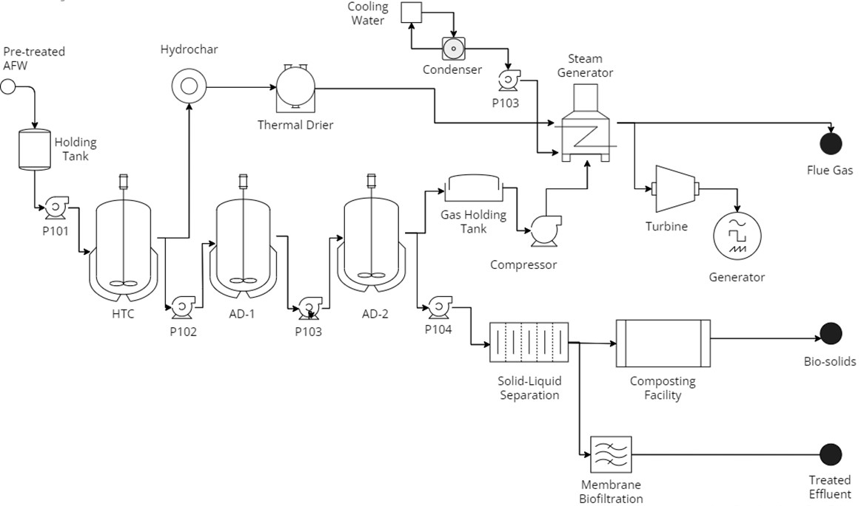
Figure SI-3b Simplified process flow model for S3_HTC&AD scenario.

SI-4 Product conversion reactions with stoichiometric equations, fractional conversion, and kinetic parameters
Table A: Stoichiometric reactions for modelling hydrolysis in AD reactor 1 (S2_AD/S3_HTC & AD)
No. | Compound | Reactant | Hydrolysis reaction | Fractional Conversion | Fractional Conversion
1 | Starch | Maltrose | C₆H₁₂O₆ + 2 H₂O → C₂H₄O₂ + C₆H₆O₃ + 2 H₂O | 0.6 ± 0.2 | 0.8
2 | Cellulose | Levoglucosan | (C₆H₁₀O₅)_{n} + H₂O → C₆H₁₂O₆ | 0.4 ± 0.1 | 0.3
3* | Cellulose | Levoglucosan | C₆H₁₂O₆ + H₂O → 2 C₂H₆O + 2 CO₂ | 0.4 ± 0.1 | 0.3
4* | Hemicellulose | Glutaric acid | C₅H₈O₄ + H₂O → 2.5 C₂H₄O₂ | 0.5 ± 0.2 | 0.6
5 | Hemicellulose | Glutaric acid | C₅H₈O₄ + H₂O → C₅H₁₀O₅ | 0.6 ± 0.0 | 0.6
6 | Xylose | D-Xylose | C₅H₁₀O₅ → C₅H₄O₂ + 3 H₂O | 0.6 ± 0.0 | 0.6
7* | Ethanol | Ethanol | 2C₂H₆O + CO₂ → 2 C₂H₄O₂ + CH₄ | 0.6 ± 0.1 | 0.5
8 | Triolein | Triolein | C₅₇H₁₀₄O₆ + 3 H₂O → C₃H₈O₃ + 3 C₁₈H₃₄O₂ | 0.5 ± 0.2 | 0.7
9 | Tripalmitin | Tripalmitin | C₅₁H₉₈O₆ + 3 H₂O → C₃H₈O₃ + 3 C₁₆H₃₄O | 0.5 ± 0.3 | 0.8
10 | Soluble Protein | - | C₁₃H₂₅O₇N₃S + 6 H₂O → 6.5 CO₂ + 6.5 CH₄ + 3 H₃N + H₂S | 0.5 ± 0.2 | 0.9
11 | Insoluble Protein | Collagen | C_{4.26}H_{8.56}N_{1.31}O_{2.39}S_{0.02} + 0.08 H₂O → 0.1047 C₃H₇NO₂ + 0.0751 C₆H₁₄N₄O₂ + 0.066 C₄H₈N₂O₃ + 0.1054 C₅H₉NO₄ + 0.2168 C₂H₅NO₂ + 0.012 C₆H₉N₃O₂ + 0.0564 C₅H₉NO₃ + 0.0156 C₆H₁₃NO₂ + 0.0293 C₆H₁₃NO₂ + 0.0336 C₆H₁₄N₂O₂ + 0.0224 C₅H₁₁NO₂S + 0.0301 C₉H₁₁NO₂ + 0.1346 C₅H₉NO₂ + 0.0342 C₃H₇NO₃ + 0.0282 C₄H₉NO₃ + 0.0131 C₉H₁₁NO₃ + 0.0225 C5H₁₁NO₂ | 0.6 ± 0.1 | 0.7
12* | Cholesterol | Palmito-linolein | C₃₇H₆₈O₅ + 4.3 H₂O → 2.2 C₃H₈O₃ + 0.9 C₁₆H₃₄O + 0.9 C₁₈H₃₂O₂ | - | 0.9
*Reactions 1-12 defined for S2_AD; Reactions 3,4,7,10, 12 only are defined for S3_HTC & AD

Table B: Stoichiometric reactions and kinetic parameters for modelling HTC reactor (n =1)
No. | Compound | Reactant | Hydrolysis Reaction | Pre-exponential Factor | Activation Energy kJ/kmol
Carbohydrate Degradation
1 | Starch | Maltrose | C₆H₁₂O₆ → 5C₂H₄O₂ + C₆H₆O₃ + 2 H₂O | 1.11 x 10¹¹ | 147.9
2 | Cellulose | Levoglucosan | (C₆H₁₀O₅)_{n} + H₂O → C₆H₁₂O₆ | 5.34 x 10⁹ | 105.1
3 | Hemicellulose | Glutaric acid | C₅H₈O₄ + H₂O → C₅H₁₀O₅ | 5.42 x 10⁴ | 62.7
4 | Xylose | D-Xylose | C₅H₁₀O₅ → 0.075C₆H₁₀O₇ + 0.3C₂H₄O₂ + 0.75C₅H₄O₂ + 0.2CO₂ + 0.55H₂ + 1.975H₂O | 1.19 x 10¹⁵ | 146.5
5 | Glucose | Dextrose | C₆H₁₂O₆ → C₆H₆O₃ + 3H₂O | 5.06 x 10⁹ | 108.0
6 | 5-HMF | 5-HMF | C₆H₆O₃ + 2H₂O → CH₂O₂ + C₅H₈O₃ | 2.62 x 10⁶ | 89.3
Protein Degradation
7 | Protein* | Collagen | C_{4.26}H_{8.56}N_{1.31}O_{2.39}S_{0.02} + 0.08 H₂O → 0.1047 C₃H₇NO₂ + 0.0751 C₆H₁₄N₄O₂ + 0.066 C₄H₈N₂O₃ + 0.1054 C₅H₉NO₄ + 0.2168 C₂H₅NO₂ + 0.012 C₆H₉N₃O₂ + 0.0564 C₅H₉NO₃ + 0.0156 C₆H₁₃NO₂ + 0.0293 C₆H₁₃NO₂ + 0.0336 C₆H₁₄N₂O₂ + 0.0224 C₅H₁₁NO₂S + 0.0301 C₉H₁₁NO₂ + 0.1346 C₅H₉NO₂ + 0.0342 C₃H₇NO₃ + 0.0282 C₄H₉NO₃ + 0.0131 C₉H₁₁NO₃ + 0.0225 C5H₁₁NO₂ | 1.90 x 10²⁰ | 236.5
8 | Triolein | Triolein | C₅₇H₁₀₄O₆ + 3 H₂O → C₃H₈O₃ + 3 C₁₈H₃₄O₂ | 1.40 x 10¹¹ | 74
9 | Tripalmitin | Tripalmitin | C₅₁H₉₈O₆ + 3 H₂O → C₃H₈O₃ + 3 C₁₆H₃₄O
10 | Cholesterol | Palmito-linolein | C₃₇H₆₈O₅ + 4.3 H₂O → 2.2 C₃H₈O₃ + 0.9 C₁₆H₃₄O + 0.9 C₁₈H₃₂O₂
*Amino acids in Reaction 7 further break down into degradation products using data stoichiometric equations in Table C and kinetic parameters for reaction 7

Table C: Stoichiometric reactions and kinetic parameters for modelling AD reactor 2 (S2_AD/S3_HTC & AD)*
 |  |  | Reactants |  |  |  | Products
 |  |  | H₂O | NH₃ | CO₂ | H₂ | C₅H₇NO₂ | C₂H₄O₂ | NH₃ | CO₂ | H₂ | CH₄ | C₃H₆O₂ | C₄H₈O₂ | C₅H₁₀O₂ | H₂O | C₂H₄O | CH₃NO | CH₄S | C₆H₆ | C₆H₆O
 |  |  |  |  |  |  |  |  |  |  |  |  |  |  |  |  |  | - | - | - | -
Amino acid reactions¹ | Alanine | - | - | - | - | - | - | 1 | 1 | 1 | 2 | - | - | - | - | - |  | - | - | - | -
 | Arginine | - | - | - | - | - | - | 2 | 4 | 2 | 3 | - | - | - | - | - |  | - | - | - | -
 | Asparagine | - | - | - | - | - | - | - | 2 | 2 | 1 | - | - | - | - | - | 2 | - | - | - | -
 | Glutamic acid | - | - | - | - | - | - | 2 | 1 | 1 | 1 | - | - | - | - | - | - | - | - | - | -
 | Glycine | C₂H₅NO₂ | - | - | - | - | - | 0.5 | 1 | 1 | 1 | - | - | - | - | - | - | - | - | - | -
 | Histidine | C₆H₈N₃O₂ | - | - | - | - | - | 2 | 2 | 1 | 1 | - | - | - | - | - | - | 1 | - | - | -
 | Hydroproline | C₅H₉NO₂ | - | - | - | - | - | 1 | 1 | 2 | 2 | 1 | - | - | - | - | - | - | - | - | -
 | Isoleucine | C₆H₁₃NO₂ | - | - | - | - | - | - | 1 | 1 | 1 | - | - | - | 1 | - | - | - | - | - | -
 | Leucine | C₆H₁₃NO₂ | - | - | - | - | - | - | 1 | 1 | 1 | - | - | - | 1 | - | - | - | - | - | -
 | Lysine | C₆H₁₄N₂O₂ | - | - | - | - | - | 1 | 2 | - | - | - | - | 1 | - | - | - | - | - | - | -
 | Methionine | C₅H₁₁NO₂S | 2 | - | - | - | - | - | 1 | 1 | 1 | - | 1 | - | 1 | - | - | - | 1 | - | -
 | Phenylalanine | C₉H₁₁NO₂ | 2 | - | - | - | - | 1 | 1 | 1 | 1 | - | - | - | - | - | - | - | - | 1 | -
 | Proline | C₅H₉NO₂ | 4 | - | - | - | - | 2 | - | - | 3 | - | 1 | - | 1 | - | - | - | - | - | -
 | Serine | C₃H₇NO₃ | 1 | - | - | - | - | 1 | 1 | 1 | 1 | - | - | - | - | - | - | - | - | - | -
 | Threonine | C₄H₉NO₃ | 1 | - | - | - | - | 1 | 1 | 1 | 1 | - | 1 | - | - | - | - | - | - | - | -
 | Tyrosine | C₉H₁₁NO₃ | 2 | - | - | - | - | 1 | 1 | 1 | 1 | - | - | - | - | - | - | - | - | - | 1
 | Valine | C₅H₁₁NO₂ | 2 | - | - | - | - | - | 1 | 1 | 1 | - | - | 1 | - | - | - | - | - | - | -
Acidogenic reactions | Dextrose² | C₆H₁₂O₆ | - | 0.1115 | - | - | 0.1115 | 0.744 | - | 0.6909 | - | - | 0.5000 | 0.4409 | - | 1.0254 | - | - | - | - | -
 | Glycerol³ | C₃H₈O₃ | - | 0.4071 | 0.0291 | 0.0005 | 0.04071 | - | - | - | - | - | 0.9419 | - | - | 1.0931 | - | - | - | - | -
Acetogenic reactions | Oleic acid⁴ | C₁₈H₃₄O₂ | 15.2400 | 0.1701 | 0.2501 |  | 0.1701 | 8.6998 | - | - | 14.4998 | - | - | - | - | - | - | - | - | - | -
 | Propionic acid⁵ | C₃H₆O₂ | 0.3143 | 0.0620 | - | - | 0.0620 | 0.9345 | - | 0.1607 | 0.0006 | 0.6604 | - | - | - | - | - | - | - | - | -
 | Isobutyric acid⁶ | C₄H₈O₂ | 0.8038 | 0.0653 | 0.5543 | 0.0006 | 0.0653 | 1.8909 | - | - |  | 0.4460 | - | - | - | - | - | - | - | - | -
 | Isovaleric acid⁷ | C₅H₁₀O₂ | 0.8044 | 0.0653 | 0.5543 |  | 0.0653 | 0.8912 | - | - | 0.0006 | 0.4454 | 1 | - | - | - | - | - | - | - | -
LCFA-degrading acetogens | Linoleic acid⁸ | C₁₈H₃₂O₂ | 15.2396 | 0.1701 | 0.2501 | - | 0.1701 | 8.6998 | - | - | 13.4998 | - | - | - | - | - | - | - | - | - | -
 | Palmitic acid⁹ | C₁₆H₃₄O₂ | 11.2396 | 0.1701 | 2.2501 | - | 0.1701 | 8.6998 | - | - | 9.4998 | - | - | - | - | - | - | - | - | - | -
Methanog-enic reactions | Hydrogen¹⁰ | H₂ | - | - | 2 | 4 | - | 1 | - | - | - | - | - | - | - | 2 | - | - | - | - | -
 | Acetic acid¹¹ | C₂H₄O₂ | - | 0.022 | - | - | - | 0.022 | - | 0.9450 | - | 0.9450 | - | - | - | 0.066 | - | - | - | - | -

*Pre-exponential Factor – 1.4 x 10¹¹; Activation Energy – 74 kJ kmol⁻¹

Table D: Stoichiometric reactions for modelling hydrochar formation in HTC reactions (S3_HTC&AD)
No. | Hydrolysis reaction
1 | 3 C₅H₈O₃ + 13.5749 H₂O --> HYDROCHAR + 22.6979 H₂ + 10.2018 CO₂
2 | 2 C₅H₄O₂ + 8.5749 H₂O --> HYDROCHAR + 10.2018 CO₂ + 9.69787 H₂ + 5.2018 CO₂
3 | 2 + 60.5749 H₂O --> HYDROCHAR + 91.6979 H₂ + 31.2018 CO₂
4 | C₆H₆O₃ + 1.5749 H₂O --> HYDROCHAR + 1.6979 H₂ + 1.202 CO₂
5 | 2 C₃H₆O₂ + 0.5749 H₂O --> HYDROCHAR + 3.6979 H₂ + 1.202 CO₂
6 | 4 C₂H₄O₂ + 0.5749 H₂O --> HYDROCHAR + 5.6979 H₂ + 3.202 CO₂
7 | 2 C₄H₈O₂ + 4.5749 H₂O --> HYDROCHAR + 9.6979 H₂ + 3.202 CO₂
8 | 3 C₃H₈O₃ + 1.5749 H₂O --> HYDROCHAR + 10.6979 H₂ + 4.202 CO₂
9 | 2 C₅H₁₀O₂ + 8.5749 H₂O --> HYDROCHAR + 15.6979 H₂ + 5.202 CO₂
10 | 2 C₆H₁₀O₇ ₊ 2.5749 H₂O --> HYDROCHAR + 9.6979 H₂ + 7.202 CO₂
11 | 2 C₁₈H₃₂O₂ + 60.5749 H₂O --> HYDROCHAR + 31.202 CO₂ + 89.6979 H₂
12 | 5 CH₂O₂ + 0.377 H₂O --> HYDROCHAR + 0.2018 CO₂ + 4.0511 O₂

SI-5 Transfer coefficients mobilised for modelling agri-food market waste MFA for all scenarios
 |  | Transfer coefficients of “goods” (i.e., bulk wastes, products, residues, or emissions) and “substances” (i.e., heavy metals)
Processes | Description of flows | As ‘goods’ | As ‘substances’
 |  |  | Zn | Cu | Cr | Ni | Pb | Cd | Hg
Separation | As organic fractions¹ (OFRAC) | 0.92 ± 0.03 | Same as the transfer coefficient used for ‘goods’
 | As mixed inorganic* residues | 0.08 ± 0.03 | Same as the transfer coefficient used for ‘goods’
Sorting & selection of easily digestible AD substrates | Easily digested² OFRAC | 0.75 ± 0.10 | Same as the transfer coefficient used for ‘goods’
 | Non-easily digested OFRAC* | 0.25 ± 0.10 | Same as the transfer coefficient used for ‘goods’
Size reduction and homogenisation | Homogenised³  OFRAC | 0.95 ± 0.32 | Same as the transfer coefficient used for ‘goods’
 | Process  losses³ | 0.05 ± 0.32 | Same as the transfer coefficient used for ‘goods’
AD treatment | As biogas  production³ | 0.12 ± 0.11 | - | - | - | 0.12 ± 0.96 | - | - | 0.12 ± 0.96
 | As digestate  (slurry)* | 0.86 ± 0.11 | 1.00 ± 0.00 | 1.00 ± 0.00 | 1.00 ± 0.00 | 0.86 ± 0.96 | 1.00 ± 0.00 | 1.00 ± 0.00 | 0.86 ± 0.96
 | As emission to air  (losses)³ | 0.02 ± 0.11 | - | - | - | 0.02 ± 0.96 | - | - | 0.02 ± 0.96
HTC treatment^{4,5} | As hydrochar  (Solid fraction) | 0.70 ± 0.10 | 0.32 ± 0.10 | 0.61 ± 0.10 | 0.45 ± 0.10 | 0.22 ± 0.10 | 0.94 ± 0.10 | 0.24 ± 0.10 | 0.95 ± 0.10
 | As process water to AD conversion | 0.25 ± 0.10 | 0.68 ± 0.10 | 0.39 ± 0.10 | 0.55 ± 0.10 | 0.78 ± 0.10 | 0.06 ± 0.10 | 0.76 ± 0.10 | 0.05 ± 0.10
 | As gaseous emission (losses) to air | 0.05 ± 0.10 | Heavy metal concentration is negligible.
Solid-liquid separation (via centrifugation)^{,6,7} | Solid fraction to aerobic composting | 0.125 ± 0.025 | 0.97 ± 0.013 | 0.97 ± 0.004 | 0.88 ± 0.04 | 0.49 ± 0.05 | 0.97 ± 0.01 | 0.98 ± 0.014 | 0.95 ± 0.10
 | Liquid effluent fraction for treatment | 0.875 ± 0.025 | 0.03 ± 0.013 | 0.03 ± 0.004 | 0.12 ± 0.04 | 0.51 ± 0.05 | 0.03 ± 0.01 | 0.02 ± 0.014 | 0.05 ± 0.10
Effluent treatment by MBR ^{3,8,9} | As permeate (treated effluent) | 0.5 ± 0.10 | 0.13 ± 0.10 | 0.02 ± 0.10 | 0.09 ± 0.10 | 0.18 ± 0.10 | 0.01 ± 0.10 | 0.04 ± 0.10 | 0.03 ± 0.10
 | Concentrate (process rejects) | 0.5 ± 0.10 | 0.87 ± 0.10 | 0.98 ± 0.10 | 0.91 ± 0.10 | 0.82 ± 0.10 | 0.99 ± 0.10 | 0.96 ± 0.10 | 0.97 ± 0.10
Aerobic composting | As compost³ | 0.36 ± 0.11 | 0.75 ± 0.32 | 0.67 ± 0.32 | 0.96 ± 0.32 | 0.36 ± 0.96 | 0.59 ± 0.32 | 0.50 ± 0.32 | 0.86 ± 0.32
 | As emission to air  (losses)³ | 0.52 ± 0.11 | - | - | - | 0.52 ± 0.96 | - | - | -
 | Compost residues to landfill* | 0.12 ± 0.11 | 0.25 ± 0.32 | 0.33 ± 0.32 | 0.04 ± 0.32 | 0.12 ± 0.96 | 0.41 ± 0.32 | 0.50 ± 0.32 | 0.14 ± 0.32
Notes
For all transfer coefficients collated or estimated without a stated standard error, a conservative 10% uncertainty was assumed.
* Estimated by difference, i.e., 1 – ($∑$transfer coefficients of all other flows)
1 Based on the average organic fractions from the three markets. Estimated from Byrne et, 2015 [Source: Byrne, A., Gold, M., Turyasiima, D., Getkate, W., Niwagaba, C., Babu, M., Maiteki, J., Orwiny, M., Strande, L., 2015. Sludge to Energy Enterprises in Kampala (SEEK) Project. Suitable biowastes for energy recovery. [Online] http://www.eawag.ch/fileadmin/Domain1/Abteilungen/sandec/schwerpunkte/ewm/SEEK/pdfs/seek_suitable_waste_streams.pdf.
2 Organic fractions of fruit and vegetables from open urban markets in Tunisia. [Source: Bouallagui, H., Touhami, Y., Ben Cheikh, R., Hamdi, M., 2005. Bioreactor performance in anaerobic digestion of fruit and vegetable wastes, Process Biochemistry, 40 (3–4), 989-995, https://doi.org/10.1016/j.procbio.2004.03.007]
3 Transfer coefficients for ‘goods’ and ‘substances’ extracted from Allesch, A. and Brunner, P.H., 2017. [Source: Allesch, A. and Brunner, P.H., 2017. Material flow analysis as a tool to improve waste management systems: The case of Austria. Environ. Sci. Technol. 51, 540 – 551]. The transfer coefficients for losses or products (e.g., compost and biogas) were first collated, and the difference was assumed as the transfer coefficients by-products/residuals.
4 Bulk ‘goods’ transfer coefficients of HTC products were informed by several studies, including Libra et al, 2011 [Source: Libra, J.A., Ro, K.S., Kammann, C., Funke, A., Berge, N.D., Neubauer, Y., Titirici, M.M., Fühner, C., Bens, O., Kern, J., Emmerich, K.H., 2011. Hydrothermal carbonisation of biomass residuals: a comparative review of the chemistry, processes and applications of wet and dry pyrolysis. Biofuels 2, 71–106. doi:10.4155/bfs.10.81] and Hoekman et al, 2013 [Source: Hoekman, S.K., Broch, A., Robbins, C., Zielinska, B., Felix, L., 2013. Hydrothermal carbonisation (HTC) of selected woody and herbaceous biomass feedstocks. Biomass Conv. Bioref. 3, 113–126. https://doi.org/10.1007/s13399-012-0066-y].
5 The transfer coefficients of heavy metals in HTC products were estimated from HM concentration in one kg of raw and hydrochar recovered from corn stover [Source: Reza, M.T, Lynam, J.G., Uddin, M.H, Coronella, C.J., 2013. Hydrothermal carbonisation: Fate of inorganics. Biomass and Bioenergy 49: 86–94]. Guided by this literature, a conservative 95% of total concentration retained in hydrochar was assumed for Hg. A conservative 10% uncertainty was assumed for all transfer coefficients.
6 Bulk ‘goods’ transfer coefficients informed by the percentage of a full-scale industrial solid-liquid-separation system deployed for digestates using decanter centrifugation. [Source: Karakashev, D., Schmidt, J.E., Angelidaki, I., 2008. Innovative process scheme for removal of organic matter, phosphorus and nitrogen from pig manure. Water Res. 42, 4083–4090. https://doi.org/10.1016/J.WATRES.2008.06.021].
7 The transfer coefficients of heavy metals data were aggregated from the element concentrations in centrifuged digestates samples in Valeur, 2011 [Source: Valeur, I., 2011. Speciation of heavy metals and nutrient elements in digestates. MSc Thesis – Norwegian Uni. of Life Science] and validated against Zhu et al. 2014 [Source: Zhu, N.M., Li, Q., Guo, X.J., Zhang, H., Deng, Y., 2014. Sequential extraction of anaerobic digestate sludge to determine the partitioning of heavy metals. Ecotoxicology Environmental Safety. 102, 18–24]. The percentage difference for most heavy metals in the liquid effluent was less than 10%.
8 Bulk ‘goods’ transfer coefficients at the effluent treatment stage was extracted from Bolzonella et al. 2018 [Source: Bolzonella, D., Fatone, F., Gottardo, M., Frison, N., 2018. Nutrients recovery from anaerobic digestate of agro-waste: Techno-economic assessment of full-scale applications. J. Environ. Manage. 216, 111–119. https://doi.org/10.1016/J.JENVMAN.2017.08.026), which reported 50% of original w/w of digestate treated via membrane technology (with 70 – 80% recovery efficiency) recovery as clean water.
9 The transfer coefficients of heavy metals at the effluent treatment stage were estimated from large scale UF plant under real-life operational conditions from Arévalo et al, 2013 [Source: Arévalo J, Ruiz LM, Pérez J, Moreno B, Gómez MÁ, 2013. The removal performance of heavy metals in MBR systems and their influence on water reuse. Water Sci Technol.;67(4):894-900. Doi: 10.2166/wst.2012.620]. A conservative 10% uncertainty was assumed for all transfer coefficients. These were validated against Camilleri-Rumbau et al, 2019. [Source: Camilleri-Rumbau M.S.; Popovic, O.; Briceno, K.; Errico, M.; Søtoft, L.F.; Christensen, K.V.; Norddahl, B. Ultrafiltration of separated digestate by tubular membranes: Influence of feed pre-treatment on hydraulic performance and heavy metal removal. J. Environ. Manag. 2019, 250, 109404]. Guided by this literature and Ref in note 3, a conservative 97% removal efficiency was assumed for Hg.
SI-6 Substance flow balances (t yr⁻¹) aggregated for all agri-food markets for S2_AD
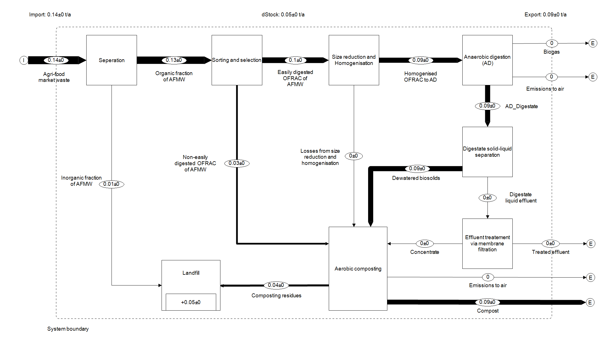
Figure SI-6A SFA for Cu

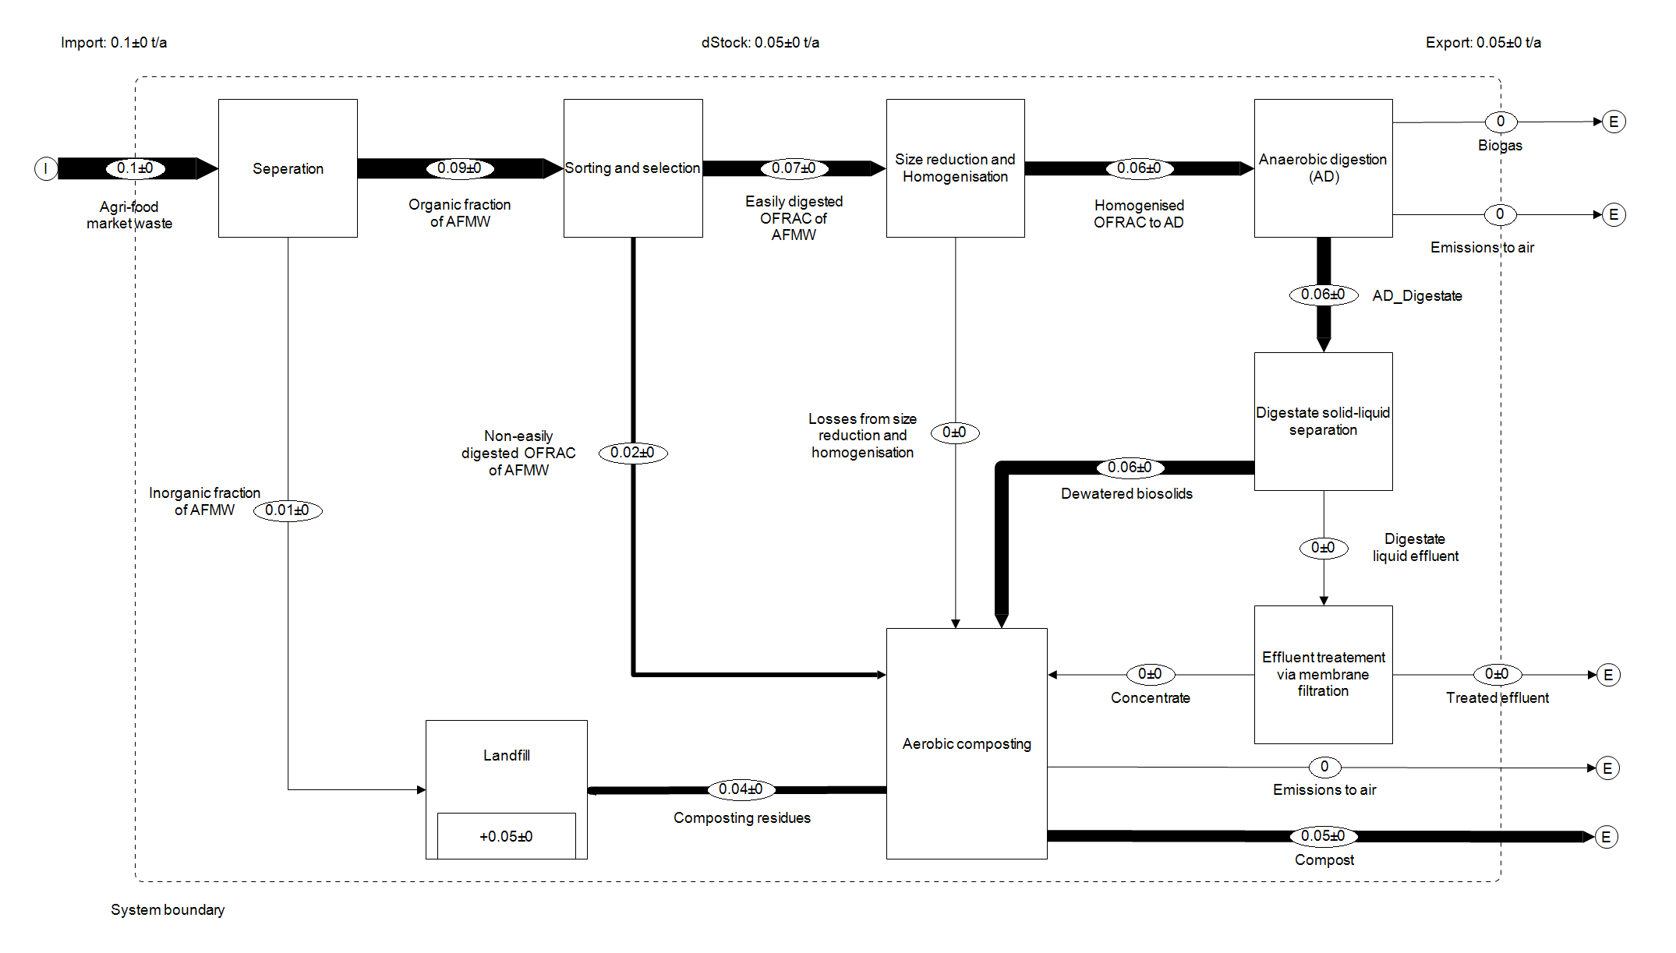
Figure SI-6B SFA for Pb
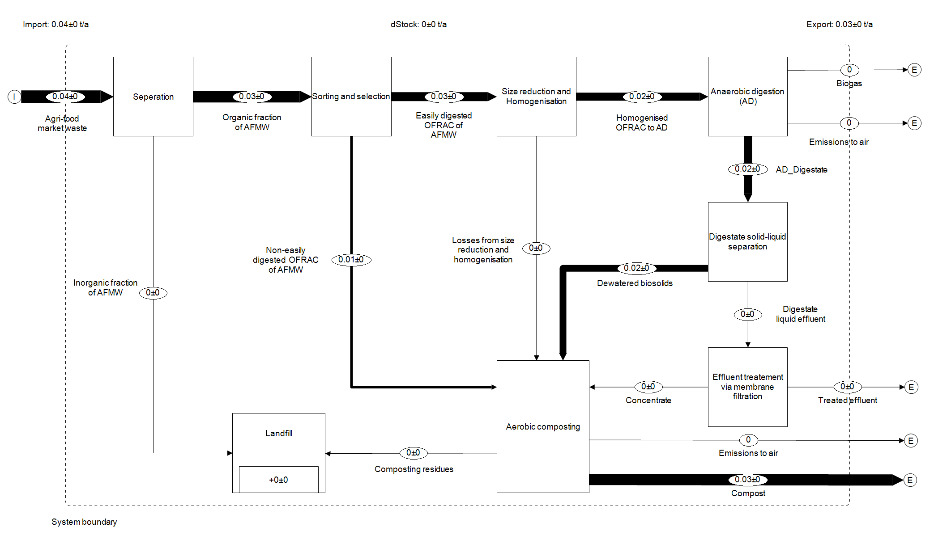
Figure SI-6C SFA for Cr
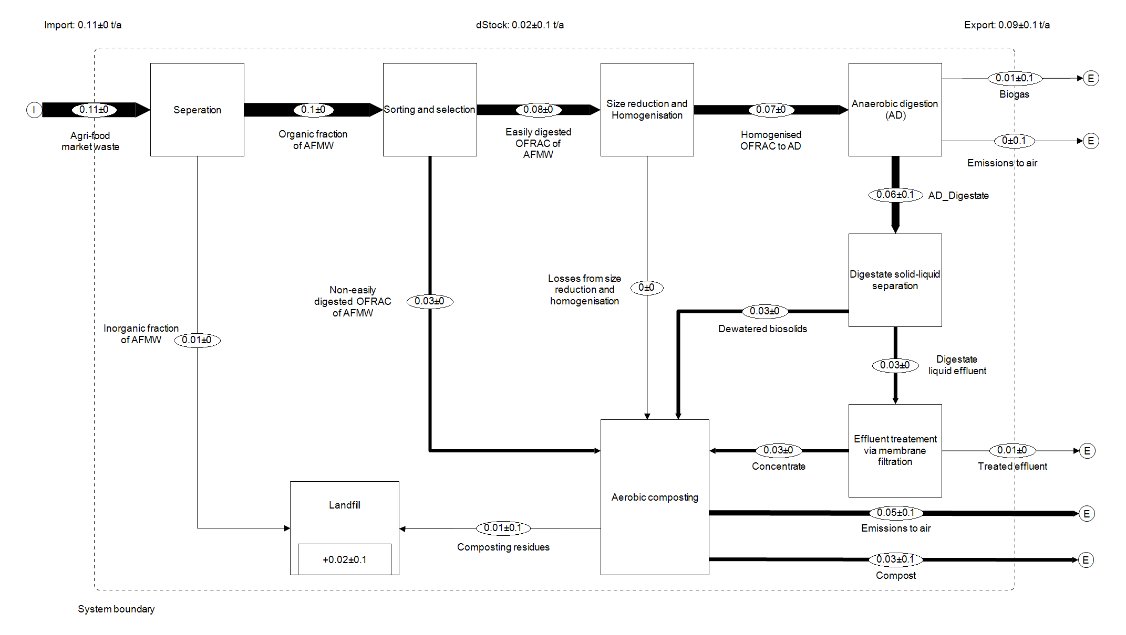
Figure SI-6D SFA for Ni
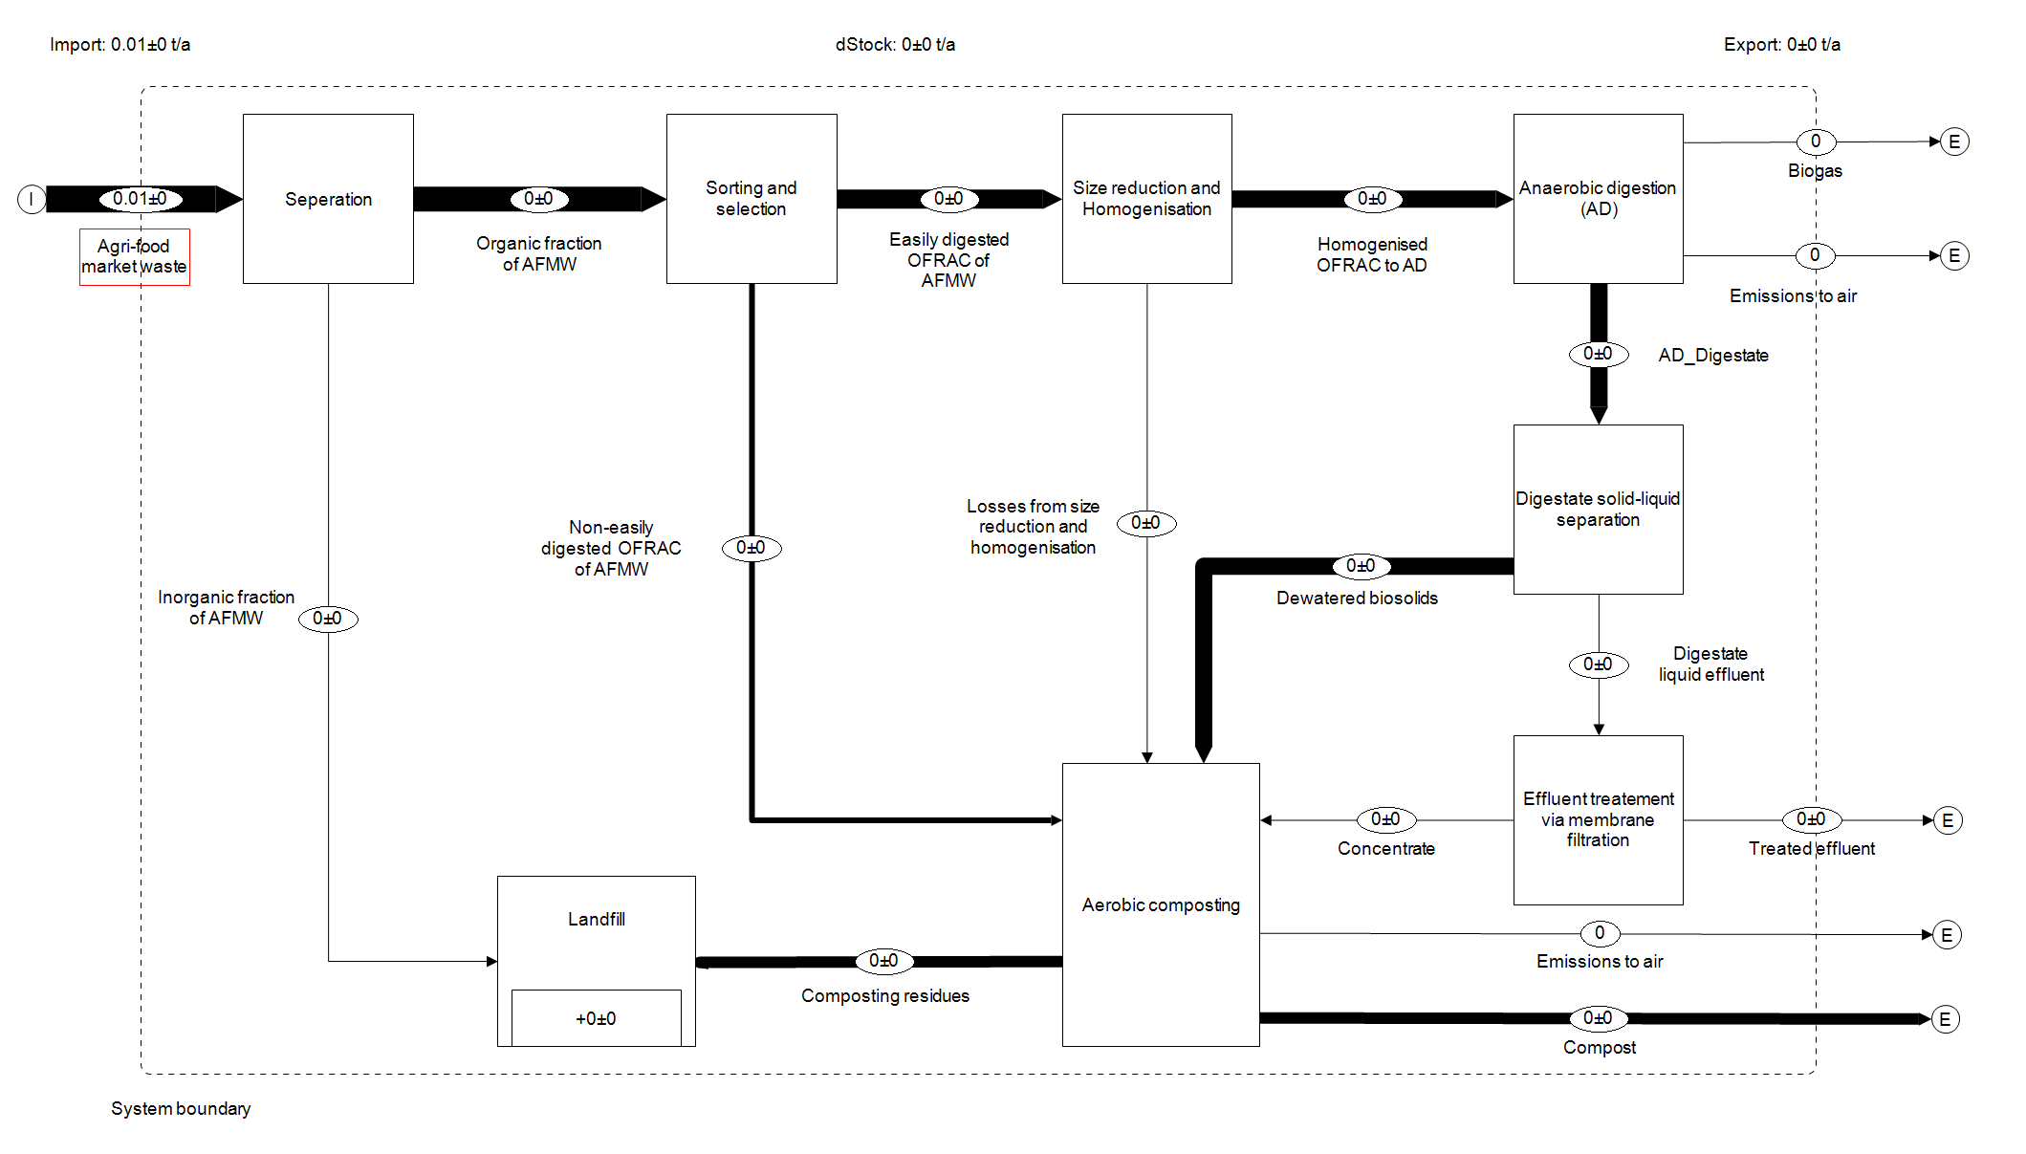
Figure SI-6E SFA for Cd
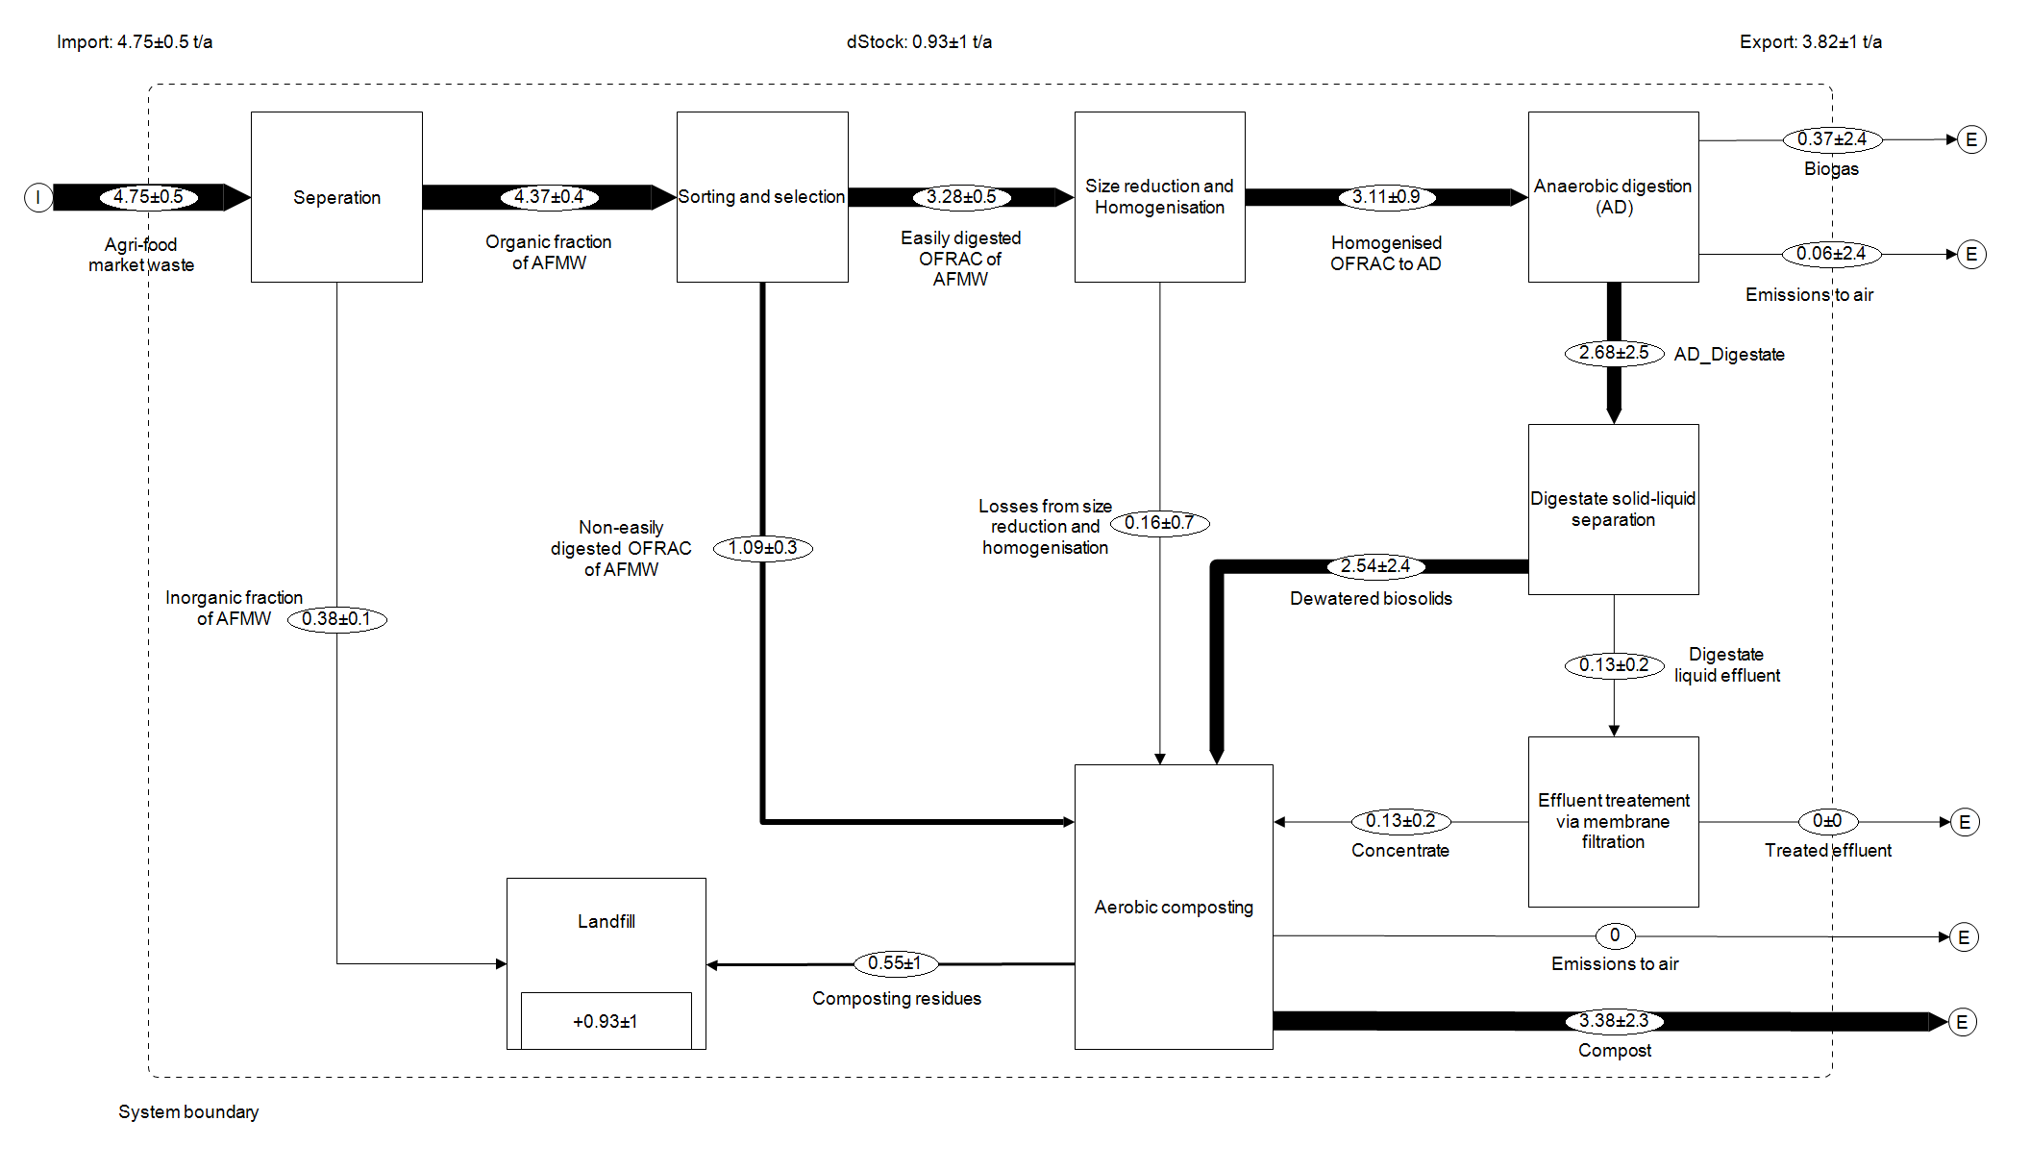
Figure SI-6F SFA for Hg
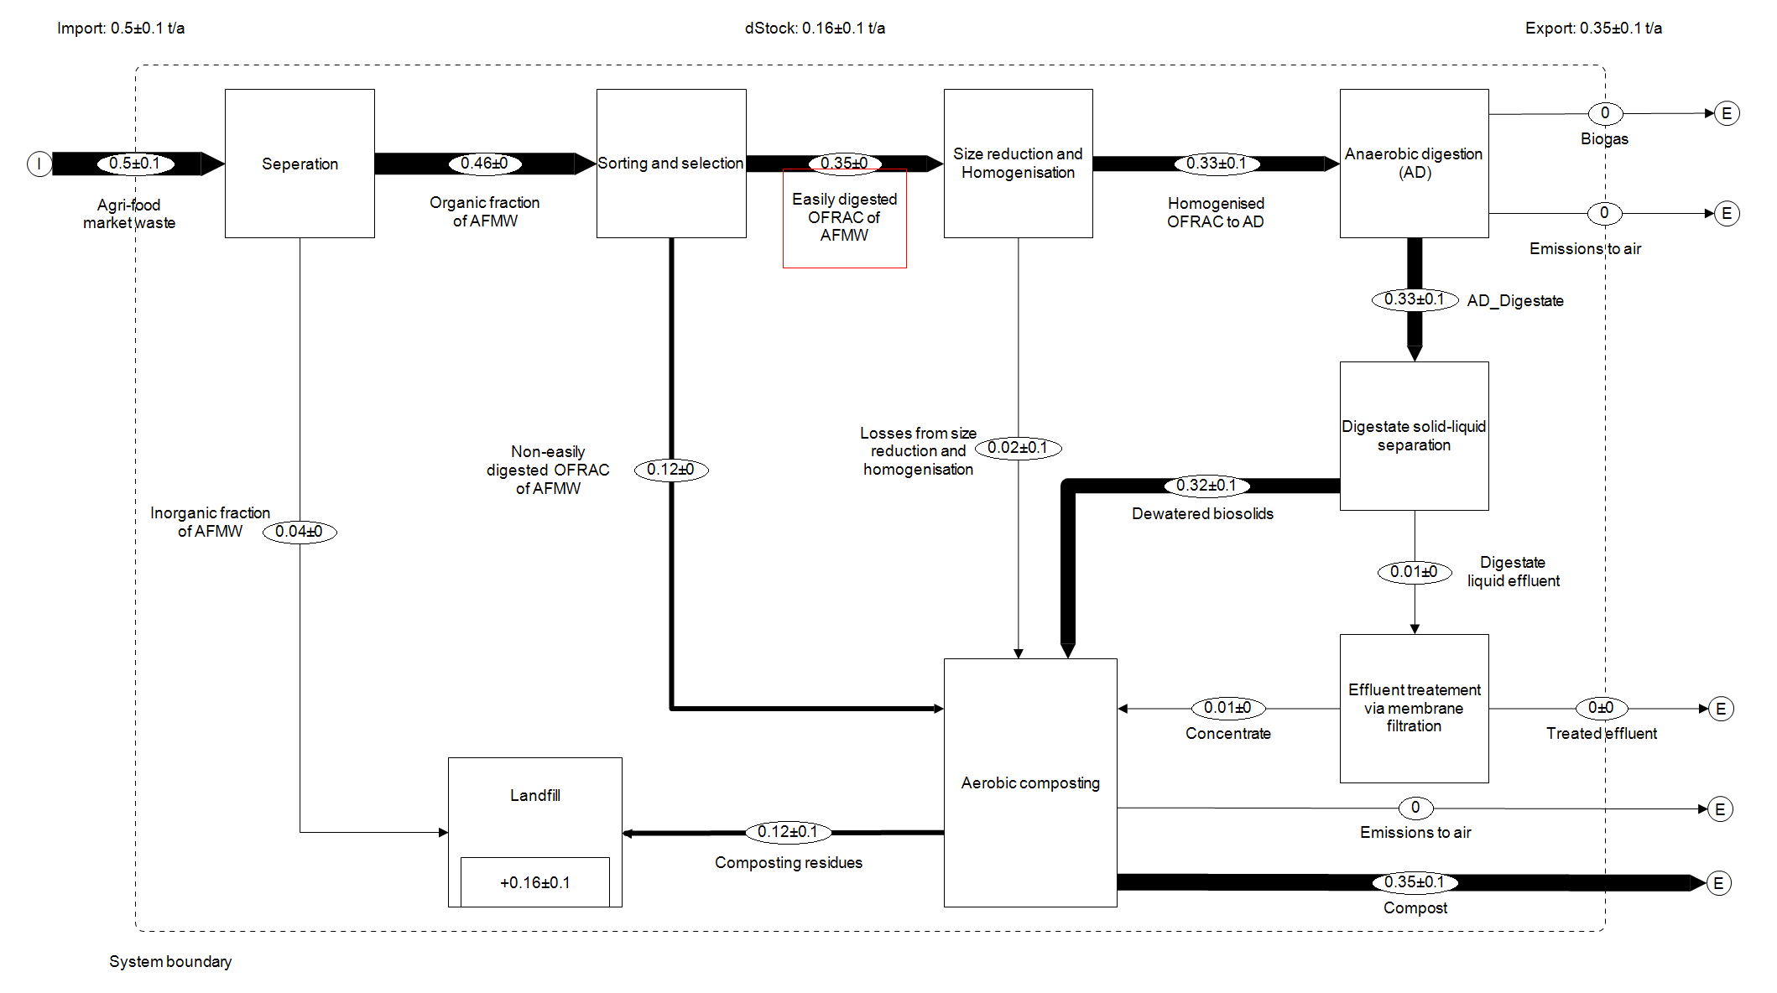
Figure SI-6G SFA for Zn

SI-7 Substance flow balances (t yr⁻¹) aggregated for all agri-food markets for S3_HTC&AD

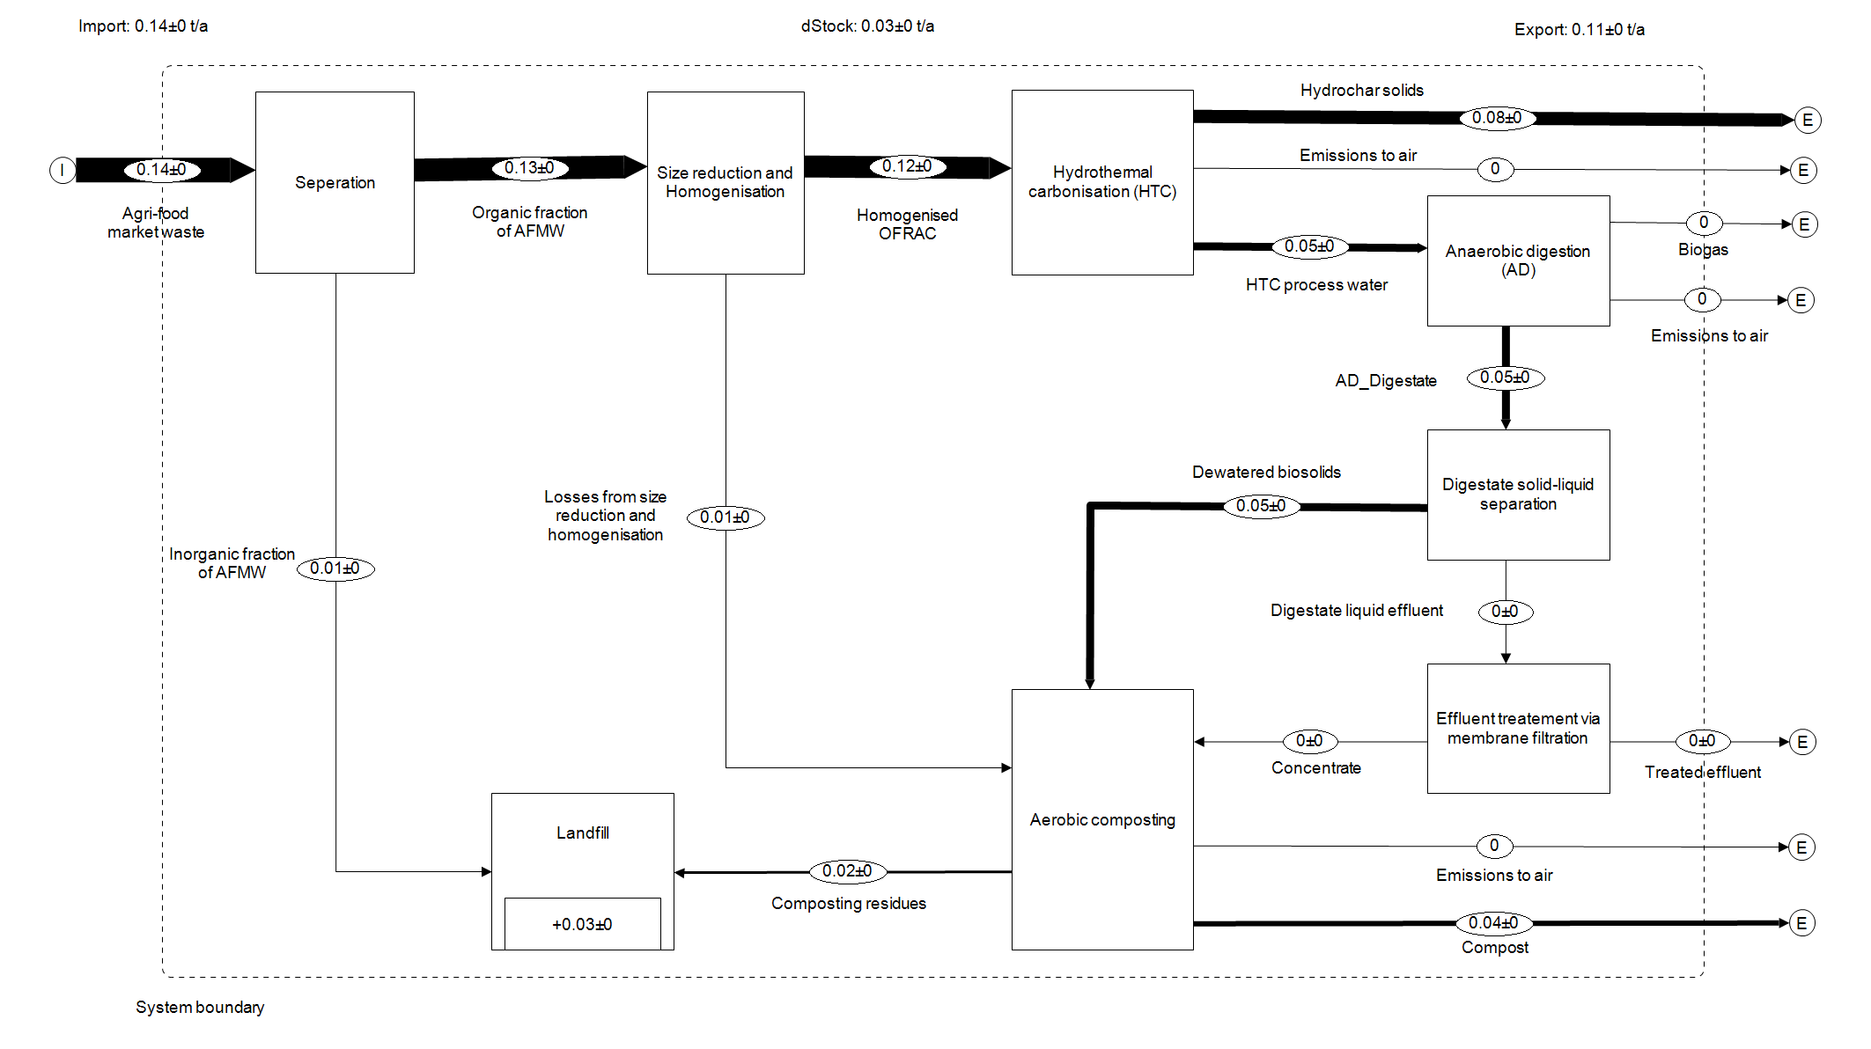
Figure SI-7A SFA for Cu
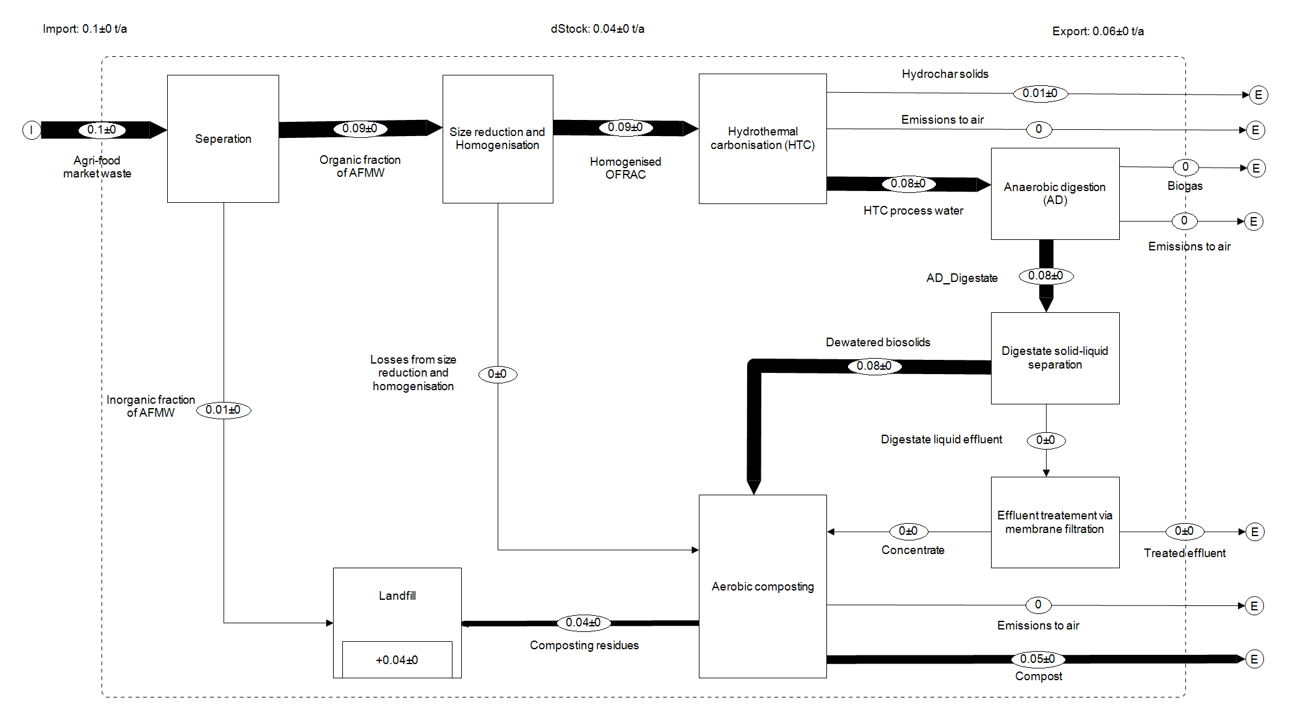
Figure SI-7B SFA for Pb
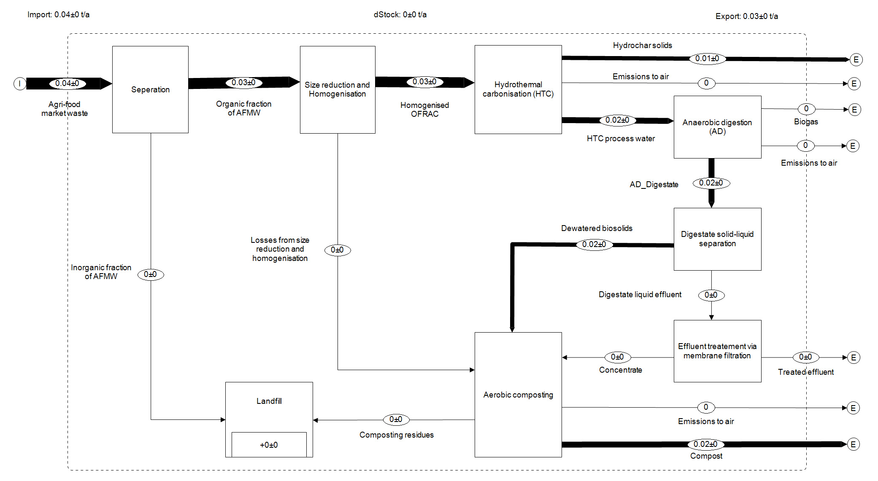
Figure SI-7C SFA for Cr
Figure SI-7D SFA for Ni
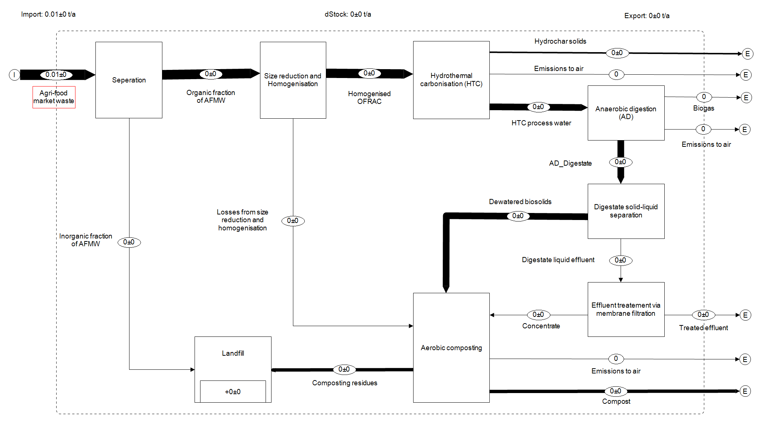
Figure SI-7E SFA for Cd

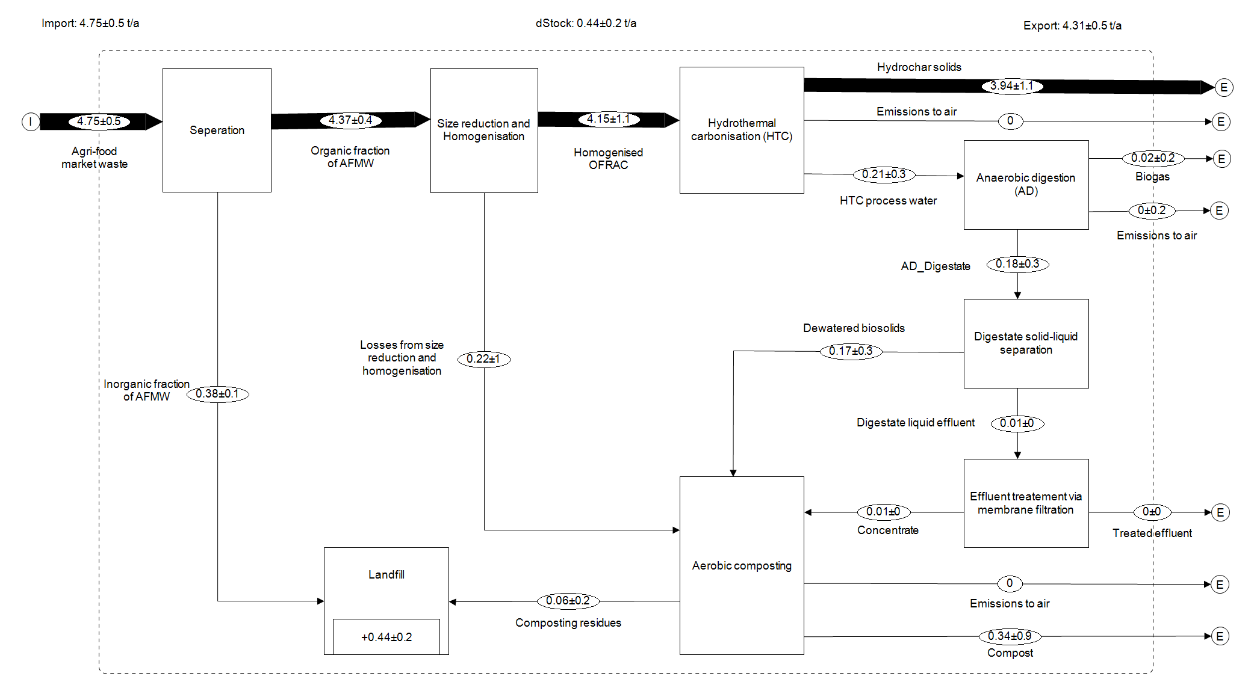
Figure SI-7F SFA for Hg

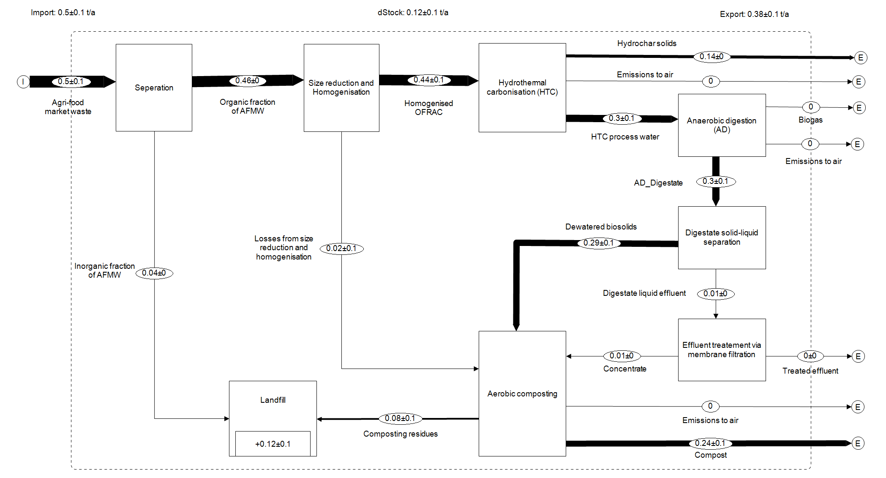
Figure SI-7G SFA for Zn

SI-8 Sensitivity Analysis Input Data for S2_AD & S3_HTC&AD
 | S2_AD & S3_HTC&AD
Scenarios | Lower Boundary | Upper Boundary
- Cumulative pre-processing loss of AFW (%) | 31.0 | 37.9
- Percentage of effluent treated via MBR (%) | 45.0 | 55.0
- Percentage of solid-liquid separation (%) | 11.3 | 13.8
- Biogas yield as a proportion of biodegradable carbon (%) | 63 | 77

Supplementary Information Reference
- Allesch, A., Brunner, P.H., 2017. Material Flow Analysis as a Tool to improve Waste Management Systems: The Case of Austria. Environ. Sci. Technol. 51, 540–551.
- Arena, U., Di Gregorio, F., 2014. A waste management planning based on substance flow analysis. Resour. Conserv. Recycl. 85, 54–66. https://doi.org/10.1016/J.RESCONREC.2013.05.008
- Stanisavljevic, N., Brunner, P.H., 2014. Combination of material flow analysis and substance flow analysis: A powerful approach for decision support in waste management. Waste Manag. Res. 32, 733–744. https://doi.org/10.1177/0734242X14543552
- Naqi, A., Kuhn, J.N., Joseph, B., 2019. Techno-economic analysis of producing liquid fuels from biomass via anaerobic digestion and thermochemical conversion. Biomass and Bioenergy 130. https://doi.org/10.1016/J.BIOMBIOE.2019.105395
- Siddiqui, O., Dincer, I., 2021. Sustainable utilization of agricultural bio-waste for multigeneration of electricity, heating, cooling and freshwater. J. Clean. Prod. 319, 128540. https://doi.org/10.1016/J.JCLEPRO.2021.128540
- APHA (2005) Standard Methods for the examination of water and wastewater, 21st ed. American Public Health Association Washington
- Rajendran, K., Kankanala, H.R., Lundin, M., Taherzadeh, M.J., 2014. A novel process simulation model (PSM) for anaerobic digestion using Aspen Plus. Bioresour. Technol. 168, 7–13. https://doi.org/10.1016/J.BIORTECH.2014.01.051

Rajendran, K et [7]
Values used in this study

