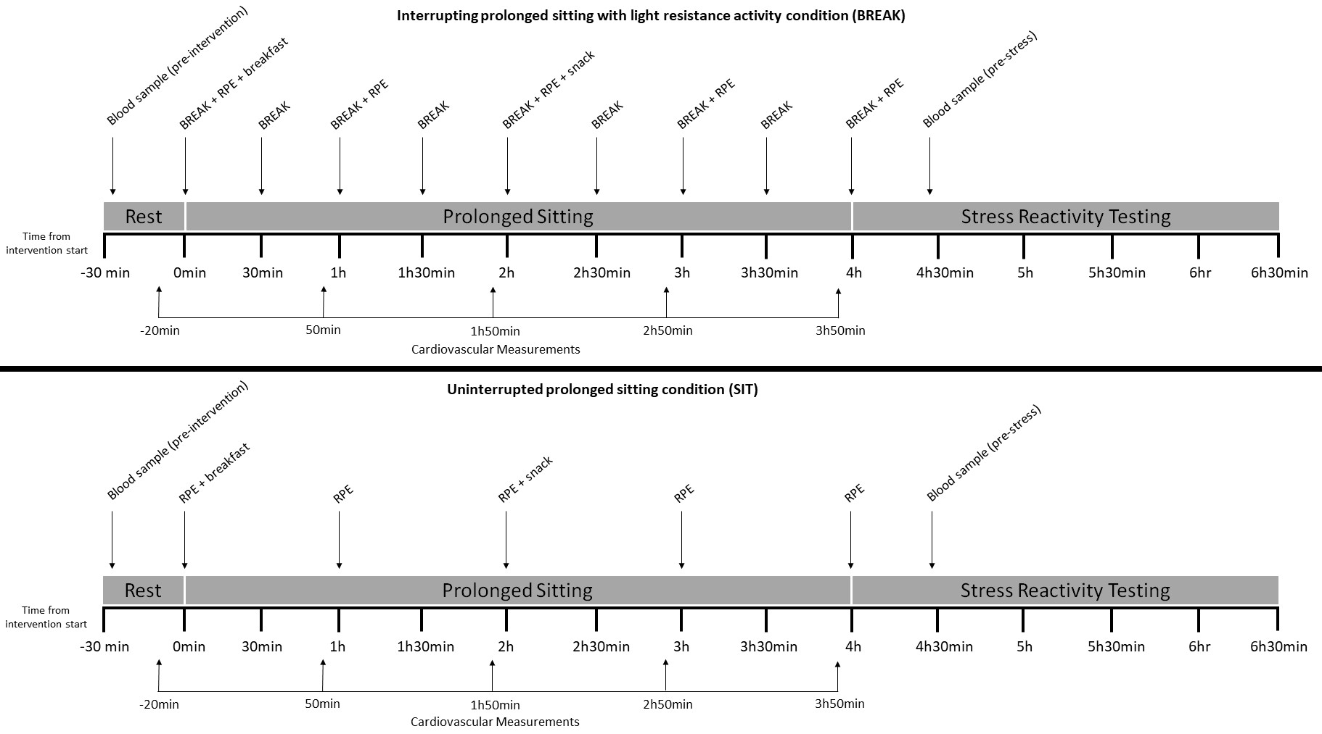
Supplementary Figure 1. Schematic depicting the intervention protocol. BREAK=4min bout of resistance activity, RPE= Rating of Perceived Exertion (BORG scale).
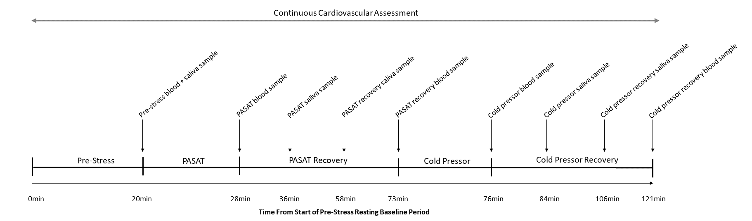
Supplementary Figure 2. Schematic depicting the stress protocol. The 8-min Paced Auditory Serial Addition Test (PASAT) and 3-min Cold Pressor (CP) task were presented in a randomised order across participants, but stress task order remained consistent for each participant during both experimental sessions. The PASAT first protocol is demonstrated above as an example.

 | Time from start of the intervention window
 | -20 min |  | 50 min |  | 1hr 50 min |  | 2hr 50 min |  | 3hr 50 min
 | SIT | BREAK | SIT | BREAK | SIT | BREAK | SIT | BREAK | SIT | BREAK
SBP (mmHg) | 110.1 [105.2, 115.4] | 110.1  [105.1, 115.4] | 111.9 [107.6, 116.4]* | 112.3 [106.5, 118.5]† | 110.9 [105.3, 116.9] | 112.2  [106.5, 118.3] | 109.9 [104.1, 115.9] | 111.3 [106.3, 116.5] | 107.6 [103.1, 112.2]* | 108.5 [103.2, 114.0]†
DBP (mmHg) | 71.8 [67.7, 76.3] | 69.7 [65.5, 74.2] | 68.8 [65.3, 72.5] | 69.6 [65.1, 74.5] | 71.0 [67.3, 74.8] | 69.5 [65.5, 73.8] | 69.8 [65.9, 73.8] | 69.8 [66.1, 73.8] | 70.1 [65.7, 74.6] | 71.5 [67.3, 76.0]
HR  (bpm) | 63.9 [59.9, 67.9] | 67.3 [62.0, 72.6] | 68.4 [63.2, 73.6]* | 74.8 [67.8, 81.8]† | 72.0 [66.1, 78.0]* | 77.5 [71.3, 83.8]† | 67.9 [62.2, 73.5]* | 75.0 [68.9, 81.1]† | 66.0 [60.5, 71.5]* | 71.3 [65.9, 76.7]†
Supplementary Table 1. Resting cardiovascular activity during the SIT and BREAK intervention windows.

Note. SIT= uninterrupted sitting condition, BREAK= interrupted sitting condition, SBP=systolic blood pressure, DBP=diastolic blood pressure, HR=heart rate. Data reflects time-by-condition estimated marginal means [95% confidence intervals] with statistical adjustment for order of intervention allocation. *indicates significantly different from pre-intervention (i.e., -20 min) in the SIT condition (p<.05), †indicates significantly different from pre-intervention (i.e., -20min) in the BREAK condition (p<.05). Time reflects from start of intervention.

