Supplementary Data
The cross-section micrograph of the raw feedstock PLA-CF filament (1.75-mm diameter) is shown in Fig. S 1. Fibres were highly aligned along the direction of the filament.
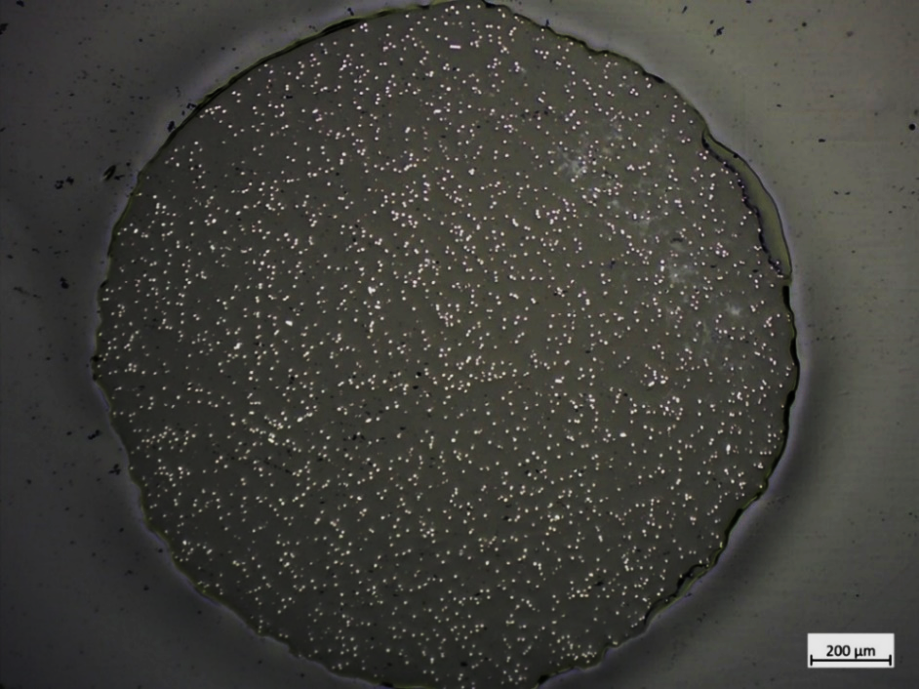
Fig. S 1 Fibre orientation in feedstock filament. Fibres are highly oriented in the feedstock filament.
The fibre orientation at angular turns, cross junction, and ‘T’ junction for ABS-CF is shown in Fig. S 2.
Fig. S 2. Measured fibre orientation of ABS at angular turns and intersections. (a) F-alignment before, at, and after turns with different turning angles. (b) 3D fibre alignment at turn corner with turning angles. (c) 3D fibre alignment at cross junction for both first and second filaments. (d) 3D fibre alignment at ‘T’ junction.

