Supplementary Material
Sustainable energy recovery from mixed agri-food waste by hydrothermal carbonisation: Mechanistic evaluation of the evolution of product characteristics

Authors
- Falilat O. Kassim*, M. Sohail, Bethany Taylor, Oluwasola O.D. Afolabi
Affiliation
School of Civil and Building Engineering, Loughborough University, Loughborough, LE11 3TU, UK.

Corresponding author
*E-mail address: f.o.kassim@lboro.ac.uk

Table S1 Experimental design matrix
Run number | Temperature (℃) | Time (hr) | Solid loading (%)
1 | 190 | 1 | 5
2 | 190 | 5 | 5
3 | 210 | 3 | 5
4 | 230 | 1 | 5
5 | 230 | 5 | 5
6 | 190 | 3 | 12.5
7 | 210 | 1 | 12.5
8 | 210 | 3 | 12.5
9 | 210 | 5 | 12.5
10 | 230 | 3 | 12.5
11 | 190 | 1 | 20
12 | 190 | 5 | 20
13 | 210 | 3 | 20
14 | 230 | 1 | 20
15 | 230 | 5 | 20

Table S2 Fuctional groups of raw-MAFW and hydrochar
Wavenumber (cm⁻¹) | Functional group | Band assignment
3400 | O─H stretching | Hydroxyl groups
2920, 2850 | C─H asymmetric and symmetric stretching | Aliphatic
1730 | C═O stretching | Esters in hemicellulose
1700 | C═O stretching | Carbonyl, ester or carboxyl from cellulose and lignin
1636 | C═O stretching | Amide I band of protein
1615, 1515 | C═C stretching | Aromatic skeletal in lignin
1383 | C─O stretching | Syringyl group in lignin
1248 | C─O stretching | Guaiacyl group in lignin
1160 | C─O─C unsymmetric stretching | Glycosidic bond in cellulose
1112, 1060, 1032 | C─O stretching | Ether bonds in cellulose
800-790 | C-H deformation in aromatic compounds | Aromatics

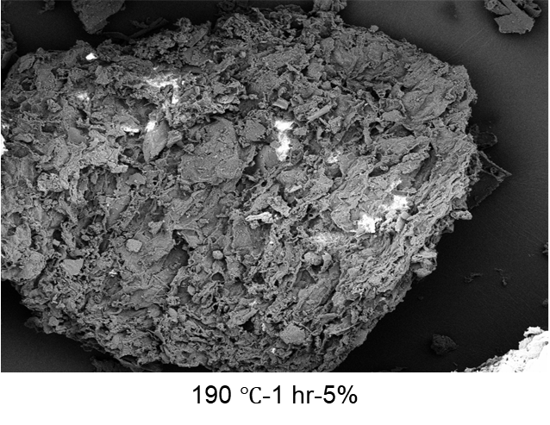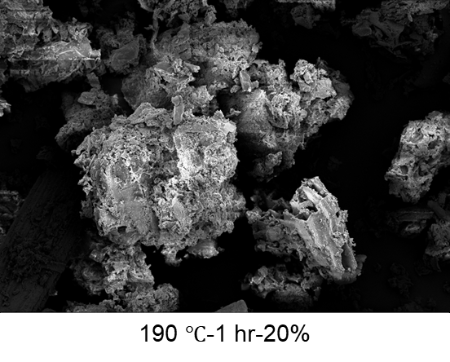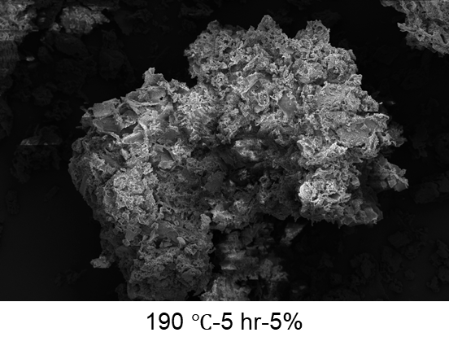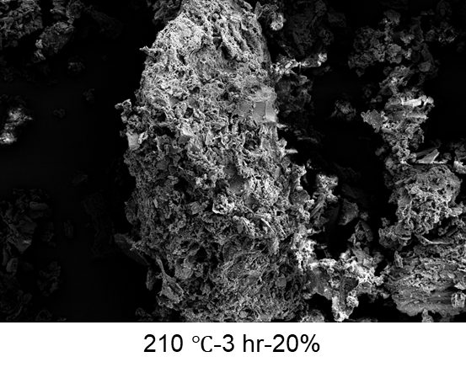
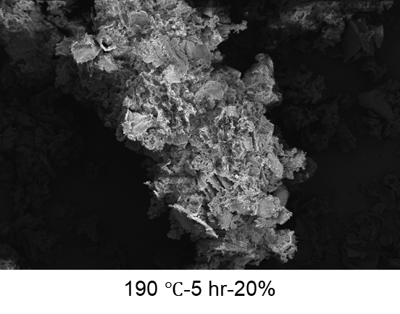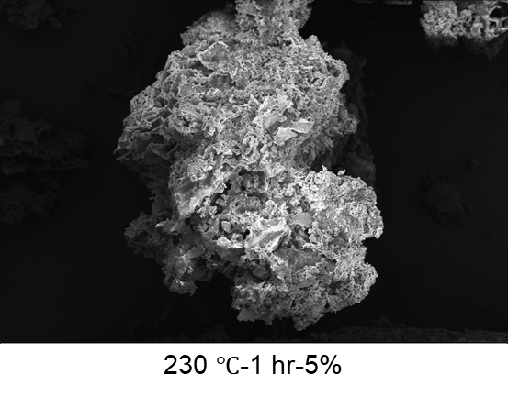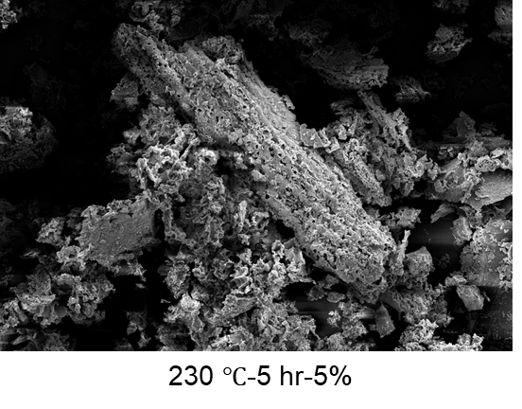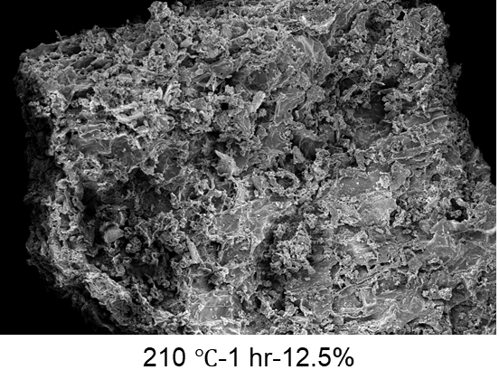
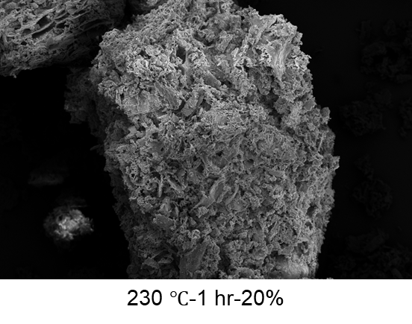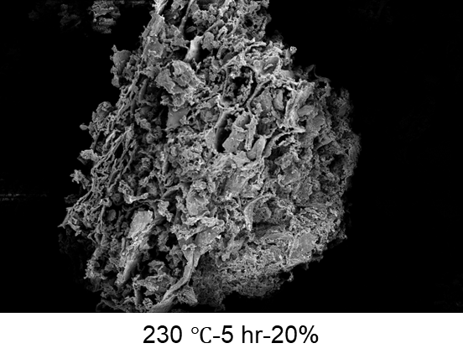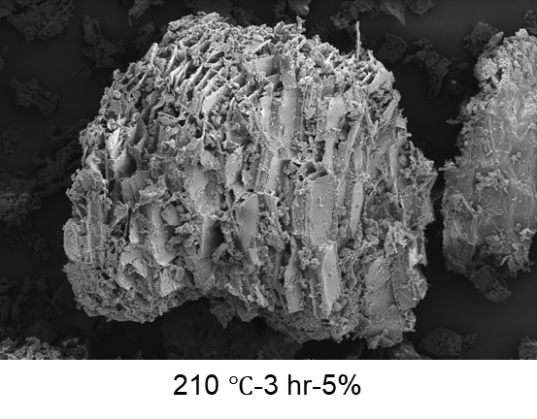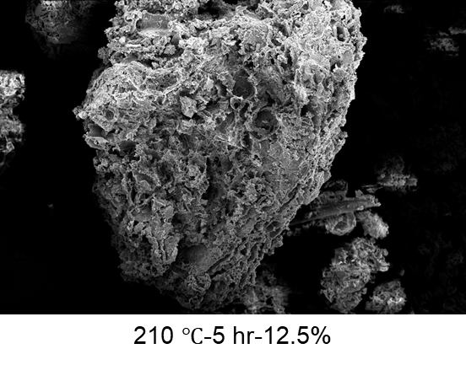
Fig. S1. SEM micrographs of raw agri-food waste and hydrochars at different operating conditions (Scale: 20 µm; Mag: ×500)

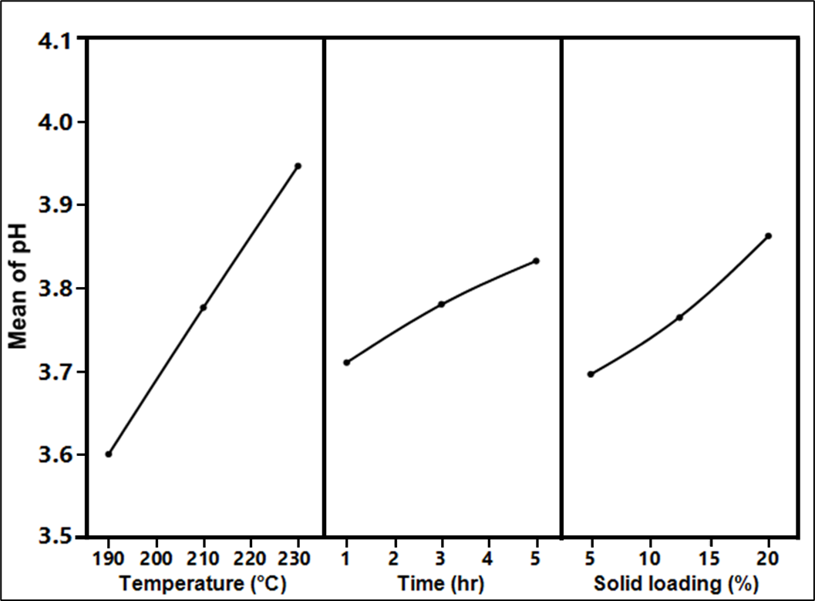
Fig. S2. Main effect plot for pH
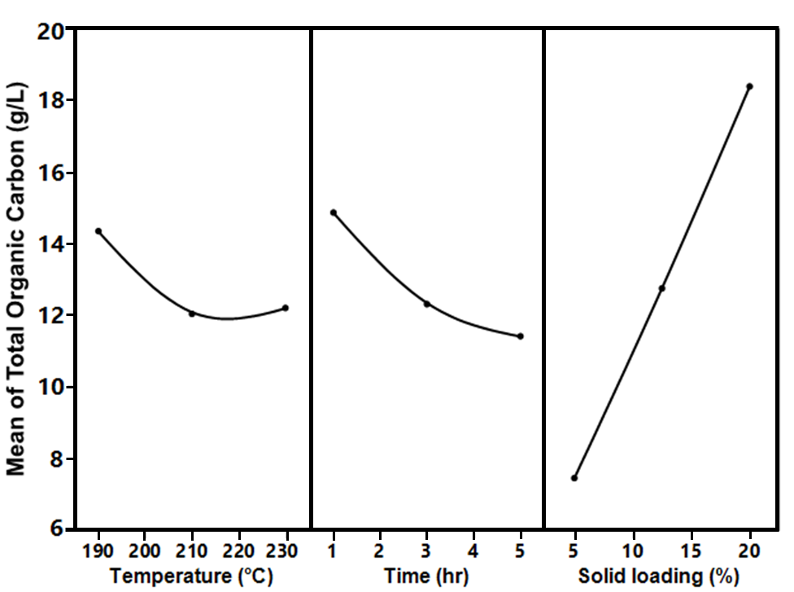
Fig. S3. Main effect plot for total organic carbon
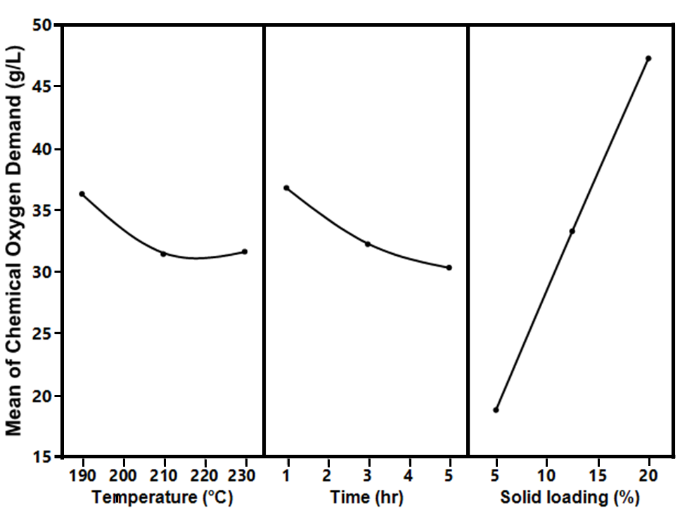
Fig. S4. Main effect plot for chemical oxygen demand
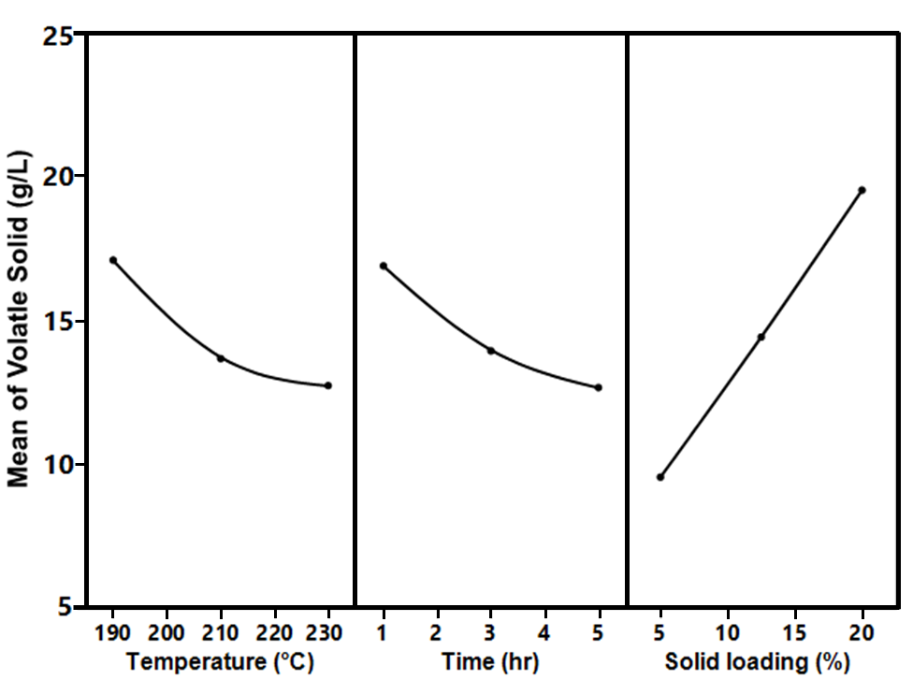
Fig. S5. Main effect plot for volatile solid
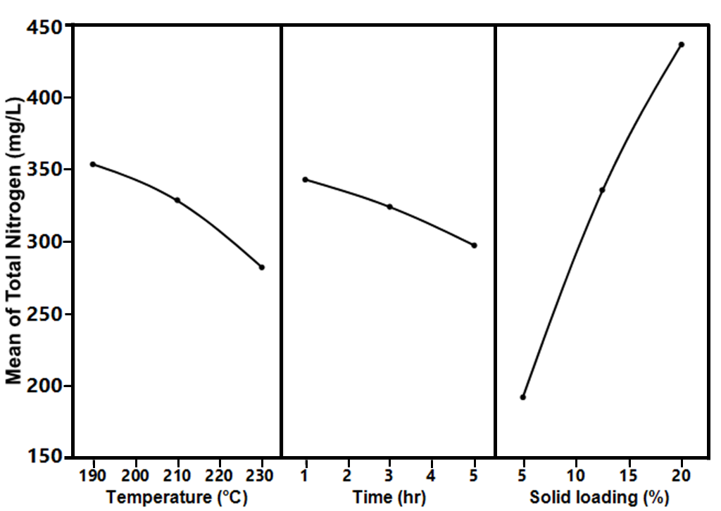
Fig. S6. Main effect plot for total nitrogen
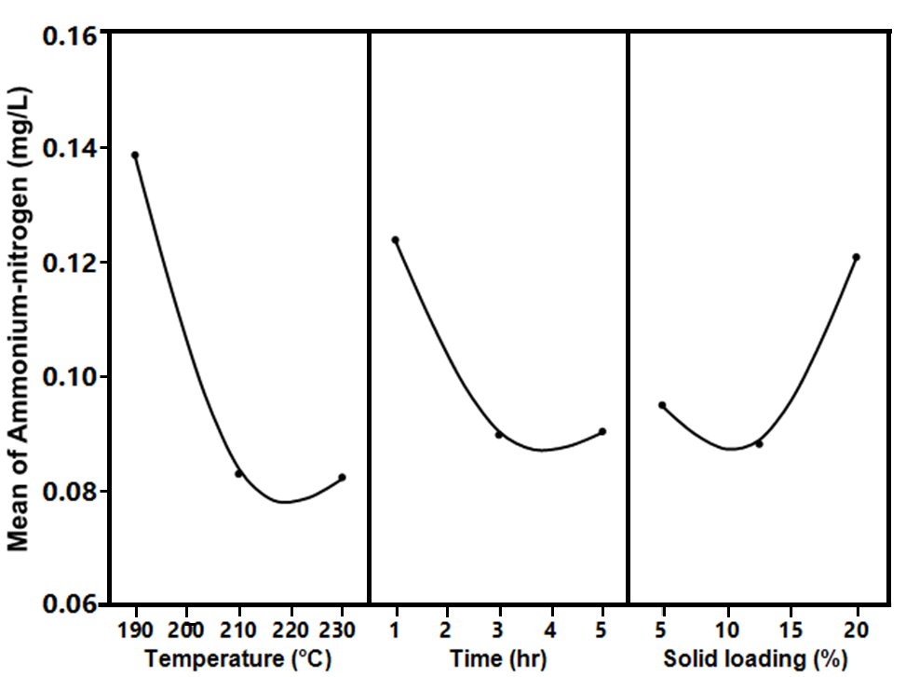
Fig. S7. Main effect plot for ammonium-nitrogen
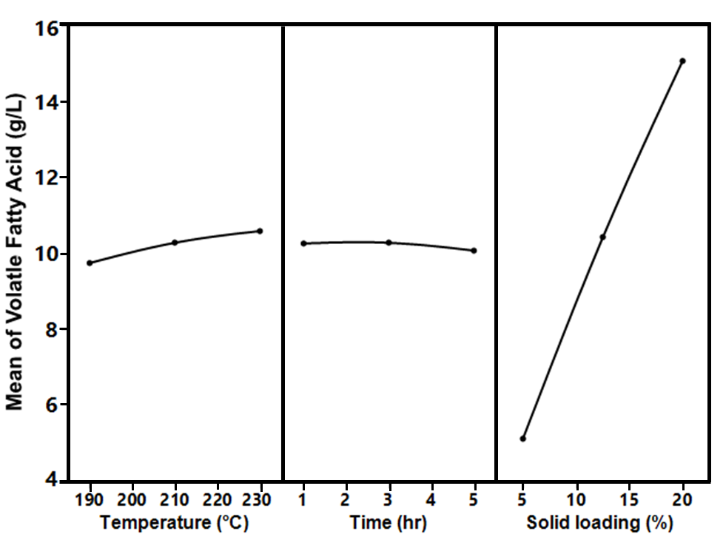
Fig. S8. Main effect plot for volatile fatty acid
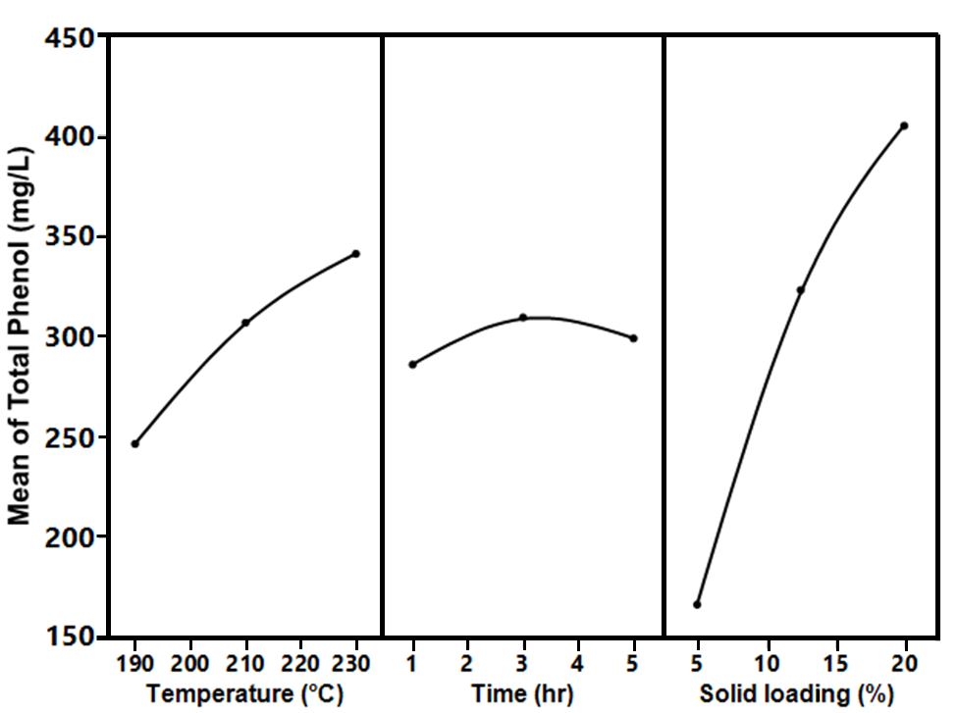
Fig. S9. Main effect plot for total phenol
(a)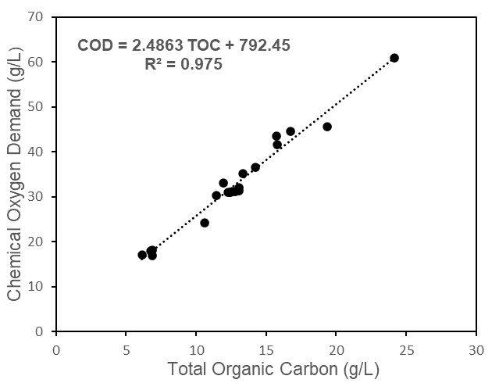
(b)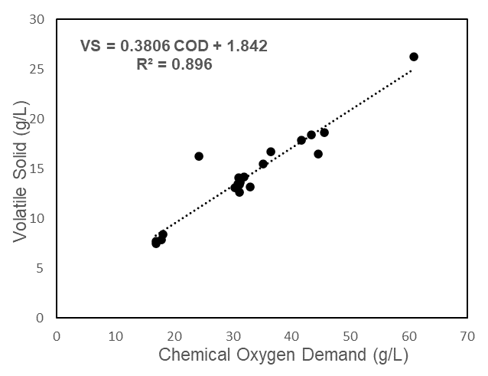
(c)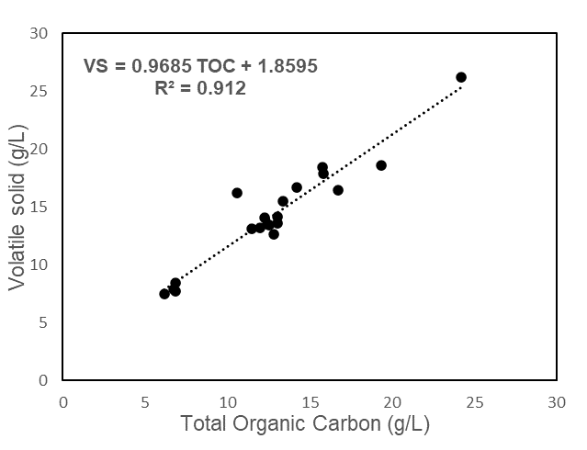
Fig. S10. Correlation of (a) chemical oxygen demand and total organic carbon (b) volatile solid and chemical oxygen demand (c) volatile solid and total organic carbon

Table S3 Benefits and limitations of different process water valorisation techniques.
Valorisation techniques | Benefits | Drawbacks
Recirculation | - Reduction of freshwater consumption.  - No requirement for additional reactor.  - Enhanced hydrochar energy yield. | - Amount of process water recirculated is restricted to initial water requirement.  - Accumulation of organic component in recycled process water.  - Final treatment of process water still required.
Anaerobic digestion | - Enhancement of energy recovery due to recovery additional biofuel (i.e., biomethane)  - High efficiency of organic matter utilisation | - Process inhibition due to toxic intermediates  - Suitable for non-toxic PW  - Limited nutrient utilisation  - Low process energy requirement
Wet oxidation | - High capability for treatment of process water rich in toxic intermediates.  - High organic matter conversion  - Resultant process water has improved biodegradability | - Limited nutrient utilisation  - High process energy requirement
Nutrient recovery | - High-value product recovery  - Efficient utilisation of nutrient | - Limited organic matter utilisation.  - Low pollutant removal rate  - Extraction efficiency is limited to nutrient concentration in process water.
Chemical recovery | - Recovery of value-added chemicals  - Efficient utilisation of chemical compounds | - Limited application for process water with highly complex composition  - Extraction efficiency is limited to the specific chemical concentration in process water

