Monthly sampling reveals seasonal fine sediment fluctuations and riverine invertebrate community responses

Noah G. Davis^{a*}, Kate L. Mathers^{b}, Roger Hodson and Christoph D. Matthaeiª

ª Department of Zoology, University of Otago, Dunedin, New Zealand
^{b} Geography and Environment, Loughborough University, Loughborough, Leicestershire LE11 3TU, United Kingdom

Corresponding author: Noah G. Davis: * davno443@student.otago.ac.nz

MCI (Fig. S2) and Sediment-MCI (Fig. S3) both detected 11 negative linear relationships with % sediment cover strong enough to be biologically meaningful (of 11 possible ones: effect size r2≥0.1). MCI and Sediment-MCI each identified a weak relationship (r2≥0.1 but >0.3) with % sediment cover in November 2019 and August 2020, a moderate relationship (r2≥0.3 but >0.5) in October 2020, and a strong relationship (r2≥0.5) in March 2020. Differences in the categorical strengths of the relationships occurred in the remaining six months. Moderate relationships were observed by Sediment-MCI in December 2019, and January, May, and September 2020 whereas MCI found strong, strong, weak, and weak relationships, respectively. In February, June, and July 2020, strong relationships were identified by Sediment-MCI compared to moderate, moderate, and weak relationships by MCI. Of the 11 sampling occasions, Sediment-MCI performed better on seven occasions compared to three by MCI (Table 1; based on absolute effect sizes, one instance where performance was the same).
QMCI (Fig. S4) and Sediment-QMCI (Fig. S5), respectively, detected ten and six biologically meaningful relationships with % sediment cover. Biologically meaningful relationships were negative and linear with the exception for Sediment-QMCI 2019 which displayed a positive linear relationship with % sediment cover. Differences in the categorical strength of relationships between QMCI and Sediment-QMCI were observed for all sampling months. No biologically meaningful relationships were identified by Sediment-QMCI for November 2019, and January, February, March, and May 2020 whereas QMCI found, respectively, strong, moderate, moderate, weak, and weak relationships. Weak relationships were identified in June, July, August, and October 2020 using QMCI compared to moderate relationships found by Sediment-QMCI. In December 2019 and September 2020, strong and no relationships were detected by QMCI, respectively, compared to weak and strong relationships identified by Sediment-QMCI. Of the 11 sampling occasions, QMCI performed better on seven occasions compared to four by Sediment-QMCI (Table 1; based on absolute effect sizes).
%EPT abundance (Fig. S6) and %Decreaser abundance (Fig. S7) both detected 11 biologically meaningful relationships (negative and linear) with % sediment cover. Categorical differences in the strengths of their relationships were found on two occasions. In November 2019 and August 2020, %EPT abundance observed a strong and moderate relationship, respectively, whereas %Decreaser abundance identified weak relationships. A strong relationship was detected in December 2019, and moderate relationships found for January – July 2020 and September – October 2020. Of the 11 sampling occasions, %EPT abundance and %Decreaser abundance both performed better on four occasions (Table 1; based on absolute effect sizes, three cases where performance was the same).
%EPT richness (Fig. S8) and %Decreaser richness (Fig. S9), respectively, detected eight and 11 biologically meaningful relationships (negative and linear) with % sediment cover. In January and September 2020, moderate and weak relationships, respectively, were identified by %EPT richness and %Decreaser abundance. Weak relationships were found in November – December 2019 and June 2020 by %EPT richness, in contrast to moderate, moderate, strong relationships, respectively, found by %Decreaser abundance. Moderate relationships were observed in February – March 2020 by %EPT richness whereas %Decreaser abundance identified strong relationships. %EPT richness did not find biologically meaningful relationships in May, July, and August 2020 whereas %Decreaser abundance was able to detect moderate, weak, and moderate relationships, respectively. In October 2020, a strong and moderate relationship was found by %EPT richness and %Decreaser richness, respectively. Of the 11 sampling occasions, %Decreaser abundance performed better on ten occasions compared to one by %EPT richness (Table 1; based on absolute effect sizes).
Both MCI (Fig. S10) and Sediment-MCI (Fig. S11) detected 11 biologically meaningful relationships with SIS. All 22 regressions displayed negative response directions and linear shapes for each invertebrate metric that were comparable for all sampling months, although in some cases the categorical strengths of these relationships differed (Table 1). MCI and Sediment-MCI both identified moderate relationships for November and December 2019, January and October 2020, and strong relationships for March, June, August and September 2020. Differences in categorical relationship strength between metrics occurred in February, May and July 2020 where MCI detected moderate, weak and moderate relationships, respectively, compared to strong, moderate, and strong relationships for Sediment-MCI. Of the 11 sampling occasions, Sediment-MCI performed better in seven cases compared to three for MCI (Table 1; based on absolute effect sizes, one occasion where performance was the same).
QMCI (Fig. S12) and Sediment-QMCI (Fig. S13), respectively, detected 11 and nine relationships (negative and linear) with SIS strong enough to be biologically meaningful. In November 2019, and March, September, and October 2020, QMCI and Sediment-QMCI both identified strong, moderate, moderate, and weak relationships, respectively. Strong relationships were observed in January, February, and June 2020 using QMCI whereas Sediment-QMCI found no meaningful, moderate, and weak relationships, respectively. QMCI detected moderate relationships in May, July, and August 2020 compared to weak, strong, and strong relationships, respectively, identified by Sediment-QMCI. In December 2019, QMCI and Sediment-QMCI, respectively, found weak and no meaningful relationships. Of the 11 sampling occasions, QMCI performed better on seven occasions compared to four by Sediment-QMCI (Table 1; based on absolute effect sizes).
%EPT richness (Fig. S14) and %Decreaser richness (Fig. S15), respectively, detected ten and 11 biologically meaningful relationships (linear and negative) with SIS. Moderate relationships were identified in December 2019 by both %EPT richness and %Decreaser richness, otherwise, categorical differences in relationship strength were observed for the remining sampling months. Strong relationships were observed by %Decreaser richness in January, February, March, July, August, and September 2020, whereas %EPT richness, respectively, found weak, moderate, weak, moderate, moderate, and moderate relationships. %Decreaser richness detected moderate relationships in December 2019, and May, June, and October 2020 compared to weak, no meaningful, weak, and moderate relationships found by %EPT richness, respectively. Of the 11 sampling occasions, %Decreaser richness performed better on ten occasions compared to one by %EPT richness (Table 1; based on absolute effect sizes).
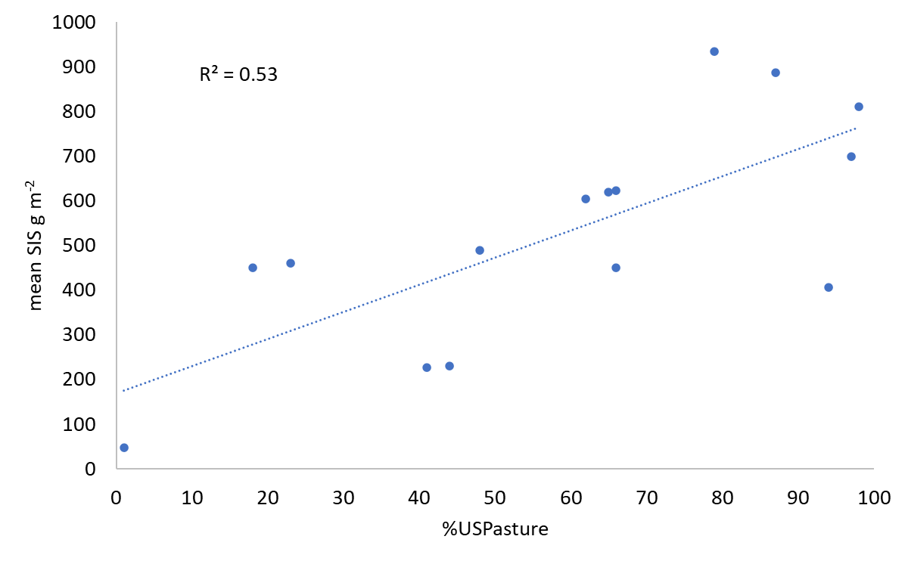
Fig. S1: Linear relationship between the percentage of pasture in the upstream catchment (%USPasture) and mean site measurements of SIS g m⁻² (see methods for further details) for the 15 sample locations.
Table S1. Geographical and physical characteristics for all 15 sampling sites.

Site Name | Easting | Northing | Soft/Hard Bottom | Stream Order | %USPasture | SIS | Climate | Source of flow | Geology | Land-cover | Valley landform
Cromel Stream at Selbie Road | 1239102 | 4942045 | hard | 4 | 1 | 47.46 | Cool-wet | Hill | Hard sedimentary | Indigenous forest | Low-gradient
Lill Burn at Lill Burn-Monowai Road | 1187270 | 4891852 | hard | 5 | 18 | 451.04 | Cool-wet | Low elevation | Soft sedimentary | Indigenous forest | Low-gradient
Aparima River at Dunrobin | 1220049 | 4923512 | hard | 5 | 23 | 460.65 | Cool-wet | Hill | Hard sedimentary | Indigenous forest | Low-gradient
Wairaki River at Blackmount Road | 1189459 | 4899570 | hard | 5 | 41 | 226.17 | Cool-wet | Hill | Hard sedimentary | Pastoral | Low-gradient
Whitestone River d/s Manapouri-Hillside | 1190428 | 4944699 | hard | 5 | 44 | 230.52 | Cool-wet | Hill | Soft sedimentary | Pastoral | Low-gradient
Otapiri Stream at Otapiri Gorge | 1248293 | 4895857 | hard | 5 | 48 | 489.78 | Cool-wet | Low elevation | Hard sedimentary | Pastoral | Low-gradient
Mokoreta River at Wyndham River Road | 1280248 | 4857717 | hard | 5 | 62 | 604.73 | Cool-wet | Low elevation | Soft sedimentary | Pastoral | Low-gradient
Mimihau Stream at Wyndham | 1281312 | 4861933 | hard | 5 | 65 | 620.25 | Cool-wet | Low elevation | Soft sedimentary | Pastoral | Low-gradient
Hamilton Burn at Affleck Road | 1226219 | 4918606 | hard | 5 | 66 | 450.19 | Cool-dry | Low elevation | Alluvium | Pastoral | Low-gradient
Hedgehope Stream 20m u/s Makarewa Confl | 1249666 | 4866258 | hard | 5 | 66 | 622.54 | Cool-dry | Low elevation | Soft sedimentary | Pastoral | Low-gradient
Otautau Stream at Otautau-Tuatapere Road | 1211972 | 4879606 | hard | 5 | 79 | 935.09 | Cool-dry | Low elevation | Alluvium | Pastoral | Low-gradient
Waituna Creek at Marshall Road | 1258129 | 4838488 | hard | 4 | 87 | 887.64 | Cool-dry | Low elevation | Soft sedimentary | Pastoral | Low-gradient
Waimatuku at Waimatuku Township Road | 1228428 | 4859573 | hard | 5 | 94 | 406.03 | Cool-dry | Low elevation | Alluvium | Pastoral | Low-gradient
Waihopai River u/s Queens Drive | 1243748 | 4852763 | hard | 5 | 97 | 698.69 | Cool-dry | Low elevation | Alluvium | Pastoral | Low-gradient
Longridge Stream at Sandstone | 1258724 | 4909162 | hard | 4 | 98 | 810.28 | Cool-dry | Low elevation | Alluvium | Pastoral | Low-gradient

Fig. S2: Linear relationships between site measurements of % sediment cover and Sediment-MCI scores (n=15) for each sampling month. Regression lines and r² values are shown for biologically meaningful relationships. Note: Due to river conditions on the day of sampling (see Methods), n=13 in March 2020, n=14 in August 2020, and n=14 in October 2020.
Fig. S3: Linear relationships between site measurements of % sediment cover and Sediment-MCI scores (n=15) for each sampling month. Regression lines and r² values are shown for biologically meaningful relationships. See Fig. S2 for further details.
Fig. S4: Linear relationships between site measurements of % sediment cover and QMCI scores (n=15) for each sampling month. Regression lines and r² values are shown for biologically meaningful relationships. See Fig. S2 for further details.
Fig. S5: Linear relationships between site measurements of % sediment cover and Sediment-QMCI scores (n=15) for each sampling month. Regression lines and r² values are shown for biologically meaningful relationships. See Fig. S2 for further details.
Fig. S6: Linear relationships between site measurements of % sediment cover and %EPT abundance (n=15) for each sampling month. Regression lines and r² values are shown for biologically meaningful relationships. See Fig. S2 for further details.
Fig. S7: Linear relationships between site measurements of % sediment cover and %Decreaser abundance (n=15) for each sampling month. Regression lines and r² values are shown for biologically meaningful relationships. See Fig. S2 for further details.
Fig. S8: Linear relationships between site measurements of % sediment cover and %EPT richness (n=15) for each sampling month. Regression lines and r² values are shown for biologically meaningful relationships. See Fig. S2 for further details.
Fig. S9: Linear relationships between site measurements of % sediment cover and %Decreaser richness (n=15) for each sampling month. Regression lines and r² values are shown for biologically meaningful relationships. See Fig. S2 for further details.
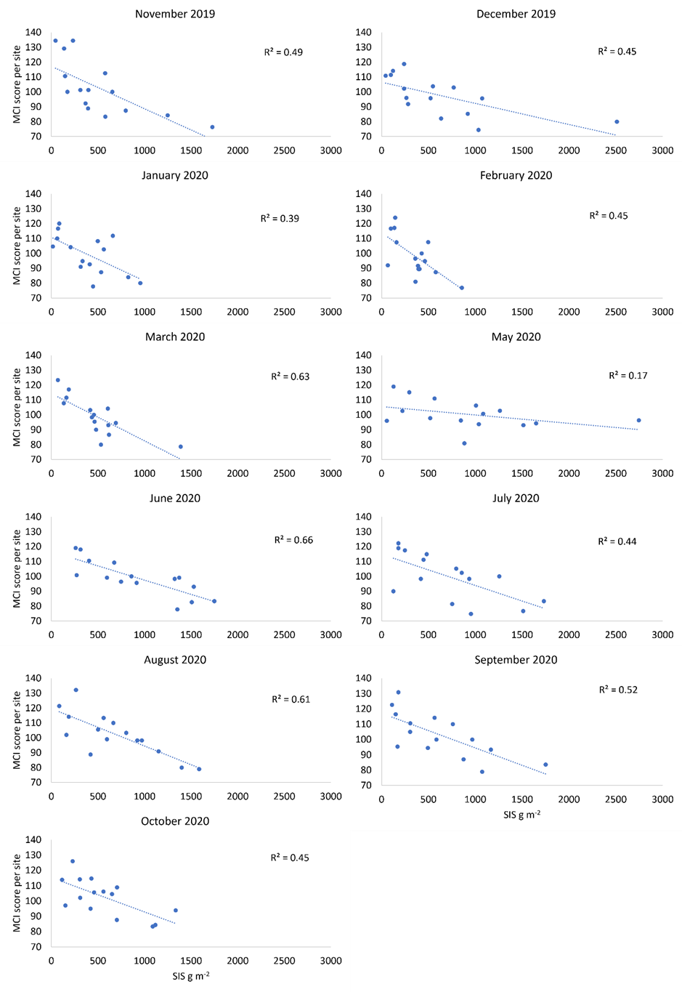
Fig. S10: Linear relationships between site measurements of SIS g m⁻² and MCI scores (n=15) for each sampling month. Regression lines and r²-values are shown for biologically meaningful relationships (r² ≥ 0.1).
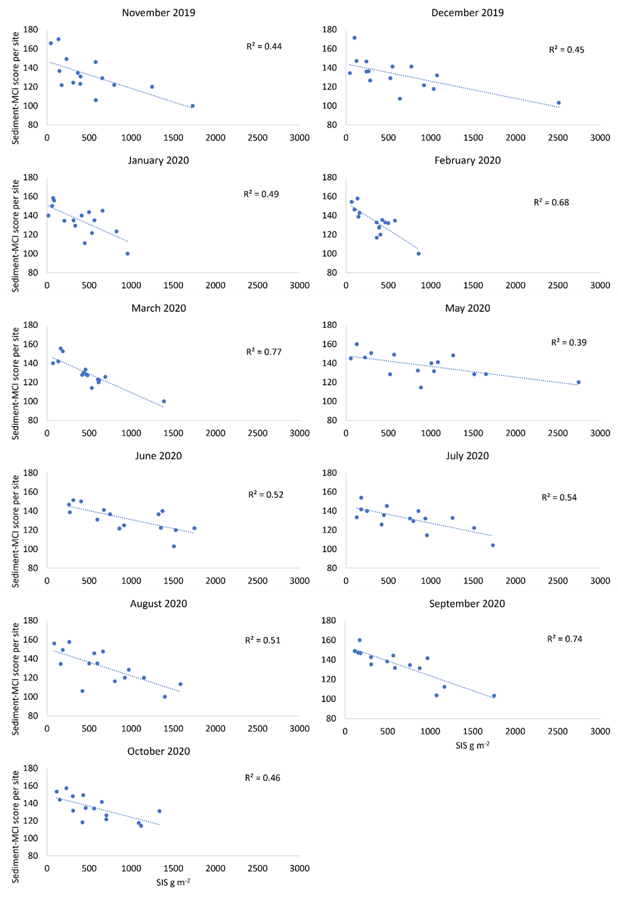
Fig. S11: Linear relationships between site measurements of SIS g m⁻² and Sediment-MCI scores (n=15) for each sampling month. Regression lines and r² values are shown for biologically meaningful relationships.
Fig. S12: Linear relationships between site measurements of SIS g m⁻² and QMCI scores (n=15) for each sampling month. Regression lines and r² values are shown for biologically meaningful relationships.
Fig. S13: Linear relationships between site measurements of SIS g m⁻² and Sediment-QMCI scores (n=15) or each sampling month. Regression lines and r² values are shown for biologically meaningful relationships.
Fig. S14: Linear relationships between site measurements of SIS g m⁻² and %EPT richness (n=15) for each sampling month. Regression lines and r² values are shown for biologically meaningful relationships.
Fig. S15: Linear relationships between site measurements of SIS g m⁻² and %Decreaser richness (n=15) for each sampling month. Regression lines and r² values are shown for biologically meaningful relationships.

