Appendices
Appendix A: Search terms & strategy
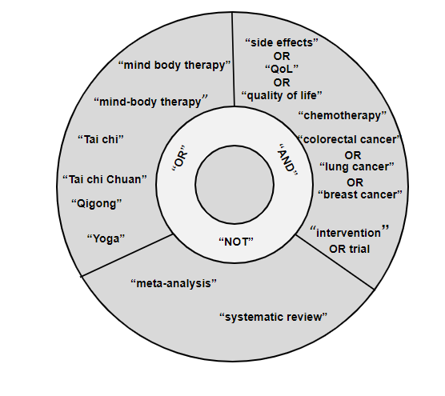

Appendix B: Questions assessed for risk of bias.
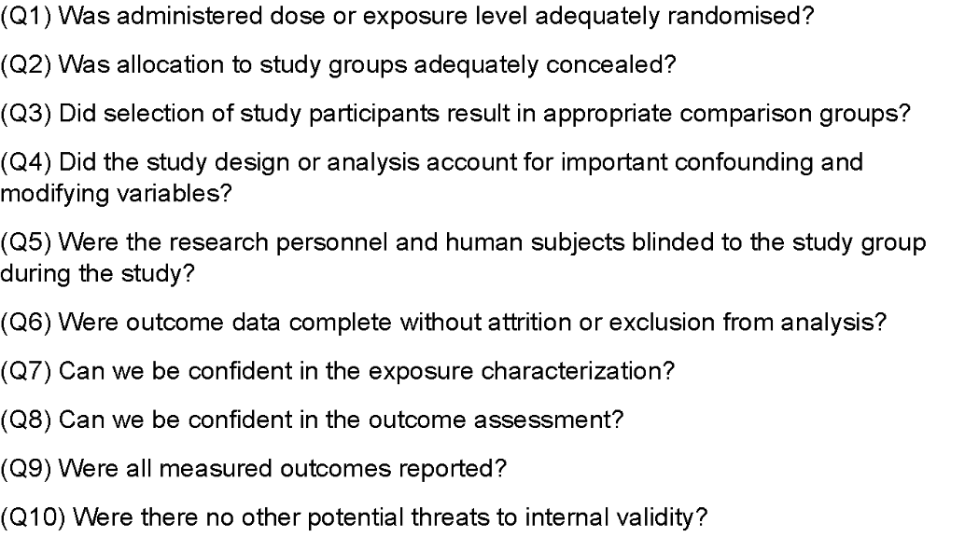

Appendix C: Sensitivity analysis.
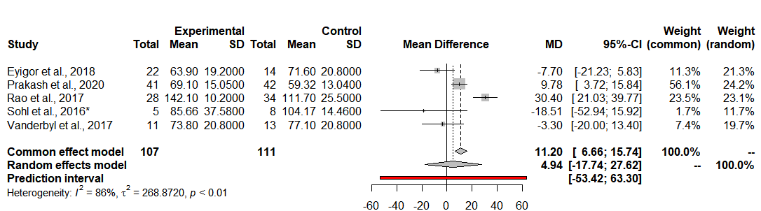
Appendix C1. Combined observations: 300. Observed heterogeneity between publications detected using Higgin's I² and t². Meta-analytical method: Inverse variance method, Sidik-Jonkman estimator for t². Hedges g. Random effects model 7.55 (95% CI: 10.72 to 27.62; p = 0.58). Prediction interval (-40.50 to 55.61). Abbreviations: CI = confidence interval; MD = mean difference; SD = standard deviation.
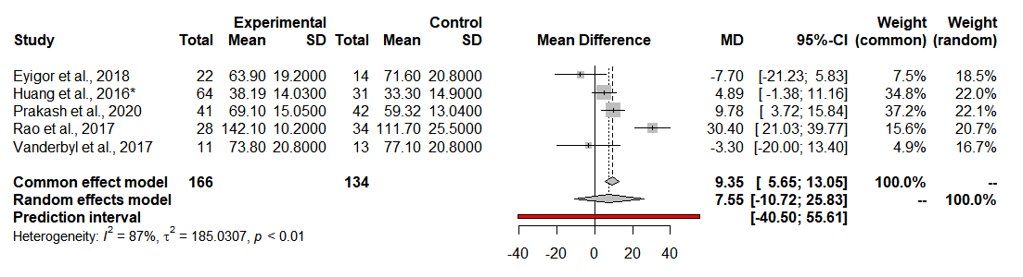Appendix C2. Combined observations: 218. Observed heterogeneity between publications detected using Higgin's I² and t². Meta-analytical method: Inverse variance method, Sidik-Jonkman estimator for t². Hedges g. Random effects model 4.94 (95% CI: 17.74 to 27.62; p = 0.32). Prediction interval (-53.41 to 63.30). *Transformed data. Data for Vanderbyl et al.(24) used with imputed SD value. Abbreviations: CI = confidence interval; MD = mean difference; SD = standard deviation.
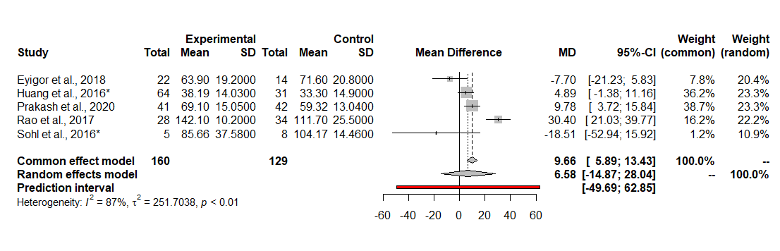Appendix C3. Combined observations: 289. Observed heterogeneity between publications detected using Higgin's I² and t². Meta-analytical method: Inverse variance method, Sidik-Jonkman estimator for t². Hedges g. Random effects model 6.58 (95% CI: -14.87 to 28.04; p = 0.085). Prediction interval (-49.69 to 62.85). *Transformed data. Data for Huang et al.(50) and Sohl et al.(52) used with imputed SD value. Abbreviations: CI = confidence interval; MD = mean difference; SD = standard deviation.
Appendix D: PRISMA Checklist
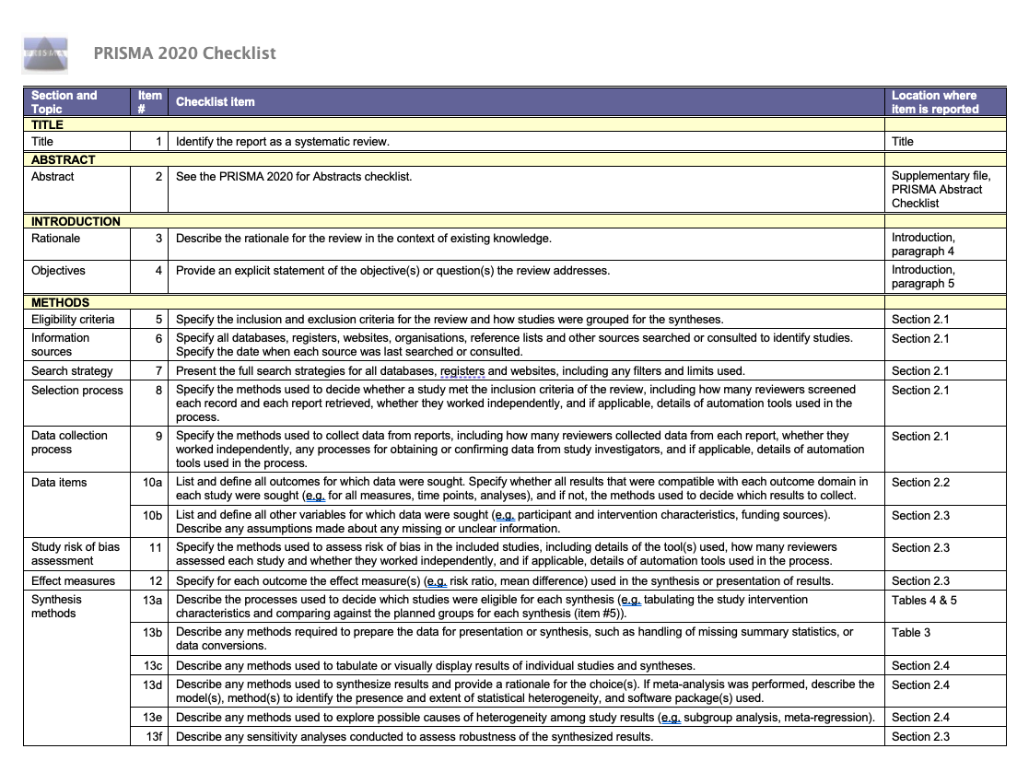
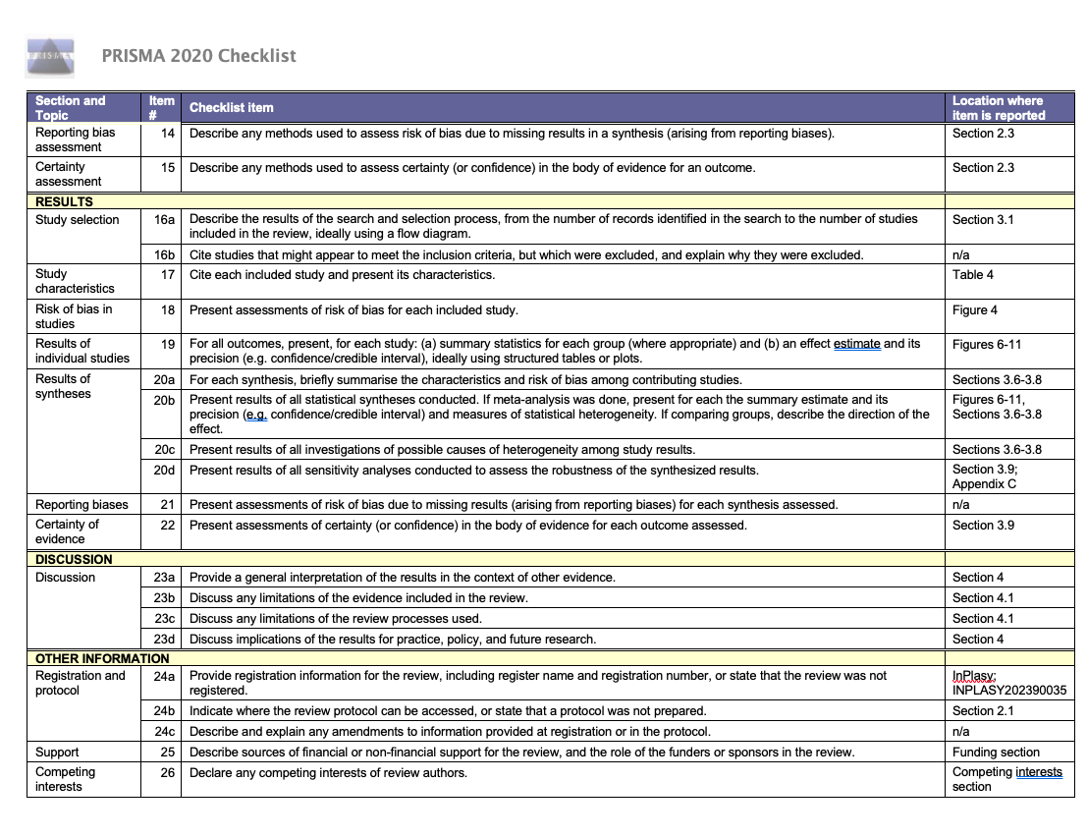
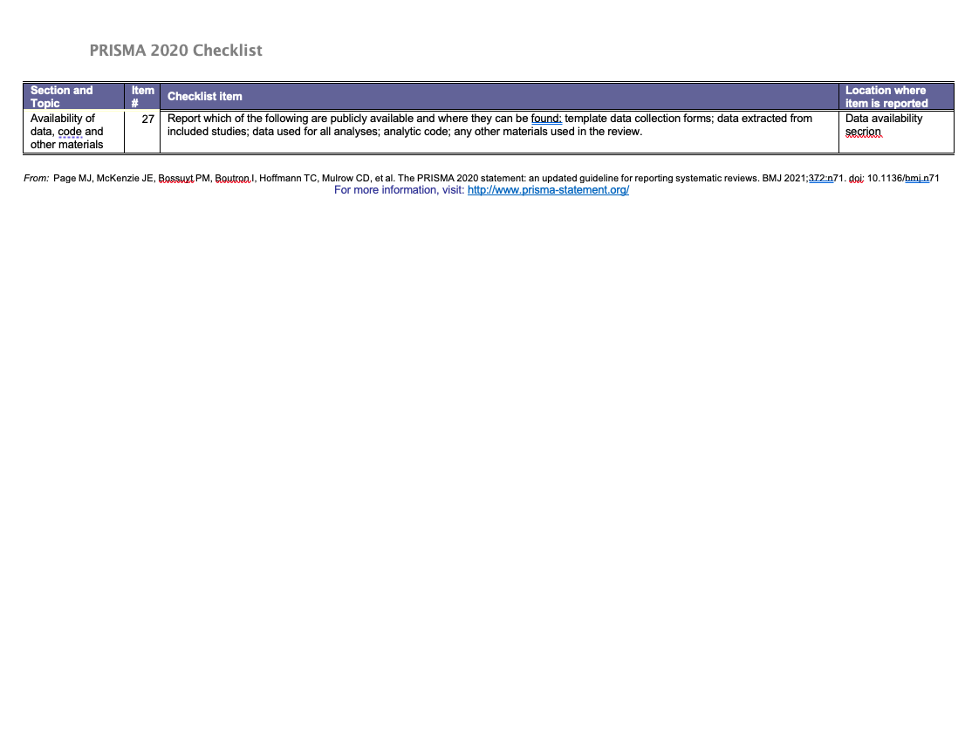

Appendix E: PRISMA Abstract Checklist
