Supplementary Material
Hydrothermal carbonisation of mixed agri-food waste: Process optimisation and mechanistic evaluation of hydrochar inorganic chemistry

Authors
- Falilat O. Kassim*, M. Sohail, Bethany Taylor, Oluwasola O.D. Afolabi
Affiliation
School of Architecture, Building and Civil Engineering, Loughborough University, Loughborough, LE11 3TU, UK.

Corresponding author
*E-mail address: f.o.kassim@lboro.ac.uk

Table S1. Analysis of variance (ANOVA) of the regression model for prediction of hydrochar yield
Source | Sum of squares | Degree of freedom | Mean square | F Value | p-value (Prob > F)
Model | 1445.6985 | 9 | 160.633 | 146.4959 | <0.0001
T | 377.43627 | 1 | 377.4363 | 344.2184 | <0.0001
t | 12.56785 | 1 | 12.5679 | 11.3706 | 0.0014
SL | 736.16440 | 1 | 736.1644 | 671.3751 | <0.0001
T × t | 51.53870 | 1 | 51.5387 | 47.0028 | <0.0001
T × SL | 34.92094 | 1 | 34.9209 | 31.8476 | <0.0001
t × SL | 11.05684 | 1 | 11.0568 | 10.0837 | 0.0026
T² | 72.00227 | 1 | 72.0023 | 65.6654 | <0.0001
t² | 0.61979 | 1 | 0.6198 | 0.5652 | 0.4557
SL² | 18.17455 | 1 | 18.1745 | 16.5750 | 0.0002
Residual | 54.8251 | 50 | 1.097
Lack of Fit | 23.401228 | 5 | 4.68025 | 6.7023 | <0.0001
Pure Error | 31.423894 | 45 | 0.69831
Cor Total | 1500.5236 | 59
Table S2. Analysis of variance (ANOVA) of the regression model for prediction of higher heating value
Source | Sum of squares | Degree of freedom | Mean square | F Value | p-value (Prob > F)
Model | 148.45082 | 9 | 16.4945 | 105.3811 | <0.0001
T | 126.25957 | 1 | 126.2596 | 806.6536 | <0.0001
t | 16.83003 | 1 | 16.8300 | 107.5246 | <0.0001
SL | 0.15038 | 1 | 0.1504 | 0.9608 | 0.3317
T × t | 0.13157 | 1 | 0.1316 | 0.8406 | 0.3636
T × SL | 0.01274 | 1 | 0.0127 | 0.0814 | 0.7766
t × SL | 1.19662 | 1 | 1.1966 | 7.6450 | 0.0080
T² | 3.19599 | 1 | 3.1960 | 20.4187 | <0.0001
t² | 0.11505 | 1 | 0.1151 | 0.7350 | 0.3953
SL² | 0.10304 | 1 | 0.1030 | 0.6583 | 0.4210
Residual | 7.82613 | 50 | 0.1565
Lack of Fit | 2.0317900 | 5 | 0.406358 | 3.1559 | 0.0159
Pure Error | 5.7943431 | 45 | 0.128763
Cor Total | 156.27695 | 59
Table S3. Analysis of variance (ANOVA) of the regression model for prediction of ash content
Source | Sum of squares | Degree of freedom | Mean square | F Value | p-value (Prob > F)
Model | 75.536712 | 9 | 8.39297 | 27.8725 | <0.0001
T | 0.241203 | 1 | 0.24120 | 0.8010 | 0.3751
t | 1.256653 | 1 | 1.25665 | 4.1733 | 0.0464
SL | 59.473920 | 1 | 59.47392 | 197.5092 | <0.0001
T × t | 2.419350 | 1 | 2.41935 | 8.0345 | 0.0066
T × SL | 4.216817 | 1 | 4.21682 | 14.0038 | 0.0005
t × SL | 0.470400 | 1 | 0.47040 | 1.5622 | 0.2172
T² | 5.282000 | 1 | 5.28200 | 17.5412 | 0.0001
t² | 2.952027 | 1 | 2.95203 | 9.8035 | 0.0029
SL² | 1.442727 | 1 | 1.44273 | 4.7912 | 0.0333
Residual | 15.055986 | 50 | 0.30112
Lack of Fit | 9.440875 | 5 | 1.88817 | 15.1320 | <0.0001
Pure Error | 5.615111 | 45 | 0.12478
Cor Total | 90.592698 | 59

Table S4. Inorganic elemental composition of the hydrochar at different HTC operating conditions
 | mg/kg (dry basis)
Sample* | Al | Ca | Fe | K | Mg | P | S | Si
190-1-5 | 491 | 2835 | 303 | 898 | 116 | 171 | 627 | 62
190-5-5 | 397 | 2263 | 229 | 762 | 108 | 136 | 541 | 21
210-3-5 | 455 | 1223 | 299 | 754 | 117 | 135 | 523 | 30
230-1-5 | 487 | 589 | 337 | 658 | 160 | 245 | 519 | 30
230-5-5 | 450 | 1295 | 369 | 900 | 175 | 613 | 631 | 35
190-3-12.5 | 395 | 2865 | 228 | 2518 | 239 | 325 | 633 | 29
210-1-12.5 | 512 | 2520 | 327 | 2308 | 233 | 332 | 602 | 39
210-3-12.5 | 428 | 2208 | 289 | 2278 | 257 | 434 | 651 | 37
210-5-12.5 | 375 | 1795 | 286 | 2040 | 256 | 611 | 661 | 27
230-3-12.5 | 468 | 1465 | 394 | 2638 | 314 | 793 | 712 | 36
190-1-20 | 494 | 3225 | 270 | 4813 | 478 | 708 | 946 | 52
190-5-20 | 371 | 3115 | 272 | 4730 | 397 | 585 | 773 | 21
210-3-20 | 424 | 2315 | 294 | 3898 | 405 | 745 | 746 | 32
230-1-20 | 376 | 2195 | 346 | 5585 | 531 | 893 | 801 | 31
230-5-20 | 378 | 2375 | 380 | 5613 | 553 | 1101 | 854 | 55
*Samples are denoted as “Temperature (℃)-time (hr)-solid loading (%)” sequence.

(a) 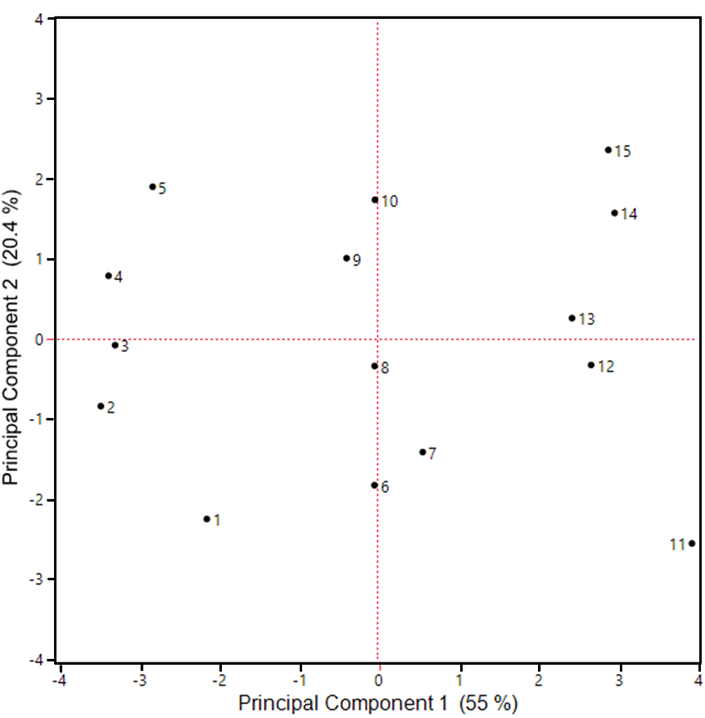

(b)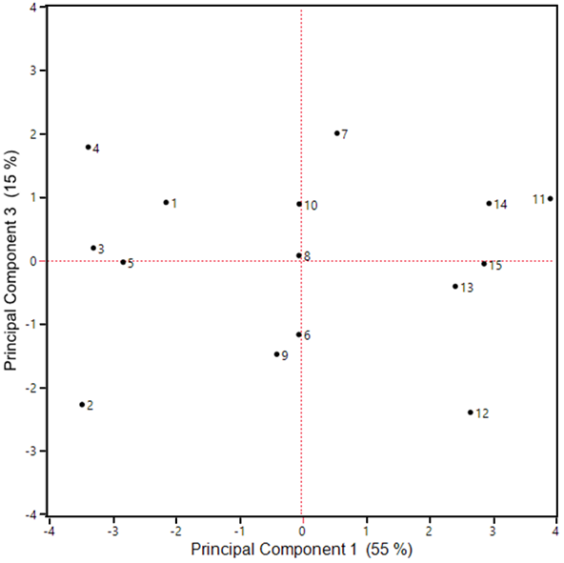
Fig. S1. Score plot showing relationship between experimental runs (a) based on principal component 1 and 2 (b) based on principal component 1 and 3.
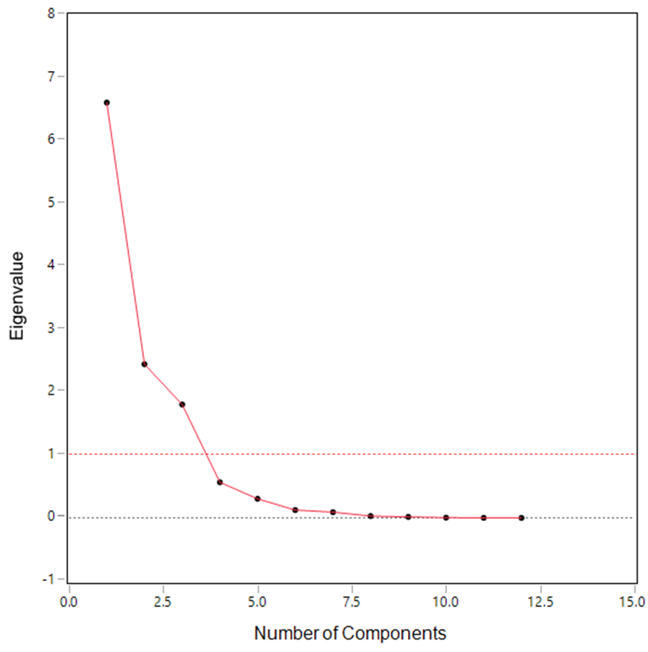
Fig. S2. Scree plot of eigen values of each principal component for selection of relevant principal component. Principal component with eigen value greater than 1 was the selection criterion [1].

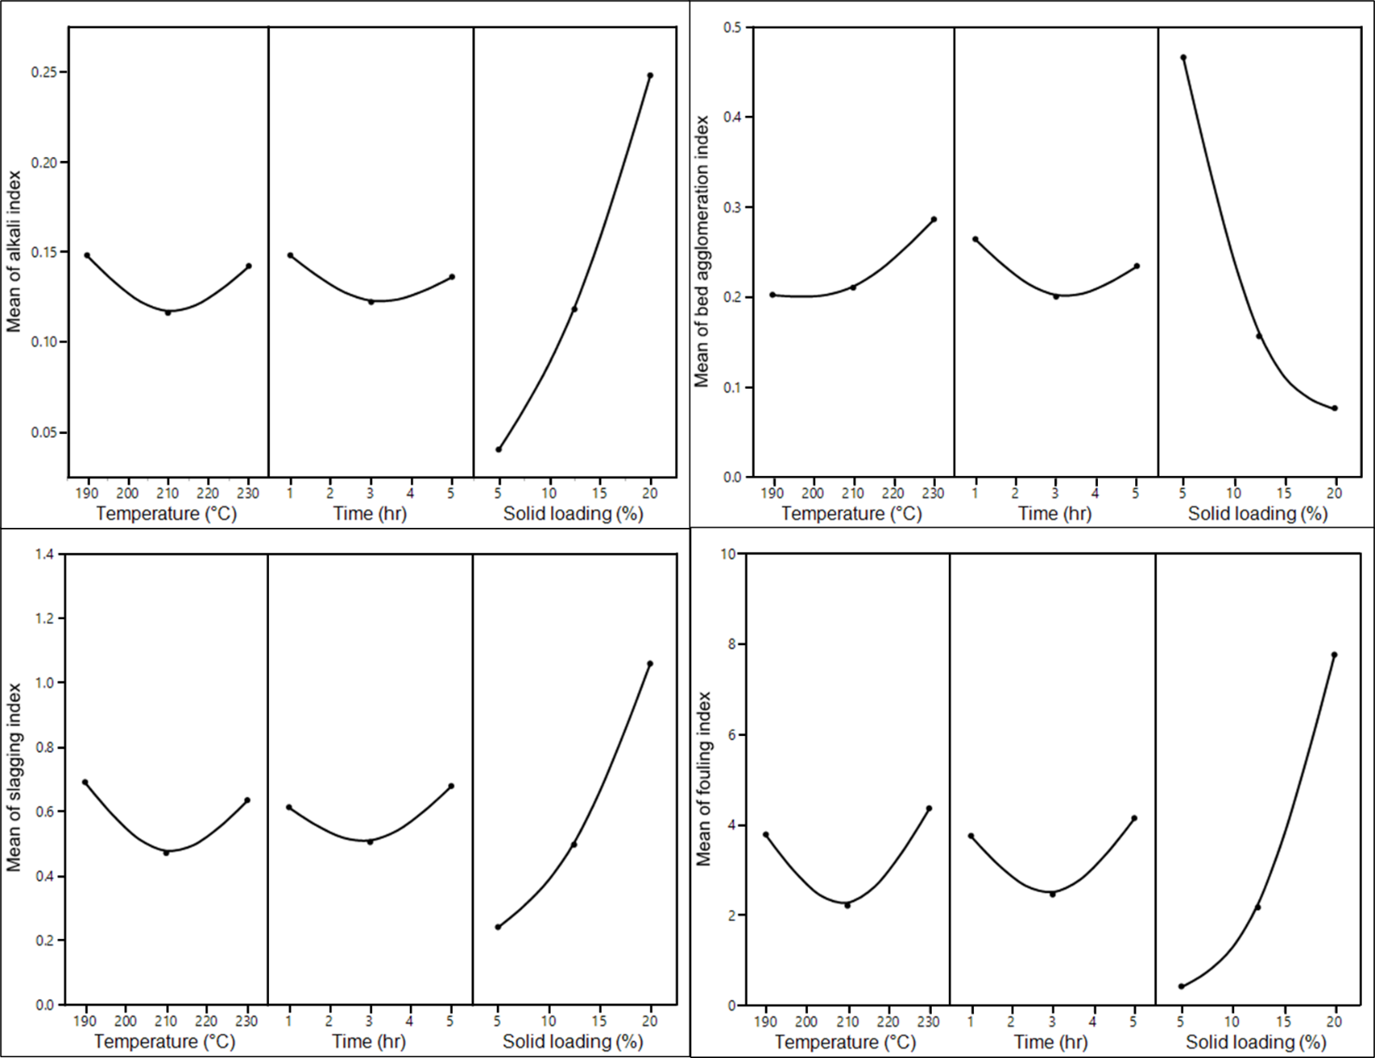
Figure S3 Analysis of the effect of operating parameter on fouling and slagging tendency using main effect plot. A main effect plot shows the mean of the responses across the level of each factor.

References
[1] Abdi H, Williams LJ. Principal component analysis. Wiley Interdiscip Rev Comput Stat 2010;2:433–59. https://doi.org/10.1002/WICS.101.

