Supporting information

A framework for systematic crystal shape and size tuning –Case of Lovastatin’s needle-shaped crystals

Wei Li* †, Lauren E. Hatcher §, Chick C. Wilson §, Chris D. Rielly †, Brahim Benyahia* †

† Future Continuous Manufacturing and Advanced Crystallization (CMAC) Research Hub at Department of Chemical Engineering, Loughborough University, Loughborough, LE11 3TU, UK

§ Future Continuous Manufacturing and Advanced Crystallization (CMAC) Research Hub at Department of Chemistry, University of Bath, Bath, BA2 7AY, UK

# Reproducibility experiments

Two experiments were conducted to test reproducibility using linear cooling crystallization at 0.2 K/min of lovastatin in ethyl acetate with initial concentration at 0.037 g solute/g solution.



|  |  |
| --- | --- |
|  |  |

Two experiments were conducted to test the reproducibility of the DNC experiments under the same target counts of 7000#/s with same initial concentration as above.

|  |  |
| --- | --- |
|  |  |
|  |  |

# UV-vis spectra in presence of PPG

The absorbance of the lovastatin is not affected by the presence of polymer additive (PPG). As shown below, the same absorbance was obtained in the absence and in the presence of PPG (here only 0.5% is presented). It was found that the within the PPG concentration range of 0-1%, the additive had very little effect on the peak position. The peak position remains the same while the PPG ratio increased from 0 to 1%. As such, the calibration model for the UV-vis used for non-additive system was used for prediction of concentration in presence of PPG additive.



# FBRM counts fine tracking

FBRM is able to detect the 1-1000 micros with 100 bins and it can detect very small particles. Here is presented the counts at small sized categories below 50 micros. It can be seen that after two heating and cooling cycles of the DNC experiment ADS-1, the smaller sized particles formed from secondary nuclei has been greatly reduced.



# Intial quantitive chracteriszetion on the growth and dissolution

In order to further clarify the effect of DNC cycles on the aspect ratio, a quantitative description of growth and dissolution rates can be derived from concentration measurements and size evolution during the cooling and heating cycles. To illustrate this point, experiment ADU-3 will be considered. By examining the evolution of crystal size in both length and width directions after the 4th and 5th heating and cooling cycles, the average growth and dissolution rates can be estimated based on the rate of size change during these periods. The calculations reveal that during heating, the dissolution rate is faster in the width direction than the growth rate, while the opposite is true for the length direction. Therefore, it can be deduced that during temperature cycling, the crystals dissolve more rapidly on the longer side, leading to a reduction in aspect ratio. This phenomenon suggests that crystal shape can be improved accordingly through controlled temperature cycling. It can be seen from the figure and tables below.

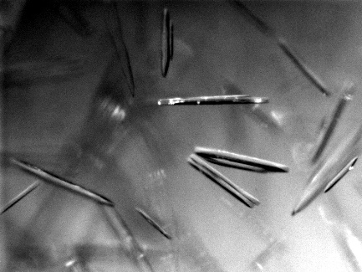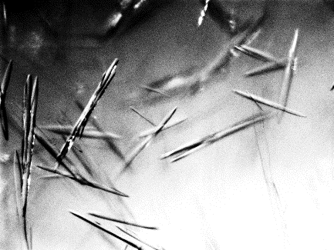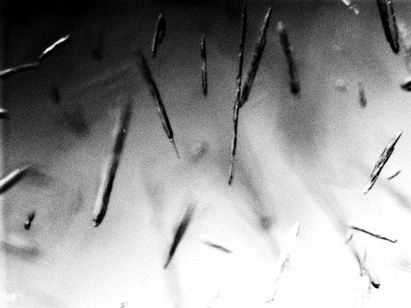

4th cooling

4th heating

5th cooling

Experiment ADU-3 with images at 4th cooling, 4th heating and 5th cooling cycles.

Table S1. Characteristic dimensions of the crystals (length and width) at the end of several dissolution and growth cycles

|  |  |  |  |  |
| --- | --- | --- | --- | --- |
| Cycles | Time (min) | Length (μm) | Width (μm) | Aspect ratio |
| End of the 4th cooling cycle | 150 | 644.0 | 42.6 | 15.1 |
| End of the 4th heating cycle | 170 | 443.0 | 41.4 | 10.7 |
| End of the 5th cooling cycle | 190 | 550.0 | 49.0 | 11.2 |

Table S2. Average dissolution and growth rates with respect to the width and length directions during 4th heating cycle and 5th cooling cycle

|  |  |  |  |
| --- | --- | --- | --- |
| 4th heating cycle | | 5th cooling cycle | |
| Dissolution rate / length um/min | Dissolution rate/t width um/min | Growth rate/ length  um/min | Growth rate / width um/min |
| 10.1 | 0.1 | 5.4 | 0.4 |