**Supplementary Information**

**A strategy for CO2 capture and utilization towards methanol production at industrial scale: an integrated highly efficient process based on multi-criteria assessment**

Ning Yanga,b, Fu Kanga, Ke Zhanga, Yunlong Zhoua , Wen-Feng Linb,*

(a College of Energy Resource and Power Engineering, Northeast Electric Power University, Jilin 132012, China)

(b Department of Chemical Engineering, Loughborough University, Loughborough, Leicestershire LE11 3TU, United Kingdom)

* Corresponding author. E-mail address: w.lin@lboro.ac.uk (Wen-Feng Lin).

**S1.** The improved Methods

The improved C-ACCMP process mainly includes the following aspects: double tower absorption with intermediate cooling, solvent split, and the change of molar ratio of H2 to CO2.

The double tower absorption with intermediate cooling is shown in Fig. S1. The improved method increases the rich solvent duty by adding the intermediate cooling device, and effectively reduces the NH3 loss of ammonia solvent while ensuring the CO2 capture rate.

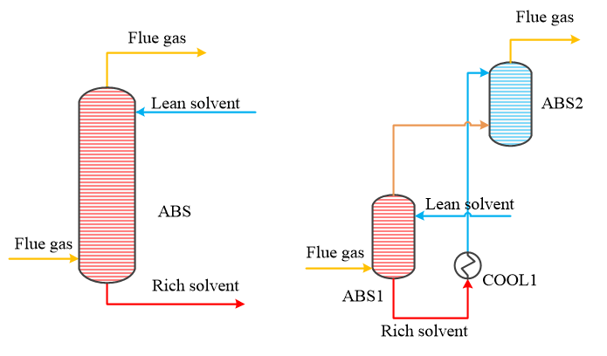

Fig.S1. Double tower absorption with intermediate cooling

The solvent split technology of ABS is shown in Fig. S2. After cooling, part of the rich solvent is directly mixed with the lean solvent and sent back to the ABS, this method reduces the circulation flow, thereby reducing the heat duty of the DES.

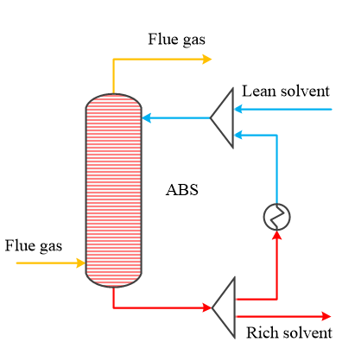

Fig.S2. Solvent split technology of ABS

The solvent split technology of DES is shown in Fig. S3, part of the cooled rich solvent is directly transferred to the upper side of desorption tower, and the other part is transferred to the lower side of DES after recovering the heat from the lean solvent.

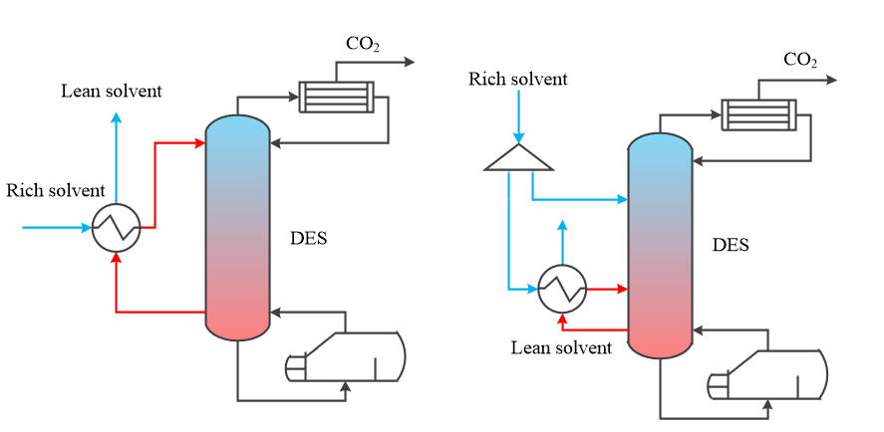

Fig.S3. Solvent split technology of DES

It is usually considered to use renewable energy for water electrolysis to produce H2 for methanol production process, but the overall benefit of this method is not ideal due to the high cost. Another source of H2 is wet hydrogen, which is a byproduct of the chlor-alkali industry. The improved gas separation technology is shown in Fig. S4. The FLASH1 in traditional methanol production process was replaced by a stripping tower (STR). In the STR, wet hydrogen is countercurrent contact with the mixture of methanol and H2O, which can not only remove CO and CO2 in the mixture, but also achieve the purpose of wet hydrogen dehydrating H2O.

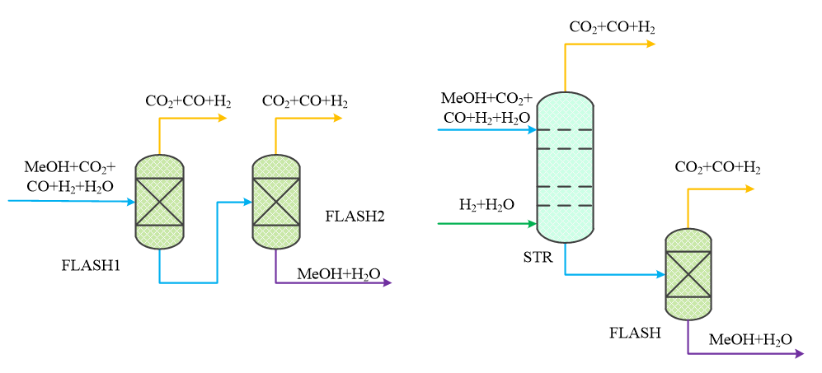

Fig.S4. Improved gas separation technology

**S2**. Kinetic models

The reaction equations involved in ammonia-based CO2 capture technology are shown in Equations (S1) - (S8), where Equations (S1) - (S3) are the equilibrium reactions, Equations (S4) - (S7) are the rate reactions, and Equation (S8) is the salt precipitation reaction.

 （S1）

 （S2）

 （S3）

 （S4）

 （S5）

 （S6）

 （S7）

 （S8）

The power-law expression is used for the rate reaction. The general power-law expression is:

 （S9）

If T0 is not specified, a simplified power-law expression is used:

 （S10）

In this simulation, a simplified power-law expression is used. In Equation (S10), the concentration basis is the molar concentration, n is 0, k and E are shown in Table S1.

Table S1 Kinetic parameters of ammonia reaction (Reaction S4-S7) [1]

|  |  |  |
| --- | --- | --- |
| Reaction ID | *k* | *E* |
| 4 | 4.32e+13 | 13249 |
| 5 | 2.38e+17 | 29451 |
| 6 | 1.35e+11 | 11585 |
| 7 | 4.75e+20 | 16529 |

NH4HCO3 salt precipitation reaction adopts the built-in chemical equilibrium formula:

 （S11）

The kinetic parameters of the reactions are shown in Table S2.

Table S2 Kinetic parameters of salt hydrolysis (Reaction S8) [1]

|  |  |  |
| --- | --- | --- |
| Reaction ID | *A* | *B* |
| 8 | 8.064 | -5013.76 |

Reaction equations involved in methanol production process are shown in Equations (S12) - (S14):

 （S12）

 （S13）

 （S14）

The kinetic expressions of the chemical reactions are shown in Equations (S15) and (S16), and the parameter settings are shown in Table S3. The data are taken from the work of Van-Dal et al [2].

 （S15）

 （S16）

 （S17）

Table S3 Kinetic parameters of methanol production (ReactionS12-S14) [2]

|  |  |  |
| --- | --- | --- |
| *ki* | *Ai* | *Bi* |
| *k*1 | -29.87 | 4811.2 |
| *k*2 | 8.147 | 0 |
| *k*3 | -6.452 | 2068.4 |
| *k*4 | -34.95 | 14928.9 |
| *k*5 | 4.804 | -11797.5 |
| *k*6 | 17.55 | -2249.8 |
| *k*7 | 0.1310 | -7023.5 |

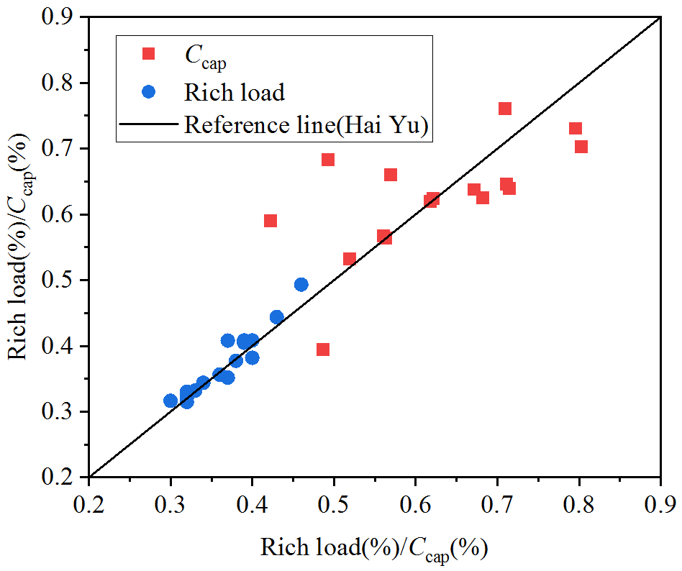

Fig.S5. Model verification of ABS, ABS1 and ABS2.

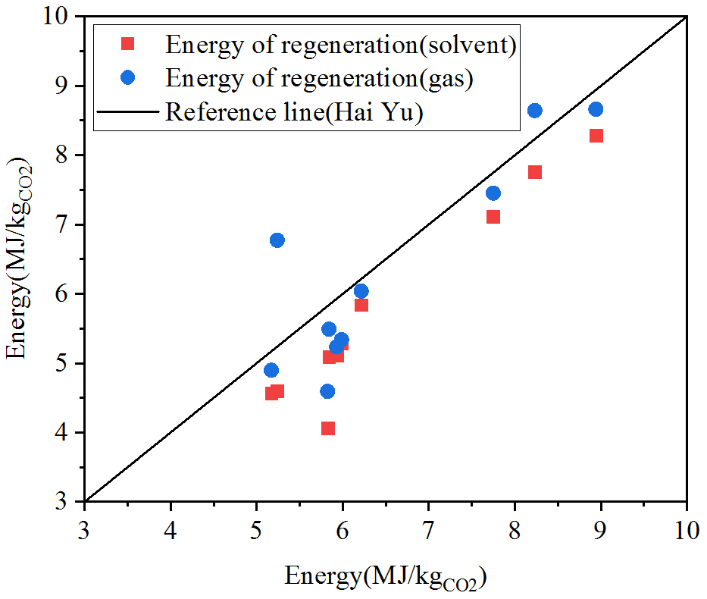

Fig.S6. Model verification of DES.

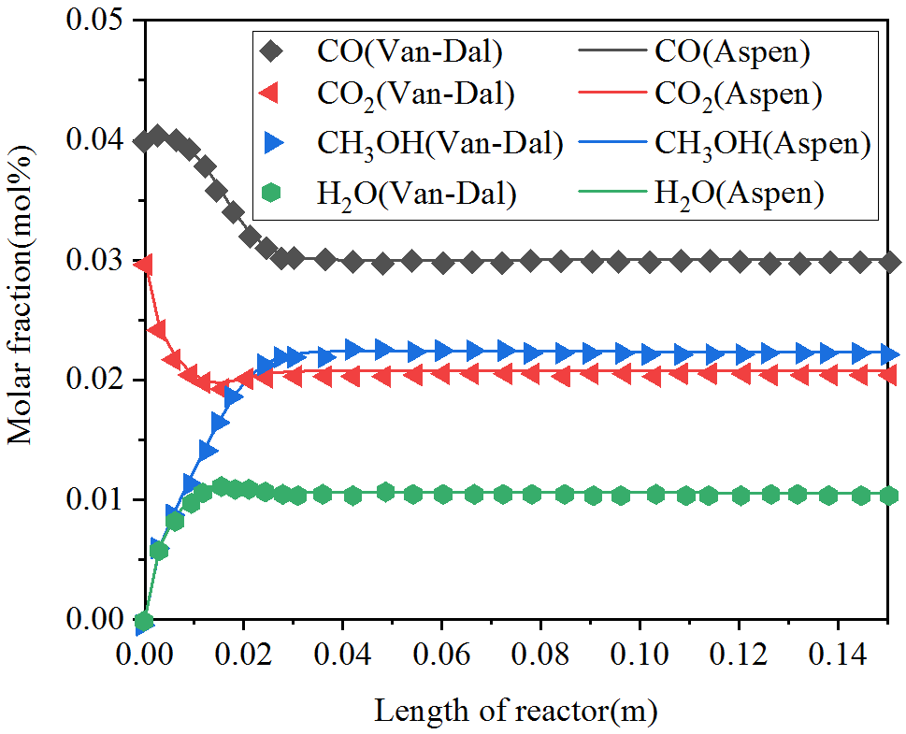

Fig.S7. Validation of RPLUG.

**S3.** Simulated data

Table S4 Logistics parameters of ammonia-based CO2 capture with solvent split process

|  |  |  |  |  |  |
| --- | --- | --- | --- | --- | --- |
| Logistics ID | 1 | 2 | 3 | 4 | 5 |
| Temperature (℃) | 18.00 | 26.41 | 28.06 | 20.00 | 20.10 |
| Pressure (bar) | 1.03 | 1.03 | 1.03 | 1.00 | 1.00 |
| Molar flow (mol/h) | 21954.02 | 21005.64 | 438535.52 | 438040.03 | 20008.31 |
| H2O | 658.62 | 678.59 | 423189.17 | 422232.75 | 456.40 |
| NH3 | 0.00 | 713.91 | 14672.06 | 14176.96 | 370.64 |
| CO2 | 2349.08 | 670.03 | 0.07 | 0.02 | 238.63 |
| NH4HCO3 | 0.00 | 0.00 | 489.52 | 950.88 | 0.00 |
| (NH4)2CO3 | 0.00 | 0.00 | 181.10 | 675.81 | 0.00 |
| N2 | 18946.32 | 18943.11 | 3.61 | 3.61 | 18942.63 |
| Logistics ID | 6 | 7 | 8 | 9 | 10 |
| Temperature (℃) | 21.66 | 21.66 | 21.66 | 21.99 | 21.99 |
| Pressure (bar) | 1.00 | 1.00 | 1.00 | 4.10 | 4.10 |
| Molar flow (mol/h) | 438257.48 | 394431.74 | 43825.75 | 394306.34 | 386420.32 |
| H2O | 422454.42 | 380208.97 | 42245.44 | 379957.99 | 372358.91 |
| NH3 | 14171.49 | 12754.34 | 1417.15 | 12629.02 | 12376.55 |
| CO2 | 0.03 | 0.02 | 0.00 | 0.03 | 0.03 |
| NH4HCO3 | 1034.07 | 930.66 | 103.41 | 1056.31 | 1035.21 |
| (NH4)2CO3 | 593.39 | 534.05 | 59.34 | 659.30 | 646.01 |
| N2 | 4.09 | 3.68 | 0.41 | 3.68 | 3.61 |
| Logistics ID | 11 | 12 | 13 | 14 | 15 |
| Temperature (℃) | 21.99 | 100.00 | 130.17 | 42.00 | 54.89 |
| Pressure (bar) | 4.10 | 4.02 | 4.00 | 4.00 | 3.94 |
| Molar flow (mol/h) | 7886.13 | 386994.28 | 396540.90 | 2145.61 | 396384.87 |
| H2O | 7599.16 | 371866.63 | 380472.89 | 0.00 | 380586.11 |
| NH3 | 252.58 | 12941.60 | 15456.37 | 0.00 | 15307.22 |
| CO2 | 0.00 | 9.18 | 5.52 | 2145.61 | 0.02 |
| NH4HCO3 | 21.13 | 2083.40 | 590.69 | 0.00 | 333.81 |
| (NH4)2CO3 | 13.18 | 89.86 | 15.42 | 0.00 | 157.71 |
| N2 | 0.07 | 3.61 | 0.00 | 0.00 | 0.00 |
| Logistics ID | 16 | 17 | 18 | 19 | 20 |
| Temperature (℃) | 51.61 | 51.67 | 26.00 | 26.00 | 26.17 |
| Pressure (bar) | 3.92 | 1.10 | 1.04 | 1.03 | 1.03 |
| Molar flow (mol/h) | 440211.07 | 440211.26 | 440111.03 | 690.24 | 440799.14 |
| H2O | 422799.73 | 422799.63 | 422830.18 | 384.34 | 423211.47 |
| NH3 | 16724.21 | 16724.41 | 16623.44 | 300.31 | 16921.67 |
| CO2 | 0.03 | 0.03 | 0.00 | 0.01 | 0.00 |
| NH4HCO3 | 468.88 | 469.18 | 337.69 | 5.23 | 343.89 |
| (NH4)2CO3 | 217.81 | 217.61 | 319.31 | 0.36 | 321.70 |
| N2 | 0.41 | 0.41 | 0.41 | 0.00 | 0.41 |

Table S5 Logistics parameters of methanol production process

|  |  |  |  |  |  |  |
| --- | --- | --- | --- | --- | --- | --- |
| Logistics ID | 21 | 22 | 23 | 24 | 25 | 26 |
| Temperature (℃) | 149.57 | 38.00 | 147.05 | 38.00 | 122.42 | 45.48 |
| Pressure (bar) | 12.00 | 11.56 | 34.68 | 34.13 | 78.00 | 78.00 |
| Molar flow (mol/h) | 2145.61 | 2145.61 | 2145.61 | 2145.61 | 2145.61 | 49267.04 |
| MeOH | 0.00 | 0.00 | 0.00 | 0.00 | 0.00 | 162.16 |
| H2O | 0.00 | 0.00 | 0.00 | 0.00 | 0.00 | 33.10 |
| H2 | 0.00 | 0.00 | 0.00 | 0.00 | 0.00 | 38972.87 |
| CO2 | 2145.61 | 2145.61 | 2145.61 | 2145.61 | 2145.61 | 8078.87 |
| CO | 0.00 | 0.00 | 0.00 | 0.00 | 0.00 | 2020.04 |
| Logistics ID | 27 | 28 | 29 | 30 | 31 | 32 |
| Temperature (℃) | 62.00 | 210.00 | 287.29 | 136.38 | 128.27 | 103.47 |
| Pressure (bar) | 77.22 | 76.39 | 75.89 | 75.70 | 75.63 | 75.60 |
| Molar flow (mol/h) | 49267.04 | 49267.04 | 45212.49 | 45212.49 | 45212.49 | 45212.49 |
| MeOH | 162.16 | 162.16 | 2189.44 | 2189.44 | 2189.44 | 2189.44 |
| H2O | 33.10 | 33.10 | 2079.36 | 2079.36 | 2079.36 | 2079.36 |
| H2 | 38972.87 | 38972.87 | 32872.06 | 32872.06 | 32872.06 | 32872.06 |
| CO2 | 8078.87 | 8078.87 | 6032.61 | 6032.61 | 6032.61 | 6032.61 |
| CO | 2020.04 | 2020.04 | 2039.02 | 2039.02 | 2039.02 | 2039.02 |
| Logistics ID | 33 | 34 | 35 | 36 | 37 | 38 |
| Temperature (℃) | 35.00 | 35.00 | 35.00 | 35.38 | 41.04 | 35.00 |
| Pressure (bar) | 75.56 | 75.56 | 74.30 | 74.25 | 78.00 | 74.30 |
| Molar flow (mol/h) | 45212.49 | 5975.47 | 46770.14 | 47121.43 | 47121.43 | 4417.82 |
| MeOH | 2189.44 | 0.00 | 145.58 | 162.16 | 162.16 | 2043.86 |
| H2O | 2079.36 | 81.51 | 29.88 | 33.10 | 33.10 | 2131.00 |
| H2 | 32872.06 | 5893.95 | 38680.38 | 38972.87 | 38972.87 | 85.62 |
| CO2 | 6032.61 | 0.00 | 5881.04 | 5933.26 | 5933.26 | 151.57 |
| CO | 2039.02 | 0.00 | 2033.25 | 2020.04 | 2020.04 | 5.77 |
| Logistics ID | 39 | 40 | 41 | 42 | 43 | 44 |
| Temperature (℃) | 20.77 | 22.05 | 22.05 | 80.00 | 64.05 | 88.85 |
| Pressure (bar) | 1.20 | 1.20 | 1.20 | 1.12 | 1.00 | 1.00 |
| Molar flow (mol/h) | 4417.82 | 250.26 | 4167.55 | 4167.55 | 1867.99 | 2299.57 |
| MeOH | 2043.86 | 16.68 | 2027.17 | 2027.17 | 1855.37 | 171.80 |
| H2O | 2131.00 | 3.23 | 2127.77 | 2127.77 | 0.01 | 2127.76 |
| H2 | 85.62 | 85.51 | 0.12 | 0.12 | 0.12 | 0.00 |
| CO2 | 151.57 | 139.09 | 12.48 | 12.48 | 12.48 | 0.00 |
| CO | 5.77 | 5.75 | 0.01 | 0.01 | 0.01 | 0.00 |

**S4.** Exergy calculation data

Table S6 Exergy calculation data of I-ACCMP process

|  |  |  |  |  |  |  |  |
| --- | --- | --- | --- | --- | --- | --- | --- |
| Logistics ID | Physical exergy  (kW) | Chemical exergy  (kW) | Total exergy (kW) | Logistics ID | Physical exergy  (kW) | Chemical exergy  (kW) | Total exergy (kW) |
| 1 | 0.49 | 17.33 | 17.82 | 23 | 5.51 | 11.92 | 17.43 |
| 2 | 0.38 | 75.33 | 75.70 | 24 | 4.95 | 11.92 | 16.86 |
| 3 | 104.76 | 1412.08 | 1516.84 | 25 | 6.25 | 11.92 | 18.16 |
| 4 | 3.16 | 1502.77 | 1505.93 | 26 | 147.53 | 2778.00 | 2925.54 |
| 5 | 0.01 | 40.30 | 40.31 | 27 | 147.84 | 2778.00 | 2925.85 |
| 6 | 31.89 | 1494.73 | 1526.62 | 28 | 164.93 | 2778.00 | 2942.93 |
| 7 | 28.70 | 1345.26 | 1373.96 | 29 | 165.34 | 2780.11 | 2945.46 |
| 8 | 3.19 | 149.47 | 152.66 | 30 | 140.05 | 2780.11 | 2920.17 |
| 9 | 2.70 | 1369.05 | 1371.75 | 31 | 138.06 | 2779.26 | 2917.32 |
| 10 | 2.65 | 1341.67 | 1344.31 | 32 | 131.43 | 2775.87 | 2907.30 |
| 11 | 0.05 | 27.38 | 27.43 | 33 | 124.45 | 2772.80 | 2897.25 |
| 12 | 16.24 | 1387.86 | 1404.10 | 34 | 17.80 | 397.71 | 415.51 |
| 13 | 114.71 | 1461.94 | 1576.65 | 35 | 138.65 | 2757.01 | 2895.66 |
| 14 | 2.02 | 11.92 | 13.94 | 36 | 139.67 | 2766.07 | 2905.73 |
| 15 | 10.00 | 1450.53 | 1460.54 | 37 | 141.39 | 2766.08 | 2907.47 |
| 16 | 7.64 | 1603.11 | 1610.75 | 38 | 0.77 | 413.52 | 414.29 |
| 17 | 7.00 | 1603.12 | 1610.12 | 39 | 0.02 | 413.54 | 413.57 |
| 18 | -0.07 | 1600.56 | 1600.48 | 40 | 0.03 | 10.15 | 10.17 |
| 19 | -0.01 | 28.16 | 28.14 | 41 | 0.00 | 403.40 | 403.39 |
| 20 | -0.08 | 1626.11 | 1626.03 | 42 | 3.78 | 406.69 | 410.46 |
| 21 | 4.09 | 11.92 | 16.00 | 43 | 2.27 | 371.43 | 373.70 |
| 22 | 3.52 | 11.92 | 15.44 | 44 | 0.30 | 34.19 | 34.49 |

Table S7 Logistics parameters of optimized ammonia-based CO2 capture with solvent split process

|  |  |  |  |  |  |  |
| --- | --- | --- | --- | --- | --- | --- |
| Logistics ID | 1 | 2 | 3 | 4 | 5 | 6 |
| Temperature (℃) | 18.00 | 26.41 | 28.06 | 20.00 | 20.10 | 21.66 |
| Pressure (bar) | 1.03 | 1.03 | 1.03 | 1.00 | 1.00 | 1.00 |
| Molar flow  (mol/h) | 21954.02 | 21005.64 | 438535.52 | 438040.03 | 20008.31 | 438257.48 |
| H2O | 658.62 | 678.59 | 423189.17 | 422232.75 | 456.40 | 422454.42 |
| NH3 | 0.00 | 713.91 | 14672.06 | 14176.96 | 370.64 | 14171.49 |
| CO2 | 2349.08 | 670.03 | 0.07 | 0.02 | 238.63 | 0.03 |
| NH4HCO3 | 0.00 | 0.00 | 489.52 | 950.88 | 0.00 | 1034.07 |
| (NH4)2CO3 | 0.00 | 0.00 | 181.10 | 675.81 | 0.00 | 593.39 |
| N2 | 18946.32 | 18943.11 | 3.61 | 3.61 | 18942.63 | 4.09 |
| Logistics ID | 7 | 8 | 9 | 10 | 11 | 12 |
| Temperature (℃) | 21.66 | 21.66 | 21.99 | 21.99 | 21.99 | 120.00 |
| Pressure (bar) | 1.00 | 1.00 | 4.10 | 4.10 | 4.10 | 4.02 |
| Molar flow  (mol/h) | 394431.74 | 43825.75 | 394306.34 | 386420.32 | 7886.13 | 387086.93 |
| H2O | 380208.97 | 42245.44 | 379957.99 | 372358.91 | 7599.16 | 371768.73 |
| NH3 | 12754.34 | 1417.15 | 12629.02 | 12376.55 | 252.58 | 13010.82 |
| CO2 | 0.02 | 0.00 | 0.03 | 0.03 | 0.00 | 32.48 |
| NH4HCO3 | 930.66 | 103.41 | 1056.31 | 1035.21 | 21.13 | 2227.23 |
| (NH4)2CO3 | 534.05 | 59.34 | 659.30 | 646.01 | 13.18 | 44.08 |
| N2 | 3.68 | 0.41 | 3.68 | 3.61 | 0.07 | 3.61 |
| Logistics ID | 13 | 14 | 15 | 16 | 17 | 18 |
| Temperature (℃) | 130.17 | 42.00 | 41.94 | 39.94 | 40.00 | 26.00 |
| Pressure (bar) | 4.00 | 4.00 | 3.94 | 3.92 | 1.10 | 1.04 |
| Molar flow  (mol/h) | 396540.90 | 2145.61 | 396346.18 | 440163.42 | 440163.60 | 440111.03 |
| H2O | 380472.89 | 0.00 | 380597.38 | 422815.63 | 422815.54 | 422830.18 |
| NH3 | 15456.37 | 0.00 | 15268.20 | 16676.29 | 16676.47 | 16623.44 |
| CO2 | 5.52 | 2145.61 | 0.01 | 0.01 | 0.01 | 0.00 |
| NH4HCO3 | 590.69 | 0.00 | 283.54 | 405.08 | 405.35 | 337.69 |
| (NH4)2CO3 | 15.42 | 0.00 | 197.05 | 266.01 | 265.82 | 319.31 |
| N2 | 0.00 | 0.00 | 0.00 | 0.41 | 0.41 | 0.41 |
| Logistics ID | 19 | 20 | S1 | — | — | — |
| Temperature (℃) | 26.00 | 26.17 | 29.54 | — | — | — |
| Pressure (bar) | 1.03 | 1.03 | 4.10 | — | — | — |
| Molar flow  (mol/h) | 690.24 | 440799.14 | 386486.81 | — | — | — |
| H2O | 384.34 | 423211.47 | 372315.70 | — | — | — |
| NH3 | 300.31 | 16921.67 | 12443.09 | — | — | — |
| CO2 | 0.01 | 0.00 | 0.06 | — | — | — |
| NH4HCO3 | 5.23 | 343.89 | 1144.94 | — | — | — |
| (NH4)2CO3 | 0.36 | 321.70 | 579.41 | — | — | — |
| N2 | 0.00 | 0.41 | 3.61 | — | — | — |

Table S8 Logistics parameters of optimized methanol production process

|  |  |  |  |  |  |  |  |
| --- | --- | --- | --- | --- | --- | --- | --- |
| Logistics ID | 21 | 22 | 23 | 24 | 25 | 26 | 27 |
| Temperature (℃) | 149.57 | 38.00 | 147.05 | 38.00 | 122.42 | 45.48 | 95.00 |
| Pressure (bar) | 12.00 | 11.56 | 34.68 | 34.13 | 78.00 | 78.00 | 77.22 |
| Molar flow (mol/h) | 2145.61 | 2145.61 | 2145.61 | 2145.61 | 2145.61 | 49267.04 | 49267.04 |
| CH3OH | 0.00 | 0.00 | 0.00 | 0.00 | 0.00 | 162.16 | 162.16 |
| H2O | 0.00 | 0.00 | 0.00 | 0.00 | 0.00 | 33.10 | 33.10 |
| H2 | 0.00 | 0.00 | 0.00 | 0.00 | 0.00 | 38972.87 | 38972.87 |
| CO2 | 2145.61 | 2145.61 | 2145.61 | 2145.61 | 2145.61 | 8078.87 | 8078.87 |
| CO | 0.00 | 0.00 | 0.00 | 0.00 | 0.00 | 2020.04 | 2020.04 |
| Logistics ID | 28 | 29 | 30 | 31 | 32 | 33 | 34 |
| Temperature (℃) | 210.00 | 287.29 | 125.99 | 106.51 | 75.61 | 35.00 | 35.00 |
| Pressure (bar) | 76.39 | 75.89 | 75.70 | 75.63 | 75.60 | 75.56 | 75.56 |
| Molar flow (mol/h) | 49267.04 | 45212.49 | 45212.49 | 45212.49 | 45212.49 | 45212.49 | 5975.47 |
| CH3OH | 162.16 | 2189.44 | 2189.44 | 2189.44 | 2189.44 | 2189.44 | 0.00 |
| H2O | 33.10 | 2079.36 | 2079.36 | 2079.36 | 2079.36 | 2079.36 | 81.51 |
| H2 | 38972.87 | 32872.06 | 32872.06 | 32872.06 | 32872.06 | 32872.06 | 5893.95 |
| CO2 | 8078.87 | 6032.61 | 6032.61 | 6032.61 | 6032.61 | 6032.61 | 0.00 |
| CO | 2020.04 | 2039.02 | 2039.02 | 2039.02 | 2039.02 | 2039.02 | 0.00 |
| Logistics ID | 35 | 36 | 37 | 38 | 39 | 40 | 41 |
| Temperature (℃) | 35.00 | 35.38 | 41.04 | 35.00 | 20.77 | 22.05 | 22.05 |
| Pressure (bar) | 74.30 | 74.25 | 78.00 | 74.30 | 1.20 | 1.20 | 1.20 |
| Molar flow (mol/h) | 46770.14 | 47121.43 | 47121.43 | 4417.82 | 4417.82 | 250.26 | 4167.55 |
| CH3OH | 145.58 | 162.16 | 162.16 | 2043.86 | 2043.86 | 16.68 | 2027.17 |
| H2O | 29.88 | 33.10 | 33.10 | 2131.00 | 2131.00 | 3.23 | 2127.77 |
| H2 | 38680.38 | 38972.87 | 38972.87 | 85.62 | 85.62 | 85.51 | 0.12 |
| CO2 | 5881.04 | 5933.26 | 5933.26 | 151.57 | 151.57 | 139.09 | 12.48 |
| CO | 2033.25 | 2020.04 | 2020.04 | 5.77 | 5.77 | 5.75 | 0.01 |
| Logistics ID | 42 | 43 | 44 | S2 | — | — | — |
| Temperature (℃) | 80.00 | 64.05 | 88.85 | 230.00 | — | — | — |
| Pressure (bar) | 1.12 | 1.00 | 1.00 | 75.89 | — | — | — |
| Molar flow (mol/h) | 4167.55 | 1867.99 | 2299.57 | 45212.49 | — | — | — |
| CH3OH | 2027.17 | 1855.37 | 171.80 | 2189.44 | — | — | — |
| H2O | 2127.77 | 0.01 | 2127.76 | 2079.36 | — | — | — |
| H2 | 0.12 | 0.12 | 0.00 | 32872.06 | — | — | — |
| CO2 | 12.48 | 12.48 | 0.00 | 6032.61 | — | — | — |
| CO | 0.01 | 0.01 | 0.00 | 2039.02 | — | — | — |

Table S9 Exergy calculation data of optimized I-ACCMP process

|  |  |  |  |  |  |  |  |
| --- | --- | --- | --- | --- | --- | --- | --- |
| Logistics ID | Physical exergy  (kW) | Chemical exergy  (kW) | Total exergy (kW) | Logistics ID | Physical exergy  (kW) | Chemical exergy  (kW) | Total exergy (kW) |
| 1 | 0.49 | 17.33 | 17.82 | 24 | 4.95 | 11.92 | 16.86 |
| 2 | 0.38 | 75.33 | 75.70 | 25 | 6.25 | 11.92 | 18.16 |
| 3 | 104.76 | 1412.08 | 1516.84 | 26 | 147.53 | 2778.00 | 2925.54 |
| 4 | 3.16 | 1502.77 | 1505.93 | 27 | 150.09 | 2778.00 | 2928.09 |
| 5 | 0.01 | 40.30 | 40.31 | 28 | 164.93 | 2778.00 | 2942.93 |
| 6 | 31.89 | 1494.73 | 1526.62 | 29 | 165.34 | 2780.11 | 2945.46 |
| 7 | 28.70 | 1345.26 | 1373.96 | 30 | 137.37 | 2778.87 | 2916.24 |
| 8 | 3.19 | 149.47 | 152.66 | 31 | 132.11 | 2776.20 | 2908.31 |
| 9 | 2.70 | 1369.05 | 1371.75 | 32 | 126.93 | 2773.83 | 2900.76 |
| 10 | 2.65 | 1341.67 | 1344.31 | 33 | 124.45 | 2772.80 | 2897.25 |
| 11 | 0.05 | 27.38 | 27.43 | 34 | 17.80 | 397.71 | 415.51 |
| 12 | 41.02 | 1399.26 | 1440.28 | 35 | 138.65 | 2757.01 | 2895.66 |
| 13 | 114.71 | 1461.94 | 1576.65 | 36 | 139.67 | 2766.07 | 2905.73 |
| 14 | 2.02 | 11.92 | 13.94 | 37 | 141.39 | 2766.08 | 2907.47 |
| 15 | 3.37 | 1449.60 | 1452.97 | 38 | 0.77 | 413.52 | 414.29 |
| 16 | 2.34 | 1601.75 | 1604.09 | 39 | 0.02 | 413.54 | 413.57 |
| 17 | 1.68 | 1601.76 | 1603.44 | 40 | 0.03 | 10.15 | 10.17 |
| 18 | -0.07 | 1600.56 | 1600.48 | 41 | 0.00 | 403.40 | 403.39 |
| 19 | -0.01 | 28.16 | 28.14 | 42 | 3.78 | 406.69 | 410.46 |
| 20 | -0.08 | 1626.11 | 1626.03 | 43 | 2.27 | 371.43 | 373.70 |
| 21 | 4.09 | 11.92 | 16.00 | 44 | 0.30 | 34.19 | 34.49 |
| 22 | 3.52 | 11.92 | 15.44 | S1 | -1.91 | 1345.51 | 1343.60 |
| 23 | 5.51 | 11.92 | 17.43 | S2 | 154.33 | 2780.11 | 2934.45 |

References

[1] Aspen Plus. Rate Based Model of the CO2 Capture Process by NH3 using Aspen Plus..

[2] É.S. Van-Dal, C. Bouallou, Design and simulation of a methanol production plant from CO2 hydrogenation, Journal of Cleaner Production 57 (2013) 38-45.