Supporting information

The Pseudocapacitive Nature of CoFe₂O₄ Thin Films

Jagdeep S. Saguª, K. G. U. Wijayanthaª* and Asif A. Tahir^{b}

ªEnergy Research Laboratory (ERL), Department of Chemistry, Loughborough University, Loughborough, LE11 3TU, UK
^{b}Environment and Sustainability Institute (ESI), University of Exeter Penryn, Cornwall TR10 9FE, UK

*U.Wijayantha@lboro.ac.uk

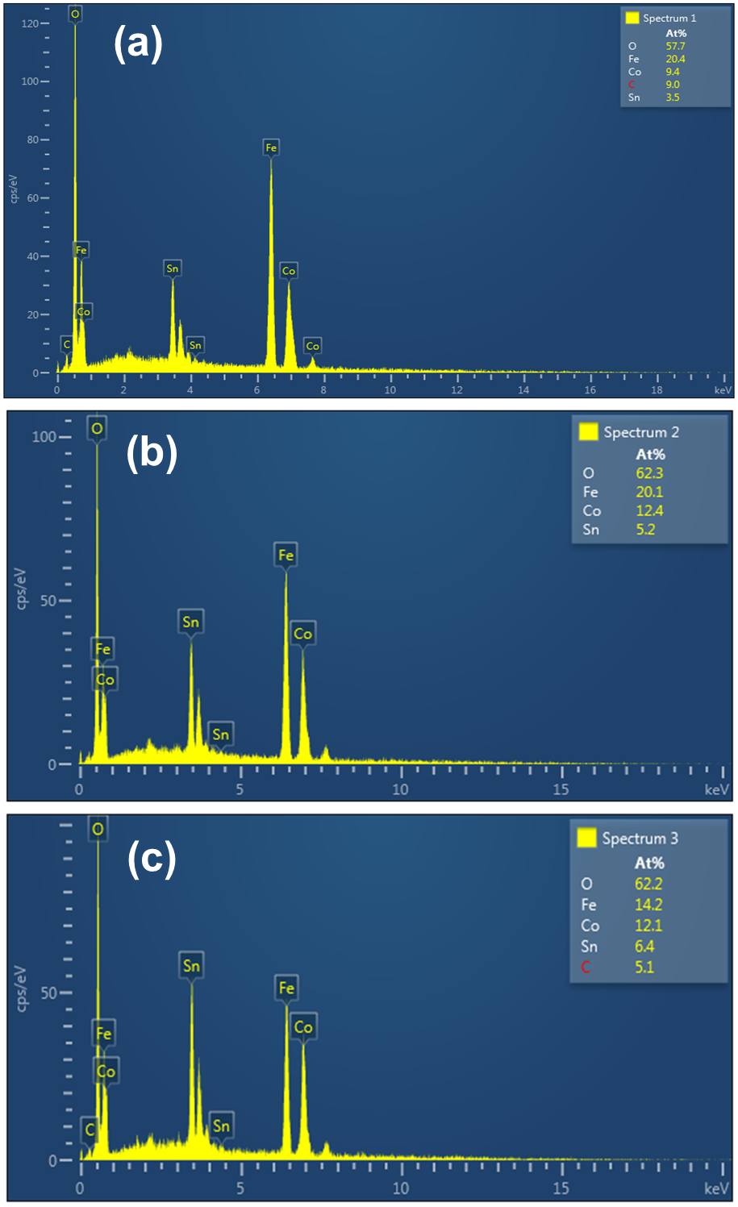
Figure S1. EDX analysis of CoFe₂O₄ thin films deposited on FTO glass substrates for 20 min using AACVD at (a) 450ºC, (b) 500ºC and (c) 550ºC. The Co:Fe ratio is 1:2.17, 1:1.62 and 1:1.17 for films deposited at 450ºC, 500ºC and 550ºC, respectively.

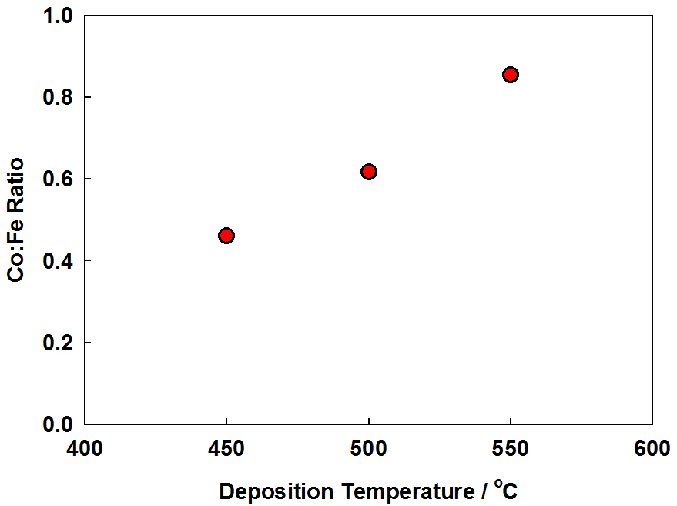
Figure S2. Co:Fe ratio as a function of deposition temperature. Expected ratio for pure CoFe₂O₄ is 0.5.

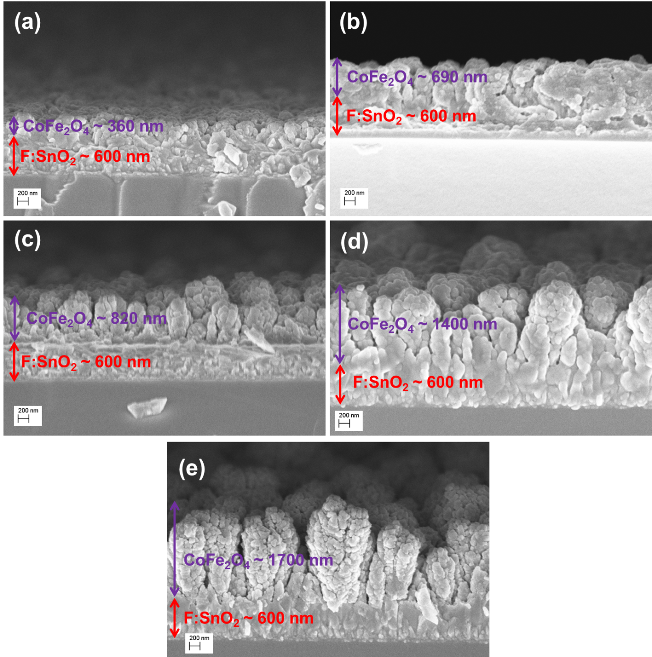
Figure S3. Cross-sectional SEM images of CoFe₂O₄ thin films deposited on FTO glass substrates at 550 ºC using AACVD for (a) 2.5 min, (b) 5 min, (c) 10 min, (d) 15 min and (e) 20 min.

Figure S4. CoFe₂O₄ film thickness as a function of AACVD deposition time at 550ºC.

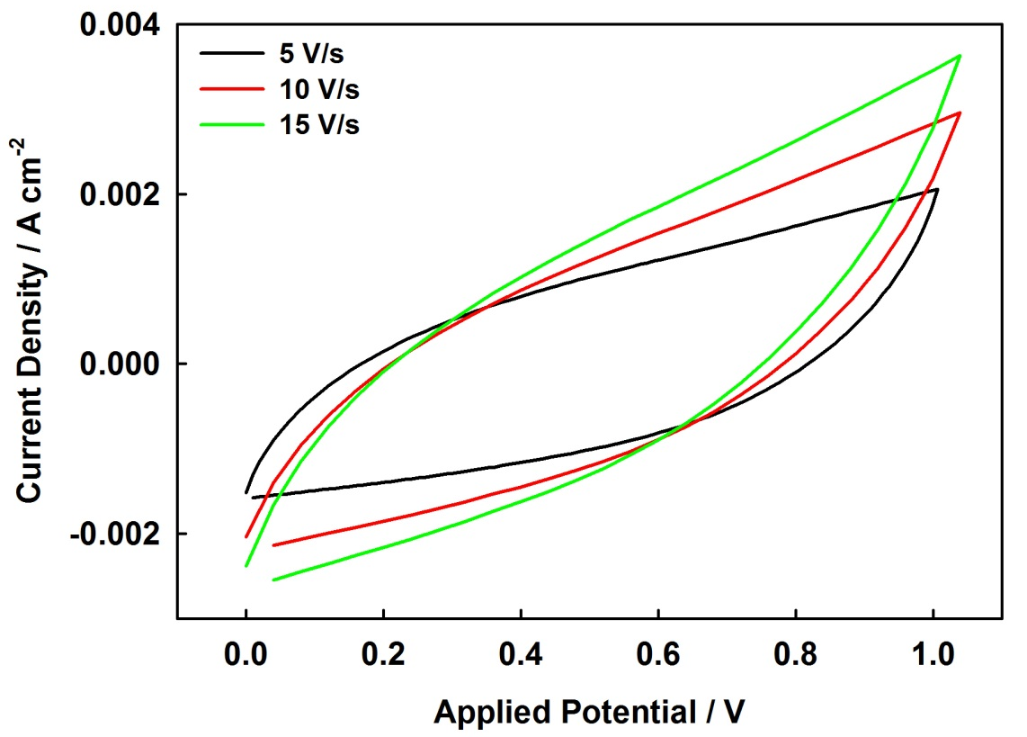
Figure S5. Cyclic voltammograms of a CoFe₂O₄ symmetric supercapacitor in 1 M NaOH at fast scan rates of 5, 10 and 15 V/s.

Figure S6. Electrochemical response of a bare F:SnO₂ substrate compared with a typical CoFe₂O₄ thin film prepared at 550ºC using AACVD.

